Code Optimization as a tool for Testing Software
Abstract— Optimization of code is one of the craved destinations in programming designing to guarantee that program makes capable use of framework assets. Optimization targets program to be bug free, and reducing time and space complexity and a compact code. This paper is in light of "Optimization of Code” in regard with C and C++ coding Structure. In compiler design, we use the optimization as one of the methods which change a bit of code to make more productive without transforming its result. The aim of the front-end are surely knew and un-optimized code generation is generally straight forward. The principle point of the code optimization is to make Quality code with respect to time and space without influencing the accurate consequence of the code. It is the area of most researchers and many compiler exploration is done today. The basis of code optimization must safeguard the semantic analysis of the system and the calculation ought not to be altered. Transformation, must accelerate coding execution part of the program. It is many times hard to think about which piece of project is using the maximum assets, and in the program ,we construct our enhancement endeavors in light of hypothesis rather than genuine information, we will waste our plenty of time accelerating the parts of our system that were quick as of now. Advancement may lead to finding a bottleneck, a basic piece of the code that is the essential consumer of the required resources –sometimes known as a problem area. Since we accept that our code may be extensive, henceforth we all need to streamline our own particular code. In a perfect world, we ought to get programming to check and take a shot at streamlining of code and relating it to execution of coding. It will lead to testing the Software to point out the suggestions which can be made during the development phases of coding. At last, an optimized code with better performance of that same code. We will talk about various methodologies and techniques for code optimization and by using a tool CCCC we will assess the quality of code after that we will identify the place where there is a scope to optimization. After that which technique which is well suited for that code is applied and we will perform methods to find quality of code . Finally after this testing through various techniques will test the code.
Manpreet Singh Bajwa Arun Prakash Agarwal Nitika Gupta
Amity University, Noida UP A. P., AUUP , Noida Amity University , Noida UP
manisinghbajwa@gmail.com apagrawal@amity.edu guptanitika25@gmail.com

- INTRODUCTION
Code Optimization upgrades a project according to time and space complexities and uses less assets. Improvement is the stage that a software engineer ought to gather at, after the coding, programs is finished. A software engineer ought to recollect that optimization ought not be considered while composing the real code. Once in a while accelerating the code triggers increment in code size. This system size development may bring about opposite result upon code's intelligibility and many-sided quality.The project work is taking into account Enhancement of Code (identified with C and C++). In compiler design, the enhancement is one of the systems which change a bit of code to make more productive (either as far as time or space) without transforming its output. In compiler design, the aim of the front-end are surely knew and un-optimized code era is moderately straight forward. The fundamental point of the code optimization is to make code with best time and space complexity without influencing the precise consequence of the code. It is the field where most compiler exploration is done today. The basis of code improvement must safeguard the semantic analysis of the system and the calculation ought not to be altered. Change, by and large ought to accelerate the execution of project. It is regularly hard to think about what some piece of project is not using the most assets, and on the off chance that we construct our optimization endeavors in light of theory rather than genuine information, we will waste our plenty of time accelerating the parts of our system that were quick as of now. Improvement may incorporate discovering a bottleneck, a discriminating piece of the code that is the essential consumer of the required asset –sometimes known as a problem area.
The code optimization mostly concerns on accuracy that implies optimization does not change the rightness of created code. By utilizing distinctive strategies of advancement we can improve our code without influencing the original calculation and last result with the goal of better performance. At the point when execution is critical, we likewise need to pick a calculation that runs rapidly and utilizes the accessible processing assets effectively. In compiler optimization hypothesis, the compiler optimization essentially alludes to the project enhancement to accomplish execution in the execution.
Program optimization refers to the three aspects:-
Source Code -> Front End -> Optimizer -> Back End -> Machine Code

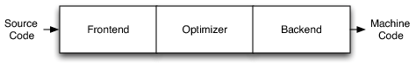

To make the code faster, smaller, reliable and more efficient we need to involve guidelines and rules for program code as an algorithm to code optimization. These optimization techniques contradict which each other. For example in general cases the code which is faster will be usually very large. And smaller code might take a bit of time. We can implement optimization at many levels like source code, front end intermediate level and back end depending upon the optimizer specialization or on basis of compiler present. Two basic level of optimization is High and low level. Basically , High level are those optimization techniques which helps in handling functions , procedures , classes and abstract entities where they need to keep in mind the basic rules and guidelines of the programming code. Structures like loop, branches which are elementary structural blocks of program coding are included in high level optimization. Low level optimization is performed after the machine instructions. Optimization is also observed as a difficult task as a new comer performance is 3 to 5 slower than that of compiler. . Knuth explains the early low level optimization in his own terms as “Premature optimization is the root of all evil".
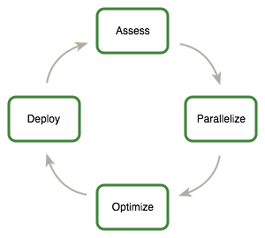

1.1 WHAT TO BE OPTIMIZED?
Code improvement done physically makes issue: one doesn't just need to know how precisely optimization ought to be done, additionally what specific piece of the project ought to be enhanced. Because of different reasons (moderate info operations, the distinction in the working speed of a human administrator), 90% of the execution time of a system is spent executing just 10% of the code. Since advancement takes additional time adding to the project, one ought to better concentrate on enhancing these time-discriminating 10% of code as opposed to attempt to upgrade the entire system. These code sections are known as bottlenecks and can be distinguished by extraordinary utilities - profilers - which can gauge the time taken by different parts of the system to execute.

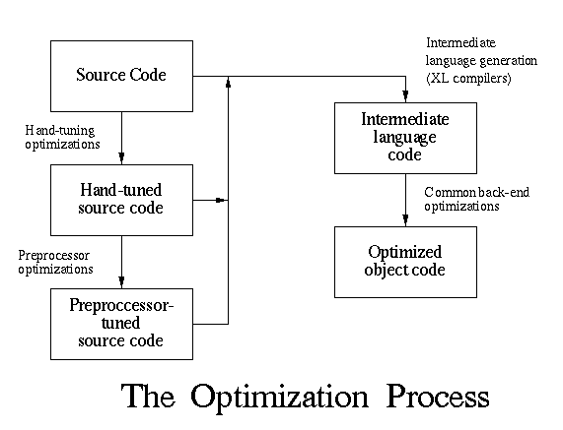

1.2 NEED AND REQUIREMENT :
• The basic necessity of code optimization is to increase its efficiency and to consume less and less time without effecting the quality of code.
• The Project is better in terms of optimization if it’s smaller, use less memory, less operations and usage of resources, execute all code quickly.
• Now comes the output phase , without compromising with output the optimization need to produce same output in comparison to the un optimized result.

- BACKGROUND AND RELATED STUDY

Always there exists a scope for optimization i.e. complete (100%) optimization is not possible. This is due to the reason that programmer might not have complete knowledge regarding underlying hardware and compiler. Optimization can take form at Design (efficient algorithms), Source Code (high quality coding preventing slowdowns), Build (build flags and directives), Compile (optimizing executable program), Assembly (using machine instructions) or Runtime (just in time compilation) level(s).
Optimization concentrates on refining few facets i.e. time complexity, space complexity, bandwidth, disk space, power utilization etc. This necessitates tradeoff i.e. one issue is enhanced on the cost of other. For instance augmenting cache size enhances performance at runtime; however it also increases the requirement of memory.
Optimizing “Hot Spot” i.e. critical fragment of the code is a best exercise.
According to author Vamsi^{[14]} There exists sundry approaches for C tuning and the paper explains a holistic tactics of C tuning where we optimize the C command performance Which explains that we should alsways Prefer Iteration of codes over Recursive function.
Few technologies explained by the author are Code Motion(like A function inside a loop is moved outside the loop.), loop Unrolling (minimizing number of iterations),Inlining( process of substitution), Prefer Ternary operator over branching to reduce the overhead of maintaing stack frame and program counter. Choosing Function over macro. If function body is large and vice versa. Reducing Line of Code.Usage of better Logical Structures, Strength Reduction (Substitute multiplication involving loop index by addition.Combine Logic Expressions, Basic Data Type Operation: +, -, *, / operators should be used instead of +=, -=, *=, /= compound operators.
Importantly Avoiding Dynamic Memory Allocation: Allocating Memory Dynamically neccessitates using locks to control allocator access.

- LITERATURE SURVEY
Chirag H. Bhatt [1] explains that Peephole Optimization Strategy and its usage. The link between the strategy and its usage to make development and enhancing of compilers with improvement which relates top research and replacement to loop like Guidelines in Coding of a program. Many other pattern matching approaches were discussed like string base, tree manipulation and object based. Peephole Optimization is a simple optimization technique targeting a small set of instructions in assembly coded version. These instruction are called Peephole or window. This paper target on four important points. Firstly, Machine dependent peephole optimizers are hard to coding and are easily compatible to be coded with object code instruction. Secondly, In case of machine independent peephole optimizers the retargeting peephole optimizers are capable to work upon register transfer to avoid the exhaustive cases rather than assembly coded. Thirdly the process of merging the code so generated and optimization into one phase and then another and to achieve the speed up the efficiency. At last, it demonstrate the different peephole optimization implement different pattern matching techniques. After reading this research paper a brief idea of research work in peephole, its issue, its construction and design were briefed.

C. Brandolese [2] presented method of estimating the execution time of software. Some new Design changes of embedded applications need an analysis and performance check, power in few first stages in components of design in comparison to alternative solution. The proposed thesis relies on Hierarchical results of coding program structure and accumulates a mathematical model of information on statistical on their timing issues. This methodology is approved by few experiments realizing the prototype toolset. In general, Gaussian distribution of absolute errors and in contrast with the actual values of these methodology for a broad range the estimates are fitting the actual values and their magnitude lies in 3 - 4%. This paper also shows the future trends and aspect of this methodology such as -
The low level processor characterization based source level energy estimation and it’s extend analysis strategies. TOSCA HW/SW code design guidelines estimating strategy which include fast and flexible timing.
Maggie Johnson [3] explains different compiling methods and optimizations. Optimization is a method of transforming set of instruction to make the code more efficient without altering its output. These days this field is the most researcher’s area. There can be two simple classification if optimization i.e. Heuristic and approximations. A simple optimizations starts after the code is written and the compiler simply optimize the code. Its main concern is that the compiling process should not change the result of the program code generated and the correctness of code need to be maintained where a compiler attack on various optimizing area where and when to optimize. The intermediate code is optimized by streamlining, rearranging, compressing etc. techniques to reduce the size of code. Other techniques are applied just for eliminating the instructions or for allocation of registers, for simple spill instructions but these all will work after final code generation targeting the efficiency of code. This paper talks about “local optimization” which is performed within a basic block of code. Few local optimization techniques are constant propagation (calculating compile time of expression where operands are constant and constant folding (which places integer constant where they are used) reducing the number of registers. This paper is also explain global optimizers making similar optimizations across basic blocks is “Data Flow analysis”. The fastest memory available is register and register allocation is important in optimization techniques. The problem is how to manage is traffic between registers and hierarchy of memory without wasting time while exchanging data across bus with different caches and common register allocation technique is called “register coloring”. Instruction scheduling is also an important optimization of final code generation.

Michael E. Lee [4] focuses on optimization techniques in C where reduction in time spent in CPU and giving suggestion from source code which gives improvement in output. In this most effective technique is to find bottle neck through profiler. The compiler uses real world data to optimize accordingly. This also suggest few precautious measure of avoiding variable both global and static in tightest loop and passing addresses to other functions. According to Donald Knuth Software engineers waste lots of time contemplating, or agonizing over, the pace of noncritical parts of their projects, and these endeavors at effectiveness really have an in number negative effect when troubleshooting and upkeep are considered. We ought to disregard little efficiencies, say in regards to 97% of the time: untimely optimization is the base of all underhandedness. Yet we ought not to leave behind our chances in that basic 3%. This article likewise depicts the systems which don't produce the course of if-else-if in the request indicated in the switch proclamation. For this situation settled switch proclamations can be utilized to get the same impact i.e. to break enormous switch explanations into settled changes to decrease the quantity of examinations. A portion of the systems portrays are similar to minimize neighborhood variables, pronounce nearby variables in the inward most degree, to lessen the quantity of parameters, utilization references for parameter passing and return quality sorts greater than 4 bytes and so forth. This article expresses the favored utilization of "int over char and short" in light of the fact that C and C++ perform number juggling operations and parameter going at whole number level. It is being presumed that int ought to be utilized for every single number variable unless stockpiling prerequisite drive us to utilize a char or short. It additionally characterizes to lean toward "initialization over assignment", "preincrement over postincrement" [6]. The archive shows some of procedures that may enhance execution on some compiler/processor blends. Some of methods which are being utilized are, for example, "structure field order" in which the part variables of classes and structures are organized in such a route, to the point that the most utilized variables are as a part of such a path, to the point that the most utilized variables are as a part of the initial 128 bytes and afterward sorted from longest question briefest. "Floating point Integer Conversion" in which nonstandard schedules are abused to round floating point numbers to whole numbers. The C++ don't give a primitive operation to round floating point numbers. The least difficult procedure to change over a floating point number x to the closest whole number n is the accompanying explanation:
n = int (floor(x + 0.5f));
For example, if x is equally far from two integers, n will be the upper integer (for example, 0.5 generates 1, 1.5 generates 2, -0.5 generates 0, and -1.5 generates -1). Considering the size of arrays or of vectors for example: it must be a power of two and that the size of large cells of arrays of vectors be not a power of two [11].
Huang Zhijun [12] describe about widely used monitoring network software Trimedia in expressway at present, used in digital video monitoring system, digital hard disk video on DSP(DVR), remote multimedia database, especially in video conference system has been large scale application. This paper discussed the full utilization of resources and coded program to make the software more efficient.

Bruce Childers [13] construct a new method based on a continuous compilation system to improve the application code by applying adaptive optimization coding techniques at all times from static optimization to online dynamic optimization. In General, These kind of adaptive and aggressive coding approaches focusing the continuous compilation are explained. The continuous Compilation is used in presenting initial research values with continuous compilation, with a new guideline frame work to predict the usage of applying code transformations of continuous compilation without actually doing transformation. Additionally the comes about that exhibit those profit for adaptively evolving application code to installed frameworks on settle on trade-offs between code size, performance, Also power utilization.

- METHODOLOGY:

4.1 PROCEDURES
The project work based on optimization of code will start with the analysis of the different codes of varying complexities, such as best case, average case and worst case. Different machine independent optimization techniques will be applied to each of these un-optimized codes. After the successful implementation, analysis would be done for the complexities of these codes. Moreover, the comparison would be done for the complexities of the un-optimized code and the optimized code. It would produce the expected results such as the reduced complexity, execution time faster, and reduce the size of the code. Although, there are many techniques for the optimization of code but the techniques which would be applied in this work are discussed below:-

4.1.1 INLINING
Inlining is those procedure by which those code of a coded program are “inlined”, basically, replicated and pasteboard As opposed to an accepted call to that program coded part - function. This type of streamlining abstains from the overhead about working calls, by eliminating those requirement should jump, make another stack frame, and What’s more reverse this procedure in the limit of the code.
Points of interest: -.
1) It doesn't require calling overhead.
2) It likewise spare overhead about variables push/pop on the stack, same time calling.
3) It additionally save overhead for comeback call starting
4) It builds area from claiming reference toward using direction book reserve.
5) Following in-lining compiler could likewise apply intra procedural streamlining in specified. This may be those practically vital one, in this approach compiler might Right away concentrate on dead code elimination, could provide for a greater amount anxiety with respect to extension prediction, incitement variable disposal and so forth.

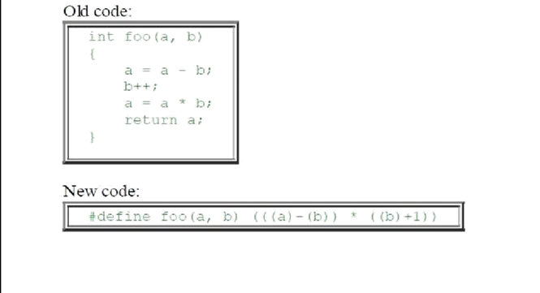
4.1.2 CONSTANT PROPAGATION AND FOLDING
It alludes to the assessment at compile time of expressions whose operands are known not steady. It includes establishing that the greater part of the operands in an expression are consistent valued, performing the assessment of the expression at same time, and afterward supplanting the expression by its value. On the off chance that an expression, for example, 10 + 2 * 3 is experienced, the compiler can process the outcome at incorporate time (16) and emanate code as though the information contained the outcome instead of the first expression.
In the event that a variable is doled out a consistent worth, then ensuing employments of that variable can be supplanted by the steady the length of no interceding task has changed the estimation of the variable.
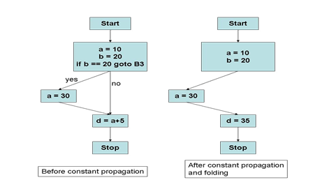

4.1.3 CODE MOTION
Code motion brings together successions of code basic to one or more fundamental pieces to decrease code size and conceivably stay away from costly re-assessment. The most widely recognized type of code movement is invariant in loop code movement that moves proclamations that assess to the same value each cycle of the loop to some place outside the repetition. All the more definitely, if an announcement is autonomous of the quantity of times a loop is executed, move it outside the branch.
It has two stages: investigation (Analysis) & change (Transform).
1: Find invariant calculation in branched loop.
• Invariant: figures same result every time assessed
2: Move them outside branch repetition of loop
• To top: code raising if utilized inside of loop
• To base: code sinking-if utilized after loop.
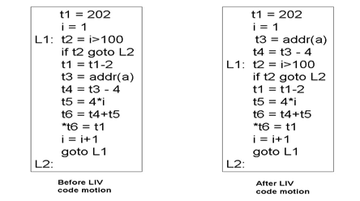

4.1.4. STRENGTH REDUCTION
The fundamental thought of quality lessening is to supplant computationally extravagant operations by less complex ones that still have a proportional impact. The essential application is to rearrange augmentation by list variables to increases inside of loops. This advancement is essential for PCs where expansion is a great deal quicker than increase and can pick up a component of 3 for numerical projects.
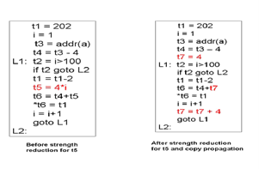

4.1.5. DEAD CODE ELIMINATION
In the event that a guideline's outcome is never utilized, the direction is viewed as "dead" and can be expelled from the guideline stream. It takes out guidelines whose outcomes are never utilized.
1. Mark every single basic guideline as helpful: directions that arrival qualities, perform I/O, or alter remotely unmistakable capacity.
2. Mark all direction that influence officially checked guideline: directions that characterize operands of i or control the execution of i.

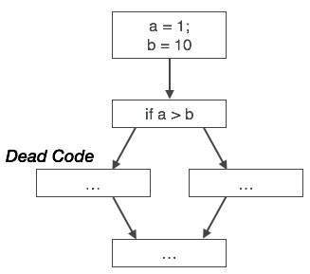

4.1.6. COMMON SUB-EXPRESSION ELIMINATION
Two operations are basic in the event that they create the same result. In such a case, it is likely more effective to register the outcome once and reference it the second time as opposed to re-assess it. An expression is alive if the operands used to process the expression have not been changed. An expression that is no more alive is dead

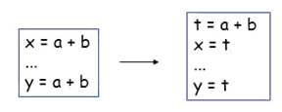

5. TOOLS USED
5.1 INTRODUCTION TO CCCC
It is a device for examining the source code where C++ is used at coding language and after examine generates a HTML report to diversify the outlined of the examined code. It was first promoted to examine C++ and ANSI C which changes today scenario to examine Java source code and records and many variations where provided by Ada95. The name CCCC stands for 'C and C++ Code Counter'. Assumptions and approximations of coding language are generally called as programming Estimations or also defined as its measurement .The minimizing complex structure help its platform running and name of its decision of records as
cccc my_types.h big.h small.h *.cc
It’s a free ware and source coding the structure released in source. Users may ask to join the company and change the coding and reflect their interest and variations.
CCCC will take an instance of big filename and its development will be explained by the compiling language and if it is supported easily than will run on the record. The HTML report which is examined and then parsed cross check the confirmation of database values for implementation of forms and report to be produced in the end. When the entire records will be placed in correct way than the database confirmation will lead to making of HTML report. The Summarization of HTML report is delivered on the user end by record cccc.html by internal directory called .cccc of the currently working registry, which also include the ordering HTML reports within all present modules examined and checked by compiler at run time. Also, the reports will run implementing the summaries and point to point evaluation of reports in association with XML and implementing the further division and database to be made Archive called cccc.db to be made.
The report contains distinctive tables seeing the modules in the records submitted and covering:
• Measures of the capacities and the volumes and scattering every module and its internal abilities.
• Measures of the suppliers and customers its events and it’s all modules associations and numbers and relations internally.
• Identification of neglected structure which were not parsed and their coeds were submitted.
• A summary report of the entire mixed bag of coding language dealt with the measures perceived. A section of the information displayed in the summary may be shown in an visible structure. These are things which have been seen as lying outside degrees. An in number abstract style or red foundation displays a quality which surpasses a most remote point depicted as being dangerous for that measure, while italic printed styles and yellow foundations show values underneath the danger edge yet meanwhile over a second lower edge which has been set down to show clarification behind concern.
5.2 METRIC DISPLAYED
The measurements showed are
•LOC
•COM
•L_C,M_C
•Fan-Out,Fan-In
•NOM (Number of Modules)
•WMC (Weighted techniques per class )

- SOFTWARE TESTING :

Testing and coding are securely attached parts of programming. We get the best results with analyzers and developers work firmly together.

6.1 Driving Development with Tests :All through this procedure, one or more analyzers will cooperate with one or more software engineers to compose tests, compose code, compose more tests, compose more code, test some all the more, the same number of modest cycles as required until the proper business worth is accomplished.

6.2 Evaluate Risk : Regardless of the amount of time we have for testing programming, we can simply utilize it up and wish for additional. We never have enough time, and short cycles of deft improvement add to the test. Some fast hazard investigation will help you choose where to center you're trying endeavors.

6.3 Little Chunks, Thin Slices : "Incremental and iterative" is the name of the amusement when you need to convey esteem every now and again, keeping up a reasonable pace.

6.4 Knowing When We're Done :When coding is done, we for the most part have Fitness tests covering all the usefulness, including edge cases and limit conditions. We've investigated the usefulness of each "dainty cut" or "little piece". Presently we need to figure out how the completed component functions, so we do end-to-end exploratory testing. We may utilize computerized scripts to help set up test information or situations, however predominantly we're utilizing our heads, eyes, ears and instinct to verify that this a piece of the item will charm the client.

Amid this post-advancement testing, we may understand that in spite of the fact that we have conveyed the exact client necessities, our element may be inadequate in ease of use, execution, security or some other part of value. We may find that the new code affects some other piece of the application in a sudden way. We may alter this immediately, or compose new stories to be done next cycle.

6.5 Cooperating :When we separate our work into little, reasonable pieces, plan and behavior testing and coding as a feature of a solitary improvement process, and concentrate on completing one lump of profitable usefulness at once, testing doesn't get crushed to the end, put off to a future cycle, or disregarded out and out. I've seen this demonstrated out on an assortment of groups - like most realistic, sound judgment approaches, it lives up to expectations.

Get your group together today and discuss how you can all - analyzers, developers and other people included with conveying the product - cooperate to incorporate coding and testing. Rather than putting resources into a major prerequisites archive, catch necessities and samples of coveted application conduct in executable tests, and compose the code that will make those pass. Meet with your business partners to comprehend their needs and clarify the amount of work you can practically tackle every cycle. Quit regarding coding and testing as discrete exercises.

- FUTURE SCOPE

As a part of the current research, a working CCCC tool is used and its performance was tested. However there is scope for future research to improve the performance We are planning to make a platform which will give suggestion for code optimization and will optimize code on above methodologies and these methodologies will focus on time complexity of compiler . Time needs to be reduced in these algorithm and which will help in testing the software performance and then with these methodologies we will test our software completely on the basis of its code. As code and testing go hand in hand we will attain a better software performance and better coded platform.

EXPECTED RESULT
The tools used CCCC is an automatic framework for building the HTML report for optimizing the code written in C. The user can simply implement the data structure to use and form a better code which is optimized in C.The real world applications are implemented in this framework is targeted to implement in optimization of code and The Developers can implemented to focus on codes and its optimization

References

- Mr. Chirag H. Bhatt, Dr. Harshad B. Bhadka, “Peephole Optimization Technique for analysis and review of Compile Design and Construction”, IOSR Journal of Computer Engineering (IOSR-JCE), Volume 9, Issue 4 (Mar. - Apr. 2013).

- C. Brandolese, W. Fornaciari, F. Salice, D. Sciuto, “Source–Level Execution Time Estimation of C Programs”,Proceedings of the ninth international symposium on Hardware/software code design.

- Maggie Johnson, “Code Optimization”, Handout 20 “August 08, 2004.

- Michael E. Lee, “Optimization of Computer Programs in C ”, Ontek Corporation, USA “Code Optimization” article available at http://www.viva64.com/en/t/0084/

- “Optimizing C and C++ code” available at http://www.eventhelix.com/realtimemantra/basics/optimizingcandcppcode.htm#.VCpsxf mSyFM

- Tips for Optimizing C/C++ Code” available at http://people.cs.clemson.edu/~dhouse/courses/405/papers/optimiz pdf

- “Writing Efficient C and C Code Optimization” article at http://www.codeproject.com/Articles/6154/Writing-Efficient-C-and-C-Code- Optimization

- “Optimization Techniques in C”, Fall, 2013. http://cs.brown.edu/courses/cs033/docs/guides/c_optimization_notes.pdf

- Mohammed Fadle Abdulla, “Manual and Fast C Code Optimization”, Anale. Seria

Informatica. Vol. VIII fasc. I-2010.

- “Optimizing C++/ Code Optimization/ Faster operations” available at
http://en.wikibooks.org/wiki/Optimizing_C%2B%2B/Code_optimization/Faster_operatio ns.

- “Research on code optimization when develop highway network monitoring software based on Trimedia” available at http://ieeexplore.ieee.org/xpl/login.jsp?tp=&arnumber=6843485&url=http%3A%2F%2Fi eeexplore.ieee.org%2Fxpls%2Fabs_all.jsp%3Farnumber%3D6843485

- “Continuous Compilation: A New Approach to Aggressive and Adaptive Code
Transformation” available at http://ieeexplore.ieee.org/xpl/login.jsp?tp=&arnumber=1213375&url=http%3A%2F%2Fi eeexplore.ieee.org%2Fxpls%2Fabs_all.jsp%3Farnumber%3D1213375\

- “CCCC User Guide” available at http://www.stderr.org/doc/cccc/CCCC%20User%20Guide.html

 

