Abstract—the most common method used to protect the intellectual property rights of videos is ‘Video Watermarking’, where the watermark can be perceptual or non-perceptual. The aim of this research is to develop a strong watermarking algorithm for a video output and in addition to provide an algorithm that is adaptive so that under no circumstance dropping of the watermark takes place either by cropping, re-scaling or frame dropping. The algorithm deals with selection of random frames to minimize the noise and to maintain robustness, and selection the best position to place watermark and maintaining the transparency to ensure the perceptual quality (unobtrusiveness).
Robust Adaptive Watermarking in Video for protecting Intellectual Properties
Uma Tiwari  Faculty of Technology  Uttrakhand Technical University  Dehradun , India  umatiwari68@gmail.com | Pawan Kumar Mishra  Faculty of Technology  Uttrakhand Technical University  Dehradun , India  pawantechno@rediffmail.com

.

INTRODUCTION
IN today’s digital age, our daily life is filled with digital multimedia content as one of the basic means for communication. As a matter of fact, it is extremely easy to create, store, transmit and process information in a digital format with the help of a wide array of low-cost cameras, computers and user-friendly editing tools. Apart from being economical and technologically advanced, the digital revolution has led to a lot of problematic issues related to multimedia security and reliability.
Therefore, it is highly paramount to be able to provide protection to digital content in order to guarantee its truthfulness, it being genuine and its security without manual intervention. The scientific & technology community has been very active in order to tackle this issue, coming up with sophisticated and accurate methods for authentication and protection of digital media.
The research field aimed at gathering information on the history of an image in order to evaluate the veracity of the image is called Digital Image Forensics. For instance, this task is fulfilled by providing answers to questions like the:
- Was an image acquired by the device it is claimed to be captured with?
- Is the scene that is being depicted still the original one?
The film industry covers the most part of digital world for enhancement of video exploitation technology. Through the ease with which video editing technology that is currently available, manipulating professionals can easily remove an item from a sequence of video, and can insert any item from a different video source into it, or even insert any graphic created by computer software to completely change the message or idea behind the original video. Undoubtedly, the advanced video editing technology has significantly enhanced our visual understanding though these methods become more and more popular to the public, unwanted editing with video recordings is emerging as a serious challenge.
Digital watermarking is the procedure of embedding information (watermark) into digital content (image, video or audio); possibly in an imperceptible way ensuring that the quality of the content is not reduced. Such embedded information can be extracted or detected at a later stage for various purposes; including ownership proof, tamper detection and access control.
The constant growth of video tampering cases is creating a brunt among people. Although only a few people are exposed for forgery, many of them are not even found /traced & reach the society resulting in eroding public trust in any video. Therefore, it is of outmost importance for the scientific community to come up with methods for verifying video recordings.

PROPOSED ALGORITHM
The robust adaptive watermarking in video for protecting intellectual properties system algorithm consist of two modules for three different approaches, first module deals with selecting a random frame for placing watermark, second module deals with finding the most suitable location to place the watermark that can be visible or invisible, and the last module helps in varying the value of transparency of watermark to maintain the sensitivity of the underside region to protect the content and to avoid the degradation of image quality.
As we know a Video signal is a sequence of frames of image, the insertion of watermark into these frames leads to the process of watermarking in video. Modifying the pixels luminance value helps in inserting the watermark into the frame. In this case, we deal with two problems: first is to discover the finest location inside the host video frame to apply a watermark that can be visible or invisible that posses a significantly lower dimension than the frame itself. That “finest” location should follow the conditions given below:
The region should be not too detailed or it should be not excessively uniform, as watermark can obscured all the details beneath it or it would be easy to avoid a simple removal of watermark by substituting its background color.
Three algorithms are proposed for this method. First the frame selection algorithm, second the watermark positioning algorithm and third the transparency maintenance algorithm.

Frame selection algorithm
A counter system is used for the block-based usage to support the video watermark position that will change overtime. A counter is assigned for every block in a video frame; each block is called as video shot. The random number of frames is selected in ascending order from a shot (block of frames). Once the frames are selected, we can apply the other algorithms on that frame i.e. to decide the position and to decide the opacity of the watermark. In the starting of video, all counters are set to zero. In our algorithm, we have set the size of each shot equal to 20, so that the robust adaptive watermarking algorithm has to be repeated after every 20 frames.

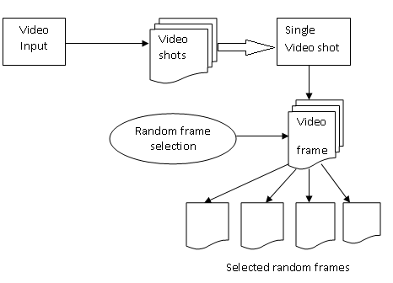

Fig. 1. Block diagram for the frame selection algorithm.

Watermark positioning algorithm
The method for positioning that we used is based on the thought of inserting the watermark over the lowest pixel region that has variance greater than a threshold selected to avoid uniform region part. For the watermark, a binary mask of same dimensions is constructed first, then the host image frame is convoluted with that mask to calculate the pixel variation over the mask and then the position for insertion is selected as the point that has the lowest variance over a fixed threshold. It is observed that variance is not a major issue if calculated on a bigger area or over major region. Therefore, the evaluation of local computation of the quantity of intensity is decided for variation within the host frame, and then the region with the lowest mean value has been selected.
A simple way to express the threshold variation in pixels of image frame is to calculate the amount of variation between the highest value of pixel and the lowest pixel value inside a moving window of n x n pixels. The result of that is called the “spread image” denoted by S, and is convolved to the watermark mask denoted by W that helps in the calculation of the mean value of S spread. The above discussed operation is bringing down in the Fourier domain. After that the best fitted region is selected for the location that has the lowest intensity (with respect to the threshold).
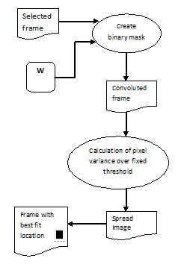

Fig. 2. Block diagram for the watermark positioning algorithm.

We can insert the watermark in both black & white and colored images as the positioning method works using the luminance channel and the insertion is performed into the selected space, no matters whether it is colored or monochrome.

Watermark visibility algorithm
One of the approaches for this is to blend the watermark with the video this allow all the content below the watermark to be partially visible. The proposed algorithm adaptively adjusts the transparency level of the watermark based on the contract between the watermark and the host video. This process is performed as frequently as the watermark positioning process. And is repeated every time the frame is selected and the position is found. We have used a method called ‘layer blend’ mode for inserting the watermark in the host image. The ‘overlay layer’ blend mode and the ‘hard light layer’ blend mode methods are coupled with an stamped version on the watermark to multiply and display a pixel color value: ‘overlay’ blend used for the base color as it is dependent on it, and the ‘hard light’ blend used for the color of the watermark, this type of blending of texture with pure white color or black color results in pure monochrome.
Here i denote a point in the host frame image and w is a point in the watermark image, i and w are both floating point values that lies between 0 and 1 (for black and white), the overlay blend mode and hard light blend mode formulas are as follows:
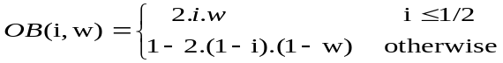 (1)
 (2)

The ‘overlay blend’ mode is responsible for making the watermark more alluring yet less distracting in the uniform image frame. Using the ‘hard light’ blend mode, the watermark obstructs the view of the frame, but it is more evident if placed in a high textured location. We can reduce the opacity to improve the blending.

experimental results
In this thesis, we have deal with the issue of adaptive positioning a Watermark into a video for protecting the copyrights of intellectual property. The role of our approach is the proposal of applying an adaptive positioning method to preserve as much as possible the information and details of the host video frames and, in the same time, it makes the watermark uneasy to remove The algorithm adjusts the position and also adjusts the opacity level of the watermark based on inter-frame relationships, perceptual content activity, and disparity/contrast. The Experimental results show the efficiency and usefulness of the proposed method at maintaining a great balance between the perceptual quality and the clarity of the watermark. So, it is understood that we can use this proposed method productively for the placement of watermarks in video shots.

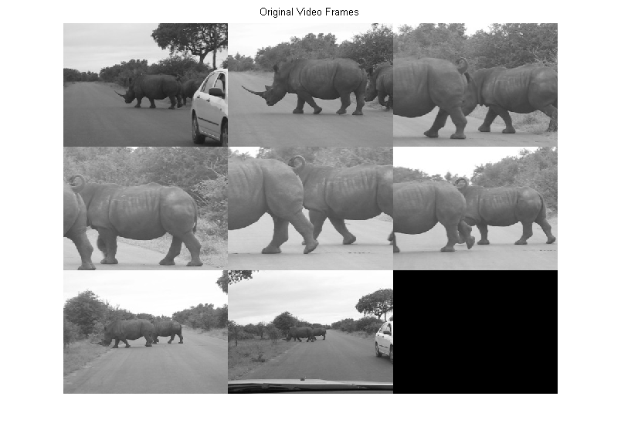
Fig. 3. Original randomly selected video frame from a single shot.

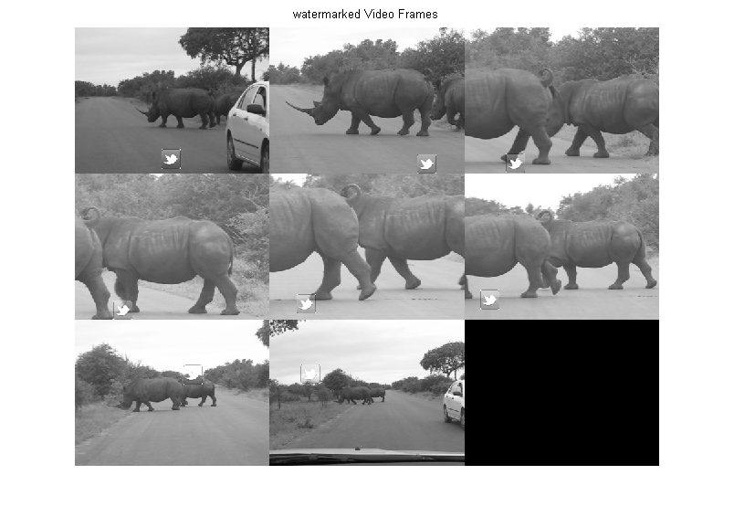
Fig. 4. Watermarked frames from a shot using robust adaptive watermarking algorithm.

conclusion
In our work, we have used fixed size watermark image for each and every of the video shot and its frame. Our robust adaptive algorithm efficiently ensures the visibility of the watermark, by finding a location that is not too detailed also not excessively uniform, to avoid the obscuring of detail under the watermark. It would be easy to avoid a simple removal of watermark by just substituting its background color. Also this algorithm maintains the quality by applying the watermarking only to the selected video frames.
This method avoids the embedding of the watermark into a detailed region, that is sensitive to changes. In the future work, we can try to work towards a better and more robust method in which the length of the video shot will be vigorously determined by some measure between successive frames based on some similarity.
References
- Bender, W., Gruhl, D., and Morimoto, N., “Techniques for data hiding”, in Proceedings of the SPIE - The International Society for Optical Engineering, vol. 2420, (San Jose, CA, USA), pp. 164–173, February 1995.
- Boland, F. M., O’Ruanaidh, J. J. K., and Dautzenberg, C., “Watermarking digital images for copyright protection,” in Proceedings of International Conference on Image Processing and its Applications, vol. 410, (Edinburgh, UK), pp. 326–330, July 1995.
- Cox, I. J., Kilian, J., Leighton, F. T., and Shamoon, T., “Secure spread spectrum watermarking for multimedia,” IEEE Transactions on Image Processing, vol. 6, pp. 1673–1687, December 1997.
- Burgett, S., Koch, E., and Zhao, J., “Copyright labeling of digitized image data,” IEEE Communications Magazine, vol. 36, pp. 94–100, March 1998.
- Chen, B. and Wornell, G. W., “Quantization index modulation: A class of provably good methods for digital watermarking and information embedding,” IEEE Transactions on Information Theory, vol. 47, pp. 1423–1443, May 2001.
- Alattar, A. M., Lin, E. T., and Celik, M. U., “Digital watermarking of low bit rate advanced simple profile MPEG-4 compressed video,” IEEE Transaction on Circuits and Systems for Video Technology, vol. 13, pp. 787–800, August 2003.
- Agarwal, P.; Choudhary, A. "Protecting video data through watermarking: A comprehensive study", Confluence the Next Generation Information Technology Summit (Confluence), 2014 5th International Conference, Advances in Web Intelligence Volume 3034, 2004
- Huang, X. and Zhang, B., “Robust detection of transform domain additive watermarks,” in Proceedings of Digital Watermarking 4th International Workshop (IWDW), vol. 3710, (Siena, Italy), pp. 124–138, September 2005.
- Sadik Ali M. Al-Taweel, Putra Sumari, Saleh Ali K. Alomari and Anas, “Digital Video Watermarking in the Discrete Cosine Transform Domain”. Journal of Computer Science 5 (8): 536-543, 2009 ISSN 1549-3636 © 2009 Science Publications.
- Wong, A. and Bishop, W., “Practical Perceptually Adaptive Approach to Video Logo Placement in TV Broadcasts,” IEEE Transactions on Multimedia, vol. 7, pp. 52–66, February 2007.
- Raymond B. Wolfgang, Christine I. Podilchuk, and Edward J. Delp, “Perceptual Watermarks for Digital Images and Video”, Video and Image Processing Laboratory (VIPER) School of Electrical and Computer Engineering Purdue University West Lafayette, Indiana USA, Bell Laboratories Lucent Technologies Murray Hill, New Jersey USA, 2010.
- Pankaj U.Lande ,Sanjay N. Talbar, G.N. Shinde, “ Robust Image Adaptive Watermarking Using Fuzzy Logic An FPGA Approach”, International Journal of Signal Processing, Image Processing and Pattern Recognition Processing and Pattern Recognition Vol. 3, No. 4, December, 2010
- Yusuf Perwej , Firoj Parwej , Asif Perwej,” An Adaptive Watermarking Technique for the copyright of digital images and Digital Image Protection”, The International Journal of Multimedia & Its Applications (IJMA) Vol.4, No.2, April 2012
- Bo Tao, Brad ley, Dickinson, “Adaptive Watermarking In The DCT Domain”, Department of Electrical Engineering Princeton University, Princeton, NJ, http://citeseerx.ist.psu.edu/ , Jan 2013.
- Krishna, Pratikh, “An Adaptive blind video watermarking technique based on SD-BPSO and DWT-SVD” Dept. Electron. & Comm., IEEE ,Jan. 2013.
- Beatriz Corona-Ramirez, Mariko Nakano-Miyatake, Hector Perez-Meana,” Adaptive Watermarking Algorithm for Binary Image Watermarks”, IEEE, 2013
- Hoda Farag Ibrahim Farag , Said E. El-KhamyEngineer, “Adaptve Video Watermarking Key Based on MultibandDWT & DCT & SVD”Proceedings of the International Conference on Computer Graphics, Multimedia and Image Processing, Kuala Lumpur, Malaysia, 2014.

- W. Lumini and D. Maio, “Adaptive positioning of a visible watermark in a digital image,” Proceedings of the IEEE International Conference on Multimedia and Expo, vol. 2, pp. 27-30, 2004.
- Zhu Yuefeng and Lin Li , Hefei university of technology, Kaifeng university, china, “Digital image watermarking algorithms based on dual transform domain and self-recovery”, International Journal on Smart Sensing and Intelligent Systems vol. 8, no. 1, March 2015.

 

