Business Strategy Prediction System for Market BasketAnalysis
Sumit Jain1, Nand Kishore Sharma2, Sanket Gupta3 NitikaDoohan4SCSIT-DAVV Indore1, ATC Indore2/3 ,MediCapsIndore
sumitjain1679@gmail.com1, er.nksharma.mtechcs@gmail.com2,
sanket.jec@gmail.com3, nitika.doohan@gmail.com

Abstract: - As per the today’s scenario the current technology of modern trend is required to improve the performance by minimum effort. To find more valuable items and extracting precious information for industry people from large dataset efficiently that containing sales transactions (for example, collections of items bought by customers, or details of a website frequentation). We are proposing novel approach Business Strategy Prediction System for Market Basket Analysis. It is to find that all existing algorithms are working to find the minimal frequent item set first but here with the help of those methods we are finding the maximal item set, When this algorithm encountered on dense data which having the large numbers of long patterns emerge that will give the more accurate and effective result which specify all of the frequent item sets.

Keyword: Business Strategy Prediction System, Market Basket Analysis, Performance Result

Introduction
In current scenario, Computer is more popular with development of database technology; their large numbers of data are stored in huge amount of database. Obviously, this is very useful information without using efficient methods is impossible to obtain. Data mining is one of the technology has seemed as a reflection of the demand. AssociationRules Mining is the one of the important research, its main aim to find out the requirement between various fields based on support and reliability. So many examples are available such as market basket analysis.
Association rules mining process is classified into two phase. The first is to find the frequent item sets. Frequent item set analysis is a data analysis and this technique is to discovers co-occurrence relationships among activities that are performed by (or recorded about) specific individuals or groups of individual. Second phase is to produce the instructions from the frequent item sets and often is an important step in terms of acquisition of set items Mining Association Rules of Procedure. The analysis of association’s rules and frequent item sets can help retailers develop marketing strategies by gaining insight into which items are frequently purchased together by buyer. Market basket analysis may help managers optimize different store layouts [9].If customers who purchase copy also tend to buy pen at the sometime, then placing the copy close or opposite open may help to increase the sales of both of these items.
Currently, the association rules mining problems are excessive valued by examiners in the various field such as database, artificialintelligence, information retrieval, visualization, informatics, and so many other fields. The so many unbelievable results have been found in this process. Mining association rules have problems from large database has become the most mature, important, and active research contents.
The paper is organized as follows: Related works in the Market Basket Analysis are reviewed in Section 2; Market Basket Analysis Approach are described in Section 3; System Architecture of business strategy prediction system are described in Section 4; Experiment Analysis are described in Section 5; Performance Result are described in Section 6; Limitation and Future scope are describe in Section 7 and 8; Conclusions and future work are given in Section 9.

- Related Work
Association rules are set of statements witch in the form of {X1,X2….Xn}→Y , meaning that when we find all of statement X1,X2….Xn in the market basket, after calculation all the set of X then we can find Y. We typically were finding merely the rules which are confidence on given threshold value. If items are placed into baskets in random order, then result in terms of higher the confidence significantly.

The Market research is the frame work activity that will work as an umbrella activity that links the consumers and end users directly to the market it is done only through information which is used to recognize and explore marketing prospect and their problems. Aim of research is to balance the producer, consumer problem i.e. sell, relationship, demand, availability and facility to find the useful item in short time duration in today's fast life, finally this balance proves beneficial for all i.e. end user and producer, retailer those are the key part of market. So Marketing research specifies the required information to deal with these issues, designs the method for collecting information, manages and implements the data collection to understand the market and overcome the all deficiencies for proper tuning between the end user and market[1][2].
This frame work activity is the systematic gathering, recording, and analysis of qualitative and quantitative data about issues that relating to running products in the market and services provided by them. The marketing research is mainly focus to identify and assess how and what changing elements of the marketing mix impacts consumer's behavior. The term is commonly interchanged with market research. Marketing research is concerned specifically about marketing processes that drastically improve the sells with consumers satisfaction [3].
To maintain the proper balancing between the all key factors which are related directly and indirectly with market,we need to find out the requirement and think as like consumers and on the basis of that result we have to find out the data and arrange them in fruit full manner. So Here Apriori algorithm is used for generating frequent item sets based on some rules from the large database. These Association rules are one of the major techniques of data mining.In this fast world due to heavy demand the volume of data is increasing day by day [4][5]. Hence we need to sort out that data,therefore,the mining association rules are work on the databases and collect the frequent item sets from massive amount of database,That's why many marketers interested in that part which help in many decision making processes, such as basket data analysis, retails sectors deciding store layout and making promotional strategies.
It helps to find the relationship among the large number of database items.the customer purchasing behavior is depend on the product's order ,their grouping,their arrangement and layout of store.On the basis that criteria for sales transaction we have to find some effective rules, such as the sell of other goods is depend on the buying of certain kind of goods and its reflects the customer's purchasing [6]. These generated rules can be used in many fields, such as analysis of consumer's need and their shopping, additional sales, goods shelves design, storage planning and classifying the users according to the buying patterns or vice versa etc. Apriori algorithm has sound theory base, but the focus is its efficient issue [7][8].

Market Basket Analysis Approach
A typical example of Apriori algorithm uses is market basket analysis. This process analyses customer-buying habits by finding relations among the different items that customers place in their shopping baskets. The discovery of such relation can help retailers to develop marketing strategies by gaining insight into which items are frequently purchased together by customers. Market basket analysis may help managers optimize different store layouts.
A typical example of use of Apriori algorithm is market basket analysis. This process analyses customer buying habits by finding relations among the different items that customers place in their shopping baskets. The discovery of such relation can help retailers develop marketing strategies by gaining insight into which itemsarefrequently purchased together by customers. Market basket analysis may help managers optimize differentstorelayouts.

- System Architecture of business strategy prediction system.
It describes the architecture for a system to satisfy specified requirements in Fig 1.
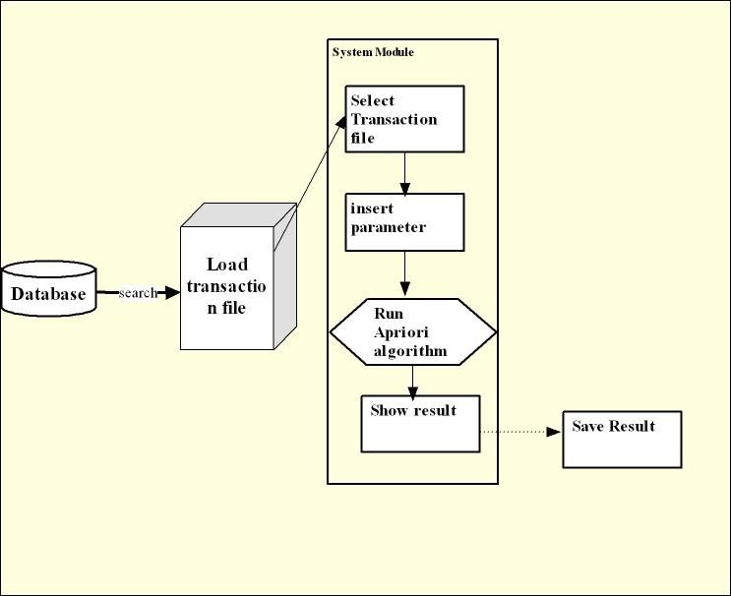

Fig 1: System architecture of business strategy prediction system.

Load Transactionfile
In this case, first all transaction file resides in the same system in which we run the software. Its database is maintained by the MySQL. This type of transaction file should be or needs to be loaded for further processing. The file is loaded & shown by searching it through name.

Select Transactionfile
User needs to enter the name of transaction file required from database. In that case user will first select the file as per the requirement. The selected file will be usedbyalgorithm when user clicks “Run Algorithm”button.

InsertParameter
For running the algorithm we should write the name of the selected transaction file in the field from transaction file name. Thenusers also need toenterparametervaluei.e.minimumsupport.Whenthis parameter issetthenuserwillrun algorithm over the selected file from database by clicking “run algorithm”button. Then user will give the name of output file in which you want to save the result. In case result file will not be displayed it means you need to increase the value of minimum support.

Show& SaveResult
This module will show final frequent item-sets as result of market basket analysis. These rules are then used by sales executive or any business analyst to predict business strategy for earning profit.

4.1 Activity Diagram
It will show the activity diagram of business strategy predictionsystem
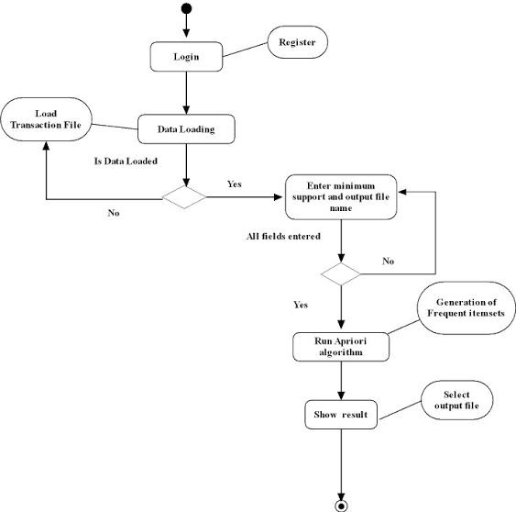

Fig 2: Activity Diagram of business strategy predictionsystem

4.2 Algorithms for business strategy prediction system

Algorithms Design
- Combining Step: Ck is generated by joining
- Lk-1with itself
- Prune Step Any (k-1)-item set that is not frequent cannot be a subset of a frequent k-item set
- Code: Ck: Candidate item set of size k
- Lk: frequent item set of size k
- L1 = {frequent items};

- For (K = 1; Lk! =∅; k++) do begin
- Ck+1= candidates generated from Lk;
- for each transaction t in database do
- increase the count of all candidates in Ck+1
- that are contained in t
- Lk+1= candidates in
- Ck+1with min_support
- end return ∪k Lk;

5 Experiment Analysis
By the proposed method, it will takes less time to find maximal frequent itemsets. This screen shot consists of 13 transactions of 9 items as input, this item set give results as most maximal frequent item set. The output results are given in the form of screenshots as follows.
- It is the first page of Business Strategy Prediction System. Where we click on start button and the system will get started.
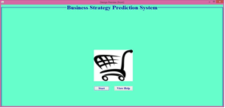
- Click on view help button to proceed. You can go back to login page after reading the help manual.
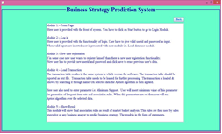
- To enter a valid username and password.
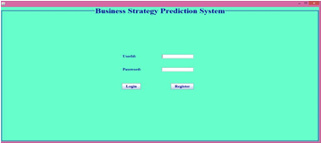

- View Load Transaction file module. Just click on load button you will be redirected to the selection menu for the file just go to the path where file is saved on your computer select it and click on open. . The selected file will get loaded like this
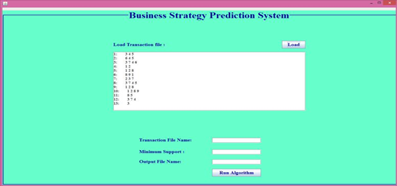
- For running the algorithm please write the name of the selected transaction file in the field transaction file name. After this enter the minimum support value desirable for your strategy. Then give the name of output file in which you want to save the result. In case result file will not be displayed it means you need to increase the value of minimum support.
- Clicking on show button will make you select the output file you just need to select it and open the result will be displayed in the frequent rules frame and the corresponding references will be displayed in another frame.
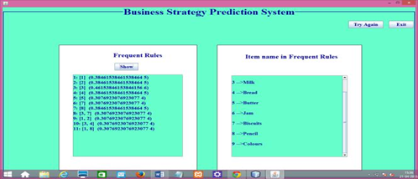

Example

An Apriori algorithm is used in market basket analysis. This process analyses customer-buying habits by finding relations among the different items that customers place in their shopping baskets. The discovery of such relation can help retailers develop marketing strategies by gaining insight into which items are frequently purchased together by customers. For instance, market basket analysis may help managers optimize different store layouts. If customers who purchase milk also tend to buy bread at the same time, then placing the milk close or opposite to bread may help to increase the sales of both of these items. The sample data contains six products bought in 10 transactions:

 | Transactions |  | Items
 | T1 | 3 | 4 | 5
 | T2 | 6 | 4 | 5
 | T3 | 3 | 7 | 4 | 6
 | T4 | 1 | 2
 | T5 | 1 | 2 | 8
 | T6 | 8 | 9 | 1
 | T7 | 2 | 3 | 7
 | T8 | 3 | 7 | 4 | 5
 | T9 | 1 | 2 | 8
 | T10 | 1 | 2 | 8 | 9
 | T11 | 8 | 5
 | T12 | 3 | 7 | 4
 | T13 |  |  |  | 3
The Business Strategy Prediction System scans the transaction to see which items are bought together frequently.
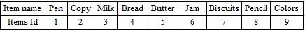

To do this the transaction are analysed to calculate:

N:- total number of transactions;
Xij:- total number of transactions in which i and j are bought together;

From this measures support is calculated using Apriori Algorithm.
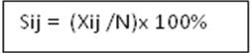

The table is shows the different items and their support, this items having support with 20% or above are bought frequently if the minimum support given is 20%.
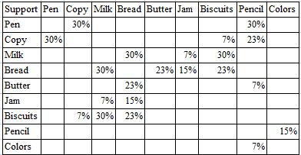

- Performance Result
These experiments were performed with the help of market basket analysis. In this section system will performed with the different parameter are used for estimating the model and their obtain result are shown in the form of time complexity and space complexity graph. Our method gives efficient result on all frequent itemsets generated by market basket analysis approach.
Time complexity
The quantity of time essential for execution of algorithm with the input data is termed as time complexity of the system. Both time slice show to graph they are based on number of transaction and number of itemsets. In both the case, giving the obtained results the time is also increases as the number of samples are increases in database.
The following fig 3 shows the time Vs number of transaction. Where X-axis shows the number of transaction and Y-axis show the amount of time in millisecond.
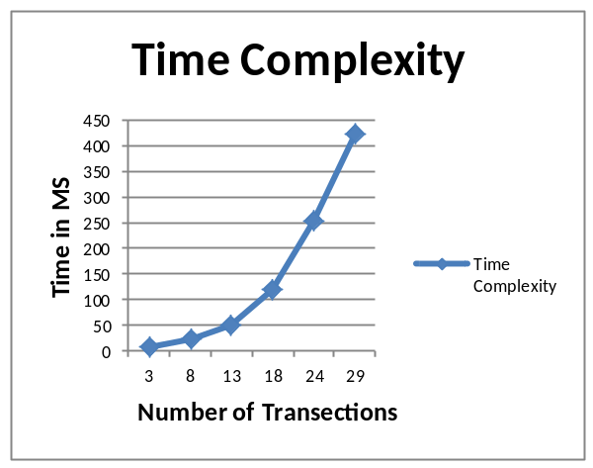
Fig 3: Time in terms of millisecond Vs. number of transaction

The following fig 4 shows the time Vs number of itemsets. Where X-axis shows the number of itemsets and Y-axis show the amount of time in millisecond.
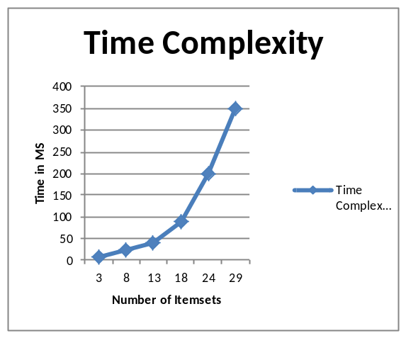
Fig 4: Time in terms of millisecond Vs. number of itemsets

Space complexity
In this case memory is misused by an algorithm at many places. It includes both extra space or temporary space and space used by input. Both time slice show to graph they are based on number of transaction and number of itemsets. According to the given results the memory consumption of the algorithm increases as the number of samples in database increases.
The following fig 5 shows the time Vs number of transaction. Where X-axis shows the number of transaction and Y-axis show the amount of memory.
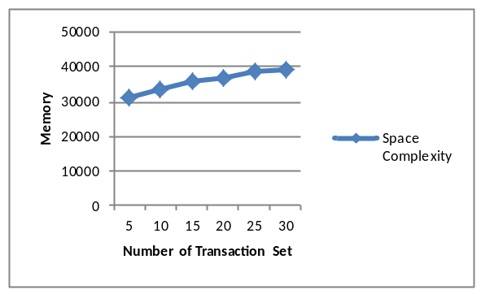
Fig 5: Memory Vs. Number of Transaction

The following fig 7 shows the time Vs number of transaction. Where X-axis shows the number of itemsets and Y-axis show the amount of memory.
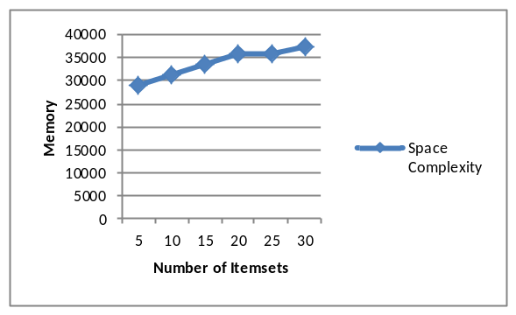
Fig 6: Memory Vs. Number of Itemsets

- Limitation

This system in only desktop application and is used by only single user at a time. This is specifically designed for business strategy. Transactions of any business should be in proper format i.e. it should be in transactional database, if it is non-transactional it needed to be converted into transactional database first.

- Future Scope

This can be applied to the mining of association rules in a large centralized database by partitioning the databaseto the nodes of a distributed system as here we are focusing on the single database. This is particularly useful if the data set is too large for data mining. It can be enhanced by deploying it on cloud so that it can work on different data sets.It will provide:

- A better access to the product.
- A better way to find the business strategies to help the businesses.

- It will be accessible to all due to deployment on cloud.
- It can work for large data sets.

- Conclusion

The “Business Strategy Prediction System” provides a better way of analyzing the behavior of the customer for making a better business strategy. It makes use of the frequent item sets which makes frequent data sets which are helpful for analyzing the purchasing behavior of customers. We have generated market basket analysis computed the results in the form of time complexity and space complexity.
Further we can elaborate this approach and remove all the complexity they are coming in the performance.

References
- WEI Yong-qing, YANG Ren-hua, LIU Pei-yu, ”An Improved Apriori Algorithm for Association Rules of Mining” IEEE(2009)
- Zhuang Chen, Shibang CAI, Qiulin Song and Chonglai Zhu, “An
Improved Apriori Algorithm Based on Pruning Optimization and
Transaction Reduction”, IEEE 2011.
[3] Rui Chang, Zhiyi Liu, “An Improved Apriori Algorithm”, 2011 International Conference on Electronics and Optoelectronics (ICEOE 2011)

[4] Huiying Wang, Xiangwei Liu, “The Research of Improved Association Rules Mining Apriori Algorithm” 2011 Eighth International Conference on Fuzzy Systems and Knowledge Discovery (FSKD).

[5] J. Han and M. Kamber, Conception and Technology of Data Mining, Beijing: China Machine Press, 2007.
[6] J. N. Wong, translated, Tutorials of Data Mining. Beijing. Tsinghua University Press, 2003.
[7] Y. Yuan, C. Yang, Y. Huang, and D. Mining, And the Optimization Technology nd Its Application. Beijing. Science Press, 2007.

[8] Y. S. Kon and N. Rounteren, “Rare association rule mining and knowledge discovery:technologies for frequent and critical event detection. H ERSHEY,” PA: Information Science Reference, 2010

[9] W. Sun, M. Pan, and Y. Qiang, “Inproved association rule mining method based on t statistical,” Application Research of Computers. vol.28, no. 6, pp. 2073-2076, Jun, 2011

