Application of GSA optimized PI controller parameters in automatic generation control for interconnected power system

Pratap Chandra Nayak¹
Department of Electrical Engineering
C.V. Raman College of Engineering
Bhubaneswar, Odisha, India
e-mail-pratapc.nayak@gmail.com

Sangram Keshari Mohapatra²
Department of Electrical Engineering
C.V. Raman College of Engineering
Bhubaneswar, Odisha, India
e-mail-sangram_muna@rediffmail.com

Abstract—Gravitational search algorithm (GSA) based Proportional-Integral (PI) controller for Automatic Generation Control (AGC) of an interconnected power system are analyzed the performance of the proposed two area non-reheat thermal system. GSA optimization employed to search for optimization controller parameters by minimizing the objective function. The objective function uses Integral Time multiply Absolute Error (ITAE) in order to increase the performance of the controller. The performance of the proposed PI controller is compared by tuning the GSA technique and best controller is compared to GA optimized PI controller over wide range of operating condition and change in system parameter.
Keywords-load frequency control, proportional-integral controller;gravitational search algorithm;automatic generation control

Introduction
The interconnected large power system generally consists of different control areas and the system frequency and tie line power remain constant for stable operation of the system .The automatic generation control (AGC) necessary to calculate area control error (ACE) and monitor the system frequency and tie line power flows to computes the net change in the generation required such that the time average of ACE at a low value [1-5].The ACE is linear combination of power net interchange and frequency deviation taken as controlled output of AGC.[6].The main function of AGC supervisory control function which attempts to match the generation trend within an area to randomly changing the load of the area keeping the system frequency and tie line power flow close to the scheduled value. Due to growth and increases the complexity of the power system with increasing the power demand, it is necessary to use intelligent system and various control techniques for the real time control the power system. The literature survey shows that the systems considered for AGC of single area hydro, single area thermal, two area thermal, two area thermal-hydro with different controller are analyzed [7, 8].Very less attention are given to the AGC of thermal system with reheat types turbines .The various types of load frequency controller are discuss with most widely conventional PI controller employed [9,10].Those the conventional controller are very simple but it take large time and highly oscillatory. The Tabu Search based algorithm for optimal design of a Fuzzy Logic based proportional integral load frequency control in a two area interconnected power system is presented [11].In order to getting the dynamic performances the number of control techniques has been employed for load frequency control in different interconnected power system by considering step load perturbation in single area as well as simultaneous of the two area. In the literature the various types of optimization techniques can be proposed and tested for comparative performance study. The research has been attempt AGC system with based on the modern control theory [12], neural network [13], Fuzzy logic [14, 15], ANFIS approach [16].The Gravitational Search Algorithm (GSA) is one of the newest heuristic optimization techniques which have been inspired by Newton’s law of gravity [17]. In this paper the optimal design of GSA based PI controller for load frequency control in two area interconnected power system is considered. The design problem is formulated as optimization problem and GSA is applied to tuning the controller parameters. The design of objective function is minimized to improve the system performance in terms of settling time and overshoot of frequency deviation and tie lie power of the interconnected power system. The simulation result of the proposed analysis to show the robustness of GSA based PI controller under wide ranges of the system parameters. The proposed design approach also compared the simulation of recently published paper GA based optimization techniques for load frequency control of interconnected power system [19].

System Modeel

Two area Power System
The AGC system investigation consists of interconnected two non reheat thermal plant having two area of equal sizes as shown in fig-1.In Fig-1 Δf1 andΔf2 are system frequency deviation in Hz, ΔP_{tie} change in tie line power, AEC₁ and ACE₂ are area control errors, ΔPG1andΔPG2 change in governors valve position,ΔPc1andΔPc2 are change in governors speed changer position,ΔPT1 andΔPT2 are change in turbine output powers,ΔPD1 andΔPD2 are load demand change, Tps1and Tps2 are power system time constant,T12 is the synchronizing coefficient,u₁ and u₂ are the control outputs form the controller,R1 and R2 are the governor speed regulation parameters,K_{PS1} and K_{PS2} are power system gains,B1 and B2 are the frequency bias parameters.TG1 and TG2 are the speed governor time constant in sec.TT1 and TT2 are the turbine time constant in sec. The applicable parameters are given in appendix.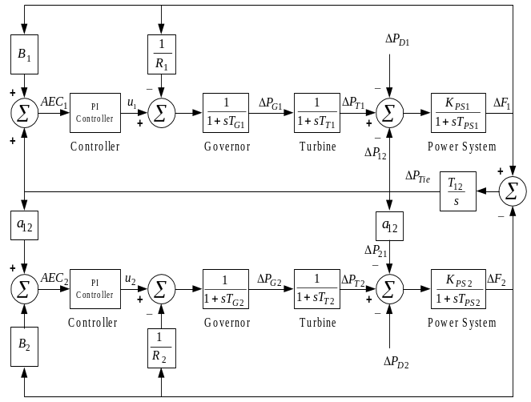 Figure 1. System under study
The two feedback controls are considered for performance analysis for the proposed system. The PI is very good feedback controller used in process industry. The structures of the PI controllers is considered as
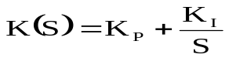
where K_{P} and K_{I} are proportional gain, integral gain respectively. The both the area same PI controller is considered. The input and output of the controller are ACE1, ACE2 and u1, u2 for area1 and area2 respectively.

Objective function
Integral of Time Multiplied Absolute Error (ITAE) objective function is considered as frequency deviation of the two areas and tie line power. The objective function (J) put as
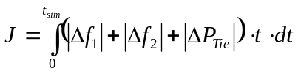
where Δf1,Δf2 are the frequency deviation of the system and ΔP_{tie} is the incremental change in tie line power. The main aim to objective function (J) is minimized the value subjected to
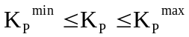
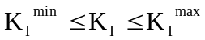
where K_{I}^{min} and Kp^{max} are minimum and maximum value of controller parameters. Here we can consider to identical area of the proposed interconnected Areas. So that K_{P1}=K_{P2}=K_{P} and K_{I1}=K_{I2}=K_{I.}

Gravitational Search Algorithm (GSA)
Gravitational Search Algorithm (GSA) is one of the newest heuristic algorithms that has been inspired by the Newtonian laws of gravity and motion [17]. In GSA agents are considered as objects and their performance is measured by their masses. All these objects attract each other by the force of gravity and this force causes a global movement of all objects towards the objects with a heavier mass. Hence masses co-operate using a direct form of communication through gravitational force. The heavy masses which correspond to good solution-move more slowly than lighter ones, this guarantees the exploitation step of the algorithm. Each agent in GSA is specified by four parameters [17, 18]: Position of the mass in d-th dimension, inertia mass, active gravitational mass and passive gravitational mass. The positions of the mass of an agent at specified dimensions represent a solution of the problem and the inertia mass of an agent reflect its resistance to make its movement slow. Both the gravitational mass and the inertial mass, which control the velocity of an agent in specified dimension, are computed by fitness evolution of the problem. The positions of the agents in specified dimensions (solutions) are updated with every iteration and the best fitness along with its corresponding agent is recorded. The termination condition of the algorithm is defined by a fixed amount of iterations, reaching which the algorithm automatically terminates. After termination of the algorithm, the recorded best fitness at final iteration becomes the global fitness for a particular problem and the positions of the mass at specified dimensions of the corresponding agent becomes the global solution of that problem. The algorithm can be summarized as below:
Step 1: Initialization of the agents:
Initialize the positions of the N number of agents randomly within the given search interval as below:
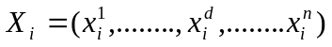 , for i =1,2,…n (4)
Where 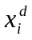 presents the position of i-th agent in the d-th dimension and n is the dimension of search space
Step 2: Fitness evolution and best fitness computation for each agents:
Perform the fitness evolution for all agents at each iteration and also compute the best and worst fitness at each iteration defined as below (for minimization problems):
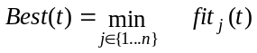 (5)
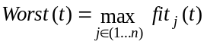 (6)
Where 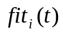 represents the fitness values of the agent i at time t and 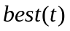 are defined as follows (for a minimization problem):
Step 3: Compute gravitational constant G:
The gravitational constant 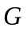is initialized at the beginning and will be reduced with time to control the search accuracy. In other word is a function of the initial value (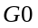) and time expressed as: 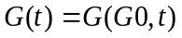
G(t)=G₀ e ^{(-άt/T)} (7)
In this problem, G₀ is set to 100, ά is set to 20 and T is the total number of iterations.
Step 4: Calculate the mass of the agents:
Gravitational and inertia masses are simply calculated by the fitness evaluation. A heavier mass means a more efficient agent. This means that better agents have higher attraction and walk more slowly. Assuming the equality of the gravitational and inertia masses, the values of masses are calculated using the map of fitness. The gravitational and inertial masses are updated by the following equations
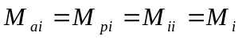, i = 1,2, .. n.
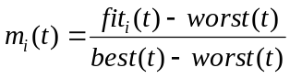 (8)
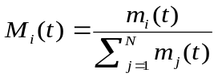 (9)
Step 5: Calculate accelerations of the agents:
One way to perform a good compromise between exploration and exploitation is to reduce the number of agents with lapse of Eq. (9). Hence, it is proposed to use only a set of agents with bigger mass for applying their force to the other. In order to avoid trapping in a local optimum the algorithm must use the exploration at beginning. By lapse of iterations, exploration must fade out and exploitation must fade in. To improve the performance of GSA by controlling exploration and exploitation only the 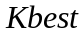agents will attract the others. is a function of time, with the initial value 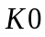at the beginning and decreasing with time. In such a way, at the beginning, all agents apply the force, and as time passes, 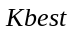is decreased linearly and at the end there will be just one agent applying force to the others. Therefore, Eq. (9) could be modified as:
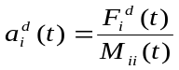 (10) 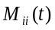is the inertia mass of i-th agent.
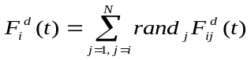 (11)
Where 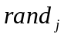 is a random number in the interval [0, 1]
Kbest is the set of first K agents with the best fitness value and biggest mass. Kbest is computed in such a manner that it decreases linearly with time and at last iteration the value of Kbest becomes 2% of the initial number of agents. F^{d}_{ij}(t) is the force acting on agent `i' from agent `j' at d-th dimension and t-th iteration is computed as below :
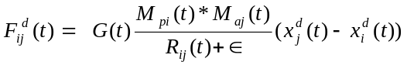 (12)
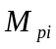 is the passive gravitational mass related to agent i
Where 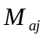 is the active gravitational mass related to agent j where, 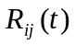 is the Euclidian distance between two agents `i' and `j' is given by 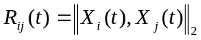
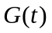 is the computed gravitational constant at the same iteration .
is a small constant.
Step 6: Update velocity and positions of the agents:
Compute velocity and the position of the agents at next iteration (t + 1) using the following equations:
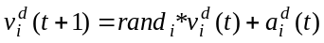 (13)
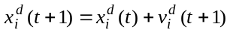 (14)
Where 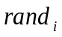is a uniform random variable in the interval [0, 1]. We use this random number to give a randomized characteristic to the search.
Step 7: Repeat from Steps 2-6 until iterations reaches their maximum limit. Return the best fitness computed at final iteration as a global fitness of the problem and the positions of the corresponding agent at specified dimensions as the global solution of that problem.
The different steps of the GSA are the followings:
- Search space identification.
- Randomized initialization.
- Fitness evaluation of agents.
- Update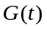, 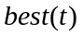, 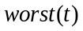and 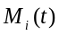for i = 1,2,. . .,n.
- Calculation of the total force in different directions.
- Calculation of acceleration and velocity.
- Updating agent’s position.
Repeat steps c to g until the stop criteria is reached
The principle of GSA is shown in Fig.2.

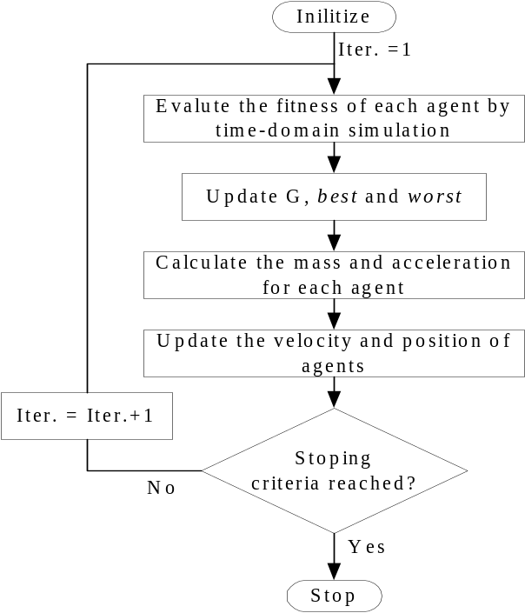
Figure 2 Flow chart of proposed GSA optimization approach

Results and Discussions
The simulation result analysis the performances cab be compared in the different cases of perturbation occurs in anywhere in the two area system, for the proposed analysis the perturbation occurs in area-1and area-2 individually and both area-1and area-2 occurs simultaneously. The optimization process was repeated 20 times and the best final solution among the 20 runs is chosen as proposed controller parameters. The best final solutions obtained in the 20 runs are shown in Table -I. The Table-II shows that the different value of ITAE and settling times of frequency deviations and tie line power of the proposed system.
TABLE I. Tuned controller parameters
GSA with PI controller | K_{P} | -0.3100
GSA with PI controller | K_{I} | 0.2670
GA with PI controller | K_{P} | -0.2346
GA with PI controller | K_{I} | 0.2662
Conventional PI controller | K_{P} | 0.7005
Conventional PI controller | K_{I} | 0.3802
TABLE II. Performance index and settling time of the system
Para  meters |  | Con.  method | GA  optimized  PI Controller | GSA  optimized  PI controller
ITAE |  | 3.5795 | 2.554 | 1.984
T_{S}  _{Sec} | Δf1 | 45 | 10.2 | 8.7
T_{S}  _{Sec} | Δf2 | 45 | 10.6 | 8.45
T_{S}  _{Sec} | ΔPtie | 29.8 | 9.2 | 6.38
Case-1: Step increase in demand of the first area
In this case-1 the step increase in demand (0.1 pu) of first area at time t=0sec at normal operating point. The system response as shown in figs.3-5 It is clear that frequency deviation of the first area(Δf1) ,frequency deviation of the second area(Δf2) and tie line power(ΔP_{tie)} of the closed loop system with convention PI controller highly oscillatory and large settling time. But when design approach GSA with PI controller is consider it improved the damping performance in terms of settling time and over shoot. It is also compared with GA, the damping performance in GSA base proposed design approach better than GA base power system.
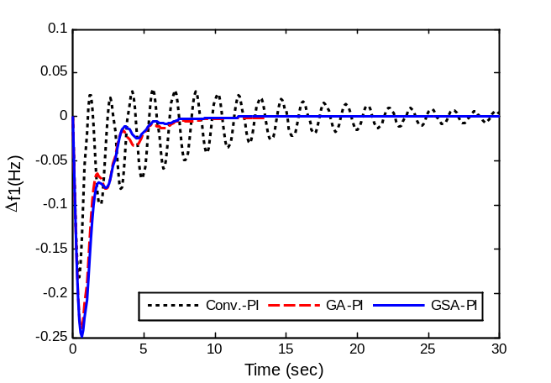
Figure 3.Frequecy deviation of the area-1 due to disturbance in area-1 as per case-1
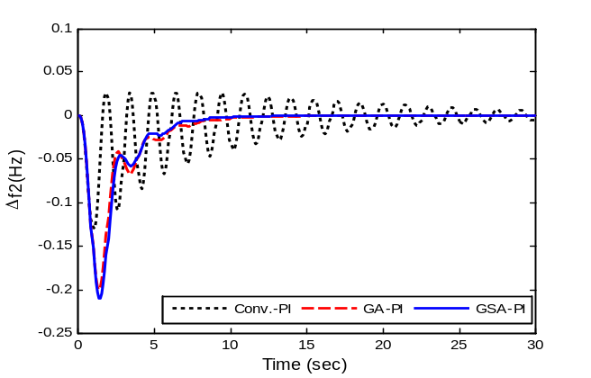
Figure 4.Frequecy deviation of the area-2 due to disturbance in area-2 as per case-1
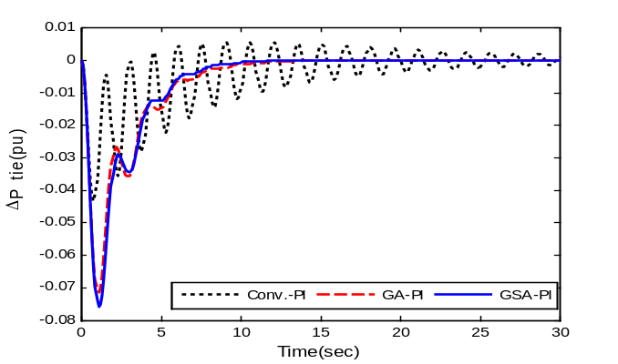
Figure 5.Tie line power deviation of the area-1 due to disturbance in area-1 as per case-1
Case-2: Step increase in demand of the second area
In case-2, the 10% step increase in demand in the second area at time t=0sec applied at same operating condition. It can be seen that the frequency deviation of both the area and tile line power as shown in figs.6-8.It can be seen that the system is highly oscillatory in conventional controller. The stability of the system remain maintain with GA based PI controller but however the proposed system with PI controller improving the damping characteristic of the power system.

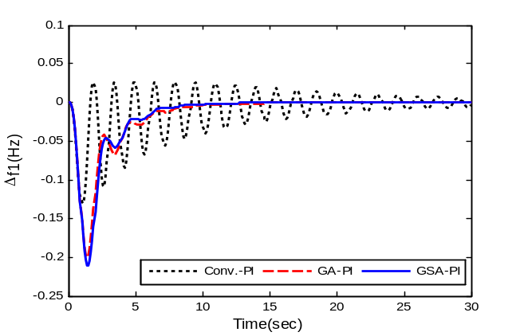
Figure 6.Frequecy deviation of the area-1 due to disturbance in area-1 as per case-2
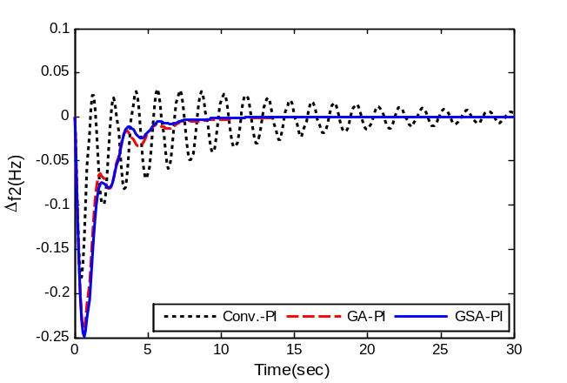
Figure 7.Frequecy deviation of the area-2 due to disturbance in area-2 as per case-2
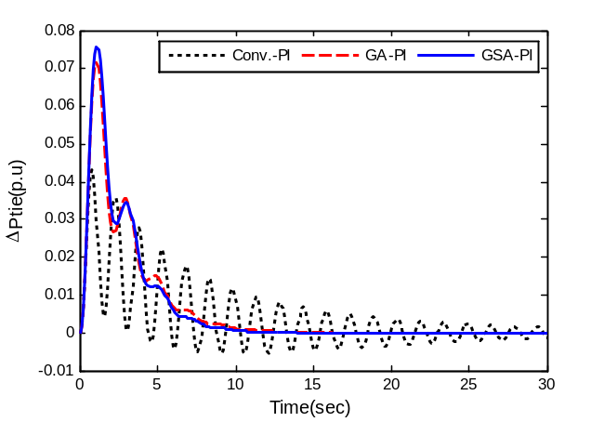
Figure 8.Tie line power deviation of the area-2 due to disturbance in area-2 as per case-2
Case-3 Step increase in demand of the first and second area simultaneously
For the effectiveness of the proposed system the step increase in demand is considered both the area-1 and area-2 simultaneously. The frequency deviation (Δf1) in area-1, frequency deviation (Δf2) in area-2 in the closed loop system and deviation in ACE1 and ACE2 are shown in Figs.9-12.It is clear from figs 9-12 the oscillation of the system is very poor with conventional controller but proposed controller is better than both GA and conventional controller as system quickly reaches steady state.
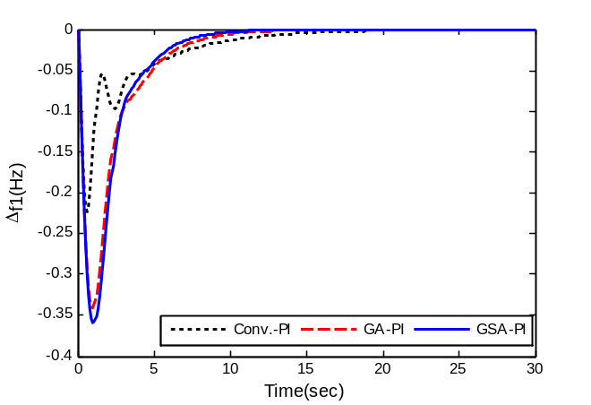
Figure 9.Frequency deviation of area-1 due to disturbance in area-1 and area-2
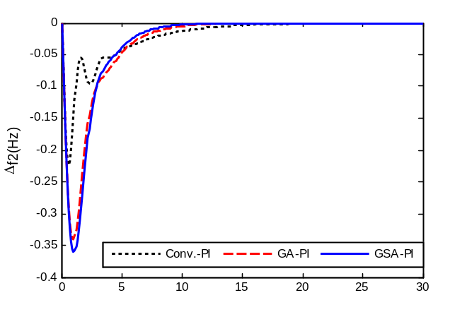
Figure 10.Frequency deviation of the area-2 due to disturbance in area-1 and area-2.

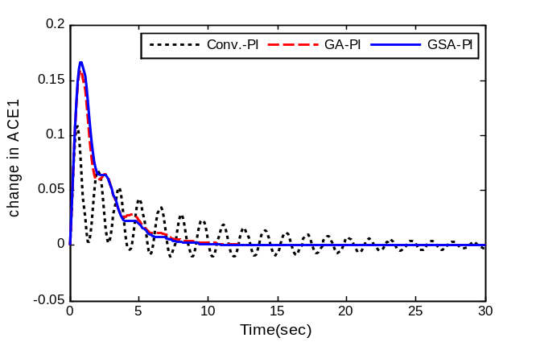
Figure 11.Change of ACE1 due to disturbance in area1 and area-2.

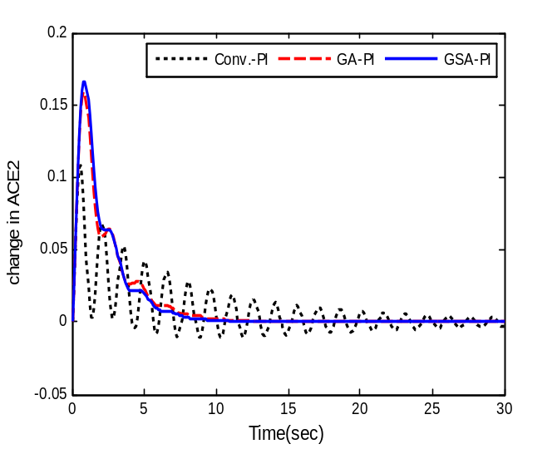
Figure 12. Change of ACE2 due to disturbance in area-1 and area-2.

Conclusion
The proposed analysis of Gravitational search algorithm based heuristic optimization techniques is applied to tune the parameter of PI and PID controller in two area power system. The ITAE of frequency deviation and tie line power in both the area taken as objective function to improved the system response in terms of settling time and overshoots. The system response is examined under different perturbation of step load individual and simultaneous area of the given system. The simulation result shows that the proposed approach by tuning the PI controller using GSA technique the performance better than PI controller under different perturbation and operating condition of the system. The superiority of PI controller are compared with conventional and in recently published result using GA techniques.
APPENDIX
The parameter of two area power system under study investigated as:
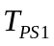= 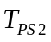= 20 s 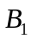=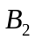= 0.045 p.u. MW/Hz; =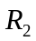= 2.4 Hz/p.u.; 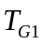= 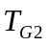=0.08 s; 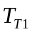=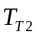= 0.3 s; 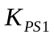=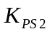=120 Hz/p.u. MW; 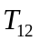=0.545 pu; 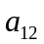= -1.

References

- O. I. Elgerd, Electric energy systems theory an introduction. New Delhi: Tata McGraw-Hill; 1983.
- O. l. Elgerd, Electric energy Systems Theory – An Introduction,McGraw Hill Co., 2001.
- O. I. Elgerd and C. E. Fosha, “Optimum megawatt-frequency control of multi-area electric energy systems”, IEEE Trans. On PAS, vol. PAS-89, no. 4, April 1970, pp. 556-563.
- D. Rerkpreedapong, A. Hasanovic and A. Feliachi, “Robust load frequency control using genetic algorithms and linear matrix inequalities”. IEEE Trans Power Syst ,vol.18,no.2,pp.855–861,2003
- TC. Yang, H. Cimen, QM. Zhu, “Decentralized load frequency controller design based on structured singular values”. IEE Proc-Generat Trans Distrib,vol.145,no.1,pp.7-14,1998.
- P. Kundur, “Power system stability and control”. New York: Mc-Grall Hill; 1994
- S. P. Ghosal, “Multi-area frequency and tie-line power flow control with fuzzy logic based integral gain scheduling,” Jour. Inst. Elec. Engg., vol.84, pp. 135-141, 2003.
- S.P.Ghosal, “Application of GA/GA-SA based fuzzy automatic generation control of a multi-area thermal generating system,” Elec.Pow. Sys. Res., vol. 70:2, pp. 115-127, Jul. 2004.
- M. L. Kothari, J. Nanda, D. P. Kothari, and D. Das, “Discrete-mode automatic generation control of a two-area reheat thermal system with new area control error”, IEEE Trans. Power Syst., vol. 4, no. 2, pp. 730- 738, May 1989.
- K. Venkateswarlu and A.K. Mahalanabis, “Load frequency control using output feedback”, Journal of The Institution of Engineers (India), pt. El-4, vol. 58,pp. 200-203,Feb. 1978.
- S. Pothiya, I. Ngamroo, S. Runggeratigul and P. Tantaswadi, “Design of optimal fuzzy logic based PI controller using multiple Tabu Search algorithms for load frequency control”. Int J Contr Autom Syst,vol.4,no.2,pp.155-164, 2006.
- M. L. Kothari, J.Nanda, D.P.Kothari, and D.Das, “Discrete mode AGC of a two area reheat thermal system with new ACE,” IEEE Trans. Power Systems, vol.4, pp. 730-738, May 1989.
- D.K. Chaturvedi, P.S. Satsangi, and P.K. Kalra, “Load frequencycontrol: a generalized neural network approach,” Intl. Jour. Elect.Power Energy Sys., vol. 21, pp. 405- 415, 1999.
- E. Çam, I. Kocaarslan, “Fuzzy logic controller in interconnected electrical power systems for load-frequency control”. Int J Electr Power Energy Syst,vol.27,no.8,pp.542-549, 2005.
- G.Panda,S.Panda and C. Ardil, “Automatic generation control of interconnected power system with generation rate constraints by hybrid neuro fuzzy approach”. Int. Journal of Electrical, Computer, Electronics and Comm. Engineering vol:6 No:4, 2012 .
- S. R. khunita and S. Panda, “A novel approach for automatic generatio control of a multi area power system”, IEEE CCECE ,Niagarea fall,Canada,2011.
- E. Rashedi, H. Nezamabadi-pour and J.S. Saryazdi, “GSA: A gravitational search algorithm”. Inform. Sciences,vol.179,pp.2232-2248, 2009.
- E. Rashedi, H. Nezamabadi-pour, J.S. Saryazdi. “Filter modeling using gravitational search algorithm. Engineering Appli of Artifi Intelli”,vol.24,pp.117-122, 2011.
- E.S. Ali and S.M. Abd-Elazim, “Bacteria foraging optimization algorithm based load frequency controller for interconnected power system”, Elect. Power and Energy Syst. vol.33,pp.633-638, 2011.

