COMPARISON STUDY OF ROUTING PROTOCOL IN WIRELESS SENSOR NETWORK- A ROAD MAP

MOHIT ANGURALA
P.T.U, GOLDEN COLLEGE OF ENGG & TECHNOLOGY
GURDASPUR, INDIA
Email Id: mohitpit@gmail.com

ANKITA SAINI
P.T.U, GOLDEN COLLEGE OF ENGG & TECHNOLOGY
GURDASPUR, INDIA
Email Id:ankitasaini63@gmail.com

Abstract – The explosive growth in wireless sensor networks over the last few years resembles the rapid growth of the internet within the last decades. A Wireless sensor network basically consists of a collection of nodes deployed for monitoring the system by means of measurement of its parameters. WSN mainly consist of two terms i.e. wireless network and sensors. Wireless Sensor is an important technology for large- scale monitoring, providing sensor measurement at high temporal and spatial resolution. The fundamental objectives for the wireless sensor network are reliability, accuracy, flexibility, cost effectiveness, and ease of deployment. This paper presents an overview of various routing protocol which are particularly designed for sensor network. We have studied three routing protocols and have compared these according to various parameters.

Keywords – GAF, LEACH, Protocols, SPIN, Wireless Sensor network.

I. INTRODUCTION
A wireless sensor network mainly consist of large number of low cost, low power, sensor nodes that can be used as an tool for gathering data in various situations. The nodes are densely distributed in a network. These sensors nodes have the ability to communicate either among each other or directly to an external base station (BS) [1]. A greater number of sensor allows for sensing over large geographical regions. The main components of the sensor nodes are controller, Transceiver, External memory, Power Source and one or more sensors.
- Controller basically performs tasks, Process data and also controls the functionality of the other components in the sensor nodes.
- Transceiver is mainly the combination of the functionality of both the transmitter and the receiver.
- External Memory now the most relevant kind of memory are the on- Chip memory of the micro controller and flash memory. Flash memory is used due to their cost and storage capacity.
- Sensor Nodes consume power for sensing, communicating and data processing. Batteries rechargeable and non- rechargeable are the main source of power supply for sensor nodes.
Wireless network provide connection flexibility between users in different places. The network can be extended to any place or building without the need for wired connection. Wireless network are classified into two types-
- Infrastructure Network
- Ad-hoc Network
The application of wireless sensor network are various from health monitoring to battle field, industrial monitoring, Environmental monitoring etc [2].This paper aims to show analysis performance of routing protocols in wireless sensor network like SPIN, LEACH and GAF. We examine the performance of each routing protocols which improve the network efficiency and maximize the network lifetime.
Routing in wireless sensor network differs from conventional routing. There is no infrastructure, wireless links are unreliable, sensor nodes may fail and routing protocols have to meet the strict energy saving requirements. Many routing algorithms were developed for wireless network; the routing protocols are classified into seven main categories mentioned below-:

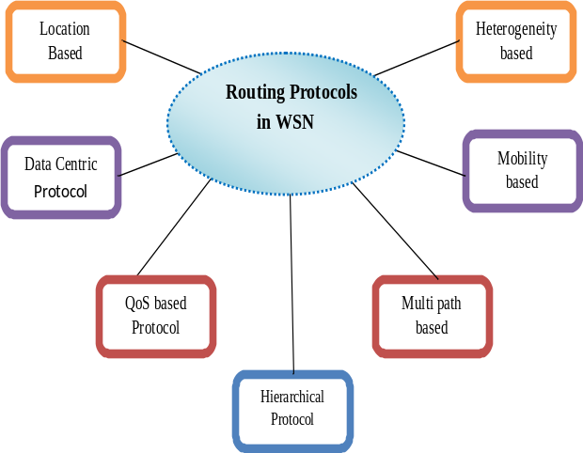
.
Fig.1 Various Routing Protocols
- Flat network Routing-In flat routing protocol all the nodes are treated equally in the network e.g.: SPIN, ACQUIRE, CADR, GBR etc
- Hierarchical network Routing-In hierarchical routing protocols different nodes are grouped to form clusters and data from nodes belonging to single cluster can be combined. EG: LEACH, TEEN, SOP, TTDD etc.

II. SPIN
SPIN [5] (Sensor Protocol for Information Negotiation) type of protocol basically designed to improve flooding or overlapping problem [3]. Nodes running a SPIN protocol name their data using high level descriptor called Meta data. They use Meta data to eliminate the transmission of redundant data throughout the network. SPIN protocol are basically based on two mechanisms namely negotiation and resource adaption. SPIN is a three stage protocol as sensor nodes use three types of messages.
ADV- To advertise new data
REQ- To request data
DATA- The actual message itself
The SPIN family of protocol includes many protocols. The two main are SPIN-1(or SPIN-PP) and SPIN-2S(or SPIN-ECS).SPIN-1 basically uses negotiation mechanism to reduce the consumption of the sensor and it is the three stage protocol while SPIN-2 basically uses resource adaption mechanism for energy saving and SPIN-2 communicate using the three stage protocol of SPIN-1 [1].
III.LEACH
LEACH [5] (Low Adaptation Energy Clustering Head) is the first and most popular efficient hierarchy protocol that was proposed for reducing power consumption. These protocols mainly use cluster nodes for the transmission of information between the nodes. All the nodes in a network organize themselves into local cluster with one node acting as a cluster head. All non- cluster head transmit their data to the cluster head while the cluster head node reserve data from the cluster members, perform single processing function and transmit data to the base station [4]. The cluster head nodes are much more energy efficient as compared to non-cluster head nodes, when the cluster head node dies all the nodes that belong to cluster loses their communication ability. The operation of LEACH is divided into two rounds having two phases-
1. SETUP PHASE-
- Advertisement phase
- Cluster Set-up phase
This phase organizes the network into clusters by using a distributed algorithm without any centralized control. There is no long distance communication with the base station required.
2. STEADY STATE PHASE-
- Schedule Creation
- Data Transmission
In this phase, operation is broken into frames where nodes send their data to the cluster head. . There is no guarantee that nodes are evenly distributed among the clusters. This phase is for data aggregation, compression and transmission to the sink.
III. GAF
GAF [4] (Geographical Adaptive Fidelity) it is energy aware routing protocol proposed for MANET but can also be used for WSN. Nodes consume energy while transmitting data i.e. at the time of receiving as well as transmitting data. It basically based on the mechanism of turning off unnecessary sensors. In GAF the whole network is divided into virtual grid. The proper size of grid is important as it directly affects the network connectivity. If the grid size is large then it is difficult to connect the whole network. The size of grid depends upon that any node can communicate with any node present in the neighbor grid.

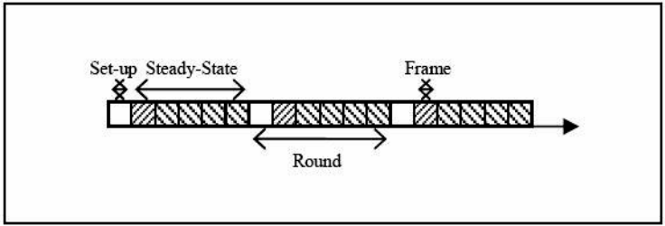
Fig.2 Leach protocol phases
A. State Transition Diagram of GAF
The different transition diagram used in GAF is sleeping state, discovery state, active state [6]. When a sensor nodes enters the sleeping state, it turns off for the energy saving. In the discovery state, a sensor exchanges its messages to learn more about the other sensors in the same grid. . Even in the active state, a sensor broadcast periodically to inform equivalent sensors about its state.GAF mainly aims to maximize the network lifetime by reaching a state where each grid has only one active sensor based on sensor ranking rule. For example, a sensor in the active state has a higher rank than a sensor in the discovery state. A sensor with longer expected lifetime has a higher rank.

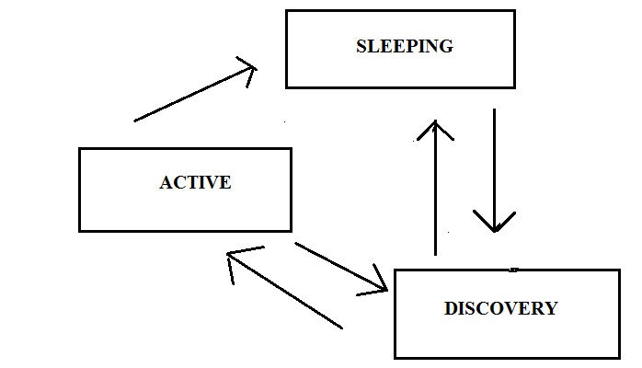
Fig.3 State Transtition Diagram of GAF
IV.APPLICATIONS
- Military application
- Home application
- Green house monitoring
- Habitat surveillance
- Industrial application
- Enviromental impact monitorings

- COMPARISION BETWEEN SPIN,LEACH,GAF
 | Protocols
 | Spin | Leach | Gaf
Classification | Flat Based | Hierarchal Based | Location Based
Power Usage | Limited | Maximum | Limited
Data Delivery Model | Event Driven | Cluster Based | Virtual Based
Scalability | Limited | Good | Good
Data Aggregation | Yes | Yes | No
Multipath | Yes | No | No
Mobility | Possible | Fixed BS | Yes
Position Awareness | No | No | No
Redundant Data | Limited | High | Limited
Reliability | Poor | High | Good

V. CONCLUSION

In this paper we have evaluated the performance between protocols SPIN, LEACH and GAF. We conclude that LEACH has limited energy and has more power consumption as compare to SPIN because of cluster head rotating whereas SPIN uses less it do not have any cluster head. In LEACH we have the limited time after the transmission is stopped but in SPINS no such time boundation so packet delivery ratio is large. LEACH shows better energy efficiency and higher throughput than SPIN protocol. GAF is high scalable and saves the energy of the nodes by turning the radio off. The Hierarchal

Based protocol gives better performance.

Acknowledgemet
First and foremost, I would like to thank my project guide, Prof. Mohit Angurala, for his guidance and support. I will forever remain grateful for the constant support and guidance extended by my guide. Though our many discussions, he helped me to form and solidify ideas and also acknowledge other for their contribution in preparing such paper.

REFERENCES
Journal References
[1] Jamal N. Al-Karaki, Ahmed E. Kamal, “routing techniques in wireless sensor networks: a survey” 1536-1284/04 IEEE Wireless Communications, Vol. 2, No. 5, pp. 64 – 69, December 2004.
[2] Shio Kumar Singh, M p Singh and DK Singh “Routing Protocols in Wireless Sensor Networks-A Survey” International Journal of Computer Science &Engineering Survet (IJCSES), Vol.1 No.2 November 2010.
[3] Mohammad S. Al_ Fares, Zhili Sun and Haitham Cruickshank, “A Hierarchical Routing Protocols for Survivability in Wireless Sensor Network” Proceedings of the International Multi Conference of Engineers and Computer Scientists 2009, Vol.I, March 18-20, 2009, Hong Kong.
[4] K. Padmanabhan, “A Study on Energy Efficient Routing Protocols in Wireless Sensor Networks” European Journal of Scientific Research ISSN 1450-216X , Vol.60 No.4 (2011), pp. 499-511 © Euro Journals Publishing, Inc. 2011.
[5] S.K. Singh, M.P. Singh, and D.K. Singh, “A survey of Energy-Efficient Hierarchical Cluster-based Routing in Wireless Sensor Networks”, International Journal of Advanced Networking and
Application (IJANA), Sept.–Oct. 2010, Vol. 02, issue 02, pp.570–580.
[6] Jamal Al-Karaki, and Ahmed E. Kamal, “Routing Techniques in Wireless Sensor Networks: A Survey“, IEEE Communications Magazine, Vol.11, no. 6, Dec. 2004, pp. 6-28.
[7] I. F. Akyildiz and W. Su and Y. Sankarasubramaniam and E. Cayirci, “Wireless sensor networks: a survey,” Computer Networks, International Journal of Advanced Research in Computer Science and Software Engineering ,Vol.38, pp. 393,422, March 2002.
[8] M. Bani Yassein, A. Al-zou'bi, Y. Khamayseh, W. Mardini “Improvement on LEACH Protocol of Wireless Sensor Network (VLEACH)”, International Journal of Digital Content Technology and its Applications, Volume 3, Number 2, June 2009.
[9] Sinchan Roychowdhury, Chiranjib Patra, Geographic Adaptive Fidelity and Geographic Energy Aware Routing in Ad Hoc Routing, IJCCT, Vol.1 Issue 2, 3, 4; 2010.
[10] Geetu, Sonia Juneja, Performance Analysis of SPIN and LEACH Routing Protocol in WSN, International Journal Of Computational Engineering Research (ijceronline.com),Vol.2,Issue. s5, December 2014
[11] Jian Wan, “A review of routing protocol in wireless sensor networks”, IEEE Communications Magazine, Vol.40, Issue.8, December 2008.
[12] Kemal Akkaya and Mohamed Younis, “A Survey on Routing Protocols for Wireless Sensor Networks”, Ad hoc Networks International Journal of Computer Science & Engineering Survey (IJCSES), Vol. 3, no. 3, pp. 325-349 May 2005.

