QUADCOPTER WITH WIRELESS VIDEO SURVEILLENCE

Mr. Amit Kumar Mishra
Electronics and Telecommunication Department
Sandip Institute of Engineering and Management
Nasik, India
amit.mishra@siem.org.in

Mr. Gandre Prasanna
Electronics and Telecommunication Department
Sandip Institute of Engineering and Management

Miss. Moharir Sneha S.
Electronics and Telecommunication Department
Sandip Institute of Engineering and Management
Nasik, India
Snehamoharir123@gmail.com

Abstract—Our project is mainly designed for military purpose. The main aim is to serve the people who stucked in natural calamities. We can serve them by means of providing food and drugs using Quadcopter. Now a day small UAVs are becoming very famous for military purpose. The Quadcopter should be able to locate and land to specified target. The purpose of this project is to provide better video surveillance in low power i.e. battery life.
In this project we are using vision device for thermal, optical and night vision mode. Flight controlled board is used to control propellers and the balancing condition of Quadcopter. We are using MQ-7 Gas/Smoke sensor to detect Gas and Smoke and after detection the message will be sent to mobile of the watch person with help of SIM900-A GSM module.
Keywords—Quadcopter, UAVs, sensor, BLDC motors, ESC.

Introduction
The UAVs or we can say Quadcopter becoming very popular now a day because it have ample amount of use in military services, television industry, agriculture, commercial, rescue mission etc. In U.S. Coast Guard maritime search and rescue mission, UAV that attached with infrared cameras assist the mission to search the target [1]. Quadcopter is the one on which many researches are going on nowadays.
In this project Quadcopter is design first of all for military purpose and then for the commercial use. We are using Arduino Uno Board and Flight Controlled Board for this project. By Arduino Uno we maintain the proper relation between sensor and SIM900-A GSM module. To balance the flight condition or hovering condition we have used Flight Controlled Board. Four BLDC (Brushless DC) motors are connected to this board through the ESC (Electronics Speed Controller). Three types of cameras are used for the surveillance purpose. You can get footage of surveillance at any time either day or night. So, this is purpose why we are using Thermal, Optical and Night Vision camera.
Disaster relief or crop assessment seems also to be likely areas where small UAVs could be useful. We were also motivated by on-campus uses such as monitoring parking or quick-look video of an incident, or monitoring hard to reach locations, or exploration of a collapsed building or other dangerous location[3].

LITERATURE REVIEW
In order to track “QUADCOPTER WITH WIRELESS VIDEO SURVEILLENCE” some research is done based on the previous reports.
In some previously done work they have used only optical camera, some researchers have used raspberry-pi, PIC microcontroller, Arduino Development Board. LPG sensor is used for detection of gas leakage.

METHODOLOGY
One of the first major design choices made was choosing the type of multi copter to be used in this project. A quad copter platform was chosen because in general they are capable of hovering in place, robust, well balanced for the amount of lift they generate, and are widely used in the UAV community[2].
Our project “QUADCOPTER WITH WIRELESS VIDEO SURVEILLENCE” is divided in two categories. One of the two category is the hardware modeling and the other is software flow of the project.

Hardware Modelling:
After deciding our project we were concern about what kind of electronics we should select. So we select some components which are stated further in brief.
The electronics components which we are going to use are:
- Flight control board
- BLDC Motors
- Electronic Speed Controllers
- Propellers
- Quadcopter Frame
- Arduino uno-R3
- MQ-7 Gas/Smoke sensor
- SIM900 GSM module
- Cameras:
  - Optical
  - Thermal
  - Night Vision

Flight Control Board:
We are using K K 2 Flight Control Board.

BLDC Motors:
BLDC is the motor which is widely used in applications like automotive, aerospace, automated industrial equipment.[4]

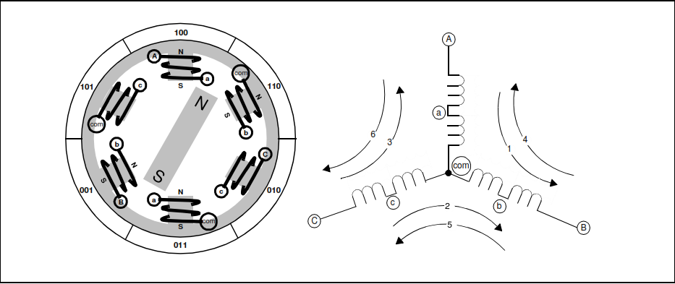
Fig. 1: BLDC Motor Diagram

It is electrically commutated by switches instead of brushes. It has several advantages like:[5]
- Higher reliability
- Higher efficiency
- Small in size
- Light in weight
- Life is longer
- Greater dynamic response
- Better speed versus torque characteristic
BLDC motors work on the principle where for feedback multiple feedback sensors are used. Torque and efficiency are very important terms.
Torque and Efficiency can be calculated as below:[6]
- Torque:
Torque (Newton - Meters) = Force(Newton) * Distance(meters)
- Efficiency:
Efficiency = [output power ÷ input power] %
Where,
Output power = Torque * Angular velocity
Input power = Voltage * Current

Electronic Speed Controllers:
Electronics Speed Controllers are specially used to control the speed of the motors. As motors are directly connected to the battery so if speed goes out of range at the same time speed controller takes the control.
In this project “Quadcopter with Wireless Video Surveillance” we are using electronics speed controller for controlling purpose.

Propellers:
Propellers are also called as the wings of the drone. The motors and ESCs are actually placed on the propellers. We are using four propellers as we are making Quadcopter.

Quadcopter Frame:

Arduino Uno R3:
Arduino Uno is a development board which replaces the controller.

MQ-7 Gas/Smoke Sensor:
SnO2 is the sensitive material of MQ-7 Gas/Smoke sensor. This sensor is used to detect the Carbon Monoxide (CO) gas in the environment or in the different gases.
MQ-7 Gas/Smoke sensor comes with the plastic encapsulation. Carbon Monoxide (CO) gas is measured in parts per million (ppm). Advantages of this sensors are one is it is highly sensitive to carbon monoxide and the other is it is safe and stable.

SIM900 GSM Module:
To send a message on the mobile after detecting the carbon monoxide gas we must have the GSM module. So, in our project “Quad copter with Wireless video Surveillance” we are using the SIM900A GSM Module.
Reason to choose only the SIM900A GSM Module is there are many advantages as compared to the other GSM Modules. The advantages are as follows [8]:
- Dual band 900/1900 MHz
- GPRS Multi slot class 10/8 GPRS mobile station class B
- Control via AT Commands
- Compliant to GSM Phase 2
- Low power consumption: 1.5mA (Sleep Mode)
- Operating temperature: -40° C to +80°C
Cameras:
We are using specially three types of cameras:
- Thermal Camera
- Optical camera
- Night vision camera

Block Diagram:

The block diagram for the project “Quadcopter with wireless video surveillance” is as shown in the figure below:

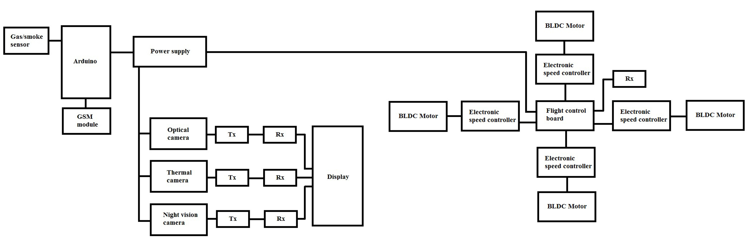
Fig. 2: Block Diagram of Quadcopter with wireless video surveillance

The above block diagram is divided into three blocks. The first section is sensor section that is gas sensor and message transmission. The second section is of the vision device. This section contains all those three cameras. The third section which is last section of our diagram is of main quad copter frame. In this third section four BLDC motors are attached to the main flight control board through the electronic speed control device. The flight control board is the brain of the Quadcopter.

Software Modelling:
In the software modelling section we will discuss about the flow of software part. So first of all we just take a look on flowchart.
The flowchart shown in fig. 3 gives the overall plan of our project “Quad copter with wireless video surveillance”. It shows that how we planned our project and how it is executed.
First of all the hardware selection is done. About that selection everything is mentioned in above section. Then we check for the flight means the all flight tests. The flight test includes take off, landing, right shift, left shift, forward and backward motions. If all motions are working in good condition then sensor is activated. If any CO gas is found in the environment then the message is transmitted to the person which is there in control room through the GSM module.
Then the camera section comes in picture. When quad copter is in take off position at the same time camera is activated. If there in DAY time then the camera which will activate is the optical camera. If the time is NIGHT time then the Night Vision camera is activated. If any warm body is detected then that will be covered through the Thermal Camera.

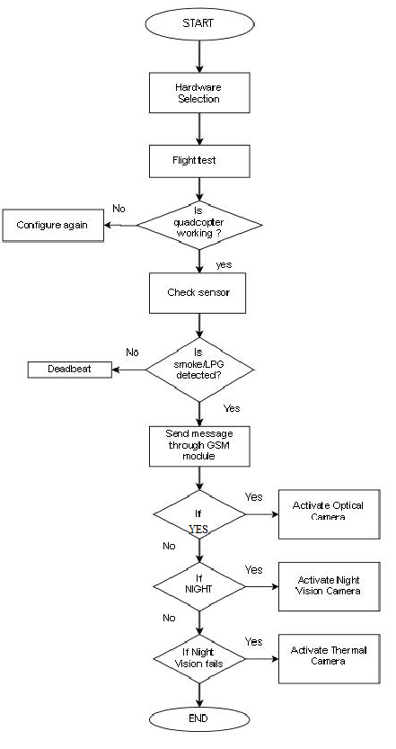
Fig. 3: Flowchart

- ADVANTAGES
- Small scale UAV’s makes vehicles safer for close interaction
- Easy to maintain
- Can be used in day and night
- It have the sensing module
- Quad copters have frames with rotors which permits flight through more challenging environment

- APPLICATIONS
- Military:
  - Used for surveillance by military and law enforcement agency
  - To provide drug and food in remote area
- Commercial:
  - In the field of arial imagery
  - For video shooting from top to get better view

- REFERENCES
[1]. Allison Ryan and J. Karl Hedrick (2005). “A mode-switching path planner for UAV- assisted search and rescue.”44th IEEE Conference on Decision and Control, and the European Control Conference 2005.

[2]. Sima Mitra (Spring 2013) “Autonomous Quadcopter docking system” Cornell University.

[3]. Matt Parker and Gerad Bottorff (Spring Semester 2012) “QUADCOPTER” Final report of Colorado State University Fort Collins,Colorado 80523.

[4]. Jian Zhao/Yangwei Yu (July 2011). “Brushless DC Motor Fundamentals Application Note”

[5].Muhammad Mubeen, “Brushless DC Motor Primer,” Motion Tech Trends, July, 2008.

[6].Pushek Madaan (Feb 11, 2013) “Brushless DC Motors – Part 1: Construction and operating principles” Cypress Semiconductor – EDN Networks.

[7]. ATLAS - “Electronic Speed Controllers”, user guide and manual, hyperion- www.hyperion-world.com.

[8]. “Getting started with SIM900A Module”- http://wm.sim.com/producten.aspx?id=1019

