Computer Adaptive Testing Using Rule Based Approach
Melwin Jose, Savio Sebastian, Daniel Pereira & Mohit Sah, Janhavi Baikerikar

Department of Information Technology
Don Bosco Institute Of Technology
Kurla(West) – Mumbai, India.
janhavibaikerikar@gmail.com, melwinmj.93@gmail.com, daniel_pereira127@yahoo.in, mohitsah21@gmail.com, saviosebastian08@gmail.com

Abstract — Computer Adaptive Testing (CAT) is a cultivated approach for delivering tests, surveys, and other measurements. It is based on complex computer algorithms rendered to achieve proper content distribution, item exposure and test length. In an Computer Adaptive Testing (CAT) environment, test assessment and evaluation of each examinee is a vital factor. This kind of Adaptive Testing helps the administrator to obtain a detailed estimation of the student’s performance level based on his/her knowledge and learning ability[3]. Another notable advantage of Adaptive Testing is that each examinee receives different sets of questions and the probability of the questions also varies depending on their performance level[3]. The Adaptive testing using rule based approach will be ensuring that the next question given to the user will be dependent on the previous set of questions answered by the user. The objective of this paper is to design and evaluate Computer Adaptive Testing Using Rule Based Approach technique for web based applications / Android Based Mobile Devices.
Keywords — Computer Adaptive Testing, Rule based approach, Android, web based application, mobile devices.

Introduction
Educational institutions and common testing services which conduct tests like GRE, TOEFL, CAT and GMAT have taken the initiative to make exams more cost effective and to lower the risk pertaining towards workload and delay of scoring. Presently, various institutions and organizations are using Computer Adaptive Testing (CAT) as a procedure for accomplishing large scale testing[3].

Using Rule based approach we are able to take CAT to a higher level in providing maximal balance of accuracy and efficiency. The basic ideology is to test each individual examinee in order to obtain accurate measurement across the examinees with varied educational background and performance levels. This testing can be accomplished through web or computer based systems such as smartphones or tablets.

Theoretical Basis Of Computerized Adaptive Test
CAT (Computerized Adaptive Testing) is a type of test developed to increase the efficiency of estimating the examinee’s knowledge. This is achieved by adjusting the questions to the examinee based on his previous answers (therefore often referred to as tailored testing) during the test duration. The degree of difficulty of the subsequent question is chosen in a way so that the new question is neither too hard, nor too easy for the examinee. More precisely, a question is chosen for which it is estimated, with a probability of 50% that the examinee would answer correctly. Of course, the first question cannot be selected in this way because at this point nothing is known about the examinee's capabilities (a question of medium difficulty is chosen), but the selection of the second question can be better adapted to each examinee. With every following answered question, the computer is increasingly better able to evaluate examinee’s knowledge[4].

Computer adaptive tests have numerous limitations, and they raise several technical and procedural issues:
- CATs are not applicable for all subjects and skills. Most CATs are based on an item-response theory model, yet item response theory is not applicable to all skills and item types.
- Hardware limitations may restrict the types of items that can be administered by computer. Items involving detailed art work and graphs or extensive reading passages, for example, may be hard to present.
- CATs require careful item calibration. The item parameters used in a paper and pencil testing may not hold with a computer adaptive test.
- CATs are only manageable if a facility has enough computers for a large number of examinees and the examinees are at least partially computer-literate. This can be a great limitation.
- The test administration procedures are different. This may cause problems for some examinees.
- With each examinee receiving a different set of questions, there can be perceived inequities.
- Examinees are not usually permitted to go back and change answers. A clever examinee could intentionally miss initial questions. The CAT program would then assume low ability and select a series of easy questions. The examinee could then go back and change the answers, getting them all right. The result could be 100% correct answers which would result in the examinee's estimated ability being the highest ability level[4].

The CAT algorithm is usually an iterative process with the following steps:
- All the items that have not yet been administered are evaluated to determine which will be the best one to administer next given the currently estimated ability level.
- The “best” next item is administered and the examinee responds.
- A new ability estimate is computed based on the responses to all of the administered items.
- Steps 1 through 3 are repeated until a stopping criterion is met[4].

The flowchart below serves as an illustration of the CAT algorithm.

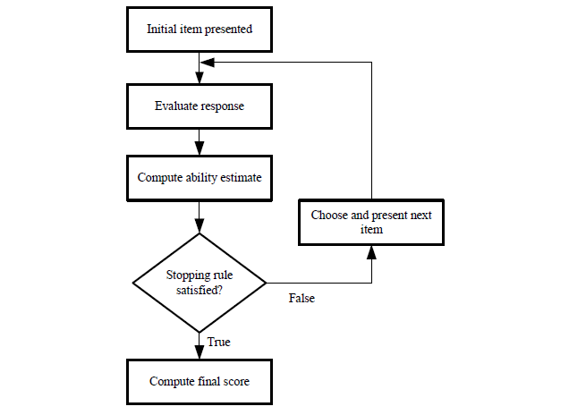

Figure 1. Illustration of the CAT algorithm [4]

Literature Review

Chi-Keung Leung, Hua-Hua Chang, Kit-Tai Hau, "Computerized Adaptive Testing: A Comparison of Three Content Balancing Methods" elaborates on the pros and cons of the three content balancing methods (CCAT, MCCAT and MMM).The main concern in all of these three methods which was specified was the “Over Exposure” problem faced by CCAT. The problem was dealt with by MCCAT (Modified Constrained CAT. We get know and learn about Exposure control and item selection procedures and precautionary measure from the study. The comparison between Over exposed and under used items leads us to understand how to deal with such scenarios in our project[1].
Nathan A. Thompson, David J. Weiss, “A Framework for the Development of Computerized Adaptive Tests”, have provided a broad framework for the development of a CAT, applicable to most situations. The development of a CAT is often left completely to the judgment of the professionals working on the CAT. We also learn that many testing programs will have various issues that must not only be identified, but also isolated so that they can be investigated as empirically as possible And through the use of simulation research, remains applicable to all programs the process of CAT can be better understood[2].

Rule Based Analysis-Assessment Environment Factors
The system is designed to suite the requirements of CAT making it easily accessible and readily available to larger audiences. Our goal is to train learning graduates and help them improve their technical skills and answering abilities by keeping track of their performance history. The complexity of the next question is currently determined by a window of 4 questions answered by the user which iterates further until completion of the test. This window attribute is known as dynamic average whose size can be variable i.e. currently the algorithm is implemented with a window of 4 questions but it can be increased to 8 and beyond.

- Question Selection
At the start of the quiz a set of 4 questions are selected from the database as simple, medium, hard and very hard respectively. Once the user has attempted these questions, the next question will be dependent on the dynamic average value. This dynamic average value is calculated depending on the previous set of question answered. The complexity levels is been assigned with a range of value for the dynamic average calculation. The dynamic average will be calculating a value which will be in range of the complexity questions. This dynamic average value will be calculated till the end of the quiz.

- Score Calculation
Initially each question answered correct is provided with static marks. Once the quiz ends it checks for the number of questions answered from each complexity levels and depending on the complexity a bonus score is been given to the user so that that the capability of each is been defined well. After the score calculation, the score will be displayed to the user showing the number of question attempted right and the bonus marks if any which depends on the complexity of the questions.

Algorithm Proposed

if (Question1=Right) Value=1;
else Value=0;
if (Question 2= Right) Value=1;
else Value=0;
if (Question 3= Right) Value=1;
else Value=0;
if (Question 4= Right) Value=1;
else Value=0;

for(int i=5; i <=20; i++)
{
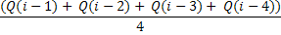
Question i =

Switch(Question i)
Case 0:
Level= Simple;
Case 0.25:
Level= Simple;
Case 0.50:
Level= Medium;
Case 0.75:
Level= Hard;
Case 1:
Level= Very Hard;
}

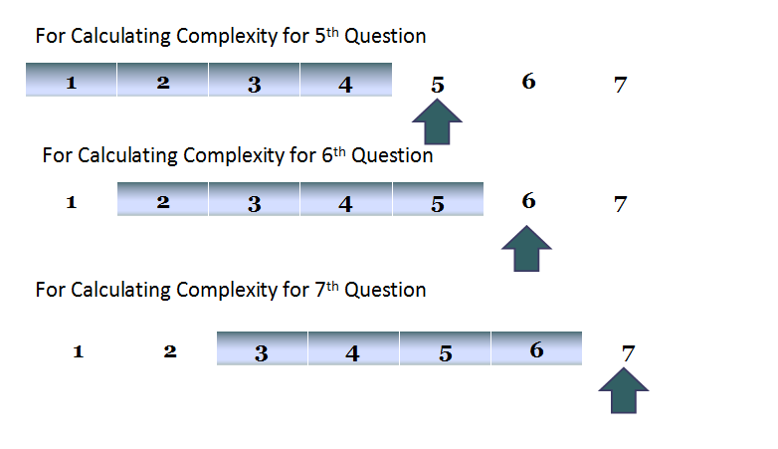
Figure 2. Illustration of the proposed algorithm

The Computer Adaptive Tests designed for Android based mobile devices have been formulated under following Pedagogical and Technical environment[3].

The learning environment based on pedagogical principles and test formats consists of the following factors:
1) Multimedia Test Content
2) Test format and presentation for various mobile devices,
3) Adaptive Test Question Sequencing based on the performance level, and
4) Test Performance Feedback[3].

- Multimedia Test Content
The Content refers to the quantity and quality of the Test items in the Test Content Server. It is very important since the test is based on these contents. The contents should be designed based on the Multimedia concepts with suitable graphics, pictures and videos along with Text. It determines not only the test topic but also the test with varying difficulty levels. The content of CAT should be based and supported by present day
scenario acceptable didactic and pedagogical theories, such as: creative, explorative, active, constructive, problem solving, critical thinking learning. It should be personalized. They should be relevant, suitable and appropriate for the indented tests, ages and educational level of the examinees. They should adjust and support the values of the examinees and the value of learning[3].

- Test Format and Presentation for various Mobile Devices
Devices like Mobile Phone and Tablets comes with different form factor hence the test format and presentation assumes prime importance apart from the content. Presentation refers to the presentation, media and format of the items in the CAT. The presentation, media and format of the items should be personalized. It should be clear, simple, and of low overhead. It should be rich, be based on a variety of media (e.g. text, picture, image, graphs, diagrams, audio, video, immersion) of high quality (e.g. resolution, number of colors, sound fidelity). There should be the right mix of media objects at the appropriate positions with low distraction. The result should be enjoyable[3].

- Adaptive Test Question Sequencing
Adaptive Test is based on the learner’s performance levels marked with each question and the test questions are to be sequenced accordingly. Sequencing refers to the sequencing of the items presented to the examinee. In CAT, the Sequencing of the items depends on the examinee’s answers. An adaptive algorithm is employed to select the next item to be presented to the examinee. This algorithm should be based on a valid and accredited pedagogical and psychometric theory. The duration and the number of items in the CAT should be enough to produce valid results. It should enhance student’s motivation and enjoyment. It should support a variety of item
types, sequencing methods and scoring methods. It should support a large number of concurrent tests and examinees. The scores should be stable, reproducibility, and consistent[3].

- Test Performance Feedback
Feedback refers to the response of the CAT system to the examinee’s actions. It may aim to control, guide and regulate the examinee, or instruct and teach him, or help and support him. It may inform him about his progress, his strengths and weaknesses. It may also try to develop, enhance and improve his strengths as well as reduce and correct his weaknesses. The feedback to the items should be personalized. It should be timely, accurate, relevant, clear and easy to understand. It should be of proper quantity, media and format[3].
The technical environment for Mobile Adaptive consists of the following factors: 1) Rich User Interface, 2) Reliability and Maintainability, 3) Functionality, 4) Connectivity, and 5) Security[3].

- Rich User Interface
The User Interface is the aggregate of input and output means by which the examinees interact with the CAT system. It includes the graphical, textual and auditory information the CAT system presents to the examinee, and the control sequences (e.g. keystrokes with the Mobile Devices Keyboard, and selections with the touch screen) the examinee employs to interact with the CAT system. The User Interface has also an important role while the examinee is attempting the quiz. The User interface should be kept simple in order that it doesn’t take much time for the examinee to understand the user interface and attempt the set of questions making the system effective and satisfying. Android and web based applications have Rich User Interface to support wide variety of input methods[3].

- Reliability and Maintainability
Reliability refers to the capability of the CAT system to maintain a specified level of operation during the assessment. The CAT system should achieve the following capabilities with minimum effort at minimum time: i) avoid failures and faults, ii) maintain consistent operation even in case of failures, iii) recover from failures reestablishing its previous state of operation, and iv) be available to the examinee at any moment during the assessment. Additionally, keeping on alternative communication paths between the examinee and the CAT system increases the reliability. Maintainability refers to the effort and time needed for installation, fault removal, update, upgrade, expansion and other modifications of the CAT system. Also, it is related to the risk taken from unexpected effects of modifications[3].

- Functionality
Functionality refers to available functions, features (e.g. alerting and reminding), tools (e.g. calculator, editor, scratch-work space, drawing, audio and video recorder, camera, etc.), and applications in the CAT systems. It examines the quantity, quality, appropriateness and the properties of these functions to support the examinee during the assessment. Android OS based devices are pre-built in with the above functional requirement tools[3].

- Connectivity
Connectivity refers to the ability of the CAT system to interact and communicate with server through wireless infrastructure. The Android based mobile devices have the capability of
Wi-Fi to interact with the server in intranet based environment and 3G facility for external factors[3].

- Security
Security refers to the protection of the CAT system against unauthorized login to the system and trying to modify the information that is present in the system which will cause the system to behave incorrectly hence producing unexpected results. It ensures a state of inviolability from hostile acts or influences. It prevents unauthorized persons from having access to restricted information. It also ensures confidentiality so that information is accessible only to those authorized to have access[3].

Results And Discussion
This paper has been dealt with the development of Computer Adaptive Testing Using Rule Based Approach for the Android phones / web browsers. The prototype developed for assessing the knowledge of a user / examinee capable of the tests conducted with the algorithm for dynamic average value. This test will yield more positive and better results from an examinee / user when compared to traditional form of testing methodology and linear classic testing where each student has been presented with a same set of questions. The database content inclusion in the different question complexity will enhanced the learners answering ability to a new higher level showing the improvisation in the knowledge acquisition and deeper understanding of the subject content. The Computer Adaptive Testing Using Rule Based Approach a methodology helps the administrator to re-design the test and question content in a quicker way and focus his attention on individual student’s performance level.

Conclusion
Computer Adaptive Testing Using Rule Based Approach can enhance the teaching-learning process in a great way in the environment with greater emphasis on examinee’s knowledge acquirement through the assessment methods.
Questions given according to the user’s / examinee’s capability will give a more precious knowledge on the given topic. Since the database is classified according to various complexity levels, it would help the administrator to identify an examinee’s / user’s knowledge about the given topic. Delving into the world of developing applications on a cross platform level it is realized that the immense learning curve associated with learning new and constantly evolving technologies..

References
- Chi-Keung Leung, Hua-Hua Chang, Kit-Tai Hau, "Computerized Adaptive Testing: A Comparison of Three Content Balancing Methods", 2003
- Nathan A. Thompson, David J. Weiss, “A Framework for the Development of Computerized Adaptive Tests” , Volume 16, Number 1, 2011
- http://www.enggjournals.com/ijcse/doc/IJCSE12-04-02-074.pdf
- http://www.uni-obuda.hu/journal/Cisar_Radosav_Markoski_Pinter_Cisar_25.pdf

