Bharati Vidyapeeth’s Institute of Computer Applications and Management

MCA – II Semester

Assignment -1
DBMS (MCA 108)
Date Of Submission: 5th Feb 2014

Q-1 Differentiate between weak and strong entity set. Explain with example how weak entities
are converted into strong entities.
Q-2 Differentiate Generalization and Specialization.
Q-3 Discuss the 3 tier architecture of Database Management System.
Q-4 Differentiate between physical data independence and logical data independence. And also explain how mapping between views absorbs the changes made at lower level to achieve data independence.
Q-5 a) List various types of relations & their notation, which can be shown in an ER-diagram?
b) Draw the ERD for a departmental shop. Take the entities to define different activities (like sales), employees (different types eg: Manager, Sales executives etc), customers and other departments or sections of the shop (like kids zone, Kitchen ware etc). Also take appropriate attributes to define the entities.
Q-6 How will you form tables out of the following ERD that shows the aggregation concept. Write
down the table definition for the below ERD.
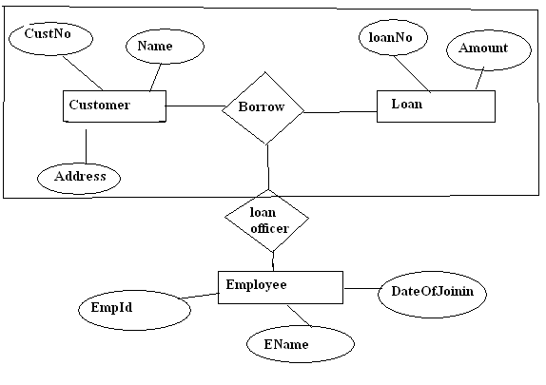

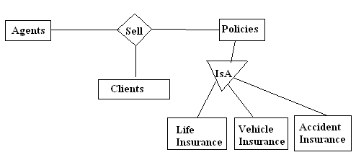

Q-7 Complete the following ERD and create tables (in SQL) for the same.

