Detecting and Isolating IP Spoofed Distributed Denial of Service Attack in Smart Grid Systems

¹Priyalakshmi.B
Department of Telecommunication Engineering
SRM University
Chennai-603203, India
¹priyalakshmi.b@gmail.com
²Karthikeyan. B
Department of Computer Science
National Institute of Technology
Rourkela, India
²karthikeyanb1911@gmail.com

Abstract— Smart grid(SG), which is considered as next generation power grid is an two way connected power system framework which enables easy monitoring and maintenance of power systems when compared to the existing power systems. Smart grid is also called as electrical grid or intelligent grid is an enhancement of 20th century power grid. Smart grid technically depends upon the network protocol and the topology over which it is constructed. Hence like the conventional connected systems, smart grid is also prone to number of security threats like Eavesdropping attack, data alteration attack, identity spoofing attack, compromised key attack, replay attack and distributed denial of service (DDOS) attack. In-spite of providing good technology to all the connected systems, there are frequent security breaches like DDOS attack which will extremely influence the availability of smart grid framework. Attacks targeting the availability like DDOS attack are the interruption of access or use of information which may further disrupt the power delivery. We have proposed three techniques to protect the framework against DDOS attack utilizing Marking system, TTL Value investigation and MAC value examination. With these schemes it is possible to pro-actively prevent the DDOS attack.
Keywords— DDOS Attack, TTL Value analysis, MAC value analysis, Smart Grid

I.INTRODUCTION
Smart grid is a new method of interconnected system for conveying power from producers to consumers in efficient, flexible and in more robust manner with high power-flow control, self-healing and with high data security using the digital technology [1]. According to the IEEE standard, Smart Grid is a mixture of power, communications and information technology for well advanced electric power system serving the power load. The word ‘Smart’ in Smart Grid is included due to the added benefit of communication and intelligence to the existing power grid which eases the monitoring and maintenance of system. The merit of converting the conventional Power Grid systems to Smart Grid is; more efficient transfer of electricity, quicker restoration of power outages, reduced maintenance and operation cost, increased integration of large scale power source and security control. Smart Grid systems can make an automatic diversion of the power based on the needs and in the case of outages. It also helps to make energy efficient process by creating awareness among customers about the power usage. Significant research has to be done towards stabilizing Smart Grid for the purpose of changing the power grid into an efficient and intelligent electric power distribution system adaptable to the present environment.
The benefits of having a Smart Grid rather than having a general Power Grid Systems make a wide difference to both the users and for the organizers of power systems by providing intelligence to the system and reliability to the customers. Some other the benefits of having Smart Grid systems are pointed out here [2]:
- Providing new services to the customers at the ease of click
- Improving the resilience of the system against the outage
- Strengthening the system against security attacks
- Automation of routine maintenance work
- Efficient routing of power
- Enhancing the efficiency of existing system
- Access to historical data
- Reduction of energy loss.

I.1. Literature review
Smart Grid systems have the goal to enhance performance of the existing power system by providing high availability, enhanced security, authenticated access control, easy maintenance and reduced cost [3]. To ensure the availability of critical real time power system, we must defend the system against all kind of security attacks. Security threats over the Smart Grid systems are applicable to all the industrial systems [5].

Some of such threats are
Denial of Service attacks [7],
Eavesdropping [8],
Man-in-the-middle attack [6],
Identify Spoofing [6],
Intrusion attack [6],
Compromised key attack [7]

The Cyber security working group in the NIST Smart Grid panel has issued various guidelines for Smart Grid Cyber security to improve the performance over the above security issues [9]. Further three level security objectives are classified for Smart Grid based upon Availability, Integrity and Confidentiality.
Attacks targeting Availability - The most important objective of Smart Grid system is to ensure reliable and timely access to the end user information. Attacks like DOS and DDOS can disrupt the availability of system for critical real time application.
Attacks targeting integrity - Protecting against incorrect modification or removal of user data are more essential for the marketing purpose. Loss of integrity in smart grid systems leads to incorrect decision regarding the user billing data.
Attacks targeting confidentiality - Preventing unauthorized access to data for preserving privacy is also a major objective of Smart Grid system. This is particularly necessary when private data should not be disclosed publicly.
Here we concentrate on the attack targeting availability. i.e, Distributed Denial of Service attack. The act of making a system or network resource unavailable to its destined users is termed as Denial of Service attack whereas in Distributed Denial of Service attack, multiple compromised systems were used to target single machine causing denial of service attack. In DDOS attack, the approaching activity overflowed from various source pointing at single exploited person is for the most part gigantic to control it by blocking single IP location and it is exceptionally troublesome to discover contrast between ordinary and assault movement when it is spread across over numerous sources.

DDOS is one of the prime threats in the current Internet world because of its ability to create enormous volume of unwanted traffic. The primary purpose of these attacks is to prevent access to a particular resource like a Web site [13]. The first reported Large-volume DDOS attack occurred in August, 1999, against the University of Minnesota [13]. This attack ceases down the victim's network for more than two days. In the year 2000, DDOS attack stopped many major commercial Web sites, including Yahoo and CNN, from performing their normal operations [13]. D. Moore et al. [13] used backscatter analysis on three weeks datasets to evaluate the number, duration and focus of DDOS attacks to characterize their behavior. They found that more than 12,000 attacks had occurred. Recently during the year 2013, massive 300Gbps attack was thrown against Spamhaus' website. Thus the severity of DDOS attack is increasing over every year. Hence in order to devise a broad solution for DDoS, there is a need to study and analyse the impact of DDoS attack against connected systems like Smart Grid. Here we have compared five different research papers which have used TTL value analysis and marking scheme as given in the below Table 1.1

Table 1.1 TTL value analysis and Marking scheme

Authors | MAC value analysis | TTL Value analysis | Marking scheme
Yao chen[9] | No | No | Yes
Ryo [10] | No | Yes | No
Cheng Jin [11] | No | Yes | No
Qiang [12] | No | No | Yes
Yaar [13] | No | No | Yes

II. Security threats in smart grid

Security threats in Smart Grid systems are classified based upon the selfish users and malicious users. Selfish clients are those who are trying to get more network resources than it was allotted to them by tampering standards. Malicious users are the one who have no motto to get advantage for their benefit but still they aim to illegally fetch, update or delete information in the network. In smart grid malicious clients have to be taken care more seriously than selfish users since a lot of frameworks are utilized for observing and control reason apart from giving information help. Further selfish users are of less importance since amount of data transmitted over the network is very less which is usually the billing data. Due to the modernization of the smart grid, security threats associated with other similar network are also applicable to the present smart grid system. Here we elaborate various such issues.
\subsection{Eavesdropping}
In Eavesdropping attack, the information packets are watched and once the attacker has the right to gain entrance to metering gadget of keen network, he is equipped for sniffing the whole information over the system. Listening in are by and large utilized for the business reason by checking and using the behavioral example of clients.
\subsection{Data alteration}
When the attacker has gained control over the grid, he can change the sniffed data as needed and send back the new version of data to the smart grid systems. Both the attackers and end users were also interested in modifying the usage for their own benefit.
\subsection{Identity spoofing attack}
In Smart Grid system each metering interface is assigned an unique IP address which is used reveal their identity. Once the attacker gains information about the system by eavesdropping, they can select any IP address from the network by IP spoofing and can send false information. Identity spoofing is used by DDOS attack when flooding data packets. Man-in-the-middle, message replays, network spoofing attack are some of the common identity spoofing attack [6].
\subsection{Compromised key attack}
Compromised key attacks are often possible in metering network of smart grid where the system uses identical key for encryption and decryption of the metering data. If the key which is being used to encipher the information is compromised then it is very easy to calculate the decryption key thereby gaining access to metering data which is modified by consumer to send false metering data. Utility operator gains access to the metering infrastructure to the utility plan of consumers.
\subsection{Replay attack}
Replay attacks can be launched when an attacker gain access to smart meters and inject control signals to the system. The attacker first needs to record data transmitted from customer to smart meters and analyse them to achieve customer’s characteristics of power usage. After analysing, the attacker may inject the data to grid system. Two common purpose of this attack is to steal energy and other is to cause physical damage to the system {17}.

III.ATTACKS OVER THE SMART GRID FRAMEWORK
Smart Grid framework is divided into four components and classified based upon the common attack possible as: power generator, service provider, Smart Grid system and customer. Power generator is responsible for generation and distribution of power to the service provider. Service provider does the monitoring operation over the entire framework for the purpose of billing and routing. Smart Grid system component does the job of load balancing, encrypting and decrypting of user billing data between each customer. Further it takes care of authentication and authorization over the framework. The encrypted data which is received from different customers are decrypted and sent back to the service provider. Different types of attack that are commonly found over the above said smart grid systems framework are Eavesdropping, Denial of Service attack, Data alteration, Identity Spoofing, Compromised Key attack and Replay attack[16][17][18]. Framework depicting the possible attack over different components of Smart Grid network is shown in Figure 1.

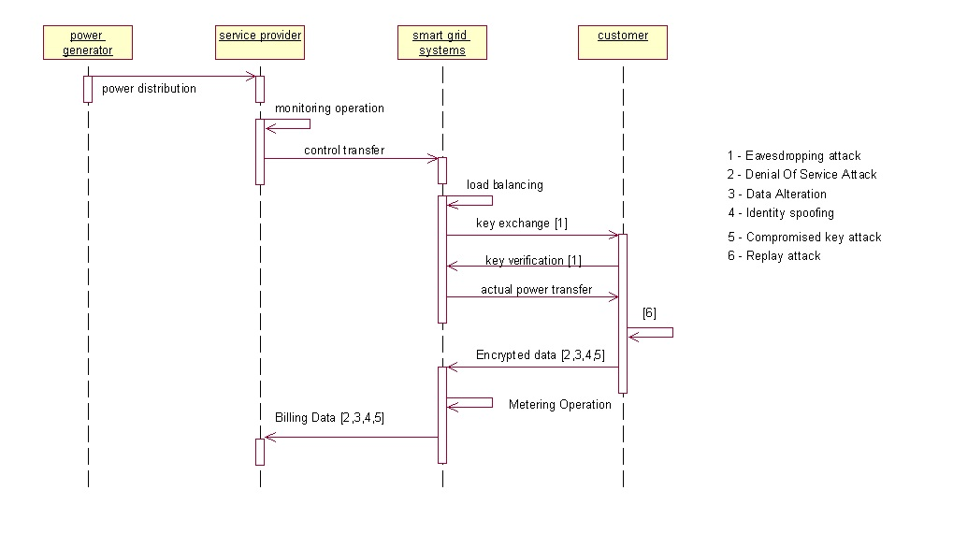
Figure 1: Smart Grid attack framework

IV.GENERAL FLOW STRUCTURE

We use three methods to detect and isolate DDOS attack. The three methods are Marking Scheme, TTL Value analysis and MAC value analysis. If the packets which are found positive in any of the methods then it has to be reject to enter the victim system. Here MAC value analysis works only when the attack packets are originated within the network. Similarly TTL value analysis works only when the packets are originated outside the network since packets which are originated within the network has no change in TTL Value. Marking Scheme works out only when the routers coordinate with each other to eliminate the DDOS attack.
\section{Marking scheme}
Distributed Denial of Service attack is crumbling the internet every day. Traditional approach to protect the system against DDOS attack is to provide Source IP address of the attacker and path it travelled. With this information, the attacker can reach out the Internet Service Provider to drop all packets coming from the specific attacker. But it is very difficult to detect and stop the DDoS attacks, particularly those attack which uses IP address spoofing to disguise those attack flow. Though the source IP address is changed by the attackers, the path it has taken to reach the victim is totally determined by the network topology and routers present inside it. Unlike the other methods, marking scheme can very well distinguish attack data from the normal data flow by the legitimate users. In marking scheme, each packet is embedded by certain marking, enabling the victim to identify the packets which are not from legitimate users by checking each packet regardless of IP address spoofing. Each packet travelling in the same path carries the same marking identification and hence the victim can pro-actively defend themselves against DDOS attack. Simulation Parameters and description is given in the Table 2.
Table 2. Simulation parameters

Simulation Parameter | Description
Number of Download | Total number of downloads in session
Request Interval | Time gap between each download request
Session Interval | Time gap between each session
Abort Time | Time taken for connection Abort
Active Interval | Time gap to check number of active download
Monitor Interval | Time gap to monitor buffer occupation
Bottleneck Bandwidth | Maximum limit for Queue
Tolerance Time | Time interval to check the number of failures
Connection Count | Number of FTP and UDP connection

Simulation results:

In marking scheme, results are analyzed based on two scenarios:

Data packets are travelled directly between source and destination

Data packets not travelling directly between source and destination.

When IP spoofed packets are used for DDOS attack, the path which each packet has taken will differ rather than original path destined for the particular IP address. Hence we use the deviation in the performance metrics over the change in path to locate the occurrence of DDOS attack in network. Each connection is made up of 50 sessions with each session having 10000 download with bottle neck bandwidth of 1.5 Megabits and request size of 5000 bits. Simulation of higher data flow is created with 50000 sessions with each session having 10 million downloads at the bottle neck bandwidth of 1.5Mb. Results derived from above specification are analyzed to prove that data with peak curve is the sign of attack and hence the algorithm to isolate the attack packets has to be initiated. Average computation data for 10/50 clients without implementation marking is given below in the Figure 2 and Figure 3. Simulation results for 10 and 50 clients with normal and attack data flow with marking scheme implemented is shown in the Figure 4 and Figure 5.

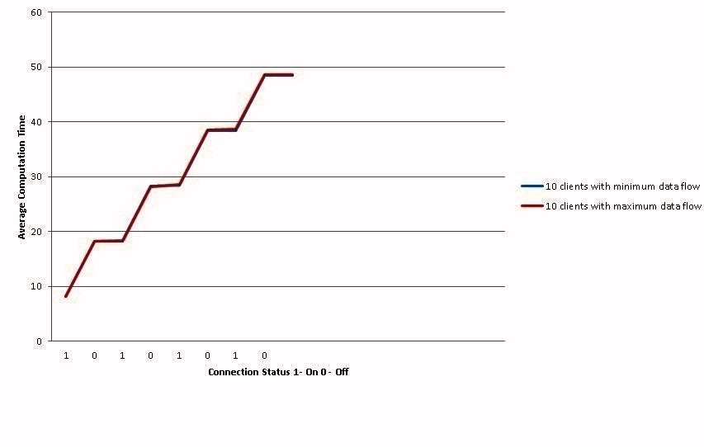
Figure 2: 10 clients comparison

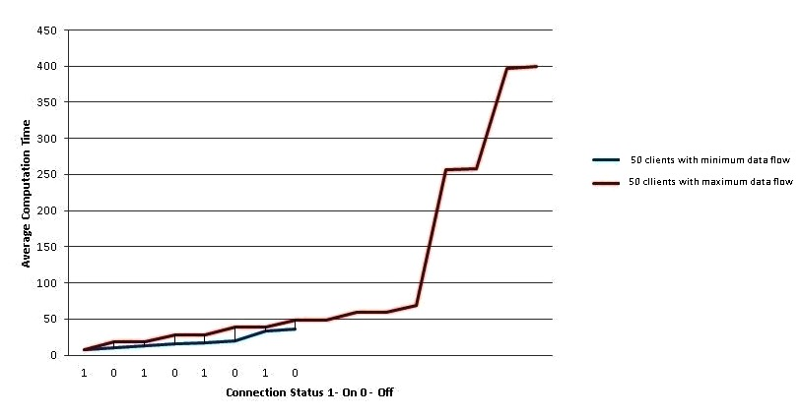

Figure 3: 50 clients comparison

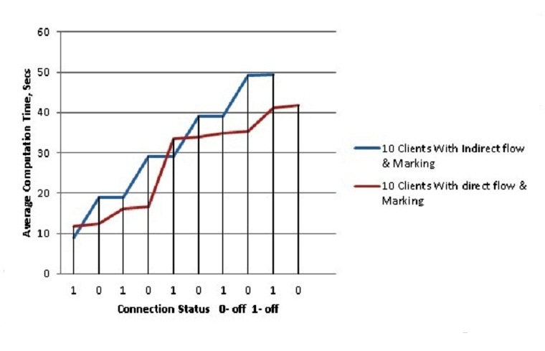
Figure 4: Comparison of 10 clients with marking scheme
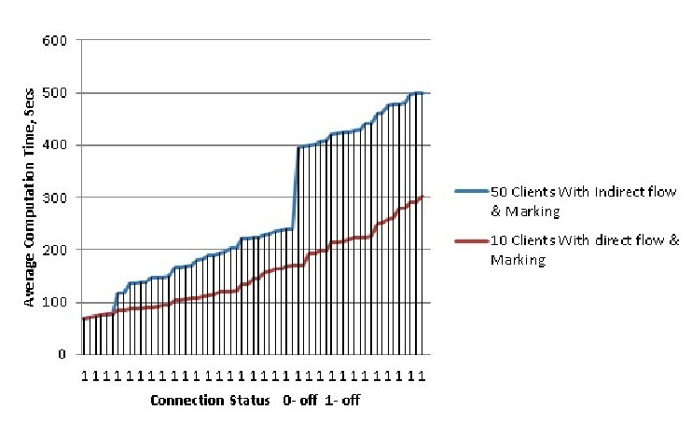

Figure 5: Comparison of 50 clients with marking scheme

V. TTL VALUE ANALYSIS:
In Internet, every IP packet goes across not more than 30 routers before reaching its destination. But some IP packets have an abnormal TTL value which is decreased by more than 30 hops. We assume that IP packets with strange TTL values in IP headers as malicious packets and hence it is discarded. These packets are likely to be generated by special tools. Every computer fix the TTL value when it sends the packet based upon the operating system and the protocol which sends the packet. It is possible to estimate the total number of routers between source and destination using the TTL values [10]. TTL Values of popular operating system were given below in the Table 3.

Table 3: TTL Values of different operating systems

Operating system | Protocol | TTL Value
Linux kernel 2.2.14 | ICMP | 255
Windows Server 2008 | ICMP, TCP, UDP | 128
Windows 7 | ICMP, TCP, UDP | 128
Windows XP | ICMP, TCP, UDP | 128
Free BSD 5 | ICMP | 64
MAC OS 10.5.6 | ICMP, TCP, UDP | 64
Solaris 2.8 | TCP | 64

TTL values of normal and abnormal IP packets based upon the average hop count is given below:
Normal TTL value: if 30<ttl<=64: 98<ttl<=128: 225< ttl<=255
Abnormal TTL value: if 1<ttl<=30: 64<ttl<=98: 128< ttl<=225
Cisco Packet tracer is used to simulate a network topology consisting of six clients connected to two servers via three routers and two switch. Each node ping's the node present in other network to test the decremented TTL value. Below Figure 4.5 shows the Network created using Cisco packet tracer to analyze the TTL values.

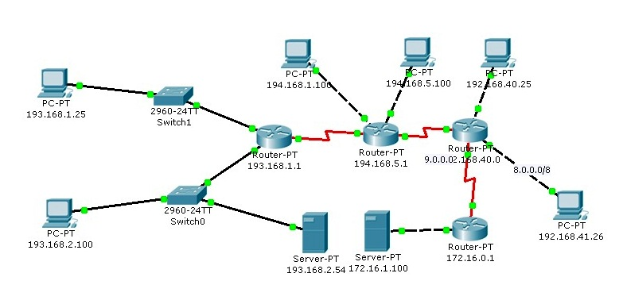

Figure 6: Network used for TTL value analysis

VI. MAC VALUE ANALYSIS

Many IP addresses attached to the same MAC would mean that many IP's coming through the same interface and hence those packets can be rejected with the help of table maintaining the list of source with its IP Address and MAC address. In most of the modern attacks, single attacker creates random source flooding attack and hence it is easy to distinguish the source with fake MAC address. Hping3 tool is used to create Random source flooding attack which creates thousands of Packets in few minutes. It produces a real time DDOS attack with same MAC address. But MAC address does not appear in the IP packet once it crosses the network on which originates. Hence MAC value analysis is useful only when the fake IP packet rises within the network. ARPwatch tool is used to analyse the list of newly added IP and MAC pairs in the ARP table. ARPwatch tool produces an alert when there is a new entry of new IP address and MAC value pairs into the ARP table which can be verified with the help of Wireshark tool also.
- Hping tool is used to create an random source flooding attack
- ARPwatch is used to monitor the network for IP and MAC address information along with time-stamp
- Ethernet traffic activity like Changing IP and MAC address address is maintained in the database and dropped using Snort tool
- Wireshark is used to cross verify the presence of fake IP and MAC entry

VII.Conclusion and future work

This paper deals with detection and isolation of DDOS attack in Smart Grid systems by using three methods. First method involves detecting fake packets which are created by the attacker during Distributed Denial of Service attack by comparing TTL value. But still there are packets which are escaping from this method since attacker now uses more sophisticated software's where they can change the TTL Values also. Hence we need a method which detects the packet escaped from the first method. So we created second scheme which uses marking scheme to produce an mark over each IP packet to find and isolate the attack packets. Each packet travelling across same router has similar kind of marking. Hence the fake packets which are having a Marking irrespective of its network can be detected. Marking scheme is useful when the routers among all networks cooperate to find the attack path. There are cases where the DDOS attacks were created within the network targeting another system inside the network. So we created third scheme which uses MAC value to differentiate fake packets Since two packets coming from two different users cannot have same MAC value.

In future we can extend the work done to prevent DDOS attack, when the attacker changes both the MAC and IP address. We can integrate the TTL value analysis and Marking scheme together at Router level to detect and prevent DDOS attack.Authors and Affiliations

REFERENCES
[1]. Ye Yan, Yi Qian, Hamid Sharif, and David Tipper. A survey on cyber security for smart grid communications. Communications Surveys & Tutorials, IEEE, 14(4):998{1010, 2012.
[2]. Xi Fang, Satyajayant Misra, Guoliang Xue, and Dejun Yang. Smart grid the new and improved power grid: a survey. Communications Surveys & Tutorials, IEEE, 14(4):944{980, 2012.
[3]. Gianni Fenu, Marco Nitti, and Pier Luigi Pau. A complex network approach for a regional power grid analysis. In Digital Information Processing and Communications (ICDIPC), 2012 Second International Conference on, pages 45-50. IEEE, 2012.
[4]. Mini S Thomas, Ikbal Ali, and Nitin Gupta. A secure way of exchanging the secret keys in advanced metering infrastructure. In Power System Technology (POWERCON), 2012 IEEE International Conference on, pages 1-7. IEEE, 2012.
[5]. Jingcheng Gao, Yang Xiao, Jing Liu, Wei Liang, and CL Chen. A survey of communication/networking in smart grids. Future Generation Computer Systems, 28(2):391- 404, 2012.
[6] T. Littler S. Sezer Eul Gyul Im Z.Q. Yao B Pranggono H F Wang Y. Yang, K. McLaughlin. Man-in-the-middle test bed investigating cyber-security vulnerabilities in smart grid in scada systems, sustaniable power generation and supply, 2012.
[7]. Guidelines for smart grid cyber security NISTIR 7628 Cyber Security Working Group. The smart grid interoperability panel, 2010.
[8]. Monika Sachdeva, Gurvinder Singh, Krishan Kumar, and Kuldip Singh. Measuring impact of ddos attacks on web services. 2010.
[9]. Yao Chen, Shantanu Das, Pulak Dhar, Abdulmotaleb El-Saddik, and Amiya Nayak. Detecting and preventing ip-spoofed distributed dos attacks. Network Security, 7(1):69-80, 2008.
[10]. Ryo Yamada and Shegeki Goto. Using abnormal ttl values to detect malicious ip packets. Proceedings of the Asia-Paci_c Advanced Network, 34:27-34, 2013.
[11].Cheng Jin, Haining Wang, and Kang G Shin. Hop-count filering: an effective defense against spoofed ddos attack. In Proceedings of the 10th ACM conference on Computer and communications security, pages 30-41. ACM, 2003.
[12]. Qiang Li, Hongzi Zhu, Meng Zhang, and Jiubin Ju. Simulating and improving probabilistic packet marking schemes using ns2. In Parallel and Distributed
Computing, Applications and Technologies, 2005. PDCAT 2005. Sixth International Conference on, pages 348{352. IEEE, 2005.
[13]. Abraham Yaar, Adrian Perrig, and Dawn Song. Pi: A path identification mechanism to defend against ddos attacks. In Security and Privacy, 2003. Proceedings. 2003 Symposium on, pages 93{107. IEEE, 2003.
[14]. Jelena Mirkovic, Ale_ya Hussain, Brett Wilson, Sonia Fahmy, Peter Reiher, Roshan Thomas, Wei-Min Yao, and Stephen Schwab. Towards user-centric metrics for denial-of-service measurement. In Proceedings of the 2007 workshop on Experimental computer science, page 8. ACM, 2007.
[15]. Jelena Mirkovic, Sonia Fahmy, Peter Reiher, Roshan Thomas, Ale_ya Hussain, Steven Schwab, Calvin Ko, and VA Centreville. Measuring impact of dos attacks. In Proceedings of the DETER Community Workshop on Cyber Security Experimentation, 2006.
[16]. Jong-Ho Lee Thien-Toan Tran, Oh-Soon Shini. Detection of replay attacks in smart grid systems. CHECK IN INTERNET, 34:27{34, 2013.
[17]. Mohd Jameel Hashmi, Manish Saxena, and Rajesh Saini. Classification of ddos attacks and their defense techniques using intrusion prevention system. International Journal of Computer Science and Communication Networks, 2(5), 2012.
[18]. R. Melhem D.Mosse S.M. Khattab, C. Sangpachatanaruk and T. Znati. Proactive server roaming for mitigating denial-of-service attacks. pages 500-504. Elsevier, 2003.
[19]. A. Yaar, A. Perrig, and D. Song. Pi: a path identi_cation mechanism to defend against ddos attacks. In Security and Privacy, 2003. Proceedings. 2003 Symposium on, pages 93{107, May 2003.
[20]. Rabab Hassan and Ghadir Radman. Survey on smart grid. In IEEE SoutheastCon 2010 (SoutheastCon), Proceedings of the, pages 210-213. IEEE, 2010.

