Exploring Cyber Intelligence Alternatives for Countering Cyber Crime: A Continuing Case Study for the Nation
P.Usha Gayatri¹ D.Radhika² G.Sruthi³ K.Chandra Sekharaiah⁴
K.Satish⁵ S.Mounika⁶ K.Shravani⁷ Ambuja Kulshreshtha⁸
^{ushagayatri@gmail.com} radhikdomanapally22@gmail.com ganaboinashruthi@gmail.com chandrasekharaiahk@gmail.com katraparthy.satish@gmail.com seethamounika.krishna@gmail.com shravani.mickey@gmail.com ambujakulshreshtha@gmail.com
Abstract
In our earlier work, we presented a case study of cyber intelligence alternatives for handling cybercrime [1]. In this paper, we present the related extension work. We present a case of two cybercrimes- (1.)Cheating crime (2.)Sedition crime. The cybercrimes exploit web technology for online cheating ‘Government of Telangana’ (CGoT) and for online seditious ‘Government of Telangana’ (SGoT) whose affiliated organization JNTUHJAC has been operational in the JNTUHyderabad university over the last many years. We present a few snapshots of the culprit website’s home page from wayback machine, an web crawler tool for Internet archiving of websites. The snapshots capture evidence of the usage of cheating & seditious identity ‘Government of Telangana’ to which the said JNTUHJAC organization claims belongingness. We present how they serve as cyber intelligence alternatives for countering cybercrime.
Keywords: Government of Telangana (GoT), National Emblem of India-abusive GoT (NEIAGoT), Seditious GoT(SGoT), Fake, Cheating and Seditious GoT(FnCnSGoT), Threats to National Integration in Bharat (TsNI), Culprit GoT which is involved in the twin crimes of Online Cheating and Online Sedition which are crimes(TsNICGoT), State Emblem of India (Prohibition of Improper Use) Act 2005 (SEIPIUA), Jawaharlal Nehru Technological University Hyderabad(JNTUH), Joint Action Committee (JAC), GoT which came into existence since the appointed day 2Jun 2014 after the Parliament passed the A.P. Reorganization Bill (PGoT)
^{1.Introduction}
In a civilized nation like India, legislatures make Acts. Acts are bills passed by the legislatures. Even prior to Independent India, there were codes of law such as Cr.P.C. and IPC which are extant. Also, there are laws such as labour law, law of torts, company law etc. Crime means violation of Act/ Code/ Law. A cyber crime is one that violates similarly but using web as the medium. Often, cyber crimes are difficult for handling and are elusive to proof of evidence. Sometimes, however, cognizable evidence of cyber crimes cannot belie the cyberforensic experts. In our earlier work in [1], we presented a case study of a crime that was violation of SEIPIUA. In this paper, cheating crime and sedition crime [4] are presented two more cyber crimes w.r.t. organized group in JNTUH by F/C//SGoT and JNTUHJAC.
In [1], the crime of violation of SEIPIUA was attributed to JNTUH-JAC. In this paper, we highlight that a GoT was on records in the website of JNTUH-JAC which used in its logo mention of “Government of Telangana” (prejudiced to law and constitution of India )during the years 2011, 2012, 2013 and in the first half of year 2014. This is termed as TsNICGoT in contrast with PGoT. TsNICGoT is the culprit organized group. This members of this TsNICGoT are liable to punitive action by the court of law under the crimes of cheating and sedition. We prove by cyberforensics capturing certain snapshots of the culprit GoT’s JNTUHJAC website.
The rest of the paper is organized as follows. Section 2 gives in brevity about Internet Archiving and Wayback Machine, a web crawler tool. Section 3 captures the snapshots of culprit website’s homepage and an analysis of time span during which the culprit GoT’s crimes were prevalent. Section 4 concludes the paper.
^{2.Internet Archiving}
The Internet Archive [2] does the function of archiving based on non-profit motto. It provides free public access to the old status of websites as saved on certain chosen dates. Internet Archive data is collected automatically by its web crawlers. Its webcrawler works to preserve as much of the public web as possible. Its web archive, The Wayback Machine, contains over 150 billion web captures.
2.1 Wayback Machine: A Web Crawler Tool
The Internet Archive Wayback Machine is a tool to capture snapshots of webpages/sites online. It is an automated system to generate an archive that contains crawls/archives of websites. As of 1Jul2015, it contains twenty three petabytes of data. Its current growth rate is 50-60 terabytes/week. In other words, the Internet Archive Wayback Machine is a service that allows people to visit archived versions of websites. Users of the tool can type in a URL of a website under consideration just as they give a search word in an internet search engine such as Google. Users can select a date range, and then surf an archived version of the website under consideration.
3. Capturing the Snapshots of the Culprits’ Website’s HomePage
8 Snapshots of the culprits’ website are shown below for the period 12Nov2011 –17May2014. They are the results of web crawling. They are dated 12Nov2011, 29Nov2011, 30Dec2011, 26Feb2012, 10Jun2013, 06Oct2013, 08Jan2014, 17May2014, as per the automated web crawls by wayback machine. The first 7 web crawls captured an image with a logo on the R.H.S. which contains Indian National Emblem. This is a cyber crime already reported in our earlier work in [1]. Also, we find mention of ‘Government of Telangana’ in the logo on the R.H.S. This is not only CGoT but also SGoT. This FGoT is misleading and cheating the nation. The logo is part of the image during the years 2011-14. It cannot be ruled out that the CGoT/SGoT/FGoT works in the background/underground/parallelly now. In the 8th web crawl, the image with the logo is found removed. Subsequent to the date of the 8th crawl, the website removed the cybercrime content in the website. The table below vindicates that the crybercrimes of online Cheating and online Sedition were committed by the C/SGoT during the years 2011, 2012, 2013 and till the first half of the year 2014 i.e. nearly 3 years.
Snapshot No. | Date & Month | Year | CyberCrime evidence present in the culprit website or not
Snapshot No. | Date & Month | Year | CGoTcrime of Cheating the nation | SGoT crime of Sedition against the nation
1 | 12 Nov | 2011
2 | 29 Nov | 2011
3 | 03 Dec | 2011
4 | 26 Feb | 2012
5 | 10 Jun | 2013
6 | 06 Oct | 2013
7 | 08 Jan | 2014
8 | 17 May | 2014 | X | X
Table: Depicts the Extent of Time/Years when the crime was prevalent
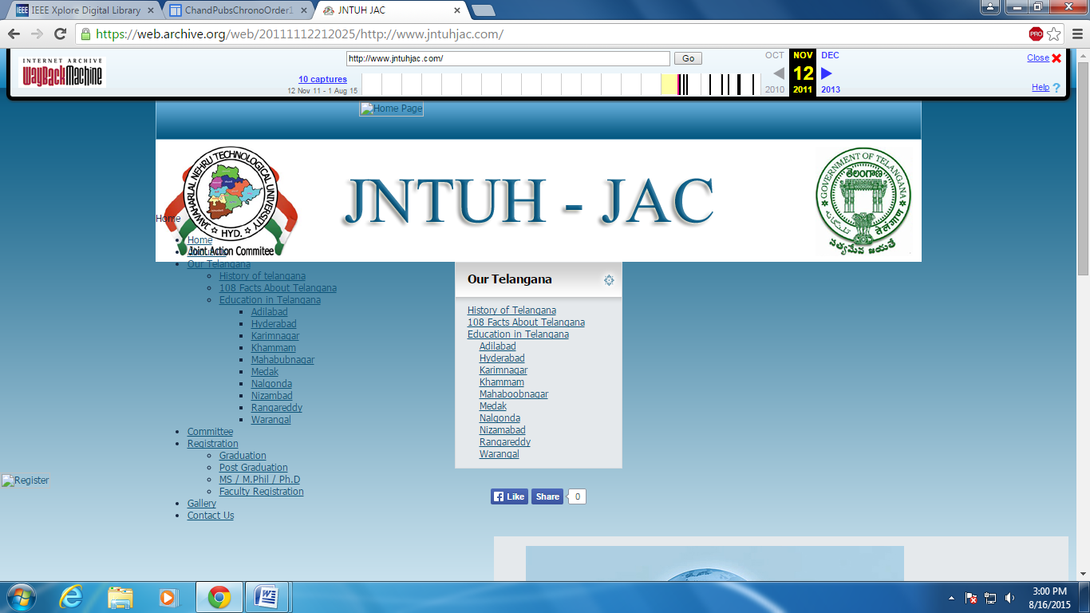
^{Snapshot 1: dt.12Nov2011}
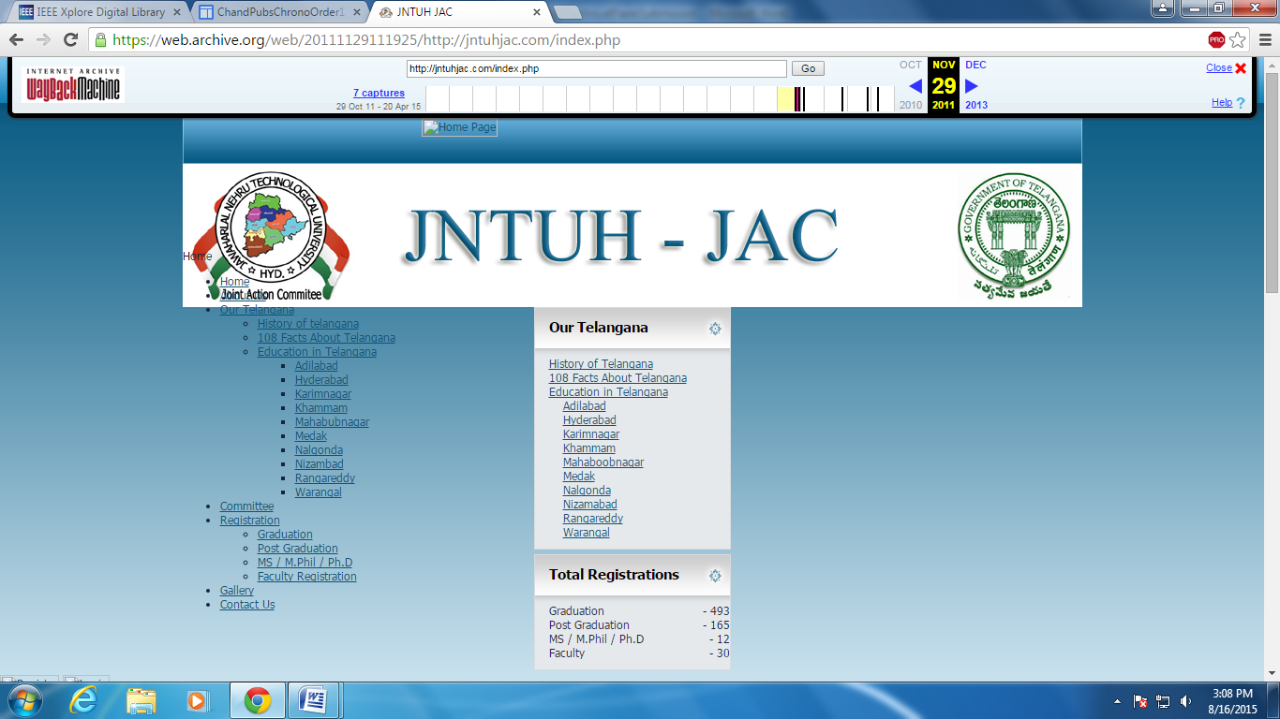^{Snapshot 2: dt.29Nov2011}
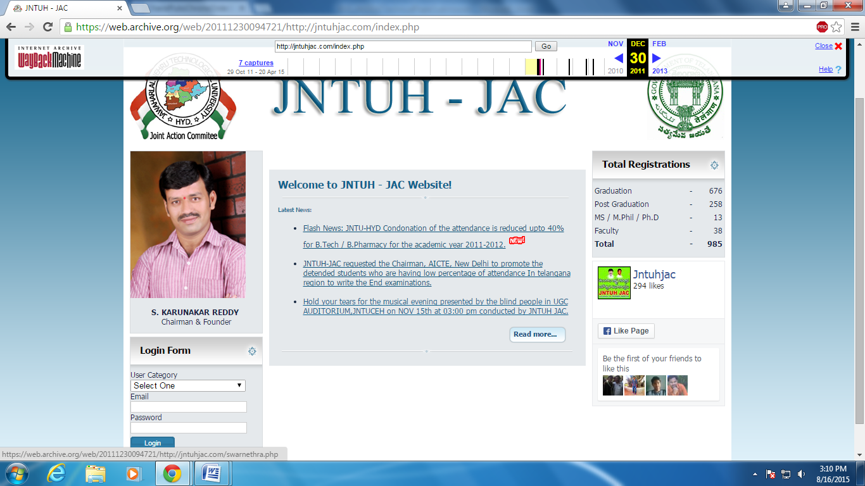
^{Snapshot 3: dt.30Dec2011}
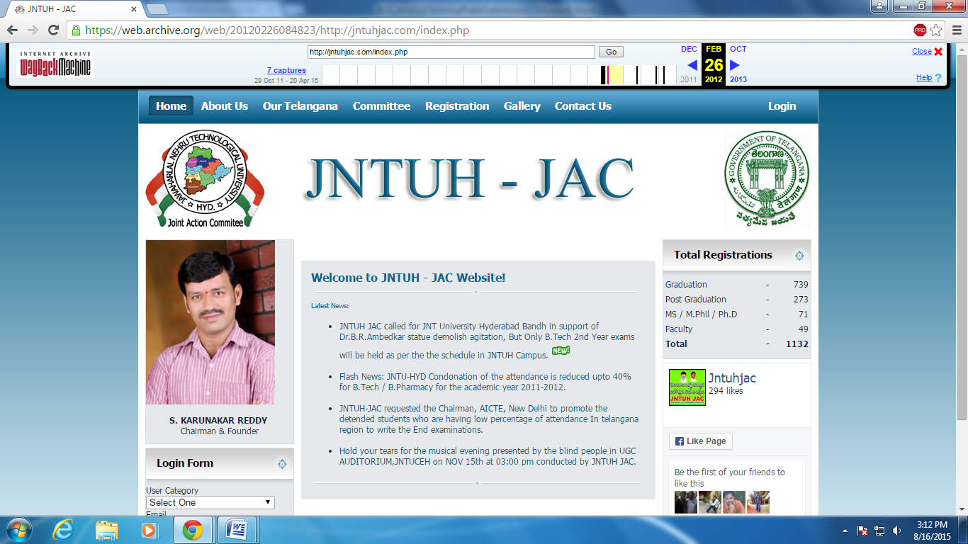
^{Snapshot 4: dt.26Feb2012}
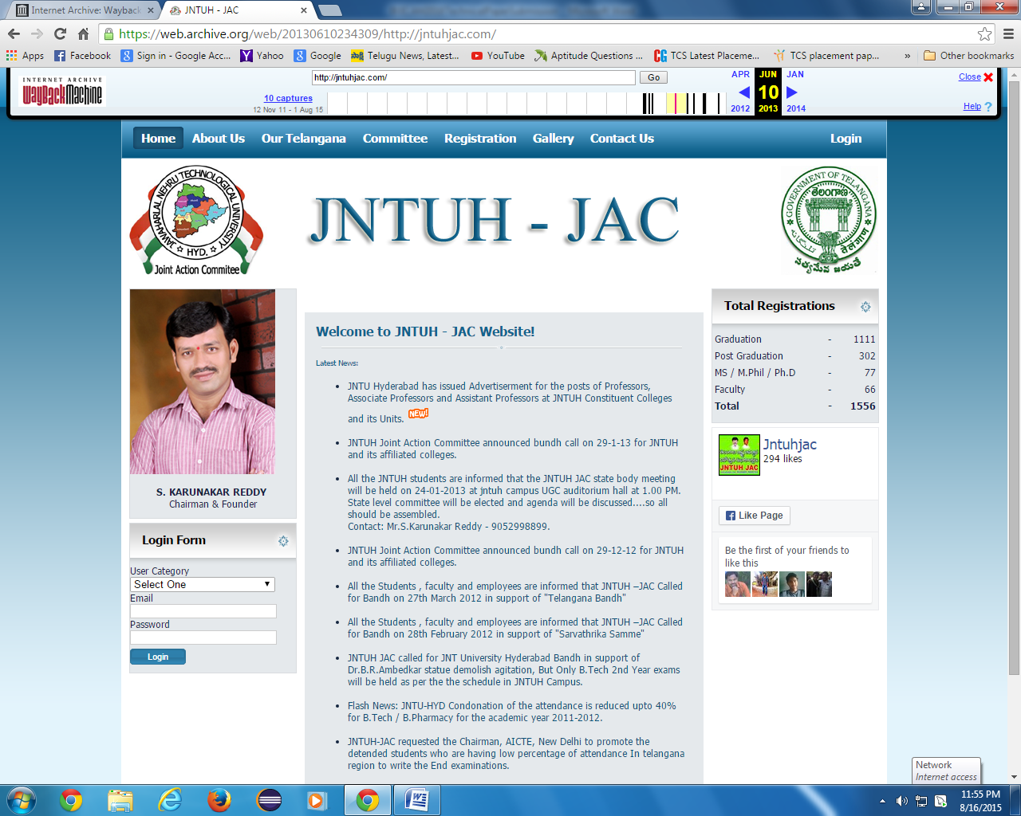
^{Snapshot 5: dt.10Jun2013}

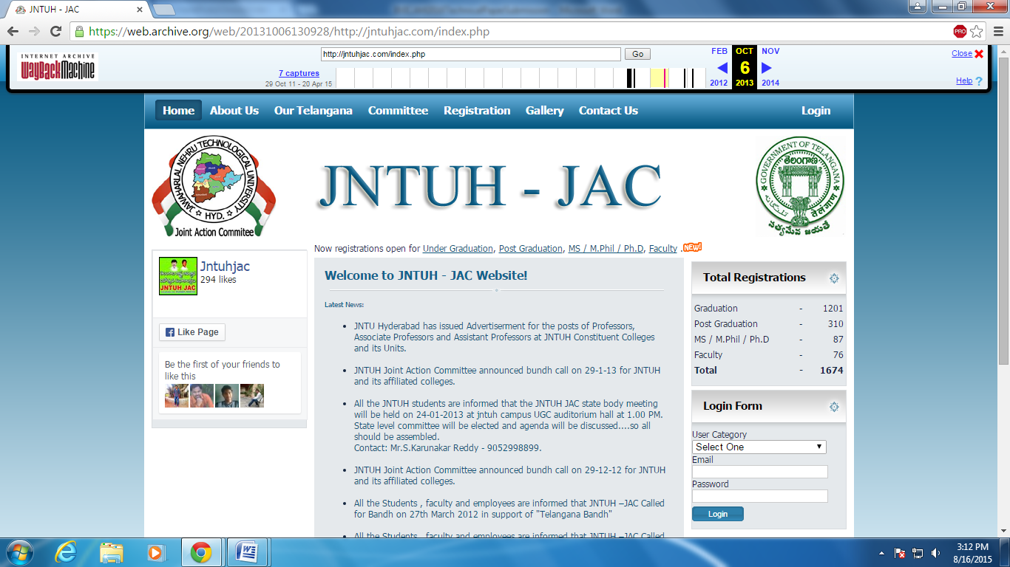
^{Snapshot 6: dt.06Oct2013}

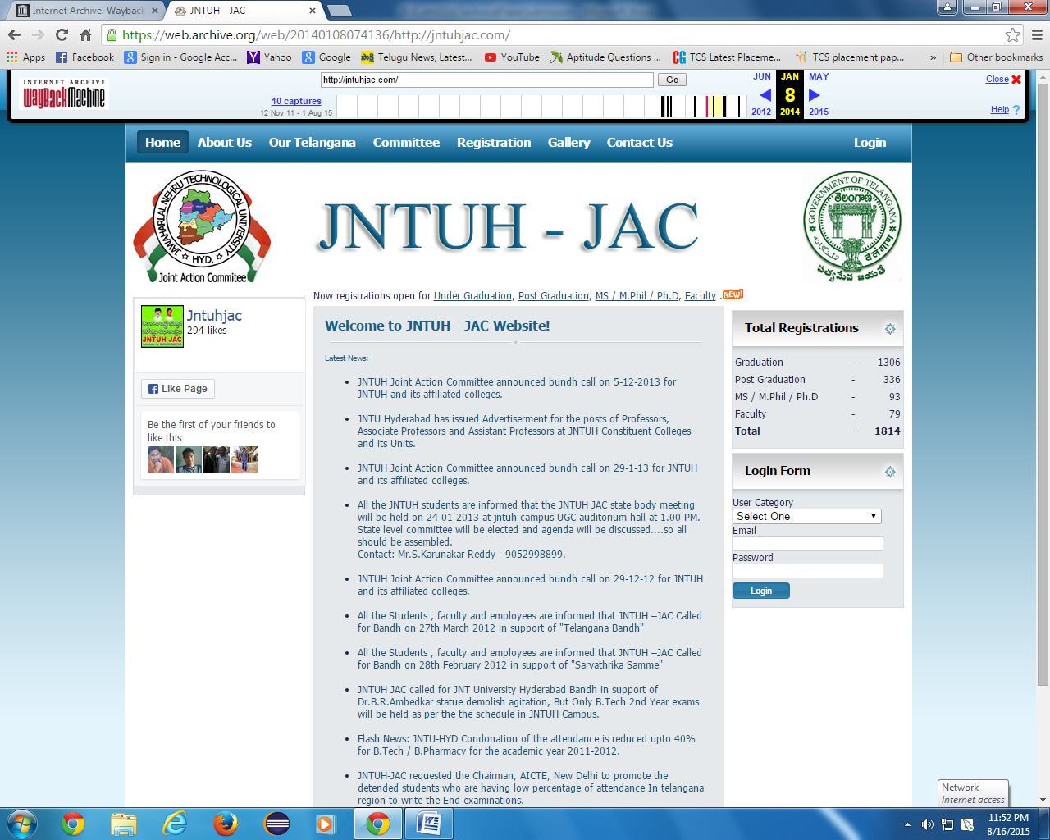
^{Snapshot 7: dt.8Jan2014}
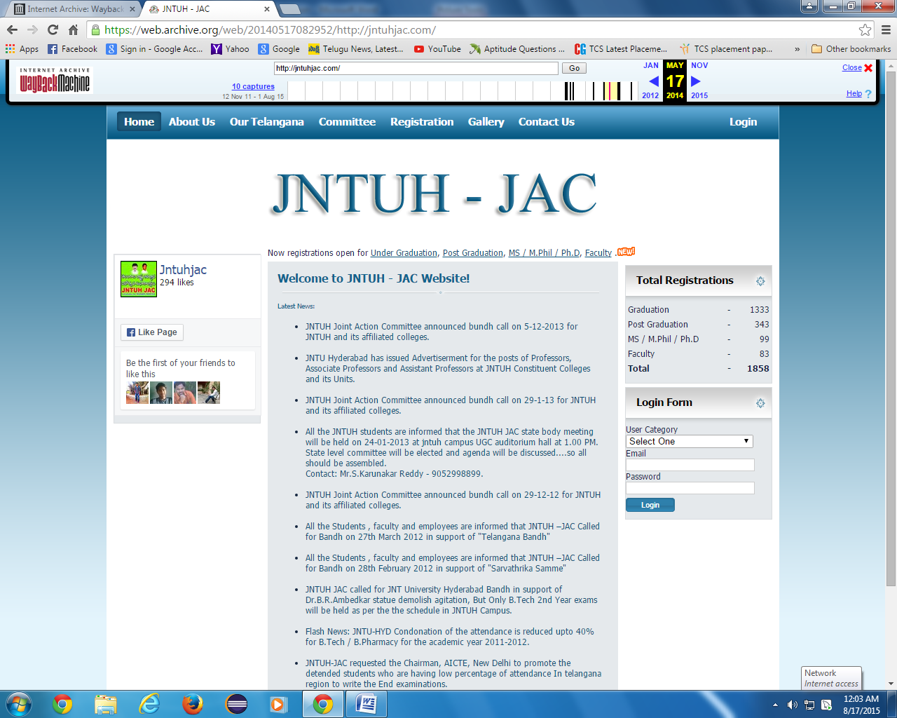
^{Snapshot 8: dt.17May2014}
^{4.Conclusions}
The culprit GoT is involved in 3 crimes altogether clearly. In this paper, sedition crime and cheating crime are highlighted.
Over the years 2011-14, these two crimes are ignored in the sense that no FIR is registered despite complaint. Using Wayback Machine web archiving tool, the instances of web crawls are retrieved. These data show that these 2 crimes were perpetrated against the nation. The 7 snapshots clearly show clues to prove the crimes of culprit GoT. Such organized crimes are threats to the national spirit and national integration in India.
If online culprit GoT is spared, it will set wrong precedence and such crimes tend to recur. It becomes a vicious cycle. Therefore, such a Cheating/Fake/Seditious Govt. should be prohibited. In [3], we attempted to remedy the situation by making available Guidance and Counseling web page to make transparent to the general public the issues involving cybercrimes against the nation.
^{References:}
- Usha Gayatri P., Neeraja S., Leela Poornima Ch., Chandra Sekharaiah K. and Yuvaraj M., “Exploring Cyber Intelligence Alternatives for Countering Cyber Crime”, Proceedings of the 8th INDIACom; INDIACom-2014, International Conference on “Computing for Sustainable Global Development”, 5-7March2014, Bharatiya Vidyapeeth’s Institute of Computer Applications and Management (BVICAM), New Delhi (INDIA).
- https://archives.org/web
- https://sites.google.com/site/chandraksekharaiah/india-against-corruption-jntu
- http://www.rmlnlu.ac.in/webj/sedition.pdf

