Hybrid Two-Tier Framework for Improved Security in Cloud Environment

Aarti Singh
Associate Professor
Maharishi Markandeshwar University, Mullana
India

Manisha Malhotra
Research Scholar
Maharishi Markandeshwar University, Mullana
India

Abstract— Cloud computing has already grabbed its roots in IT industry. It has become an appealing choice for small budget organizations since on demand resources are available on pay as you use basis. However, security of data being stored at cloud servers is still a big question for organizations in today’s digital era where information is money. Large organizations are reluctant to switch to cloud services since they have threat of their data being maltreated. Cloud service providers claim of providing robust security mechanism being maintained by third party, but still there are many reported incidents of security breach in cloud environment in past few years. Thus there is need of robust security mechanism to be adopted by cloud service providers in order for excelling cloud computing. This work proposes a hybrid two-tier agent based framework which deploys symmetric and asymmetric key algorithms in combination to provide robust security to user data. Further, this mechanism provides data decryption control to user only, thereby eliminating threat of data being misused by cloud service provider. Both cryptography algorithms being used in this work, have proved excellence for small key size, small encryption time and high speed, thus this framework would increase security without affecting processing speed of virtual machine.
Keywords— Cloud Computing, Data Security, SaaS, Cryptography, ECC algorithm, Blowfish algorithm, Agent Technolo.)

Introduction
Cloud computing provides maximum advantages of computing & virtualization by sharing resources among various users on minimum cost. In Infrastructure as a service (IaaS) model of CC, all user data is stored at service provider’s location i.e. cloud data center [4]. Functionality of a data center is abstracted from the user, however in order to attract organizations and individual users to Cloud, security and integrity of stored data has to be maintained by the cloud service provider (CSP). Considering all concerns of users for security of their data, while passing it to a black box, in today’s digital era, it creates pressure on CSPs to apply robust mechanisms to avoid data against various types of attacks and unauthorized accesses. Data security is utmost important concern of this computing. Cryptography is traditionally accepted method of ensuring data security. It is the mechanism to secure data by converting it into non-readable form. There are two types of cryptography algorithms: symmetric and asymmetric key algorithms. Symmetric algorithms use only one key i.e. private key which is used for both encryption and decryption of data. In asymmetric algorithm, there are two keys, one is private and another is public key. Public key is used for encrypting the data and private key is used for decryption of data. Asymmetric algorithms are more secure than symmetric algorithm because in asymmetric algorithms both keys are different and leakage of one single key can’t cause harm to the encrypted data.

Some well known techniques of symmetric key cryptography are Data Encryption Standard (DES), Advance Encryption Standard (AES) and Triple DES [14]. In contrast to this, BlowFish (BF) is a 64 bit symmetric block cipher with variable key length. It’s main feature includes significantly less time consumption in encryption-decryption process as compared to other algorithms. Thus this algorithm can be used effectively in those cases where key does not change often. Table I given below shows comparison of various symmetric algorithms [12].

TABLE I. PERFORMANCE COMPARISON OF SYMMETRIC KEY ALGORITHMS
 | 20527 Bytes | 45911 Bytes | 69545 Bytes | 191383 Bytes
Algorithm | Times (In Sec)
DES | 24 | 57 | 83 | 227
3DES | 72 | 158 | 243 | 655
AES | 39 | 94 | 147 | 378
BF | 19 | 46 | 67 | 176

Above table shows that blowfish takes minimum time to encrypt large data which indicates that it has high speed.
Now, lets have a glance on asymmetric algorithm. Traditional encryption algorithm like DSA, RSA, Diffie Hellman have large key sizes which result in more time consumption and space complexity. In contrast to all these algorithms, ECC is a public key crypto system having small key size and more security in the form of key exchange, communication privacy, and authentication. Due to all its features, ECC gives significant improvement over all existing asymmetric algorithms. Table II given below [16] provides comparison of key sizes for asymmetric algorithms.

TABLE II. KEYS OF VARIOUS ASYMMETRIC ALGORITHMS
ECC | DH/RSA/DSA
163 | 1024
224 | 2048
282 | 3072
409 | 7680
512 | 15360

Above discussion reveals that Blowfish and ECC are most efficient encryption algorithms in symmetric and asymmetric key cryptography. These algorithms when deployed in combination may increase security level of a system. This work aims to develop an efficient security engine for cloud environment using above algorithms in combination.

Section 2 presents literature review on cloud security aspects. Proposed work is elaborated in section 3. Section 4 describes the results and implementations of proposed architecture. Finally section 5 concludes the paper.

RELATED WORK
This section presents existing work related to security concerns in cloud computing and solutions proposed by various researchers in this domain.

Loganayagi et al., [8] proposed an automated monitoring tool which keeps the information of every incoming request and its path from where it has been generated. This tool identifies any violation in the system and it works with virtual server. But due to this complexity of system increases. Faniyi et al. [2] proposed a novel dynamic data driven architecture which has the capability of resource provision in cloud federation with minimum service level agreement (SLA) violations. The author presented a new layer between the cloud user and provider named as cloud federation middleware which works on dynamic data driven architecture and provides the permissible services without any violation. However authors didn’t pay any attention towards security issues. Orellana et al. [10] proposed a new transparent layer which encrypts the data before storing it on Google server. The authors have presented a solution particularly for google server to store Google docs. In proposed encryption layer, an index file keeps the information of doc_id and type of security algorithms, so that the user may choose security algorithm based on requirement. After selecting the algorithm the data would be converted into cipher text and would be stored in google server. Results shows that blowfish has smaller key size and faster speed as compared to other algorithms. However, all algorithms discussed are symmetric algorithms which are less secure than asymmetric algorithms. Yuefa et al. [17] has highlighted the need of security in cloud computing. Currently, most of the agencies are working on Hadoop Distributed File System (HDFS) architecture which is based on master (name node) and slave (data node) node. Every data has three replicas being stored on data nodes. According to this study, all access control of data nodes are managed by a single point i.e. name node which can be a cause of failure. Huiqi et al. [6] proposed Random Space Perturbation (RASP) method and Nearest Neighbour ( kNN ) which addressed the four main aspects of data confidentiality, query privacy, efficient query processing and low processing cost. The experiment was performed under a threat model which shows efficiency with minimum cost. But in this model there is chance of data leakage.

Schwarzkopf et al. [15] presented an architecture which increases the security of virtual machines. The architecture is divided into two parts one is update checker architecture and another is online penetration suite architecture. Update checker identifies the outdated information installed on virtual machines. Second one scans all virtual machines and boot them if there is need for it. The proposed architecture is applicable only on Linux environment. However, there is need of a platform independent architecture which can be applied on every environment. Khalid et al. [7] have presented a solution towards the security of cloud by designing an anonymous authentication and authorization protocol using anonymous public key certificates along with standard strong authentication. The proposed model is divided into two phases one is authentication and second is authorization. The authors have only focused on web attacks on the data. Govinda et al. [5] proposed a method for identity anonymity in private cloud using group digital signature. However the mechanism uses RSA algorithm for encryption and decryption.

Salama et al. in [14] has given the comparative analysis of six symmetric key algorithms Blowfish, RC6, AES, DES, 3DES, RC2 for wireless devices. The authors have compared all these algorithms to check the power consumption of devices. Firstly they have checked the throughput of these algorithms by varying packet size. The result shows that Blowfish have the maximum throughput. Further, the power consumption of all these algorithms has been compared and blowfish have been found to consume lesser percentage of battery. Rabah [12] presented a detailed study on Elliptic Curve Cryptography. The author emphasized that ECC is superior than other existing asymmetric algorithms. Due to its smaller key size, ECC gives maximum throughput in minimum time. This paper illustrated applicability of ECC in wireless networks areas. Singh et al. [16] proposed an ECC based security engine for multi-agent system communication. Their work emphasized on applicability of ECC for wireless and web based applications.

From the literature review it has been noticed that there is need of a strong security mechanism to ensure security, integrity and authorization of user data stored on cloud. However, security mechanism shouldn’t affect efficiency of overall system. Present mechanisms of security adopted by cloud service providers involve one level encryption of data from user to network and at storage place in cloud. This also has the possibility of data being hacked from CSP server. This work proposes a hybrid security mechanism using ECC and Blowfish techniques for encrypting data to be stored on cloud. Proposed mechanism employs mobile agents to increase efficiency of the system and ensures robustness. Next section elaborates the proposed work in detail.

HYBRID TWO TIER SECURITY ENGINE FOR CLOUD ENVIRONMENT (HT2SE)
Main motive of this security mechanism is to provide strong security of data placed in cloud and to ensure that even CSP can’t breach this security. However, it is well known fact that as complexity of encryption mechanism is increased, security increase but efficiency of the system decreases. To remove this problem, this work proposes combined use of two encryption algorithms having smaller key sizes to provide stronger security than existing. As far as threat of security breach from CSP is concerned, security mechanism must provide data decryption control to user only, even CSP should not be able to decrypt data in any way; it is possible with use of symmetric key cryptography; however in case of symmetric key algorithm complexity is less but security is also low. Whereas in case of asymmetric key algorithms complexity is more and security of data while travelling in network is also more. However, if asymmetric key mechanism is opted in CC, then one part of key would be saved with CSP, which is a constant threat for the users.

Proposed mechanism presents hybrid two tier security engine henceforth termed as HT2SE, it is an agent based framework which uses both types of encryption i.e. symmetric and asymmetric in combination before sending data to CSP. This mechanism has two layers, first layer makes use of symmetric key algorithm i.e. Blowfish to encrypt data, this key would only be known to the user. Output of the first layer would be processed by second layer, which would again encrypt it with asymmetric key ECC, for this layer ECC private key will be with user and corresponding public key will be with CSP. Figure 1. given below provides high level view of HT2SE architecture where first layer makes use of symmetric key algorithm BF and second layer makes use of asymmetric key algorithm ECC.

Whenever a user wants to keep his/her data on the cloud, the user will need to get encryption keys from the standard authorities. Every user will receive a set of two keys as shown in equation (1) below:

.............(1)

Here BF_{i} refers to symmetric key of i^{th} user, this key is known and used by user only.

ECC_{prti} refers to asymmetric private key of i^{th} user, this key is known and used by user only.
ECC_{pubi} refers to asymmetric public key of i^{th} user, this key is known and kept with the CSP.

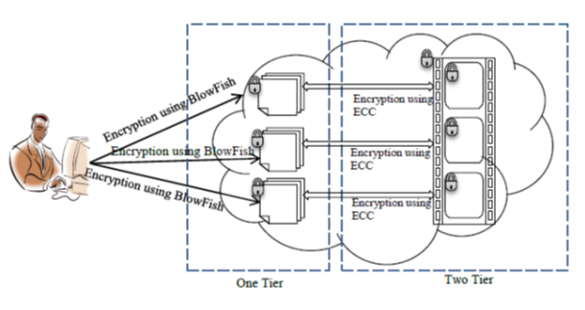
Fig. 1.Agent Based Two Tier Architecture

In the same way, a CSP, will also acquire the above set of keys for it, to be used at its end. Now whenever user has to save his/her data from CSP, it will first encrypt it with its , ciphertext obtained after encryption is again encrypted using before sending it to CSP. of the user is available with the CSP, however even if CSP wishes to decrypt data for some reason, it can only decrypt data to one level only, because first level symmetric key of the user is unknown to the CSP. This way security threats, due to multi-tenancy in CC may be resolved.

This mechanism comprises of intelligent agents for providing cryptographic services both at user and CSP end. It consists of Crypto agent and CSP agent as given below:

Crypto_Agent (CA): This agent is responsible for encryption and decryption of data at client end. It is equipped with user’s set of keys. Whenever a user gets registered with a CSP, CA exchanges its with through CSPA. When user sends some data to cloud data center, CA first encrypts it with and then with . In case some data is received from cloud data base it decrypts it with .
Cloud_Service_Provider_Agent (CSPA): This agent is responsible for interacting with CA of user. It receives encrypted data from the user, places it in cloud data base. It also keeps record of user in server key log file. Whenever user requests for its data, it authenticates user, then it decrypts data to level1 using of concerned user and then again encrypts that data using CSP’s . Then it sends data to the user. CSPA knows and uses it for encrypting Key server log so that even if a hacker hacks this database, it can’t access user data. Figure 2 given below provides detailed architecture of proposed HT2SE framework and illustrates working of above discussed agents:

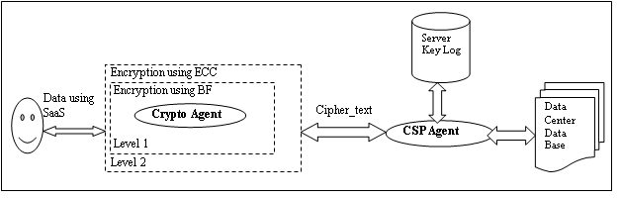
Fig. 2. Detailed Architecture of HT2SE

HT2SE Working
After user registration, whenever data is received from the cloud user for storage on cloud database, CA gets activated. It first applies Blowfish algorithm for converting original data into cipher form of level 1 and then it applies ECC private key to encrypt cipher text obtained from level 1 to encrypt it for the second time. It then sends this data for travel in the network and storage in cloud database. When data reaches cloud data centre, CSPA gets activated, it stores data in cloud data centre data base. Whenever data is required by a particular user, CSPA fetches requested data along with ECC public key of the user, it then decrypts data using this key to level1 cipher text and again encrypts it using its own ECC private key, it then sends the final encrypted data to the user. This way data is always double protected while travelling in the network and both encryption keys can’t be hacked as they are distributed. Process adopted by CSPA, is to defeat any silent intruder listening to network traffic in order to get hold of the encryption keys, here final cipher text generated using different keys from user to CSP and from CSP to user thus it would be difficult to predict for the intruder. Further, CSPA encrypts its Server key log file using its own BF symmetric key which is kept with this agent only. This is an additional safety measure, however since CSP is an agent, it is also vulnerable to attack possible for other software components. But even compromising CSP can’t solve purpose of the hacker since data placed in data centre data base is still encrypted by user BF key which is unknown to CSP. This way security of user data placed in cloud data centre is enhanced to a high level.
The algorithms of Crypto agent and Cloud Service Provider Agent are presented below in Figure 3 & 4 respectively.

Next section shows the results and implementation of proposed architecture.

results and implementations
This section discusses the observations obtained on implementation of proposed architecture. Real time implementation of proposed architecture was difficult because of commercial nature of concerned domain, so implantation has been done in simulated environment to ensure applicability of this architecture. Proposed mechanism has been implemented using MATLAB, where initially ECC and Blowfish algorithm were used for encryption of different file sizes separately and then in combination as in proposed mechanism.
Crypto_Agent( ):
Input: Plain text from User/ Cipher Text from DC
Output: Cipher Text/ Plain text

CA ( )
{
on receiving (plain text)
{
ciphertext₁←BF_{i}(plaintext);
ciphertext_{final}←( ciphertext₁);
send CSPA(ciphertext_{final});
}
on receiving (ciphertext_{final})
{
ciphertext₁←( ciphertext_{final} );
plaintext←BF_{i}(ciphertext₁);
return (plaintext );
}
}

Fig 3. Algorithm of Crypto Agent (CA)

Cloud_Service_Provider_ Agent ( ):
Input: ciphertext_{final}
Output: ciphertext₁, ciphertext_{final};

CSPA ( )
{
on receiving (ciphertext_{final})
{ store ciphertext_{final}→ database; }

on receiving (data_request)
{ authenticate(user_{i});
if (authentication==successful)
{
fetch (userdata, );
ciphertext₁← (user data);
ciphertext_{final} ← (ciphertext₁ );
send CA(ciphertext_{final});
}
Else
reject (data_request);
}
}

Fig. 4. Algorithm of Cloud Service Provider Agent (CSPA)

TABLE III. COMPARISON IN ENCRYPTION AND DECRYPTION TIME OF VARIOUS ALGORITHMS

 | ECC Algorithm |  | Blowfish Algorithm |  | Proposed Algorithm
File Size | Encryption Time (sec) | Decryption Time (sec) | Encryption Time (ms) | Decryption Time (ms) | Encryption Time (sec) | Decryption Time (sec)
49 | 62 | 25 | 34 | 38 | 62.3 | 25.3
59 | 66 | 26 | 36 | 26 | 66.5 | 26.4
100 | 71 | 39 | 37 | 52 | 71.4 | 39.8
247 | 99 | 103 | 45 | 66 | 99.8 | 103.4
321 | 102 | 116 | 45 | 92 | 102.9 | 116.8

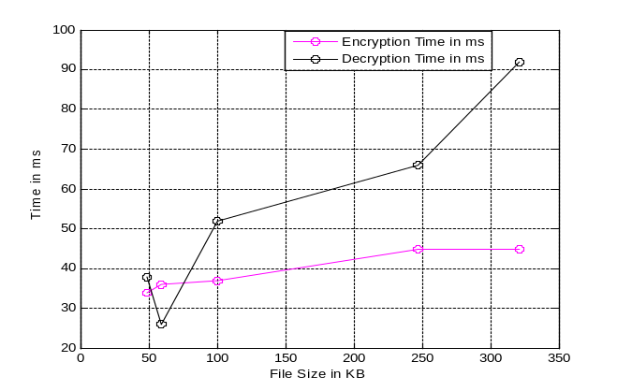
Encryption and decryption time has been noticed for all three techniques separately. As discussed earlier also, symmetric key encryption algorithm takes less time than asymmetric key algorithm. Due to this reason, encryption – decryption time of symmetric algorithm has been taken in milliseconds and for asymmetric algorithms, it is taken in seconds. Encryption-decryption time of input files of same sizes has been recorded using proposed technique also. Table III indicates the encryption and decryption time of ECC, Blowfish and Proposed algorithm respectively.

As is clear from the above table, proposed mechanism takes significantly more time than symmetric key algorithm Blowfish, however it takes approximately same amount of time as taken by asymmetric key algorithm ECC. This small increase in encryption –decryption time seems acceptable, considering the level of security achieved.
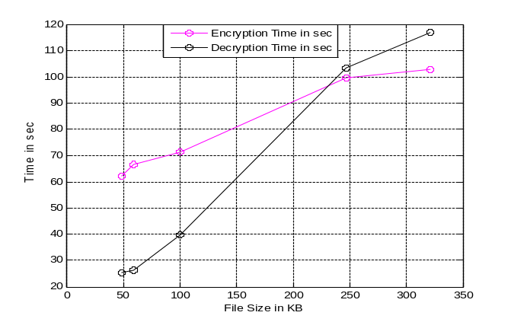
Graphical representations of all these algorithms are shown below in figure 5, 6 and 7.

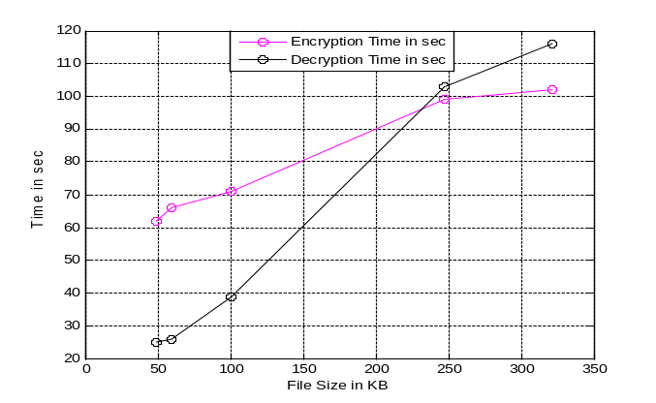
Fig. 5: Encryption and Decryption time using ECC

Fig. 6: Encryption and Decryption time using Blowfish

Fig. 7: Encryption and Decryption time of Proposed Algorithm

CONCLUSION
Data security is one of the most debated and important issue in Cloud computing. Although cloud service providers claim of providing high level of security but still there are increasing number of incidents of security breaches in cloud environments. For increasing trust of user in cloud, there is dire need of robust security mechanism. However, cloud service providers are still using traditional symmetric key algorithms for data security and not providing much transparency on the security algorithms being deployed. This work presents a hybrid two tier security engine which combines symmetric and asymmetric key algorithms, further the algorithms deployed have already proved their excellence for lesser time and better speed of encryption. Proposed mechanism has been simulated and results achieved seems encouraging. Future work aims to focus on providing security solutions for other levels of cloud computing.

References

- Chong, S., Abawajy, J., Ahmad, M., Hamid, I., “Enhancing trust management in cloud environment”, In International Conference on Innovation, Management and Technology Research, 2013, pp 314-321.
- Faniyi, F., Bahsoon, R., Theodoropoulos, G, “A dynamic data driven simulation approach for preventing service level agreement violations in cloud federation” In International Conference on Computational Science ICCS-2012, pp 1167-1176.
- Ferrara, A., Greeny, M., Hohenberger, S. and Pedersen, M., “Practical short signature batch verification”, In Proceedings of CT-RSA, volume 5473 of LNCS. Springer-Verlag, 2009, pp. 309–324.
- Gonzalez, N., Miers, C., Redigolo, F., Jr, M., Carvalho, T., Naslund, M.,Pourzandi, M. (2012). A quantitative analysis of current security concerns and solutions for cloud computing. In Journal of Cloud Computing: Advances, System and Applications, pp 1-11.
- Govida, K., Sathiyamoorthy, E., “Identity anonymization and secure data storage using group signature in private cloud”, In Procedia Technology, 2012, pp 495-499.
- Huiqi, Xu., Shumin Guo, Keke Chen, “Building confidential and efficient query services in the cloud with rasp data perturbation”, In IEEE Transactions on Knowledge and Data Engineering, vol. 26 issue 2, 2014, pp 322-335.
- Khalid, U., Ghafoor, A., Irum, M., Shibli M., “Cloud based secure and privacy enhanced authentication and authorization protocol”, In 17th International Conference in Knowledge Based and Intelligent Information and Engineering System-KES 2013, pp 608-688.
- Longanayagi, B., Sujatha, S., “Enhanced cloud security by combining virtualization and policy monitoring techniques” In International Conference on Communication Technology and System Design, 2011, pp 654-661.
- Mladen A. Vouk, “Cloud computing – issues, research and implementations”, In Journal of Computing and Information Technology - CIT 16, 2008, pp 235–246.
- Orellana, L., Silva, D., Castineira, F., “Privacy for google docs: implementing a transparent encryption layer. Cloud views 2010, In International Conference on Cloud Computing”, 2008, pp 41-48.
- Pavithra, s., Ramadevi, E., “Performance evaluation of symmetric algorithms”, In Journal of Global Research in Computer Science, 3(8), 2012, pp 43-45.
- Rabah, K., “Elliptic curve cryptography”, In Information Security Research Journal vol. 1issue 1, 2009, pp 2-5.
- Ryoo, J., Rizvi, S., Aiken, W., Kissell, J., “Cloud security auditing: challenges and emerging approaches”. IEEE Security and Privacy, 2013, pp1-13.
- Salama, D., Kader, H., Hadhoud, M., “Studying the effects of most common encryption algorithms”. In International Arab Journal of e-Technology, vol. 2 issue 1, 2013, pp 1-10. 14
- Schwarzkopf, R., Schmidt, M., Strack, C., Martin, S., Freisleben, B., “Increasing virtual machine security in cloud environments”, Journal of Cloud Computing, 2012 vol. 1 issue 12, pp 1-12.
- Singh A., Juneja D., Sharma, A., “Elliptical curve cryptography based security engine for multivalent system operating in semantic cyberspace”. In International Journal of Research and Reviews in Computer Science, 2012, vol. 2 issue 2, pp 283-290.
- Yuefa, D., Bo, W., Yaqiang, G., Quan, Z., Chaojing, T., “Data security model for cloud computing”, In Proceedings of International Security and Applications, 2009, pp 141-144.
- Singh, A., & Malhotra, M., “Agent based framework for scalability in cloud computing”, In International Journal of Computer Science & Engineering Technology 2012, vol. 3 issue 4, pp 41-45.
- Malhotra, M., Singh, A., “Autonomous agent based load balancing algorithm in cloud computing”. In Science Direct, Procedia of Computer Science, 2015,Volume 45, pp 832-841.
- Singh, A., & Malhotra, M., “Analysis for exploring scope of mobile agents in cloud computing”, In International Journal of Advancements in Technology, vol. 3 issue 3, 2012, pp 172-183.
- Malhotra, M., & Malhotra, R., “Cloud adaptive resource allocation mechanism for efficient parallel processing”, Published in IGI Global, International Journal of Cloud Applications and Computing, 2014 vol. 4 issue 4, pp 1-6.
- Malhotra, M., Singh, A, “Analysis of security issues at different levels in cloud computing paradigm: a review”, Published in International Journal of Computer Networks and Applications. 2015 vol. 2 issue 2, pp 41-45.
- Malhotra, M., Singh, A., & Juneja, D., “Security issues in cloud computing: an approach”, In National Seminar "The Futuristic Approach to Ethical Hacking & Network Security, Feb 2014, pp 1-5.
- Hossein, R., Elankovan, S., Zulkarnain, M., A., & Abdullah, M., Z., “Encryption as a service as a solution for cryptography in cloud”, In Proceedings of 4th International Conference on Electrical Engineering and Informatics, indexed in Science Direct, 2013 pp 1202-1210.
- Jungwoo, R., Syed, R., William, A., & John, K., “Cloud security auditing: challenges and emerging approaches”, Published in IEEE Security and Privacy, 2013 pp 1-13.

http://www.tomsitpro.com/articles/cloud-computing-ibm-homomorphic-encryption-cloud-security,1-1506.html

