Misplaced Book Management using Radio Frequency Identification and Raspberry Pi
Ravi B. Pandhi¹, Parth C. Shah²
Jignesh Patoliya³ Parth D. Shah⁴
¹ Dept. of Information Technology, Chandubhai S. Patel Institute of Technology, Charotar University of Science and Technology (CHARUSAT) At: Changa, Dist: Anand – 388421, India.
Email: ravipandhiait@gmail.com
² Dept. of Information Technology, Chandubhai S. Patel Institute of Technology, Charotar University of Science and Technology (CHARUSAT) At: Changa, Dist: Anand – 388421, India.
Email: parthcshah@outlook.com
³Dept. of Electronics and Communication, Chandubhai S. Patel Institute of Technology, Charotar University of Science and Technology (CHARUSAT) At: Changa, Dist: Anand – 388421, India.
Email: jigneshpatoliya@charusat.ac.in
⁴ Dept. of Information Technology, Chandubhai S. Patel Institute of Technology, Charotar University of Science
and Technology (CHARUSAT) At: Changa, Dist: Anand – 388421, India.
Email: parthshah.ce@ecchanga.ac.in

Abstract – Libraries are huge collections of valuable texts. There are protocols which adhere to proper management and arrangement of books in a library. In some advanced library systems, there are computer databases which give the information about a particular book and its location in the library, i.e. in which rack and in which self, a particular book should be placed. If rules are followed, there will never be any chaos when searching for a particular book in a library. But in most cases, patrons are not so cooperative in arranging the books from where they have picked. And knowingly, some patron notoriously places a book in some other rack, which has absolutely no connection with the subject of that particular book. However, it can also happen that a book is misplaced when the returned books are arranged back in shelves. We can’t keep a watch every time a patron doesn’t cooperate. Mistakes are bound to happen now and then. If we have to accurately manage a library, and bring up the patron satisfaction, we need to devise a technical method to find the location of every misplaced book in a library and consequently arrange the books. This approach addresses this problem by developing a prototype of a device which embeds RFID reader and Raspberry Pi, a portable minicomputer into one device. This device when scans the different areas of the library, identifies the books that are misplaced and feeds them to a list. This list is then transferred to Librarian’s Computer for convenience.

Index Terms— Radio Frequency Identification (RFID), Raspberry Pi, SQLite, Java FX, Java.

I. Introduction
The objective of this research is to address the issue of misplaced book management. The proposed prototype to solve this problem uses a Passive Radio Frequency Identification Reader with Raspberry Pi, a portable mini microprocessor and embeds them into one device naming it Book Location Grabber (BLG) Device. The books in a library are affixed with Passive RFID tags [1]. Raspberry Pi is provided the facility to communicate wirelessly by interfacing a Wireless-Module with it. Librarian’s Computer and the BLG device are connected in the same wireless network. This device when scans the areas of a library such as racks and shelves, (indeed the tags are being scanned) identifies the misplaced books by comparing the books present with a universal book database and then creates the list of misplaced books with attributes such as title of the book, current position of the book and the correct position of the book. The universal book database resides on the Raspberry Pi. The approach described here uses SQLite DBMS as it is suitable for portable devices and resource constrained environments [2]. The database consists of the fields such as the EPC code, the title of the book, the correct location of the book. The attribute EPC code is the unique Electronic Product Code of the RFID tag that is affixed on that particular book. The attribute ‘correct location of the book’ will have values like “Rack-1, Shelf-3” or “Rack-2, Shelf-4” so on and so forth. The text file generated is transferred to the librarian’s computer automatically and this text file can prove to be handy when the librarian wants to arrange the books. Daily, before the library is made open to the public, the whole library needs to scanned to find out the misplaced books and thus consistency in book position is maintained. This is an approach towards building a demonstrable working model of Book Location Grabber Device. The approach can be further altered to expand the model into a finished portable device suitable for the purpose. When the books have been arranged in their correct positions by the librarian, there can be an isolated GUI client which is interfaced with a database containing fields such as title of the book, the author of the book, the publication of the book, issued status of the book and the correct position of the book. A patron before entering the library searches for his desired book on the GUI client and consequently the client returns the location of the book like Rack-1, Shelf-2 by querying the database interfaced with the client. In this case, it is guaranteed that the client will fetch the correct value of the location of the book at almost all the times. The programming of the approach mentioned here is carried out using Java programming language. The main program runs on Raspbian OS installed on Raspberry Pi [3]. The graphical user interface was developed with Java FX along with Scene Builder. The GUI application project contains FXML which is an xml file for the Java FX applications and the controller for each stages (each separate window) [4]. The drawback of the approach proposed here is that it may be time consuming to scan the whole library if the size of the library is huge, but we can deal with that by having multiple BLG devices with highly responsive RFID readers.

II. PROPOSED WORKFLOW

Step: 1Selection of area to be scanned
- The Raspberry Pi is interfaced with a keypad which has numerical numbers to select the area. For example if Rack-1, Shelf-3 is to be scanned, the keys 13 needs to be pressed.
- The interfacing between Raspberry Pi and the keypad enables the transfer of the selected numbers to the main program via serial communication. The keypad has to be interfaced with Raspberry Pi via GPIO pins [5].
- The selected number will be validated, i.e. does such an area exist? In our prototype model, 41 is invalid, because the demo contains only 3 racks. If it is invalid, an LED needs to glow, indicating to re-select the area to be scanned.
Step: 2Scanning of books (tags)
When the area is scanned, the EPC code is fetched by the RFID reader and consequently the EPC code is fetched into the Java program running on Raspberry Pi.
- The EPC codes of that particular area is fetched and stored in a temporary array for faster processing so that the values of all the EPC codes can be compared at a time, rather than comparing one-by-one EPC codes with the database.
Step: 3Comparison with the database
- When the stop switch on the BLG device is pressed, the temporary array which contains the EPC codes is compared with the database in the following manner.
- If there exists a tuple containing both the area selected and the EPC code, it is an indication that the book is at its correct position. No further action is required in this case.
- If there doesn’t exist a tuple containing both the area selected and the EPC code, it is an indication that the book is misplaced. Further action is required in this case.
Step: 4Creating a text file and feeding records
- In Step 3 when second case holds true, the details about the misplaced books is fed into a text file, the procedure for the same is highlighted next.
- The correct position of the book and the title of the book is fetched from the database by querying it with the parameter as EPC code.
- The current position of the misplaced book is calculated from the area that has been scanned and the index of the misplaced book’s EPC code. A simple concatenation operation between the two will suffice. For example, if the area selected was “Rack-1, Shelf-2” and the index of the misplaced book’s EPC is 5th it is easily inferred that the 5th book in Rack-1, Shelf-2 is misplaced. Consequently the current position will be “Rack-1, Shelf-2, Number-5”
- After gathering the details, it is accumulated as a record and then fed to a text file. A snapshot below of the same gives a clearer picture. A single record indicates a misplaced book’s title, its current position and its correct position. The counter or the exact position of the book retrieved from the current position of the book does help in a lot quicker rearrangement of the misplaced books.
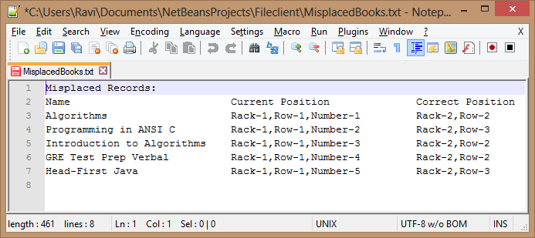
Figure 1. Text file with details of misplaced books
- If all the books are in their correct positions, i.e. Case-1 of Step-3 holds true for all the EPCs, then there is no need of creating a text file as no books are misplaced.

Step: 5Transfer of text file to Librarian’s Computer
- After the text file containing the information about the misplaced books in the scanned area is generated, it is more convenient if the BLG device transfers the file automatically to the Librarian’s Computer. Later on, a simple program can be written which concatenates the text file for each area and prints the merged file. This merged file can be used by the librarian to rearrange the books in a quick way. The procedure of sending the text file to a librarian is highlighted in below steps.
- As soon as all the EPC codes have been compared with the database, the text file will no longer receive records from the program. At this moment a simple Port programming paradigm between the Librarian’s Computer and the BLG device can yield the transfer.
- BLG device acts as a server in the Port programming paradigm. It sends the text file when it is ready and also the server listens on a pre-decided port number to accept incoming requests from the client.
- Librarian’s Computer acts as a client in the Port programming paradigm. It connects to the server on the pre-decided port number and when connection is established, it receives the text file from the server [6].
Step: 6GUI client
- After the books have been arranged, the patron can inspect the GUI client and find the location of his desired book by typing in the title of the book or the author of the book or the publication of the book or any of the two fields or all the three fields.
- The more the number of fields specified, more accurate the results will be.
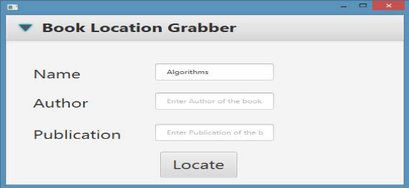
Figure 2. GUI client with a single field entered
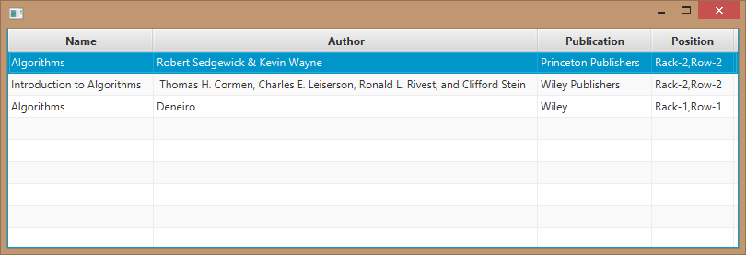
Figure 3. Results containing matching records
Assumptions:
- Patron has the basic knowledge of the computer and knows how to search for a book and understand what the outcome is.
- The hardware that will be used has to be ensured that it is always secured, not tampered and used by authenticated personnel only.
- All access rights will be provided to the librarian. He will have to scan the library at least once every morning before the library opens for public.
- If an update takes place (new books are added or some copies are removed) then the databases at both the sides (BLG device and GUI client) needs to be updated.

- PROPOSED CONNECTION VIEW

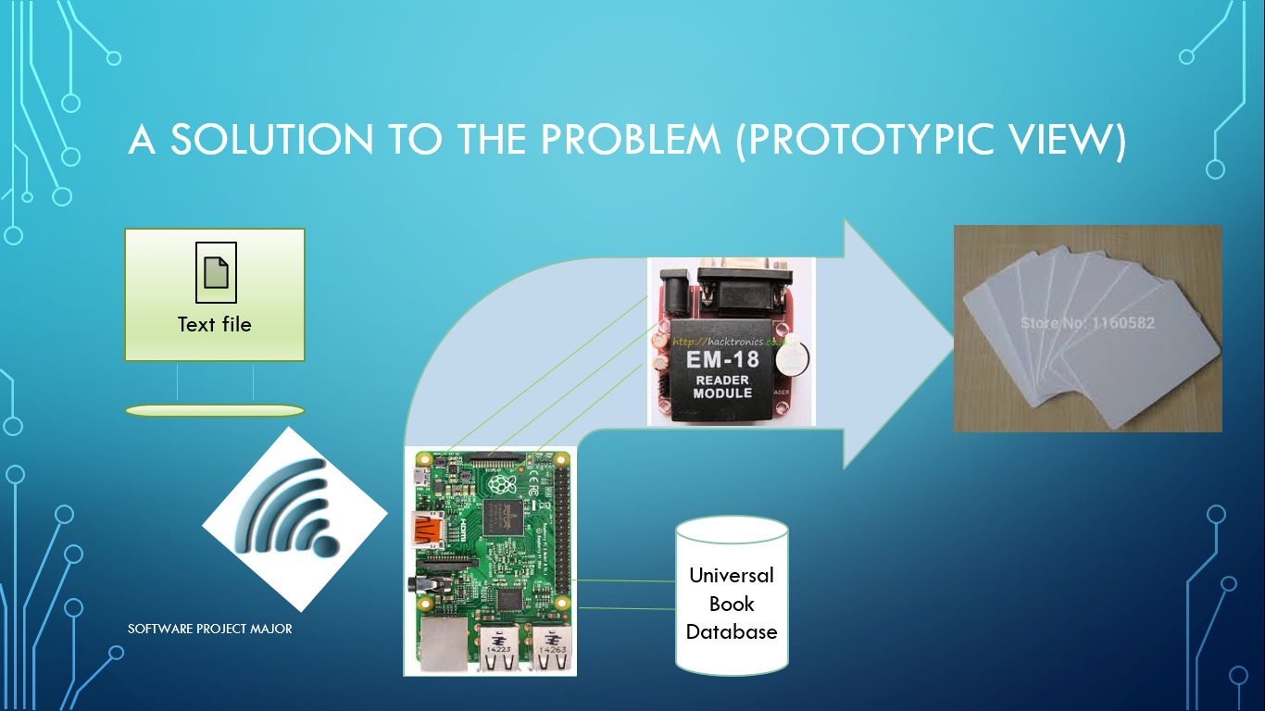
Figure 4. Componential overview of the system
- The figure denotes the components as well as the connection between them. The RFID cards represent the books affixed with RFID Passive tags.
- The wireless signal denotes that there is wireless network connection between Raspberry Pi and Librarian’s Computer.
- The approach described here has implemented the prototype using EM-18 RFID Reader. However, more responsive and powerful readers can speed up the time taken to process the EPC codes from the tag.
- The universal book database is the driving force of the system. As new books are added or deleted, it needs to be updated accordingly.

- CONCLUSIONS

- In this article, a solution to the problem of misplaced books is proposed. If a library opting for this solution is RFID enabled, then the implementation is an easy roadmap.
- Also, if the library is not currently RFID enabled, then the main reason behind addressing the problem of misplaced books using RFID is justified, as the solution provides a considerable scope of expansion in the way of automating the library with RFID.

- ACKNOWLEDGEMENT

- We express our gratitude to the healthy and massive research that has taken place in the field of Radio Frequency.

- REFERENCES

- “RFID Based Library Management System” by Dhanalakshmi M, Uppala Mamatha
- https://www.sqlite.org
- https://www.raspberrypi.org
- http://docs.oracle.com/javase/8/javase-clienttechnologies.htm
- https://www.raspberrypi.org/forums/
- http://mrbool.com/file-transfer-between-2-computers-with-java/24516

