Green Cloud Computing Through Dynamic Resource Consolidation - a layered approach
Amit Nayak¹,Parth Shah²
¹Ph.D Scholar, Assistant Professor, Information Technology Department
Charotar University of Science & Technology, Gujarat, India
¹amitnayak.it@ecchanga.ac.in

²Ph.D Research Scholar & Head, Information Technology Department
Charotar University of Science & Technology, Gujarat, India
²parthshah.ce@ecchanga.ac.in

Abstract— Data centre is to be considered as a central entity of management in cloud computing, so techniques needs be evolved pertaining resource consolidation. In today's data centre major implications are of energy consumption and it should be focused more to achieve green cloud computing so that environment can be sustainable and the problem of global warming can be overcome. Data centre energy aware computation may be considered for application level, kernel level and hardware level. To develop context specific power aware computing system we have observed some parameters by which we can achieve green cloud computing. At the end we have made the simulation with various parameters on green cloud simulator which is an extension of ns2 simulator. To reduce the energy consumption we have also gone through Cloudsim toolkit to develop the solution by keeping vm consolidation in mind. In cloud sim toolkit we took Planet Lab data set which is a live dataset.

Index Terms— MTU, Cloud Burst, Green Cloud,
VM

INTRODUCTION

With the growth of high speed networks over the last decades, there is an alarming rise in its usage comprised of thousands of concurrent e-commerce transactions and millions of Web queries a day. Increasing demand is handled through big datacenters, which consolidate hundreds and thousands of servers with other infrastructure such as cooling, storage and network systems. Many internet companies such as Google,

Amazon, eBay, and Yahoo are operating such huge datacenters around the world.

[1] The commercialization of these developments is defined currently as Cloud computation, where computing is delivered as utility. Traditionally, business organizations used to invest huge amount of capital and time in acquisition and maintenance of computing resources. Emergence of Cloud computing is rapidly changing this ownership-based approach to subscription-oriented approach by providing access to scalable infrastructure and services. Users can store, access, and share information in Cloud. Small or medium enterprises/organizations do not have to worry about purchasing, and maintaining their own computing infrastructure.Organiztions can focus on sharpening their core competencies by exploiting a number of Cloud computing benefits such as demand driven computing resources, faster software development capabilities at low cost. Cloud computing also offers enormous amount of compute power to organizations which require processing of tremendous amount of data generated almost every day. For example, financial companies have to maintain every day the dynamic information about their clients and research related big data [1].
Finally we can say that computing requirement increases day by day but to cop up with that need organizations have to rely upon cloud computing service provider because it is not even feasible for the organizations to purchase new hardware at some frequent interval.

Therefore, many companies not only view Clouds as a useful on-demand service which helps in computation, but also a potential market opportunity. As per to IDC (International Data Corporation) report , the global IT Cloud services spending is increase from $16 billion in 2008 to $42 billion in 2012, representing a compound annual growth rate (CAGR) of 27%. Attracted by this growth prospects, Web-based companies (Amazon, eBay, Salesforce.com), hardware vendors (HP, IBM, Cisco), telecom providers (AT&T, Verizon), software firms (EMC/VMware, Oracle/Sun, Microsoft) and others are all investing huge amount of capital in establishing Cloud datacenters. According to Google’s earnings reports, the company has spent $US1.9 billion on datacenters in 2006, and $US2.4 billion in 2007[1].

Today global warming affects the nature. Most of the IT equipments are running by consuming excess power supply. By considering this fact, consumption should be reduced so that energy can be saved. Resultant system which is going to be developed will be based on reduction of energy consumption at three levels in cloud computing architecture which lends towards achieving green cloud computing [1].

Today Green cloud computing is the research issue in cloud computing by which researchers want to reduce the carbon footprints. To reduce the emission of the carbon or to decrease the heat produced by the data center appropriate technique needs to be developed. If we observe the cloud computing deployment models such as IAAS (infrastructure as a service), PAAS (platform as a service) and SAAS (Software as a service) then we can think in terms of identifying some parameters which will reduce the energy consumption. This would result in developing a system which works at application, kernel and hardware layer. Green cloud simulator is an extension of NS2 simulator in which energy aware simulation is possible so we can use the same with our proposed work. Major cloud computing providers are facing the problems about the energy consumed by their data center.

The technique which helps in achieving green cloud computing is known as energy aware technique. We can focus on two different aspects of energy aware management of the cloud. The first technique is thermal aware cloud computing in which the temperature of the cloud computing artifact is considered. The second technique is power aware cloud computing in which the amount of voltage consumed by the cloud computing artifact is considered. Both the techniques will help to sustain the environment. We have focused on power aware cloud computing in which our goal is to reduce the energy consumption in terms of voltage consumed by cloud computing artifact.

Studies show that Cloud computing can actually make traditional datacenters more energy efficient by using technologies such as virtualization and workload consolidation. The traditional data centers running Web applications are often provisioned to handle uneven peak loads, which can result in low resource utilization and wastage of energy. Cloud datacenter, can reduce the energy consumed through server consolidation, whereby different workloads can share the same physical host using virtualization and unused servers can be switched off. A recent research by Accenture shows that moving business applications to Cloud can reduce carbon footprint of organizations. As per the report, small businesses saw the most dramatic reduction in emissions – up to 90 percent while using Cloud resources. Large corporations can save at least 30-60 percent in carbon emissions using Cloud applications, and mid-size businesses can save 60-90 percent [1].

Contrary to the above opinion, some studies, for example Greenpeace, observe that the Cloud phenomenon may aggravate the problem of carbon emissions and global warming. The reason given is that the collective demand for computing resources is expected to further increase dramatically in the next few years specifically we can say that communication equipment consumes more energy. Even the most efficiently built datacenter with the highest utilization rates will only handle, it cannot eliminate, harmful CO2 emissions. The reason given is that Cloud providers are more interested in electricity cost reduction rather than carbon emission [1].
Cloud computing, being an emerging technology also raises significant questions about its environmental cost. While financial benefits of Cloud computing have been analyzed widely during the cloud computing analysis, the energy efficiency of Cloud computing as a whole has not been analyzed so we need to be more concentrative in terms energy consumed by individual resource. Through the use of large shared virtualized datacenters Cloud computing can offer large energy savings. Cloud services can also further increase the internet traffic and its growing information database which could decrease such energy savings. Our analysis is important for users and organization that are looking at Cloud computing as a solution for their administrative, infrastructural and management problems [1].

Finally, we also propose and recommend certain strategies for reducing its carbon footprint in wholesome manner in some cases without sacrificing the quality of service (performance, responsiveness and availability) offered by the Cloud providers.

What Is Cloud Computing?
Cloud computing is the use of computing resources (hardware and software) that are delivered as a service over a network (typically the Internet). The name comes from the use of a cloud shaped symbol as an abstraction for the complex infrastructure it is reflected in system map. Cloud computing entrusts remote services with a user's data, software and computation [12].

The growing popularity of Cloud computing has led to several proposal defining its characteristics. Some of the definitions given by many well known scientists and organizations include following:

Buyya[9] define the Cloud computing in terms of its utility to end user: “A Cloud is a market-oriented distributed computing system consisting of a collection of interconnected and virtualized computers that are dynamically provisioned and presented as one or more unified computing resource(s) based on service-level agreements established through negotiation between the service provider and consumers.”

National Institute of Standards and Technology (NIST) [8] defines Cloud computing as follows:“Cloud computing is a model for enabling convenient, on-demand network access to a shared pool of configurable computing resources (e.g., networks, servers, storage, applications, and services) that can be rapidly provisioned and released with minimal management effort or service provider interaction. This Cloud model promotes availability and is composed of five essential characteristics, three service models, and four deployment models.”

The characteristics of Clouds include on-demand self-service, broad network access, resource pooling, rapid elasticity, and measured service. The available service models are classified as SaaS (Software-as-a-Service), PaaS (Platform-as-a-Service), and IaaS (Infrastructure-as-a-Service). The deployment models is categorized into public, private, community, and hybrid Clouds [1].

Existing And Proposed Work
Many attempts have been made to resolve the issues related to Green Cloud.

Existing Work

Application Level Solution: Some computer programs make your computer to use more power. We need a tool that helps to find those programs that are misbehaving while your computer is idle. The application that misbehaved the most was occupying highest CPU cycle and highest energy.

Kernel Level Solution: [2] By removing multitude of packages, it has been observed by some scientist that the system image is reduced from GBs into Mbs. This minimization speeds up migration of the image from one server to another as there is less network traffic during the movement phase.

Hardware Level Solution: CPU frequency scaling [10] does what it sounds like. It will raise and lower the frequency of your processor depending on a set level of demand being made on the processor at the time. One of the reasons you might want to do this would be to save energy.

Remove any user space CPU scaling programs. There are some users pace programs that can be run to scale the processors frequency. We will be scaling the CPU with the kernel so we don't need these. More CPU cycle your program consumes results in highest energy consumption in cloud computing specifically if we focus on the servers then at individual server level we can identify those programs which are unnecessarily occupying CPU cycles.

Proposed Work

Energy consumption can be reduced by following the energy management models available for cloud:

Thermal Aware Energy Management [2]: Temperature is a prominent factor in determining the performance, reliability, and leakage power consumption for the modern processors. As a result, estimating temperature accurately is an essential step in successful thermal aware energy management.

Power Aware Energy Management [3]: Power aware energy management technique deals with the power consumed by the devices in the cloud so to achieve green computing we should reduce the power consumption in cloud.

Following figure shows the architecture of the proposed
Solution.

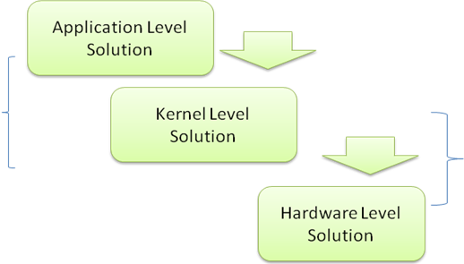
Figure 1.1 Proposed Architecture with respects to cloud computing
Figure 1.1 indiacates that if we consider cloud computing in terrms of three different levels, as a result there is a scope of improvement at various layers, if we combine various approaches at various layer and the resultant data center design leads to power aware cloud computing design.we can consider software as a service with application level pesrpective,plateform as a service with kernel level and infrastructure as a service with hardware level perspective.
Based on the few obsevatios we have made on greencloud simulator
- In cloud computing at application level specifically we can focus on cloud burst time for the cloud and based on the burst time if we can design the model to provide efficient utilization of time to the cloud user. If the cloud burst is consolidated then as a result we can clearly see the differences in the energy consumption. Cloud bursting means the time taken by a cloud in the event of spike to relocate itself to other place.
- In computer networking, the packet size of a communications protocol of a layer is the size (in bytes) of the largest protocol data unit that the layer cake can pass in the communication system. MTU parameters usually appear in association with a communications interface (NIC, serial port, etc.). Standards (Ethernet, for example) can fix the size of an MTU; or systems (such as point-to-point serial links) may decide MTU at connect time [7]. Due to Ethernet limitation MTU is fixed size unit.

- At kernel level by scaling the packet size we can reduce the energy consumption.

- At Hardware level we can think in terms of architecture of the data center [11] it can be two tiers or three tiers up to certain limit we can go for two tier architecture without violating SLA. If we think in terms of architecture of data center then by taking appropriate architecture we can reduce the energy consumption.

Here our focus is to identify the various parameters at each layer and hence later on we can combine those parameters to produce the optimum result.

Our work to reduce the energy consumption is further extended by working with cloud sim [13] toolkit. We have focused on vm consolidation & it is done by following many techniques. The vm selection and vm allocation policy are there in cloud computing which is responsible for which vm is selected for the migration and the later is responsible for to which host the VM is allocated.

VM IMAGE MANAGEMENT POLICIES

VM IMAGE SELECTION POLICY

VM IMAGE ALLOCATION POLICY

VM IMAGE MIGRATION POLICY

Figure 1.2 VM image management
We can see from the figure 1.2 that VM image can be managed by various policies and from them we are focusing on VM image selection policy.

To implement VM selection we need to select vm based on some criteria and to do so we have considered one criteria called bandwidth requested by the vm, less bandwidth requested vm is preferred for the migration. It is minimum bandwidth oriented vm selection policy [MBOS]. The above said VM selection policy works in association with static threshold vm allocation policy [14] which works by following threshold value if the threshold value goes above some threshold then new host is selected for the vm allocation. Let’s look the algorithm MBOS.
The results which we have derived in table 3.4 and 5 are based on
1.Static Threshold VM allocation policy
2.Minimum bandwidth oriented VM selection policy [variant of MMT VM selection policy [14]].

ALGORITHM--Minimum bandwidth oriented VM selection policy [MBOS]

ALGORITHM - [MBOS]
- MAXVALUEßmaximum number
- MinMatricßMAXVALUE
- FOR I IN 1 TO N
- IF VM < IS IN MIGRATION STATE THEN
- step 3
- metricßVM.GETREQUESTEDBW()
- IF metric < minMetric THEN
- minMetric ß metric
- VMToMigrate ß VM
10. return VMToMigrate

Results
Following figures show the initial observed results carried out on green cloud simulator [5] which is an extension of network simulator [4] with following parameters. These results were derived by using default script file which comes with green cloud simulator.
Here some observations are made
- 1536 servers (Default Case for sample script given with green cloud simulator).
- 2 Cloud users.
- DC computing capacity 1536000000 MIPS.
- >25400 Tasks Executed On Cloud.

IV.A Observations
Sr. No | Parameter Name | Value | Energy Consumption  In W*H
1 | Burst Time  [Cloud Burst] | 950ms | ≥2170W*H[By Servers]
1 | Burst Time  [Cloud Burst] | 500ms | ≤2140W*H[By Servers]
2 | Packet Length  [Kernel level] | 1500 Bytes or >1400 Bytes | ≤2150W*H[By Servers]
2 | Packet Length  [Kernel level] | 2000 Bytes Or  <750 Bytes | ≥2200W*H[By Servers]
3 | Data Centre Architecture  [Hardware level] | Two Tier | ≤2000W*H [Energy consumed by switches]
3 | Data Centre Architecture  [Hardware level] | Three Tier | ≥2540W*H [Energy consumed by switches]
Observations on default script by changing some parameters [Table-I]
* Energy Consumption in W*H

IV.B Experimental Result [MBOS]
Cloud sim [13] tool kit has produced following results for minimum bandwidth oriented vm selection policy. We have already discussed in the previous section that how the MBOS policy works.

Sr.  No | Minimum Migration Time VM Selection Policy  [mmt] [14] | Minimum Bandwidth  \ Oriented Selection Policy  [mbos]
1 | Number of hosts: 800 | Number of hosts: 800
2 | Number of VMs: 1052 | Number of VMs: 1052
3 | Total simulation time: 86400.00 sec | Total simulation time: 86400.00 sec
4 | Energy consumption: 191.73 kWh | Energy consumption: 185.71 kWh
5 | Number of VM migrations: 26634 | Number of VM migrations: 24441
6 | Average SLA violation: 10.14% | Average SLA violation: 10.14%
7 | Number of host shutdowns: 5863 | Number of host shutdowns: 5669
Comparison results MMT VS.MBOS for planet lab data 20110303 Data Set with default
Parameters [Table-2]
Sr.  No | Minimum Migration Time VM Selection Policy  [mmt] [14] | Minimum Bandwidth  Oriented Selection Policy  [mbos]
1 | Number of hosts: 800 | Number of hosts: 800
2 | Number of VMs: 898 | Number of VMs: 898
3 | Total simulation time: 86400.00 sec | Total simulation time: 86400.00 sec
4 | Energy consumption: 144.75 kWh | Energy consumption: 139.93 kWh
5 | Number of VM migrations: 20640 | Number of VM migrations: 18903
6 | Average SLA violation: 10.13% | Average SLA violation: 10.07%
7 | Number of host shutdowns: 4650 | Number of host shutdowns: 4471
Comparison results MMT VS.MBOS for planet lab data 20110306 Data Set with default
Parameters [Table-3]

N Sr.  No | Minimum Migration Time VM Selection Policy  [mmt] [14] | Minimum Bandwidth  Oriented Selection Policy  [mbos]
1 | Number of hosts: 800 | Number of hosts: 800
2 | Number of VMs: 1033 | Number of VMs: 1033
3 | Total simulation time: 86400.00 sec | Total simulation time: 86400.00 sec
4 | Energy consumption: 151.74 kWh | Energy consumption: 145.69 kWh
5 | Number of VM migrations: 22301 | Number of VM migrations: 20531
6 | Average SLA violation: 10.75% | Average SLA violation: 10.68%
7 | Number of host shutdowns: 4737 | Number of host shutdowns: 4529
Comparison results MMT VS.MBOS for planet lab data 20110420 Data Set with default
Parameters [Table-4]
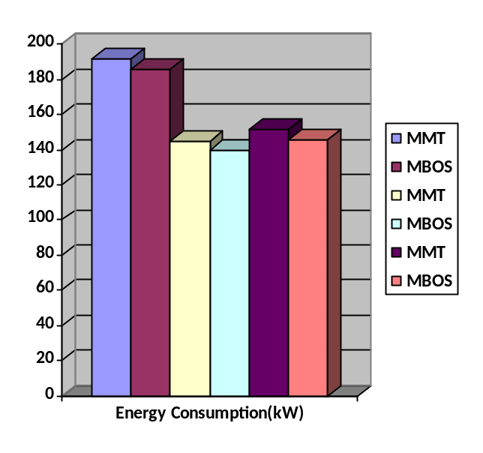
Figure 2. Energy consumption MMT Vs MBOS
Data shown in figure 2,3 ,4 and 5 are based on Tables 2,3 and 4.
For example from table 2 MMT and MBOS parameter energy consumption is displayed as first two vertical bars in figure 2.
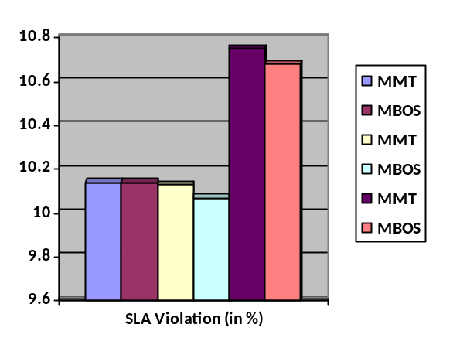
Figure 3. Average SLA vilation MMT Vs MBOS
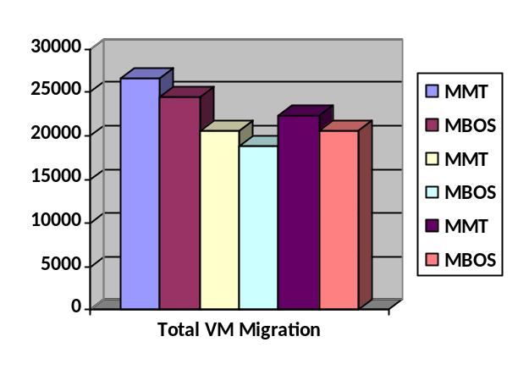
Figure 4. Average VM migration MMT Vs MBOS
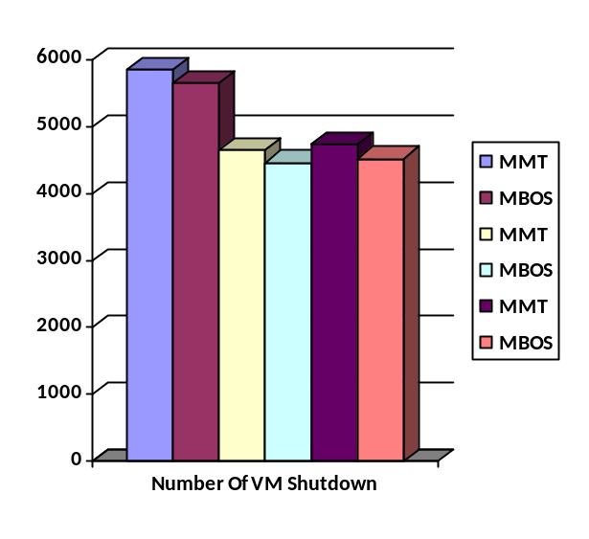
Figure 5. Number of VM shutdowns MMT Vs MBOS
The authors have suggested in their research work in following research paper "Optimal Online Deterministic Algorithms and Adaptive Heuristics for Energy and Performance Efficient Dynamic Consolidation of Virtual Machines in Cloud Data Centers [14]" that in minimum migration time MMT VM selection policy we can even go with bandwidth and some other parameters so based on the simulation we have made we can say that if bandwidth is preferred over ram then we may get the improvement without compromising some important parameters.

Merits
By considering parameters like data center architecture, cloud burst time and MTU scaling we can reduce the energy consumption with minimum violation of the SLA [6].If we focus on vm consolidation and if we use the toolkit like cloud sim then we can take the power aware techniques which is reflected in vm creation & maintenance.

Demerits
It is found that if we consider only burst time or packet size scaling for the real time services provided by cloud computing than numbers of task which are being submitted to the cloud from them some of tasks are dropped so clearly violating SLA [6] parameter so for a task critical application it is not suitable.
If we consider vm selection policy like MBOS then it shows some SLA violation which should be reduced to 0%.

Conclusion
To achieve best energy conservation in cloud data centre we should not only consider a specific service delivery models like infrastructure as service, platform as a service or software as a service but we should think in terms of layered approach. Achieving the energy reduction at each layer will result in overall reduction of energy in the cloud data centre.
For the resource broker point of view [platform as a service point] careful placement of VM is very much crucial.
Effective policy for VM allocation and selection leads to achieving green cloud computing with less violation of SLA.
Power aware Minimum bandwidth oriented vm selection policy [MBOS] helps in reducing the energy consumption.

VI. ACKNOWLEDGMENT
We are thankful to The Omnipotent GOD for making us able to do something. We express our gratitude to our department of Information Technology and the management of Chandubhai S Patel Institute of Technology for providing us research opportunities and motivating environment. Finally, our acknowledgement cannot end without thanking to the authors whose research work helped us in this research. We are very much thankful to Rajkumar Buyya, Saurabh Kumar Garg and Anton Beloglazov for their research contribution on the green cloud computing & Vm allocation with Vm selection policies it inspires us to undergo the research.

VII. FUTURE WORK
By performing the simulation with certain parameters it is clear that if we focus on energy consumption and if we want to reduce the energy consumption then it may lead in violation of SLA parameters. So we can extend this work and define the relation between energy consumption and SLA parameter violation. if we can achieve zero percent violation of SLA and reduced energy consumption then it would be very much helpful for the cloud service providers and they can adopt our technique.
VIII. References
[1] Saurabh Kumar Garg and Rajkumar Buyya , "Green Cloud computing and Environmental Sustainability", Retrieved from www.buyya.com , Cloud computing and Distributed Systems (CLOUDS) Laboratory,Dept. of Computer Science and Software Engineering ,The University of Melbourne, Australia , 2011
[2] Andrew J Younge,Sonia Lope- Efficient resource management for cloud computing environments 2011.
[3] Ranganathan P, 2010, Recipe for efficiency: principles of power-aware computing. Communication. ACM, 53(4):60–67.
[4] The Network Simulator Ns2 (2010) Available at: http://www.isi.edu/nsnam/ns/
[5] Dzmitry Kliazovich , Pascal Bouvry ,Samee Ullah Khan: Green Cloud: A Packet-level Simulator of Energy-aware Cloud Computing Data Centers," in Journal of Supercomputing, special issue on Green Networks, 2011.
[6] Pankesh Patel, Ajith Ranabahu, Amit Sheth, "Service Level Agreement in Cloud Computing" Cloud Workshops at OOPSLA09, 2009.
[7]http://en.wikipedia.org/wiki/Maximum_transmission_unit.
[8] Mell, P. and Grance, T. 2009. The NIST Definition of Cloud computing, National Institute of Standards and Technology.
[9] Buyya, R., Yeo, C.S. and Venugopal, S. 2008. Market-oriented Cloud computing: Vision, hype, and reality for delivering it services as computing utilities. Proceedings of the 10th IEEE International Conference on High Performance Computing and Communications, Los Alamitos, CA, USA.
[10]https://wiki.archlinux.org/index.php/CPU_Frequency_Scaling.
[11] Specification of Modular Data Center Architecture-white paper by Neil Rasmussen.
[12] http://en.wikipedia.org/wiki/Cloud_computing
[13] www.cloudbus.org/cloudsim/
[14] Anton Beloglazov, and Rajkumar Buyya, "Optimal Online Deterministic Algorithms and Adaptive Heuristics for Energy and Performance Efficient Dynamic Consolidation of Virtual Machines in Cloud Data Centers", Concurrency and Computation: Practice and Experience, ISSN: 1532-0626, Wiley Press, New York, USA, 2011, DOI: 10.1002/cpe.1867.

First Author:
Pursuing the Ph.D degree in the Computer Engineering Discipline at CHARUSAT University-Anand-Gujarat-India in the field of cloud computing & recently completed M.Tech in the year 2013 with Computer engineering from the same University. Experience in the teaching field is more than 8 years.

Second Author:
Pursuing the Ph.D degree in the Computer Engineering Discipline at CHARUSAT University-Anand-Gujarat-India in the field of cloud computing & completed M.E in Computer engineering in 2004 from the D.D University Nadiad-Gujarat-India. Experience in the teaching field is more than 9 years. Author is peer reviewer of IJEIT,IJSC NCTM Conference.

