Survey of Fault Detection Techniques in Cloud Computing Environment

Smita Kulkarni, Deven Shah

Department of Information Technology
Terna Engineering College, Nerul, Navi Mumbai

Abstract

Coud Computing is a large, distributed environment which provides web based services to its clients. These web based services are used to provide data services and virtualized resources as computing services through cloud on on-demand and pay-per-use basis. With highly dynamic and heterogeneous working environment and huge number of clients, it is quiet difficult to assure that all the resources are well-configured, working properly and free from faults. If faults are ignored and not addressed in time, they may lead to the major service failure. Though much research work is going on to keep the cloud systems reliable in presence of faults, in long run, it can drastically affect the cloud system performance. So more focus should be towards detecting the faults in their early stage and to address them to keep the cloud system abreast. This paper, thus, provides a detailed taxonomy of faults, their types and a survey of various fault detection techniques in cloud computing environment.

Keywords: Cloud computing, fault, fault detection.

- INTRODUCTION

Cloud computing is a distributed, heterogeneous technology used to provide virtualized resources to large number of clients over the Internet. These virtualized resources are provided to clients on metered basis through web services. Underlying heterogeneous network,shared access to different types of virtualized resources, large number of clients, web services increase the complexity of cloud computing environment making it difficult to trace the performance of each and every part of it.
Cloud provides services at different levels such as infrastructure (IaaS), platform(PaaS), application (SaaS), database(DaaS), security (Sec-aaS) etc. More over cloud has different deployment methodologies with their specific requirements such as- public cloud, private cloud, community cloud and hybrid cloud. Also cloud based applications that are used to provide web services are developed using different languages and tools. So, if any service fails to perform normal, it becomes difficult to find exactly where is the fault- at configuration level, deployment level, infrastructure level, platform level, application level, is it a security breach or inside any virtualized resource.
Though there is lot of research work going on to keep the cloud system reliable and maintain required performance in presence of faults, in long run it can affect the cloud system performance drastically.
There fore much focus should be towards detecting the faults at their early stage and to address them to keep the cloud system abreast.
This paper, thus, provides a detailed survey on fault detection techniques in cloud computing environment. This paper is divided into four part. Part one- introduction, part two fault- taxonomy, part three- types of fault detection techniques, part four- fault detection techniques in cloud part 5- conclusion.

- FAULT TAXONOMY
I. System Failure

If any system deviates from normal behavior and gives incorrect results then it is said to be faulty system. Cloud systems are basically designed to tolerate the existence of faults and then too provide good performance and correct results. However if these faults are not noticed and addressed in time, they may lead to major system failures. System failures in cloud computing are of two types- data failures and compute failures. [8]
    - Data Failures:- These are due to exploitation of data, omitted source data and other faults in a data.
    - Computation Failures:- These are due to either hardware faults, software faults or network fault. Hardware faults are related to errors occurred in CPUs, hard disks Ics and memory. They cause the failures like defective VMs, storage access exceptions etc. Software faults application failure. Whereas network fault occure due to overloaded servers, high traffic over network and these faults affect the communication between cloud and its users.
To find the faults in a system, one should determine which processes of system are operational and which processes are crashed. To find this various Failure Detectors (Fds) can be used. Failure Detectors can be viewed as distributed program giving a hint on operational status of a process. A failure detector is used to monitor the system heath status and help to reduce the fatal accident rate by increasing the reliability.[3]

II. Faults in Coud Computing

In simplest term, deviation of a system from expected behavior or expected results is nothing but a system fault.

Faults in cloud computing can be broadly classified into four classes: faults at different levels, faults at different service stage, faults at different influence range and faults from different source. [2]
    - Faults at different Levels: Services in cloud computing are divided into 3 levels, IaaS, PaaS and SaaS. So the faults occurring at these levels are classified as infrastructure faults, platform faults and software faults.
    - Faults at different Service Stage: Based on the how service is processed, faults are classified as service look-up stage fault, service request stage fault, and service provide stage fault.
    - Faults having different Influence Range: According to the severity of fault, faults can be classified as own influence faults, other parts influence faults, and service result influence faults.
    - Faults from different Sources: Based on source, faults can be classified as either hardware fault or software fault. Hardware faults can be SAN, faults, network faults or Host fault. Software faults can be cloud system fault, user application fault, VM fault, third party software fault, security software fault, billing software fault or database fault.

III. Fault Detection Activities

If we consider providing a particular service through cloud as a project, then fault detection activities can be carried out at various life cycle phases of this project. In project life cycle, fault detection activities start after design phase. These activities include detection i.e identifying abnormal system behavior, localization i .e. finding the location of fault, fault diagnosis i.e collecting the information about fault symptoms and corrective measures and fault representation i.e representing faults that other similar faults can be identified by other individuals without specific domain knowledge. By using fault diagnoses information and fault representations future faults can be predicted. That can be called as fault prediction activity.[7]

- FAULT DETECTION TECHNIQUES

Faults , if existing, themselves cause the performance degradation of a system or can be externally exploited to perform malicious activities resulting in system failure. Hence fault detection and removal is very important instead of increasing fault tolerance of a system.
Fault detection techniques can be broadly categorized as static fault detection techniques and dynamic fault detection techniques. Static detection involves automated tools running through the code and data to identify defects and abnormalities. These are usually based on configurable rules and predefined specifications on expected values of results.
Dynamic fault detection involves advanced techniques such as pattern matching, machine learning, model based detection and analysis of log files etc. Dynamic fault detection techniques are used to find out anomalies in system behavior and results.

- FAULT DETECTION TECHNIQUES IN CLOUD

Some of the researchers have given idea about how to fault detection can be carried out in cloud computing environment. Bellow is the survey of current work done in fault detection in cloud system.

Ganglia Monitoring System is widely and popularly used monitoring system for distributed technologies such as cloud computing and grid computing. Ganglia can work on various operating systems and supports almost all architectures. Ganglia is used by top organizations such as Berkley, Twitter, Flicker, NASA, Wekimedia and many more for their Grid and Cluster Monitoring. It provides hourly, monthly and yearly detailed utilization of all the resources such as total CPU, total UP hosts, total DOWN hosts , current load, average utilization etc. Figure shows few of the demo snapshots of Wikimedia Grid.

Based on this Ganglia Monitoring System, Bhaduri [1] has proposed an automated fault detection framework for cloud system FDCS which detects anomalies using machine performance data in the cloud. The distributed algorithm proposed by them runs locally on each computing machine on the cloud and ranks the machines based on their anomalous behavior for their assigned jobs. The algorithm generates error reports and allows system administrators to take corrective actions. This FDCS framework runs on the top of the Ganglia cloud monitoring system, takes all the data from Ganglia and generates a ranked list of machines based on its anomaly or fault score. System administrators can identify most faulty variable that caused anomaly and can take corrective actions.

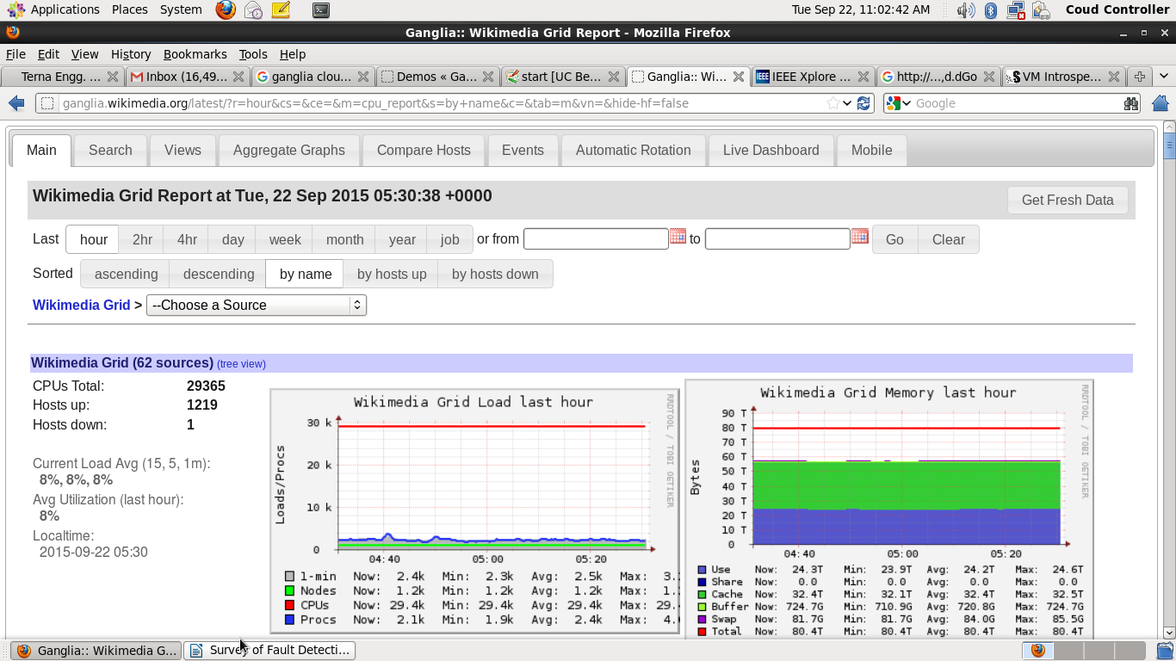
Figure: Ganglia Wikimedia demo sceenshot 1. [14]

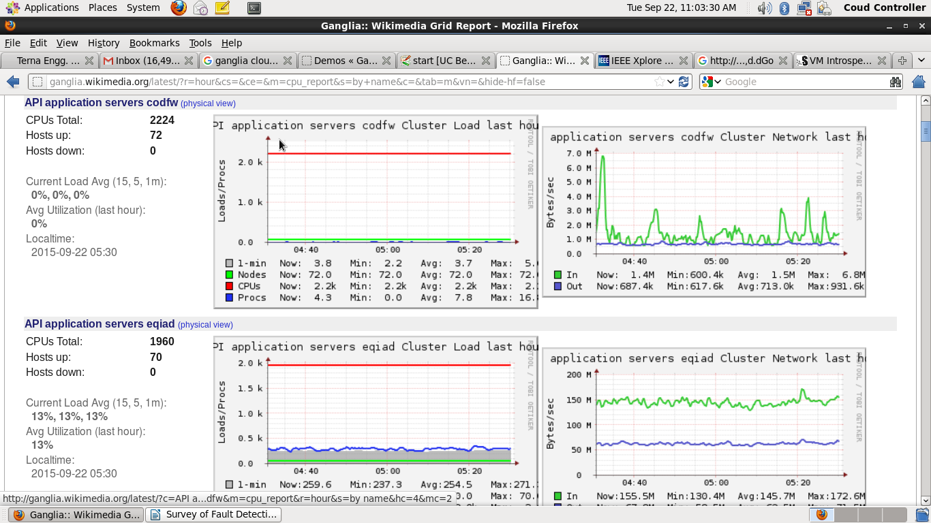
Figure: Ganglia Wikimedia demo sceenshot 2. [14]

Using the concept of software fault model, Ying Jiang[2] proposed the fault model in cloud computing system combining with the characteristics of cloud computing. The proposed model classifies the cloud faults in four classes: level, service stage, influence range and source; and applies improved C4.5 decision algorithm to distinguish the cloud faults. The simulated results shows that decision tree based fault model and improved algorithm are effective. The improved C4.5 algorithm analyzes the fault data in training set, calculates the infogainratio for all attributes of each class, and chooses the attribute with largest infogainratio for new node and marks it as new attribute.

Gabel [4] developed a domain independent framework for identifying latent faults. A latent fault is a hidden one but capable of becoming active and cause failure. Not all machine failures are caused by latent faults. The framework proposed by Gabel is unsupervised and non-intrusive. It compares the machine performing the same tasks at the same time. If a machine is found to be deviating from normal behavior it is marked as suspicious. To compare the machines, framework uses performance counters. Machines in data centers are periodically reporting logging wide range of such performance counters. The counters can be collected from hardware (e.g., temperature), the operating system(e.g., the number of threads) and from the application. As framework is domain independent, all counters are treated equally. The framework proposes three tests at two stages to detect faults.

Tao Wang [5] proposes an automatic fault diagnosis method for web applications in cloud computing Canonical Correlation Analysis(CCA). It uses online incremental clustering method to recognize access behavior patterns of customers and apply the CCA to model the correlation between workloads and metrics of application performance and resource utilization. The method detects faults by finding abrupt changes in correlation coefficients with EWMA control chart and locate root cause with feature selection method combining ReliefF and SVM-RFE automatically. This method can be used in various applications without domain knowledge.

Xiang [6] presented a fault feature extraction method called Companion State Tracer (CSTracer) to detect faults in cloud computing system. CSTrcer identify early symptoms of a fault, and monitors fault for latter symptoms once it is identified. CSTracer construct a general identifier for the early symptoms of a fault and a finite state machine model for the fault to trace the latter symptoms.

Shweta Jain [7] has proposed fault detection and tolerant system (FDTS) for SaaS layer in cloud computing. FSTS uses heartbeat algorithm(s) and gossip algorithm to detect whether application in SaaS layer is working smoothly or not. If application is failed, then the framework deploys application recovery mechanism such as , restarting application, recovery from failure or re-installation of application. FDTS is having a User Management Application running on a cloud. Cloud is also having Vms running web applications to provide SaaS. The FDTS then uses heartbeat algorithm to detect if the web application is running contineously in VMs. If the FDTS looses the connection with the web application, it will test the ports if they are working fine or not. If not, web application will be restarted using another application running over VM by using Gossip Protocol.

Chen [8] has proposed an approach for failure diagnosis using decision trees. This is a supervised approach for large real world services based on learning decision trees. It requires labeled examples of failures and domain knowledge. Over large Internet sites, they recorded runtime properties of each request and applied automated machine learning and data mining techniques to identify the causes of failures. They trained decision trees on the request traces from time periods in which user-visible failures were present. Paths through the tree were ranked according to their degree of correlation with failure, and nodes are merged according to the observed partial order of system components. They
evaluate this approach using actual failures from eBay web site.

Pelleg [11] proposed a system, Viligant, for monitoring VMs for problems. Hypervisor itself monitors the resource requests and resource utilization and then machine learning methods are imposed to analyze the data. Vigilant uses a decision tree based framework which uses classifiers on the top of XEN hypervisor to identify the faults and determine their current state. Vigilant demonstrates out-of-band monitoring using XENMON utility. This utility collects information about hypervisor scheduler. It maintain counter about information such as Execution count, CPU usage, Time waiting, Time blocked, Time allocated, IO count etc. In particular, Pelleg focused on the fault of extremely high CPU usage in kernel space, which can be result of programming error leading to infinite loop. To demonstrates this, Pelleg has written a minimal Linux kernel module, which, when loaded, directly enters infinite loop. In this case, Linux kernel does not stop functioning at all, but it responds to the networking pings and performs functions like opening a web page extremely slowly. Thus detecting the fault.

As fault detection is important for smooth operations of cloud, it is also vital in keeping cloud free from malicious attacks.

A group of institutes such as AIT Austrian Institute of Technology, ETRA Investigación y Desarrollo •
Fraunhofer, Institute for Experimental Software Engineering IESE, Karlsruhe Institute of Technology, NEC Europe Ltd., Lancaster University , Mirasys, Hellenic Telecommunications Organization OTE
has given a welknown framework “SECCRIT”, SEcure Cloud computing for Critical infrastructure IT
.SECCRIT provides anomaly-based detection techniques to discover deviations in system and network behavior. It plays and important role in discovering the cyber attacks and predict their impact. Cloud is featured by live migration of services and VM s. SECCRIT measures and documents effects of live migration on anomaly detection and establishes best practices for deploying critical infrastructure in cloud environment. Figure shows a reference architecture used in SECCRIT . The framework takes input from network and system activity which is measured at physical cloud infrastructure layer. Network activities can also be measured in tenant infrastructure layer where tenants are running anomaly detectors in their VM. [12]
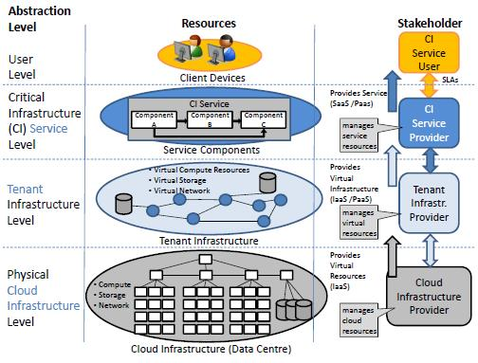
Figure: SECCRIT architecture framework. [12]
Alarifi [13] proposed a methodology to detect anomalies in IaaS environments through virtual machine host system call analysis. Its advantageous to monitor system calls at the VM host level without requiring any instrumentation within VMs and does not require any knowledge about VMs from inside nor requiring any OS or hypervisor modifications.
Host level anomaly monitoring involves monitoring the processes in user and kernel space. User level anomaly detection can occure through system call interface for user level processes, and a new monitoring interface driver can be created at kernel level in host itself. This driver's execution behaviour can be monitered to identify on-host processes anomalies. Abhinav Shrivatava [16] has given insite into creating interface at kernel level and monitoring kernel activities through accessing DomU kernel memory,parsing kernel data structures and kernel mode monitoring at VM host. This helps in robust and secure monitoring of malicious behaviors in virtual host.

The comparison of existing fault detection techniques is given following table.

Sr. No. | Fault Detection Framework | Author | Methodology Used | Monitored / Target system
1 | Fault Detection framework for Cloud System (FDCS) | Kanishka Bhaduri | Automated, Rule Based Monitoring System | Computing Machines in cloud
2 | Fault Model using improved C4.5 algorithm | Ying Jiang | DecisionTtree Based  Classifiers | All components at all the layers in cloud
3 | Latent Fault Detection Framework | Mickey Gabela | Performance counters and event log analysis | Computing machines that perform similar tasks in cloud
4 | Fault Diagnosis Framework | Tao Wang | Canonical Correlation Analysis based model | Web Applications in cloud
5 | CSTracer | Rao Xiang | Finite machine state based identifiers for tracing companion state | Entire Cloud
6 | Fault Detection and Tolerent System | Shweta Jain | Heartbeat Algorithm and Gossip Algorithm for detecting failures | SaaS layer in cloud
7 | Framework for anomaly detection | Chen | Decision tree based supervised framework | Any System
8 | Vigilant | Dan Pelleg | Decision tree based fault classifier | Vms
9 | SECCRIT | Various Institutes | Monitoring system and network activites at various layers | Entire cloud
10 | Anomaly detection in IaaS | Alarifi | Monitor system calls at the VM host level | IaaS in cloud
11 | Robust and Secure Monitoring of Malicious Behavior | Abhinav Shrivastava | Monitoring user and kernel levels of vm host | VM s in cloud

This survey gives the broad view about various fault detection techniques in cloud computing environment that work at various levels. The survey gives information about fault detection in computing machines, virtual machines, web applications, SaaS components and IaaS components and at all the systems in cloud.

- CONCLUSION

As cloud computing environment consists of hundreds and thousands of machines running in distributed network over a heterogeneous platform, it is very difficult to assure fault free smooth service at all the time. Even though current cloud technology is assuring good performance using fault tolerant mechanisms, for long term performance we need to identify and address the faults. From this survey we can conclude that decision tree based techniques are more popularly used to define fault classifiers and identifiers by researchers to identify faults.

REFERECES

[1] Kanishka Bhaduri, Kamalika Das, Bryan L. Matthews: “ Detecting Abnormal Machine Characteristics in Cloud Infrastructures.” ICDM Workshops 2011: 137-144

[2] Ying Jiang, Jie Huang, Jiaman Ding and Yingli Liu ,”Method of Fault Detection in Cloud Computing Systems”,nternational Journal of Grid Distribution Computing, Vol.7, no.3 (2014), pp.205-212 , http://dx.doi.org/10.14257/ijgdc.2014.7.3.21

[3] Yi Pan, “Fault-Detection in Cloud Computing Systems”, trust.csu.edu.cn/conference/.../20111116-KeynotePPT-Yi%20Pan.pdf

[4] Mickey Gabel, Ran Gilad-Bachracha , Nikolaj Bjørnera , Assaf Schuster,“Latent Fault Detection in Cloud Services”, Microsoft Research Technical Report,July 13, 2011 research.microsoft.com/pubs/151507/main.pdf

[5] Tao Wang, Wenbo Zhang, Jun Wei and Hua Zhong, “Fault Detection for Cloud Computing Systems with Correlation Analysis”, IEEE International Symposium on Integrated Network Management, Otawa, Canada, May 2015.

[6] RAO Xiang, WANG Huai-Min, CHEN Zhen-Bang, ZHOU Yang-Fan , CAI Hua, ZHOU Qi, SUN Ting-Tao, “Detecting Faults by Tracing Companion States in Cloud Computing Systems”,
Chinese Journal of Computers , 2014-07-21 , DOI: 10.3724/SP.J.1016.2012.00856

[7] Shweta Jain, Prof. Ashok Verma, Prof. Rashween Kaur Saluja, “Fault Detection and Tolerant System (FDTS) for SaaS Layer in Cloud Computing”, International Journal Of Engineering And Computer Science ISSN:2319-7242, Volume 3 Issue 8 August, 2014 Page No. 7938-7942

[8] M. Chen, A. X. Zheng, J. Lloyd, M. I. Jordan, and E. Brewer , “Failure diagnosis using decision trees.“ Autonomic Computing, International Conference on, 2004.

[9] K. Umadevi 1, S. Brintha Rajakumari2, Ramya.K3, “Software Fault Detection and Diagnostic Techniques:A Review and Current Trends”, International Journal of Emerging Technology in Computer Science & Electronics (IJETCSE) ISSN: 0976-1353 Volume 13 Issue 1 –MARCH 2015.

[10] Radhika Kalyan, Anil Kumar, “ Trends towards Failover Techniques for Cloud Computing
Environment”, nternational Journal of Advanced Research in Computer Science and Software Engineering, Volume 5, Issue 1, January 2015, ISSN: 2277 128X

[11] Dan Pelleg, Muli Ben Yehuda, Rick Harper,Lisa Spainhower, Tokunbo Adeshiyan, “ Vigilant—Out-of-band Detection of Failures in Virtual Machines”, ACM SIGOPS Operating Systems Review archive,Volume42Issue1,January2008Pages 26-31

[12] “Anomaly Detection Techniquesfor Cloud Computing”, SEcure Cloud computing for CRitical
infrastructure IT, Contract No 312758, https://www.seccrit.eu/.../D4-1-Anomaly-Detection-Techniques-for-Clou...

[13] Alarifi, S.S.; Wolthusen, S.D., "Detecting anomalies in IaaS environments through virtual machine host system call analysis," in Internet Technology And Secured Transactions, 2012 International Conference for , vol., no., pp.211-218, 10-12 Dec. 2012

[14] http://ganglia.wikimedia.org/latest/

[15] Rodrigo N. Calheiros, Rajiv Ranjan, César A. F. De Rose, and Rajkumar Buyya, “CloudSim: A Novel Framework for Modeling and Simulation of Cloud Computing Infrastructures and Services”

[16] Abhinav Srivastava , “Robust and Secure monitoring and Attribution of Malicious Behavior”, A Thesis
Presented to The Academic Faculty, Georgia Institute of Technology, August 2011

