Static program slicing-An efficient approach for Prioritization of test cases for Regression Testing

Ms. Jyoti Arora
Rukmini Devi Institute of Advanced Studies
2A & 2B, Phase-1, MadhubanChowk, Outer Ring Road, Rohini, Delhi-110085
Email Id: jyoti.arora@rdias.ac.in

Abstract – Test case Prioritization is a process of re-arranging the test cases in an order to that improves the performance of regression testing. There are many techniques used for prioritization test cases at the time of regression testing. This paper present a new approach for prioritization of test cases using static executable program slices for regression testing. Program slicing is a process to classify the program into number of parts based on various types of dependencies between program statements. This paper presents an overview of basic concept of generating static program slices and on the basis of these programs slices prioritization of test cases at the time of regression testing
Keywords – Regression testing, Program dependency, static program slices, test cases prioritization and execution history

- INTRODUCTION
Regression Testing is performed after modification of program code/software. After modification of program, it is very difficult to find out affected test cases due to modification of program. Regression Testing is a technique that classified existing test cases into two parts, re-used test cases after modification and affected test cases after modification. Test case Prioritization is a technique of re-arranging the existing test cases such that the most beneficial are executed first thus allowing for an increase in the effectiveness of testing [6]. Many techniques used by researchers for prioritization of test cases, this paper presents an executable static program slicing technique for prioritization of test cases for regression testing. The concept of Program Slicing is to decompose the program into small units depends on various types of dependencies (data dependency, control dependency, call dependency and so on) between the program statements. Program slicing is applied into number of application for example in computer understanding, debugging, and testing and program comprehension by reducing the complexity of the program. This paper shows the process of automatically generation of static program slices from the program and used these static program slices for prioritizing test cases at the time of regression testing.
II. PROGRAM SLICING
In the software development life cycle software testing plays very import role, with the help of software testing compare the estimated and actual result of software by executing a program or system with the intent of finding different types of faults. There are two approaches for performing software testing one is functional testing and other one is structural testing. In the case functional testing, only focus on functional part of the program and ignore internal details while comparing estimated and actual result. In the case of structural testing, focus on internal structure of the program while comparing estimated and actual result and finding out faults. The process of structural testing is only focus on Software Testing is the process of executing a program or system with the intent of finding errors.
Full white-box testing is a large task. However, for many properties, only a small portion of the program is relevant. Hence property-based testing has the potential to substantially simplify much of the testing work. The portion of a program that relates to a given property can be identified through slicing.

Slicing is an important testing technique with the help of those simplifying programs by focusing on selected aspects of semantics. It is method of program analysis which is used to extract a set of statements in a program which is relevant for a particular computation. This set of statements is called a program slice. Various type of slicing strategies exist such as forward slicing, backward slicing, static slicing, dynamic slicing, etc. These different slicing techniques have different application domains such as software maintenance, software optimization, program analysis, information flow control, etc. Program slicing refers to finding all statements in a program that directly or indirectly affect the value of a variable occurrence. The selected statements constitute a slice.

Depending on the run-time environment, Program Slicing classified as static slicing and dynamic slicing. In the case static slicing, a slice S consists of all statements in program P that may affect the value of variable v at some point p. The slice is defined for a slicing criterion C=(x, V), where x is a statement in program P and V is a subset of variables in P. A static slice preserves the program’s behavior (value of variable v) for all possible program executions. Static Slicing is used to identify those parts of the program that potentially contribute to the computation of the selected functions for all possible programs inputs. In the case of dynamic slicing, a dynamic program slice is part of a program that “affects” the computation of a variable of interest during program execution on a specific program input. This paper shows automatic generation of static program slicing process^{.[5]}

Terminology used in Static Program Slicing:-
- Program Slice :- A program slice is a subset of a program.
- Slicing Criteria :- Assume that: P is a program and V is the set of variables at a program location (line number) n. A slice S(V,n) produces the portions of the program that contribute to the value of V just before or after the statement at location n is executed.
- Slicing Variable :- Slicing variable is variable specified in the slicing criteria , used to find out directly or indirectly affected lines from the program at the slicing Point.
- Slicing Point :- Slicing Point is point from where programmer wants to slice the program that contribute to the value of slicing variable.
- Slicing Direction :- Slicing direction used to exact the slice from the program in the forward or backward manner.
- Type of the Slicing result:- The result of slicing may be equivalent to the program or few set of statements from the program.
A Program slice Must Satisfy the following conditions:-
- Slices created with respect to one variable not a set of variables.
- Creating slices for all nodes/program statements whose focus is on the variables in the right hand side of an assignment.
- Slices should be executable.
For example figure shows C’ language code:- Figure-1
1. void main()
2. {
3. inti,sum,mul;
4. i=1;
5. sum=0;
6. mul=1;
7. while(i<=10)
8. {
9. sum=sum+i;
10. mul=mul*i;
11. i=i+1;
12. }
13. printf(“%d”,i);
14. printf(“%d”,mul);
15. printf(“%d”,sum);
16. getch();
17. }

Figure-2 shows the demonstration for various program slices of program -1. Figure 2. Shows executable program slices of all variables of program -1, every program slice includes statements from program-1 that directly or indirectly affects the value of that program slice variable.

With the help of program slices, we decompose our program -1 into number of slices containing statements that directly or indirectly affect the slice variable in program-1. Finally for slice S1, count the value of i variable, for slice S2, compute the multiplication function and for slice S3 compute the sum function.

Figure :2 Executable Program Slices for above C’ language Program

S1(i, 13)  void main()  {  inti,sum,mul;  i=1;  while(i<=10)  {  i=i+1;  }  Printf(“%d”,i);  getch();  } | S2(mul,14)  void main()  {  inti,sum,mul;  mul=1;  i=1;  while(i<=10)  {  mul=mul*i;  i=i+1;  }  printf(“%d”,mul);  getch();  } | S3(sum,15)  void main()  {  inti,sum,mul;  sum=0;  i=1;  while(i<=10)  {  sum=sum+I;  i=i+1;  }  printf(“%d”,sum);  getch();  }

III PROGRAM SLICING PROCESS

The step by step activities for generating static program slicing are:-

Figure3. Static program slicing process

Select the slicing criterion

Create Program Dependency Graph
Slice Extraction

Figure 4. Example Program

- inti,sum;
- i=1;
- sum=0;
- while(i<11) {
- sum=sum+i;
- i=i+1;}
- Write(sum);
- Write(i);
- } }

- Select the slicing criterion:- The slicing criterion specifies a point of interest (a statement in the program to be sliced) and interested variable. For static program slices, criterion is expressed as (n,V)- where n is point of interest and V is interested variable. For dynamic program slices, criterion is expressed as (value,n,V)- where value is input variable value, n is point of interest and V is interested variable. For example Slicing criterion for above program is ( i,8)^{[2]}
- Create Program Dependency Graph:- The second step for program slicing process is to create program dependency graph on the basis of various types of dependencies between the statements^{[4]}. For example dependency can be data, control, function call etc. The Program Dependency Graph for above program is as follow:

Figure 5. Program Flow Graph
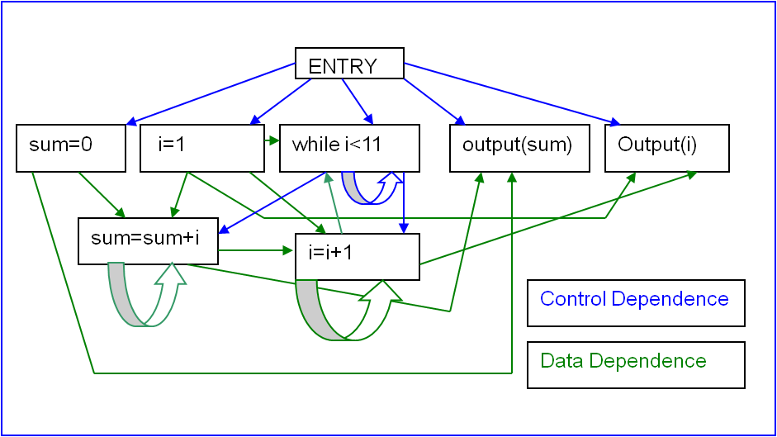
- Slice Extraction: - After creating dependency graph, the next step is to extract slices from program dependency graph using forward or backward approaches. Backward slices contain all parts of the program that might have influenced the variable in the statement under consideration. Here the slice is computed by working backwards from the point of interest finding all statements that can affect the specified variable at the point of interest and discarding the other statements. Forward slices contain all parts of the program that might be influenced by the variable in those statements which are affected by the slicing criterion. Here the slice is computed by working forwards from the point of interest finding all statements that can affect the specified variable at the point of interest and discarding the other statements^{[3].}
Figure 6. Program flow graph of variable i
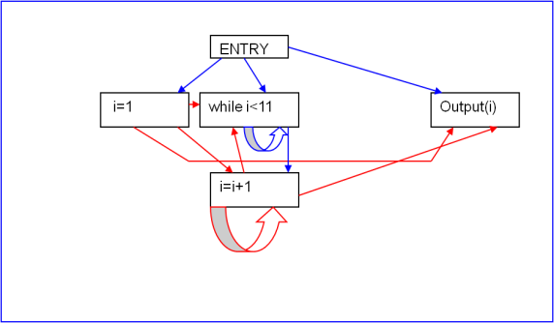

IV Existing Program Slicing Tools

Figure 7.Comparison between static Program Slicing Tools

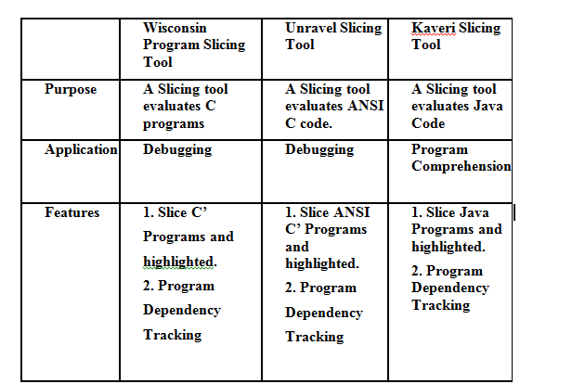
The above figure shows various existing tools for static program slicing.

V PROPOSED APPROACH

Figure 8. Proposed Approach

Create Executable Program Slices Module

Identify differences between Original & Modified Program in case of Regression Testing Module

Generate Test cases from the Executable static Program slices Module

Prioritization of Test cases in case of Regression Testing Module

- Create executable Static Program Slices Module

This module includes four steps:-
- Select the Slicing Criteria.
- Create Software Dependence Graph.
- Slicing Extraction
- Slicing Execution
In the first step of this module, input the slicing criteria from user –slice variable and slicing point.

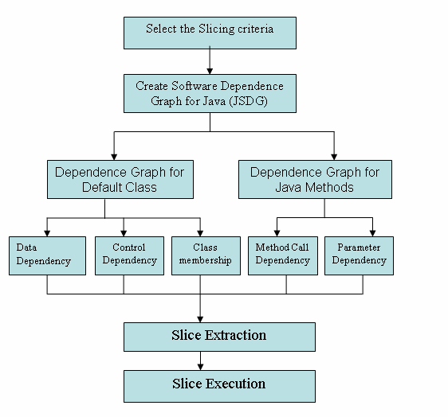
In the second step of this module, create program dependence graph.
- Generate Test Cases from the Executable Static Program Slices Module:- The executable static program slices contained line numbers of original program. On the basis of line numbers of individual executable static program slices generate test cases and maintained its execution history.
- Identify differences between Original & Modified Program in case of Regression Testing Module:-
This module includes four steps:-
- Input original and modified java program.
- Creation of flow graph of original and modified program.
- Identify differences between flow graph of original and modified java program.

- Display difference- new lines, deleted lines and modified lines.

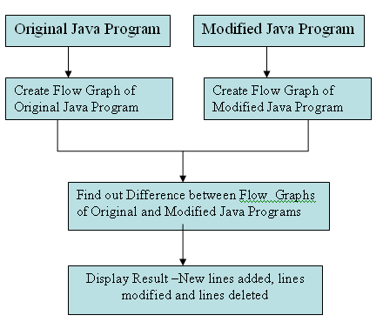
- Prioritization of Test Cases in case of Regression Testing Module:-

This module includes two steps:-
- Search Modified lines into all slices of original java program & find out effected program slices: - In this step if slice contain modified lines, then it declared effect program slice.
- Compare execution history of original test suite with lines numbers of every effected program slices:- In this step compare execution history of original test suite with lines numbers of every effected program slices and if both are equals then it declared effected test cases after modification.
- Prioritization of Test Cases :- On the basis of maximum number of matches from the execution history of original test suite with lines numbers of every effected program slices, prioritized the test cases.

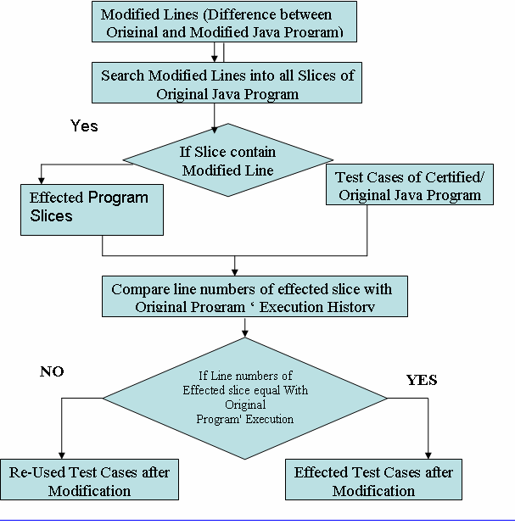
VI DETERMINING TEST S
UITE
EFFECTIVENESS USING AVERAGE PERCENTAGE OF FAULTS
DETECTED (APFD) METRIC

THE ALGORITHM FOR TEST CASE PRIORITIZATION

Input: Test suite T, number of faults detected by a
test case f, and cost to run each test case Tcost.
Output: Prioritized Test suite T’.
1: begin
2: set T’ empty
3: for each test case t ε T do
4: calculate average faults found per minute as
f/Tcost
5: end for
6: sort T in descending order based on the on
the value of each test case
7: let T’ be T
8: end
VII EXPERIMENTATION AND ANALYSIS

Let’s suppose following are the existing test suite before modification of code/program. (we only included test case id and execution history in the existing test suite for our experimentation.
Test case id | Execution history
T1 | 1,2,3,5,7
T2 | 1,2,3,5,7,8
T3 | 1,2,4,8,9
T4 | 1,2,3,5,5,6,7
T5 | 8,9,10
T6 | 1,2,8,9
T7 | 1,2,3,9,10
And modified lines are 3,4 and 5

According our execute static program slicing approach affected test after modification are:-
Test case id | Execution History
T1 | 1,2,3,5,7
T2 | 1,2,3,5,7,8
T3 | 1,2,4,8,9
T4 | 1,2,3,4,5,6,7
T7 | 1,2,3,9,10
Below table shows the number of faults detected
by a test case in the test suite and total time taken
by each test case.

 | T1 | T2 | T3 | T4 | T7
F1(for modified line no.3) | * | * |  | * | *
F2(for modified line no. 4) |  |  | * | *
F3 (for modified line no. 5) | * | * |  | *
No. of faults | 2 | 2 | 1 | 2 | 1
Time | 5 | 7 | 2 | 1 | 3

VTi=fault/time(rate of fault detection)
The calculations are:
VT1=2/5=0.4
VT2=2/7=0.28
VT3=1/2=0.5
VT4=2/1=2
VT7=1/3=0.33
Priority set according to decreasing order of value of VTi, since more the rate of fault detection more will be the priority.
Hence the prioritized order is:

T4,T1,T3,T2,T7
In the above table
m=no. of faults = 10
n=no. of test cases = 10
So putting the values of m , n ,TFi(The position of
the first test in T that exposes fault i) in the
equation
APFD = 1 – TF1 + TF2+ ........ +TFm + 1
nm 2n
Putting values:
APED=1-2+3+2 +1/10
5*3
=0.43

VIII. CONCLUSION

Program slicing is an approach for program analysis and understanding using statement dependence information to identify parts of a program that influence or are influenced by an initial set of program point of interest. This paper shows process of automatic generation of static executable program slices and using these slices to find effected test cases after modification of the program and on the basis of maximum number of lines comparing prioritized test case when modified the original program.

REFERENCES

Journal Papers:

[1]M.Weiser, “Programmers use slices when debugging”, Communications of the ACM, vol. 25, 1982, pp. 446-452.

[2] Weiser, Program Slicing, IEEE Transactions on Software Engineering 10(4), 352-357 (1984).

[3] Tip,F A survey of program slicing techniques. Journal of programming languages 3, 121-189 (1995).

[4] Jianjun Zhao “Applying Program Dependence Analysis to Java Software”In Proc. Workshop on Software Engineering and Database Systems,Pages 162-169, Taiwan, December 1998.

[5]Andrea De Lucia Program Slicing: Methods and Applications, IEEE international workshop,2001

[6] Praveen Ranjan Srivastava, Test Case Prioritization, Journal of Theoretical and Applied Information Technology
Web Links

[7] Indus Project. http://indus.projects.cis.ksu.edu/

[8] Unravel Project. http://hissa.nist.gov/unravel/

[9] Wisconsin Program Slicing Project. http://www.cs.wisc.edu/wpis/html/

[10] Topics in Program Slicing, http://www.cs.drexel.edu/~spiros/teaching/CS576/slides/5.slicing.pdf.

