SELECTION OF A BEST CLOUD SERVICE PROVIDER (CSP)

Dr. Mukesh Chandra Negi
Project Manager, TechMahindra Ltd.
PhD, MCA, M.Sc., APGDCA, PGDCA, CIC
Mukesh_negi77@yahoo.com, Mukesh.negi0910@outlook.com

Abstract

Today we often heard about migration towards different cloud computing delivery models where lots of organizations are moving their complete IT infrastructure or e-business towards different cloud delivery models. One of the major time taking and complicated area towards adoption of cloud computing is the selection of a best cloud service provider from the market according to your requirements and need. We know as of now there are uncountable number of cloud service providers in the market like Google, Amazon, Microsoft, Salesforce, Cisco, IBM etc. but how do you identify which one is best provider for you, according to your requirements. It’s not like all cloud service providers are providing all kind of services, almost all service providers providing services in their specialized areas like infra, application, database, public cloud, private cloud, networking etc. Now as an end user, how would you identify which cloud service provider should I approach to get my expected benefits by adopting the cloud computing model? My article will give you a brief idea on how to first identify you objective from the cloud computing, then how to perform due diligence of your exact requirements and then how to select a best cloud service provider from the cloud of cloud service providers.

Keywords - Cloud Service Provider, Cloud Migration, Cloud Delivery Models, Cloud due diligence

INTRODUCTION

Cloud computing is a very generic term which almost everybody knows but, rarely people knows about its backend complexity and how different service providers in the market providing same kind of services in different ways and with different characteristics, and if you are planning to move to cloud computing then how to choose one of them. Every cloud vendor is having his own infrastructure, applications, implementations, security etc. for cloud services which they are maintaining at the backend and you as an end your or client does not have any visibilities on the same, you just have to purchase or subscribe for the services you wanted to use and pay for that as per your usages monthly, quarterly or yearly as per service provider payment model. Every cloud service provider

do not provide every services which you may require, some may be dealing with infrastructure, some may be with applications and some may be with both infra and applications but don’t have your requirement specific application(s) or infrastructure. So you may have to go with a single cloud service provider or may be with more than one service provider. It’s a day or week work to choose a cloud service provider, implement and start using your applications. Sometime even just selection of a cloud service provider or providers may take couple of months based on your specific requirements. You have check for cloud service provider market credentials, past history with existing clients and specially the performance and all in terms of specific applications you wanted to buy from the service provider.

IDENTIFY YOUR OBJECTIVES

Before selection of a cloud service provider you have to first identify and document all of your objectives you wanted to achieve from the cloud computing. Until you don’t have clarity on your objectives you can’t able to take proper decision to choose any of the cloud service providers from the market. You have to identify all of your pain areas from your current IT infrastructure to identify all of your objectives. Make sure to segregate your entire objectives in terms of tangible and intangible categories and benefits. Even you go to any service provider and the first very basic question is why you wanted to move to cloud computing. You can reach to n number of cloud service provider for evaluations once you have clear picture and understanding of all of your objectives. Some of the generic objectives for moving towards the cloud computing are as below -

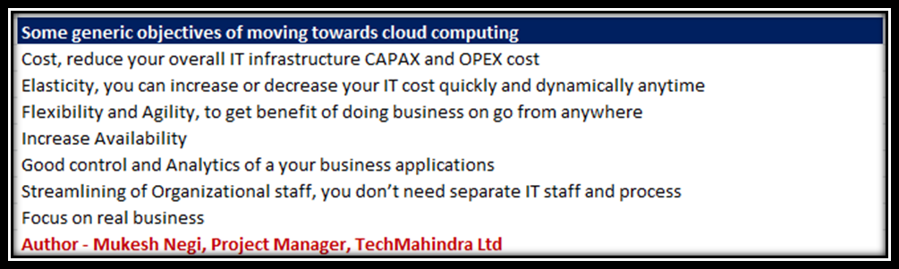

Further, based on above objectives, you have to perform a further deep drive on each and every point as below -

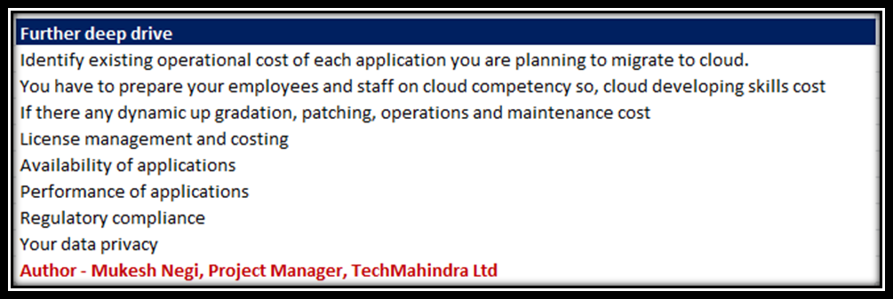

DUE DILIGENCE OF YOUR REQUIREMENT

Once you are clear with your objectives, you have to perform due diligence on all current existing threats and risks related with the cloud computing and specially related with all of the applications and technologies you wanted to use in cloud computing to make sure on what is the impact on your objectives with respect to the same. Identify if that’s acceptable or now and if there any alternate provider or options available in the market to mitigate the same and what is the extra cost associated with the same if there any. In similar way, make sure to perform due diligence of each and every related risks with respect to your specific requirements.
Below are some existing generic cloud related risks and threats as of now -

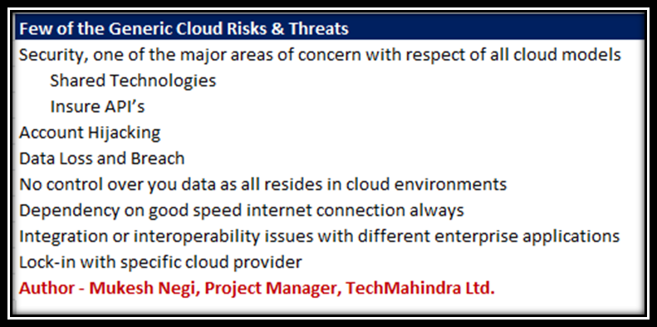

A generic flow of decision is as below

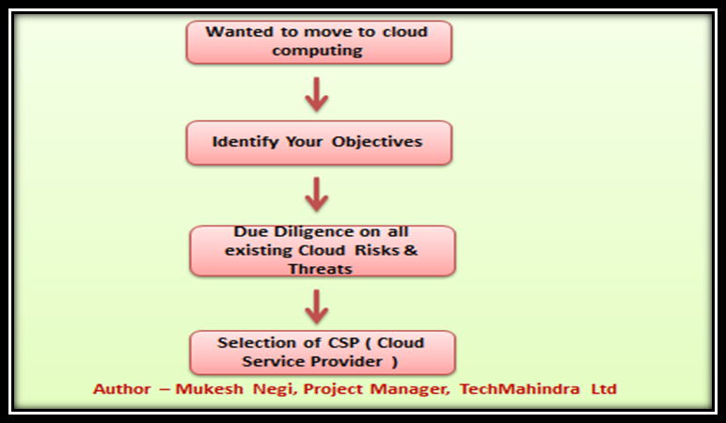

EVALUATION OF CSP (CLOUD SERVICE PROVIDER)
PORTFOLIO

Evaluation of CSP (Cloud Service Provider) portfolio is the most critical step towards selection of a cloud service provider. You complete business is dependent on the provider you are going to select at this stage, and it may land you in big trouble if you would not do a proper due diligence on cloud service provider portfolio before selection. Once moved, you can’t even think about to move back and have to stick with options available with the provider which may increase your problems and you would not be able to achieve all of your objectives.
You can start high level discussion with CSP’s as below –

- Identify top 5 or 10 cloud service providers in the market
- Discuss some of your generic queries and questions with all
- Present your objectives and requirements to all
- See who full fill all or maximum of your requirements
- Fix a one to one meeting with all of them to discuss on your requirements and their understandings
- Based on above discussion, filter top 2 or three
- Submit you current requirements and infra details with them and ask them with come up with their technical and commercial proposals
- Evaluate all based on their technical and commercial proposal to identify one of them

Above are few high level steps you have to take to filter top 2 or three and then one final from them, but since all organizations from different sectors are running with almost different applications and requirements, so top two or three doesn’t mean that good fit for your requirement. May be they are running some good enterprise infrastructure and applications but may be don’t have enough experience or good history of applications according to your requirements.

Below are some generic queries and questions which you can discuss with all cloud service providers irrespective if they are in top 5 or 10 or not –

- What all the cloud services they are providing
- What is their pricing structure and payment modes, monthly, quarterly, yearly etc.
- How secure is their cloud and what all different methods and policies they have implemented for their cloud security.
- Where is their data center how safe it’s
- Where is their DR (Disaster Recovery) center and failover time from primary data enter
- What are their Service Level Agreements in terms of availability, performance, maintainability, upgradability, security, response etc.
- Customer support service and engineers availability
- How feasible to scale up in future as per your business requirements
- How will you access your cloud from anywhere?

Below are some generic credentials and things you have to verify for each and every service provider –

- Their Technical expertise and understanding as per your requirements
- Experience – experience in the field of cloud computing
- Downtime history – their past complete downtime history
- SLA (Service Level Agreements)
- Customer Support and Resources availability in case of critical support
- Scalability in future - How fast they can scale your requirements in future
- Third-party compliance & audit – if they have some process of compliance and audit from some third party organizations by own from clients
- Provider organization, governance, planning and risk management
- Documented policies and procedures
- Event management – How they manage the events in case of alerts, partial or full breakdowns
- Logical security
- Change management – What’s their change management process
- Data integrity – How they maintain the data integrity
- Physical and environmental security – How secure is their data center
- Client reporting, billing and satisfaction – You have to confirm it with existing clients
- Financial credentials – If can able to sustain marker pressures

Refer below figure for understand cloud service provider selection process in easy & graphical way

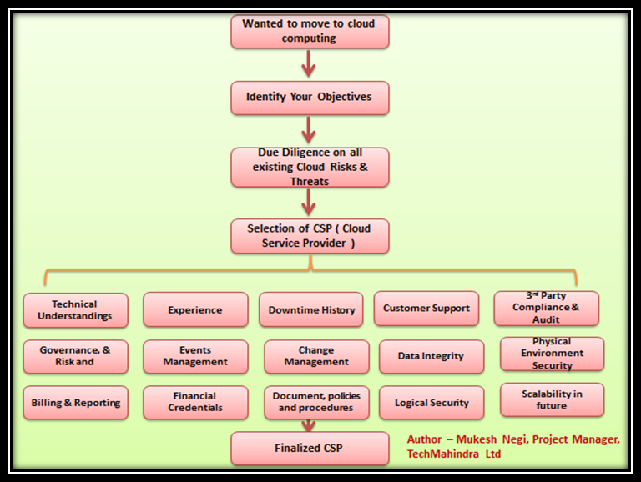

CONCLUSION

Moving to cloud computing can be an easy decision but selection of a perfect cloud service provider is equally tough and critical process. There are uncountable numbers of cloud service providers are there in the market, but selection of a specific provider according to your objectives and goals is equally important and time taking process. You have to dedicate your good amount of time for selection of cloud service providers otherwise after implementation of the cloud computing solution; it can land up you in a drastic situation in the future. Make sure to first identify your objective as well deep due diligence on current associated risks and threats. A bunch of risks and threats doesn’t mean you should not opt for cloud solutions, you have identify how much of then actually related to your specific requirements. Dedicate your as much as time you can able to give for filtering and selection of cloud services provider(s) because after implementation and migration, most of the time you have only choice to listen and give your agreement to cloud service provider(s).

REFERENCES

[1] A. Khajeh-Hosseini, I. Sommerville, and D.Greenwood, Cloud Migration: A Case Study of Migrating an Enterprise IT System to IaaS Submitted to 1st ACM Symposium on Cloud Computing (SOCC 2010), 2010.

[2]. Aymerich, F. M., Fenu, G., Surcis, S., & IEEE. (2008) Ostrava, An Approach to a Cloud Computing Network. 1st International Conference on the Applications of Digital Information and Web Technologies,120-125,

[3]Anthony T. Velte, Toby J. Velte, & Robert Elsenpeter.(2010), Cloud Computing: A Practical Approach. United States, TATA McGraw-Hill.

[4] F. A. Alvi1, B.S Choudary,N. Jaferry, E.Pathan.- A review on cloud computing security issues & challenges.

[5]Chang, L, Ti ; Chin L; Chang, A.Y.; Chun J, C;(2010), “ Information security issue of enterprises adopting the application of cloud computing”, IEEE 2010 Sixth International Conference on Networked Computing and Advanced Information Management (NCM),pp 645, 16-18 Aug. 2010.

[6]Cloudreviews.com, (2011), Cloud Migration: Cloud Migration Strategy in Brief, http://www.cloudreviews.com/blog/best-cloud-migration- services.

[7]Dean and S. Ghemawat; (2010), “MapRduce: Simplified data processing large clusters”, communication of the ACM, Vol.51, pages 107-113.

[8] Geng L; David F; Jinzy Z; Glenn D; (2009), “Cloud computing: IT as Service, “IEEE computer society IT Professional”, Vol. 11, pp.10-13, March-April 2009.

[9]Jensen, M.; Schwenk, J.; Gruschka, N.; Iacono, L.L.; (2010), “On Technical Security Issues in Cloud Computing”, IEEE International Conference on Cloud Computing, 2009. CLOUD '09, pp 109, 21-25 Sept. 2009. 5708519 searchabstract

[10] M. Jensen, J.O. Schwenk, N. Gruschka, and L.L. Iacono, "On Technical Security Issues in Cloud Computing," IEEE International Conference on Cloud Computing (CLOUD-II 2009), Bangalore, India: 2009,pp. 109-116.

[11]Mohagheghi P, Saether T (2011) Software Engineering Challenges for Migration to the Service Cloud Paradigm Ongoing Work in the REMICS Project. IEEE World Congress on Services

[12]M. Klems, J. Nimis, and S. Tai, "Do Clouds Compute? A Framework for Estimating the Value of Cloud Computing," Markets, Services, and Networks, Lecture Notes in Business Information Processing, vol. 22, 2009.

[13] M.A. Vouk, "Cloud computing issues, research and implementations," 30th International Conference on Information Technology Interfaces (ITI 2008),Cavtat/Dubrovnik, Croatia: 2008, pp. 31 40.

[14] NIST, NIST Definition of cloud computing v15, NIST, Editor. 2009, National Institute of Standards and Technology: Gaithersburg, MD (2009).

[15] P. Mohagheghi, T. Saether, Software Engineering Challenges for Migration to the Service Cloud Paradigm Ongoing Work in the REMICS Project, 2011 IEEE World Congress on Services

[16] Pearson, S.; (2009), “Taking account of privacy when designing cloud computing services”,5071532 searchabstract CLOUD '09. ICSE Workshop on Software Engineering Challenges of Cloud Computing, 2009. pp 44, 23-23 May 2009.

[17] Ramcoblog.com, (2010) Migrating to the cloud: A 5 Ste Structured Approach, http://www.ramcoblog.com/migrating-to- the-cloud-a-5-step-structured-approach.

[18] Rashmi, Dr.Shabana Mehfuz, & Dr.G.Sahoo. (2012), A
five phased approach for the cloud migration. International Journal of Emerging Technology and Advanced Engineering

[19] Salvatore D'Agostino, Miha Ahronovitz, & Joe Armstrong (2011), Moving to the Cloud (Version 1.0). A white paper produced by the Cloud Computing Use Cases Discussion Group

[20] Tian L.Q; NI Y,LING; (2010) , “Evolution of user Behavior Trust in Cloud Computing”, 2010 International Conference on Computer Application and System Modeling (ICCASM 2010),Vol. 7,pp V7-567, 22-24 Oct. 2010.

[21] Yuefa D; Wu B; Yaqiang G; Zhang Q; Tang C; (2009), “ Data Security Model for Cloud Computing”, Proceedings of the 2009 International Workshop on Information security and Applications (IWISA 2009)

