Intrusion Detection and Recovery of MANET by using ACO Algorithm and Genetic Algorithm

Kuldeep Singh
Department of Computer Engineering
Master of Technology
Punjabi University Patiala
E-mail: sidhu.kuldeep89@gmail.com
Karandeep Singh
Department of Computer Engineering
Assistant Professor
Punjabi University Patiala
E-mail: karan_rob07@yahoo.co.in

Abstract— Mobile Adhoc Network (MANET) is a self configuring, agglomeration of wireless nodes with dynamically changing network topology that formed without using any pre installed infrastructure or any central administrator. Intrusion detection is the security system that is used to automatically detect the problem when someone trying to break information system through violation of security policy. Alone Intrusion Prevention method is not sufficient because in MANET, network topology is continuously changing so intrusion detection technique is used. This paper is based upon the intrusion detection in MANET based upon the different parameters of Mobile Nodes (MNs). Based upon some threshold values of parameters, ACO algorithm is used to detect the intrusion present in the network. And after that Genetic algorithm is used to recover the network.
Keywords—MANET; MNs; IDS; ACO;GA

Introduction
Mobile Adhoc Network (MANET) is the rapidly growing area of research and most prominent technology of wireless network because the demand of wireless network is increasing day by day. There is not pre-installed and fixed infrastructure in MANET, each node act as intermediate router. Therefore it becomes easy to attack such type of network in which there is no monitor or administrator. The various types of attack on MANET are flooding attack, warm hole attack, black hole attack, dropping attack, [3, 4] byzantine attack, passive eavesdropping, active interfering, data tampering, leakage of secret information, message replay, impersonation, message distortion, and denial of service (DoS) attacks. These types of attack are not detected easily so all Mobile nodes (MNs) in MANET need much cooperation for proper functioning of network. In wired network traffic can be monitored and analyzed through specified point or single administrator but in case of MANET it is very difficult to monitor and analyzed the traffic because there is no central control over the network. Traffic can be analyzed in their radio transmission range only.

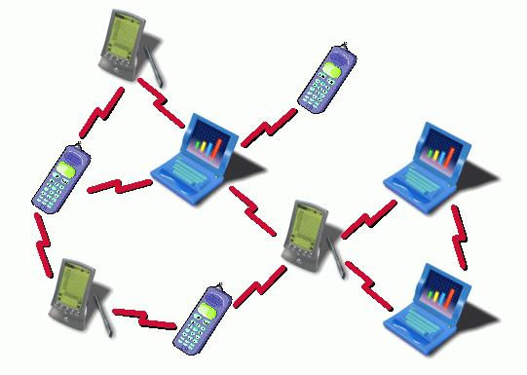
Fig.1 Structure of Mobile Adhoc Network

Background

Intrusion Detection System (IDS)
Intrusion detection[5, 6] is the act of detecting action that used to break the confidentiality, integrity and availability of the system and network resources. Intrusion detection system is mainly three types:
Network Intrusion detection system (NIDS): In NIDS whole network traffic are analysis to determine the behavior of the network. Network traffic is continuously sensed to find the abnormal behavior. Once the attack is identified or abnormal behavior is detected, system alert can be send to administrator by notifying that there is problem in the network.
Network Node Intrusion detection system (NNIDS): In NNIDS, the analysis of traffic done at specific node present in the network. Whole network traffic is not examined. Based upon the parameter values of that particular node we can identify that there is problem in node or not.
Host Intrusion detection system (HIDS): In HIDS the current state of the host and previous state are compared, if the critical files of the system are decontaminate or modified the alert can be send that there is problem in that particular host.

Ant Colony Optimization (ACO)
Ant colony [1, 2] optimization algorithm used to find the optimization paths that is based on the behaviour of ants searching for foods. At first ant wonders randomly, when an ant find source of food it returns back leaving a markers (pheromones). That shows the path has food. When other ants come across the markers, they are likely to follow the path with a certain probability. If they do, they then populate the path with their own markers as they bring the food back. As more ants find the path, it gets stronger until there are a couple streams of ants traveling to various food sources near the colony.
Same way we can apply ACO algorithm to find the intrusion present in the network. We are working with number of parameters of MNs like battery backup, throughput, packet delivery ratio, end to end delay and packet drop ratio. These parameters have some threshold values. Based on these threshold values we can detect whether the parameter is faulty or not.
Initially at first parameter of each node ant wonders. If the value of the parameter is less than the specified values (threshold value) of node then ant leaves markers (pheromones) and move further. Likewise on all five parameters of each node ants moves and leave pheromones and then finally move one ant which counts all the pheromones on each nodes at all parameters. The accuracy of this algorithm depends upon the selection of parameters and threshold values.

Genetic Algorithm (GA)
Genetic algorithm [7, 8] is a heuristic search algorithm that is used to mimic the behavior of natural selection. It is inspired from biological immune system and it is evolutionary algorithm. Is used chromosomes as a data that evolved through selection, mainly selection process is randomly and crossover that is various recombinations of selected data to produce the better results and finally it use mutation process that is used to create the diversity in the selected population. The process is repeating until the best result is not obtained.

The proposed intrusion detection and recovery technique

Parametr extraction and detection of intrusion

Intrusion detection and recovery is the main goal of this technique. So first step is to select the N number of nodes after that we need to detect the parameters of all N nodes. In this work parameters used are battery backup, throughput, packet delivery ratio, end to end delay and packet drop ratio. Intrusion detection is depending upon the efficient selection of parameters of nodes. As much the parameter will be strong intrusion detection probability will be more.

TABLE I
LIST OF PARAMETR USED FOR INTRUSION DETECTION SYSTEM.
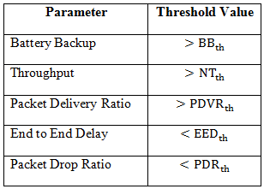

Next step is detection of intrusion. Intrusion detection can be done by ACO algorithm. Each parameter have some threshold value like battery backup have some threshold value , Packet drop ratio have some threshold value . Based on this threshold value we can detect the problem in that node. Launch the iterations of and on first parameter of each node if the parameter value is less than the required value then ant leaves a pheromones and move forward likewise second and is moved on second parameter of each node and identify that whether there is problem or not. At last one ant in moved from fist node of first parameter to last node of last parameter and counts the all pheromones leaves by other ants. And hence we can list the number of faulty parameters and can analysis how many node have problem due to intrusion present in the network.

Algorithm Ant Colony Optimization for intrusion detection
Step1. Randomly select number of nodes.
Step2. Detection of parameters values of all nodes.
Step3. Launch the iteration of ants on each parameter of all N nodes.
Step4. If parameter value is less than or greater than specified values
Step5. Then leave pheromones on that node and move forward
Step6. Else move ant forward without leaving pheromones.
Step7. Repeat step3 to Step6 until all parameters of all nodes are not processed.
Step8. Leave single ant from first nodes of first parameter to last node of last parameter.
Step9. Count the number of pheromones and move forward
Step10. Calculate how many parameters of all N nodes have problem.

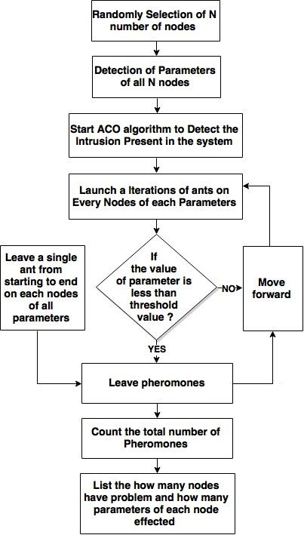

Fig.2 Ant Colony Optimization Algorithm Flow chart

Recovery of network from intrusion
Intrusion done by ACO algorithm. It lists how many parameters have faulty. Genetic algorithm is used to recover the network. It uses all parameters values of all nodes as initial population. After that it selects the populations of parameters from initial population and the techniques of selection is based on random procedure. The number of iterations can be performed to recover the problem so we can provide that how many iterations we required to perform so that our result will be efficient. Crossover is the process that is applied after selection process. In crossover process various recombination of selected chromosomes are made to recover the problem. We can perform one point, two point and three point crossover parameters values. After crossover the new obtained generation is stronger than previous generation. The final step of genetic algorithm is mutation. Before apply the mutation we need to select the probability of mutation process. Mutation is mainly used to create the diversity in the selected population that is obtained after crossover process. After the total iteration the result are obtained and analyzed that how many parameters have removed problem and how many parameters have still problem is remaining. Following is the algorithm that is used to recover the problem in Mobile Adhoc network due to present of intrusion.
Genetic Algorithm for recovery of nodes
Step1. Take into account of population of all parameters of all N nodes.
Step2. Select initial population on which algorithm is need to be applied.
Step3. Select the number of iteration.
Step4. Perform one point, two point and three point crossover on sleeted population.
Step5. Select mutation probability.
Step6. Perform mutation to create diversity.
Step7. If number of iteration finish
Step8. Calculate and analyze the result that how many nodes have removed problem and how many have still remaining.
Step9. Else repeat the step4 to step7.

Experimental results
By using ACO algorithm we identify that how many parameters have problem listed below as total number of faulty parameters and for recovery we used Genetic Algorithm. Each time we can select different number of iterations and with different probability of mutation listed as Mut_Pr(i) and after applying algorithm the number of parameter corrected listed as No. of Par_Cor. . Experimental results for various numbers of nodes values has been listed below.

TOTAL NUMBER OF NODE-30
TOTAL NUMBER OF PARAMETERS-150
TOTAL NUMBER OF FAULTY PARAMERTS-106
TABLE II
NUMBER OF ITERATIONS WITH MUTATION PROBABILITY AND NUMBER OF CORRETED NODES
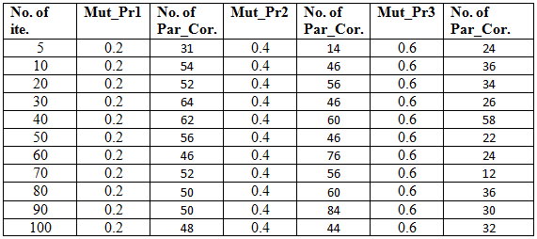
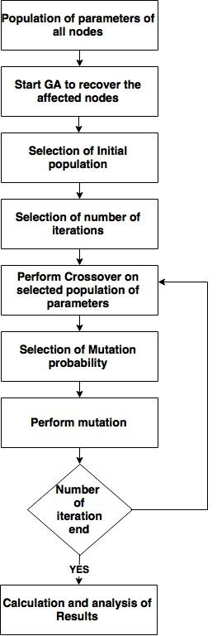
Fig.3 Genetic Algorithm Flow chart

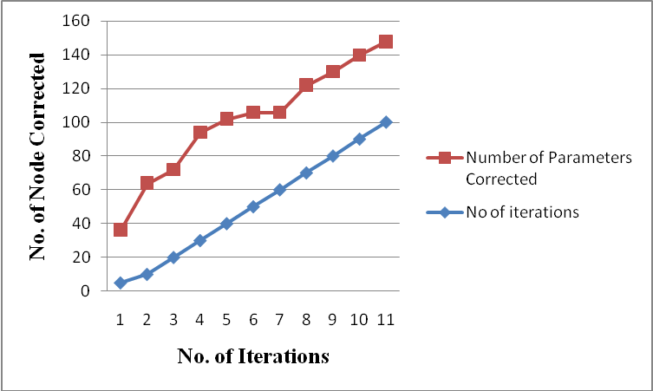
Fig.4 Number of nodes corrected when mutation probability =.2
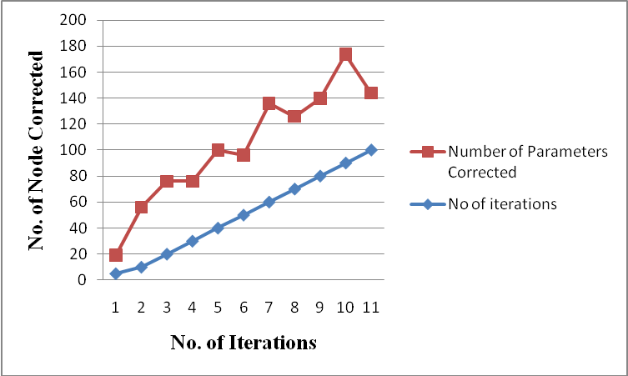
Fig.5 Number of nodes corrected when mutation probability =.4

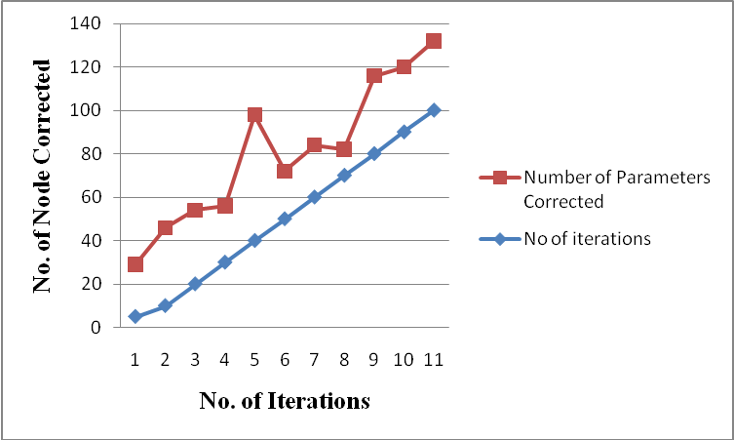
Fig.6 Number of nodes corrected when mutation probability =.6

TOTAL NUMBER OF NODE-70
TOTAL NUMBER OF PARAMETERS-350
TOTAL NUMBER OF FAULTY PARAMERTS-242

TABLE III
NUMBER OF ITERATIONS WITH MUTATION PROBABILITY AND NUMBER OF CORRETED NODES
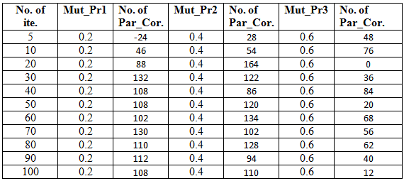
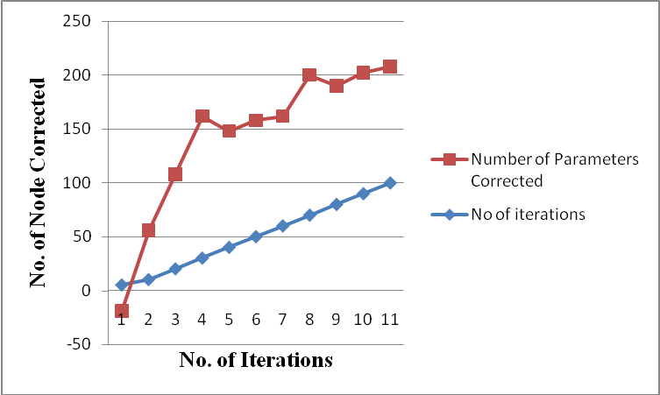
Fig.7 Number of nodes corrected when mutation probability =.2
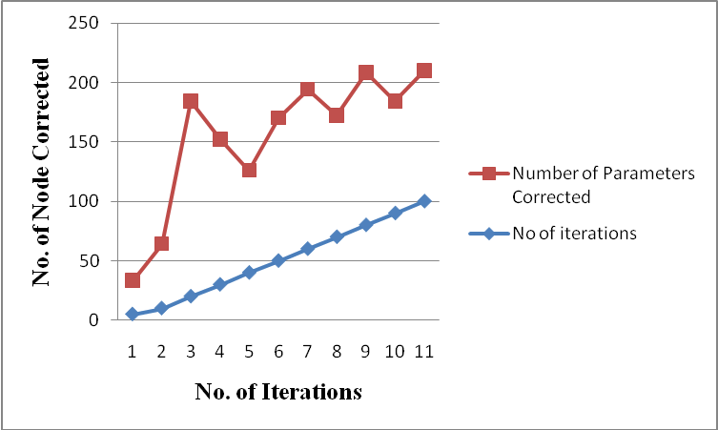
Fig.8 Number of nodes corrected when mutation probability =.4
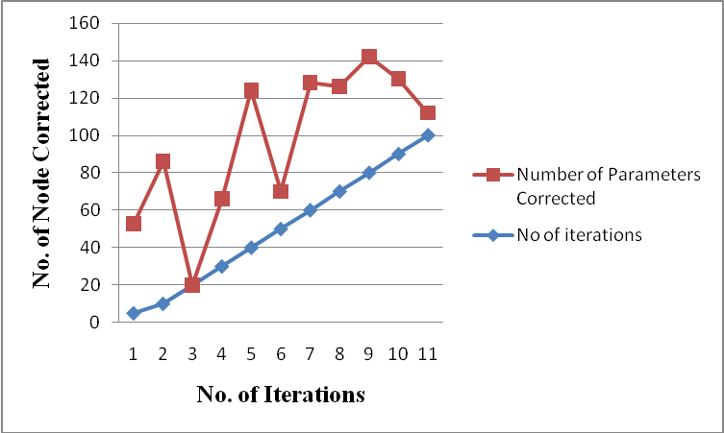
Fig.9 Number of nodes corrected when mutation probability =.6

TOTAL NUMBER OF NODE-150
TOTAL NUMBER OF PARAMETERS-750
TOTAL NUMBER OF FAULTY PARAMERTS-489
TABLE IV
NUMBER OF ITERATIONS WITH MUTATION PROBABILITY AND NUMBER OF CORRETED NODES

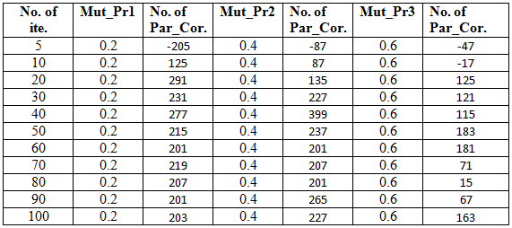
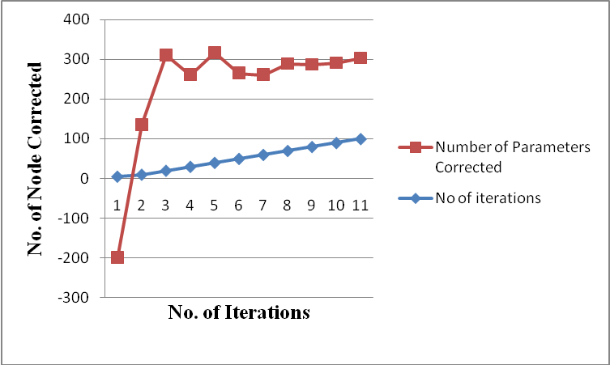
Fig.10 Number of nodes corrected when mutation probability =.2

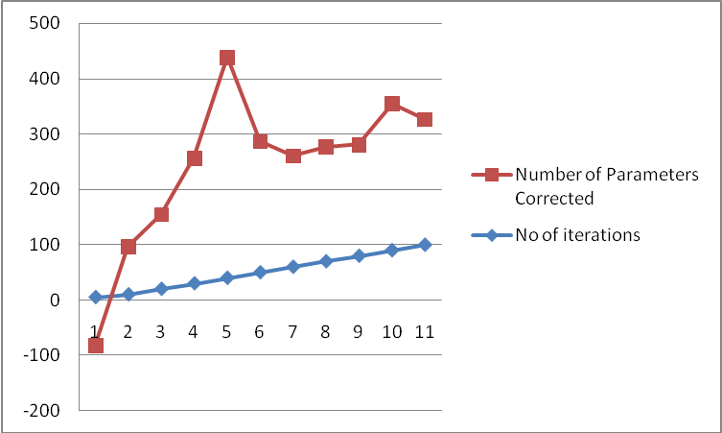
Fig.2 Number of nodes corrected when mutation probability =.4

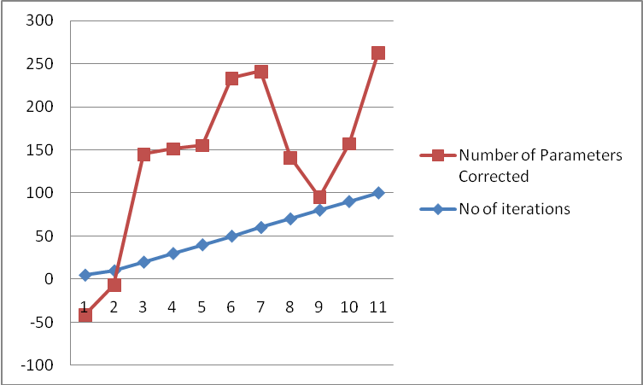
Fig.11 Number of nodes corrected when mutation probability =.6

Conclusion and future scope
Intrusion detection is done by ACO algorithm and recovery of network from intrusion is done by Genetic algorithm. The accuracy of the algorithm is depends upon the selection of parameters. As much the parameters will be strong the result will be more accurate. Research work shows that best result can be obtained by using number of iteration between 10 to 80 and mutation probability within the range of 0.2 to 0.4 units. For future work we can use different techniques for intrusion detection and can compare with this work. Like neural network can be used for intrusion detection system.

References

- Rajani Muraleedharan, and Lisa Ann Osadciw, “An Intrusion Detection Framework for Sensor Networks Using Ant Colony,” IEEE Nov 2009.
- Wei Song Li, Xiao Ming Bai, Long Zhen Duan and Xu Zhang, “ Intrusion Detection based on ant colony algorithm of fuzzy clustering,” International Conference on Computer Science and Network Technology IEEE Dec 2011.
- Hoang Lan Nguyen, and Uyen Trang Nguyen, “ A Study of Different types of Attacks in Mobile Adhoc Networks,” 25th IEEECsnadian Conference on Electrical Computer Engineering (CCEC) 2012.
- Er. Kiran Narang, and Sonal “ A Study of Different types of Attacks in MANET and discussion about Sloutions of Black Hole Attack on AODV Protocol,” International Journal of Advanced Research in Computer Engineering & Technology (IJARCET) Volume 2, Issue 4, April 2013.
- Elhadi M. Shakshuki, Nan Kang and Tarek R. Sheltami,“EAACK—A Secure Intrusion-Detection System for MANETs,” IEEE TRANSACTIONS ON INDUSTRIAL ELECTRONICS, VOL. 60, NO. 3, MARCH 2013.
- Ismail Butun, Salvatore D. Morgere, and Ravi Sankar,“A Survey of Intrusion Detection System in Wireless Sensor Networks,” IEEE Communication Systems &Tutorials VOL. 16, NO. 1, First Quarter 2014.
- Mostaque md. Morshedur Hassan,“ Network Intrusion Detection System Using Genetic Algorithm and Fuzzy Logic,” International Journals of Innovative Research in Computer and Communcation Engineering Vol. 1, Issue 7, September 2013.
- Vivek K. Kashirsagar, Sonali M. Tidke and Swati Vishnu,“ Intrusion Detection System Using Genetic Algorithm and Data Mining Overview,” International of Computer Science and Informatics ISSN (PRINT): 2231 –5292, Vol-1, Iss-4, 2012.

