A Secure and High Capacity Image Hiding Scheme Using DWT and Arithmetic Coding

Janki Jasani
Department of Information Technology
CSPIT, CHARUSAT
Anand, India
jasanijanki@gmail.com
Sarita Visavalia
Department of Information Technology
CSPIT, CHARUSAT
Anand, India
saritasign@gmail.com

Abstract— Steganography is the art of hiding the existence of the secret message being communicated in the multimedia carrier such as image, audio file, video file etc. Due to widespread usage of images over internet and presence of high redundancy in images image steganography is very popular. In this paper, we propose a novel scheme for hiding the secret image behind the grey scale cover image. We use the properties of Haar wavelet coefficients for hiding the secret bits. Arithmetic coding is performed on secret image before embedding in the cover image to reduce the size of secret message. It also provides security to the secret data as the result of arithmetic coding will be in encoded form. PSNR and SSIM are used to measure the quality of the stego image. Proper cover selection is very necessary for effective use of this technique.
Keywords- Arithmetic coding, haar coefficients

Introduction
In today’s communication world, the transfer of information through digital media has been increased very much. Information is very important and major factor for any organization by all aspects. With rapid growth of technologies in the internet, it has become so easy to use and access it for everyone. So security of such information has become potential requirement at the time of communication as well as storage and other purposes too. Steganography is one of such technique that provides privacy to communication. The word Steganography is derived from the Greek words “stegos” meaning “cover” and “grafia” meaning “writing” [2]. It is the kind of technique that hides the existence of the secret information behind digital object such as image, audio or video etc. Image Steganography has become the most popular technology because images are widely used medium over internet and images contain high redundancy. Many of the fields like medical, defence, intelligence, banking, commercial business etc have many applications that need research in this area. All these applications seeking security of information need different degrees of privacy.
Image steganography techniques can be of various types. The classification is based on the type of domain used i.e. spatial domain or transforms domain, based on file format and type of compression used, and the embedding method used for embedding secret message into the cover image.
Spatial domain techniques include bitwise manipulation of intensity of pixels and noise manipulation. In [6], Secret message bits are embedded into the blocks by shifting the arithmetic difference values. It can withstand JPEG compression. In [10], secret data is embedded in LSBs according to pixel intensities. The technique mentioned in [11], Combines TPVD and EPVD schemes to overcome steganalytic attacks. Security is guaranteed in this scheme. In [16] Huffman encoded bit stream of secret message/image is embedded in LSBs of the cover image. It also embeds size of Huffman encoded bit stream using four tier storage procedures. The advantage of that scheme is it doesn’t require cover image at receive side for extraction process. Data is embedded in intermediate significant and LSB bit planes of encrypted cover image in [21] and the method makes use of PAS and ASDP for finding exact locations for embedding. It provides high security.
Transform domain techniques are generally more robust than spatial domain ones. They give high robustness at the cost of compromising the capacity of hiding data. In [7], the secret bits are embedded in 2D wavelet transformed blocks of cover image according to complexity of the block decided by BPSC. In [17], IWT is done of cover and secret image for finding error blocks and assignment algorithm is used for finding matched blocks which are replaced by error blocks. This method is also doesn’t require cover image at receiver side. In [13], Secret bits are embedded into DCT coefficients of cover image blocks as per adaptive length. In [12], secret data is embedded in LSBs of non-zero coefficients of a sparse representation of the DWT of the cover image. The technique proposed in [14], embeds secret data bit stream in 1-level 2D DWT detailed coefficients of cover image. In [25], Huffman encoded bit stream is embedded into DWT coefficients of cover image. In this method, secret message bits are extracted 100%.
In [4], the proposed method transforms the image to separate high and low frequency components then inverse transform is applied and secret bits are embedded into high frequency LSBs. In [8], Embedding of secret bits is performed in some of the brighter pixels where changes made are imperceptible to HVS. In [9], secret data is embedded in edge regions using LSB matching revisited, takes into account secret data bits size and difference between two consecutive pixels for selecting proper edge regions. In [24], Except for the left most and top most blocks of the image, each of the other blocks in raster scanning order can be embedded with secret data and compressed by SMVQ or image inpainting adaptively according to current embedding bit. The technique proposed in [26] embeds the data in AMBTC compressed codes, during embedding in smooth blocks, two new quantization levels are recalculated to minimize the distortion, embedding in complex blocks won’t introduce distortion.
In this paper, we propose a novel image steganography technique that hides the secret image behind the cover image in encoded form. It does not require cover image presence at the other side to fully reconstruct the secret message. So security of the method is high. One of the advantages of this method is 100% extraction of secret message bits at receiver side. The paper is organized as follows. In the next section fundamental details of the DWT and arithmetic coding is elaborated. In Section III, the proposed method is discussed in detail. Experimental results are shown in Section IV. In the last Section, the paper is concluded.

BASIC TECHNIQUES USED IN THE PROPOSED SYSTEM
Two techniques are used mainly in the proposed algorithm i.e. 2D-DWT and arithmetic coding. In DWT, we use haar wavelet transformation.

2D- Discrete Haar Transform
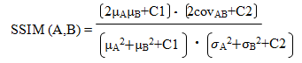
Discrete wavelet transform is applied on cover image to transform it from spatial domain to the frequency domain. Haar wavelet is of the simplest form and is elementary type of wavelet. It is fast, simple and memory efficient. The haar transform decomposes a discrete signal into two sub signals of half its length representing approximation (average) coefficients and detailed (difference) coefficients. In that, the low frequency wavelet coefficients are generated by averaging the two pixel values and then multiplying it by √2 and high frequency coefficients are generated by taking half of the difference of the same two pixels and then multiplying by√2. When we apply DWT to 2-D images, it becomes separated into four sub bands i.e. LL_{i,j}, HL_{i,j}, LH_{i,j} and HH_{i,j} as shown in the figure.

LL₃
LH₃
LH₂
HL₃
HH₃
LH₁

HL₂
HH₂

HL₁
HH₁

Figure 1. Components of 2-D DWT at third level

Arithmetic Coding
Arithmetic coding is the most efficient amongst the lossless compression techniques. So we will use arithmetic coding for compressing the image before embedding it into the cover image. Arithmetic coding assigns sequence of bits to a message, a string of symbols. In this method, a code word is not used to represent a symbol of the text as it is the case in Huffman code. Instead of that, it produces a code for an entire string or message. Arithmetic coding assigns an interval to each symbol. Then a decimal number is assigned this interval. Initially the interval is [0,1). A message is represented by a half open interval [x,y) where x and y are real numbers between 0 and 1. The interval is then divided into sub intervals. The number of sub intervals is identical to the number of symbols in the current set of symbols and size is proportional to their probability of appearance. For each new symbol a new internal division takes place based on the last sub interval. By this compression of secret image, we are enhancing the security of the image as well as reducing the message size and in turn increasing capacity of hiding the secret data.

Quality Measurements used for Evaluation of Stego Image Quality
At receiver side, for evaluating the quality of extracted image, the quality measurements we will use are Peak Signal Noise Ratio (PSNR) and Structural SIMilarity Index (SSIM). PSNR is a metric to evaluate the ratio between possible maximum signal and influence of modifying noise to fidelity of its representation. SSIM is a method for measuring the similarity between two images. The SSIM and PSNR is calculated by the following formulas. Here MSE represents Mean Squared Error.
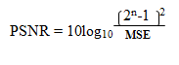
[db]

Proposed technique description
The proposed algorithm relies on the properties of haar wavelet coefficients for hiding the secret bits. When we apply 2D haar transformation to the matrix, the resulting coefficients take the values of type integers or decimal numbers. In decimal numbers, decimal part may either have 0 or 0.5. So in the decimal part there is a possibility of hiding one bit. In the second level transformation, the coefficients take the values of type integers or decimal numbers. In decimal numbers, decimal part may have any one of these values: 0.25, 0.5 or 0.75. So in the decimal part there is a possibility of hiding two bits. In the third level transformation, the coefficients take the values of type integers or decimal numbers. In decimal numbers, decimal part may have any one of these values: 0.125, 0.25, 0.375, 0.5, 0.625, 0.75, or 0.875. So in the decimal part there is a possibility of hiding three bits. Besides this, we are making use of the even and odd parity of integer number to enhance the embedding capacity further. So one more bit can be hidden by even and odd form of integers. Thus we can hide four bits in the third level coefficients, three bits in the second level coefficients and two bits to one transformation coefficient of first level.
In the proposed system, one of the important characteristic of haar transformation used is high correlation between the coefficients in the same position in different decomposition areas. If we change the value of one coefficient in one area, then the relative change is needed in rest of the three decomposition areas too in order to have integer numbers after application of 2D inverse haar transformation. As after inverse transformation, if the values are not integers then image will not be generated again.
The proposed algorithm is divided into two parts: Embedding Process and Extraction Process.
Embedding Process:
Input: Cover image, Secret image
Output: Stego image
Step 1.Adjust the secret image picture elements to a column vector.
Step 2.Convert the values of column vector elements into binary form. Then arrange them into the row vector such that Most Significant Bits of all elements come first and likewise Least Significant Bits come last in the vector. Then from starting, convert them to integers again.
Step 3. Apply arithmetic coding on row vector of secret image we get in previous step. For that perform Method A on row vector of secret image.
Step 4.Generate header vector by including statistical information about secret image and merge it with encoded bit stream. It represents the actual message to be embedded in the cover image. It is created by Method B.
Step 5.Create suitable number of matrices of suitable dimensions from secret message vector.
Step 6.As shown in figure 6 Create four auxiliary picture matrices from cover image having same dimension as cover image such that each matrix contains one of the combinations of elements like: all the elements contained in odd row and odd columns, odd row and even columns, even rows and odd columns and even rows and even columns. Rest of the elements in the auxiliary matrices are zero.
Step 7. Apply Method C on each matrix.
Step 8. Now do addition of all four embedded matrices we got in previous step. It represents stego image matrix.
Method A (Arithmetic coding)
Input: Row vector of secret image.
Output: Bit stream encoded by arithmetic coding
Step 1. Find the unique symbols in the vectors of secret image
Step 2. Find the number of occurrences of each unique symbol in the whole sequence of vectors.
Step 3. Generate the sequence of indexes of unique symbols according to values of row vector.
Step 4. Apply arithmetic coding function on sequence of vector by using frequencies.
Method B (Header + Payload)
Input: Length of image vector, length of encoded bit stream and the array containing frequency of every unique symbol in image vector.
Output: A final row vector to be embedded in cover image.
Step 1.Convert the length of encoded bit stream in single bit array.
Step 2.Find the maximum frequency from the array of frequency counts. Count the number of bits required to represent maximum frequency. We will use same number of bits to represent each frequency. Create the single bit array representing that number.
Step 3. Count the frequency of all possible unique symbols i.e. 0-255. Convert them into single bit array.
Step 4. First store the single bit array containing length of encoded bit stream in the first 20 bits allocated to it in header vector. Now append the single bit array representing amount of useful bits to represent each frequency in the next 5 bits allocated to it. Now append the single bit array of 256 symbols’ frequencies in the next allocated space in which each frequency is represented by number of bits that equals to store maximum frequency. Header is complete now merge the header vector with the encoded bit stream vector. Append it with zeros to have final length of generated vector to total capacity of cover image if it is required.
Method C (Embedding)
Input: Auxiliary matrix of image
Output: Embedded auxiliary matrix
Step 1. Apply Method D on matrix.
Step 2. Combine four coefficients LL₃, HL₃, LH₃ and HH₃ at second and third level.
Step 3. Apply Method E on the third level coefficient matrix.
Step 4. Now divide the modified third level matrix into LL₃, HL₃, LH₃ and HH₃. They are now embedded. Measure the modifications of each coefficient by taking difference of modified coefficient and original one.
Step 5. Add the modification done in one decomposition area to the remaining three decomposition areas.
Step 6.Apply inverse DWT on the modified third level coefficients. It represents modified LL₂.
Step 7. Now measure the modification in LL₂ with original one. Add it in other three areas.
Step 8. Now combine all four modified decomposition areas of second level.
Step 9. Apply Method F on second level decomposed matrix we got in previous step.
Step 10. Now divide the modified second level matrix into LL₂, HL₂, LH₂ and HH₂. They are now embedded. Measure the modifications of each coefficient by taking difference of modified coefficient and original one.
Step 11. Apply inverse DWT on the modified second level coefficients. It represents modified LL₁.
Step 12. Apply Method G on the modified LL₁.
Step 13. Now do inverse DWT of first level decomposition after changing the signs of LL₁. In the first level decomposition, there is only difference of sign in coefficients. Absolute values are same. So according to the auxiliary matrix, by changing the sign of LL₁, apply inverse DWT to that. It represents embedded auxiliary matrix.
Method D (DWT)
Input: Auxiliary matrix of image
Output: Transformation coefficients by DWT at third level.
Step 1. Apply First level DWT on matrix at first level. It will give four sub bands: LL₁, HL₁, LH₁ and HH₁.
Step 2. Apply Second level DWT on approximation coefficient (LL₁). It will give: LL₂, HL₂, LH₂ and HH₂.
Step 3. Apply Third level DWT on approximation coefficient (LL₂). It will give: LL₃, HL₃, LH₃ and HH₃.
Method E (Third Level Embedding)
Input: Third level DWT coefficients matrix and one secret matrix.
Output: Embedded third level coefficients matrix
Step 1: Change the value of the coefficients according to following rules:
TABLE I CHANGES IN COEFFICIENTS IN THIRD LEVEL
Secret bits pattern | Change in the coefficient value according to bits pattern | Secret bits pattern | Change in the coefficient value according to bits pattern
0000 | + 0.0000 | 1000 | + 0.0000
0001 | + 0.1250 | 1001 | + 0.1250
0010 | + 0.2500 | 1010 | + 0.2500
0011 | + 0.3750 | 1011 | + 0.3750
0100 | + 0.5000 | 1100 | + 0.5000
0101 | + 0.6250 | 1101 | + 0.6250
0110 | + 0.7500 | 1110 | + 0.7500
0111 | + 0.8750 | 1111 | + 0.8750
The above table shows the changes applied to the decimal part of the coefficient. Integer part is converted into the odd or even number if required according to the secret bits. If the first bit of secret message is 0 and corresponding coefficient’s integer part is odd make it even. Same ways if the first bit of secret message is 1 and corresponding coefficient’s integer part is even make it odd. The same changes are applied at all the levels.
Method F (Second Level Embedding)
Input: Second level DWT coefficients matrix and one secret matrix.
Output: Embedded second level coefficients matrix
Step 1: Change the value of the coefficients according to following rules:
Secret bits pattern | Change in the coefficient value according to bits pattern | Secret bits pattern | Change in the coefficient value according to bits pattern
000 | + 0.0000 | 100 | + 0.0000
001 | + 0.2500 | 101 | + 0.2500
010 | + 0.5000 | 110 | + 0.5000
011 | + 0.7500 | 111 | + 0.7500
TABLE II CHANGES IN COEFFICIENTS IN THIRD LEVEL
Method G (First Level Embedding)
Input: First level DWT coefficients matrix and one secret matrix.
Output: Embedded first level coefficients matrix
TABLE III CHANGES IN COEFFICIENTS IN THIRD LEVEL
Secret bits pattern | Change in the coefficient value according to bits pattern | Secret bits pattern | Change in the coefficient value according to bits pattern
00 | + 0.0000 | 10 | + 0.0000
01 | + 0.5000 | 11 | + 0.5000
Extraction Process:
Input: Stego Image
Output: Secret Image
Step 1.Create four auxiliary matrices based on stego image as per the rules we created in embedding process. Perform the same following steps on each matrix.
Step 2. Apply first level 2D-DWT on the auxiliary matrix.
Step 3. Extract the bit stream from LL₁ according to the rules it was embedded.
Step 4.Now remove the modification from the LL₁ i.e. added due to second level embedding.
Step 5.Apply 2D-DWT to modified LL₁ we got in last step.
Step 6.Remove the modifications from all the decomposition areas that are added due to embedding in that level.
Step 7.Combine the four decomposed area of second level.
Step 8.Extract the bit stream from second level coefficients according to the rules it was embedded.
Step 9.Remove the modification from LL₂ i.e. added due to third level embedding.
Step 10. Apply 2D-DWT on modified LL₂.
Step 11.Remove the modifications from all the decomposition areas that are added due to embedding in that level.
Step 12.Combine the four decomposed area of third level.
Step 13.Extract the bit stream from third level coefficients according to the rules it was embedded.
Step 14.Combine the secret message matrices extracted from all three levels of all four auxiliary matrices as per the rules they were divided in embedding process.
Step 15.Count the length of the encoded bit stream from the first 20 bits, count the no of bits by which each frequency is represented from next 5 bits. Then count frequency of all unique symbols from next 256 elements of bits. Then fetch the encoded bit stream from payload.
Step 16.Apply arithmetic decoding function on the extracted bit stream using extracted frequencies.
Step 17Calculate unique symbols by not considering symbols having 0 frequencies from extracted frequencies vector. Assign actual values in the decoded indexes from the unique symbols array.
Step 18.Convert the values of the vector retrieved in previous step into binary values. Then create 8 equal chunks of them. It represents MSBs to LSBs of actual image vector values. Rearrange them into row vectors of 8 bits from LSB to MSB. Then convert them to integer values.
Step 19.Reshape the image vector. It shows the secret image.

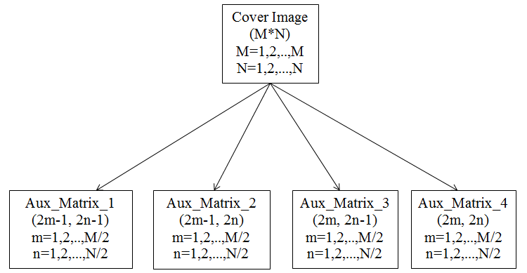
Figure 2. Creation of Auxiliary Matrices

EVALUATION OF THE SCHEME
The algorithm has been tested on Matlab R2012a. The configuration of the machine was 2.20 GHz processor and 3 GB RAM. The secret image is grey scaled image having 2^8 detailed levels. Cover image is also grayscale. For evaluating the performance of the arithmetic coding we use compression efficiency, Efficiency is defined as the ratio of size of original image to the size of compressed vector. To test the proposed system, and compare it with some of existing systems, we have taken the standard sample images from the database maintained by University of Southern California- Signal and Image Processing Institute (USC-SIPI). It includes most favourite images such as lena, baboon, boats etc. The sizes are 256x256, 512x512, and 1024x1024. Apart from quality of the stego image, the performance is measured for time taken for embedding the secret image in cover image and time taken for extraction of secret image. Results are shown in table 4. Sample output of the proposed system is shown in figure 3.
The capacity of the proposed scheme of hiding the secret bits in cover image and imperceptibility of the stego image is compared with some of existing techniques. To test the efficacy

TABLE IV EXPERIMENTAL RESULTS OF QUALITY MEASURES OF PROPOSED ALGORITHM

of the proposed system in terms of capacity of hiding secret data, the results obtained have been compared with [11, 12, 15, 17, 18, 28, 29, and 30].Figure 4 presents the comparison results in graphical form. To test the efficacy of the proposed scheme in terms of perceptual transparency, the results obtained for a payload of 25% have been compared with [18, 31, and 32]. Comparison results are presented in table 5. Figure 5 presents the comparison results in graphical form. Cover images are of size 512 x 512. SSIM and PSNR is compared with one of the existing system for the image lena of size 384 x 384. Table 6 shows the comparison results of the same.
Cover Image  (384 x 384)  (.bmp) | Secret Image  (384 x 384)  (.bmp) | PSNR  (db) | SSIM | Capacity  Used  (%) | Time for embedding  (seconds) | Time for extraction  (seconds)
boats | girl | 41.6328 | 0.9384 | 99.681 | 48.80 | 54.82
baboon | plane | 41.6212 | 0.9596 | 96.936 | 47.81 | 53.45
pirate | couple | 41.5970 | 0.9422 | 91.564 | 46.70 | 51.74
jetplane | clock | 41.6541 | 0.9157 | 90.764 | 46.84 | 52.21
scene | aerial | 41.7301 | 0.9385 | 90.010 | 46.99 | 51.71
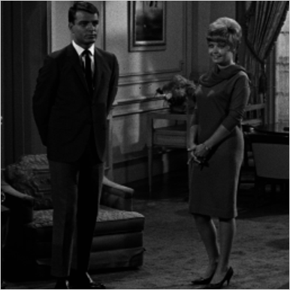
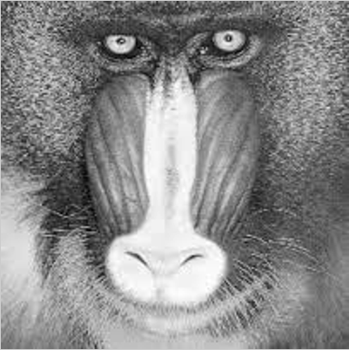

Secret Image (couple.bmp) Cover Image (baboon.bmp)

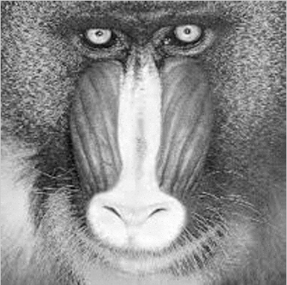

Stego Image (stego_baboon.bmp)
Figure 3. Sample output of the system

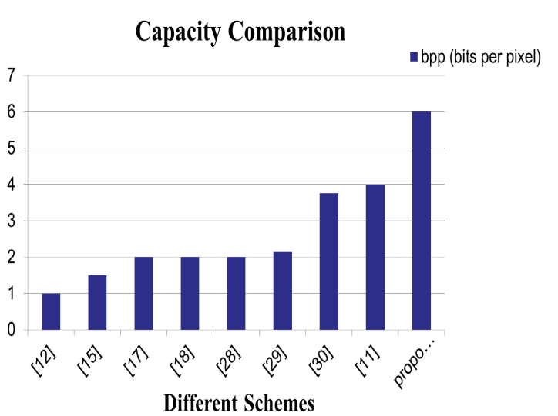

Figure 4. Comparison of proposed scheme with [11, 12, 15, 17, 18, 28, 29, and 30] for capacity parameter

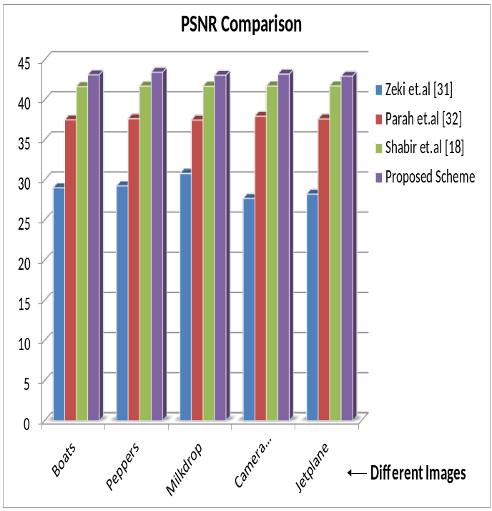

Figure 5. Comparison of proposed scheme with [18, 31 and 32] for 25% of payload

TABLE V. COMPARISON OF PROPOSED SCHEME WITH [18, 31 AND 32] FOR 25% OF PAYLOAD
Techniques | Boats | Peppers | Milk drop | Cameraman | Jetplane
Zeki et.al [31] | 29.03 | 29.28 | 30.81 | 27.71 | 28.25
Parah et.al [32] | 37.50 | 37.65 | 37.48 | 37.97 | 37.63
Shabir et.al [18] | 41.65 | 41.72 | 41.70 | 41.71 | 41.74
Proposed | 43.12 | 43.44 | 43.06 | 43.20 | 42.95

TABLE VI. COMPARISON OF PSNR AND SSIM OF PROPOSED SCHEME WITH THE SAME OF [11] FOR 50% OF PAYLOAD IN COVER IMAGE LENA (384X384)
Techniques | PSNR(db) | SSIM
Gabriel Bugar et.al [11] | 35.064 | 0.8723
Proposed | 41.881 | 0.9257

Conclusion
In this paper we proposed an image hiding scheme that is based on haar wavelet coefficients. It utilizes the property of high correlation of haar coefficients for hiding secret bits. By this image steganography method, we have tried to achieve high capacity of hiding in cover image as well security of secret data. The performance of the algorithm depends mainly on selection of cover image. Selection of cover image is very important in performance of this algorithm as large monotonous surfaces of the cover image would cause degradation on the areas where embedding has been done. So it will lower the perceptibility of the stego image.

REFERENCES

- Morkel, T., Eloff, J. H., & Olivier, M. S. (2005, June). An overview of image steganography. In ISSA (pp. 1-11).
- Arjun, S., & Negi, A. (2006). A filtering based approach to adaptive steganography. In TENCON 2006-2006 IEEE Region 10 Conference (pp. 1-4).
- Zeng, X. T., Ping, L. D., & Pan, X. Z. (2010). A lossless robust data hiding scheme. pattern recognition, 43(4), 1656-1667.
- Sarreshtedari, S., & Ghaemmaghami, S. (2010, January). High capacity image steganography in wavelet domain. In Consumer Communications and Networking Conference (CCNC), 2010 7th IEEE (pp. 1-5). IEEE.
- Qing, X., Jianquan, X., & Yunhua, X. (2010, May). A high capacity information hiding algorithm in color image. In e-Business and Information System Security (EBISS), 2010 2nd International Conference on (pp. 1-4). IEEE.
- Luo, W., Huang, F., & Huang, J. (2010). Edge adaptive image steganography based on LSB matching revisited. Information Forensics and Security, IEEE Transactions on, 5(2), 201-214.
- Hussain, M. (2010, June). Pixel intensity based high capacity data embedding method. In Information and Emerging Technologies (ICIET), 2010 International Conference on (pp. 1-5). IEEE.
- Zaker, N., & Hamzeh, A. (2010, December). Security enhancement for TPVD steganographic method. In Telecommunications (IST), 2010 5th International Symposium on (pp. 206-209). IEEE.
- Ahani, S., & Ghaemmaghami, S. (2010, December). Image steganography based on sparse decomposition in wavelet space. In Information Theory and Information Security (ICITIS), 2010 IEEE International Conference on (pp. 632-637). IEEE.
- Shiva Kumar, K. B., Raja, K. B., Chhotaray, R. K., & Pattnaik, S. (2010, December). Coherent steganography using Segmentation and DCT. In Computational Intelligence and Computing Research (ICCIC), 2010 IEEE International Conference on (pp. 1-6). IEEE.
- Banoci, V., Bugar, G., & Levicky, D. (2011, April). A novel method of image steganography in DWT domain. In Radioelektronika (RADIOELEKTRONIKA), 2011 21st International Conference (pp. 1-4). IEEE.
- Das, R., & Tuithung, T. (2012, March). A novel steganography method for image based on Huffman Encoding. In Emerging Trends and Applications in Computer Science (NCETACS), 2012 3rd National Conference on (pp. 14-18). IEEE.
- Raftari, N., & Moghadam, A. M. E. (2012, May). Digital Image Steganography Based on Integer Wavelet Transform and Assignment Algorithm. In Modelling Symposium (AMS), 2012 Sixth Asia (pp. 87-92). IEEE.
- Parah, S. A., Sheikh, J. A., Hafiz, A. M., & Bhat, G. M. (2014). Data hiding in scrambled images: A new double layer security data hiding technique.Computers & Electrical Engineering, 40(1), 70-82.
- Qin, C., Chang, C. C., & Chiu, Y. P. (2014). A Novel Joint Data-Hiding and Compression Scheme Based on SMVQ and Image Inpainting. Image Processing, IEEE Transactions on, 23(3), 969-978.
- Bugar, G., Banoci, V., Broda, M., Levicky, D., & Dupak, D. (2014, April). Data hiding in still images based on blind algorithm of steganography. InRadioelektronika (RADIOELEKTRONIKA), 2014 24th International Conference(pp. 1-4). IEEE.
- Ou, D., & Sun, W. (2014). High payload image steganography with minimum distortion based on absolute moment block truncation coding. Multimedia Tools and Applications, 1-23.
[18] Shabir A. Paraha, Javaid A. Sheikha, Abdul M. Hafiza, G.M. Bhatb, “Data hiding in scrambled images: A new double layer security data hiding technique”, Elsevier, aPost Graduate department of Electronics and Instrumentation Technology, University of Kashmir 190006, India, bUniversity Science Center University of Kashmir, Shrinagar, Jammu and Kashmir 190006, India, 2013.
[19] Mrs. Kavitha, Kavita Kadam, Ashwini Koshthi, Priya Dunghav, “Steganography using Least Significant Bit Algorithm”, Maharashtra Academy of Engineering, Department of Computer Engineering, Pune University, International Journal of Engineering Research and Applications (IJERA), Vol 2, Issue 3, May-June 2012, pp. 338-341.
[20] HAI Mei1, Zhang Jian-jun1, NI xing-fang2, “An Improved Arithmetic Coding Algorithm”, Springer, 1Department of mathematics, college of sciences, Shanghai University, Shanghai 200436, P. R. China, 2Department of Electronic Engineering, college of Technology, Shanghai University, Shanghai 200036, P. R. China, Journal of Shanghai University, 2004.
[21] Xizhi, Zhu. "The application of wavelet transform in digital image processing."MultiMedia and Information Technology, 2008. MMIT'08. International Conference on. IEEE, 2008.
[22] Kharrazi, Mehdi, Husrev T. Sencar, and Nasir Memon. "Cover selection for steganographic embedding." Image Processing, 2006 IEEE International Conference on. IEEE, 2006.
[23] Gabriel BUGAR, Vladimir BANOCI, Martin BARODA, Dusan LEVICKY,”A Novel Method in Image Steganography in DWT Domain”, IEEE Dept. of Electronics and Multimedia Communications, Faculty of Electrical Engineering and Informatics, Technical University of Kosice, Letna 9, 042 00 Kosice, Slovak Republic, 2011.
[24] S. Ashvin1, S. Arvind Kumar2, J. Ramesh3, K. Gunavathi4, “Novel and Secure Encoding and Hiding Techniques using Image Steganography : A Survey”, IEEE, 1Master’s Degree in Embedded and Real time Systems, PSG College of Technology, Coimbatore, 2Graphics Hardware Engineer in Intel Technologies, India Pvt. Lte. Bangalore, 3(Sr. Gr.) Department of ECE, PSG College of Technology, Coimbatore, India, 4ECE Department, PSG College of Technology, Coimbatore, India, 2012.
[28] Roy, R., Sarkar, A., & Changder, S. (2013). Chaos based Edge Adaptive Image Steganography. Procedia Technology, 10, 138-146.
[29] Arjun, S., & Negi, A. (2006). A filtering based approach to adaptive steganography. In TENCON 2006-2006 IEEE Region 10 Conference (pp. 1-4).
[30] Shiva Kumar, K. B., Raja, K. B., Chhotaray, R. K., & Pattnaik, S. (2010, December). Coherent steganography using Segmentation and DCT. In Computational Intelligence and Computing Research (ICCIC), 2010 IEEE International Conference on (pp. 1-6). IEEE.
[31] Zeki, A. M., Abdul Manaf, A., & Mahmod, S. S. (2011). High watermarking capacity based on spatial domain technique. Information technology journal, 10(7), 1367-1373.
[32] Parah, S. A., Sheikh, J. A., & Bhat, G. M. (2012, December). Data hiding in intermediate significant bit planes, a high capacity blind steganographic technique. In Emerging Trends in Science, Engineering and Technology (INCOSET), 2012 International Conference on (pp. 192-197). IEEE.
[33] Sarita R. Visavalia1, Dr. Amit Ganatra2, “Improving Blind Image Steganalysis Using Genetic Algorithm and Fusion Technique”, 1Department of Information Technology, 2Department of Computer Engineering, Charusat, India, International Conferences on Advances in Engineering & Technology – 2014, (ICAET-2014) pp-40-46.

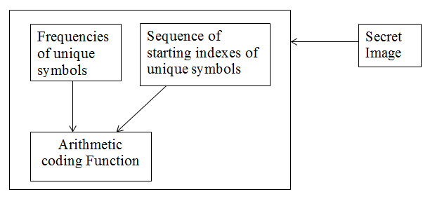

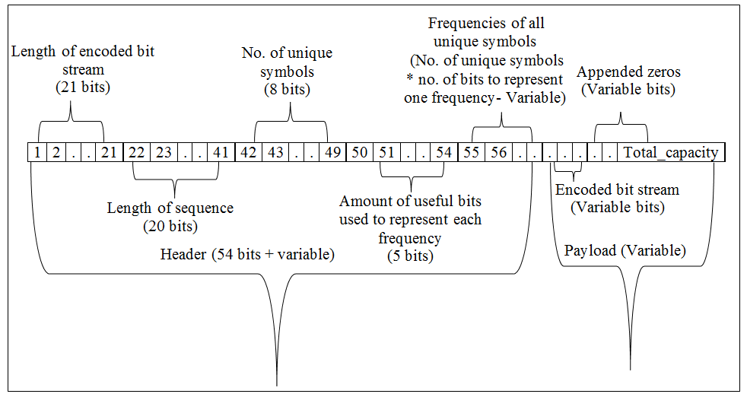

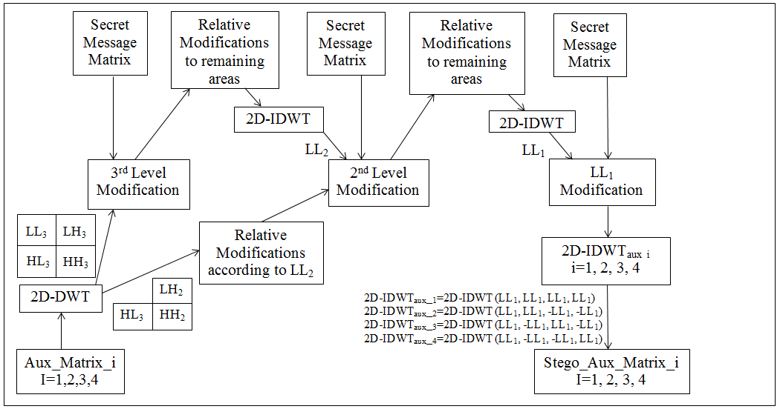

Cover Image

Aux_Matrix_i
I=1,2,3,4

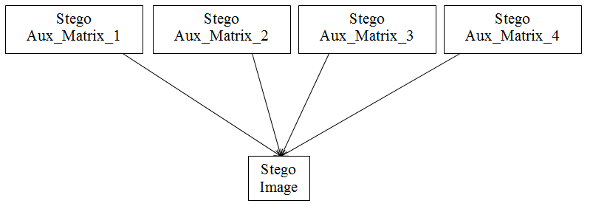

Figure 3. Block Diagram of Proposed System
Figure 6. Block Diagram of Proposed System

