##### **Design Secure Duplicate removal mechanism for Android**

**Vaibhav Vyas Yogita Sinha**

Asst.Professor,Dept of ComputerScience, MCA student,

AIM & ACT,Banasthali Vidyapith Banasthali Vidyapith

**Email id:-** vaibhavvyas4u@gmail.com **Email id:-** yogitasinha93@yahoo.in

**Karnica Sharma Madhu Kumari**

MCA student, MCA student,

Banasthali Vidyapith Banasthali Vidyapith

**Email id:-** karnicasharma@gmail.com **Email id:-** ok07madhu@gmail.com

**Pooja Tripathi**

MCA student,

Banasthali Vidyapith

**Email id:-**ptripathy195@gmail.com

***Abstract:-Duplicate removal mechanism for android helps us to remove the duplicate data for the external as well as internal memory of a smart phone. This mechanism will help the user to get convenient towards, not searching the duplicate file and deleting them. This mechanism will find the duplicate files not only on the basis of the name but on the basis of content as well.***

***KEYWORDS-:*** *Android, Audio, External memory, File, Image, Internal memory, Smart phone.*

I. INTRODUCTION

Duplicate removal mechanism is an algorithm which will fetch the duplicate contacts or duplicate media files (like audio, images) or document files( pdf, txt, doc ) from internal memory as well as external memory. In this application we are collecting all the duplicate file at a place and the user can delete the file as per his/her convenience.

Deleting unnecessary files is a good idea, but most of us give a blind eye to duplicate files. On an average, about 10% of the physical storage on most devices is filled with duplicate files. Deleting these duplicate files will help you to free up additional space on your Android phone.

Deleting duplicate files manually won’t be a good idea, for instance duplicate files will always have the same file size but not the same name, which is why we need to make use of an android app to make this process as easy and simple.

Here is an Android app that will help you to easily find and delete duplicate files from your android phone.

With this app you will be easily able to locate duplicate files on your android phone, but you are required to manually verify the files and delete them yourselves.

II. WORKING CRITERIA

In this we will actually talk about the following steps how this android algorithm works:-

* User will select the categories for the removing of duplicate data. So only that type of data will be deleted that a user wants. Category of different type of files/data are as followed:
* Contacts
* Files
* Images
* Audio
* After selecting the categories, the data will we fetched from internal or external storage where as internal storage refers to phone memory and external storage refers to memory card.
* After retrieving duplicate data from the storage then that whole data will be shown at the interface of the application.
* User can select those files whom he want to delete as per his convenience by clicking on the checkbox.
* After selecting those files who are going to be deleted, click on delete button and the message will prompt “ARE YOU SURE U WANT TO DELETE?“ YES/No. If user click on Yes then the data will be deleted permanently else no data will be deleted.

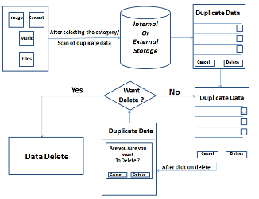

**Fig:-** Diagrammatic representation of working criteria.

III. TECHNOLOGY

* *Android:-* Androidis an open source mobile operating system designed for mobile devices like smart phones, tablets, etc. This algorithm actually requires the version of android above than cupcake (1.3).[1]
* *Advantages:*
* Android does Google and Social integration.
* Android lets you change your setting faster.
* Android gives you better notification.
* Android gives you more option to fit your budget.
* Android has a better app market.
* Support for extra-large screen sizes and resolution.
* System-wide copy and paste functionalities.
* Redesigned multi-touch software keyboard.
* Improved power management and algorithm control.[4]
* *Disadvantage:*
* Due to the fact that the Android operating system is an “open source” it makes the operating system to be easily accessed to hacking and if the system is hacked it would lead to serious security measures of locking the devices, which would be a shame.

* *Smart Phone:***-**  Smart phone is the device which works on any kind of mobile operating system including Android operating system. This is the device on which this Application runs.
* *Java:***- Java** is a functional computer programming language that is concurrent class-based, object-oriented and specifically designed to have as few implementation dependencies as possible.
* *ADT:***-** Android Development Tools (ADT) is a plug-in for the Eclipse IDE that Android projects, create an algorithm UI, add packages extends the capabilities of Eclipse to let you quickly set up new based on the Android Framework API, debug your algorithms using the Android SDK tools, and even export signed (or unsigned) .apk files in order to distribute your algorithm.[5]

IV. ROLE OF THIS ALGORITHM TOWARDS PHONE

* *Reduce Data Redundancy:-*As this Algorithm is for the removal of duplicate data, therefore it acts according to it’s name and it will remove the duplicate data as per user choice.
* *Optimization of memory:-*Since the duplicate data consumes some memory space, when deleted, can be used for other various purposes.
* *Increase the effectiveness and efficiency of the phone:-* If the memory of the phone is being optimized than we can optimized our phone more efficiently.
* *Reduce the consumption of user time:-*For the removal of duplicate data ,the user needs to
* Search the duplicate data at various locations.
* Confirm that the data is duplicate or not.
* Finally, delete that data.

As we can see, this procedure consumes a lot of

time by the user.

But the Duplicate Removal Mechanism will

show the list of the duplicate data, from which the

user can delete the redundant data from his choice

of location.

Thus, this mechanism will help reduce a lot of

time ,of the user-interaction with the duplicate

data.

V. SEARCH DUPLICATE FILE(SUPER) FEATURES

* One Click to search and select.
* Save/load search results.
* Specify path/size to search for.
* Support searching photo/audio/video or custom files.
* Support searching hidden files/folders.
* Support internal/external SD card.
* Support previewing photo/apk/storage.
* Notify you when a search complete.
* Search results are grouped by file size.
* View file content before deleting/excluding it.
* Batch select/deselect files/groups.
* Batch delete/exclude files/groups.
* Batch expand/collapse groups.

VI. HOW IT ACTUALLY WORKS WHILE COMPARISON?

As we said before it will work with the different categories present in the smart phone:-

* *Contact*:-

The contacts are being brought up from the storage and from the SIM as well. The contacts will be compared on the basis of:

* *By name: -* Contact are compared on the basis of the name mentioned in the contact list.
* *By Contact number: -* Contacts are being compared on the basis of the contact number that means if there are different name but same contact number.[3]
* *Images:-*

The images are being fetched from the external storage and internal storage. The images are being compared pixel by pixel. Each pixel from one image is compared at the same location in all other images in the dataset. A set of different pixels are identified which represents pixels with varying color values in the images. Generally duplicate images will be removed on the basis of comparison done:-

* *By name: -* Images are compared on the basis of the name mentioned on the internal or external storage.
* *By image:-* The images will compared not on the basis of their name but on the basis of the image recognition.

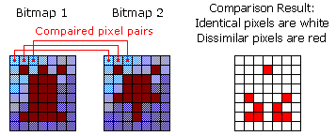

**Fig:-** Image comparison by the content of image.[6]

*Pseudo code regarding Image duplicates:-*

**//Fetching memory card items**

**Begin,**

str={MediaStore.Images.Media._ID,MediaStore.Images.Media.DATA,MediaStore.Images.Media.DISPLAY_NAME,MediaStore.Images.Media.SIZE};

Cursor phones = managedQuery(MediaStore.Images.Media.EXTERNAL_CONTENT_URI, null, null,null, null);

while (phones.moveToNext())

{

name=phones.getString(phones.getColumnIndexOrThrow(MediaStore.Images.Media.DISPLAY_NAME));

list.add(name);

}

**END**

**//Comparison of two images.**

**Begin,**

if (null != list1 && list1.size() != 0)

{

Collections.sort(list1, new Comparator<String>()

{

Function compare(String lhs, String rhs)

{

return lhs.compareTo(rhs);

}

});

}

**END**

Here, ‘str’ is a string array which holds all the value fetched from external and internal storage. We perform comparison of two images with the help of ‘compare’ function. Here string ‘lhs’ and ‘rhs’ stores the name of consecutive images which are stored in ‘list1’.

* *Files:-*

Files will be picked from the internal storage and external storage. The comparison will be done on the different files categories. File categories for the removing of duplicate files[2]:-

* character files. Text files will be compared on the basis of:
* *Name:-* Text file are compared on the basis of the name mentioned on the internal or external storage.
* *Contents:*- Text file are compared character by character from one file to another.

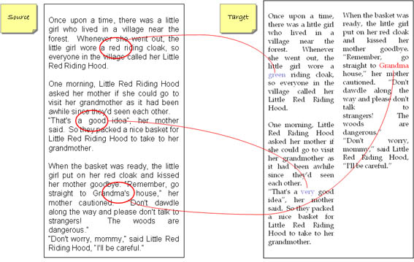

**Fig:-** text comparison character by character[7]

* *PDF:-* This is a Portable Document Format. These files are non-editable files.
* *Name:-* PDF file are compared on the basis of the name mentioned on the internal or external storage.
* *Contents:*- PDF file are compared by extracting the txt from the file and comparing that txt with other PDF file which are also converted text files.

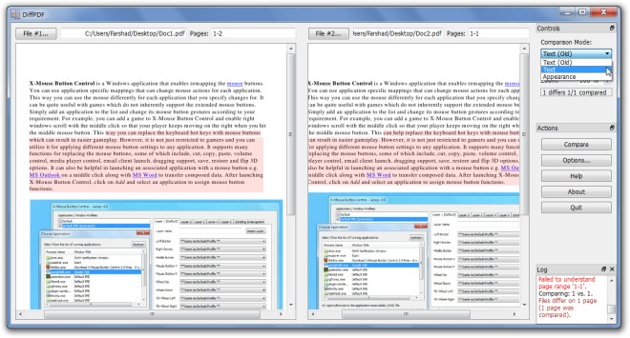

**Fig:-** PDF comparison by content of PDF[8]

* *Document:-* These files are the document files of MS-Office. They will be compared as the text files compared.
* *Audio:-* Audio files are the musical files. This algorithm works with the wav format only. The file will be compared:-
* *Name:-* Audio file are compared on the basis of the name mentioned on the internal or external storage.
* *Contents:*- Audio file are compared by generating the fingerprint of the local songs in the phone and compare them with other compared.

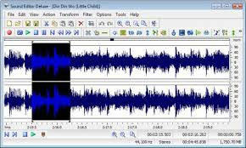

**Fig:-** audio comparison using fingerprint[9]

### VII. SOFTWARE REQUIREMENTS

* ***At the user side****:*
* Operating Systems:- Android 2.3 (Gingerbread) to Android 4.3 (Jellybean)
* ***At the developer side****:-*
* Operating System:- Windows XP or higher
* Developing Kit:- Android developing tool kit and Java eclipse.

### VIII. HARDWARE REQUIREMENTS

* Processor – minimum recommended requirement 1 GHz (single core) or onwards
* RAM – 307 MB recommended
* HDD – 20MB or more (free space excluding data size)

IX. ADVANTAGES

* *Convenient to the user:-*As this algorithm will provide a list of duplicate data to the user. So, the user does not need to search for the redundant data.
* *Save time:-*As the user will get the list of the duplicate data by this algorithm, he saves time for searching it individually.

And also he can delete the duplicate data from his desired location in no time.

* *Memory efficient:-*Less redundant data in the memory helps us to utilize the saved memory for new things.

As the memory plays a vital role in the smart phones, this algorithm will help user to save lots of memory.

* *Enhances performance:-* Smooth running of our smart phones can only be maintained ,if some specified amount of space is free in our smart phone.

Thus, less the duplicate data will be, smoother will be the performance.

X. FUTURE SCOPE

* This algorithm provide to the user will help the user that user can use his time more efficiently rather than searching the duplicate files in the phone and delete them.
* This algorithm saves the phone as well as external memory for the user, so user can save more and more data as much user wants.
* This algorithm gathers the whole information about the phone so user can see how much extra data is occupying the space.

REFERENCES

**Journal References**

[1] BURNS, J. Developing Secure Mobile Applications for

Android.

iSEC Partners, October 2008. http://www.isecpartners.

com/files/iSEC_Securing_Android_Apps.pdf.

[2] ADMOB. AdMob Android SDK: Installation Instructions.

http://www.admob.com/docs/AdMob_Android_SDK_

Instructions.pdf. Accessed November 2010.

[3] Liu, Jianye, and Jiankun Yu. "Research on Development

of android Applications." Fourth International conference

on Intelligent Networks and Intelligent Systems. 2011.

**Book References**

[4] Donn Felker and Joshua Dobbs-*Android Application*

*Development For Dummie,* Wiley Publishing Inc.,2011.

[5] Zigurd Mednieks, Laird Dornin, G. Blake Meike and

Masumi Nakamura, *Programming Android,* First Edition,

O’Reilly Media Inc., July 2011.

**Other References**

[6] http://support.smartbear.com/viewarticle/55590

[7] http://content-compare.com/product-description

[8] http://www.addictivetips.com/windows-tips/compare-pdf-

file-difference-with-diff.pdf

[9] http://illumin.usc.edu/109/letting-no-music-go-

Unrecognized