COMPACT SLOTTED MEANDERED PIFA VERSUS CONVENTIONAL PIFA ANTENNA FOR DCS, GPS, Bluetooth/WLAN, 4 G LTE, WiMAX, UMTS, GLONASS Applications

AKHILESH VERMA

Department of Electronics and Communication

Tula's Institute

Dehradun, India

akhilesh.verma6388@gmail.com

ANAMIKA CHAUHAN

Department of Applied Physics

Dr. BR. Ambedkar National Institute of Technology

Jalandhar, India

anamikachauhan2000@gmail.com

***Abstract*—** **A novel multiband meandered PIFA antenna with a coax feed is proposed, which covers DCS (1710-1880 MHz), UMTS (1920-2170 MHz), Bluetooth/WLAN (2400-2480 MHz), GPS (1227-1575 MHz), WiMAX (2500-2690 MHz). The size of the proposed antenna 20 x 10 x 5.57 mm3 and it is suitable to be used as an internal antenna in mobile phone. In this paper two different antennas constructed, one is conventional PIFA and other is designed by using meandered slots on conventional PIFA. The planar inverted F antenna is most popular internal antenna to be used in mobile phones and other wireless portable devices. However it one of the limitation of narrow bandwidth makes it unsuitable for wireless communication. A conventional PIFA shows very narrow bandwidth and also operates in single frequency band. By applying the two meandered slots on radiating patch of conventional PIFA, its improve the characteristics of the proposed antenna. These meandered slots separate the patch into two resonant paths, generating two bands of about 2 GHz and 2.6 GHz. The obtained impedance bandwidth for S11 < -10 dB from 1.4560 to 3.0010 GHz which can covers DCS, UMTS, Bluetooth/WLAN, GPS, WiMAX applications. The simulation results are analyzed by using HFSS.**

Keywords— GLONASS, Internal Antenna, Planar Inverted F Antenna, Meandered, Multiband

# Introduction

Today technological advancement in wireless communication increases the demand of low profile, multiband, multifunction antenna in mobile handset application. Now it is challenge to design low profile and space efficient antenna with wide bandwidth for use in multi-standard mobile handsets. Planar Inverted F antenna is one of the most promising candidate in the category of low profile antenna because of its simple design, light weight, low-cost, reliable performance [1-2]. PIFA consist of rectangular radiating patch, shorting pin and ground plane. Multiband can be achieved by introducing slots on top radiating patch [3]. PIFA has proved to be the most widely used internal antenna in commercial wireless applications. PIFA consider as a sort

of Inverted F antenna (IFA), where the thin wire has been replaced with a large metallic plate in order to increase the bandwidth. PIFA is also called a short-circuited microstrip antenna due to the fact that the structure of short circuit MSA resembles to the PIFA antenna. The shorting post near the near the feed point of PIFA structure is a good method for reducing the antenna size [4]. But this result into the narrow impedance bandwidth. Narrow bandwidth characteristic of PIFA is one of the limitations for its use in wireless mobile devices [5]. In order to improve the bandwidth characteristics, antenna has transformed the horizontal element from a wire to a plate, resulting in planar inverted-F antenna (PIFA).

It has a self-resonating structure with purely resistive load impedance at the frequency of operation. Variation of length, distance and location of the feed and shorting point, height of the radiator etc. affects the electrical performance of these antenna structures. Narrow bandwidth characteristic of PIFA is one of the limitations for its use in wireless mobile devices. The resonant frequency of PIFA can be approximate with following expressions [6]:

LP + WP= λ/4 (1) (1)

when W/LP=1 then Lp + h = λ/4 (2) (2)

when W=0 then Lp + WP + h = λ/4 (3)

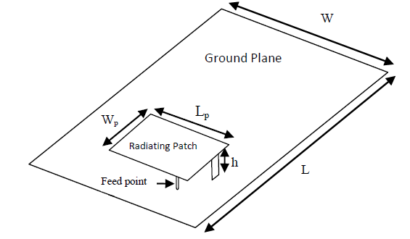

1. Conventional Planar inverted F antenna [7]

The resonance frequency of PIFA is given by the formula:

f0 = (4)

Where c is the speed of light, Lp and Wp are the length and width of top patch, fo is the resonant frequency. There are many methods to enhance the bandwidth like reduce ground plane size, adjusting the location and the spacing between two shorting pins, use of thick air substrate.

If the size of the antenna decreases to meet the requirement for mobile handset, gain of an antenna also decreases. In this paper, the proposed antenna comes over the limitations of narrow bandwidth, low gain, single band operation of conventional PIFA by applying meander structure and slots on the top radiating patch and it can further reduces the size of planar inverted F antenna to 20 mm x 10 mm and high gain, large bandwidth. Meander PIFA antenna is used where it can resonate broadband and produces circular, horizontal and vertical polarizations. It also achieves high gain which is higher than that of other antennas in the market [8]. Meandered PIFA has been generally employed for size reduction and multi-band implementation compared with conventional PIFA [9], [10], [11].

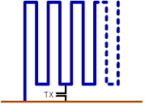

# MEANDERED PIFA antenna

This type of antenna is use, where it can resonate broadband and produces circular, horizontal and vertical polarizations. It also achieves high gain which is 1 to 4 dB higher than that of other antennas in the market [12].

These antenna structures are physically small, electrically large. Here electrical length of an antenna is defined as the length expressed as number of wavelengths. To improve the characteristics of PIFA antenna and overcome the limitation of PIFA of single band operation, meander line structure can be introduced. Meander PIFA is generally employed for further size reduction and multiband implementation compared with the conventional PIFA. By applying the meander structure on PIFA antenna, size can further be reduce, which is the most important requirement for handheld devices & can be used for multiband implementation.



Fig. 2. Meander Line Structure [13]

These antenna structures are physically small, electrically large. Here electrical length of an antenna is defined as the length expressed as number of wavelengths. A meander line antenna can be realized by bending the conventional linear monopole to decrease the size of antenna. The design of meander line antenna is a combination of horizontal and vertical lines. Horizontal lines act as a capacitor and vertical

lines act as an inductor. If the spacing between meander lines increases, the resonant frequency decreases [14].

# design of conventional planar inverted f antenna

The characteristics of conventional PIFA have first been analyzed. The structure of the proposed PIFA antenna is shown in Fig. 3. The proposed planar inverted F antenna is designed on the surface of low cost FR4 substrate (relative permittivity εr = 4.7, loss tangent δ = 0.02, and thickness of 1.57 mm). The size of the top radiating patch 20 x 10 mm2 which is mounted on ground plane of size 60 x 40 mm2.  The thickness of the top radiating patch is 0.2 mm. The height of the top radiating patch above the ground plane is H= 5.57 mm.

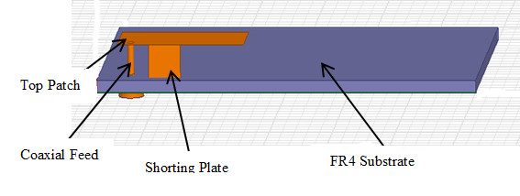

Fig. 3. Basic structure of the proposed Conventional PIFA antenna

The top radiating patch is shorted to the ground plane with the help of shorting plate of thickness 5 mm and length of 5.57 mm.

# design of proposed meandered planar inverted f antenna

To improve the characteristics of PIFA antenna and overcome the limitation of PIFA of single band operation and narrow bandwidth, meander line structure is introduced. Meander PIFA has been generally employed for size reduction & multiband implementation compared with conventional PIFA. The structure of the proposed antenna is shown in Fig. 4. The antenna is built in an FR4 substrate that is h=1.57 mm thick and has a permittivity of 4.4 with dielectric tangent loss δ=.02. The size of the top radiating plate is 20 x 10 mm2 which is mounted on ground plane of size 60 x 40 mm2. The air gap between ground plane and radiating patch is H = 5.57 mm. The shorting plate of thickness 6 mm and length of 5.57 mm which is basically shorting the top radiating patch to the ground plane and control the resonant frequency of the antenna.

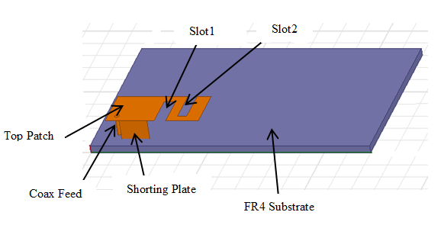

Fig. 4. (a) Proposed Meandered Planar Inverted F Antenna



Fig. 4. (b) Side View

The top radiating meander patch consist of two rectangular slots, first slot S1 has length 8 mm, width is 2.5 mm and second slot S2 has length 8 mm and width is 2 mm. In this structure, two rectangular slots has created to enhance the bandwidth, increase the gain and it also increase the electrical length and decrease the physical length of antenna. It is also noted that by varying the length and width of meandered slots, return loss, bandwidth and gain of the antenna also varies. By varying the meandered slots geometry of the top meandered patch, the desired quad-band frequencies operation is able to be implemented. When air gap between top patch and ground plane increase, bandwidth also increases but return loss decreases and the size of the antenna also increases which make it unsuitable for use in handheld devices.

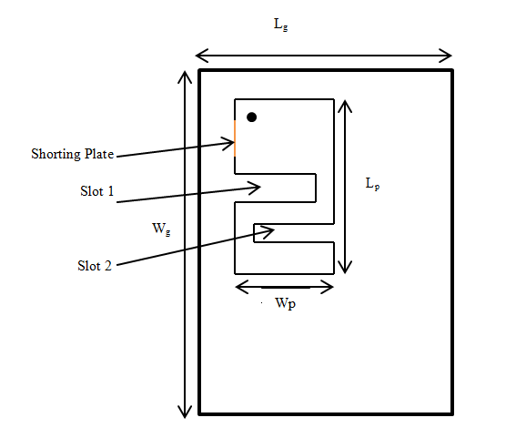

Fig. 4. (c) Detailed Dimension of Proposed Meandered Planar Inverted F Antenna

TABLE I. Detailed dimensions of Proposed Antenna

|  |  |  |  |
| --- | --- | --- | --- |
| ***Parameter*** | ***Value (mm)*** | ***Parameter*** | ***Value (mm)*** |
| Lg | 60 | Ls | 5.57 |
| Wg | 40 | Ws | 6 |
| Lp | 20 | Slot1 | Length=8, Width = 2.5 |
| Wp | 10 | Slot2 | Length=8, Width = 2 |
| h | 1.57 | H | 5.57 |

# results

## Reflection Coefficient Characteristics

The PIFA has been simulated in HFSS. The reflection coefficient (S11) frequency responses of the proposed PIFA and MPIFA are shown in Fig. 4. The graph shows that conventional PIFA is operated in single band centered at 1.7 GHz at return loss of -17.1001 dB and the achieved bandwidth is 837.6 MHz, while meandered PIFA is showing dual band operation. The proposed MPIFA antenna resonant at 2 GHz and 2.6 GHz frequency and operating bandwidth of 1.5450 dB which covers following frequency bands: DCS (1710-1880 MHz), UMTS (1920-2170 MHz), Bluetooth/WLAN (2400-2480 MHz), GPS (1227-1575 MHz), WiMAX (2500-2690 MHz).

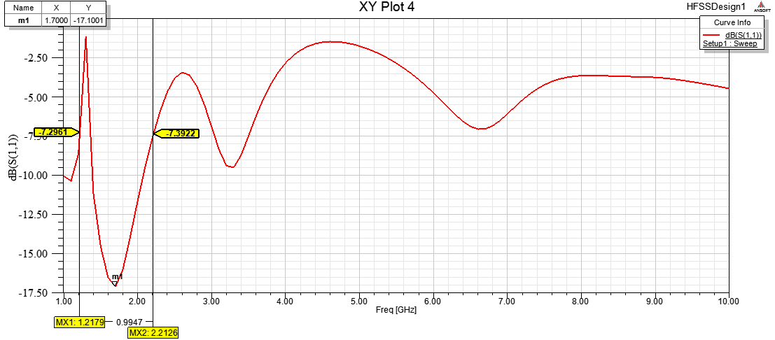 (a)

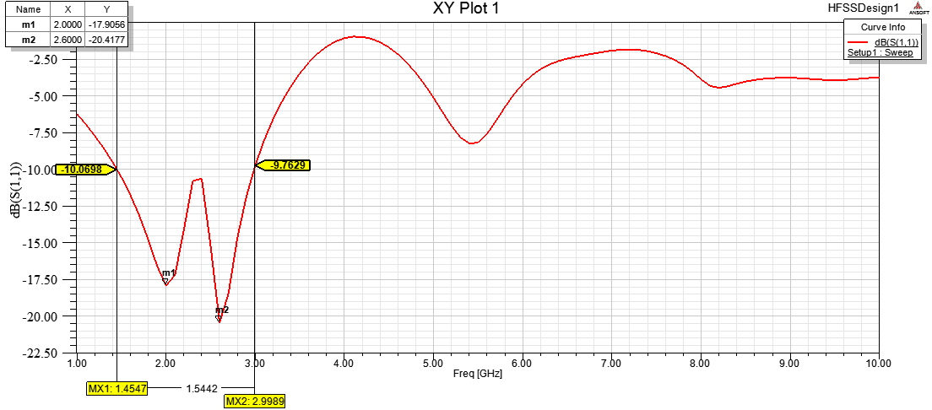

(b)

Fig. 5.1. Reflection coefficient (S11) frequency response of the (a) PIFA and (b) Meandered PIFA

It is noted that as applying the meandered slots on conventional PIFA, multiband operation is achieved and bandwidth of the antenna also enhanced.

## Radiation Pattern

2 D radiation pattern of proposed conventional PIFA and MPIFA are shown in Fig.5.2

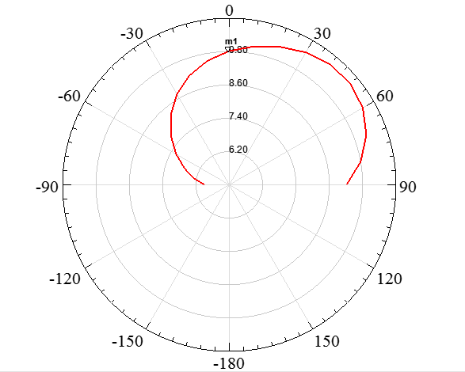

(a)

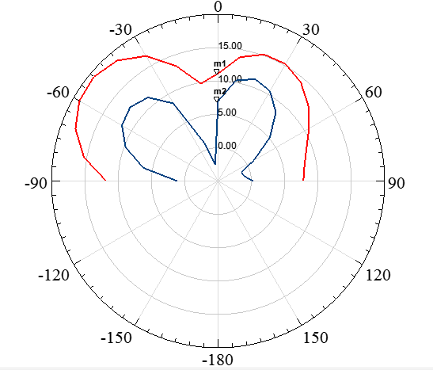

(b)

Fig.5.2. 2 D radiation pattern of PIFA for E and H plane (a) at 1.7 GHz, and for MPIFA (b) at 2 and 2.6 GHz

Since the antennas are electrically very small and omnidirectional radiation pattern is achieved for PIFA antenna but for MPIFA antenna, directional radiation pattern is achieved. For conventional PIFA, gain of the antenna is 9.1874 dB. It is clear from the plot that gain of the proposed antenna at both resonance frequencies is good. At 2 GHz band, gain of the antenna is 11.1197 dB and at 2.6 GHz band gain is 6.9596 dB.

## Far Field Radiation Pattern

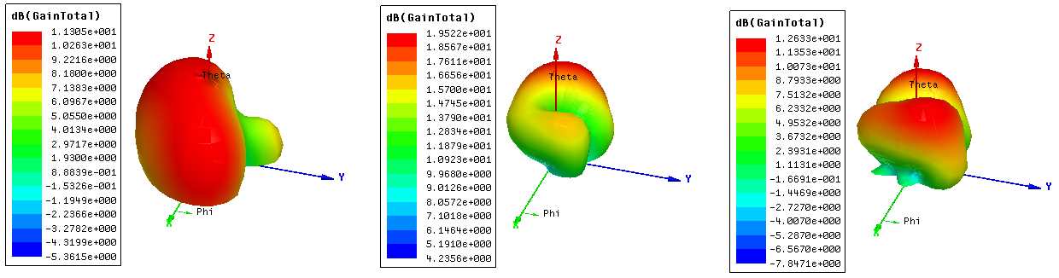

Fig. 5.3.Far fieldgain radiationpatterns of (a) PIFA at 1.7 GHz, and (b) Meandered PIFA at 2 and 2.6 GHz

# CONCLUSION

Meander slots structures were applied to conventional PIFA to overcome the limitations of narrow bandwidth, single band operation. The main objective of this research work is to compare the advantages of meandered PIFA over conventional PIFA. The proposed meandered structure covers DCS (1710-1880 MHz), UMTS (1920-2170 MHz), Bluetooth/WLAN (2400-2480 MHz), GPS (1227-1575 MHz), WiMAX (2500-2690 MHz). Proposed meandered PIFA achieved multiband, wide bandwidth and large gain as compared to conventional PIFA. The peak gain of PIFA is 27.56 dB, radiation efficiency is 24.443 % and the peak gain of MPIFA is 84.357 dB, radiation efficiency is 82.148 %. The proposed MPIFA has compact in size and can be used in portable devices.

# References

[1] H. T. Chattha, Y. Huang, and Y. Lu, “ A Further Study of Planar

Inverted-F Antenna”. IEEE International Workshop on Antenna

Technology,pp. 1-4, 2009.

[2] T. Taga and K. Tsunekawa, “ Performance analysis of a built-in

planar inverted-F antenna for 800 MHz hand portable radio units”.

IEEE J Select Areas Commun. SAC-5, pp. 921-929, 1987.

[3] Zhang, J.-W., Liu, Y, “A Novel Dual-frequency Planar Inverted-F

Antenna”, In: PIERS Proceedings, pp. 662–665, 2009.

[4] Hang Wong, Kwai-Man Luk, Chi Hou Chan, Quan Xue, Kwok Kan

So, Hau Wah Lai, ”Small antennas in Wireless Communications”,

Proceedings of the IEEE Journal, Vol. 100, No. 7, pp. 2109 –

2121, 2012.

[5] R. Vaughan, “Model and results for single mode PIFA antenna”,

IEEE Antennas and Propagation Society International Symposium 4,

pp. 4028 – 4031, 2004.

[6] Hassan Tariq Chattha, Yi Huang, Xu Zhu, and Yang Lu, “An

empirical equation for predicting the resonant frequency of Planar

inverted-F antennas”, IEEE Antennas and Wireless Propagation

Letters 8, pp. 856 – 860, 2009.

[7] Rowell, C Lam, E.Y, “Mobile-phone antenna design”. IEEE

Antennas and Propagation Magazine Vol. 54, No. 4, pp. 14 – 34,

2012.

[8] W. Geyi, Q. Rao, S. Ali, and D. Wang, “Handset Antenna Design”

Practice And Theory. Progress In Electromagnetic Research Journal

(PIER), Vol. 80, pp. 123–160, 2008.

[9] M. Jung, Y. Kim and B. Lee, “Dual frequency meandered PIFA for

Bluetooth and WLAN applications”, IEEE Antennas and

Propagation Society International Symposium 2, pp. 958 – 961,

2003.

[10] H. Chen, K. Wong and T. Chiou, “ PIFA with a meandered and

folded patch for the dual-band mobile phone Application”, IEEE

Transactions on Antennas and Propagation, Vol. 51, No. 9, pp. 2468

– 2471, 2003.

[11] K. Michael, A.A. Kucharski, “GA/MoM Optimization of PIFA

Antennas with Meandering Slits”, The Second European Conference

on Antennas and Propagation, pp. 1 – 4, 2007.

[12] W. Geyi, Q. Rao, S. Ali, and D. Wang., “Handset Antenna Design”

Practice And Theory. Progress In Electromagnetic Research

Journal (PIER), Vol. 80, pp. 123–160, 2008.

[13] K. Fujimoto, “ Mobile Antenna Systems Handbook”, Norwood,

MA, Artech House, pp. 219-313, 2008.

[14] S.R Best and J.D Morrow, “Limitations of Inductive Circuit Model

Representations of meander line antennas”, IEEE Antennas and

Propagation Society International Symposium 1, pp. 852-855 2003.