Designing of Accident Avoidance Algorithm in Mobile Wireless Sensor Networks

**Nikhat Ikram**

M.tech student

Department of CSE & IT

North Cap University

[Nk24786@gmail.com](mailto:Nk24786@gmail.com)

**Shilpa Mahajan**

Sr. Assistant Professor

Department of CSE & IT

North Cap University

[shilpa@itmindia.edu](mailto:shilpa@itmindia.edu)

ABSTRACT

Accidents are the major cause of destruction of human lives as it is the most uninvited and unintentional happening that causes a lot of damage, injury as well as they can cause loss of human life. Road accidents have been major reason for loss of many human lives. As the population is growing like ways road accidents are increasing due to increase in vehicles running on road. Seeking the current scenario of increasing accidents, I have thought to design an application that will help to avoid road accidents. This application is design keeping in mind the increasing of accidents at an alarming rate. With the help of this application accidents occurring through collision over turns can be reduced to a greater level as well as over-speeding of vehicles can be well controlled.

Keywords- Accident, WSN, VANET, Mobility model.

INTRODUCTION

As though the population of our country is increasing at a higher rate, still there are billions of people losing their lives daily. Major reason behind this loss of life is the accidents. The accidents are the most uninvited, unintentional event that causes lot damage and even can cost a person’s life. There have been a lot of preventive measures in order to prevent the miss-happening to occur. But still in spite of having such measures accidents still occur in large number. Road accidents are the major part of accidents. Road accidents occur daily in large number. Most prone areas are the highways or the sharp turns, the turns at hilly areas. By integrating VANETs with Wireless Sensor Networks[1][3][5] road accidents can be prevented. Sensors in this case are deployed on road side[8]. These sensors capture the information and send message to the vehicles. The sending of message requires proper routing protocol which is energy efficient, cost effective, flexible, delivers data in best way and has good service quality.

LITERATURE SURVEY[1][3][4][5][6][8][9]

The given table represents the various papers:

|  |  |  |  |
| --- | --- | --- | --- |
| **Paper** | **Central /proposed work** | **Simulation tool** | **Conclusion** |
| HYBRIST Mobility Model - A Novel Hybrid Mobility Model for VANET Simulations(January 2014) | New mobility model name as Hybrist mobility model is designed for smooth movement of vehicles. | NS-2.35 CBR generation tool | Hybrist mobility model is more realistic for design testing of protocols of VANET. |
| A hybrid VANET-WSN system for driving safety using efficient communication protocol (May 2013) | A new system proposed of hybrid VANET-WSN designed for safe driving. | No simulation | High efficiency of event detection by the sensors and energy saving as the sensors become active only when there is a danger level in that area. |
| Location based energy- efficient reliable routing protocol for wireless sensor networks(2015) | Routing protocol designed called as LEAR which is energy efficient. | OMNET++ | LEAR protocol provides more flexibility, load balancing, reduces end to end delay, energy efficient and is effective. |
| Vehicle-to-vehicle and road-side sensor communication for enhanced road safety(2015) | Hybrid intelligent transport system which involves vehicle-to-vehicle communication as well as vehicle-to sensor communication. | No simulation | A proper roadside sensor deployment reduces the cost of overall system of WSN. WSN with RSU are more useful. |
| Packet Transmission Analysis in Vehicular Ad Hoc Networks using Revival Mobility Model(2010) | New mobility model called Revival mobility model is proposed that capture the movement of vehicles on different levels. | NS-2.27 | Revival mobility model is better in comparison to other mobility models. |
| Efficient Data Propagation in Traffic-Monitoring Vehicular Networks(2011) | Proposed an algorithm that minimizes communication caused by traffic monitoring system. | Multi-agent traffic simulator | The proposed algorithms are better in communication cost, maintains high packet delivery ratio and provides low delay in delivery. |
| An Integrated Network of Roadside Sensors and Vehicles for Driving Safety: Concept, Design and Experiments(2015) | Integration of VANET-WSN system in order foe efficient vehicle-vehicle, vehicle-sensor interaction. | NS-2 | VANET-WSN system is better than pure VANET based system, as it is more safe, more energy efficient than the later one. |

**Paper overview**

MOBILITY MODELS[7][11][12][13][14]

As name suggests mobility model deals with the mobility or motion of sensor nodes. Sensor nodes when in motion follow one of these mobility models. Sensor nodes move according to these models. Mobility of nodes is directly proportional to performance and efficiency of Wireless Sensor Networks.

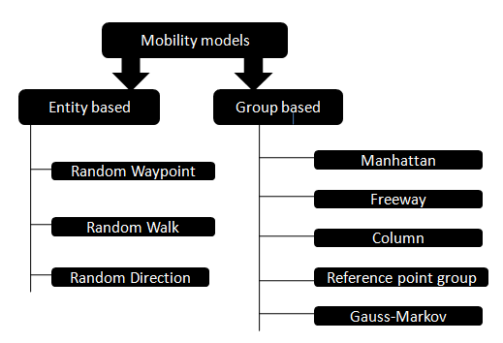 **Types of mobility models**

These models have been explained in detail below:

|  |  |  |  |  |  |  |  |  |
| --- | --- | --- | --- | --- | --- | --- | --- | --- |
| **Mobility models** | **Model subcategory** | **Throughput** | **Direction** | **Speed** | **Routing overhead** | **Packet ratio** | **Packet delivery function** | **Average end to end delay** |
| *Random Waypoint* | Random model | Greater than random direction but less than gauss-markov | Random | Uniform | Less overhead than random direction | Less packet ratio | Low pdf but higher than random direction | High |
| *Random walk* | Random model | Greater than random direction but less than gauss-markov | Random | Random | Low overhead | Low | Low pdf but higher than random direction | High |
| *Random direction* | Random model | Minimum | Random | Random | Highest overhead | Low | Low pdf | Highest |
| *Manhattan*[9] | Geographic model | Lies between random direction and gauss-markov | Either horizontal, vertical or straight | Uniform as well as random | Lies between random direction and gauss-markov | High | High pdf | Moderate |
| *Freeway*[9] | Geographic model | Lies between random direction and gauss-markov | Straight | Uniform | Lies between random direction and gauss-markov | High | High pdf | Moderate |
| *Column* | Controlled model | Lies between random direction and gauss-markov | Not defined | Uniform | Lies between random direction and gauss-markov | Low | High pdf | Low |
| *Reference point group* | Random mobility | Lies between random direction and gauss-markov | Random | Random | More overhead | Low | High pdf | Low |
| *Gauss-Markov* | Random model | Maximum | No defined | Random | Lowest overhead | High | Higher pdf | Least |

**Detailed view of mobility models**

PROBLEM STATEMENT

Problem statement is related to accidents, mainly to avoid road accidents. “Designing of accident avoidance algorithm in mobile wireless sensor networks”- the problem statement on which I will be working upon. The sensor nodes will detect the vehicles within a pre-defined range over the turn and if two or more vehicles falls within the range the alert(or warning) message is send to the drivers of that vehicles about the other vehicle being near to it and the warning message is also send to nearby traffic police station. Also the sensors will detect the over-speeding of vehicles over that turn, if a vehicle does over-speeding the sensors will send the warning message to the nearby traffic police and the police will take action accordingly.

METHODOLOGY

The designing of an algorithm takes part in various phases:

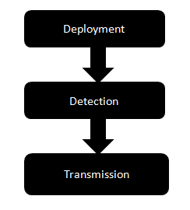 **Phases of algorithm**

**PHASE 1: DEPLOYMENT**

This phase deals with deployment of sensor nodes. Sensor nodes are deployed over sharp turns (angle of road junction is either <=90o or >=270o), as this type of area is more prone to accidents. So in order to reduce the accidents via collision of vehicle the sensors are deployed over these areas so as to collect information. Such sensor nodes are called access point sensor nodes. These access point nodes communicates with the vehicle i.e. these nodes are responsible for detecting the vehicle and sending warning message to the drivers.

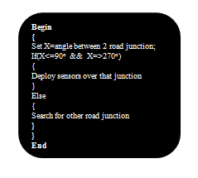  **Psuedocode**

**PHASE 2: DETECTION**

In this phase there are basically two types of detection

Firstly, the detection of over-speeding of passing by vehicle, this can be done by acceleration detectors. These detectors can detect whether or not the vehicle is slowed down while turning. Range rate is determined by using Doppler information. For this detector, few detectors are placed in linear formation. These linear detector’s outputs will give us the approximate acceleration of the vehicle.

Secondly, the detection of vehicles within the pre-defined range is done by Doppler range system. It works on Doppler effect. Doppler effect is the difference between observed frequency and emitted frequency of a wave for an observer who is moving relative to the source of the wave. Variation between the two frequencies is maximum when source is moving directly towards or away from the observer and is minimum with increasing angle between direction of motion and direction of waves.

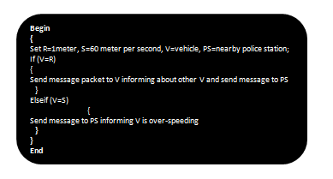 **Psuedocode**

**PHASE 3: TRANSMISSION**

In this phase the sensor nodes sends the warning message to the vehicles and nearby traffic police. This message is send through a routing algorithm called LEAR(location based energy efficient reliable).[4] In this routing protocol the message can be send by either of one method:

* **Hop by hop routing:** The source node sends the message packet to the neighbor having nearest location, then that node passes packet to the next node near to it, process continue until the message packet reaches the destination.
* **Greedy forwarding:** This technique is simple, efficient and robust. It can pass message packet to any node without knowing the status of the nodes. It optimizes energy consumption.
* **Cluster head:** In this the cluster head collects the information from sensor nodes and pass it to base station. Cluster head is selected among the cluster node on some selection parameters.

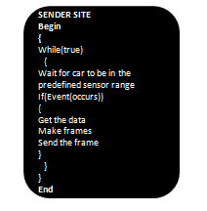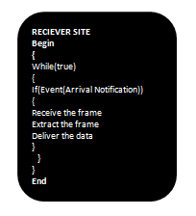

CONCLUSION

By using above technique, that is by integrating VANETs with WSN road accidents can b reduced over hilly area(or sharp edges) by deploying sensors on that areas. In future I will be simulating the whole scenario either by NS-2 or by QUALNET. The simulator will check and prompt that the messages send by the sensors are delivered on time or not. It will also tell that the proposed technique will be working up to what extend i.e. till what extend accidents get reduced after applying the above proposed algorithm.

REFERENCES

[1] Wiseborn Manfe Danquah and D. Turgay Altilar, “HYBRIST Mobility Model - A Novel Hybrid Mobility Model for VANET Simulations”, International Journal of Computer Applications (0975 – 8887) Volume 86 – No 14, January 2014.

[2] Faisal Riaz, Syed Ismail Shah, Muhammad Raees, Imran Shafi and Arslan Iqbal, “Lateral Pre-crash Sensing and Avoidance in Emotion Enabled Cognitive Agent based Vehivle-2-Vehicle Communication System”, International Journal of Communication Networks and Information Security (IJCNIS), Vol. 5, No. 2, August 2013.

[3] Pushpender Singh, Amit Ashthana and Manik Chandra Pandey, “A Hybrid VANET-WSN System for Driving Safety using Efficient Communication Protocol”, International Journal Of Advance Research In Science And Engineering IJARSE, Vol. No.2, Issue No.5, May 2013.

[4] Rafe Alasem Alserhan, Ahmed Reda and Mmahmud Mansour, “Location based energy- efficient reliable routing protocol for wireless sensor networks”, 2015.

[5] Hua Qin, Zi Li, Yanfei Wang, Xuejia Lu, Wensheng Zhang and Guiling Wang, “An Integrated Network of Roadside Sensors and Vehicles for Driving Safety: Concept, Design and Experiments”, 2015”.

[6] Antonios Skordylis and Niki Trigoni, “Efficient Data Propagation in Traffic-Monitoring Vehicular Networks”, IEEE TRANSACTIONS ON INTELLIGENT TRANSPORTATION SYSTEMS, VOL. 12, NO. 3, SEPTEMBER 2011.

[7] Pu Wang and Ian F. Akyildiz, “Effects of Different Mobility Models on Traffic Patterns in Wireless Sensor Networks”, IEEE, 2010.

[8] Andreas Festag, Alban Hessler, Roberto Baldessari, Long Le, Wenhui Zhang and Dirk Westhoff, “Vehicle-to-Vehicle and Road-side Sensor Communication for Enhanced Road Safety”.

[9] K.Prasanth, Dr. K. Duraiswamy, K. Jayasudha, Dr. C. Chandrasekar, “Packet Transmission Analysis in Vehicular Ad Hoc Networks using Revival Mobility Model”, Int. J. Advanced Networking and Applications Volume: 01 Issue: 01 Pages: 252-257 (2010).

[10] Francisco J.Martinez, Juan-Carlos Cao, Carlos T.Calafate and Pietro Manzoni,” City Mob: a mobility model pattern generator for VANETs” ICC 2008.

[11] M. Kartakarte, A. Tavildar and R. Khanna, “Effects of Mobility Models on Performance of Mobile Wireless Sensor Networks”, International Journal of Computer Networking, Wireless and Mobile Communication (IJCNWMC), March 2013.

[12] Vasanthi.V, Romen Kumar.M, A.Singh, and M. Hemalatha, “A Detailed Study of Mobility Models in Wireless Sensor Network”, Journal of Theoritical and Applied Information Technology, Vol-33, November 2011.

[13] R. Alagu Pushpa, A. Vallimayil and .R .Sarma Dhulipala, “Impact of Mobility Models on Mobile Sensor Networks”, International Journal of Communication Network and Security, Vol-1, 2011.

[14] M. S. Godwin Premi and K. S. Shaji, “Impact of Mobility Models on MMS Routing in Wireless Sensor Networks”, International Journal of Computer Applications, Vol-22, May 2011.