Road Accidents: An Overview of its Causes, Avoidance Scheme and a New Proposed Technique for Avoidance

**Nikhat Ikram**

M.tech student

CSE & IT Dept

NorthCap University

[nk24786@gmail.com](mailto:nk24786@gmail.com)

**Shilpa Mahajan**

Sr. Assistant Professor

CSE & IT Dept

NorthCap University

[shilpa@ncuindia.edu](mailto:shilpa@ncuindia.edu)

ABSTRACT

Accidents can cause loss of life destruction; they are the unwanted happening that can cause lifetime injuries. With the advancement of the world, accidents are increasing at an alarming rate. So there is an urgent call for stopping these accidents, so as to save mankind from destruction. This paper focuses on road accidents and throws light on various causes of road accidents, existing measures to avoid them and further there is a measure explained in detail.

INTRODUCTION

With the changing trend of world, everything is changing except for the few that remains constant like birth and death. Increase in the population has even led to increase in death rate. One of the major causes for this is increase in accidents. Accidents are dangerous whether is be on road, on air, in water, all these cause a lot of destruction and can cause injuries and loss of life. In this paper I have focussed upon road accidents various causes and existing measures of road accidents have been discussed in detail in this paper. Prevention from road accidents can save many lives. This can be done by being cautious and following preventive measure for avoiding it.

LITERATURE SURVEY

|  |  |
| --- | --- |
| **Paper** | **Central idea of paper** |
| A Hybrid VANET-WSN System for Driving Safety using Efficient Communication Protocol, May 2013. | Protocols basically designed for nodes to effectively interact. The proposed system has active/sleep mode so as to make system energy efficient. |
| HYBRIST Mobility Model - A Novel Hybrid Mobility Model for VANET Simulations | Proposed Hybrist model is proved to be efficient and better than the VANET protocols. |
| An Integrated Network of Roadside Sensors and Vehicles for Driving Safety: Concept, Design and Experiments | Integration of VANET and WSN technique has proved to be more reliable, efficient and flexible than the traditional existing scheme. |
| Road Safety: Defeat, Complicity and the Bankruptcy of Science | The increase in dependency on vehicles leads to increase of road accidents. One should not be so dependent on vehicles so as to reduce the road accidents. |
| Road Accidents Prevention system using Driver’s Drowsiness Detection | It has system that keep account of driver’s face, eyes, mouth, yawn and alert the driver of the system finds the driver is feeling drowsy. |
| Road Accident Avoiding System using Drunken Sensing Technique | Alcohol detector are embedded on system, it indicates the level of drunkenness by displaying the information on the screen and if the driver is too much drunk the system will deactivate the vehicle ignition system and the vehicle won’t get started, thus increasing safety. |
| Lateral Pre-crash Sensing and Avoidance in Emotion Enabled Cognitive Agent based Vehivle-2-Vehicle Communication System | IVC systems based on EEC are proposed that improves the safety on roads thus reducing road accidents. |

CAUSES OF ROAD ACCIDENTS

Major root causes that lead to the miss-happening are as follows:

* **Over-speeding**

Driving vehicle with speed that is more than the safety limit. It can cause a lot of damage as driver can loose control while driving at such a high speed.

* **Obstacle**

Any sort of obstacle on road like animals, stone, etc. Occurring suddenly can cause collision.

* **Drunken driving**

Driving after drinking can lead to loss of human life and can cause serious injuries.

* **Collision**

Accidents caused by collision can cause lot destruction.

* **Distraction**

Any sort of distraction to drivers can cause collision of vehicles and can cause injuries.

* **Drowsiness**

Driver feeling drowsy can make vehicle go out of control and this in turn can

* **Avoidance of safety measures**

Safety belts should be put while driving by drivers as well as by the co driver; injuries can be reduced by putting up seat belt as it holds back the people.

* **Lack of traffic rules**

Vehicles generally not following traffic are subjected to accidents more that the one following traffic rules.

* **Lane changing**

Sudden change of lanes on highway can cause collision of vehicles which can cause massive destruction as well as loss of human life.

PREVENTION CONCEPTS

Prevention from accidents can be of different types like:

|  |  |
| --- | --- |
| **Preventions** | **Deals with** |
| Primary | It deals with preventing from the situations that can cause injuries like no over-speeding, no alcohols. |
| Secondary | It deals with reducing the severity of accident to occur like safety belts in care, fire alarms. |
| Tertiary | It deals with rehabilitation and treatment of injuries like first aid, hospital care. |

EXISTING MEASURES TO AVOID ROAD ACCIDENTS

Prevention is better than cure- this phrase exactly fit in this case. It is advisory to be cautious beforehand in case of accidents as these can cause a lot of destruction. There are many techniques that can be put up in vehicle. Few of them are:

|  |  |  |
| --- | --- | --- |
| **Systems** | **About** | **Technique involved** |
| Driver alert system | This technique helps to remove the drowsiness of driver while driving. If the system detects the driver is shutting his eyes, it quickly alerts the driver and the driver is awaken. | Face recognition via camera. |
| Auto steering | Whenever any emergency need arises, the vehicle control is taken by the system in order to avoid any of miss-happening. | Motion detection of driven car. |
| Driver attention monitor | Whenever there is a situation like for a long time driver is concentrating in some other direction rather than concentration on their own lane, after certain point of time the monitor inside the care alerts the driver and the driver then focuses on his lane. | Face scanning via camera. |
| Blind spot management | It keeps an idea of the vehicles on side of one’s vehicle in order to avoid collision while lane changing or turning. | Other vehicle detection through sensors. |
| Lane support system | This system helps to protect the vehicle from collision on sudden change of lane over highways. | Detection via sensors on outer side of vehicles. |
| Rollover system | A lot of destruction is caused when a vehicle roll over. So this type of system avoids rolling over of  vehicle in an accident. | In-built system. |

PROPOSED METHOD FOR ACCIDENT AVOIDANCE

By looking at above various techniques to avoid accidents, we put forward a new method which is by integrating VANET and WSN we can avoid accidents too. Basic outline of our proposed technique is shown below:

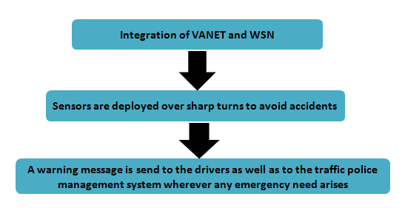

The sensors will collect the information about the vehicles passing by, suppose we set the range of sensor as 3/4th of the road. The sensors will detect within the range and if there is any chances of collision it send message to the driver and traffic police informing them about the occurrence of collision and even if the vehicle is over speeding over that area the sensor will detect it and will inform the traffic police about it. How actually this will work is given under.

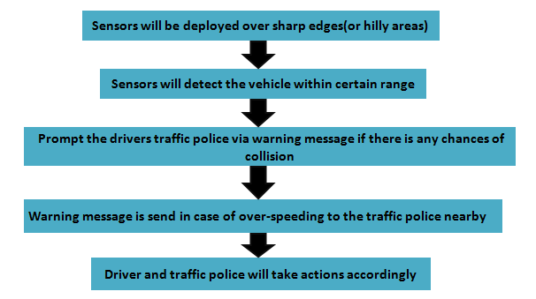

CONCLUSION

The above discussed technique is slightly different from existing techniques. While the existing techniques are in-built techniques and the technique proposed by us is the technique based on integration of VANET and WSN. The proposed technique will be useful in reducing the accidents over accident prone areas. In future we will be designing a proper algorithm for this technique and will simulate it to know further results.

REFERENCES

[1] Wiseborn Manfe Danquah and D. Turgay Altilar, “HYBRIST Mobility Model - A Novel Hybrid Mobility Model for VANET Simulations”, International Journal of Computer Applications (0975 – 8887) Volume 86 – No 14, January 2014.

[2] Faisal Riaz, Syed Ismail Shah, Muhammad Raees, Imran Shafi and Arslan Iqbal, “Lateral Pre-crash Sensing and Avoidance in Emotion Enabled Cognitive Agent based Vehivle-2-Vehicle Communication System”, International Journal of Communication Networks and Information Security (IJCNIS), Vol. 5, No. 2, August 2013.

[3] Pushpender Singh, Amit Ashthana and Manik Chandra Pandey, “A Hybrid VANET-WSN System for Driving Safety using Efficient Communication Protocol”, International Journal Of Advance Research In Science And Engineering IJARSE, Vol. No.2, Issue No.5, May 2013.

[4] Hua Qin, Zi Li, Yanfei Wang, Xuejia Lu, Wensheng Zhang and Guiling Wang, “An Integrated Network of Roadside Sensors and Vehicles for Driving Safety: Concept, Design and Experiments”, 2015”.

[5] Garima Turan and Sheifali Gupta, ”Road Accidents Prevention system using Driver’s Drowsiness Detection”, International Journal of Advanced Research in Computer Engineering & Technology (IJARCET) Volume 2,Issue 11, November 2013.

[6] Prashanth K P, Kishen Padiyar, Naveen Kumar P H and K Santhosh Kumar, “Road Accident Avoiding System using Drunken Sensing Technique”, International Journal of Engineering Research & Technology (IJERT) ISSN: 2278-0181, Vol. 3 Issue 10, October- 2014.

[7] John Whitelegg, “Road Safety: Defeat, Complicity and the Bankruptcy of Science”, Sept 1982.