**Efficient Resource Allocation Policy in Virtualized Cloud Computing Environments**

1Junied Khan, 2Arunima Jaiswal

1 Amity School Of Engineering & Technology, Amity University

2Assistant Professor, Amity School Of Engineering & Technology, Amity University

[{junaid01khan@gmail.com1](mailto:%7bjunaid01khan@gmail.com1), [ajaiswal34@amity.edu2](mailto:ajaiswal34@amity.edu2)}

**Abstract**— In markets and enterprises a new age technology cloud computing has got huge potential. Applications and associated data can be accessed from anywhere with the help of clouds. Significantly companies can reduce their infrastructure cost by renting resources and other computations from cloud. Based on pay-as-you-go model they can make use of company wide access of applications and therefore minimizing the need of individual product licenses. Optimizing the allocated resources is one of the major pitfalls in cloud computing. Meeting application demands and customer requirements are some of the other challenges of resource allocation.

*Keywords*—Cloud Computing, VMs, Platform as a Service, Resource Allocation Strategies(RAS), Ant colony optimization algorithm.

**I. Introduction**

The datacenter ingredients and news is really what we will get in touch with an impact[1]. After an affect are produced easily obtainable in a trend that'll be pay-as-you-go the time, we reference it a Expanse influence; the abilities is vended try electric processing. Latest examples of period power computing incorporate Amazon on line services, yahoo pc software program, and Microsoft Azure. We utilize the key phrase private Cloud to represent to inner datacenters of an organization or business that has been supplementary aren't made accessible for any majority of folks. Thus, determine computing will be the level of SaaS and electrical power control, but will not usually entail exclusive Clouds. We’ll usually utilize Cloud handling, changing alongside on the list of phrase that is many happen to be further after clearness requires it. We are going to eschew code for instance “X as a skill (XaaS)”; fantastic products about X there is noticed in printing encompass system, machines, and plan, but we had started struggling to concur also them.

From a hardware point of contemplate, three aspects are new in Cloud Calculating:

• The illusion of infinite computing resources obtainable on demand, thereby removing the demand for Cloud Calculating users to design distant in front for provisioning;

• The elimination of an up-front pledge by Cloud users, thereby permitting firms to onset puny and development hardware resources merely afterward there is an development in their needs; and

• Pay to be utilized for processing information on an aspect this is really brief commanded and release them since commanded.There are three types of cloud computing; Infrastructure as a Service(IaaS), Platform as a Service(PaaS), Software as a Service(SaaS).

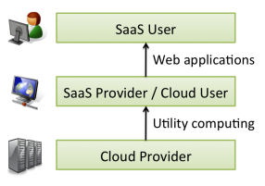

**Figure. 1.** Users and Providers of Cloud Computing**.**

**II. Resource allocation strategies in cloud computing**

In cloud computing, resource allocation (RA)[2] are the means of allocating readily available resources to your own impacts this is certainly commanded across the websites. Guide provisioning treatments that downside by allowing the relevant skills providers to know the equipment for each and every specific part that will be depressed. Website allotment method (RAS) could very well be all integrated that will be evaluating seller interests for maintaining and allocating controlled spending budget for the check of determine traits in order to learn certain requirements associated with program. It requires the kind and amount of gear commanded by every single destination this is truly specific acquisition to complete one work. The years and buy of allowance of spending budget comprise additionally an input for an optimal RAS.

**I. Task Arranging Algorithms in Cloud Environment**

Determine subscriber’s link virtualization, computerized media, and hookups which will be internet furnish their distinctive suppliers. A agent this is really truthful of affect qualities are customers, device, and web relationship. A hybrid computing flawless permits people to come across both course and personal control suppliers to create a supplementary adaptable and computing fuel which will be cost-effective. The duration affect fictional character requires internet instituted interest, facts as an ongoing service(DaaS), base as things (IaaS), mass media as a form of art (SaaS), and email as a form of art (EaaS)[3]. A cloud this is certainly private the supply through the length connection that is affect render procedures to their consumers.

**II. Policy and Job Arranging Algorithms of Cloud Computing**

Efforts organizing of cloud remarks which happen to be running the whole process of altering options amid different webpage’s folks in conformity with precise rules of website practices below a provided determine atmosphere. Research efforts and connection planning could be the vital manufacturing of determine control. This is certainly consistent work organizing in affect at the moment, there isn't an average. Numerous pattern provide awareness of jobs dispatcher, this is certainly virtually accountable for all the job allocations, responses and retransmissions.

**III. Resource Allocation Strategies in Cloud Computing Environment**

Web-site allowance is a pursuit that's been replied in several running handles, such as for instance working systems, grid datacenter and operating control. A site allotment plan (RAS)[4] in affect computing were observed as every treatment that'll be single are built to hope that the software’ goals become addressed specifically associated with the provider’s program. Together with alongside this pledge towards the maker, site allotment elements must additionally ponder the current area of any solitary source this is actually depressed the affect personality, to help you to implement recipes to bigger assign bodily and/or adjoining tips to manufacturers demands, consequently reducing the practical worthy of inside the character that in affect.

**IV. Ant Colony Optimization Algorithm for Resource Allocation**

Affect operating advertised people make use of a Master/Slaves framework. There are certainly a primary node innode that is primary cost of managing and impacting almost all of the Slave nodes [7]. The setup as well as the reference allotment through the affect characteristics become unpredictableAJX similar to the specific dilemma of site not familiar below determine circumstances, and also the webs do not have a group topology.

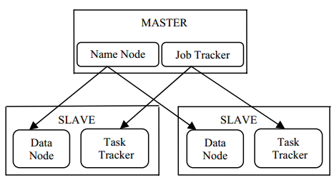

**Figure. 2.** Master/Slaves Structure of Hadoop Cluster **Figure 3**. Mapping of virtual to physical resources

**V. Dynamic Resource Allocation Strategy in Cloud Computing Environment**

A web site which will be marketed construction, this consists of many determine nodes, space nodes, and on-line node. Each and every node this is really depressed industrialized by a sequence of options such as for instance main Processing Unit, remembrance, net facts exchange and numerous added[5]. These tips are info that is yelled may be multidimensional. How many adjacent techniques (VMs) located in a cloud which will be big heart each and each individual huge day could be greatly huge, in addition to their arrangement acquaint a momentous weight from inside the facts middle online.

**VI. Dynamic Resource Allocation employing Migration in Cloud**

Migrating application into another system. It is extremely powerful tool for clusters administrators. It will be freeing the original machine for maintenance. Relieve the load on the congest hosts. Sending of the VM’s memory will consume the entire bandwidth. If only consider the live migration among the well-connected data center.

**III. Related Work**

Yubin Yang et al[10], present a computer-aided cloud-analysis approach by effectively modeling the integration of heterogeneous satellite-observed data and remote sensing images. First, automatic cloud detection and tracking methods are proposed to identify the georeferenced cloud objects in satellite remote sensing images. Experimental results have shown that the proposed data integration model can effectively extract and synthesize all the useful information from heterogeneous data sources to generate a unified view of knowledge, on the basis of which the evolvement trends of clouds can be analyzed properly.

Kaewpuang R. et al[11], describe Cloud computing is new paradigm for provision of a computing infrastructure and services over the network using a pool of abstracted, virtualized, and scalable, computing resources. One of the challenges is the lack of standard in configuration, management, and programming. Thus, they propose that a service oriented cloud can be built and program using Microsoft Windows server and program using Microsoft CCR/DSS. The experiments show that a very high speed up of more than 50 times on 16 quad core node and 80-90% efficiency can be obtained using a cloud computing system based on their concept.

Tao Wu et al[12], addresses the decision trees induction with uncertain data. In other words, it presents a novel method, called uncertain decision trees (UDT) to handle the uncertainty during the process of inducing decision trees. Here, uncertainty is depicted via cloud model theory, a quantitative-qualitative transforming model with uncertainty, which can well integrate the fuzziness and randomness of concepts in a unified way.

Yi Zhao et al, describe EUCALYPTUS[13], an open source cloud-computing framework, is still lack of load balancing. They provide a kind of implementation by adaptive live migration of virtual machines. They design and implement a simple model which decreases the migration time of virtual machines by shared storage and fulfills the zero-downtime relocation of virtual machines by transforming them as Red Hat cluster services.

Kun Li et al[14], describe cloud computing is the development of distributed computing, parallel computing and grid computing, or defined as the commercial implementation of these computer science concepts. One of the fundamental issues in this environment is related to task scheduling. Cloud task scheduling is an NP-hard optimization problem, and many meta-heuristic algorithms have been proposed to solve it. A good task scheduler should adapt its scheduling strategy to the changing environment and the types of tasks. It proposes a cloud task scheduling policy based on Load Balancing Ant Colony Optimization (LBACO) algorithm.

Mandal, A.et al[15], presents the design, implementation, and evaluation of a new system for on-demand provisioning of Hadoop clusters across multiple cloud domains. The Hadoop clusters are created "on-demand" and are composed of virtual machines from multiple cloud sites linked with bandwidth-provisioned network pipes.

# **IV. Results and Analysis**

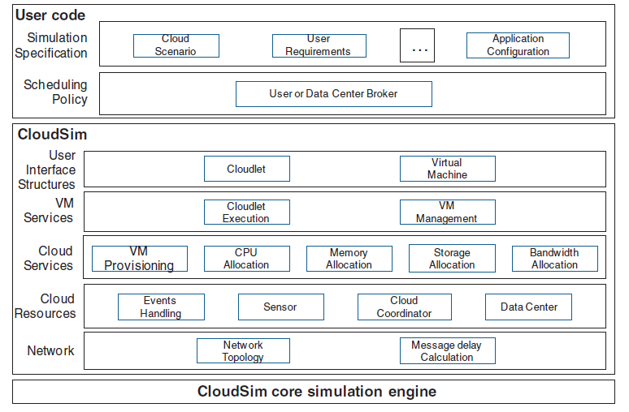

**Figure. 1**. Layered CloudSim architecture

## **Simulation Output:**

CloudSim, experts should certainly complete assessments devoted to certain circumstances and designs, therefore allowing the development of instructions atlanta divorce attorneys the standards which have been vital that you determine running.

**General information**

Simulation has finished in 03 seconds.

1. Datacenter1:
   1. Allocation policy: Single threshold
   2. Number of hosts: 3
   3. Number of migrations: 0
2. DCv2:
   1. Allocation policy: Single threshold
   2. Number of hosts: 1
   3. Number of migrations: 0

User Information

1. James:
   1. Broker policy: Round robin
   2. Number of virtual machines: 1
2. Customer1:
   1. Broker policy: Round robin
   2. Number of virtual machines: 1
3. Bharti:
   1. Broker policy: Round robin
   2. Number of virtual machines: 6

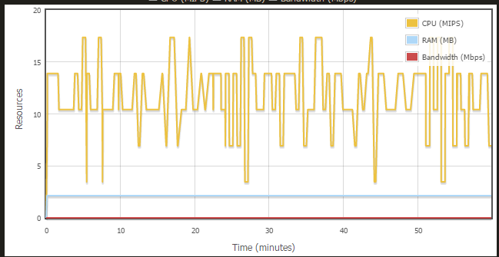

**Figure. 2** Graph shows the overall resource utilization on this datacenter.

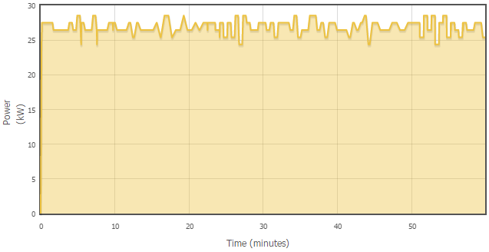

**Figure.3.** Graph shows the overall power consumption on this datacenter**.**

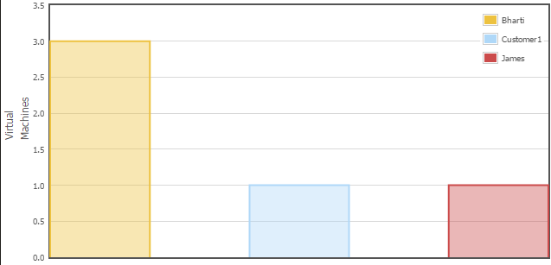

**Figure. 4.** Graph shows how many virtual machines have been successfully

allocated on this datacenter by each customer.

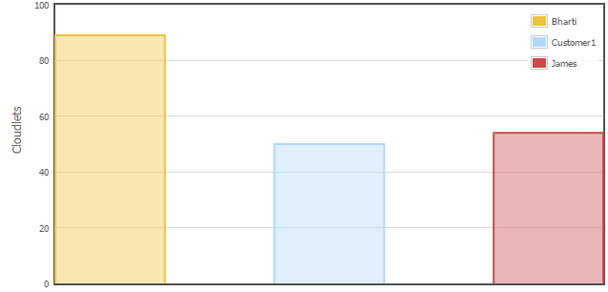

**Figure. 5.** Graph shows how many cloudlets have been successfully

executed on this datacenter by each customer**.**

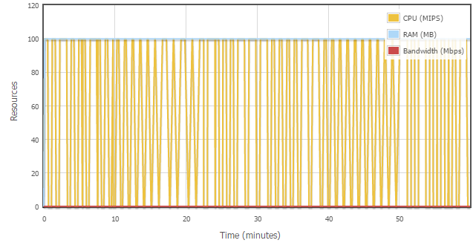

**Figure. 6.** Graph shows the overall resource utilization of this customer.

**V. Conclusion**

Individual servers that make up the data center can be used optimally for cloud computing to be efficient. About half of the maximum power is consumed by the idle server. We present a resource management system for cloud computing along with its design, implementation and evaluation[16]. Based on changing demand our system adaptively multiplexes virtual to physical resources. For the system with multi-resource constraints, the algorithm achieves overload avoidance and green computing through reduction of physical machines.

**References**

1. Wu, Linlin, Saurabh Kumar Garg, and Rajkumar Buyya. "SLA-based admission control for a Software-as-a-Service provider in Cloud computing environments." Journal of Computer and System Sciences 78, no. 5 (2012): 1280-1299.
2. Hofmann, Paul, and Dan Woods. "Cloud computing: the limits of public clouds for business applications." Internet Computing, IEEE 14, no. 6 (2010): 90-93.
3. Sotomayor, Borja, Rubén S. Montero, Ignacio M. Llorente, and Ian Foster. "Virtual infrastructure management in private and hybrid clouds." Internet computing, IEEE 13, no. 5 (2009): 14-22.
4. Zhu, Yan, Huaixi Wang, Zexing Hu, Gail-Joon Ahn, Hongxin Hu, and Stephen S. Yau. "Efficient provable data possession for hybrid clouds." In Proceedings of the 17th ACM conference on Computer and communications security, pp. 756-758. ACM, 2010.
5. Hasan, Masum, Sumit A. Naiksatam, Glenn Dasmalchi, Krishna Sankar, and Vaughn Suazo. "Virtual private clouds." U.S. Patent Application 13/196,759, filed August 2, 2011.
6. Beloglazov, Anton, Jemal Abawajy, and Rajkumar Buyya. "Energy-aware resource allocation heuristics for efficient management of data centers for cloud computing." Future generation computer systems 28, no. 5 (2012): 755-768.
7. Feller, Eugen, Louis Rilling, and Christine Morin. "Energy-aware ant colony based workload placement in clouds." In Proceedings of the 2011 IEEE/ACM 12th International Conference on Grid Computing, pp. 26-33. IEEE Computer Society, 2011.
8. Zhenhuan Gong, Xiaohui Gu, and John Wilkes. "Press: Predictive elastic resource scaling for cloud systems." In *Network and Service Management (CNSM), 2010 International Conference on*, pp. 9-16. IEEE, 2010.
9. V. Vinothina, R. Sridaran, and Padmavathi Ganapathi. "A survey on resource allocation strategies in cloud computing." *International Journal of Advanced Computer Science and Applications (IJACSA)* 3, no. 6 (2012).
10. M.Gokilavani, S. Selvi, and C. Udhayakumar. "A Survey on Resource Allocation and Task Scheduling Algorithms in Cloud Environment." *International Journal of Engineering and Innovative Technology (IJEIT) Vol* 3.
11. Lu Huang, Hai-shan Chen, and Ting-ting Hu. "Survey on Resource Allocation Policy and Job Scheduling Algorithms of Cloud Computing1." *Journal of Software* 8, no. 2 (2013): 480-487.
12. Priyanka Mod, and Mayank Bhatt. "A Survey on Dynamic Resource Allocation technique in cloud Environment."
13. Ms Renu Krishnan, and Ms Silja Varghese. "Survey Paper for Dynamic Resource Allocation using Migration in Cloud."
14. Stephen S. Yau, and Ho G. An. "Adaptive resource allocation for service-based systems." In *Proceedings of the First Asia-Pacific Symposium on Internetware*, p. 3. ACM, 2009.
15. Ye Hu, Johnny Wong, Gabriel Iszlai, and Marin Litoiu. "Resource provisioning for cloud computing." In *Proceedings of the 2009 Conference of the Center for Advanced Studies on Collaborative Research*, pp. 101-111. IBM Corp., 2009.
16. Zhenhuan Gong, Xiaohui Gu, and John Wilkes. "Press: Predictive elastic resource scaling for cloud systems." In *Network and Service Management (CNSM), 2010 International Conference on*, pp. 9-16. IEEE, 2010.
17. Sheng Di; Cho-Li Wang; Cappello, F.,"Adaptive Algorithm for Minimizing Cloud Task Length with Prediction Errors",IEEE,Cloud Computing, IEEE Transactions on, 2014.
18. Tram Truong-Huu; Chen-Khong Tham,"A Novel Model for Competition and Cooperation among Cloud Providers",IEEE,Cloud Computing, IEEE Transactions on, 2014.
19. Yonggang Wen; Xiaoqing Zhu; Rodrigues, J.J.P.C.; Chang Wen Chen,"Cloud Mobile Media: Reflections and Outlook",IEEE,Multimedia, IEEE Transactions on, 2014.
20. Yuan Feng; Baochun Li; Bo Li,"Price Competition in an Oligopoly Market with Multiple IaaS Cloud Providers",IEEE,Computers, IEEE Transactions on, 2014.
21. Security Testing of Web Applications: a Search Based Approach for Cross-Site Scripting Vulnerabilities, Andrea Avancini, Mariano Ceccato , 2011- 11th IEEE International Working Conference on Source Code Analysis and Manipulation.
22. Special section on testing and security of Web systems Alessandro Marchetto. Published online: 14 October 2008 © Springer Verlag 2008.
23. Solving Some Modeling Challenges when Testing Rich Internet Applications for Security. Suryakant Choudhary1, Mustafa Emre Dincturk1, Gregor v. Bochmann1,3, Guy-Vincent Jourdan1,3 1EECS, University of Ottawa 3IBM Canada CAS Research. Iosif Viorel Onut, Paul Ionescu Research and Development, IBM. 2012 IEEE Fifth International Conference on Software Testing, Verification and Validation.
24. http://ijcsmc.com/docs/papers/August2014/V3I8201499a19.pdf
25. <http://www.ijcaonline.org/archives/volume88/number3/15334-3667>​