Design & Fabrication of E-Shaped Microstrip Patch Antenna for WLAN Application

Chandan and Dr.B.S.Rai

[chandanhcst@gmail.com](mailto:chandanhcst@gmail.com) and bsr_54@yahoo.co.in

***Abstract-* In this paper discussion is E- shaped mircostrip patch antenna. In the proposed antenna is suitable band (2.303-2.611GHz). The proposed antenna meet the required impedance bandwidth is 12.53%. The dimension of the proposed antenna is (30×30×1.6 mm3). This antenna exhibits bandwidth at 2.457GHz and gain 3.5dBi. In a working band can be flexibly controlled by suitable change of corresponding parameters of E- shaped antenna. The variations in the design structure from E-shaped antenna are three edge slot cut in the structure. The proposed antenna by embedding three edges slit in to rectangular E shaped reradiating patch, cover the application such as WLAN 2.4 GHz is realized within a 1.5 VSWR.**

***Index Terms:* WLAN 2.4GHz, VSWR, three edges slit cut, proposed antenna testing.**

1. **INRODUCTION**

High mobility necessity multiple demands for wireless communication devices increase the interest for compact and low profile antennas in years. The frequency range of proposed antenna is (2.303-2.611GHz) in used for Wireless Local Area Network (WLAN) at 2.457GHz resonant frequency. In this paper the design of E-shaped of a rectangular microstrip patch antenna for WLAN application is realized by aggregating three edges cutting in the proposed antenna. It may be used as indoor WLAN antenna application and is small enough that it will fit nicely into any environment.

To generate band for 2.457 GHz WLAN operation, a compact antenna two biggest length of E shaped antenna top and bottom length and width of the patch antenna ( 15 ×15×1.6 mm3) and small size of middle of E shaped antenna (10×5×1.6mm3). Designs, along with detailed design considerations, simulation and testing results, for WLAN, phone antenna, Very–low–profile monopoles for internal mobile phone antennas. Patch is antennas for cellular systems, planar antennas for WLAN applications [2]. The antenna dielectric subtract thickness is used FR4 type because low-cost and easily available. The antenna is driven by a 50-Ω mirostrip line. The presented antenna has also been loaded by thin FR4 layer top to achieve good impedance matching at this band.

In this paper, a new design of single band of E-shaped microstrip patch antenna that operates at frequency band (2.303-2.611GHz) than experimental result proposed antenna band is (2.503-2.723 GHz) at 2.613 resonant frequency which can be well used for 2.457 GHz WLAN applications. The VSWR is proposed antenna 1.5 dB, very important for used communication purpose. The presented antenna is also fabricated, and good agreements between simulated and measured results can be achieved, which is also verifying the advantages of the proposed E-shaped antenna: easy configuration, good VSWR, good efficiency and good radiation pattern. The proposed antenna used parameters of E-shaped in the three edge slot cut in the rectangular E-shaped antenna are also investigation to effectively and flexibly adjust each of the working band, which make our proposed antenna design easily extended to the other communication band.

1. **ANTENNA CONFIGURATION**

The geometry of E-shaped microstrip patch with three edge rectangular slot cut. In the patch antenna geometry is (30 ×30×1.6 mm3) and each edges rectangular slot geometry is (2.5× 1×1.6 mm3) as symmetric of other two edges rectangular slot, and is an FR4 epoxy with relative permittivity ɛr = 4.4 and loss tangent tanδ = 0.0013. Excitation is made through a coaxial core of a SMA connector (inner diameter = 1 mm and outer diameter = 3.5 mm) at 0.7 mm away from the lower edge of the RMSA as shown in figure. The dimensions of the proposed antenna were optimized by simulation using the full-wave simulator IE3D 15.20. The presents the design flow (including the simulated and measurement return losses) of this proposed antenna, size of patch 30mm × 30 mm full radiating patch; whereby a lower frequency f1 of around 2303 MHz and higher frequency f2 of around 2611 MHz at resonant frequency is 2457 MHz for wireless local area network (WLAN) application.

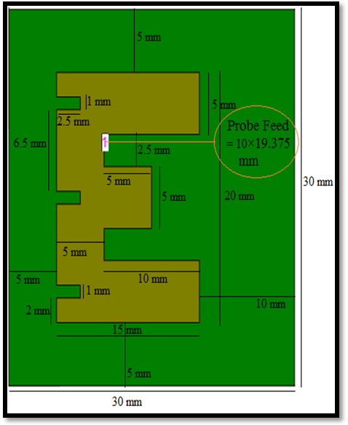

Fig. 1. Geometry of the proposed antenna

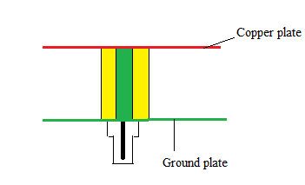

Fig. 2. Side view of proposed antenna

The proposed antenna is design for wireless local area network (WLAN) at 2457 MHz resonant frequency. Proposed antenna E-shaped microstrip patch antenna modelled on substrate of the height h = 1.6 mm, dielectric constant 4.4 FR4 epoxy. Geometry of the proposed antenna is given in the table 1. This patch of rectangular shapes with three rectangular slots cut in patch, coaxial probe point x = 10 mm and y = 19.375 mm given figure 1, in this point is highly impedance matching and obtained various results figure 2 is represent side view of the proposed antenna. Upper layer is called patch and bottom layer is called ground in the middle is dielectric substrate.

**TABLE 1**

PARAMETER OF THE PROPOSED ANTENNA (UNIT: MILIMETERS)

|  |  |
| --- | --- |
| **Parameters** | **Value** |
| Dielectric constant of the substrate | 4.4(FR4 epoxy) |
| Loss tangent | 0.0013 |
| Length of the patch | 30 mm |
| Width of the patch | 30mm |
| Substrate of thickness | 1.6 mm |
| Operating frequency | 2.45 GHz |
| $$Z_{o}$$ | 50 |

1. VERIFICATION OF SIMULATION AND EXPERIMENTAL RESULTS

In the reference to figure 1, simulation of relevant parameters is carried out by commercial software: IE3D FLEXnet 10-9-7391BFEF.

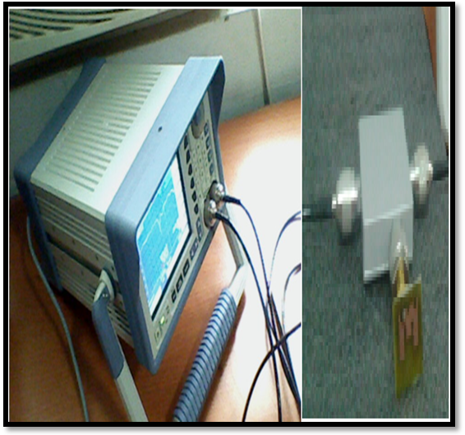

Fig.3. Testing of proposed antenna

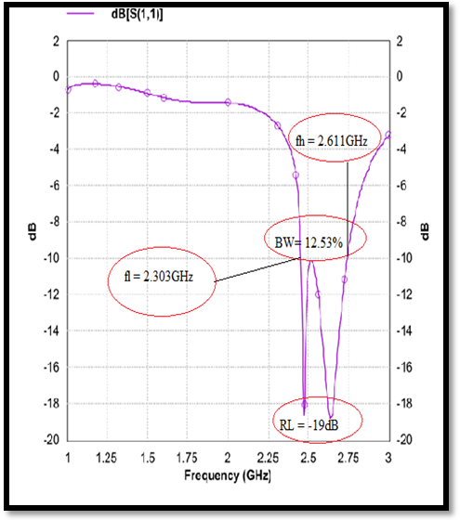

Fig. 3. Simulation result of S11 of the proposed antenna

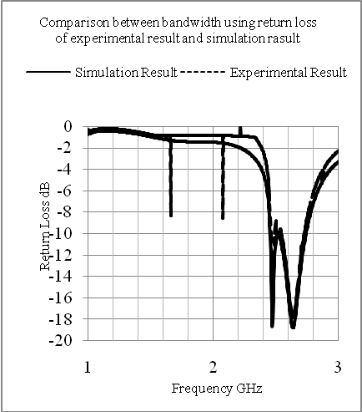

Fig. 4. Simulated and measured results of S11of the present antenna

The simulated and measured S11 is shown in figure 4, from which it can been seen that two results have good agreement, through some manufacture and measured error leads to small shift of measured results. From the measured S11, it is clear that the proposed antenna works at 2.457GHz with a -10dB bandwidth of 12.53% (2.303-2.611GHz) for simulation result and bandwidth of 8.89% (2.422-2.647GHz) at 2.534GHz resonant frequency for experimental result, those are resonate application for Wireless Local Area Network (WLAN).

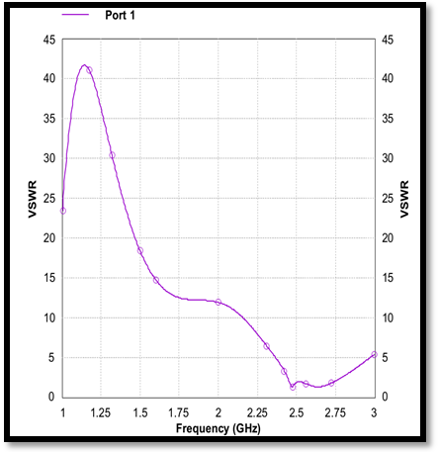

Fig. 5. Simulation result of VSWR of the proposed antenna

In the simulation result, Voltage Sanding Wave Ratio (VSWR) performance is required for wireless communication. The performance is evaluated from the VSWR relative to 50Ω. The frequency ratio $\frac{f_{H}}{f_{L}}$ is calculated as a function of the antenna. Where $f_{H}$ and $f_{L}$ are higher and lower resonance of the antenna respectively. VSWR is the proposed antenna 1.5dB at 2.457GHz resonant frequency. VSWR is the very important role of the communication system; the VSWR is the standard for communication purpose VSWR≤2.

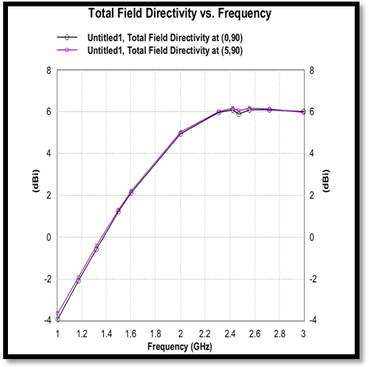

Fig. 6. Simulation of Directivity of the proposed antenna

Investigate the frequency–agile performance of the directivity of such an antenna. Two lumped element capacitor are introduced in to parasitic disk. Show in figure 6 directivity is another parameter of the antenna which is closely related to the gain. The analyses the frequency curve show the value of directivity is equal to 6 dBi at 2.457 GHz resonant frequency.

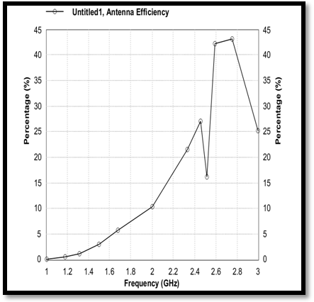

Fig. 7. Simulation of antenna efficiency of proposed antenna

Antenna efficiency is also very important term and is used to analyse whether the antenna is efficiently, the curve for antenna efficiency is shown figure 7. It can be clearly observed that the antenna structure design provide an antenna efficiency of 43%. According to curve efficiency of proposed antenna is 43% at 2.457 GHz frequency.

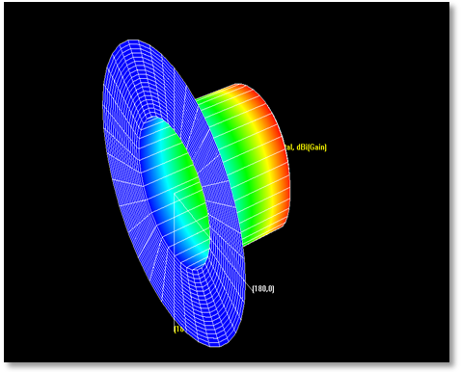

Fig. 8. Simulation of radiation pattern of proposed antenna

This power variation as a function of the arrival angle is observed in the antennas for field. The 3D plot gives a better insight of the analysis, gain and directivity analysis is done more precisely through this 3D pattern.

1. **CONCLUSION**

E-shaped microstrip patch antenna is designed and analyzed to support Wireless Local Area Network (WLAN) band (2.303-2.611GHz at 2.457 resonant frequency and bandwidth is achieved 12.53%. Good agreement between the simulation result and measurement result is shown in figure 4. Bandwidth is achieved of 8.89% (2.422-2.647GHz) at 2.534GHz resonant frequency for experimental (measurement) result. VSWR is measured of the separation band of about 1.5 dB is obtained at 2.457GHz. The proposed antenna the design technique used for the WLAN using 2.457GHz resonant frequency.

**REFERENCES**

1. U.Chakraborty, “Compact Dual-Band Microstrip Antenna for IEEE 802.11a WLAN Application,” IEEE Antenna and Wireless Propagation Letter, Vol. 13, pp. 407-410, 2014.
2. Bahadir Yildirim, “Dielectric –Loaded Compact WLAN/WCDMA Antenna With Shorted and Monopole Element,” IEEE Antenna and Wireless Propagation Letter, Vol.12, pp. 288-291, 2013.
3. Chih-Chiang chen, “A Novel Compact Quad –Band Narrow Strip-Loaded Printed Monopole Antenna,” IEEE Antenna and Wireless Propagation Letter, Vol. 8. pp. 974-978, 2009.
4. Ahmed Khidre, “Circular Polarization Reconfigurable Wideband E-Shaped Patch Antenna for Wireless Application,” IEEE Transaction on Antenna and Propagation, Vol. 2, pp. 960-964, 2013.
5. Ahmed Khidre, “Wideband Circularly Polarized E-Shaped Patch Antenna for Wireless Application,” IEEE Antenna and Propagation Magazine, Vol. 52, pp. 220-227, 2010.
6. Yuehe Ge, “E-Shaped Ptch Antenna for High-Speed Wireless Network,” IEEE Transaction on Antenna and Propagation, Vol. 52, pp. 3213-3219, 2004.
7. C.A. Balanis,“Antenna theory: analysis and design,” John Wiley and Sons, INC., New York, Third Edition, 2005.
8. Yi Kai chen, Shiwen Yang, “Bandwidth Enhancement Method for Low Profile E-Shaped Microstrip Patch Antenna”, IEEE Transactions, Vol. 58. Issue 7, PP.2442-2447, 2010.
9. IE3D Release 15.2, HyperLynx®3D EM, Mentor Graphics, 1993-2012.