A New Efficient Approach for Designing Intelligence Interleaver

|  |
| --- |
| Tarun Agrawal  G.L.A. University Mathura  (UP), India  tarun.ag.1506@gmail.com |

*Abstract*— **In communication system for removing burst error various algorithms, techniques are used. This paper contains designing of interleaving based on Artificial Intelligence state space search technique i.e. Breadth first search (BFS) and Depth first search (DFS), which gives number of possible solution, from the number of solution designer choose best solution. This algorithm is totally different from traditional algorithm. This algorithm takes more time than conventional algorithm but designer obtained result which is more efficient as compared with traditional.**

Keywords—Interleaver, burst error, security, BFS, DFS, Artificial Intelligence, State space search, BER, FEC Codes, Noise.

# Introduction

The current all-fiber interleavers are basically two-port devices. A number of interleavers will have to be cascaded to achieve high channel counts for a communication system. Unfortunately, the insertion loss will increase with the number of interleavers used. Furthermore, with two-port devices, only configurations of power of two is possible and this limits the capability of the interleaver in multiplexing more complicated coded signals needed in optical communications. Therefore, it is of great interest to design multiport optical interleavers in order to efficiently increase the channel counts with less stages of interleavers and to provide more flexibility for optical signal multiplexing [1]. Optical interleavers are filters that separate an incoming spectrum into two complementary set of periodic spectra (odd and even channels) or combine them into a composite spectrum. They play a key role in dense wavelength division multiplexing (DWDM) systems, as in gain equalization, dispersion compensation, pre-filtering, and channels add/drop applications. Asymmetric interleavers separate the odd and even channels with different pass bandwidths. In fact, symmetric interleavers are a particular case in which both channel groups have the same pass bandwidths [2]. In today’s scenario in field of Mobile communication during data transfer there are various types of error occurs i.e. due to noise. Noise may be internal or external. Internal noise generates inside the electronics system on other hand external noise is due to from outside source. In Analog Communication the performance of the system is measured in terms of SNR (Signal to Noise Ratio) while in case of digital communication the performance of the system is measured in terms of BER (Bit Error Rate). In Digital Communication for improving performance of the system i.e. BER, Data transferring rate, security we apply several types of Forward Error Correcting Codes or in other word Source Coding and Channel Coding. Forward Error Correcting code is having very good advantage i.e. these codes can correct as well as detect the error. After applying various types of coding the performance of the communication system has been improved. As improving the performance of communication system in terms of BER there is another type of error occur i.e. Burst Error. When there is error in 2 or more than 2 continuous bit, this type of error can be termed as Burst Error. Burst errors encountered in digital bit streams transmitted over wireless channels are characterized precisely. This enables us to derive a formula to approximate the error content in a data frame of given length. This is a signiﬁcant parameter, as it determines the average throughput and the time delay of frame- based protocols [2]. For removing this type of error researcher gave the idea of interleaving the data i.e. Interleaver. For removing burst error, we design a block that can termed as Interleaver. Interleaving can be applied in both wired and wireless communication. there was no such standard way for designing interleaver but during designing of interleaver designer must remember some key points that are interleaver must be design in such a way that deinterleaving designing be possible of interleaved data. In this work we will design interleaver based upon state space search based techniques i.e. BFS (Breadth First Search), Breadth first search is the prototype of many important graph algorithms such as minimum spanning tree algorithm: shortest path algorithm and so on, which are similar with breadth first sea& Furthermore it is one of the simplest searching algorithms in graph theory [5]. And DFS (Depth First Search). Breadth-ﬁrst search (BFS) has wide applications in electronic design automation (EDA) as well as in other ﬁelds [8]. A S-random inter­ leavers have two major drawbacks: 1) finding good interleaver (larger spreading factor 8) with longer length becomes difficult or computationally demanding, and 2) pruning the interleaver for shorter-length code word applications typically results in reduction of spreading factor 8 and thus causes noticeable performance degradation [11]. General synthesis method for designing asymmetric flat-top birefringent interleavers uses a combination of digital signal processing approach and computational optimization by Gas. This method allows approximation of interleaver’s specifications such as ripple, bands, and CD at both outputs. One output with linear phase can be achieved where higher bit rate channels can be allocated [2]. Block inter- leavers, which are the basis of most turbo code schemes, are introduced as a special case. A turbo code is obtained by the parallel concatenation of simple constituent convolutional codes connected through an interleaver. Turbo codes, although decoded through an iterative suboptimum decoding algorithm, yield performance extremely close to the Shannon limit. In spite of the fact that several research issues are still open, turbo codes are obtaining a large success and their introduction in many international standards is in progress. For decoding purposes, the trellises of the con- stituent convolutional encoders are almost always terminated, so that the turbo code can be considered as a block code [3]. A interleaver can be assumed a black box that takes input bits and gives interleaved bits which are shown in figure-1 given below.

*Figure 1- Interleaver*

INTERLEAVER

Output

Input

# Previous Work related to designing of interleaver block

1. *Interleaving of Random Data in Matrix Format*

In this kind of designing, the data is taken in such a way that bits are mapped into square matrix.

Considering 3X3 Matrices with 9 bit of random input data

D = {1,2,3,4,5,6,7,8,9}

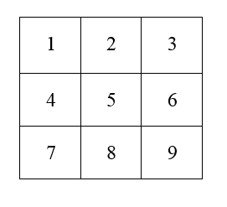

Let Error is in 6th, 7th and 8th position

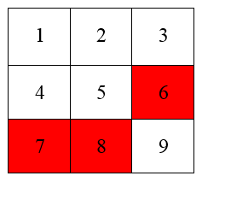

Interleaver

Output: Di

Input: D

Where D: Input Data

Di: Interleaved Data

 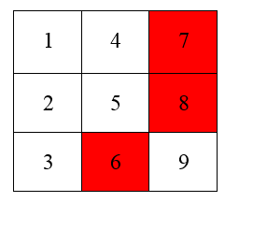1st format

Interleaver

Di (1) = {1,4,7,8,5,2,3,6,9} ------------------------------(1)

In this case the 1 bit is safe from the burst error , but here there is also burst error.

2nd Format

Di (2) = {1,2,4,3,5,7,6,8,9} -------------------------------(2)

In this case burst error is not removed.

3rd Format

Di (3) = {1,4,7,8,9,6,3,2,5} -------------------------------(3)

In this case there is also burst error present. Here burst error is partially removed.

1. *Interleaving of Random Data in Reverse Matrix Format*

Here in this kind of designing, the data is also taken in such a way that bits are mapped into square matrix.

Here Data is same of 9-bit.

D = {1,2,3,4,5,6,7,8,9}

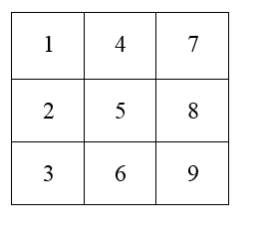

Here the data is entered in other format. Here we are assuming the burst error 6th, 7th and 8th bit.

 

Interleaver

1st format

Di (1) = {1,2,3,6,9,8,7,4,5} ------------------------------(4)

In this case the 1 bit is safe from the burst error , but here there is also burst error.

2nd Format

Di (2) = {1,4,2,7,5,3,8,6,9} -------------------------------(5)

In this case burst error is not removed.

3rd Format

Di (3) = {1,2,3,6,9,8,7,4,5} -------------------------------(6)

In this case there is also burst error present. Here burst error is partially removed.

# state space search techniques based interleaving designing

State Space search technique is modern technique which is based upon Artificial Intelligence. It can be classified into two types 1. BFS, 2. DFS. Which are also given in figure-2.

Figure 2- Classification of State Space Search Technique

## First Approach MBAID(Map in BFS And Interleaved in DFS):

In this technique for designing the interleaver both techniques will be used. In this technique first map input bits in BFS and then Interleaved in DFS. Here we are considering 9- bit data. Data is random is nature.

D = {1,2,3,4,5,6,7,8,9} --------------------------------(7)

D: is Input bits

Steps:

1. First Map the input bit in tree using BFS
2. Now Interleave bits acc. to DFS
3. Write the interleaved bits in BFS pattern
4. Now analysis the result.

Note: Here also assuming same error bits 6th, 7th and 8th.

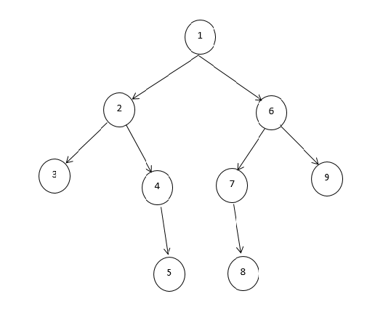

Figure 3 Input bits in BFS Pattern

Applying Interleaving on this BFS pattern and interleaved results in DFS Pattern.

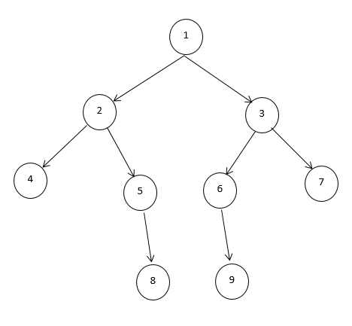

Figure 4 Interleaved DFS Pattern output

Output Interleaved bit Di = {1,2,4,5,8,3,6,9,7} --------------(8)

From Equation 8 it is clear that the burst error is removed.

## Second Approach MDAIB(Map in DFS And Interleaved in BFS):

Here in this technique also for designing the interleaver both techniques will be used. In this technique first map input bits in DFS and then Interleaved in BFS. Here we are considering 9- bit data.

D = {1,2,3,4,5,6,7,8,9} --------------------------------(7)

D: is Input bits

Steps:

1. First Map the input bit in tree using DFS
2. Now Interleave bits acc. to BFS
3. Write the interleaved bits in DFS pattern
4. Now analysis the result.

Note: Here also assuming same error bits 6th, 7th and 8th.



Figure 5 Input Bits in DFS Pattern

Applying Interleaving on this DFS pattern and interleaved results in BFS Pattern.



Figure 6 Output Interleaved bit in BFS Pattern

Output Interleaved bits Di = {1,2,6,3,4,7,9,5,8} ----------(9)

Equation 9 shows the interleaved bits without burst error. Here burst error is strongly removed as compared with previous technique.

# Conclusion

Instead of using old traditional technique algorithm for designing interleaver for reducing burst error there can use Modern Artificial Intelligence based Algorithms. Which removes burst error very efficiently without affecting the performance of overall system. From the equation-8 and 9 it is clear that MDAIB technique removes burst error strongly as compared with MBAID technique.

# Future Scope

Our main goal is to design interleaver in very efficient way that removes burst error. In this work we have taken the data of 9 bit. In future we can make it for 16-bit, 64-bit, 1024-bit any number of bit. And based upon designing of interleaver in such a way we can also design Deinterleaver. In future we can also design this interleaver on FPGA board and can tested with different IO standards and after analyzing the power consumption we can determine on which IO standard it can design on FPGA with lower power consumption.

# References

1. John P. Fonseka, Eric M. Dowling, Sang Ik Han, and Yuan Hu "Constrained Interleaving of Serially Concatenated Codes with Inner Recursive Codes" IEEE COMMUNICATIONS LETTERS, VOL. 17, NO. 7, JULY 2013.
2. P. J. Pinzo´n, C. Va´zquez, I. Pe´rez, and J. M. Sa´nchez Pena "Synthesis of Asymmetric Flat-Top Birefringent Interleaver Based on Digital Filter Design and Genetic Algorithm" IEEE Photonics Journal, Vol. 5, No. 1, February 2013.
3. Roberto Garello, Guido Montorsi, Sergio Benedetto and Giovanni Cancellieri"Interleaver Properties and Their Applications to the Trellis Complexity Analysis of Turbo Code" IEEE TRANSACTIONS ON COMMUNICATIONS, VOL. 49, NO. 5, MAY 2001.
4. Cheng-Xiang Wang and Wen Xu “A New Class of Generative Models for Burst-Error Characterization in Digital Wireless Channels” IEEE TRANSACTIONS ON COMMUNICATIONS, VOL. 55, NO. 3, MARCH 2007.
5. Liu yun,“ The application of Breadth first search in the dispatching system of the China railway communication network”, Pmceedngs of /EEE TENCON’02.
6. Bor-Yiing Su, Tasneem G. Brutch, Kurt Keutzer, “PARALLEL BFS GRAPH TRAVERSAL ON IMAGES USING STRUCTURED GRID”, Proceedings of 2010 IEEE 17th International Conference on Image Processing September 26-29, 2010, Hong Kong.
7. Yingquan Wu, “Novel Burst Error Correction Algorithms for Reed-Solomon Codes” , IEEE TRANSACTIONS ON INFORMATION THEORY, VOL. 58, NO. 2, FEBRUARY 2012.
8. Sang Ik Han, John P. Fonseka, and Eric M. Dowling, “Constrained Turbo Block Convolutional Codes for 100G and Beyond Optical Transmissions” IEEE PHOTONICS TECHNOLOGY LETTERS, VOL. 26, NO. 10, MAY 15, 2014.
9. K. D. R. Jagath-Kumara and Mark Bebbington , “Error Content in Frames Transmitted Over Burst-Error Channels”, IEEE TRANSACTIONS ON WIRELESS COMMUNICATIONS, VOL. 4, NO. 5, SEPTEMBER 2005.