A Novel Compact Slotted Microstrip Patch Dual-band Antenna With Rectangular Slotted Substrate And Symmetrical W-Shaped Slotted Ground Having Band-Notching Characteristics For UWB Application

Somesh Sharma

Department of Electronics & Communication Engineering

Maharishi Arvind College of Engineering & Research Center, Jaipur, Rajasthan, India

somesh.sharma2006@gmail.com

***Abstract*—In this paper, a novel compact slotted microstrip patch dual-band antenna with rectangular slotted substrate and symmetrical W-shaped (with middle and exterior arms extending longer than the remaining interior arms) slotted ground having band-notched characteristics is presented. The slotted patch is embedded on FR4-epoxy substrate having relative permittivity of 4.4. For increasing the impedance bandwidth, W-shaped (with middle and exterior arms extending longer than the remaining interior arms) notched ground and a rectangular slotted substrate are introduced. The impedance bandwidth, VSWR, radiation pattern, antenna gain and Smith chart are observed for the proposed antenna. The results show good characteristic performance for Ultra-Wideband and the VSWR requirement of less than 2 is satisfied in the frequency band from 4.43 GHz to 5.02 GHz and from 5.89 GHz to 9.00 GHz. Due to this, a bandwidth of 3.7 GHz is achieved at two central frequencies of 4.73 GHz and 7.45 GHz. The measured radiation patterns show good omni-directional performance and antenna gains across the operational bandwidth.**

***Keywords---*Slotted Microstrip Patch Antenna, Impedance Bandwidth, VSWR, Radiation Pattern, Antenna Gain and Smith chart.**

I. INTRODUCTION

In the current years, since United States Federal Communication Commission (FCC) brought its report in 2002 [1], Ultra-Wideband (UWB) antennas being a part of Ultra-Wideband systems have drawn a great attention of the researchers and engineers for utilizing Ultra-Wideband frequency for commercial applications. A wide impedance bandwidth of 7.5 GHz ranging from 3.1 GHz to 10.6 GHz, stable gain, omni-directional radiation patterns and small size antenna is required for this purpose. For Ultra-Wideband applications, various types of planar Ultra-Wideband antennas have been developed [2-10]. However, it should also be noted that there are various licensed Narrow-Band (NB) communication systems operating below 10 GHz range that may cause interference with the Ultra-Wideband systems like Wireless Local Area Network (WLAN) systems that operate within 5.15 GHz to 5.825 GHz frequency band. In order to avoid this interference, band-notching characteristics have been developed in Ultra-Wideband antennas [8-11]. Some of the techniques are based on printing a very thin slot on the patch, like ¼-shaped slot [8], or utilizing parasitically coupled strips, like inverted C-Shaped parasitic strip [9]. Some other techniques are based on printing a stub inside a slot in the patch [10], or utilizing a slotted Defected Ground Structure (DGS) within the ground plane like H-Shaped slotted DGS [11].

In this paper, we are presenting a novel compact slotted microstrip patch dual-band antenna with rectangular slotted substrate and symmetrical W-shaped (with middle and exterior arms extending longer than the remaining interior arms) slotted ground having band notching characteristics.The proposed antenna comprised of a rectangular patch on which, first of all, a rectangular slot of 11 mm x 7 mm is cut and then a rectangular patch of 6.1 mm x 4.9 mm is fabricated. Thereafter, a rectangular slot of 5 mm x 14 mm is cut on the substrate. This is then fed by a microstrip feed line. The ground plane consists of two symmetrical W-shaped (with middle and exterior arms extending longer than the remaining interior arms) slots. The results show that the an impedance bandwidth of 3.7 GHz from 4.43 GHz to 5.02 GHz and from 5.89 GHz to 9.00 GHz is achieved by the proposed antenna for a reflection coefficient less than -10 dB. The band-notch performance is obtained by embedding a rectangular patch of 6.1 mm x 4.9 mm on the substrate. The desired band-notching resonance frequency and the impedance bandwidth can easily be achieved by varying the dimensions of the patch and the slots.

II. ANTENNA DESIGN

The geometry of a novel compact slotted microstrip patch dual-band antenna with rectangular slotted substrate and symmetrical W-shaped (with middle and exterior arms extending longer than the remaining interior arms) slotted ground having band-notched characteristic is presented in Figure 1. The proposed antenna is printed on the glass epoxy FR-4 dielectric substrate of 24 mm x 22 mm dimension with substrate thickness ‘Tsub’ = 1.59 mm, relative permittivity εr = 4.4 and loss tangent tan δ = 0.02. First of all, a rectangular patch of 12 mm x 9 mm dimension is printed on the top side of the dielectric substrate. Then a slot of 11 mm x 7 mm is cut into the patch leaving two edges of 1 mm thickness each. Due to this, the shape of the patch starts looking like “U”. Thereafter, a rectangular patch of 6.1 mm x 4.9 mm is fabricated on the substrate. In order to feed the slotted patch, a rectangular feed line of 8 mm x 1.9 mm dimension is printed on the same side of the substrate. The bandwidth is increased by cutting two symmetrical W-shaped (with middle and exterior arms extending longer than the remaining interior arms) slots on the ground plane. The operational bandwidth is further increased by cutting rectangular slot of 5 mm x 14 mm on the substrate. Due to this, an overall bandwidth of 3.7 GHz is achieved. The performance of this structure can be varied by varying the dimensions of the rectangular patch and the slots that have been cut on the substrate and the ground plane.

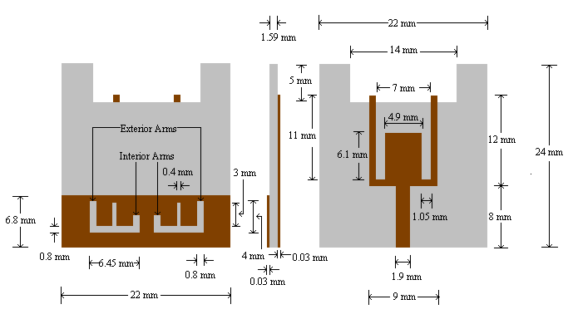

(a) (b) (c)

**Figure 1:** Geometry of Proposed Antenna: (a) rear side showing symmetrical W-shaped (with middle and exterior arms extending longer than the remaining interior arms) slots on ground; (b) side view; (c) front side showing microstrip-fed rectangular slotted radiation patch.

It should also be noted that higher bandwidth can also be achieved by increasing the height of the substrate but due to this undesirable surface waves are generated because for direct radiation (surface waves) it extracts some power from the total available power. These surface waves are scattered at the surface discontinuities and bends while travelling within the substrate, like edges of the ground plane and the dielectric. This results in the degradation of the radiation pattern and the polarization characteristics of the antenna. While maintaining large impedance bandwidth, surface waves can easily be removed by using the cavities. This is why slotted microstrip patch antennas came into existance.

III. RESULTS AND DISCUSSION

In this section, predicted results of a novel compact slotted microstrip patch dual-band antenna with rectangular slotted substrate and symmetrical W-shaped (with middle and exterior arms extending longer than the remaining interior arms) slotted ground having band-notched characteristics is presented. Figure 2 shows the return loss v/s frequency curve for the proposed antenna. The range of frequency falling below -10db is from 4.43 GHz to 5.02 GHz and from 5.89 GHz to 9.00 GHz. Due to this dual-band, a bandwidth of around 3.7 GHz is achieved at two central frequencies of 4.73 GHz and 7.45 GHz.

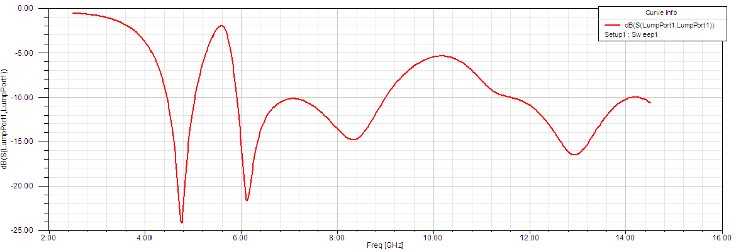

**Figure 2:** Return Loss v/s Frequency Curve of Proposed Antenna.

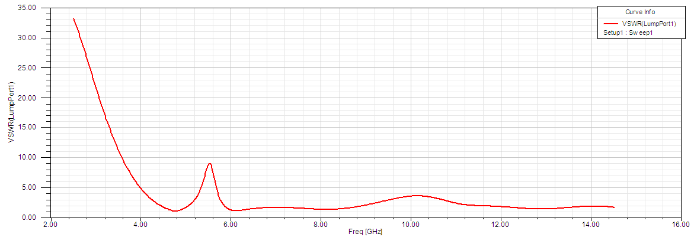

**Figure 3:** VSWR v/s Frequency Curve of Proposed Antenna.

Figure 3 shows the VSWR v/s frequency curve of the proposed antenna. The VSWR falls below 2 for the proposed antenna under the desired band.

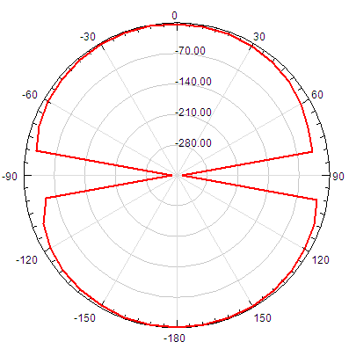

**(a)**

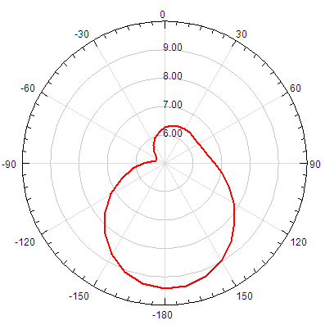

**(b)**

**Figure 4:** Radiation Pattern of the Proposed Antenna (a) E-Plane (b) H-Plane

Figure 4 shows the E-Plane and H-Plane Radiation Pattern of the proposed antenna. It indicates that the presented antenna has the required omni-directional radiation pattern.

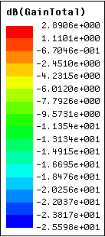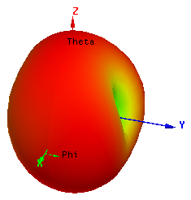

**Figure 5:** 3D Polar Plot of Proposed Antenna.

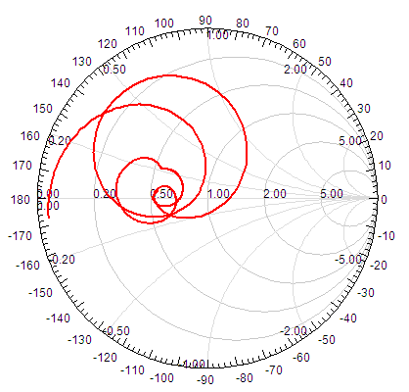

**Figure 6:** Smith Chart showing Input Impedance Loci of the Proposed Antenna

Figure 5 and Figure 6 shows the radiation pattern and the input impedance using smith chart of the proposed antenna respectively. We can see in Figure 5 that a gain of as high as 2.9 dB (shown by red colour) and as low as -2.56 dB (shown by blue colour) is achieved. Also, we can notice from Figure 6 that the proposed antenna has good impedance matching characteristics.

IV. CONCLUSIONS

In this paper, a novel compact slotted microstrip patch dual-band antenna with rectangular slotted substrate and symmetrical W-shaped (with middle and exterior arms extending longer than the remaining interior arms) slotted ground having band-notched characteristics has been designed and its results are presented and analysed. The reflection coefficient of the antenna is less than -10 dB over the impedance bandwidth of 3.7 GHz from 4.43 GHz to 5.02 GHz and from 5.89 GHz to 9.00 GHz forming a dual-band. The band notching characteristic in the frequency band of 5 GHz to 6 GHz WLAN (Wireless Local Area Network) is achieved by varying the length of the rectangular patch of 6.1 mm x 4.9 mm dimension which was embedded on the substrate. Due to this band notching characteristic, interference with the already existing licensed WLAN (Wireless Local Area Network) is avoided and hence the efficiency of the antenna is increased.

REFERENCES

[1] FCC, First report and order, revision of part 15 of the commission's rules regarding ultra-wideband transmission systems, FCC02-48, April 2002.

[2] Zhao, Y., J. Xu, and K. Yin, “A minature coplanar waveguide- fed ultra-wideband antenna," Microwave and Millimeter Wave Technology, ICMMT 2008, 2008.

[3] Zhang, J.-P., Y.-S. Xu, and W.-D. Wang, “Microstrip-fed semi- elliptical dipole antennas for ultrawideband communications," IEEE Trans. Antennas Propag., Vol. 56, 241-244, 2008.

[4] Abbosh, A. and M. Bialkowski, “Design of ultra wideband planar monopole antennas of circular and elliptical shape," IEEE Trans. Antennas Propag., Vol. 56, 17-23, 2008.

[5] Ahmed, O. and A. Sebak, “A printed monopole antenna with two steps and a circular slot for UWB applications," IEEE Antennas Wireless Propag. Lett., Vol. 7, 411-413, 2008.

[6] Hsu, C.-H., “Planar multilateral disc monopole antenna for UWB application," Microwave Opt. Technol. Lett., Vol. 49, 1101-1103, 2007.

[7] Liang, J., C. C. Chiau, X. Chen, and C. G. Parini, “Study of a printed circular disc monopole antenna for UWB systems," IEEE Trans. Antennas Propag., Vol. 53, 3500-3504, 2005.

[8] Zhao, Y.-L., Y.-C. Jiao, G. Zhao, L. Zhang, Y. Song, and Z. B. Wong, “Compact planar monopole UWB antenna with band- notched characteristic," Microwave Opt. Technol. Lett., Vol. 50, 2656-2658, 2008.

[9] Huang, C.-Y., S. A. Huang, and C.-F. Yang, “Band-notched ultra- wideband circular slot antenna with inverted C-shaped parasitic strip," Electron. Lett., Vol. 44, 891-892, 2008.

[10] Hong, C.-Y., C.-W. Ling, I.-Y. Tarn, and S.-J. Chung, “Design of a planar ultrawideband antenna with a new band-notch structure," IEEE Trans. Antennas Propag., Vol. 55, 3391-3397, 2007.

[11] Naghshvarian-Jahromi, M., “Compact UWB bandnotch antenna with transmission-linefed," Progress In Electromagnetics Research B, Vol. 3, 283-293, 2008.