**A Novel Compact Slotted Microstrip Patch Dual-band Antenna With Rectangular Slotted Substrate And Symmetrical W-Shaped Slotted Ground Having Band-Notching Characteristics For UWB Application**

**Somesh Sharma**

Department of Electronics & Communication Engineering

Kautilya Institute of Technology & Engineering and School of Management, Jaipur, India

**Email Id:** somesh.sharma2006@gmail.com

***Abstract -- In the following paper, an unusual compressed slotted microstrip patch dual band antenna with rectangular slotted substrate and symmetrical W-shaped (with middle and exterior arms extending longer than the remaining interior arms) slotted ground having band-notched characteristics is presented. The slotted patch is embedded on FR4-epoxy substrate having relative permittivity of 4.4. For increasing the impedance bandwidth, W-shaped (with middle and exterior arms extending longer than the remaining interior arms) notched ground and a rectangular slotted substrate are introduced. The impedance bandwidth, VSWR, radiation pattern, antenna gain and Smith chart are monitored for the projected antenna. The outcomes show good characteristic performance for Ultra-Wideband and the Voltage Standing Wave Ratio necessity of less than 2 is satisfied over the frequency range from 4.43 Gigahertz (GHz) to 5.02 Gigahertz (GHz) and from 5.89 Gigahertz (GHz) to 9.00 Gigahertz (GHz). Due to this, a bandwidth of 3.7 Gigahertz (GHz) is achieved at two central frequencies of 4.73 Gigahertz (GHz) and 7.45 Gigahertz (GHz). The calculated radiation patterns demonstrate decent omni-directional presentation and antenna gains across the operational bandwidth.***

***Keywords -- Slotted Microstrip Patch Antenna, Impedance Bandwidth, VSWR, Radiation Pattern, Antenna Gain and Smith chart.***

NOMENCLATURE

UWB – Ultra Wide Band  
FR – Flame Retardant  
VSWR – Voltage Standing Wave Ratio  
GHz – Gigahertz  
NB – Narrow Band  
E-Plane – Electric plane  
H-Plane – Magnetic Plane  
3D – Three Dimensional  
dB – Decibels  
WLAN – Wireless Local Area Network

I. INTRODUCTION

In the current years, since United States Federal Communication Commission brought its report in front of the world in the year 2002 [1], Ultra-Wideband antennas being a division of Ultra-Wideband systems have drawn an enormous interest of the researchers and engineers for utilizing Ultra-Wideband frequency for commercial applications. A wide impedance bandwidth of 7.5 Gigahertz (GHz) ranging from 3.1 Gigahertz (GHz) to 10.6 Gigahertz (GHz), stable gain, omni-directional radiation patterns and small size antenna is required for this purpose. For Ultra-Wideband applications, a variety of planar Ultra-Wideband antennas have been built up [2-10]. However, it should also be noted that there are various licensed Narrow-Band (NB) communication means working below 10 Gigahertz (GHz) range that may result in hindrance with the Ultra-Wideband systems like Wireless Local Area Network that operate within 5.15 Gigahertz (GHz) to 5.825 Gigahertz (GHz) frequency range. In order to stay away from this intervention, band-notching characteristics have been developed in Ultra-Wideband antennas [8-11]. Few of the methods are based on printing a very narrow opening on the patch, like ¼-shaped opening [8], or utilizing parasitically coupled stripes, like upturned C-formed parasitic stripe [9]. Some additional methods are based on printing a stub within an opening in the patch [10], or utilizing a slotted Defected Ground Structure within the ground level like H-formed slotted Defected Ground Structure [11].

In my paper, I am presenting an unusual compact slotted microstrip patch dual-band antenna with rectangular slotted substrate and symmetrical W-shaped (with middle and exterior arms extending longer than the remaining interior arms) slotted ground having band notching characteristics.The proposed antenna comprised of a rectangular patch on which, first of all, a rectangular slot of 11 mm x 7 mm is cut and then a rectangular patch of 6.1 mm x 4.9 mm is fabricated. Thereafter, a rectangular slot of 5 mm x 14 mm is cut on the substrate. This is then supplied by a microstrip feed line. The ground plane consists of two symmetrical W-shaped (with middle and exterior arms extending longer than the remaining interior arms) slots. The outcomes show that a bandwidth of 3.7 Gigahertz (GHz) from 4.43 Gigahertz (GHz) to 5.02 Gigahertz (GHz) and from 5.89 Gigahertz (GHz) to 9.00 Gigahertz (GHz) isattained by the proposed antenna with reflection coefficient of less than -10 dB. The band-notch operation is acquired by implanting a rectangular patch of 6.1 mm x 4.9 mm on the substrate. The desired band-notching resonance frequency and the impedance bandwidth can easily be achieved by altering the size of the patch and the openings.

II. ANTENNA DESIGN

The geometry of a novel compact slotted microstrip patch dual-band antenna with rectangular slotted substrate and symmetrical W-shaped (with middle and exterior arms extending longer than the remaining interior arms) slotted ground having band-notched characteristic is presented in Fig. 1. The projected antenna is embossed on the glass epoxy FR-4 dielectric substrate of 24 mm x 22 mm dimension with thickness of the substrate ‘Tsub’ = 1.59 mm, relative permittivity of εr = 4.4 and loss tangent of tan δ = 0.02. First of all, a rectangular patch of 12 mm x 9 mm dimension is embossed on the top of the dielectric substrate. Then an opening of 11 mm x 7 mm is cut into the patch leaving two edges of 1 mm thickness each. Due to this, the shape of the patch starts looking like “U”. Thereafter, a rectangular patch of 6.1 mm x 4.9 mm is fabricated on the substrate. In order to feed the slotted patch, a rectangular feed line of 8 mm x 1.9 mm dimension isembossed over the same surface of the substrate. The bandwidth is increased by cutting two symmetrical W-shaped (with middle and exterior arms extending longer than the remaining interior arms) openings on the ground level. The operational bandwidth is further increased by cutting rectangular slot of 5 mm x 14 mm on the substrate. Due to this, an overall bandwidth of 3.7 Gigahertz (GHz) is achieved. The performance of this structure can be varied by varying the size of the rectangular patch and the openings that have been sliced on the substrate and the ground level.

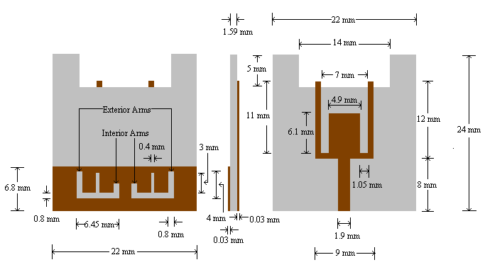

(a) (b) (c)

**Fig. 1.** Architecture of Projected Antenna: (a) rear surface showing symmetrical W-shaped (with middle and exterior arms extending longer than the remaining interior arms) slots on ground; (b) side view; (c) front side showing microstrip-fed rectangular slotted radiation patch.

It should also be noted that higher bandwidth can also be attained by rising the substrate’s height but due to this undesirable surface waves are generated because for direct radiation (surface waves) it extracts some power from the total available power. These surface waves are scattered at the surface discontinuities and bends while travelling within the substrate, like edges of the ground level and dielectric. This outcomes in the degradation of the radiation pattern and the polarization characteristics of the antenna. While maintaining large impedance bandwidth, surface waves can easily be removed by using the cavities. This is why slotted microstrip patch antennas came into existance.

III. RESULTS AND DISCUSSIONS

Here, calculated consequences of an unusual compact slotted microstrip patch dual-band antenna with rectangular slotted substrate and symmetrical W-shaped (with middle and exterior arms extending longer than the remaining interior arms) slotted ground having band-notched characteristics is presented. Fig. 2 presents the return loss v/s frequency curve of the projected antenna. The range of frequency falling below -10db is from 4.43 Gigahertz (GHz) to 5.02 Gigahertz (GHz) and from 5.89 Gigahertz (GHz) to 9.00 Gigahertz (GHz). Due to this dual-band, a bandwidth of around 3.7 GHz is achieved at two central frequencies of 4.73 Gigahertz (GHz) and 7.45 Gigahertz (GHz).

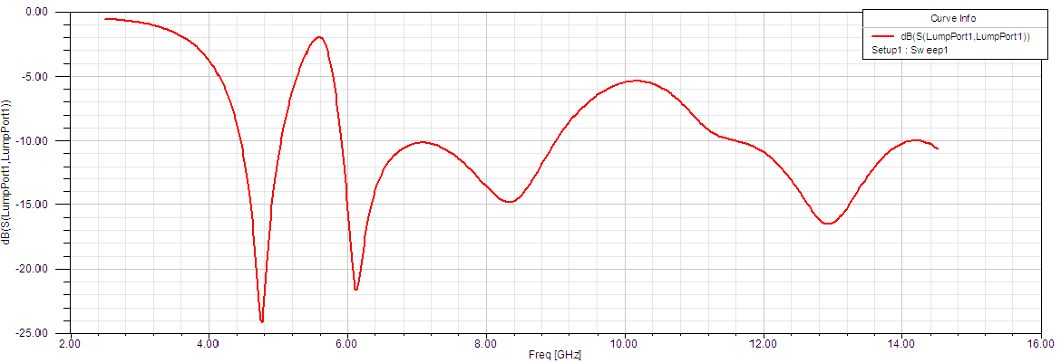

**Fig. 2.** Return Loss v/s Frequency Curvature of Projected Antenna.

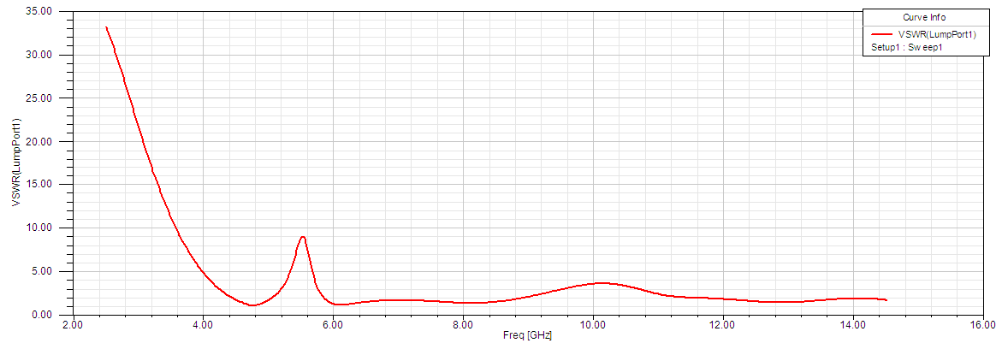

**Fig. 3.** VSWR v/s Frequency Curvature of Projected Antenna.

Fig. 3 shows the VSWR v/s frequency curvature of the projected antenna. The VSWR falls below 2 for the projected antenna under the desired range of frequency.

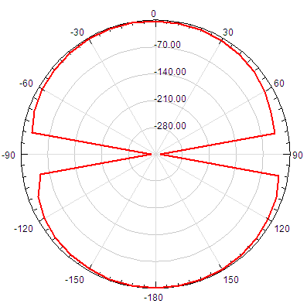

**(a)**

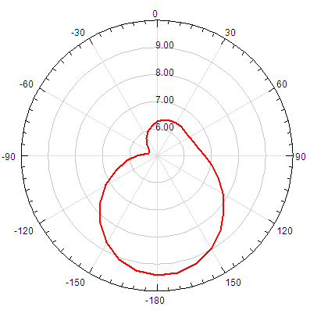

**(b)**

**Fig. 4.** Radiation Pattern of the Projected Antenna (a) E-Plane (b) H-Plane.

Fig. 4 presents the E-Plane & H-Plane Radiation Pattern of the projected antenna. It indicates that the presented antenna possess the required omni-directional radiation pattern.

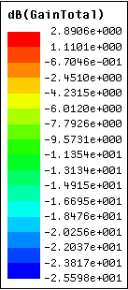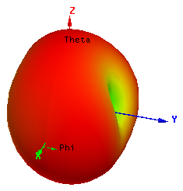

**Fig. 5.** 3D Polar Plot of Projected Antenna.

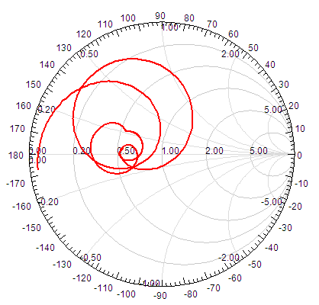

**Fig. 6.** Smith Chart showing Input Impedance Loci of the Projected Antenna.

Fig. 5 and Fig. 6 demonstrates the radiation pattern and the input impedance using smith chart of the projected antenna respectively. We can see in Fig. 5 that a gain of as high as 2.9 dB (shown by red colour) and as low as -2.56 dB (shown by blue colour) is achieved. Also, we can notice from Fig. 6 that the projected antenna possess good quality impedance matching characteristics.

IV. CONCLUSIONS

In the following paper, an unusual compressed slotted microstrip patch dual-band antenna with rectangular slotted substrate and symmetrical W-shaped (with middle and exterior arms extending longer than the remaining interior arms) slotted ground having band-notched characteristics has been designed and its results are presented and analysed. The reflection coefficient of the antenna is less than -10 dB over the impedance bandwidth of 3.7 Gigahertz (GHz) from 4.43 Gigahertz (GHz) to 5.02 Gigahertz (GHz) and from 5.89 Gigahertz (GHz) to 9.00 Gigahertz (GHz) forming a dual-band. The band notching characteristic is achieved by altering the length of the rectangular patch of 6.1 mm x 4.9 mm dimension which was embedded on the substrate. Due to this band notching characteristic, interference with the already existing licensed WLAN (Wireless Local Area Network) is avoided and hence the efficiency of the antenna is increased.

REFERENCES

[1] FCC, First report and order, revision of part 15 of the commission's rules regarding ultra-wideband transmission systems, FCC02-48, April 2002.

[2] Zhao, Y., J. Xu, and K. Yin, “A minature coplanar waveguide- fed ultra-wideband antenna," Microwave and Millimeter Wave Technology, ICMMT 2008, 2008.

[3] Zhang, J.-P., Y.-S. Xu, and W.-D. Wang, “Microstrip-fed semi- elliptical dipole antennas for ultrawideband communications," IEEE Trans. Antennas Propag., Vol. 56, 241-244, 2008.

[4] Abbosh, A. and M. Bialkowski, “Design of ultra wideband planar monopole antennas of circular and elliptical shape," IEEE Trans. Antennas Propag., Vol. 56, 17-23, 2008.

[5] Ahmed, O. and A. Sebak, “A printed monopole antenna with two steps and a circular slot for UWB applications," IEEE Antennas Wireless Propag. Lett., Vol. 7, 411-413, 2008.

[6] Hsu, C.-H., “Planar multilateral disc monopole antenna for UWB application," Microwave Opt. Technol. Lett., Vol. 49, 1101-1103, 2007.

[7] Liang, J., C. C. Chiau, X. Chen, and C. G. Parini, “Study of a printed circular disc monopole antenna for UWB systems," IEEE Trans. Antennas Propag., Vol. 53, 3500-3504, 2005.

[8] Zhao, Y. L., Y. C. Jiao, G. Zhao, L. Zhang, Y. Song, and Z. B. Wong, “Compact planar monopole UWB antenna with band- notched characteristic," Microwave Opt. Technol. Lett., Vol. 50, 2656-2658, 2008.

[9] Huang, C.-Y., S. A. Huang, and C.-F. Yang, “Band-notched ultra- wideband circular slot antenna with inverted C-shaped parasitic strip," Electron. Lett., Vol. 44, 891-892, 2008.

[10] Hong, C.-Y., C.-W. Ling, I.-Y. Tarn, and S.-J. Chung, “Design of a planar ultrawideband antenna with a new band-notch structure," IEEE Trans. Antennas Propag., Vol. 55, 3391-3397, 2007.

[11] Naghshvarian-Jahromi, M., “Compact UWB bandnotch antenna with transmission-linefed," Progress In Electromagnetics Research B, Vol. 3, 283-293, 2008.