**Ubiquitous System For Institute Mangement Via**

**Mobile Based Interactive Communication**

Harshada Gangurde*, Pallavi Pote*

# Department of Information Technology, Sandip Institute of Technology and Research centre  
Mahiravani, Trimbak Road, Nashik-422213, Maharashtra, India

Email: [info@sitrc.org](mailto:info@sitrc.org) Website: www.sandipfoundation.org

Savitribai Phule Pune University

www.unipune.ac.in

Abstract— **Institute management system is a Mobile application which helps the user to know the detail information about the Institute that includes many modules Admission process, Hostel admission process, Transport, Campus map, Events, department.Though a Institute management software is actually custom based, as it is developed for meeting the requirements of a particular Institute but we have created the project as a global one which can satisfy the needs of all Institute systems.The purpose of this application is for student and Institute benefits**. **Features included in our software are Platform Independent: As our software is coded in java so it is platform independent i.e. it can work on any operating system whether it be any version of Microsoft or Ubuntu. Reduced Data Redundancy: Easy to search the document related to particular student or staff .It will also give the detailed information about the technical and non-technical events held in college. It also gives the information of Institute campus to unknown persons with map navigation so they can easily locate the place where they want to visit.We are going to provide security to his mobile application by using Advanced Encryption Standard(AES) algorithm.**

Keywords— Mobile application, tracking system, GPS,AES.

I. INTRODUCTION

Institute management system is the Mobile application which is use by students, staff or any other third person to manage all the tasks related to the Institute goals,Institute faculty, employees and also reducing time for searching of appropriate location in Institute premises. In admission process any new user or the existing one can easily take the admission by sitting at their own place and no need to go anywhere just by downloading the mobile application.This application also contains all the information about the online admission process for reducing student worries and safety of the information of the student. The purpose of this application is for student and Institute benefits. This application also contains all the information about the online admission process for reducing student worries and safety of the information of the student. In hostel admission process the student who have taken the admission in institute have the right to take admission in hostel and this module will also help to show the hostel details.This mobile application provides the detailed structure about the Institute campus and it’s all the departments.In the transport module student who are using the transport facility having their respective user name and password can easily login using GPS. And this module will show details about the student route that includes till where the bus has reached how much time it requires to reach the particular stop from where the user has requested. In this application, we are going to use the GPS TRACKER for bus navigation in transportation module. Also, we can save time using the GPS tracker. The Map module will show the particular path from where to where the new user has requested in institute premise only. Event module includes technical as well as non-technical events which were held in previous years as well as which are going to held in the upcoming year. Department module consist of department information Hod and staff of the department, toppers and the placed students of the various department.It synchronizes the working of all the departments. It looks on all the aspects of our college, its students, faculty members, departments, academic marks and other extra-curricular activities.

The number of students are increasing day by day so the management must have to handle all records of all the students, because of this management faces problems to maintain all the records of the students. So we are going to develop an Mobile application for Institute management system and processing with admission process, transportation, map navigation, hostel, event, canteen and departmental information using smartphone. We are going to use this application for ease of access. Our application working is based on Android .Mobile consist of many activities. It also includes services, information providers, and receivers. Each & Every component performs various role in the application each can performs its own role individually. Non-coded resources like images, files and many more should also have many alternatives for configuration of the device like strings of different-different languages. Due to the rapid growth in the technology life of the people has become more comfortable and advanced. But this is for only those who are using the applications. The Global Positioning System(GPS) is a space-based navigation system. It provides exact location and time information in all weather conditions. It can be used anywhere everywhere on the earth there is no obstructed line to GPS satellites. The important point is that this concept is based on *time*. GPS satellites gives their current time and position. A GPS receiver monitors multiple satellites and solves equations to determine the exact position of the receiver. At a minimum, four satellites must be in focus of the receiver for it to compute three dimensional location i.e. longitude, latitude and altitude. GPS has network of 24 satellites and that is located in the orbit. Global Positioning System works in any weather conditions in the world.

II. REVIEW OF LITERATURE

To receives and transfer signals through GPS satellite there is a equipped software unit & Automatic Vehicle Location (AVL) is advanced method used to track and monitor any remote vehicle. There are two types of AVL system that are GPS based and Signpost based. The signpost based system was used in earlier days. But with increasing development in modern satellites GPS based system is used for tracking devices. GPS satellites transmit signals to equipment which is to be tracked on ground. The vehicle have GPS receivers which passively receive satellite signals which do not transmit. The accuracy to find the position of vehicle with the GPS device is depends on the type of receiver which is used. Most of the GPS devices have accuracy about 10-20 meter [1].

There is a tracking device mounted on a vehicle to obtain GPS data of the vehicle locations, after that the data will transfer to one centralized control unit and provide information by activating LEDs in the appropriate geographic positions of the vehicle on the route map [2].

The vehicle with tracking system provide the information about location and route followed by it & that can be observed from any location. The vehicle can also be tracked in any weather circumstances using GPS and GSM technologies. The system described in this paper include hardware specification like GPS, GSM, Atmega microcontroller MAX 232,16x2 LCD and software part used for connecting all the required modules & main application is developed at client end. The system provide a platform for further development and should be easily installed which is microcontroller based that also include GPS, GSM which provide two way communication using GSM modem.GM862 cellular quad band is used for main implementation[3].

This system provides online comprehensive solution to provide information regarding various Universities, their courses and admission procedures for admission seekers in courses or Programs. The aim of Web Based Admission System is to computerize University admission process for higher education courses. Some of the factors that are identified to protect the software from accidental or malicious access, use, modification, destruction, or disclosure are described below. Specific requirements in this area could include the need to: Utilize certain cryptographic techniques, Keep specific log or history data sets, Assign certain functions to different modules, Restrict communications between some areas of the program, Check data integrity for critical variables [4]

Mobile is an open source mobile OS based on Linux with Java. It is free for use. According to report of 2014, 900 million people uses Mobile & 76.66% smart phones have Mobile as their OS. In existing scenario, in Institutecampus the all required information about the working and schedule is in the form of notice, Manual which are hand written, verbal notice is given to the students. Therefore using Mobile devices this process can be spread to students, teachers directly on their Mobile phones. Also the maintenance of application in future will be easier because of MVC which separates provides difference between major part of application like database management mobile UI and web service which controls for fast and efficient maintenance of application[9].

Like any other system hostel management is also become a very tedious task in this paper they developed a application which provides a easy access for hostel management. The proposed application is like a social networking site. The application is developed with Mobile technology. This system provides a platform for hostelites to share their problems, ideas about development and also get updates of hostel activities with matron. Because it is Mobile application it reduces work load of user as it can be used through their smartphones having Mobile OS [11].

A GPS-based vehicle tracking system will inform where your vehicle is and where it has been, how long it has been. The system is developed using geographic positon and time information which is obtained from GPS Satellites. There are basically two important module which are 1. On-Board Module which is mounted in vehicle which is going to be tracked. It consist of GPS receiver, GSM modem. 2. Base Station which monitors data from the vehicles [13].

III.PROPOSED SYSTEM

This mobile application will help the Institute admin to browse the contents efficiently and easily. Student and any unknown user will get information of all facilities in their pocket smart phones. It is to serve as a decision document . It is economically feasible to use, it will only require a single operator to operate the application, who is responsible for entering the data into the database via a user interface provided to him, who can also able to show all the information regarding the students who are either taken admission or to take admission, since it requires only a single person to operate the whole system thus reduces the cost to operate the system.

Figure: System Architecture of Application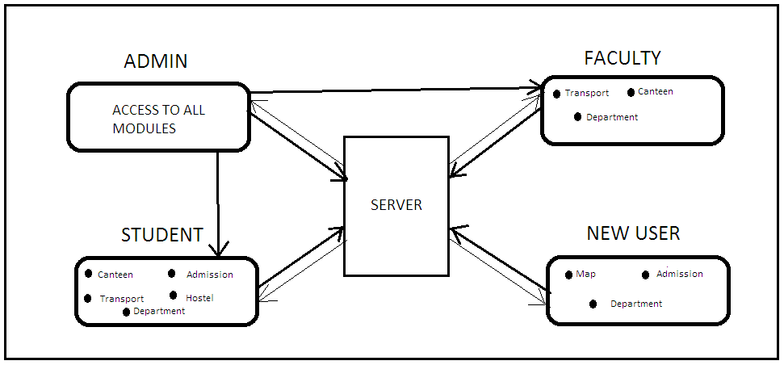

It is technically feasible, since the whole system is designed into the latest technologies like PHP and MYSQL and android which are the most recent technologies to develop web based application and design databases. We are going to developed new system, which is most reliable and time saving system. It is easy to handle fast and convenient. It also replaces manually process and accessibility of information.

Student using the Institute facility can easily take admission by sitting at their own place, no need to go anywhere just by downloading the Sandip Mobile application. Students who are standing on their respective bus stop can easily come to know where the bus have reached and how much time it will take to arrive that respective bus stop. The new user will get information about the Institute campus using map. Also students will get updates about the technical & non-technical events.

V. CONCLUSION

This article going to cover detailed about Institute admission process, hostel admission process, transport, bus navigation, canteen, events, department, and campus map. And this all process will be done online by sitting at home we are able to do online admission of Institute and hostel and can get detail about the department’sstaff and HOD. In transport we will get the detail about which bus passes through which route and the arrival time of the bus. In campus map navigation we are able to see the location of department and it will be helpful for the unknown person.

VI.REFERENCES

[1] Devyani Bajaj, Neelesh Gupta, “GPS Based Automatic Vehicle Tracking Using RFID”, ISSN: 2277-3754 International Journal of Engineering and Innovative Technology (IJEIT) .

[2] Jitesh Deshpande, Saylee Gharge, “Real Time Bus Monitoring And Passenger System”, International Journal of Soft Computing and Engineering (IJSCE) ISSN: 2231-2307, Volume-1, Issue-, January 2012

[3] Pankaj Verma , J.S Bhatia, , “Design and Developement of GPS-GSM based Tracking System With Google Map Based Monitoring”, International Journal of Computer Science, Engineering and Applications (IJCSEA) Vol.3, No.3, June 2013

[4]Rajnish Kumar, Pritam Desale, Chetan Puri, “Web Based Admission System”, International Journal of Emerging Technology and Advanced Engineering, ISSN 2250-2459, ISO 9001:2008 Certified Journal, Volume 3, Issue 7, July 2013.

[5]Mr. Nilesh Manganakar , Mr. Nikhil Pawar , Mr. Prathamesh Pulaskar, “Real Time Tracking of Complete Transport System Using GPS”.

[6]Mahadevaiah K G , Sujay Sajjan T , Abhishek V , Rakshith P R , Ashish N Koushik, “Mobile Based Remote Vehicle Dis-Engaging System” R V Instituteof Engineering, Bangalore-560059, Karnataka, India

[7] M.Abinaya, R.Uthira Devi, “Intelligent Vehicle Control Using Wireless Embedded System in Transportation System Based On GSM and GPS Technology”. International Journal of Computer Science and Mobile Computing ISSN 2320–088X.

[8]S.Sahitya, N.Swetha, “Real Time Vehicle Tracking System Using GPS and GPRS", International Journal of Research in Computer and ISSN Communication Technology Online 2278- 5841 .

[9]Ankit Bansal, Ajit Rana, Akhil Bansod, Prafulla Baviskar, “Mobile Based Campus Information Retrieval Mobile Application", International Journal of Computer Science and Mobile Computing ISSN 2320–088X .

[10]Mr. Pawale S. R, Mr M. M. Bokare , Dr. V. M. Thakare , Dr. Mrs. Sadhana Chidrawar, “Low Cost SMS based Vehicle Tracking System using Mobile”, International Journal of Application or Innovation in Engineering & Management (IJAIEM) ISSN 2319 – 4847 .

[11]Vaishnavi Kandalkar, Snehal Mehetre, Vijeta Shetty, Sampada Raut, Prof. Sheetal barekar, “Mobile Application for Hostel Management System”, JSART - Volume 1 Issue 5 –MAY 2015 ISSN [ONLINE]: 2395-1052 .

[12]Leon Stenneth, Ouri Wolfson, Philip S. Yu, Bo Xu, “Transportation Mode Detection using Mobile Phones and GIS Information”.

[13]Baburao Kodavati , V.K.Raju, 3 S.Srinivasa Rao, A.V.Prabu, T.Appa Rao, Dr.Y.V.Narayana, “GSM And GPS Based Vehicle Location And Tracking System” , International Journal of Engineering Research and Applications (IJERA) ISSN: 2248-9622 .