***Performance Analysis of Shunt Active Filter under different loading and Distorted Voltage condition***

*Mr. Vishal Patil*

*Dept. of Electrical Engineering*

*Annasaheb Dange College of Engineering & Technology, Ashta*

*tanavadesatish@rediffmail.com*

*Mr. Parikshit Jamdade*

*Dept. of Electrical Engineering*

*PVG’s College of Engineering & Technology, Pune, India*

*parikshit.jamdade@yahoo.com*

*Mr. Santosh Patil*

*Dept. of Electrical Engineering*

*Annasaheb Dange College of Engineering & Technology, Ashta, Sangli, India*

*santoshpatileps@gmail.com*

***Abstract*: *In this paper, a comparison of two control algorithms to calculate the reference current generation for shunt active power filter has been presented. The two algorithms studied are Instantaneous reactive power theory and synchronous reference frame theory. The analysis of these two theories are done on the basis of balanced, unbalance, and dynamics loading conditions as well as distorted source voltage condition. The performance of this active filter is evaluated and compared using MATLAB/ Simulink ®.***

***Keywords- Shunt active power filter, Calculation of reference current, p-q theory, d-q theory.***

1. INTRODUCTION

Nowadays, in distribution system power quality issues are proliferating due to the greater use of non linear loads in all the sectors. The harmonic current limits set by the IEEE 519 for non linear loads at the point of common coupling are 5% [1]. The non linear load draws non sinusoidal current from the source as its requirement that disturbs the other loads connected to the same system. Different control strategies are used to resolve the power quality problems. The harmonics analysis is mainly divided into time domain and frequency domain. In frequency domain method, FFT, DFT, wavelet transform WT are implemented to extract compensating current. But time domain analysis is simpler and having fast response. The time domain control strategies for active power filter use instantaneous reactive power theory and/or synchronous reference frame theory. The compensating current is injected into utility through PWM controlled voltage source converter and makes the source current sinusoidal.

Many efforts have been taken to develop active power filters and conditioners that can soften the power quality problems [2-3]. One of the cornerstones of the active filter is its control strategy that is implemented in its controller. The performance of an active filter depends mainly upon the selected reference generation scheme.

Fig. 1. Principle of shunt active Power filter

Fig. 1 shows schematic for shunt active power filter. The control strategy for a shunt active power filter generates the reference current, that must be provided by the power filter to compensate reactive power and harmonic currents demanded by the load. This involves a set of currents in the phase domain, which will be tracked generating the switching signals applied to the electronic converter by means of the appropriate closed-loop switching control technique such as hysteresis or deadbeat control. Several methods including instantaneous real and reactive power (p-q) theory and Synchronous Reference Frame (d-q) method have been proposed for extracting the harmonic content [4-7]. All these methods are simulated and compare under balanced loading, unbalance loading, dynamic loading and distorted source voltage conditions using MATLAB/SIMULINK.

1. REFERENCE CURRENT GENERATION

In this paper, two techniques of reference current generation have been evaluated. Instantaneous reactive power theory (p-q) that instantaneously calculates the active and reactive power of the system using Clerk’s transformation and accordingly compensating current is injected or absorbed into the system. However, in synchronous reference frame theory (d-q theory), Park’s transformation is used to generate the reference current. The harmonics can be extracted by subtracting the reference current from load current.

1. *Instantaneous Reactive Power (p-q) Theory*

Three phase source voltage and load currents are transformed into Clerk’s components (α-β-0). Instantaneous real & reactive powers (p & q) are calculated in α-β frame of reference. These powers contain non-oscillating and oscillating components. These components are then processed for generating reference currents for compensation of reactive power and oscillatory component of instantaneous active power. To compensate the oscillating component of instantaneous active power, a low pass filter (LPF) is used and reactive power is compensated by equating it to zero (q=0). The hysteresis current controller receives these reference currents and generates switching signals for the voltage source inverter to generate compensating currents.

 Fig. 2. Generation of the reference current method using p-q theory

Fig.2. shows the block diagram for Instantaneous Reactive Powerscheme. To regulate the dc input capacitor voltage fed to VSI, a PI regulator is used. The error between reference dc capacitor voltage and actual capacitor voltage is fed to the PI regulator. Output of PI controller, which accounts for loss component [8], is added with averaged real power in α-β reference frame for maintaining dc capacitor voltage at its reference value.

1. *Synchronous Reference Frame (d-q) Theory*

Fig. 3 shows reference current generation using d-q theory. In d-q theory, three phase load currents are transformed into their d-q-0 equivalent components using Park’s transformation as shown in Eq. 1. A d-q reference frame rotates synchronously with d-axis coinciding with direction of ‘a’ phase.

 Fig. 3. Generation of the reference current method using d-q theory

A phase locked loop (PLL) processes three phase source voltages Va, Vb, Vc, to generate sin & cos required for a-b-c to d-q-0 transformation. With the help of PLL, this active filter gives better performance even in the case where the three phase voltage is not ideal.

(1)

where, θ is the angular position of the synchronous reference frame. The currents in the synchronous reference can be decomposed into two terms as:

(2)

These d-q-0 components of currents are processed to generates reference currents (i*a, i*b, i*c) to compensate for iq and oscillating component of id. A LPF is used for eliminating oscillating component of id. ilq is equated to zero to compensate the reactive component. The active power filter reference currents will be then:

(3)

In order to find the currents in three phase system, the inverse Park transform can be used as given in Eq. 4.

(4)

1. *SIMULATION RESULTS*

For comparative analysis of p-q & d-q methods, simulations are carried out using MATLAB/SIMULINK. A diode bridge rectifier is used as non linear load on the system. Performance of the two methods is compared under balanced loading condition, unbalanced loading condition, dynamic loading condition and distorted source voltage condition. The system parameters are Vs = 415 volt, 50 Hz, with three phase diode bridge rectifier with R= 25Ω, L= 5mH. Balanced load is applied to the system at t=0. Unbalance in the system is created at t=0.3S by connecting unbalanced load parallel to existing balanced load. The same is removed at t=0.5S. At t=0.7S, the load is dynamically changed & the original loading condition is restored at t= 1S. Fig. 5(a) shows the results of simulation for the p-q and results for d-q control strategies are shown in Fig. 5(b).

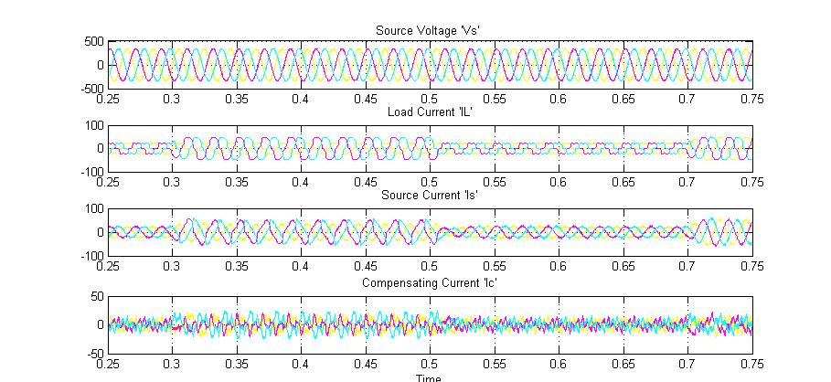

(a)

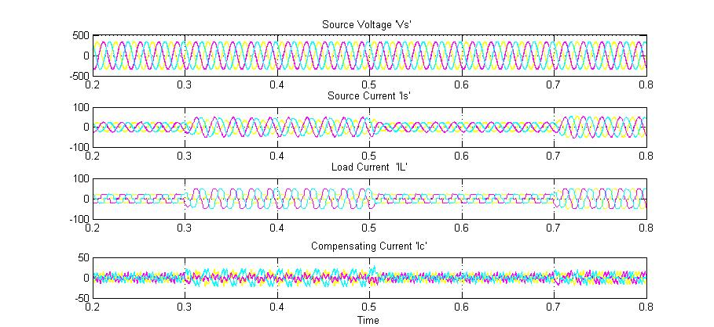

(b)

Fig. 5. Simulation results for shunt active filter under balanced, unbalanced and dynamic loading conditions (a) using p-q theory for reference current generation (b) using p-q theory for reference current generation.

It can be seen from these results that performance of filter using p-q theory under distorted source voltage condition as well as unbalanced loading condition is inferior to that using d-q theory. The main reason for this is use of voltage signals for computation of instantaneous active & reactive power components under p-q theory. Although, use of low pass filter (LPF) introduces a delay in response in both schemes, an additional delay is observed in d-q scheme due to tuning of phase lock loop (PLL). However generation of sinθ and cosθ is crucial in determination of reference currents. Harmonic analysis is also carried out under balanced, unbalanced, and distorted source voltage condition for both control algorithms. Results for the same are shown in Fig. 6 and Fig. 7 for filter using p-q theory and that using d-q theory respectively. Under balanced loading condition total harmonic distortion (THD) using p-q and d-q theories is found to be 3.88% and 3.53% respectively. This adheres to IEEE 519 standards. Under unbalanced loading condition these values found to be 5.05% and 4.78% for p-q and d-q theories. To create distorted source voltage condition 5th order harmonic signal is superimposed on the source. Under this condition THD under p-q theory increases to 30.23% while that under d-q theory is 4.48%. Thus, it can be seen that the performance of filter using d-q theory is superior under all operating conditions. The THD is maintained within permissible limits under all operating conditions as shown in Fig. 6-7.

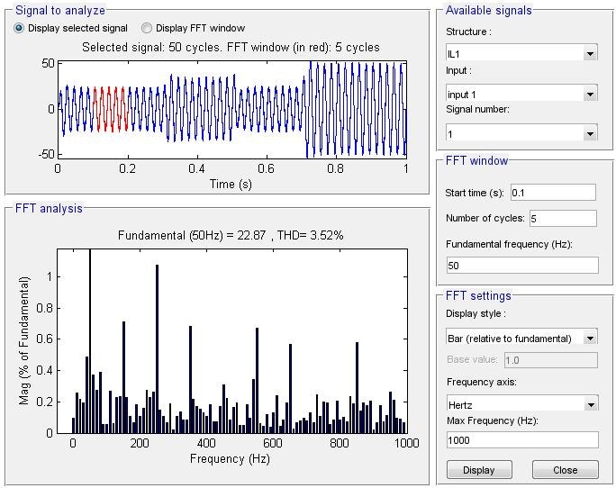

(i) Harmonic analysis under balanced loading condition

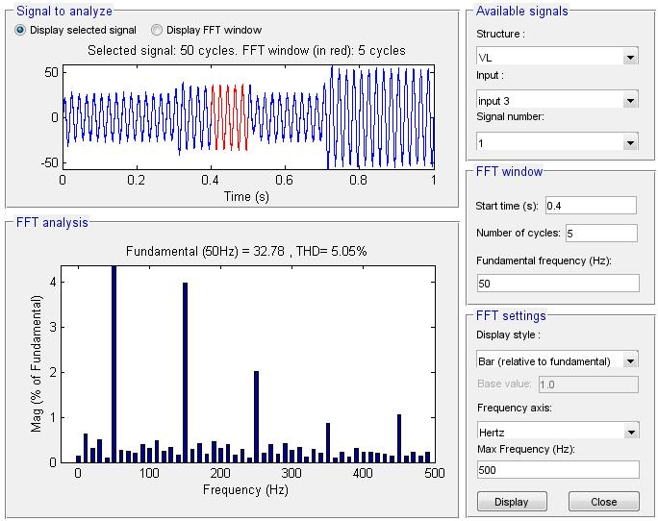

(ii) Harmonic analysis under unbalanced loading condition

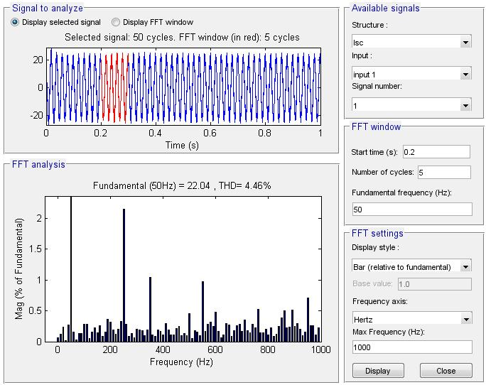

(iii) Harmonic analysis under distorted source condition

Fig. 6. (i), (ii), (iii) Harmonic analysis of source current Is for p-q theory under different loading conditions

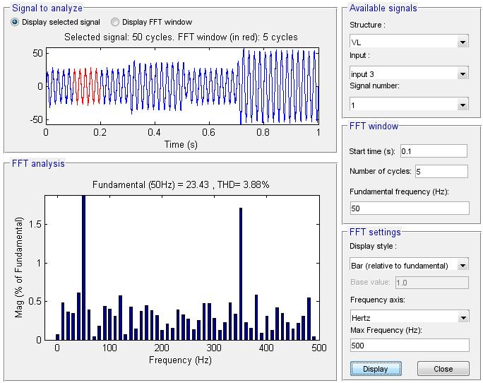

(i) Harmonic analysis under balanced loading condition

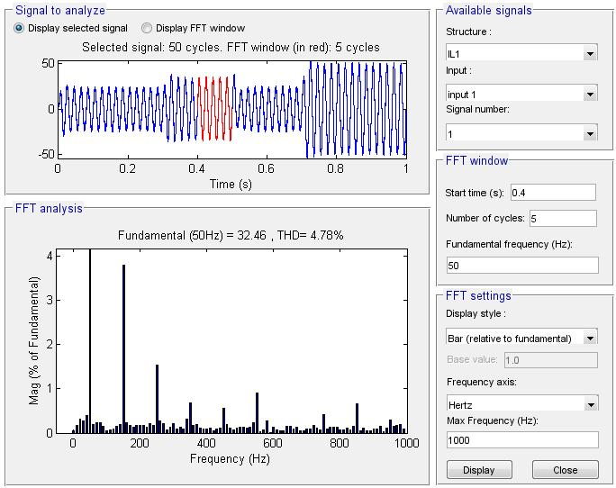

(ii) Harmonic analysis under unbalanced loading condition

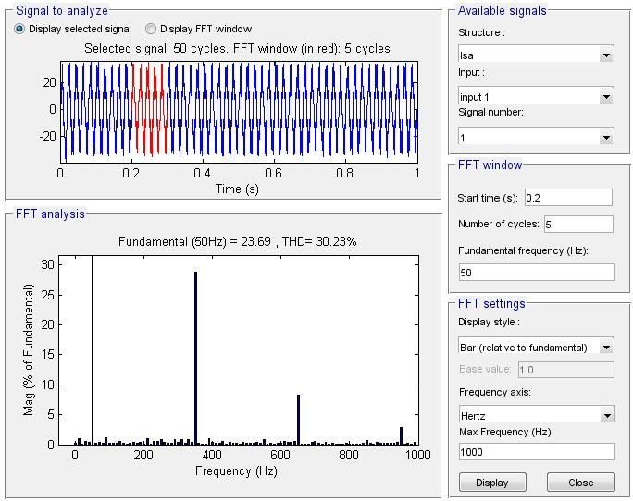

(iii) Harmonic analysis under distorted source condition

Fig.7. (i), (ii), (iii), Harmonic analysis of source current Is for d-q theory under different loading conditions

The power factor improvement using active filter using the p-q and d-q strategies is shown in table 1.

Table.1. Power factor Improvement using shunt active filter

|  |  |  |  |
| --- | --- | --- | --- |
| **Operating condition** | **Power factor without Active filter** | **Power factor with Active filter** | |
| ***p-q*** | ***d-q*** |
| *Balanced condition* | 0.9484 lag | 0.9987 lag | 0.9992  lag |
| *Unbalanced condition* | 0.9473 lag | 0.9991 lag | 0.9948  lag |
| Dynamic loading condition | 0.9625 lag | 0.9987 lag | 0.9994  lag |
| Distorted source voltage condition | 0.9678 lag | 0.9990 lag | 0.9932  lag |

Table 2 shows performance of shunt active filter using p-q and d-q theory with regards to compensation of reactive power of the system. It can be concluded that d-q theory is more suitable under all operating conditions. The active and reactive power of the system under different operating conditions is also mentioned in Table 2.

Table.2. Reactive Power compensation using shunt active filter

|  |  |  |  |
| --- | --- | --- | --- |
| **Operating Condition** | **Without filter** | **With filter** | |
| **p-q** | **d-q** |
| **Balanced Condition** | P = 11.84 kw | P=11.92 kw | P= 11.91 kw |
| Q= 3.825 KVAr | Q= 0.460 KVAr | Q= 0.594 KVAr |
| **Unbalance Condition** | P=21.11 kw | P=21.26 kw | P=21.22 kw |
| Q= 7.08 KVAr | Q= 2.276 KVAr | Q= 0.855 KVAr |
| **Dynamic loading condition** | P=22.58 kw | P=19.65 kw | P=22.58 kw |
| Q= 5.10 KVAr | Q= 0.495 KVAr | Q= 0.906 KVAr |
| **Distorted voltage condition** | P= 14.92 kw | P=12.1 kw | P=11.55 kw |
| Q= 1.852 KVAr | Q= 0.545 KVAr | Q= 2.256 KVAr |

1. CONCLUSIONS

Of all the reference current generation techniques used for shunt active filters, synchronous reference frame theory and instantaneous reactive power theory are simpler and most widely used. Hence performance of these algorithms is compared by simulating the same using MATLAB-SIMULINK under balanced, unbalanced and dynamic loading conditions as well as distorted source voltage condition. Under all the operating conditions, dc capacitor voltage at the input of active filter is maintained constant. From the results of simulation it can be seen that use of d-q theory for reference current generation results in improved performance over that using p-q theory under all operating conditions owing to use of PLL. The performance of the shunt active power filter using d-q theory has been seen to adhere to IEEE 519 standards under all operating conditions.

1. REFERENCES

[1] Christopher K Dufey, Ray P. Startford, “Update of Harmonic Standard IEEE- 519: IEEE Recommended Practices and Requirements for Harmonic Control in Electric Power Systems” IEEE Transactions on Industry Applications, Vol. 25, No. 6, November/December 1989.

[2] A. M. Massoud, S. J. Finney, and B. W. Williams, “Practical Issues of Three-phase, Three-Wire, Voltage Source Inverter-Based Shunt Active Power Filters” 11th IEEE International Conference on Harmonics and Quality of Power, 2004.

[3] Hirofumi Akagi, “New trends in Active Power Filters for power conditioning”, IEEE Transactions On Industry Applications, VOL 32, NO 6, November/December 1996.

[4] Wenjin Dai, Yu Wang “A Novel Three-phase Active Power Filter Based on Instantaneous Reactive Power Theory”, International conference on Power Electronics and Intelligent Transportation System, August 2-3, 2008.

[5] Sudhakar kothuru, Appala Naidu.k, Suresh. Y, J Kotturu, “Investigation on Shunt Active Filter with P-Q Theory”, IEEE International Conference on Circuits, Power and Computing Technologies, 2013.

[6] Nassar Mendalek and Kamal Al-Haddad, “Modeling and Nonlinear Control of Shunt Active Power Filter in the Synchronous Reference Frame”, IEEE Ninth International Conference on [Harmonics and Quality of Power, October 2000.](http://ieeexplore.ieee.org/xpl/mostRecentIssue.jsp?punumber=7191)

[7] Naimish Zaveri, Ankit Mehta, Ajitsinh Chudasama, “Performance Analysis of Various SRF Methods in Three Phase Shunt Active Filters” Fourth IEEE International Conference on Industrial and Information Systems, 28 - 31 December 2009, Sri Lanka

[8] Aiswarya.M, Ilango.K and Manitha P.V, Manjula G Nair, “Simulation Analysis of Modified DC Bus Voltage Control Algorithm for Power Quality Improvement on Distributed Generation Systems”, IEEE [Power and Energy Systems Conference: Towards Sustainable Energy, March 2014](http://ieeexplore.ieee.org/xpl/mostRecentIssue.jsp?punumber=6798821).