*Soft Computing based Transformer Incipient Fault Detection*

*Tapsi Nagpal*

Department of Electrical and Instrumentation Engineering, Thapar University, Patiala,

Punjab, India-147004

[tapsi.nagpal@thapar.edu](mailto:tapsi.nagpal@thapar.edu)

*Yadwinder Singh Brar*

Department of Electrical Engineering,

Guru Nanak Dev Engineering College, Ludhiana,

Punjab, India-141006

[braryadwinder@yahoo.co.in](mailto:braryadwinder@yahoo.co.in)

***Abstract*** - **The most commonly used method for power transformer fault diagnosis is the dissolved gas analysis (DGA) of transformer oil. Several methods have been developed to interpret DGA results such as key gas method, and roger’s ratio method. The proposed fault diagnosis scheme focuses on IEC 60599 ratio method, to discriminate fault in transformers, which is advantageous when compared with other ratio methods, as it takes into account three gas ratios instead of four gas ratios used in other ratio methods. In some cases, the DGA results cannot be matched by the existing codes, making the diagnosis unsuccessful in multiple faults. To overcome this limitation of conventional methods, the authors have proposed the use of neural networks to highlight their ability to diagnose the incipient faults in transformer.**

*Keywords – Artificial intelligence; Fault diagnosis; Power transformer; Neural network.*

1. INTRODUCTION

Power transformer is one of the major apparatus in power system. If power transformer develops any sort of abnormality or faults, huge economic loss will occur. Therefore, it is very important to detect incipient failures of power transformer as early as possible. A long in-service transformer is subjected to electrical and thermal stresses, which may form byproduct gases to indicate the type of incipient failure. Dissolved gas analysis (DGA) is a common practice for incipient fault diagnosis of power transformer. The fault-related gases mainly include hydrogen (H2), methane (CH4), acetylene (C2H2), ethylene (C2H4), ethane (C2H6). Therefore, if we forecast these dissolved gases content in power transformer oil according to the recent historical data, incipient failures of power transformer and its development trend will be found out early, then the loss of transformer will be reduced minimally [14].

The analysis of specific dissolved gas concentrations (obtained from DGA) in insulation oil of a transformer gives the knowledge about a transformer state, and therefore, allows taking the necessary preventive actions. In the past years, various fault diagnosis techniques have been proposed, including the conventional key gas method used in [15], ratio method presented in [20] and [7], and graphical representation method introduced in [5].

Booth et al. [1] covered the generic capabilities of artificial neural networks, in both estimation and classification mode, for condition monitoring applications, using examples based around the work, carried out with respect to the monitoring of a power transformer while Patricia et al. [2] showed that a combinatorial intelligent system based on neuro-fuzzy, neuro-expert and fuzzy-expert algorithms for the detection of a number of faults in a range of equipments.

Mohammed et al. [8] proposed a transformer fault diagnosis scheme by firstly pre-processing the input data, then designing an artificial neural network (ANN) to detect the faults, thereby determining the faulty-side of the transformer while Zhenyuan et al. [10] developed a transformer incipient fault diagnosis system to detect thermal faults, low-energy discharge, high-energy discharge and cellulose degradation.

Miranda et al. [11] described that mapping of a neural network into a rule-based fuzzy inference system which leads to knowledge extraction. They have used the mapping to explicit the knowledge implicitly captured by the neural network during the learning stage, by transforming it into a set of rules. They have applied this to transformer fault diagnosis using dissolved gas-in-oil analysis.

Sun et al. [15] utilized the back propagation (BP)-based artificial neural networks (ANN) to identify complicated relationships among dissolved gas contents in transformer oil and corresponding fault types. They have determined the optimal connection weights and bias terms to achieve accurate diagnosis model for DGA.

In this paper, a novel methodology has been used for transformer incipient fault diagnosis using artificial intelligence techniques, which optimizes the weight updation by applying a learning algorithm using input-output datasets. Parameter optimization is done in such a way that the error measure between the target and the actual output is minimized.

1. DISSOLVED GAS ANALYSIS

Dissolved gas-in-oil analysis (DGA) is a common practice in transformer fault. Electrical insulation such as mineral oils and cellulosic materials degrade under excessive thermal and electrical stresses forming byproducts gases which can serve as indicators for the type of stress and its severity. In this way, gas-in-oil concentrations, relative proportion of gases, and gas generation rates (gassing rates) are used to estimate the condition of a transformer. Commonly used gases include hydrogen (H2), methane (CH4), acetylene (C2H2),ethylene (C2H4), ethane (C2H6), carbon monoxide (CO) and carbon dioxide (CO) [3,5-6].

DGA techniques include the conventional key gas method, ratio methods, and recently, the artificial intelligent methods. The key gas method relates “key gases” to “fault types” and attempts to detect four types of fault (overheating of oil, overheating of cellulose, partial discharge, arcing) based on key gas contents (C2H4, CO, H2, C2H2). The ratio methods are coding systems that assign certain combination of codes to a specific fault type. The codes are generated by calculating gas ratios and comparing the ratios to pre-defined ratio intervals. A fault condition is detected when a code combination fits the code pattern of the fault [13,19-20].

The two widely used ratio methods are the Dornenberg Ratio Method and the Rogers Ratio Method. Both methods are able to detect thermal decomposition, corona and arcing faults. The latter can distinguish between low temperature, <700°C and >700°C in thermal faults. The proposed approach utilizes IEC 60599 ratio method, a DGA interpretative technique to diagnose the faults in power transformer.

*A. IEC 60599*

IEC 60599 ratio method is an improvement over the Roger’s ratio method. Instead of using four gas ratios, ratio C2H6/CH4 was dropped because it indicated only a limited temperature range of decomposition [18,34, 36]. Therefore, this method gains the advantage to discriminate faults by reducing the computation time thereby enhancing the efficiency of transformer fault diagnosis. A generally accepted ppm concentration typical values range of the fault gases, observed in power transformers according to IEC 60599 is as follows:

Table 1 shows the IEC 60599 standard for interpreting fault types and gives the values for the three key-gas ratios corresponding to the suggested fault diagnosis. A fault type can be deduced by checking the three ratio ranges. When key-gas ratios exceed specific limits, incipient faults can be expected in the transformer. The ratios are significant only if at least one of the gases is above the typical value. The limitations are that it is only able to detect a single f2014

fault type and calculated ratios may fall outside the ratio ranges [4, 11,16].

TABLE 1. DIAGNOSIS USING THE RATIO METHOD (IEC 60599)

|  |  |  |  |
| --- | --- | --- | --- |
| Fault Type | C2H2/ C2H4 | CH4/H2 | C2H4/C2H6 |
| PD | <0.1 | <0.1 | <0.2 |
| D1 | >1 | 0.1-0.5 | >1 |
| D2 | 0.6-2.5 | 0.1-1 | >2 |
| T1 | <0.1 | >1 | <1 |
| T2 | <0.1 | >1 | 1-4 |
| T3 | <0.1 | >1 | >4 |

1. NEURAL NETWORK BASED FAULT DETECTION

In this section ANN is used for DGA based transformer fault detection system. An ANN is trained to detect the faults of the transformer. Artificial neural networks (ANNs) have been used to deal with the transformer fault diagnosis, due to their accurate and efficient performance in numerical modeling problems. The ANNs can acquire new experiences by incremental training from newly obtained samples. Moreover, they can interpolate and extrapolate from their experiences, yielding at least a best guess of the fault. The ANNs trained by an error back-propagation algorithm have great diagnostic capabilities. However, certain issues, such as local convergence, determination of the network configuration and control parameters (learning rate and momentum constant), must be resolved before the ANNs can become a practical tool. Furthermore, the error back-propagation algorithm is based on a gradient descent technique using classification errors to modify connection weights and bias terms in the ANNs. The gradient descent technique may stagnate at the potentially local optimal solutions, reducing the performance of the ANNs, because the typical search space frequently includes local minima [1,7, 9,15].

In the neural network the most basic information - processing unit is the neuron model. The neural model organized in three or more layers, such as input layer (one or more), hidden layer(one or more) and single output layer, use a back-propagation for training, presented in Fig. 1.



Fig.1. General Architecture of Artificial Neural Network (ANN)

The number of neurons in the hidden layer remains variable for each diagnosis criterion, depending upon the complexity. Each neuron model receives input signals, which are multiplied by synaptic weights. An activation function transforms these signals into an output signal to the next neuron model and so on [12, 17, 18, 21-23].

In this paper, the authors have proposed two ANN structures:

* 5 Input nodes and 2 output nodes (classes),say N1
* 5 Input nodes and 6 output nodes (classes),say N2

N1 accepts the concentration (ppm) of the gases (C2H2, C2H4, C2H6, H2 and CH4) on input and predicts the condition of the transformer as healthy or faulty as output while N2 accepts the concentration (ppm) of the gases (C2H2, C2H4, C2H6, H2 and CH4) as input and predicts all fault types in IEC 60599 ratio method (Table 1) as output.

First of all the N1 is trained with historical data based on actual gas records collected from Punjab State Electricity Board. The 77 dissolved gas analysis (DGA) samples were collected. These DGA samples associated with their real fault types were classified with the help of various DGA interpretative techniques, by the Electricity Board experts after internal examination of the suspected transformers and the subsequent analysis. The graphical representation of the dataset of dissolved gases (in ppm) is shown in Fig. 2.

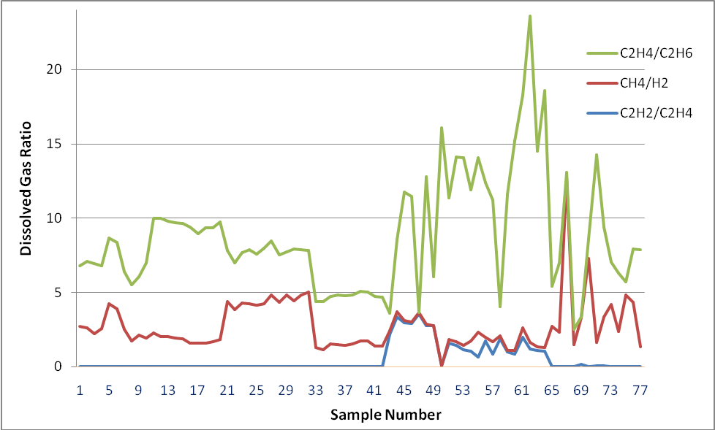

Fig. 2: Dataset of Dissolved Gas Concentration (in ppm)

N1 has been trained using error back propagation algorithm, tested with several combinations of data, trained for 3500 epochs resulting in the train recognition accuracy of 93.17%. During the training process, the number of hidden neurons and network weights and momentum were adjusted until required accuracy was obtained. The graph between mean square error (MSE) and epoch is shown in Fig. 3.

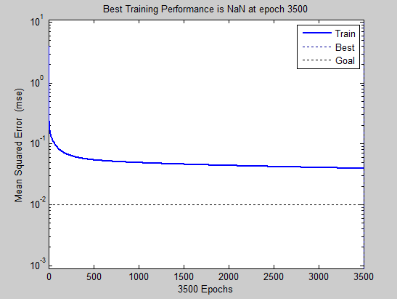

Fig. 3. MSE v/s epochs (N1)

N2 is trained and tested on the same grounds, resulting in train recognition accuracy of 89% with the iteration number equal to 143 epochs as shown in. Fig. 4.

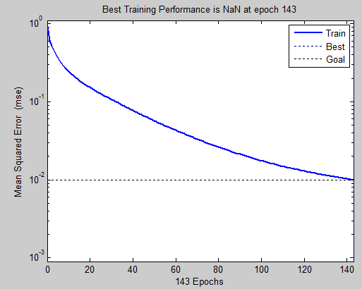

Fig. 4. MSE reduced to minimal value at 143 epochs (N2)

Network parameters taken for both the ANN structures, N1 and N2, have been listed below:

1. Learning Rate = 0.05
2. Momentum Constant = 0.7
3. Tolerance = 0.001
4. RESULTS AND DISCUSSIONS

Neural network has been used to train the existing DGA data and then fault detection is done. Two configurations of neural networks are used. In first configuration, there are five inputs and two output classes (healthy and faulty) where as in second configuration; there are five inputs and six output classes (PD, D1, D2, T1, T2, T3). The results are shown in Table 2.

TABLE 2. ARTIFICIAL NEURAL NETWORK (ANN) STRUCTURES: COMPARISON

|  |  |  |  |  |
| --- | --- | --- | --- | --- |
| ANN  Structures | Input Nodes | Output Nodes | Max. no. of epochs | Test Recognition Accuracy |
| N1 | 5 | 2 | 3500 | 90.4% |
| N2 | 5 | 6 | 243 | 89% |

From Table 3, it is clearly observed that the faults which remain unidentified by IEC 60599 ratio method (conventional DGA method), get detected with the help of back propagation neural network. From the results, it is clear that by applying neural networks for transformer fault diagnosis using dissolved gas-in-oil analysis, one could develop an intelligent diagnosis system which provides better results.

1. CONCLUSION

In the proposed scheme, neural networks have been used to diagnose the incipient faults in power transformers through the analysis of dissolved gases in oil. Such schemes are advantageous when compared to conventional DGA methods, since in case of multiple fault diagnosis by DGA, the gases from different faults get mixed up resulting in such gas ratio, which cannot be matched by the existing codes thereby reducing the accuracy..Therefore, the proposed scheme provides better results of transformer incipient fault detection than the other soft-computing techniques.

ACKNOWLEDGEMENT

The authors extend their heartiest thanks to Dr. B. N. Chudasama, Assistant Professor, SPMS department, Thapar University, for his valuable contribution to this work.

REFERENCES

[1] C. Booth and J.R. McDonald., “ The use of artificial neural networks for condition monitoring of electrical power transformers”, Neurocomputing, vol. 23, pp. 97-109,April 1998.

[2] R.S. Patricia, Syed Jotal, M Islam, Wu Tony, and Gerard Ledwich, “A class of hybrid intelligent system for fault diagnosis in electric power systems”, Neurocomputing, vol. 23, pp. 207-224,1998.

[3] Mineral Oil Impregnated Equipments in Service—Guide to the Interpretation of Dissolved and Free Gases Analysis, IEC Publication 60599, March 1999.

[4] Michel Duval, and Alfonso dePablo, “Interpretation of Gas-in-oil Analysis using new IEC Publication 60599 and IEC TC 10 Databases ”, IEEE Insulation Magazine,vol.17,pp. 31-41,2001.

[5] Michel Duval, “A review of faults detectable by gas-in-oil analysis in transformers”, IEEE Electrical Insulation Magazine, vol. 18, pp. 8-17, May-June 2002.

[6] N. Liu, K. Tan, and W. Gao, “Fault Diagnosis Method for Power Transformers Based on Patterns of Dissolved gasses in the oil,” Proc. J.Tsinghua Univ., vol. 43, pp. 301–303, March 2003.

[7] C.P. Hung, and M.H. Wang, “ Diagnosis of incipient faults in power transformers using CMAC neural network approach, Electric Power Systems Research ,vol. 71, pp. 235–244,2004.

[8] Mohammed, E.A., Abdelaziz, A.Y. , Mostafa, A.S. , “ A neural network based scheme for fault diagnosis of power transformers”, Electric Power Systems Research, vol. 75, pp.29-39, July 2005.

[9] B. Karthikeyan, S. Gopal, and M. Vimala, “ Conception of complex probabilistic neural network system for classification of partial discharge patterns using multifarious inputs”, Expert Systems with Applications, vol. 29, pp. 953-963,2005.

[10] Wang Zhenyuan, Yilu Liu, P.J. Griffin, “Neural net and expert system diagnose transformer faults,” IEEE Computer Applications in Power, vol. 13, pp.50-55,Jan. 2000.

[11] V. Miranda, A. Rosa, and Garcez Castro, “Improving the IEC table for transformer failure diagnosis with knowledge extraction from neural networks”, IEEE Transactions on Power Delivery, vol. 20, pp. 2509–2516, October 2005.

[12] Y. Zhang, X. Ding, Y. Liu, P.J. Griffin, “An artificial neural network approach to transformer fault diagnosis”,IEEE Transactions on Power Delivery, vol. 11 ,pp. 1836-1841, Oct. 1996.

[13] Indian Standard Method of Evaluating the Analysis of Gases in Oil-Filled Electrical Equipment in Service (first revision), IS 10593: 1992 (reaffirmed 2006) and IS 9434: 1992 (reaffirmed 1995).

[14] Andrew K.S. Jardine, Lin Daming, Dragan Banjevic, “ A review on machinery diagnostics and prognostics implementing condition-based maintenance”,Mechanical Systems and Signal Processing, vol. 20, pp. 1483-1510,2006.

[15] Cheng-Chien Sun, Shen Zhang, Chang-xin Miao, Jing-meng Li, “ Improved BP Neural Network for Transformer Fault Diagnosis”, Journal of China University of Mining and Technology, vol.17, pp.138-142,2007.

[16] Cheng-Chien Kuo, “ Particle Swarm Trained Neural Network for Fault Diagnosis of Transformers by Acoustic Emission”, Expert Systems with Applications, vol. 4682 , pp. 992-1003, 2007.

[17] J.L.Guardado, J.L. Naredo, P. Moreno, C.R. Fuerte, “ A comparative study of neural network efficiency in power transformers diagnosis using dissolved gas analysis”, IEEE Transactions on Power Delivery, vol. 16, pp. 643-647, Oct. 2001.

[18] Souahlia Seifeddine, Khmais Bacha, “ Artificial Intelligence Tools Aided-decision for power transformer fault diagnosis”, International Journal of Computer Applications,vol.7, pp.1-8, Jan. 2012.

[19] W.H.Tang, J.Y. Goulermas, , Q.H. Wu, Z.J. Richardson, and J.Fitch, “A probabilistic classifier for transformer dissolved gas analysis with a particle swarm optimizer”, IEEE Transactions on Power Delivery, vol. 23, pp. 751–759,April 2008.

[20] Dong Lixin, Xiao Dengming, Yishan Liang and Yilu Liu, “ Rough set and fuzzy wavelet neural network integrated with least square weighted fusion algorithm based fault diagnosis research for power transformers”,vol.78, pp. 129-136,2008.

[21] Chin-Pao Hung, Mang – Hui Wang ,“ Diagnosis of incipient faults in power transformers using CMAC neural network approach”, Electric Power Systems Research,vol.71, pp. 235-244, Nov.2004.

[22] Bhalla Deepika, Bansal Raj, Kumar, and Gupta Hari Om Integrating AI based DGA fault diagnosis using Dempster–Shafer Theory, International Journal of Electrical Power & Energy Systems 48 (2013) 31-38.

[23] Konstantinos Theofilatos , Dionisios Pylarinos , Spiros Likothanassis , Damianos Melidis , Kiriakos Siderakis, Emmanuel Thalassinakis and Seferina Mavroudi A Hybrid Support Vector Fuzzy Inference System for the Classification of Leakage Current Waveforms Portraying Discharges, Electric Power Components and Systems 42 (2014) 180-189.

TABLE 3. COMPARISON BETWEEN NEURAL NETWORK AND IEC 60599

|  |  |  |  |  |  |  |  |
| --- | --- | --- | --- | --- | --- | --- | --- |
| Sample | Transformer Rating | R1 | R2 | R3 | Neural Network Based fault detection | IEC 60599  method | Actual  fault |
| 1 | 115 kV &20 MVA | 1 | 0.2 | 1.2 | D1 | D1 | D1 |
| 2 | 68 kV & 30 MVA | 0.2 | 1.8 | 2 | D2 | Not  Identified | D2 |
| 3 | 69 kV & 25 MVA | 0.13 | 2 | 0.1 | PD | Not  Identified | PD |
| 4 | 220 kV & 100 MVA | 0.08 | 2.0 | 4.7 | T3 | T3 | T3 |
| 5 | 210 kV & 120 MVA | 2.5 | 0.08 | 3.3 | D1 | Not  Identified | D1 |
| 6 | 65 kV & 35 MVA | 0.2 | 2 | 3 | D2 | Not Identified | D2 |
| 7 | 70 kV & 40 MVA | 1.3 | 0.09 | 5 | T3 | T3 | T3 |
| 8 | 78 kV & 45 MVA | 0.1 | 1.2 | 0.1 | PD | Not Identified | PD |
| 9 | 85 kV & 50 MVA | 3.36 | 0.328 | 4.88 | D1 | D1 | D1 |
| 10 | 125 kV & 25 MVA | 2.74 | 0.134 | 9.89 | D2 | Not Identified | D2 |
| 11 | 135 kV & 35 MVA | 0.004 | 2.3 | 4.6 | T1 | Not Identified | T1 |
| 12 | 150 kV & 50 MVA | 0.005 | 2.72 | 2.67 | Not Identified | T2 | T2 |
| 13 | 215 kV & 125 MVA | 0.008 | 4.34 | 3.55 | T3 | Not Identified | T3 |
| 14 | 205 kV & 95 MVA | 1.478 | 0.275 | 15.67 | D2 | D2 | D2 |
| 15 | 220 kV & 120 MVA | 1 | 0.046 | 0.032 | PD | Not Identified | PD |