ANALYSIS OF TRADITIONAL BEEM BASED PROTOCOL IN WIRELESS SENSING ENVIRONMENT

Harpreet kaur1, Amandeep kaur2,

M.Tech Student , Global Institutes of Management& Emerging Technologies, Batala Road, Asr,India1.

Head of Department of ECE, Global Institutes of Management & Emerging Technologies, Batala Road, Asr, India2

**Abstract –** Wireless communication becomes one of the fastest growing fields in today’s technological world. It will be increase day by day and its growth in technology. Any type of protocol can be used in this network to get desired range and output. In this research article, WSN performance is measured by BEEM AND MBEEM over a different environment such as running or dead nodes, packets sent to cluter or Base Station. The main objective of this article is evaluate the operation of BEEM in heterogeneous mode and to provide data transmission at high speed and lesser requirements.

**Keywords –** Wireless sensor node, Dead node, cluster, Base station, protocol, BEEM, MBEEM.

1. **INTRODUCTION**
   1. **Wireless Sensor Networks**

Sensor networks are dense wireless networks of small, low-cost sensors, which collect and disseminate environmental data. Wireless sensor networks facilitate monitoring and controlling of physical environments from remote locations with better accuracy[1]. They have applications in a variety of fields such as environmental monitoring, military purposes and gathering sensing information in hospitable locations. Sensor nodes have various energy and computational constraints because of their inexpensive nature and adhoc method of deployment. Previously, sensor networks consisted of small number of sensor nodes that were wired to a central processing station. However, nowadays, the focus is more on wireless, distributed, sensing nodes. But, why distributed, wireless sensing? [2] When the exact location of a particular phenomenon is unknown, distributed sensing allows for closer placement to the phenomenon than a single sensor would permit. Even there algorithmic issues in sensor deployment and coverage, routing, and fusion[3]. A wireless sensor network consists of a large amount of sensor nodes which can be densely deployed either inside the environmental surroundings or near it. This permits random deployment in inaccessible hazardous environments. One of the limitations of wireless sensor nodes is their inherent limited energy resource. Besides maximizing the lifetime of the sensor nodes, it is preferable to distribute the energy dissipated throughout the wireless sensor network in order to minimize maintenance and maximize overall system performance [4,5,6].

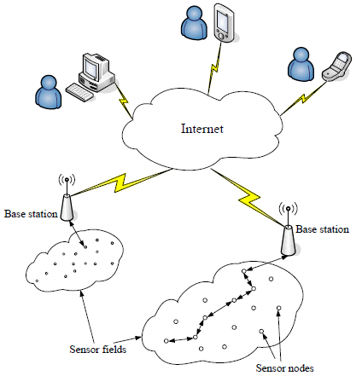

**Figure 1:** WSN through Internet

Seema Bandyopadhyaye [7] proposed a distributed, randomized clustering algorithm to organize the sensors in a wireless sensor network into clusters.Wei Ye[8] proposed S-MAC, a medium-access control (MAC) protocol designed for wireless sensor networks. Where results shown that, on a source node, an 802.11-like MAC consumes 2–6 times more energy than S-MAC for traffic load with messages sent every 1–10s.Sensor nodes tend to coordinate among themselves to produce much qualitative information about the physical environment. Every sensor node makes its decisions on its mission, the information it currently posses, and its knowledge of its computation, communication, and about energy resources. Every one of these scattered sensor nodes has the capability to collect and route data either to other sensors or back to an external base station. B. Munish [9] have analyzed that group of cluster heads saves energy consumption in the network. As the number of cluster heads increases the number of sleepy nodes also increases. The BS possess very large storage and large data processing capabilities. Q. Wang [10]have proposed a novel clustering-CH-exchange-method which includes the concept of MIMO in WSN.M.Kiranmayi[11] explored the significant advantages, disadvantages of design issues of different routing protocols. This article also discussed for security in UWSNs, underlying the specific characteristics of these networks, possible underwater attacks, their countermeasures and challenges.

* 1. **Heterogeneous Wireless Sensor Network**

Heterogeneous sensor network,consists of two or more different types of nodes with different batteryenergy and functionality are used. The motivation being that the more complex hardware and the extra battery energy can be embedded in few cluster head nodes, thereby reducing the hardware cost of the rest of the network. Jae-Hwan [12,13] described a heterogeneous routing protocol according to network structure, location and protocol operation. All protocol have their own specialties to perform on certain operations.

* 1. **BEEM Based Protocol**

It is the algorithm based on HEED. BEEM[14] exceeds HEED and LEACH from two perspectives that is longevity and balanced sensor distribution. It can guarantee the network coverage for a longer time, compared with HEED and LEACH. In BEEM nodes can communicate symmetrically. All the nodes are deployed randomly and placed at fixed location. Lina Xu [15] introduced Balanced Energy Efficiency(BEE) clustering algorithm and its multi hop version (BEEM)

1. **PROPOSED ALGORITHM**

Following are the basic steps which are taken into consideration to complete the assigned task.

INITIALIZE WSN

FOR EACH SENSOR NODE 1

IF NODE(1) ENERGY>0

SELECT NODE AS CH BASED ON T(N) HETEROGENEOUS FUNCTION

ASSOCIATE MEMBER NODES WITH THEIR RESPECTIVE CHs

APPLY INTER-CLUSTER DATA AGGREGATION

UPDATE REMAINING ENERGY OF EACH NODE(1)

NO

YES

**Figure 2 :** Proposed Method

1. **SIMULATING RESULTS AND DISSCUSSION**

In this article, simulation results are obtained with the help of MATLAB software. All following figures are representing the possible operation of BEEM and MBEEM.

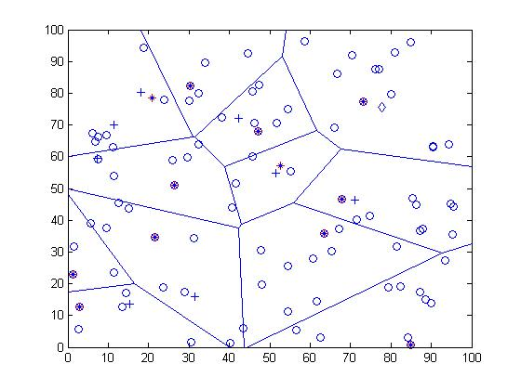**Figure 3:**All running Dead Nodes

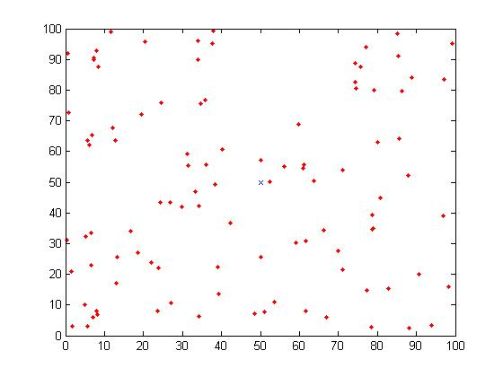**Figure 4:** All Dead Nodes

The figure 3 is showing all the running dead nodes.100x100 sensor area is taken in figure 3 and figure 4 is showing the all dead nodes.

Where Red diamonds = The dead nodes.

Circles = Normal node

Blue circles = The cluster head

Plus = The advance node

Diamond = Base station

Blue advance node = the cluster head 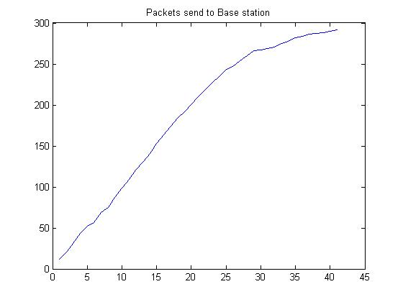

**Figure 5:** Packets send to Base Station(BEEM)

In figure 5, 280 packets are sent to base station until 42 rounds. Therefore more packets are sent ,hence results are better than existing method..

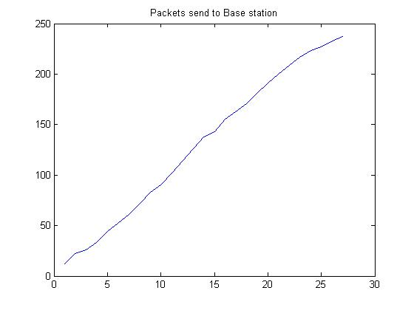

**Figure 6:** Packets send to Base Station(MBEEM)

In figure 6, 280 packets are sent to base station until 42 rounds.

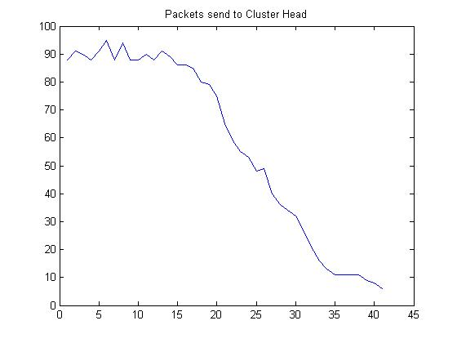

**Figure 7:** Packets send to Cluster Head(BEEM)

The figure 7 shows that 95 packets are sent to cluster head until 42 rounds.The 15 rounds are full and after that packets are deploying at high speed.

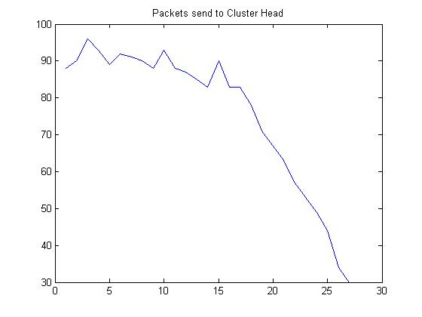**Figure 8:** Packets send to Cluster Head(MBEEM)

The figure 8 shows that 90 packets are sent to cluster head until 26 rounds.The 10 rounds are full and after that packets are deploying at high speed.

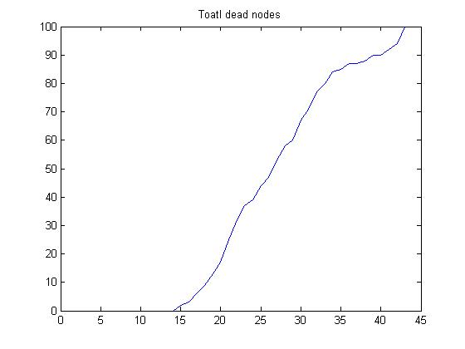

**Figure 9:** Total Dead Nodes(BEEM)

The first dead node is happened at 14 round and last dead node is happened at 42 round.

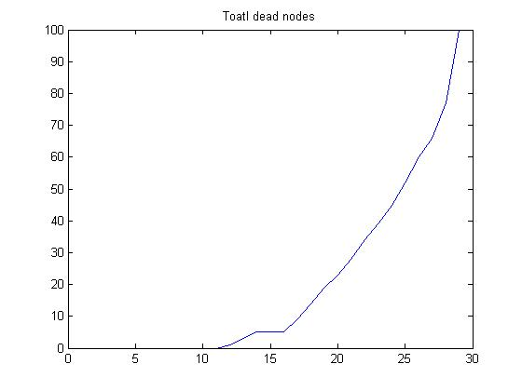**Figure 10:** Total Dead Nodes(MBEEM)

In figure 10,the first dead node is happened at 11 round and last dead node is happened at 26 round.

1. **CONCLUSION AND FUTURE SCOPE**

At this paper, the main challenge is to evaluate the performance of Balanced energy efficient protocols for heterogeneous wireless sensor networks be observed. Secondly, it is also evident that BEEM performs very well than traditional MBEEM protocol in all aspects. Near to future, different technique can be used to overcome the disadvantage of MBEEM and more enhanced outcome can be found. Even in future, the integration of MBEEM with Token bucket algorithm may show advanced results.

**REFERENCES**

1. Archana Bharathidasan, Vijay Anand Sai Ponduru, “Sensor Networks: An Overview”, Department of Computer Science,University of California, Davis, CA 95616,2007.
2. D. Estrin, L. Girod, G. Pottie, M. Srivastava, “Instrumenting the world with wireless sensor networks,” In Proceedings of the International Conference on Acoustics, Speech and Signal Processing (ICASSP 2001), Salt Lake City, Utah, May 2001.
3. Sartaj Sahni and Xiaochun Xu, “Algorithms For Wireless Sensor Networks”, Department of Computer and Information Science and Engineering, University of Florida, Gainesville, FL 32611,2004.
4. W. Mangione-Smith and P.S. Ghang, “A Low Power Medium Access Control Protocol for Portable Multimedia Systems”, In Proceeding 3rd Intl. Workshop on Mobile Multimedia Communications, Princeton, NJ, Sept. 25-27, 1996.
5. K. M. Sivalingam, M.B. and P. Agrawal, “Low Power Link and Access Protocols for Wireless Multimedia Networks”, Proceedings IEEE Vehicular Technology Conference VTC’97, May 1997.
6. M. Stemm, P. Gauther, D. Harada and R. Katz, “Reducing Power Consumption of Network Interfaces in Hand- Held Devices”, Proceedings 3rd Intl. Workshop on Mobile Multimedia Communications, Sept. 25-27, 2013.
7. Seema Bandyopadhyay and Edward J. Coyle, “An Energy Efficient Hierarchical Clustering Algorithm for Wireless Sensor Networks”, IEEE INFOCOM 2009.
8. Wei Ye, John Heidemann, Deborah Estrin, “An Energy-Efficient MAC Protocol for Wireless Sensor Networks”, University of Southern California,2012.
9. Munish Bharadwaj, Dinesh Kumar Kotary, Surender Soni “Comparative Analysis of Energy Efficient Routing Protocol for Wireless Sensor Network,” International Journal on Wireless Communication and Mobile Networks, pp. 65-69, 2012.
10. Q. Wang and Y. Qu, “An Effective organizing method for Wireless Sensor Networks based on MIMO,” IEEE Conference on Wireless Communications, Networking and Mobile Computing(WICOM), pp. 2775-2778, 2007.
11. M.Kiranmayi, Dr. Kathirvel Ayyaswamy, “Underwater Wireless Sensor Networks: Applications, International Journal of Emerging Trends in Engineering Research, Vol. 3 No.1, 2015.
12. Jae-Hwan Chang, Leandros Tassiulas, “Maximum Lifetime Routing in Wireless Sensor Networks,” IEEE Transactions on Networking, Vol. 12, No. 4, pp. 609-619, 2004.
13. Kazem Sohrabym Daniel Minoli, Taieb Znati, “Wireless Sensor Networks, Technology, Protocols and Applications” , A JohnWiley & Sons, Inc., Publication, 2007.
14. Jasdeep Kaur, Snadip Wraich, Comparative analysis of various energy effiecient protocol for wireless sensor networks, International Journal of Computer Applications, Vol.115, 2015.
15. L Xu, GMP O'Hare, R Collier “A Balanced Energy-Efficient Multihop Clustering Scheme for WSN”- Wireless and Mobile Networking Conference, 2014.