**Resource Management in Grid System based on Trust and QOS**

Ravneet Singh, Assistant Professor, CSE Department, SDDIE, Panchkula.

***Abstract-*Grid is a set of independent computers that performs selection, sharing of resources for application programs. A grid computing system is geographically distributed environment that share resources among themselves. The grid needs to respond more quickly to various requests. To make such systems more reliable for day to day use we include trust awareness (confidentiality). In this paper we present an idea for resource groping on the basis of Trust and QOS including delay, bandwidth, in order to select resources more quickly and appropriately.**

***Keywords-Quality of Services:delay, bandwidth and Trust***

1. INTRODUCTION

A Grid System is a geographical distributed environment with autonomous domain that shares resources amongst themselves. In such systems computers and recourses are distributed geographically. Grid computing is a term referring to the combination of computer resources from multiple administrative domains for a common goal. It consists of[distributed system](http://en.wikipedia.org/wiki/Distributed_system) that involves a large number of files. It tends to be more loosely coupled, heterogeneous and geographically dispersed system. Grid computing is a HIGH PERFORMANCE COMPUTING (HPC) environment, where number of computer devices (processors, data storages etc) is linked together parallel to solve a problem, Grid computing provides highly scalable, highly secure and extremely high performance mechanism for discovering and accessing to remote computing resources. It makes possible sharing of computing resources among an infinite number of geographical distributed environments. Grid computing environment must construct upon Coordinated resources: Avoid building grid system with centralized control, instead we must provide necessary infrastructure for coordinating among resources based on policies and agreements (at Service levels), Open standards, protocols and frame work: It provides inter-operatability and integration facilities, Quality of Service required for End users. The most important feature in parallel and distributed systems are speedup and also in grid environment, it is the availability of appropriate resource[1,2,3,4] To arrive at faster and more appropriate access to resources, they are grouped in terms of trust and QoS criteria such as network bandwidth,delay. Each group includes a number of nodes. In each group, the strongest node in terms of QOS and trust criteria is selected as the super node and each super node has the most complete information on the nodes in its group [5, 6].

The notion of trust is a complex subject relating to a firm belief in attributes such as reliability, honesty and competence of the trusted entity. Trust*s* must exist where resources can selected and provide services safely, the firm beliefis dynamic values and spans over a set of values ranging from very trustworthy to very untrustworthy. This Trust level (TL) is built on past experiences and given for a specific context. . It is estimation of competence of a resource provider in completing a task based on reliability, security, capability and availability in the context of distributed environment. Section 2 of this paper reviews the related literature. Section 3 proposed work. Section 4 presents the methodology for selecting resources. Section 5 elaborates on conclusion and future work.

1. LITRATURE RIVIEW

Based on resources type, [7] has organized grid environment as hierarchical cluster having three management levels i.e Individual Resource Manager (IRM),Cluster Resource Manager (CRM),and Grid Resource Manager (GRM). An IRM manages resources of individuals and stores updated information on resource situation and its accessibility. It also has management policies for the resource. A CRM manages a cluster and through connection with IRMs collects information onresources of its management clusters. In the third level, the CRM of the second level is grouped into virtual clusters managed by CRM. Each CRM stores an abstract body of information on clusters. GRM is in the highest level and has connection with corresponding GRMs. Enabling GRM to participate for providing inter-organizational resource. [8] Employs p2p technology for resource management in two stages: wide-area manager for managing resources on hosts with one or more than one virtual organization(s), and a local manager which is for managing resources on one host.[9] Has used super-peer and cluster model in which each super-peer acts as a central server for some clients, and super-peers communicate with each other. [10] Has used super-node model for managing resources. [9] Has used Description Logic (DL) systems and distributed hash table for semantic description. DL systems have evolved as knowledge representation systems. In such system, knowledge is divided into two parts: Taxonomical-BOX that stores conceptual knowledge on words and it can be compared with a database system model and Assertional-BOX that represents concrete knowledge on individuals and it includes conceptual assertion and rule assertion. Sample’s list, i.e. the list of resources of each node is put there.[11] In this paper we proposed a trust management architecture that can evolve and maintain the trust. In computing trust and reputation, several issues have tobe considered. First, trust decays with time. For example, if*x* trusts *y* at level *p* based on past experience five years ago,the trust level today is very likely be lower unless theyhave interacted since then

Trust Level table:

|  |  |
| --- | --- |
| ***Trust Level*** | ***Description*** |
| A | Very high trustlevel |
| B | High trust level |
| C | Low trust Level |
| D | Very low trust level |

1. PROPOSED WORK

To provide faster and better resource management, resources are divided into groups according to Trust and QoS. All groups are organized hierarchically. In our suggested model, two QOS criteria, i.e. delay and bandwidth and also Trust have been selected.

1. Resource grouping based on Trust

The figure1 shows how the client, resource broker and resources are connected to each other. Model works as client sends request to resource broker for allocating the resources with values of trust requested (A, B, C and D). Broker send request to peer-resource node which has all the information regarding trust of other resource nodes and provide required resources to the user or client.

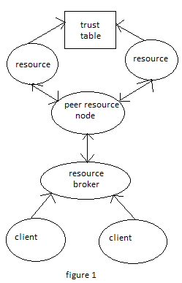

As shown in figure 2, resources with same level of trust are put in same group. In this grouping, node with higher trust value is the super node and it has all the information about other nodes in the group. Since the node with same level of trust are grouped together and is known as trust group.In the higher level, some close groups are considered as the higher trust group, and among them super groups with the highest trust average is selected and thereby higher levels are created so that all resources become members of one group in the highest level.

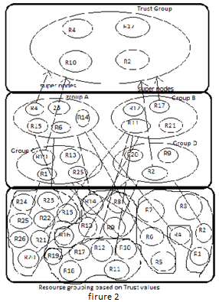

1. Resource Grouping based on Delay

As shown in Figure 3, resources near each other geographically are put in the same group in order to decrease delay. In this grouping, the node with the lowest delay average is selected as the super node and it receives information of other nodes. Since nodes are near each othertheir delay is minimal. This group is called geographical group, as its nodes are members of the same group due to their geographical neighborhood. In the higher level, some close groups are considered as the higher geographical group and among them a super group with the lowest delay average is selected and thereby higher levels are created so that all resources become members of one group in thehighest level. By using this grouping requests which should be responded quickly receive relevant resources.

1. Resource Grouping based on Network Bandwidth

As illustrated in Figure 4, in this grouping nodes are organized due to network bandwidth from high bandwidth, middle bandwidth and low bandwidth. Here, a node with the highest bandwidth in its group is selected as the super node and receives other nodes' information. Works with large size or works with high information exchange are sent to the group.

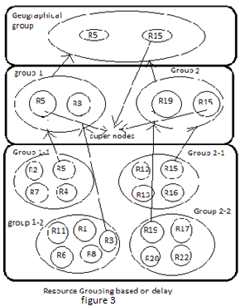

1. Properties of groups

In the proposed method, only three trust, geographical and bandwidth groups exist in the highest level. The requests for resources are analyzed and assigned to one of groups, and it is directed to the lower subgroups, until it arrives at the desired resource. The features of groups can be outlined as follow:

* All groups are open and hierarchical
* Super nodes are used to manage the group, and to maintain group information.
* To group addressing, IP address is used. Each super node has a list of its members IP addresses that is used to send and receive.
* Trust, Geographical and bandwidth groups overlap. Each node can be a member of each three groups.

1. METHODOLOGY
2. Aggregation collection operation

There may be a request with at least one of QoS or some trust value. Here, some nodes are selected based on each standard. Then, request can be met according to aggregation collection operation.

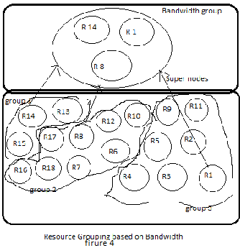

1. Difference collection operation

There may be a request with some criteria but not others. In this case, some nodes are selected based on each standard. The selected nodes set is subtracted from other nodes set in terms of QoS criteria using collection operations. For example, we may need a node with high bandwidth but its CPU is not having less then C trust level.

1. Trust Level Requirement

There may be request with criteria that it may require a CPU with trust value A, memory with trust level B and processor with trust level A. then it provides nodes based on required criteria.

1. CONCLUSION

By grid expanding and higher variety of requests, a grid system is much needed a system which responds to various requests faster and more properly. In this paper, the idea of resource grouping is presented based on Trust and QoS like delay, bandwidth. In this method, several QoS are considered in selecting the nodes simultaneously through subscription, collective, difference, combination. High speed in selecting the nodes with several services; trust and quality standard are examined simultaneously, and to select the appropriate node, collective operation can be used, and therefore resource selection speed should rapidly increases. There should be decrease of delay or waiting time; as request is conducted from the geographical group, delay would be minimal. Decrease in time for great works; for the works with great size or works with high information exchange in which information volume is very high, high bandwidth groups have been used. Scalability; since all groups are hierarchical, new nodes can be added to group.

1. REFERENCES

[1] B. Jacob, M. Brown, K. Fukui, N. Trivedi," Introduction to Grid Computing", IBM, 2005

[2] M. Li, M. Baker, "the Grid, Core Technologies", John Wiley & Sons Ltd, 2005

[3] R. Prodan, T. Fahringer, "Grid Computing, Experiment Management, Tool Integration, and Scientific Workflows", University of Innsbruck, Institute for computer Science, Springer, 2006

[4] E. Caron, V. Garonne , A Tsaregorodtsev, "Definition, modeling and

simulation of a grid computing scheduling system for high throughput computing", Future Generation Computer Systems 23 , 2007, pp. 968–97

[5] A. S. Tanenbaum, "Distributed Operating Systems", Vrije Universities,

Amsterdam, the Netherlands, Prentice-Hall International, Inc, 1998

[6] J. Huo, L. Liu, L. Liu, Y. Yang, L. Li, "A Study on Distributed Resource Information Service in Grid System", 31st Annual International Computer Software and Applications Conference(COMPSAC 2007),pp. 613-618

[7] M. El-Darieby, D. Krishnamurthy, "a Scalable Wide-Area GridResource Management Framework", Networking and Services, ICNS '06,2006, pp. 76-79.

[8] S. Chen, X. Du, F. Ma, J. Shen, "A Grid Resource ManagementApproach Based on P2P Technology", Proceedings of the Eighth

International Conference on High-Performance Computing in Asia-PacificRegion (HPCASIA’05), 2005, pp. 8

[9] J. Huo, L. Liu, L. Liu, Y. Yang, L. Li, "A Study on DistributedResource Information Service in Grid System", 31st Annual InternationalComputer Software and Applications Conference(COMPSAC 2007),pp.613-61

[10]_A._Nagargadde, S. Gopalan, v. Sridhar, "Hybrid P2P Based Self

Organizing Grids for Efficient Resource Distribution", Telecommunications, International Conference on Internet and WebApplications and Services/Advanced International Conference on, 2006,pp. 140-14.

[11] Farag Azzedin and Muthucumaru Maheswaran“Evolving and Managing Trust in Grid Computing System”