An Efficient Color DNA Barcode Identification using Image Processing Techniques

|  |  |  |  |
| --- | --- | --- | --- |
| **R.Anitha1**  Research Scholar  Dept. of Computer Sciences  Sri Sri Padmavathi Mahila Visva vidhyalayam  Email: anitharaju15@gmil.com | **S.Jyothi2**  Professor,  Dept. of Computer Sciences  Sri Padmavathi Mahila VisvaVidhyalayam  Email:jyothi.spmvv@gmail.com | **P.RameshBabu3**  Research Scholar  Dept.of Computer Sciences  Rise Prakasam Group of Institutions  Email:rams.babu18@gmail.com |  |

**Abstract**- A wide range of real time applications is using the Barcode technology for automatic identification. The computer vision techniques must be use to read barcode. The various types of codes and applications impose some special problems, so it is required to have an improved effective solution. However there are several methods for barcode localization and segmentation that are characterized by speed and accuracy. Particularly, automatic barcode localization and segmentation is needed for high-speed processing places e.g. automated production, conveyor belt. For the real-time barcode reading system, the segmentation method is proved to work well. Here we mainly concentrate on segmentation of images with 1D barcode and also concentrate the operation of different methods for 2D barcode images. Our aim is to detect an accurate feature extraction of barcode location automatically.

**Index Terms**—**Barcode detection, Morphalogical Opperations, bottom-hat filter.**

1. **INTRODUCTION**

Image analysis provides an alternative for laser scanners is barcode reading, and makes it possible to decode two-dimensional symbols. In real life applications barcode detection is required. Barcode readers are based on images implement segmentation and decoding. Many traditional barcodes are binary barcodes. Barcodes are used for various types of visual codes. While reading the barcodes in real time system there are mainly three problems for efficient segmentation. 1) When the types of the symbols are unknown, all symbols are different in texture and shape need to be segmented at one time. 2) Geometric warping and Motion blur will also be considered, the background is complex and the environment is varying. 3) For the orientation of the barcodes the method should be insensitive. In this paper, we concentrated on classical 1D barcodes segmentation. Traditional devices have been adopted for Barcodes because barcodes are not human readable and such codes can be read optically by a machine. The variation in barcodes of different thickness of parallel light and dark bars represent information. The type of codes is varying from each other based on Color bars correspond to a given character. Here we propose a novel barcode detection algorithm, which guarantee high efficiency based on bottom-hat filtering and other morphological operations. The most popular frequent application of barcodes is the trade, e.g. goods packing, where it permits identification of goods data such as manufacturer’s identification number, manufacturer’s country, and the product’s item number etc.,. The most well known element in barcode identification is the GS1 system, which is an inseparable part of trading procedures. For speedup the information streaming the identification number is visualized with symbols which permit the use of electronic reading by machines.

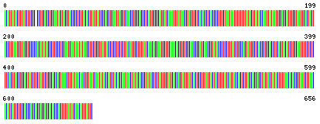

**Figure1.** A Color BarCode of an Image

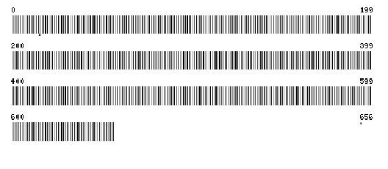

**Figure 2.**A gray scale image of Barcode image

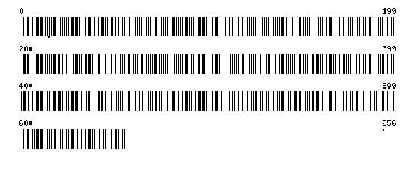

**Figure 3.** A Brute Force Thresholding of an Image

Based on the densities and sizes there is vary in the Barcodes. There are two types of Barcode. One is fixed length code, in which specifies the number of characters in a code, the other type is variable length which can have an arbitrary number of characters. These code types have some specific features which help to localization. The following figure shows a set of standard 1D barcode types of images. The localization method has two objectives. Barcode localization methods have two objectives, accuracy loss of profit. Accuracy is playing a key role since sometimes missed codes may lead to loss of profit. Speed is the secondary for the desired property of the detectors. Various techniques such as classical line scanning and morphological approaches are used to locate and decode barcodes from photographs. We propose a bottom-hat filtering and other morphological operations for barcode detection algorithm. These novel methods provide guarantee high efficiency. We compare with several approaches from the literature survey and show that this algorithm is more effective and performs well.

1. **RELATED WORK**

Barcode classification has been studied optimized for decades and it is represents a consolidated industrial standard. However, it became to use more expensive hardware for barcode reading. There are some commercial scanners like those used in supermarket, focus the light on the barcode and measure the intensity of the light reflection. The extracted scan lines are very high quality. The first step for barcode interpretations is its localization. Binary image methods are Existing methods for localization.

The other approaches are estimating the width of all the bars in the barcode from the binary image. The following figure shows the process of the identification of Barcode.

Barcode Image

Thresholding

Pattern Matching

Key Generation

Barcode Image

Thresholding

Pattern Matching

Key Generation

1. **PROPOSED SYSTEM**

In proposed system we are building a system which processes a Barcode image to remove noise and performed the classification to get a perfect result. After reading a color image we are converting it to the grayscale image and performing filtration operation to remove the noise on it. Then apply the thresholding algorithm and post filtering process we are generating a bit-pattern for template matching. We follow the following steps

* Capture the image through image scanners
* Apply Gray scale algorithm to convert into gray scale image.
* Apply the filtering techniques to remove the noise.
* Apply the Thresholding algorithm to extract the features.
* Barcode detection.
* Template Matching.

**REFERENCES:**

[1].Stephen Johnson, “Stephen Johnson on Digital Photography”, 2006.

[2]. Shapiro, L. G. and Stockman, G. C, "Computer Vision", page 137, 150, Prentence Hall, 2001.

[3].Mark S. Nixon and Alberto S. Aguado, “Feature Extraction and image Processing”, Academic Press, pp. 88, 2008.

[4].Gonzalez, Rafael C. and Woods, Richard E., “Thresholding”, Digital Image Processing, pp. 595–611. Pearson Education, (2002).

[5]. E. Tekin and J. M. Coughlan, “An algorithm enabling blind users to find and read barcodes,” in Applications of Computer Vision (WACV), 2009.

[6]. P. Bodn´ar and L. G. Ny´ul, “Efficient barcode detection with texture analysis,” in Signal Processing, Pattern Recognition, and Applications, Proceedings of the Ninth IASTED International Conference on, 2012,pp. 51–57.

[7]. R. C. Gonzalez and R. E. Woods, Digital Image Processing. Prentice Hall, 2007.