Utilization of TVWS for high speed Wi-Fi application

Bishal Dey Sarkar1 , Sonali Shankar2, Arun Kumar Singh3

1,2Student, M.Tech. WC, Amity University, Noida, 3Additonal Vice-President, Tata Teleservices Ltd., New Delhi  
[bishaldeysarkar6891@gmail.com](mailto:bishaldeysarkar6891@gmail.com), [sonalishankar03@gmail.com](mailto:sonalishankar03@gmail.com) , [arunkumar.singh@tatatel.](mailto:arunkumar.singh@tatatel.)co.in

Abstract— **Unutilized or under- utilized UHF (Ultra High Frequency) licensed TV spectrum band is known as TVWS (Television White Space). FCC has evaluated that most of the uhf band used for TV transmission is being unutilized. This paper aims to discuss how efficiently the unutilised licensed band spectrum can be used for the purpose of creating a super high speed Wi-Fi (Wi-Fi 2.0) which can provide data rates of gigabits per seconds and their future opportunities and unique advantages. Since in TVWS the channels are of variable length based on availability, a comparison is done for varying channel width with the help of BER and SNR.**

Keywords- **UHF, FCC, Wi-Fi2.0, TVWS**

1. Introduction

Within the last 5 years there is a huge incrimination of smart phone users that ranges up to 70%. This huge increase demands the high speed Wi-Fi as with the more number of smartphone users, the Wi-Fi users also increased with the same amount. In this case, the TVWS band came as a bone and is largely a matter of importance. TVWS comes under the UHF band ranging from 300 MHZ to 3 GHz. Currently the operating frequency of Wi-Fi is 2.4 GHz as well as 5.7 GHz, which is a bit high[1]. The frequency and wavelength are inversely proportional to each other, so if there is an increase in the frequency then wave length decreases and with the decrease in wavelength the signal is easily attenuated and it will not be able to travel longer distance and will also face problems while penetrating walls and buildings. With higher frequency, power demand is also high for transmitting and receiving the signal. Also, higher frequency leads to more complex hardware and software which in turn effects the cost factor [2][3]. These drawbacks are compensated by using TVWS band for Wi-Fi application since the frequency used for wifi lies in UHF band, proving long range wifi with improved speed. Wi-Fi. Scarcity of spectrum demands to innovate new technologies that will if not remove the problem, then at least reduce it to minimum. As a result of this, the “Hybridization” of even channels has taken place. Here, the same TVWS channels are used for portable as well as for fixed licensed devices with the principle of “Sensing before Sending” (SS). Digital Switch Over (DSO) vacates the large amount of TV spectrum which was before used for analog TV leaves us with an advantage of using those vacant bands for other applications with the “safe harbor” principle introduced by Google.

The FCC order to use TVWS for fixed as well as personal/portable devices is revolutionary in the telecom industry which was facing the problem of spectrum shortage at its peak [4]. The analog TV signal which was before using approximately 8 MHz of bandwidth (BW) for one channel, after digitization has reduced to almost 2 MHz. This spare bandwidth can be used to create another channel thus increasing the number of channels along with the capacity of the network [5]. These licensed unused portion or white spaces can be used for the purpose of super speed Wi-Fi. Presently Wi-Fi networks are based on 802.11g which roughly provides the data transfer speed of around 54 mbps. The simulation model is created in a Matlab where OFDM modulation and demodulation is done by varying the channel bandwidth of 2MHz, 4MHz, 6MHz and 8MHz and also varying the channel specification as using different fading techniques [6]. The simulation for frequency selective channel then for flat fading channel and at last for no fading channel is done. In wireless communication, fading is the process of gradual decrease in the signal strength due to variations in the conditions in the transmission medium. When a channel experiences fading then it is called fading channel. There are various types of fading channels such as frequency selective fading channel, flat fading channel and no fading channel. When all the frequency components of the signal experience the same magnitude of fading then it is a flat fading. In flat fading the bandwidth of the signal is smaller than the bandwidth of the channel. If N is discrete fading path with its own average power gain and delay then a channel with N=1 is also defined as flat fading channel. In frequency selective fading the bandwidth of the signal is larger than the bandwidth of the channel, therefore all the frequency components of the signal will experience uncorrelated fading. When N > 1 then also we can say it as a frequency selective fading. When fading is absent in the channel than it is known as No fading channel or Additive White Gaussian Noise (AWGN) channel. Additive means the signal that is received at the received end includes transmitted signal along with some noise. White means that power is uniformly distributed throughout the frequency band for the information system.

In section II, the evolution mechanism for the proposed high speed wifi is discussed which utilises the TVWS band for signal transmission [7]. Section III through some light on the easy and safe usage of the proposed method where as in section IV, the comparative study of different variable length fading channel is carried out with respect to BER and SNR curve where reduced BER represents the effectiveness of using TVWS for wifi applications. BER and SNR can also be calculated theoretically by using equation (1) and (2),

$BER=\frac{1}{2}erfc(\sqrt{E_{b}/N_{0}})$…. (1)

SNRdb=10log10(Es/N0)……...(2)

1. Evolution Mechanism

Here the value configuration scheme to understand the working principle of spectrum trading is used [8]. There are actors and technical components. Actors interacts through business interface where as technical components interacts with the help of technical interface. It includes mobile operators (MO), local area operators (LAOs) and mobile operator subscribers (MOS). The demands of the MOS are served by MO using the cellular network architecture. And in between both the parties the agreement is based on data subscription by business interface. If demand of MOS is high for the data then MO is failed to meet the needs of MOS. And it may happen that within the particular area LAO has excess amount of capacity but they can’t get help from each other because there is no such interface through which they can interact, therefore there is a mismatch that occur between the data demand and data supply.

Fig. 1 shows the main block diagram for the evolution mechanism. The evolutionary steps includes Wi-Fi capacity, Super Wi-Fi capacity and leasing spectrum.

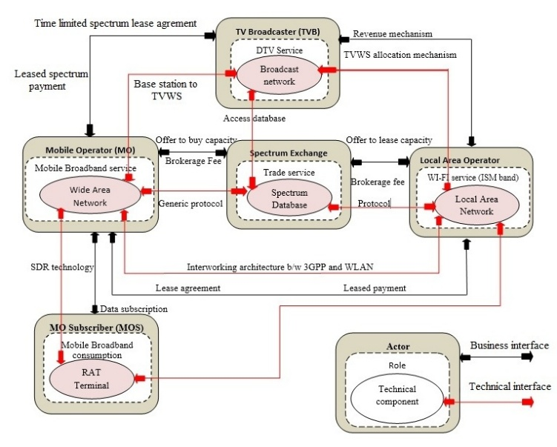

Fig. 1: Value Network Design of market mechanism

*Wi-Fi capacity: -* Here a new entity i.e. Spectrum Exchange which acts as a intermediate between the demand and supply sides is implemented. Fig. 2 shows Wi-Fi capacity market scenario. With the help of spectrum exchange the problem of spectrum mismatch is solved. The spectrum exchange serves as a database that contains all information regarding the LAOs in a particular geographical area. Whenever there is a demand from the MOS the spectrum exchange acts as a broker and it searches in the database that which LAO can provide that much required amount of capacity. If the spectrum exchange finds the same then MOs buys the capacity and after that they get the right to use the spectrum for a temporal amount of time.

*Super Wi-Fi capacity*: - It is termed as super Wi-Fi because it operates in TVWS. Here MOs, LAOs, spectrum exchange and television broadcasters (TVB) are assembled. The role of spectrum exchange is same i.e. it is a database but the any difference is that it stores all the data that are related to TVWS. So it is also known as TVWS database. Basically it is a 3 tier interaction, in the first tier LAOs ask the TVB for the spectrum then TVB search it in spectrum exchange if any spectrum is available in the database then it provides the spectrum to the requested LAOs. Whenever LAO gets the available white spectrum then it can access it as an unlicensed user. The spectrum exchange also maintains many other details such as for what amount of time the particular local access operators(LAOs) is able to use the spectrum and also notes that two different LAOs can not get the same spectrum at the same time else they both will suffer interference. Between TVB and LAOs there exists a sharing mechanism. In the second tier the interaction between LAOs and MOs takes place with the help of spectrum exchange. After that, the spectrum exchange supplies the spectrum to the MOs or in other word TVB is the indirect supplier to the mobile operators. And in the third tier MOS get the required services. In this way unused portion of the licence spectrum can be used to generate Wi-Fi like services. Fig. 3 shows Super Wi-Fi capacity market scenario.

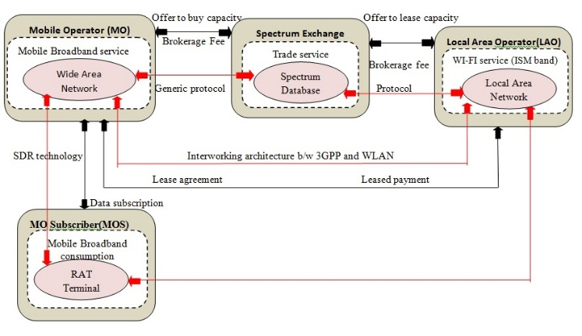

Fig. 2: Wi-Fi capacity market scenario

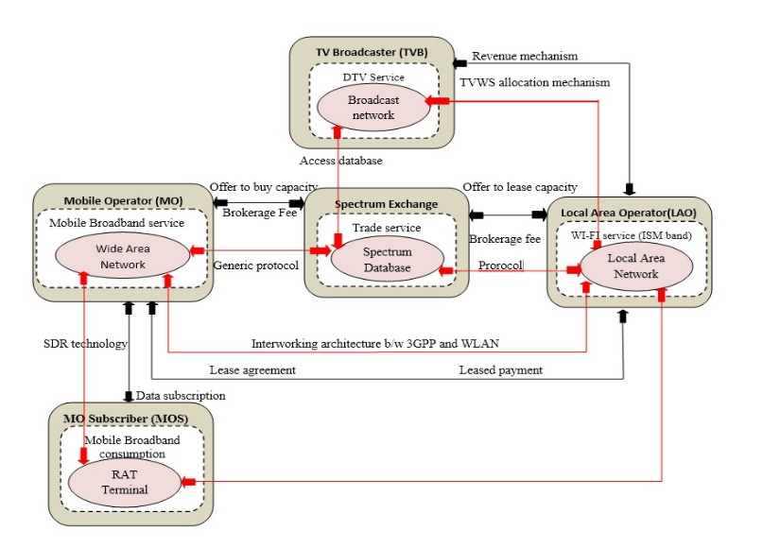

Fig. 3: Super Wi-Fi capacity market scenario

*Leasing spectrum: -* Fig. 4 shows TVWS spectrum leasing market,basically there are two types of MOs, licensed MOs and unlicensed MOs. Those that are unlicensed they can get the spectrum by the previous method and those MOs which are licensed can get the spectrum directly from the TVB. MOs can get the spectrum by auction mechanisms which is done by spectrum exchange. There are some licensed MOs that takes part in the auction and the one who wins the auction get the exclusive rights to use the allotted TVWS.

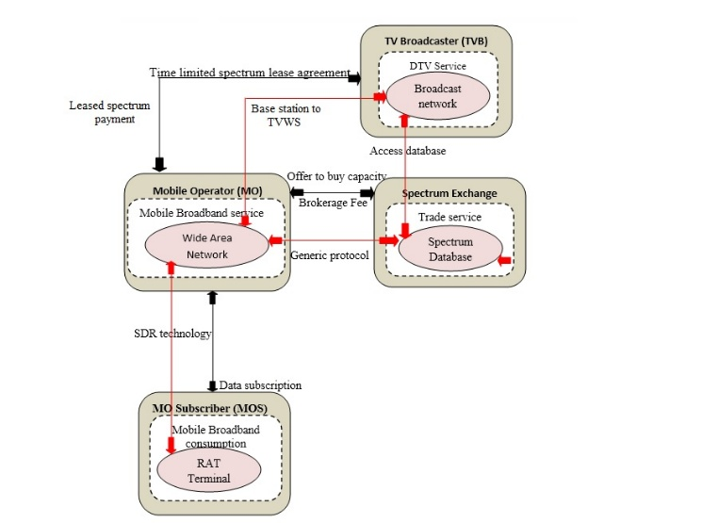

Fig. 4: TVWS spectrum leasing market

1. Ease Usage And No Risk

Here the can the hybrid approach can be used so that it can easily combines with both the fixed unlicensed and unlicensed portable/personal devices. And this approach provides benefits like low cost, easy to installation, easy to use and long distance connectivity. Mobile users can get it all kinds of platforms such as in Android, Microsoft etc. Consumers can enjoy connectionless and robust Internet access when travel long distances [9][10]. Users are authorized to download lawful applications and utilise them. With the help of such spectrum utilisation both the government and LAOs, MOs and MOS get the benefit for the unused portion of the spectrum. Government got paid from the LAOs and MOs, LAOs and MOs provide free high speed Internet at very low cost which is very beneficial for MOS.

There are certain problems when dealt with TVWS, so to solve these problems there are certain mechanisms that can be adopted. Creation of a database that stores all the details of the licence television channel and their respective locations in a particular geographical area is one of them. The other device that wants to use the spectrum first have to establish its location with the help of GPS or by other mechanism and then it will search the database for the available spectrum, to avoid conflict only licensed users are permitted to do so. The channel number 37 is already being used for the purpose of wireless microphone, radio astronomy as well as in medical telemetry. Wireless microphones are being used by conference members, News crews and others to avoid these problems a beacon device can be created, which broadcast the fact that the channel is currently in use in a particular area and no other TVBS users can send data on the channel. TVBS devices first receive the “all clear” signal from the channel and then it will start transmitting in the channel. Any other device without database access and geographic location are not permitted to access the channel. For more protection a “safe harbor “is created. Safe harbor contains channel from 36 to 38 and it will ensure that no other device are permitted to send data on these channels.

1. 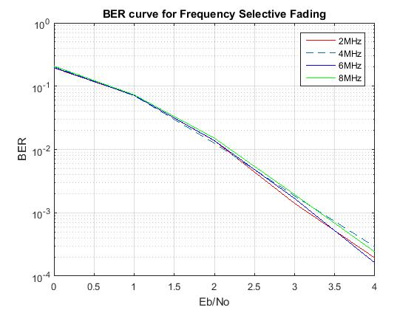Results

Fig. 5(a): BER curve for Frequency Selective Fading

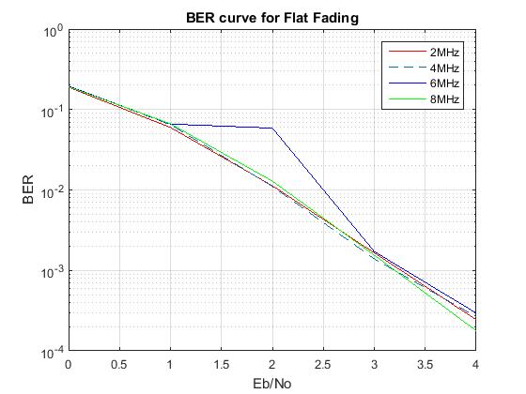

Fig. 5(b): BER curve for Flat Fading

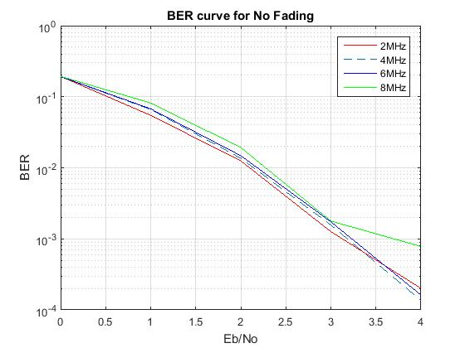 Fig. 5(c): BER curve for No Fading

There are various types of fading channels such as frequency selective fading channel, flat fading channel and no fading channel. The proposed mechanism implements the variable length channels therefore the graphical representation is done using channel width of 2, 4, 6 and 8 MHz. Fig 5(a) shows the BER curve for selective fading, Fig 5(b) shows the BER curve for flat fading and Fig 5(c) shows the BER curve for no fading. The BER curve for different channel fading at different channel width is obtained. The low BER of TVWS is responsible for its implementation in high speed wifi. In a same way SNR is also calculated for different channel fading with flat fading channel with high SNR value as shown in fig 6.

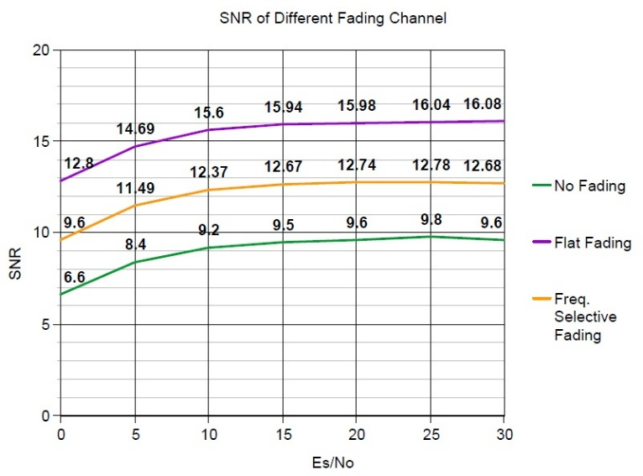

Fig. 5(c): BER curve for No Fading

1. Conclusions

Bandwidth deficiency is one of the major hindrances to the path of advancement faced today. Therefore, to find the new ways for the efficient use of spectrum has become the need of time. In this paper, the focus is made on the use of vacant band which was used before in analog TV transmissions for high speed Wi-Fi along with the licensed applications with least possible interference. Digitization has decreased the pressure on bandwidth scarcity to pretty good extend. The low BER of TVWS is responsible for its implementation in high speed wifi in a proposed method.

ACKNOWLEDGMENT

Express gratitude to the Amity University and Tata Teleservices Ltd. that has provided a platform to explore the ideas and think out of the box and come up with the new innovation.

References

1. IEEE802.11af Task Group. <http://www.ieee802.org/11/Reports/tgafupdate.htm>
2. M. Fitch *et al.*, “Wireless service provision in TV white space with cognitive radio technology: A telecom operator’s perspective and experience,”*IEEE Commun. Mag.*, vol. 49, no. 3, pp. 64 –73, March 2011.
3. M. R. Brew, F. Darbari, L. H. Crockett, M. B. Waddell, M. Fitch, S. Weiss, and R. W. Stewart, “UHF white space network for rural smart grid communication,” in *2nd IEEE Smart Grid Comms Conf.*, Brussels, Belgium, Oct. 2011, pp. 138–142.
4. FCC, “Second memorandum opinion and order - in the matter of unlicensed operation in TV broadcast bands ET Docket No. 04-186 - additional spectrum for unlicensed devices below 900 MHz and in the 3 GHz band ET Docket No. 02-380.” 2010.
5. Federal Communications Commission. Second Memorandum Opinion and Order: In the Matter of Unlicensed Opeartion in the TV Broadcast Band and Additional Spectrum for Unlicensed Devices Below 900 MHz in the 3 GHz Band. [Online]. 2010. Available at:http://www.fcc.gov/Daily Releases/Daily Business/2010/db0924/FCC-10174A1.pdf.
6. M. Payaro, A. Pascual-Iserte, M. Na Jar, Performance comparison between FBMC and OFDM in MIMO systems under channel uncertainty. In Proc. IEEE European Wireless EW 2010. Lucca (Italy), 2010.
7. IEEE 802.22 Working Group on WRANs, <http://www.ieee802.org/22/>.
8. H. Harada, K. Ishizu, H. Murakami, “Research and Development on White Space Dynamic Spectrum Access Broadband Radio Systems,” IEICE Technical Report, Vol. 111, No. 261, SR2011-76, pp. 199-206,Oct. 2011.
9. Achtzehn, M. Petrova, and P. M¨ah¨onen, “Deployment of a cellular network in the TVWS: A case study in a challenging environment,” in *Proc. ACM CoRoNeT*, Las Vegas, 2011.
10. S. J. Shellhammer, A. K. Sadek, and W. Zhang, “Technical challenges for cognitive radio in the TV white space spectrum,” in *Information. Theory and Applications Workshop*, Feb. 2009, pp. 323–323.