**Research Initiatives in Supply Chain System for Drug Delivery and Management System**

***Abstract:*** Government of India has initiated several programs to provide health benefits to the ultimate beneficiary who is a common man of India. The major thrust is to provide the perk in transparent manner without any pilferage. Free Drug Distribution is one of thrust area for all the State Government and Government of India. Information Technology enablement of the scheme was the only option to meet the objective of the Government. The ulterior motive of the research work is to gradually transform a lucid and intelligible Inventory Management System into a well-organized and competent Supply Chain Management of Drugs To commence with, the system is a complete blend of standard procedures offered by GS1 Standards and MDDS (Metadata and Data Standards), further grouped with heterogeneous enhanced processes like Digital Signature in PO/Acceptance Certificate, Categorization of Drugs as per CIMS, GFR (General Financial Rule) for defining the rules for procuring the drugs and many more. The paper also focuses on various innovations like Desktop application', which grips the complete application without using internet connection, that uproots and upgrades the system into a more competent application in rural areas. The research adopted variant mathematical analysis and algorithms to manage inventory and predict future requirement of drugs. The paper even illustrates a staple and customary procedure to not only manage Drug Inventory, but create a benchmark for same.

Keywords—Supply Chain Management System, Drug distribution, Standard Procedures, GS1 Standards

I. INTRODUCTION

A well-driven and successfully implemented Supply Chain Management System, altogether known as e-Aushadhi. This system radically targets at transforming an ordinary supply chain management system into a commixture of certain broad processes with all new advancements.

The fundamental overflow is accorded with compilation of Annual demand from various Sub Stores, generation of purchase order and Challan, quality check and finally distribution of drugs to patients.

With reference to other Supply Chain Management Systems, there is always disorientation between practical implementation and documentation regarding system. However, this is not the case with e-Aushadhi, various research implications and advancements had transfigured the system completely according to standards.

II. PROBLEM IN TRADITIONAL SUPPLY CHAIN MANAGEMENT SYSTEM

Obsolete and slow moving Inventory management is the main detriment that needs to be conquered in prevalent and more effectively refined Supply Chain management System. In existent System, fruition is directed and added feature of customer satisfaction in accordance with an increased speed to market changes in terms of item rates and technology enhancement. A proper authenticated System is being provided to the user by following certain standards that are defined world-wide to limit the occurrence of slip and scrutiny.

III. RESEARCH INITIATIVES AND ITS METHODOLOGY

Our research work includes various contrasting features that we have tried to include in our system to make it more gainful to the end users. The ingenious research work is being categorized as under:

1. Barcode Reader and its utilization in various processes:

There are circumstances where a petty human fallacy leads to hindrance in service against mankind. This is the same scenario that used to arise while receiving and distributing drugs to patients. A purchase Order generation is one such process in which Bar Code reading proves highly favorable. GS1 standard Bar

Code reading is being done by using GTIN 14 i.e. Global Trade Item No. The description is as below:

|  |  |  |
| --- | --- | --- |
| Standard | Application Identifier | Explanation |
| Global Trade Item No. (GTIN-14) | 01 or 02 | GTIN-14 can be formed by adding a preceding digit as a logical variant (a number between 1 and 8) to GTIN-13 format. |

Table I. GTIN 14 Standards

Following GS1 standards, there are considered three levels of packaging and bar code reading. The code structure is in Data Matrix and GS1-128 format. There are three levels of packaging and each packaging involves bar codes with all new attributes denoting some or other features. [2]

Methodology Used:

For example: - Consider the following example of bar code that deals with explanation of various attributes.



Fig I Bar Code on primary packaging

a. Unique product identification code (GTIN-14)

b. Expiry date

c. Batch No.

d. Unique Serial No. of the Secondary pack {Serialization}

Benefits & Future Scope:

The person caused due to the human flaw may figure out the boon well. Usage of bar code reader has diminished the possibility of wrong delivery of medicines. Moreover, this mechanism has downsized the time at both supplier’s end and receiver’s end. Also the future extension includes the usage of this mechanism in various other processes like Physical Stock Verification, Condemnation; Issue to patients or to third party and in receiving same from them.

## Digital Signature:

## A Digital Signature is nothing but a construct which helps achieve non-repudiation of Origin of a particular data. By digitally signing the document, it is assured that the person who signs is the author of the document or the message that was signed.

As we all are aware that confirmation is necessary, and authentication from correct person is the main consideration especially in areas that deals in areas related to health information. There are disparate scenarios in which a malicious person can tamper with personal information whether it is related to drug distribution or managing the stock well. To prevent this case, digital signature has been in-built in the system. Processes like Challan Receive Process, to accredit a supplier with respect to delivery he made. A valid digital signature gives a recipient reason to believe that the message was created by a known sender, such that the sender cannot deny having sent the message ([authentication](http://en.wikipedia.org/wiki/Authentication) and [non-repudiation](http://en.wikipedia.org/wiki/Non-repudiation)) and that the message was not altered in transit ([integrity](http://en.wikipedia.org/wiki/Data_integrity)).

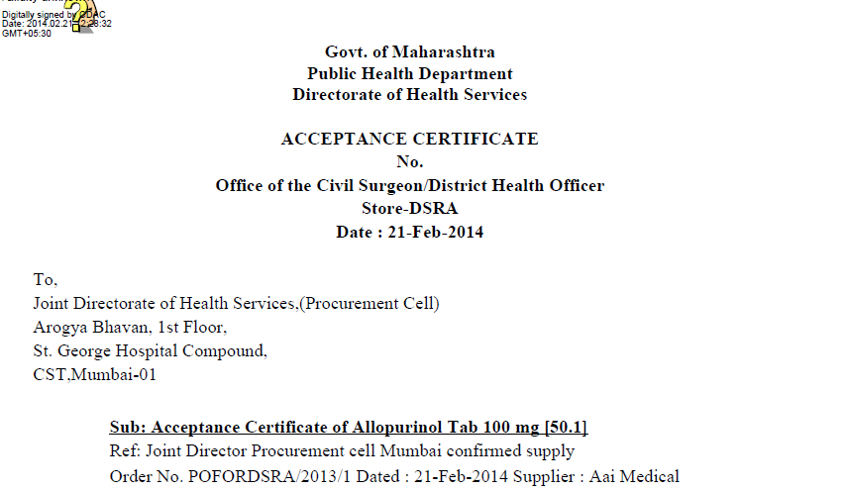

Fig IISnapshot of implementation of Digital Signature

Methodology Used:

Digital signature is being carried out by generating a pfx file with the signature. Each user will have the .pfx file of his digital signature that can only be included in the document via correct userId and password. There are two main security points that need to be followed while setting up Digital Signatures in such web based applications:

1. Sign the message and then encrypt the signed message
2. Instead of whole message, sign the hash of the message.

Following steps and algorithm is being used while implementing Digital Signature:

For Committee to send Supplier a private message only Supplier can read, she performs the following operation on the message (M):

**C = MeSupplier mod nSupplier**

Supplier, who is the only one to possess his private key (dSupplier), performs the following to recover the message (M):

**M = CdSupplier mod nSupplier**

To sign the message, Committee encrypts with her own private key:

**C = MdCommittee mod nCommittee**

Because only Committee possesses dCommittee, only she can create this ciphertext C. Anyone in possession of her public key (eCommittee and nCommittee) can verify the signature, however:

**M = CeCommittee mod nCommittee**

It bears note that (p) and (q), the factors of (n), are not needed for encryption or decryption; they are only used in the key generation step (creating the modulus (n) and the second exponent). In addition, while it is important for key generation purposes that the modulus (n) be the product of two prime numbers, the exponentiation and modular arithmetic operation would work just as well with prime numbers. [1]

Benefits & Future Scope:

Authentication provides a feel of security and aimmune transaction of processes without inclusion of a third party malicious user. Future scope includes its usage in Issuing medicines to patients by only authenticated person or in any other process that demands verification.

1. Desktop Application:

Unavailability of network and internet leads to shut down of several applications world-wide. However, this problem can be overcome by a novel and topical effort by developing a desktop Application. There are areas where internet and network fails to connect, and these are such areas where mankind needs to be highly proved by serving people, providing them good health facilities and medicines.

Methodology Used:

Desktop Application demands complete functioning without use of scripts and internet connection. Due to this limitation, javaFx is one of the technologies that provide the best User interface designing ability. Data import and export is carried out using XML files and an inbuilt database Derby.

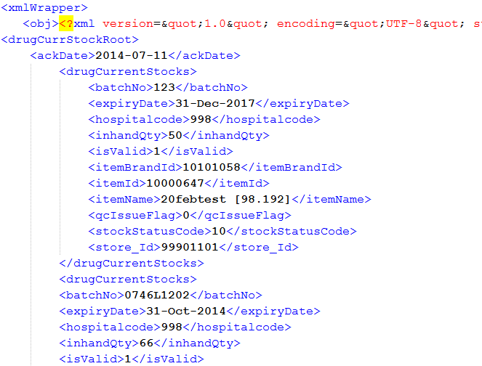

Fig III Snapshot of XML file used for import export of data

The system acts as a full-fledged application and endures synchronization with main application server at regular intervals. [3]

Benefits & Future Scope:

The circle that is highly benefitted by this development is none other than the common person in rural areas. No internet connection, no proper facilities and still a more appropriate Supply chain management system illustrate that following some standards and technology cannot hinder the functionality of any system.

1. Item Categorization:

Due to up growing health issues and diseases, there needs to be a well-developed medical system that can identify the disease and can prepare a better solution for it. With increasing medical facilities and drugs, there needs to be a categorization for them that can lead to identification of same easily.

Methodology Used:

With reference to the Supply Chain Management System for drugs, they had been categorized based on distinct norms:

1. Programmes available or opted by government depending on health scenario of a particular location.
2. Based on the type of Drugs, for example: Anesthetics, Anti allergic etc.
3. Based on the permission from Doctors and specialists.
4. Based on the effects from other medicines, if given to same patient.
5. Based on Batch No. assigned to a medicine.

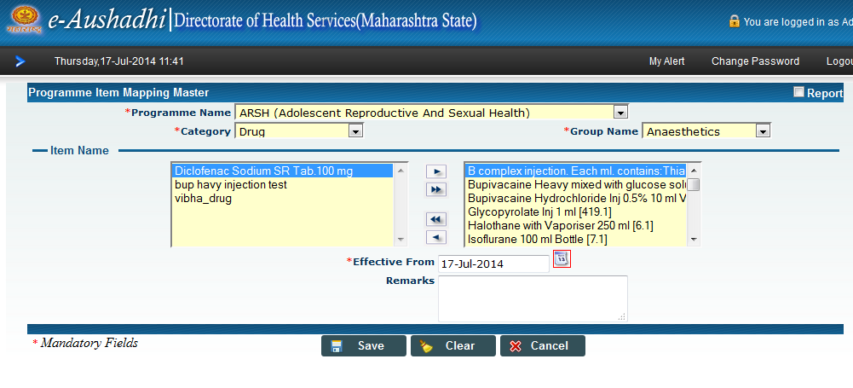

Fig IV Snapshot of Item Categorization under various Programmes and drug type.

Benefits & Future Scope:

This categorization helps in easily distinguishing the medicines from one other with respect to the disease caused. Moreover, it provides the best flipside for tracking the making, manufacturing and other specifics of same that can be constructive in case of any miss happening. Future Scope may include further categorization based on certain disease active in any area for a particular time or any other categorization based on effects from drugs to aclique of patients.

1. General Financial Rules:

There is possibility in supply chain management system that for drug and inventory management, one needs to follow certain rules. These rules had been followed in the system for standardization and proper management of monetary transactions among suppliers and committee.

Methodology Used:

A well-known module named as purchase module had been developed strictly following GFR. GFR includes tendering, bidding, quality check approval, purchase transactions etc.

There are manifold GFR Rules that have been incorporated into the System:

1. Rule 136 for Definition of Goods.
2. Rule 152 for Two Bid System
3. Rule 154 for Single Tender Enquiry
4. Rule 158 for Performance Security

Benefits:

These standards helped in shaping the system into a well-organized manner.

1. Standardized Report Formation:

Managing high amount of data with all the forecasting of drugs and budget allocation, it demands proper and standardized reports with the help of which information can be tracked and utilized.

Methodology Used: Major reports are being categorized under MIS Reports popularly known as ‘Management Information System Reports’ that uses various algorithms like ABC Analysis, Forecasting Algorithms, etc. These reports basically aim at displaying the information at statistical level using various data charts and tables.

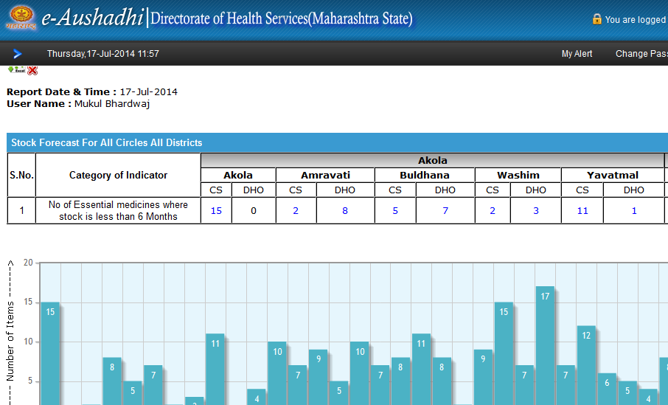

Fig V Snapshot of implementation of MIS reports

Benefits & Future Scope: Transformation of data into a graphical manner improves the readability by user and management of statistical data well. Critical data and its related information prove to be highly propitious with the help of these reports. Future Scope includes graphical representation of diverse processes as per user requirement or system demand.