**Standard Operating Procedure for Supply Chain Management**

***Abstract*—**The foremost drive of this research paper is to standardize certain issues that burst out while handling a Data Management System, specifically A Drug ware House Management System, designed serve common people in rural and urban areas. This paper will offer certain guidelines for implementing an application to manage inventory and supply chain tobe implemented in any state. The paper will figure out a standard procedurebased on MDDS (Meta Data and Data Standards) for healthdomain. Also the paper will discuss certain challenges faced bya Management System due to lack of dexterity and efficiency inrural areas.

***Keywords*— Drug Ware House, Inventory Management,Data Management Standards, Identifiers, Standardization, Common Data Modeling**

1. Introduction

There are various Health Management Systems these days that focus on serving people with best facilities it can provide both in rural and urban areas. However, these days certain standards need to be followed to manage such operations and procedures. Setting up a management System is comparatively easy than managing the whole data flow, which is the main view point that needs to be standardized. These standards are given by a general supply chain management system, and from now we will be focusing on same to cater all the problems that exist while serving the patients.

There are certain problems which are addressed by SCM:

* Network Configuration
* Distribution Strategy
* Management of Raw material and Finished goods
* Trade-offs in logistical activities
* Information Management

Various supply chain management system have been implemented worldwide, however the standard procedure has not yet been defined. This paper will discuss the case studies of four web application ‘e-Aushadhi- Rajasthan’,

‘e-Aushadhi- Maharashtra’, ‘e-Aushadhi- Punjab’, ‘e-Aushadhi- Odisha’ which will conclude the guidelines, that is to be followed while implementing a Supply Chain Management System.

There are certain points that are to be kept in mind while creating an idea of an efficient Supply Chain Management. They are described as follows:

1. Every product that reaches end user is a cumulative effort of multiple organizations, not a
2. single one and these organizations are collectively referred as supply chain.
3. Supply China is not only paying attention to the functionality within four walls; it is entire chain of activities that ultimately deliver product to the final customers. These activities are actually less managed and less attention seeker.
4. It covers everything from production, logistics, sourcing and product development.
5. Methodology And Standard processes
6. Identifiers and their types:

Identifiers refer to the accurate identification of person/facility receiving or providing health services, also anyone using or accessing these services.

Healthcare Identifiers are necessary to ensure that patient related information is accessed by right persons and individual patient records are not duplicated across multiple systems. There are various identifiers that need to be considered. They are:

* Patient Identifiers: To uniquely identify a patient, there shall be a universal identification number, i.e. Aadhar Number. However in case patient does not have Aadhar Number a provision has been made for the use of Alternate ID, issued by any other competent authority e.g. Election ID, Driving License ID, RationCard ID, PAN Card ID, BPL ID etc.

These Id’s can be used at Health department System to cater the information that what drugs have been issued to the patient and related to what disease.

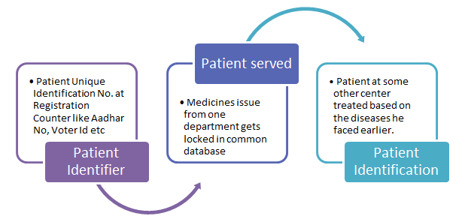

Fig I. Patient Identification work flow

* Disease Identifiers:Each disease shall be identified uniquely by any particular codes that shall be same for complete system. These codes are precisely known as ICD Codes which are again linked with certain departments and doctors serving those departments.

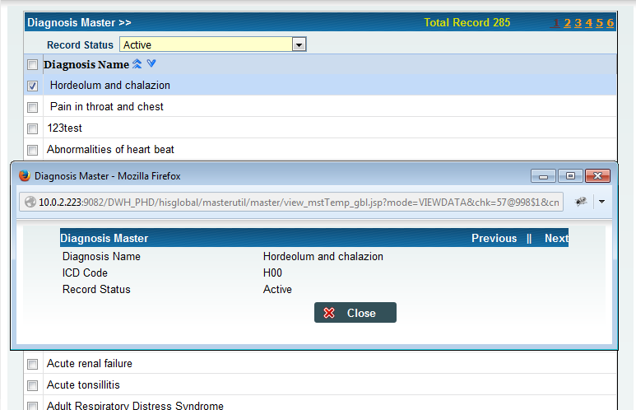

Fig II.Screenshot of Disease Master

* Drug & Inventory Identifiers: Each drug whether generic or brand is given a unique identifier. For generic names– drug list from National Formulary of India (NFI) is used as the code directory. These drugs are again categorized into sub categories like Ayurveda, eye drops, cream etc.

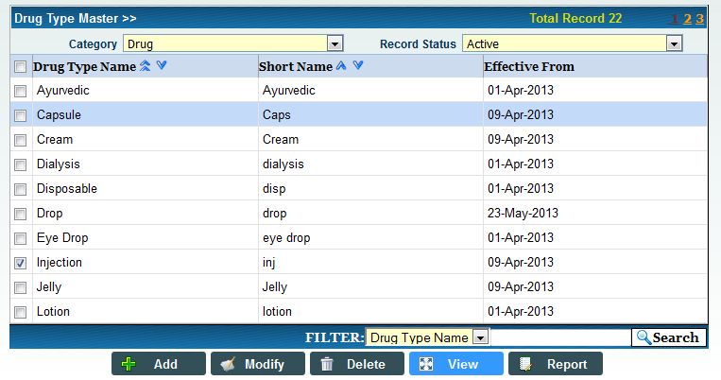

Fig III.Screenshot of Drug Master

* Lab Identifiers: For laboratory procedures and various laboratory tests, unique code shall be defined.
* Financial Identifiers: Source of payment and billing need to be identified for different procedures, medications and billings.
* Program Identifiers: These are the identifiers that help any medical corporation to categorize the medicines under certain Programmes. This categorization will help in auditing as well as in determining the usage of medicines for particular and specific diseases. Examples of Programmes under MDDS are Mother and Child Tracking System (MCTS), Revised National Tuberculosis Program (RNTP).

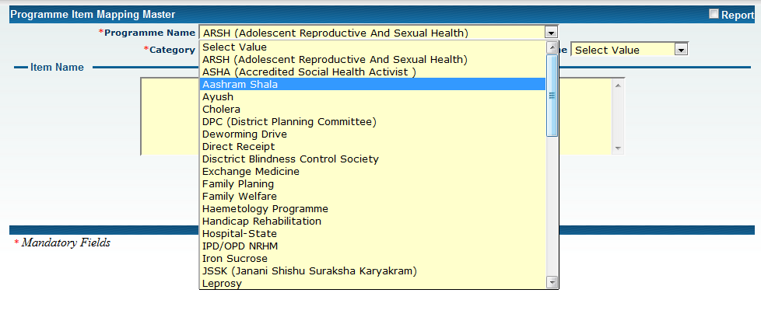

Fig IV.Screenshot of Programme Master

1. Detection of Common Data Elements

There are cases in which the organizations want to change their data quickly between different computer systems without paying much attention to semantic interoperability. For example: If a hospital application sends the insurance reimbursement bill to insurance company/government, the recipient application should be able to understand and represent the same meaning of bill information.Based on certain ideas and data modeling designs, organization need to follow certain principle domain to frame their data.

Data Element:The basic principle of data modeling is the combination of an Object class and an Attribute to form a more specific ‘data element concept’. For example- the abstract concept ‘Frequency of Medication’ is combined with the object class ‘Medication Order’ and is associated with Attribute ‘Frequency’ to form the data element concept ‘Medication Frequency’. The standard must select the most appropriate keyword as the representation of the concept. In the above case the

* **Object:** is ‘Medication Order’ and,
* **Attribute:** is ‘Frequency’

Value Domain: A value domain is the permitted range of values for a concept. If the data element concept has a single value then it will remain as a single data element. If it has a limited set of values attached to it then it will have a value list. If the data element has a long list of values that are liable to change or be modified due to the business needs of the health domain then it is advisable to create a Code Directory for those values.

|  |  |
| --- | --- |
| Example | Depiction of Health Condition |
| Data Element | Health Condition Code |
| Object | Health Condition (Dengue) |
| Attribute | Code DE-101 |
| Value Domain | DE-10 code for DE1.0 |

Table I. Illustration of Common Data Elements

1. Inventory Management and Analysis:

The scope of inventory management concerns the fine lines between asset management, inventory forecasting, inventory valuation, inventory visibility, future inventory price forecasting, physical inventory, available physical space for inventory, quality management, replenishment, returns and defective goods, and demand forecasting. Balancing these competing requirements leads to optimal inventory levels, which is an on-going process as the business needs shift and react to the wider environment.[2]

Analysis of Inventory and demand forecasting plays a necessary role while Inventory Management. For analysis, what a system requires is the past and current demand or record based on which analysis can be done. There are certain methods of analyzing inventory based on various parameters.

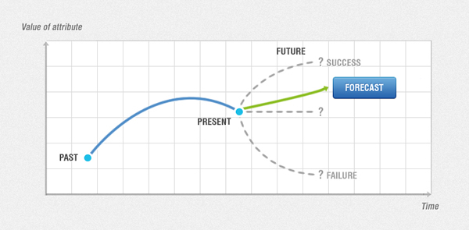

Fig V. Drug Forecasting based on previous records

1. Selection of Suppliers on different Perspective

Role of Supplier and their selection is a crucial part in terms of delivery for drugs. Medicines being the essential part of life, compromise in quality and time are not acceptable. One of the key to successful supply chain management system is based on the cooperation and mutual decision between suppliers and consumers.

Selection of Suppliers needs to be based on certain selection criteria:

1. Document & Process Accuracy
2. Perfect Order Delivery
3. Continuous Communications
4. Supply Chain Responsiveness
5. Coordinated Continuous Improvement
6. Vendor Managed Inventory [6]

There are certain mandatory processes that need to be added in Supply Chain Management System:

1. Supplier Interface Desk: This desk will provide information regarding suppliers and Purchase Orders filed against them.

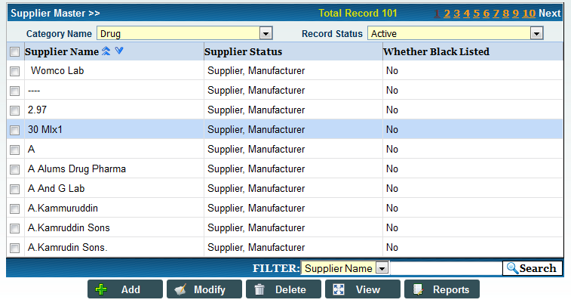

Fig VI.Screenshot of Supplier Master

1. Challan Process: which states that Challan has to be generated when Supplier deliver the material and accepted by consumer.
2. Supplier Grading Master: This process will let the consumer grade supplier based on the products he has delivered. Same process may help other consumers in selecting their appropriate suppliers. [8]
3. Detection of drug distribution Network:

Identification of distribution network for the distribution of drugs is essential. Due to high topological diversity, there has to be a proper distribution network. To make such disparities interoperable, there have been defined three options:

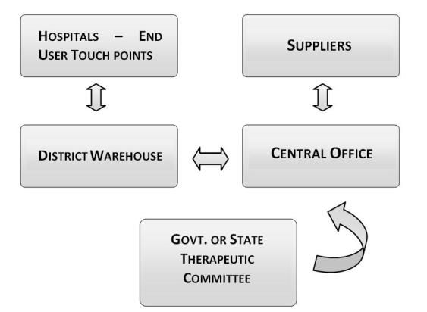

Fig VII. Drug Distribution Network

* Point to point:states that there will be direct connection between consumer and producer. This is however expensive to maintain and the resultant solution will end up with approximately ${(X)}^{n}$ point-to-point connections for 35 States and UTs.
* Broker Based:This requires setup a centralized data warehouse model for reporting, which is a costly proposition in terms of maintainability and feasibility.
* Exchange Based:Health Information Exchanges are typically categorized by how a patient’s health information is stored and how the legitimate members or participants can access patient health information.
* **Centralized Model** – Also known as a consolidated model. In this model all data is stored in a single warehouse or data repository and participants regularly submit patient data while being able to view the data through external delivery methods.
* **Decentralized Model – Also known as Federated or Distributed. In this model all data stays at the point of service (POS) and the participant is a member of an organization and agrees to share their information with the other members of the organization.**[5]

1. Standardization

These days information requirement in health domain changes more rapidly today’s information systems and standards slowly becomes obsolete if not updated on a regular basis. Any authority looking for setting up a Supply Chain Management System need to focus on certain responsibilities:

1. Maintaining the repository of standards: This shall be the sole responsibility of an organization to consistently manage and update standards of repository for efficient and better functionality.
2. Ensuring compliance to standards: Ensurance can be done by certification, conducting testing, auditing. This task should be performed by ‘Standards Auditor Group’.
3. Update and upgrade standards: As soon as new programs get added up in the system, standards need to be added as well as upgraded at the same point. Also the organization needs to arrange specific standard consultation with participation from various stakeholders and will discuss and recommend any updation in standard list. All the competent stakeholders should be dully notified using the prevalent mode of communication by standards organization. The standards once notified should be available in public space for usage.
4. Facilitate adoption/ implementation:The facility can provide incentives for system design, implementation

and maintenance if they comply with MDDS Standards.

1. Availability of Application in Remote Areas:

There are problems related to availability of internet and network, in that case, managing an application with large data and synchronization between becomes unmanageable. To resolve the problem, the idea of setting a desktop application in every remote rural area is highly beneficial.

This desktop application is framed such that main process can run on this application and data can be synchronized with main application server using XML via import/export of files.

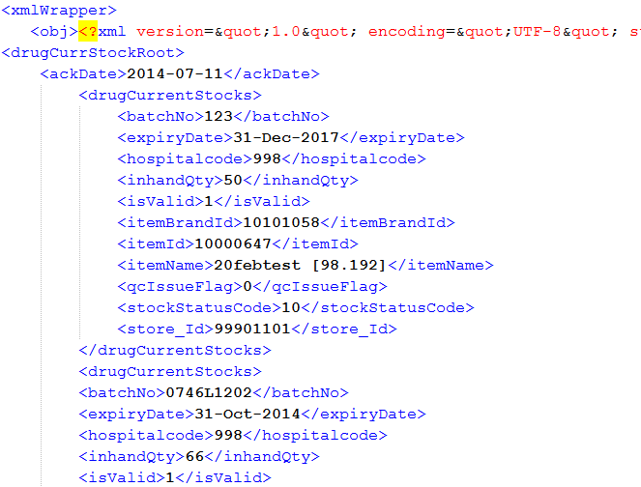

Fig VIII.Screenshot of XML file to be imported and exported

Benefits of Desktop Application:

* No dependency on internet connection.
* Best applicable to rural areas
* Multi user, Multi location storage
* No special requirement of hardware or software devices. [9]

1. Results

With Reference to the above procedure and standard method/ processes, there came to a conclusion that there are certain benefits that can be achieved following this. The benefits are framed as under for various categories:

|  |  |  |  |
| --- | --- | --- | --- |
| Supplier and Inventory Management | Business Management | Consumer Satisfaction | Business for Growth |
| * Balance service levels with stocking levels | * Gain visibility across all areas of your company | * Identify most profitable customers | * Handle substantial business volume and growth |
| * Gain company-wide, real-time inventory visibility | * Make faster, better decisions with real-time information | * Measure sales and service performance | * Open access to database for desired use |
| * Forecast with accuracy and predictability | * Assign, track & monitor issues, events and projects | * Improve quality of customer inquiry responses | * Extend capabilities without major system changes |
| * Reduce lost sales due to out-of-stock products | * Proactively identify and correct issues | * Discover customer insights, preferences and trends | * Employ virtually unlimited staff on system — locally and globally |
| * Inject speed and flexibility into the order process | * Explore, uncover & analyze decision alternatives |  |  |

Table II. Benefits of Standard Operating Procedure to different perspectives[9]

Acknowledgment

We express our deep thanks to Mr. B.K. Murthy, Executive Director; CDAC Noida (India) with the help of his vast experience, efforts, valuable suggestion, support and motivation helped us to great extent for the design and development of this utility.

References

1. <http://en.wikipedia.org/wiki/Supply_chain_management#Problems_addressed>
2. <http://en.wikipedia.org/wiki/Inventory>
3. <http://en.wikipedia.org/wiki/ABC_analysis>
4. <http://www.bms.co.in/write-a-note-on-ved-analysis/comment-page-1/>
5. <http://www.hieanswers.net/hie-fundamentals/hie-models/>
6. <https://www-304.ibm.com/jct03001c/tools/cpeportal/fileserve/download5/30625/Mar05_JFraser_SCMExecBrief.pdf?contentid=30625>
7. Goel Himani, Srivastava Praveen, Garg Chinmay, Gupta Ajay, ‘e-Aushadhi’ A DRUG WAREHOUSE MANAGEMENT SYSTEM<http://www.prjpublication.com/PrjAdmin/UploadFolder/%E2%80%98e-Aushadhi%E2%80%99%20A%20DRUG%20WAREHOUSE%20MANAGEMENT%20SYSTEM.pdf>
8. Goel Himani, Srivastava Praveen, Gupta Ajay, A Standalone Utility-‘e-Aushadhi Desktop’

<http://www.gdeepak.com/iacc14/html/DDM-25.xml>

1. <http://supply-chain-management.acctivate.com/supply-chain-management-benefits/>