**Design and Analysis of Rectangular Microstrip Patch Antenna for ZigBee Applications**

Sanya Srivastava

Research Scholar, Dept. of Electronics & Communication Engineering

Poornima University, Jaipur, INDIA

sanyasrivastava18@gmail.com

Devendra Somwanshi

Asst. Professor, Dept. of Electronics & Communication Engineering

Poornima University, Jaipur, INDIA

imdev.som@gmail.com

*Abstract*—A rectangular microstrip patch antenna is presented in this paper for 915 MHz band applications. These applications include ZigBee and Bluetooth. Recently, these applications have been appreciated and became essential for daily use in industrial and home automation in small areas because of their low power requirement for operation and long battery life. The proposed antenna is constructed on an FR-4 epoxy substrate with thickness of 1.6 mm and εr =4.4. The proposed antenna operates from 902MHz to 928MHz with good omnidirectional radiation patterns, its narrowband impedance bandwidth protect it from interference problem from other applications in ISM band. Proposed antenna has compact size of 60x30mm2.Proposed antenna has advantages in simple design, narrow bandwidth, and compact in size and easy in fabrication. The measured result is in good agreement with simulated one.

Keywords— ZigBee Antenna; ISM Band Antenna; Bluetooth Antenna; Omnidirectional Antenna.

# Introduction

Since the FCC announced to allow the unlicensed use of the industrial, scientific, and medical (ISM) frequencies by any potential users, the wireless communications community has seen an enormous opportunity to drive many wireless devices that could communicate over short distances. For example, some practical applications operate at the internationally available unlicensed ISM band at 915 MHz and 2.4 GHz like the Bluetooth or wireless local-area network (WLAN) system, ZigBee systems, Wireless sensor networks and at 5.2 and 5.8 GHz like the WLAN systems. Recently, it is well known that several small antenna designs suitable for practical applications have been reported [1]–[7]. In these designs, they have provided a single-band or dual-band operation for the application in the wireless communication systems. However, a multi band system is becoming necessary to provide more services for various users of personal wireless communications. It is also necessary for this kind of multiband antenna design to be available as a diversity antenna for wireless communication systems.

Recently, printed antennas have played a major rule in development of antennas with different frequencies and bands [11], [12]. Several previous papers have discussed antennas for 915MHz applications such as Printed Double-T MonopoleAntenna [13], Small Planar Monopole Antenna with a Shorted Parasitic Inverted-L Wire [14], A Quasi-Omnidirectional antenna [15].

In this paper, rectangular microstrip patch antenna has been proposed which operates for 902-928 MHz band (ISM) using a rectangular patch. Radiating patch and a partial ground used to cover the 915 MHz band (ISM- Band) from 902-928 MHz with VSWR less than 2. The complete antenna size is 60x30 mm2. The proposed antenna has compact size which is added advantage to use it in wireless sensor networks Mote modules.

II. ANTENNA DESIGN AND DIMENTIONS FINALIZATION

After an exhaustive literature review of the papers ranging from the year 1996-2014, there have been different types of approaches for making the small size antenna which are used only for ZigBee applications. For ZigBee technology there are various antennas used at 915 MHZ frequency, like Micro strip patch antenna or PCB antenna, Chip antenna, Helical Wound Stub antenna, Low Profile Dome antenna, Dipole antenna with flying lead etc.

Nowadays, in mobile communication systems, the requirement of small sized antenna for miniaturization purpose of mobile units has been increased. Hence, reduced size and enhanced bandwidth are the major considerations in microstrip antennas for practical applications. Therefore, study regarding small size and enhanced bandwidth of microstrip antenna has been greatly increased. In the past few years, great progress in the design of small sized micro strip antenna with dual and circular polarization, dual frequency, broadband and gain enhanced performance has been reported hence we select the microstrip patch antenna for Zigbee application. There are many types of shapes which can be selected for patch.Comparison Analysis of Different types of patch shapes are listed bellow in table 1, which is created in the basis of literature review.

Table 1

**Comparison Analysis of Different types of patch shapes**

|  |  |  |  |  |  |
| --- | --- | --- | --- | --- | --- |
| S. No. | Parameters | Rectangular shaped patch micro strip antenna | Elliptical shaped patch micro strip antenna | Annular ring shaped patch micro strip antenna | Triangular patch micro strip antenna |
| 1. | Operating Frequency | 2.43 GHz | 2.43 GHz | 2.43 GHz | 2.43 GHz |
| 2. | Return Loss | -49.2762 db | -42.4581 db | -30.87 db | -40.7632 db |
| 3. | Impact on shape on bandwidth | 46 MHz | 47.6 MHz | 34.9 MHz | 42.2 MHz |
| 4. | Impedance real part | 50.4380 | 50.0025 | 48.09153 | 50.3042 |
| 5. | Impedance Imaginary Part | 0.3360 | 0.4509 | 2.7686 | 0.1589 |
| 6. | VSWR | 1.0220 | 1.0152 | 1.0589 | 1.0185 |
| 7. | Directivity  =0 deg | 3.8363 | 4.0114 | 0.3443 | 3.3706 |
| 8. | Directivity  =90 deg | 3.8387 | 4.0114 | 0.3318 | 3.3609 |

Hence according to the table 1, which is created in the basis of literature review, it is clear that rectangular patch is best for ZigBee band application. Therefore rectangular patch is to be selected. The flow chart for selecting the dimensions for antenna is as bellow.

The value which, get from the Convocational method is very large i.e. L=99 and W=78, so the dimensions of antenna are to be obtained by introducing external components or making some modification in dimensions of antenna. In the fig.1, the flow cart makes the whole process easy to understand.

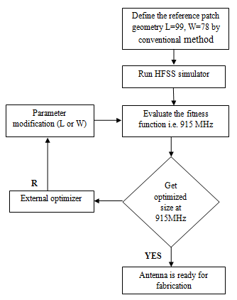

Fig. 1 Flow Chart of Antenna Dimentions Finalization

At first define the reference patch geometry i.e. the value which gets from the conventional method. After calculating the parameters, simulating software will be decided for antenna. After analyzing the antenna model with simulator, evaluate the fitness function i.e. 915 MHz frequency. If optimized size of antenna is to be obtained at desired frequency range it means antenna is to be ready for fabrication. Otherwise some external components are to be used or make some modifications in dimensions of antenna to achieved desired output. Whole process will be followed until desired output will not be achieved. The optimized dimensions of proposed antenna have shown in table 2.

Table 2

**Optimized dimensions of proposed antenna**

|  |  |  |  |  |  |  |  |
| --- | --- | --- | --- | --- | --- | --- | --- |
| Parameters | Ws | Ls | Wg | Lg | Lp | Wp | Lf |
| Unit (mm) | 30 | 60 | 30 | 06 | 14.8 | 20 | 44.3 |
| Parameters | Wf | Sw1 | Sw2 | Sw3 | S1(Ls1) | S2 (Ls2) | S3 |
| Unit (mm) | 03 | 1.4 | 2 | 1 | 33 | 9.6 | 1.6 |

# ANTENNA DESIGN AND ANALYSIS

The geometry and configuration of the proposed antenna optimized with the Ansoft HFSS 13, is shown in fig. 2. This antenna is printed on the FR-4 substrate with thickness of 1.6 mm, relative dielectric constant of εr =4.4, and loss tangent of 0.02. The proposed antenna is fed by a microstrip feeder, and the width of the microstrip feed line is 3 mm to achieve 50-Ω characteristic impedance. There is a partial ground and UWB primary antenna Fig.1.The size of primary antenna has been chosen such that it provides a pass band of 915 MHz band (ISM), but in simple rectangular patch it was very difficult to achieve ISM pass band, so here we have introduce open stub symmetry, integrated and the dimensions which we have chosen are Wp=2o mm, Lp=44.3 mm, S1=3mm, S2=9.6mm and S3=1.6mm. The partial ground is used here to control the ISM pass band i.e. Wg=30 mm, Lg=60 mm.

The optimized dimension of the proposed antenna has been presented in table 2. Front and back view of proposed antenna geometry has shown in fig. 2.(a) & (b), respectively.

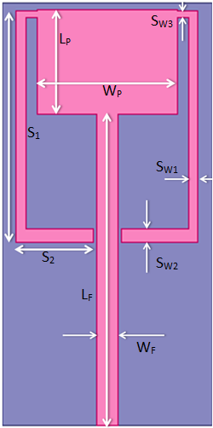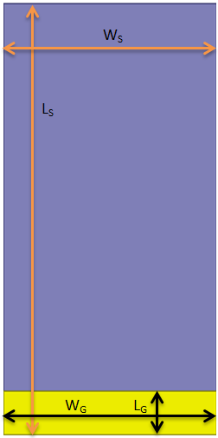

(a) (b)

Fig.2. (a) Top view of Proposed Antenna (b) Back view of Proposed Antenna

Front and back view of fabricated proposed antenna has been presented in fig. 3.(a) & (b), respectively as bellow.

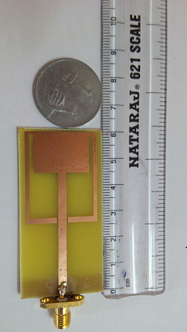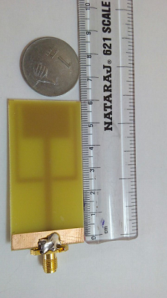

Front View Back View

Fig.3. Fabricated Proposed Antenna

To achieve the ISM pass band characteristic through proposed antenna, first of all calculate the dimentions of basic antenna i.e. UWB primary antenna. Then integrated two open stubs symmetry with primary antenna to achived desired frequency, in fig.2 (a), which provides the passband in ISM band. The return loss (S11 in dB) after integrating two open stubs symmetry is presented in fig.4. From fig. 4, it is seen that proposed antenna provides a single passband characteristic in ISM band. from fig. 4, it is seen that proposed antenna is able to operate on Zigbee Band at desired frequency 915 MHz. Simulation of proposed antenna is to be done with HFSS simulator.

HFSS is based on FEM method, so it can say that the frequency domain analysis of proposed antenna shows desired output.

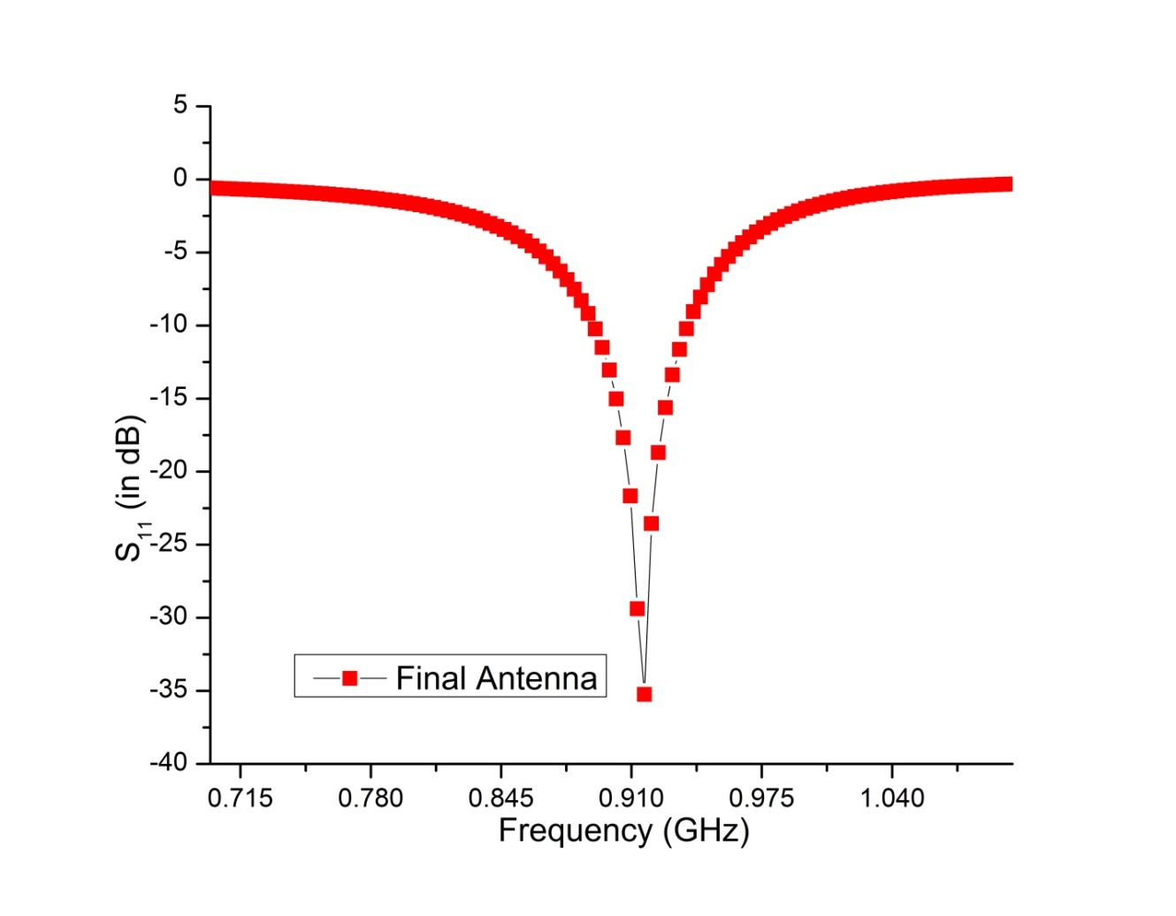

Fig. 4 .Return loss vs. Frequency graph

Length of ground namely Lg varied with a range of values and results are presented.

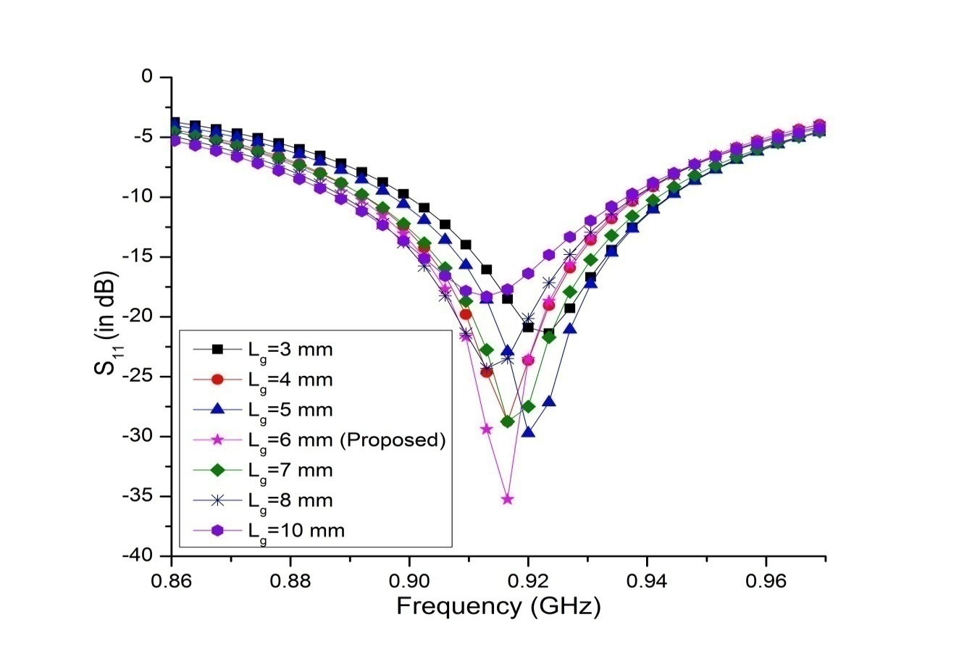

Fig. 5. S11 in (dB) vs Frequency graph for variation in length of graund

From fig.5, it is seen that with the length of ground Lg at 3 mm, 4 mm and 5 mm, our desired ISM band can not be achieved but with 6 mm, desired band is achieved. The width optimization of Sutbs Sw1 and its effect on the S11 has been shown in fig. 6. Proposed width Sw1 is 1.4 mm.

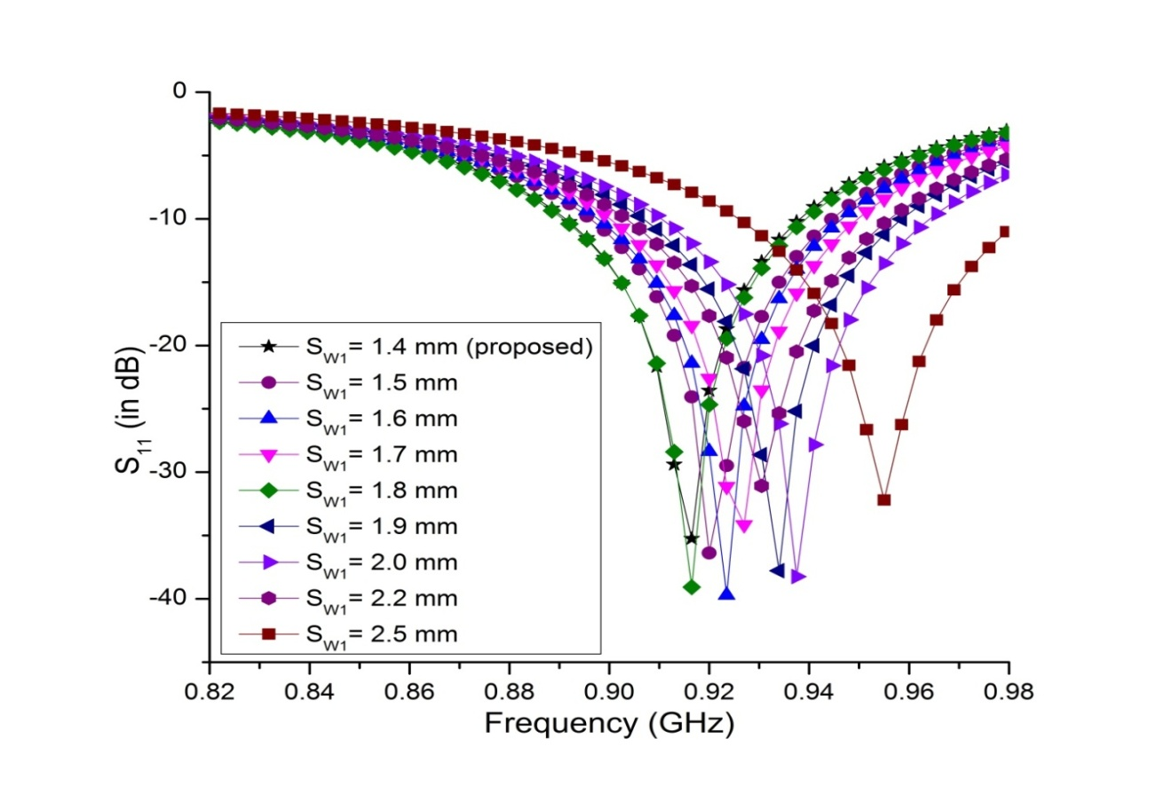

Fig. 6. S11 (in dB) Vs Frequency graph for variation in Width of stub S1

Stubs ‘S2’ which is integrated with primary antenna, varied with a range of values and results are presented.

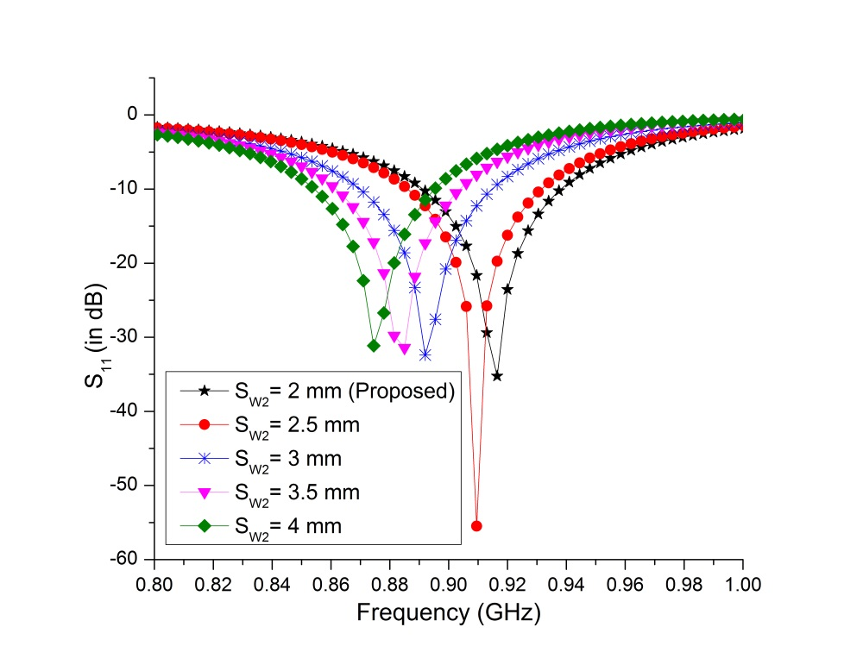

Fig.7. S11 (in dB) Vs Frequency graph for variation in Width of stub S2

From fig.7, it is clear that with the width of S2 at 2.5 mm, 3.0 mm, 3.5 mm and 4.0 mm, our desired ISM band can not be achieved but with 2.0 mm, desired band is achieved. The stubs S2 width optimization and its effect on the S11 has been shown in fig. 7. Proposed width of stub S2 is 2.0 mm.

In order to observe the effect of open stubs on current distribution, from fig. 8 it is seen that due to the stub current density is highly disturbed so there is a resonance at 915 MHz frequency. It is clear from the Fig.8 that the accumulation of current density near the edges of the slot is very strong that shows a positive sign to create the resonance at ZigBee band.

.

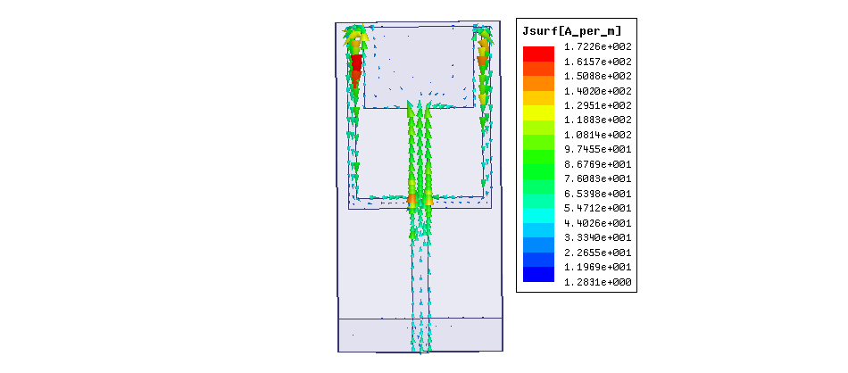

Fig. 8. Vector current distribution due the stub S­1 at 915 MHz

# RESULT AND DISCUSSION

Simulated and measured result of proposed antenna has been shown in Fig.9. The measurement was performed with a Vector network analyzer. Measured result shows good agreement with the simulated result. The antenna with ISM band (915 MHz), maintaining the required bandwidth (902-928 MHz) with VSWR less than 2. The simulated radiation pattern at 915 MHz has been shown in Fig.10. At the 915 MHz frequency 3-D polar plot of gain is presented in Fig.11. From Fig.11 it is seen that the gain is dB, as it is known that the ISM band applications required a very low power rating so achieved gain is sufficient to fulfill the required gain in this band. The proposed antenna displays good omnidirectional radiation patterns in the H-plane and dipole like radiation patterns in E- plane as shown in Fig.10.

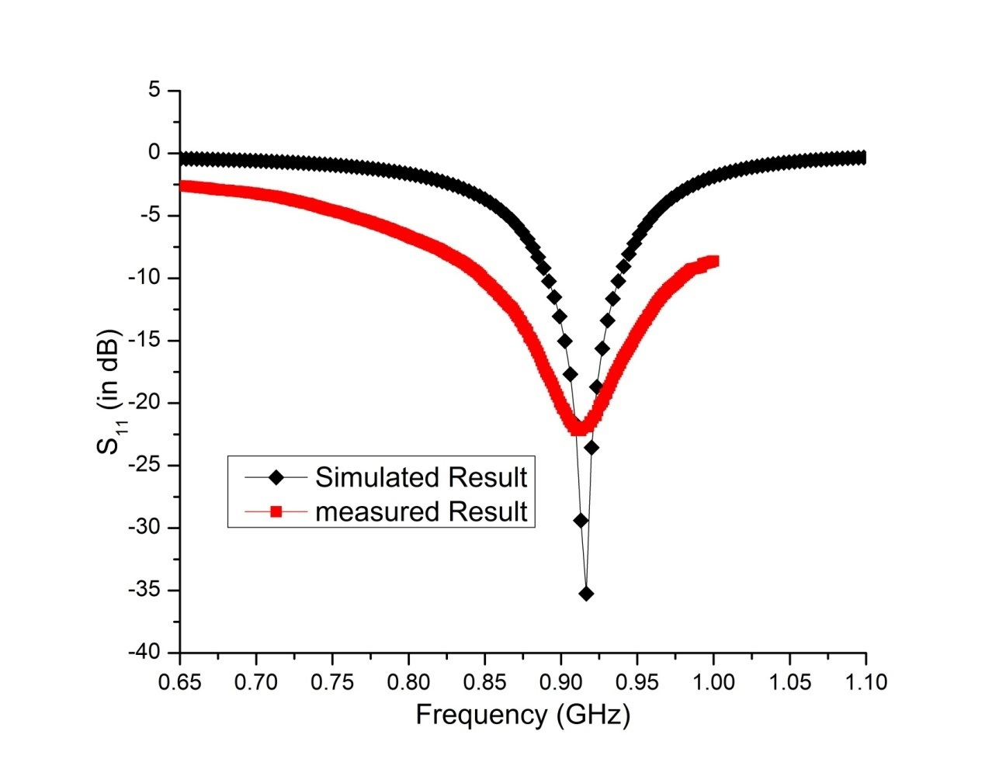

Fig. 9. S11Vs frequency



Fig. 10. Radiation patter at 915MHz of proposed antenna.

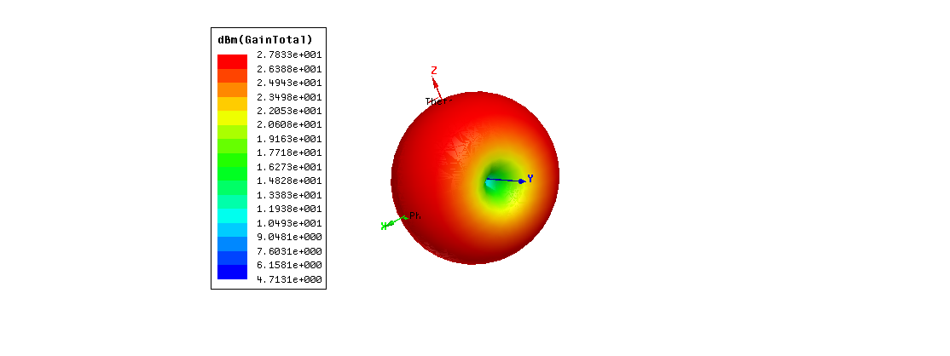

Fig. 11. 3-D Polar plot of gain at 915MHz of proposed antenna.

# V . CONCLUSION

A compact ZigBee antenna is presented in this paper. This antenna has simple structure and compact size of 60 x 30mm 2. This is easy to be integrated in miniature devices. Proposed antenna covers frequency band from 902-928 MHz, where simulated and measured results are good in agreement. Results & analysis of this antenna indicates that it is applicable in miniature devices, simple design & compact size as added advantage. Surface current distributions were used to show the effect of these slots in getting the ISM band.

ACKNOWLEDGMENT

Authors are thankful to Mr. Krishna Ranshu Ranjan, Assistant Professor, G.B. Pant Engineering College, and New Delhi, INDIA for providing the measuring facilities and useful discussions.

References

1. Z. D. Liu andP . S. Hall, “Dual-band antenna for handheld portabletelephones,” *Electron. Lett.*, vol. 32, pp. 609–610, 1996.
2. P. Salonen, M. Keskilammi, andM. Kivikoski, “New slot configurationsfor dual-band planar inverted-F antenna,” *Microwave Opt. Technol.Lett.*, vol. 28, pp. 293–298, 2001.
3. H. C. Tung andK. L. Wong, “A shorted microstrip antenna for 2.4/5.2GHz dual-band operation,” *Microwave Opt. Technol. Lett.*, vol. 30, pp.401–402, 2001.
4. M. J. Ammann and L. E. Doyle, “A loaded inverted-F antenna for mobilehandset,” *Microwave Opt. Technol. Lett.*, vol. 28, pp. 226–228, 2001.
5. Y. H. Suh andK. Chang, “Low cost microstrip-fed dual frequencyprinteddipole antenna for wireless communications,” *Electron. Lett.*vol. 36, pp. 1177–1179, 2000.
6. M. Ali andG. J. Hayes, “Analysis of integrated inverted-F antennas forBluetooth application,” in *Proc. IEEE-APS Conf. Antennas and Propagationfor Wireless Communications*, Waltham, MA, 2000, pp. 21–24.
7. J. Y. Jan andL. C. Tseng, “Planar monopole antennas for 2.4/5.2 GHzdual-band application,” in *Proc. IEEE-APS Int. Symp. Dig.*, Columbus,OH, 2003, pp. 158–161.
8. F. Shahin, “ZigBee Wireless Networks and Transceivers”, 2008.
9. Fred Eady, “Hands-On ZigBee: Implementing 802.15.4 with Microcontrollers”,2007.
10. Diane MCMichael Glister, “Bluetooth End to End”, Wiley, 2002.
11. C. A. Balanis, “Antenna Theory Analysis and Design”, *2nd Edition,John Wiley & Sons, 1997*.
12. J. D. Kraus, and Marhefka, R. J., “Antennas for All Applications”, *3rdEdition, PHI. 2002.*
13. Yen-Liang Kuo, Kin-Lu Wong, “Printed Double-T Monopole Antennafor 2.4/5.2 GHz Dual-Band WLAN Operation” *IEEE transaction onantennas and propagation, vol.51, no. 9, September 2003.*
14. Jen-Yea Jan, Liang-Chi Tseng, “Small Planar Monopole Antenna witha Shorted Parasitic Inverted-L Wire for Wireless Communications inthe 2.4-, 5.2-, and 5.8-GHz Bands” *IEEE transaction on antennas and propagation,* vol. 52, no. 7, July 2004.
15. P. C. Bybi, Gijo Augustin, B. Jitha, C. K. Aanandan, K. Vasudevan,P. Mohanan, “ A Quasi-Omnidirectional Antenna for Modern wirelessCommunication Gadgets” *IEEE transaction on antennas and propagation letters*, vol. 7, 2008.