# EXTRACTION OF ROADS FROM SATELLITE IMAGES USING PROPOSED ALGORITHM BASED ON COLLINEAR POINTS AND EDGE DETECTION

Simranjit Singh

Department of Computer Engineering,

Punjabi University

Patiala, India

E-Mail:simran.jita@gmail.com

**Abstract- Line detection is very important in digital image processing which can be used for very handy purposes like computer vision algorithms etc. Nearly every line detection methods use Hough transform and its variants to detect the lines efficiently. But it requires more computation speed and more space for accumulator array. In this paper an algorithm is developed to detect the lines from satellite images using collinear points in an image. The detected lines in the images denote the roads.**

***Keywords-*LOG*,satellite images,* collinear*,edge, edge detection***

I.Introduction-

The Hough transform is the traditional line detection method [8]. The Hough transform and its variants are most commonly used for line detection. Originally, the Hough transform method was developed by Hough which is based on the intercept and slope parameters. Later the discrete HT is proposed by duda and hart. DHT (discrete Hough transform) calculate the cosine and sine function but its complexity of computation is very high [5]. The Discrete Hough transform is given as:

$$ρ=xcosθ+ysinθ$$

Where (x, y) denotes the coordinates of the given edge points. $ρ$ And $θ$ denote the distance to the line from the origin and the angle of the line related with the + x-axis, respectively [4].

In this paper the edge detection operator canny operator is also used. The canny operator gives us lines on which our algorithm is applied [2]. Edges in an image are abrupt change in intensity values of images. By just seeing at the variation in the intensity values we can reach at the conclusion that this point or pixel is of edge.

Balwinder Singh

Department of Computer Science,

Govt. Multipurpose Sr. Sec. School (Passi Road), Patiala, India

E-Mail: balli2000in@gmail.com

Edge detection in the algorithm is very important step because this step will give us the lines (edges) which are manipulated further in this algorithm.

All edge detection operators are shown in figure1 [1].

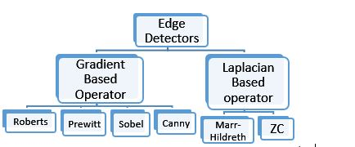

Figure 1-Edge detection operators

**Why LOG edge operator is used in the algorithm?**

We use the edge detection operator LOG because it generates the best result in edge detection. No doubt canny generates the best results in edge detection but noise component is also very abundant if the image contains noise [10]. So the operator which is most close to canny and suppresses the noise component is LOG [9].

**Hough transform varients**

1. **Discrete Hough transform(DHT)-**

DHT is given as:

$$ρ=xcosθ+ysinθ$$

DHT contains two phases

1. The Evidence collecting phase
2. The searching phase

In the evidence collecting phase it uses the voting technique. In DHT the edge points are transformed, quantized and represented by an accumulator array. After the evidence phase the searching phase play its part by searching the cells whose scores are greater than some threshold in the accumulator array. So to implement this technique we need large space for accumulator array and it requires more computation power for voting and searching.

1. **Randomized Hough Transform(RHT) -**

In order to avoid the large storage and computation. Xu proposed the randomized Hough transform method. RHT randomly take two edge points just like the DHT but it takes randomly so every edge point has the equal probability of being picked up. So after picking up the point it maps the points in the parameter space which are accumulated by voting in the accumulator. This process is performed when some cells in the accumulator have average scores and each represents a candidate line. Candidate line is all the lines which are candidates for the desired line. Then each candidate line follows the evidence phase which calculates the no of edge pixels in the candidate line. This step is the important step because it tells us that whether the candidate line is actually a desired line. This whole process is repeated until a given criteria is reached.

1. **Connective randomized Hough transform(CRHT)-**

Kalviainen and Hirvonen proposed CRHT. This method is further improved version of RHT. The improvement is made by exploiting the connected edge pixels. The efficiency and effectiveness of this technique mainly depend upon the connected neighboring edge pixels. It has a disadvantage that it can cause problem whenever there is noise and distortion.

1. **Extended connective randomized Hough transform(ECRHT)-**

To overcome the problem of CRHT Kyrki and as CRHT as it uses same local information to improve RHT, but it has the limitation that it allows gaps in the line segment.

So basically all the RHT, CRHT and ECRHT uses the same technique of voting for collection of evidence in the accumulator array. So ultimately these all belong to HT and they still need the space for accumulator array.

II.BASIC IDEA

The algorithm is based on the concept of co- linearity of the points. Three or more points are collinear if they lie in the same line. This concept is used to know that a three points can form a triangle or not. If the points are collinear then these can never form a triangle.

Let $u_{i}={(x}_{i},y_{i})$ denotes a pixel with coordinates ${(x}_{i},y_{i})$ in an image. Given three pixels u1, u2, and u3. If the area of triangle is 0 of these three points it means that the points are collinear meaning they are in a line. Area of triangle is calculated by:

|z| denotes the absolute value of z

So in this way we can easily calculate the points which are in same line. So extracting those points in the spatial domain gives the image which only contains the line horizontal or vertical depends on how the algorithm is applied.

Following series of synthetic images show the basic idea of collinearity in vertical and horizontal way:

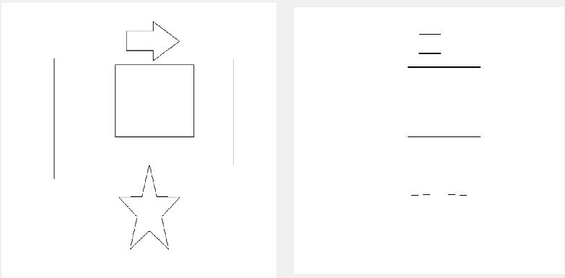

1. (b)

**Figure 1(a)-**Synthetic image **(b)** Horizontal lines

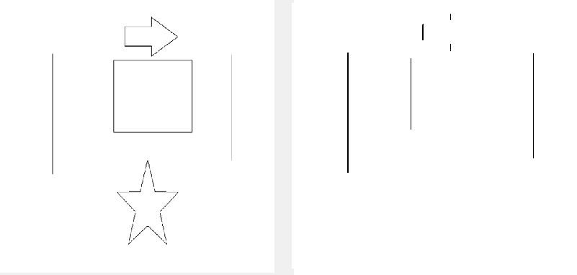

1. (b)

**Figure 2(a)-** Synthetic image (b) Vertical lines

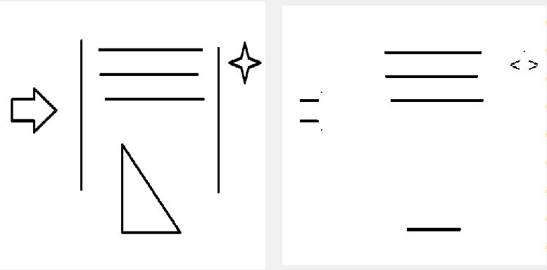

1. (b)

**Figure 3(a)-**Synthetic image **(b)** Horizontal lines

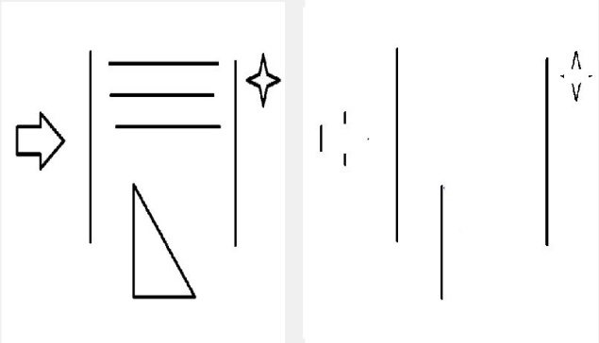

1. (b)

**Figure 4(a)-**Synthetic image **(b)** Vertical lines

III. PROPOSED ALGORITHM in simple steps:

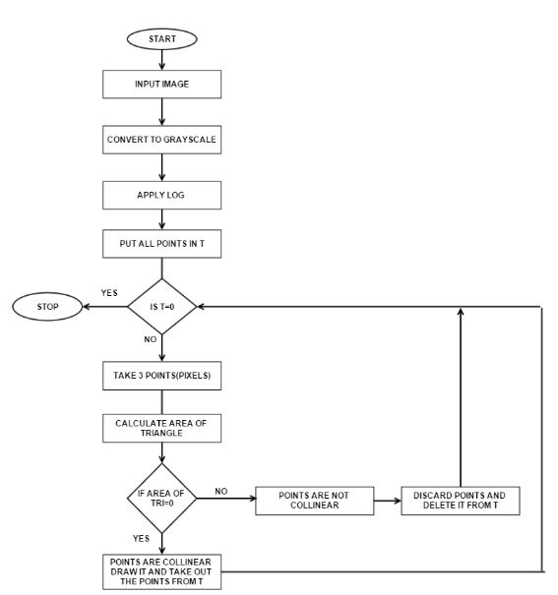

**Figure 5-Flowchart of Proposed algorithm**

**PROPOSED ALGORITHM**

**Step 1-** Take the remote image $(I_{1})$ as input

**Step 2-** Apply the edge detection operator (LOG) on $(I_{1})$ to obtain an image $(I_{2})$ with detected edges.

**Step 3-** Put all the pixels in T

**Step 4-** Take 3 points and apply the equation to find the area of triangle

$$\text{|}\frac{1}{2}\left[\left(x2-x1\right)\left(y3-y1\right)-\left(x3-x1\right)\left(y2-y1\right)\right]|$$

**Step 5-** If the area is 0 that means that the three points are collinear and take those three pixels and draws those points (x, y) coordinates in another plane and take out the points

Else

Discard those points.

**Step 6-** If T=0 then stop

Else

Goto step 4

IV. EXPERIMENTAL RESULTS:

**IMAGE 1**

The images used has the original resolution of 512 $×$ 512. The output is shown below: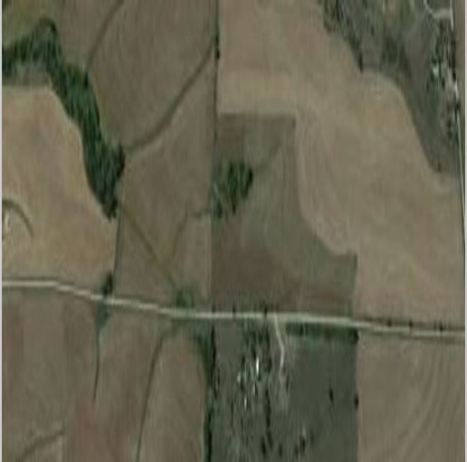

**Figure 5** –The original image 1

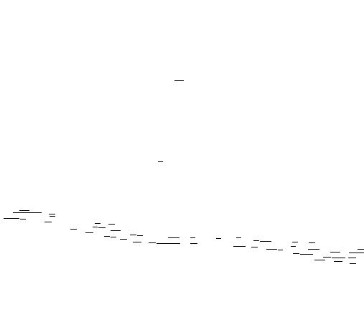

**Figure 6**-Resulting image after applying algorithm

**IMAGE 2**

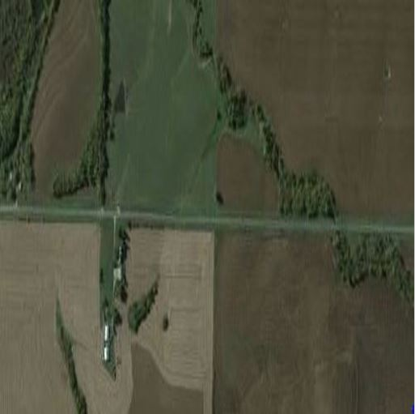

**Figure 7**- The original image 2



**Figure 8**- Resulting image after applying algorithm

V. CONCLUSION

In this paper an algorithm is made for extracting the roads from the satellite images. This method is simple approach based on the collinearity of the points. It requires less computation as compared to Hough line detection method and contains less noise.

VI.REFERENCES

[1] R. C. Gonzalez and R. E. Woods. 2nd ed.Prentice Hall, 2002, “Digital Image Processing”.

[2] J. F. Canny.IEEE Trans. Pattern Anal. Machine Intell, . “A computational approach to edge detection” vol. PAMI-8, no. 6, pp. 679-697, 1986

[3] Raman Maini. ”Study and Comparison of Various Image Edge Detection Techniques”, IJIP, Volume (3): Issue (1)

[4] Teh-Chuan Chen* and Kuo-Liang Chung” A New Randomized Algorithm for Detecting Lines”, Real-Time Imaging 7, 2001

[5] N. C. Fitton and S. 1. D. Cox, "Optimising the application of the Hough transform for automatic Feature extraction from geoscientific images," Computers and GeOSCiences, vol. 24, pp. 933-51,Dec. 1998.

[6] l.Matas and C.Galambos and1. Kittler, "Robust detection

of lines using the progressive probabilistic Hough

transform," Computer Vision and Image

Understanding, vol. 78, pp.119-37, Apr. 2000.

[7] B. K. Jeon and J. H. Jang and K. S. Hong

Optical , vol. 39, pp. 2413- 21, Sept. 2000 , "Map-based

Engineering road detection in spacebome synthetic

aperture radar images based on curvilinear structure

extraction,"

[8] Illingworth, J. & Kittler, J. (1988) ``Surver: Survey of the

Hough Transforms,'' Computer Vision, Graphics, and

Image Processing, 44:87-116.

[9] Singh, Simranjit; Singh, Rakesh, "Comparison of various

edge detection techniques," Computing for Sustainable

Global Development (INDIACom), 2015 2nd

International Conference on , vol., no., pp.393,396, 11-13

March 2015

[10] Singh, Simranjit.; Singh, Balwinder., "Effects of noise on

various edge detection techniques," Computing for

Sustainable Global Development (INDIACom), 2015 2nd

International Conference on , vol., no., pp.827,830, 11-13

March 2015