Abhi mujh mein kahin Baaqi thodi si hai zindagi  
Jagi dhadkan nayi Jaana zinda hoon main toh abhi  
Kuch aisi lagan iss lamhe mein hai Ye lamha kahaan tha mera  
Ab hai saamne Issey chhoo loon zaraa Mar jaaoon ya jee loon zaraa  
Khushiyaan choom loon yaa ro loon zaraa..Mar jaaoon ya jee loon zaraa

Ho o.. abhi mujh mein kahin Baaqi thodi si hai zindagi  
Ho.. dhoop mein jalte huey tann ko  
Chhaya perh ki mill gayee  
Roothe bachche ki hansi jaise  
Phuslaane se phir khill gayee  
Kuchh aisa hi abb mehsoos dil ko ho rahaa hai  
Barso'n ke purane zakhm pe marham laga sa hai  
Kuch aisa rahem, iss lamhe mein hai  
Ye lamha kahaan tha mera  
Ab hai saamne  
Issey chhoo loon zara  
Mar jaaoon ya jee loon zara  
Khushiyaan choom loon  
Yaa ro loon zaraa  
Mar jaaoon yaa jee loon zaraa

Dor se tooti patang jaisi, thi ye zindagani meri  
Aaj ho kal ho mera naa ho  
Har din thi kahani meri  
Ik bandhan naya peechhe se abb mujhko bulaaye  
Aane waley kal ki kyun fikar mujhko sata jaaye  
Ik aisi chubhan iss lamhe me hai  
Ye lamha kahaan tha mera aa  
Ab hai saamne  
Issey cho loon zara  
Mar jaaoon ya jee loon zara  
Khushiyaan choom loon  
Yaa ro loon zaraa  
Mar jaaoon ya jee loon zara

https://www.youtube.com/watch?v=7MRhP6pK6I4  
  
Read more: [SONU NIGAM - Abhi Mujh Mein Kahin Lyrics | MetroLyrics](http://www.metrolyrics.com/abhi-mujh-mein-kahin-lyrics-sonu-nigam.html#ixzz3dC2Gr7Hu)

Behati Hawa Sa Tha Woh, Udati Patang Sa Tha Woh  
Kahaan Gaya Use Dhundon  
  
Behati Hawa Sa Tha Woh, Udati Patang Sa Tha Woh  
Kahaan Gaya Use Dhundon  
Hmm Hamako Toh Raahein Thi Chalaati  
Woh Khud Apani Raah Banaata  
Girata Sambhalata Masti Mein Chalata Tha Woh  
Hamako Kal Ki Fikar Sataati, Woh Bas Aaj Ka Jashn Manaata  
Har Lamahe Ko Khulake Jita Tha Woh  
Kahaan Se Aaya Tha Woh, Chhuke Hamaare Dil Ko  
Kahaan Gaya Use Dhundon  
  
Sulagati Dhup Mein Chhanv Ke Jaisa  
Registaan Mein Gaanve Ke Jaisa  
Mann Ke Ghaanv Pe Marham Jaisa Woh  
Ham Sehame Se Rehate Kuye Mein  
Woh Nadiya Mein Gote Lagaata  
Ulati Dhaara Chir Ke Tairata Tha Woh  
Baadal Aawaara Tha Woh, Pyaar Hamaara Tha Woh  
Kahaan Gaya Use Dhundon  
Hamako Toh Raahein Thi Chalaati, Woh Khud Apani Raah Banaata  
Girata Sambhalata Masti Mein Chalata Tha Woh  
Hamako Kal Ki Fikar Sataati, Woh Bas Aaj Ka Jashn Manaata  
Har Lamahe Ko Khulake Jita Tha Woh  
Kahaan Se Aaya Tha Woh, Chhuke Hamaare Dil Ko  
Kahaan Gaya Use Dhundon

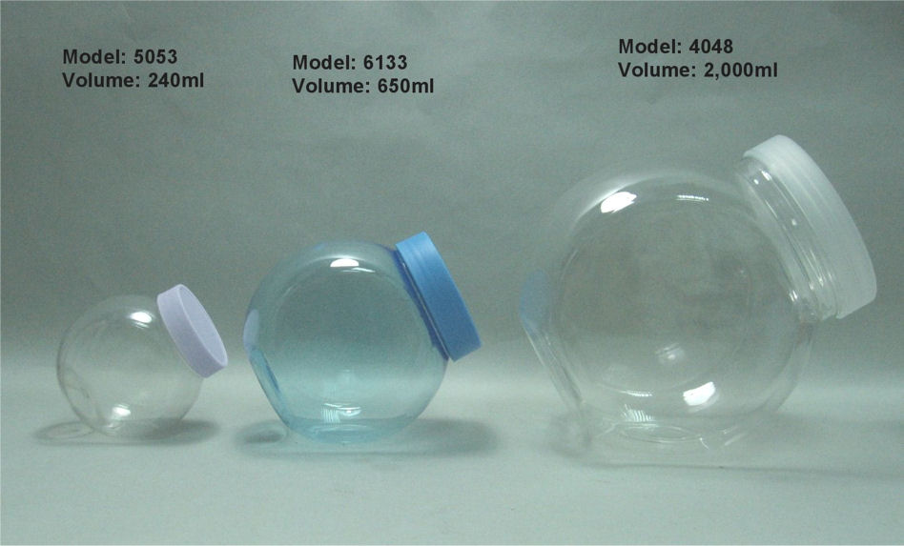

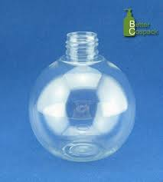

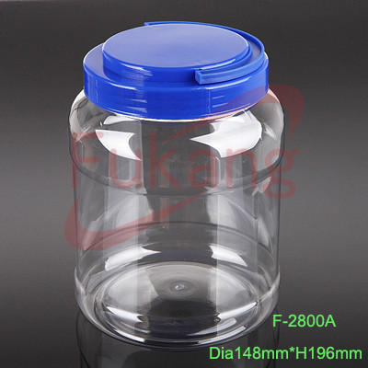

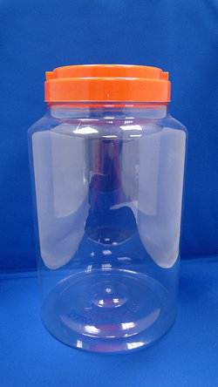

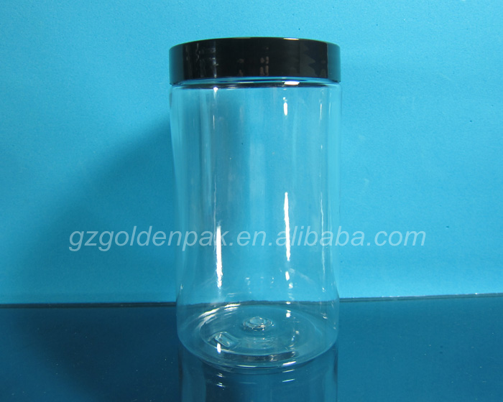

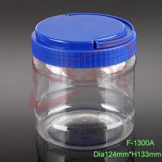 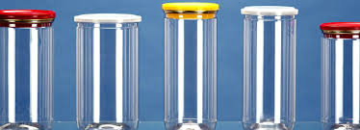

|  |  |  |  |  |  |  |
| --- | --- | --- | --- | --- | --- | --- |
| **PRODUCT LIST OF CAPS WITH PRICE** | | | | | |  |
|  |
| **SR. NO.** | **NECK SIZE (MM)** | **DESCRIPTION** | **APPLICATION** | **PRICE(Rs.)** | **PACKING(pcs.)** |  |
| 1 | **19** | Flip top Short | Cosmetics | 0.90 | 4000 |  |
| Flip top Long | Cosmetics | 0.90 | 5000 |  |
| Thumb Spray Pump | Glass Cleaner | 4.15 | 2000 |  |
| Body Lotion Pump | Cosmetics | 5.10 | 2000 |  |
| 2 | **24** | Thumb Spray Pump | Glass Cleaner | 4.15 | 1000 |  |
| Body Lotion Pump | Cosmetics | 5.10 | 1000 |  |
| Soap Dispenser | Liquid soap | 5.10 | 1000 |  |
| 3 | **25** | Pilfer Proof (Without Wad) | Pharmaceuticals | 0.47 | 5000 |  |
|  |  | Two Piece Closure | Pharmaceuticals | 0.82 | 5000 |  |
|  |  | Flip Top | Cosmetics | 0.85 | 12500 |  |
| 4 | **28** | 3 Start Alaska | Mineral water | 0.29 | 7000 |  |
|  |  | Compression | Hot Fill | 0.67 | 5000 |  |
|  |  | 1881 Short Neck | Hot Fill Juices | 0.55 | 4500 |  |
|  |  | Two Piece Cap | Pharmaceuticals | 0.90 | 5000 |  |
|  |  | Flip top | Cosmetics | 1.15 | 3500 |  |
|  |  | With EPE WAD | Pharmaceuticals | 0.55 | 3000 |  |
|  |  | Thumb Spray Pump | Glass Cleaner | 4.15 | 1000 |  |
|  |  | Soap Dispenser | Liquid soap | 5.10 | 1000 |  |
|  |  | Body Lotion Pump | Cosmetics | 5.10 | 1000 |  |
| 5 | **38** | Pilfer Proof 3 Start cap | Edible Oil /Lubricant Oil | 0.78 | 2000 |  |
| 6 | **46** | Tupperware Type | Fridge bottle | 1.50 | 3000 |  |
|  |  | Plain Cap | Pesticides | 1.35 | 5000 |  |
|  |  | Plug | Pesticides | 1.00 | 2000 |  |
|  |  | Pilfer proof (5lt) | Edible Oil | 1.50 | 2000 |  |
|  |  | Butterfly handle | Edible Oil | 2.00 | 2000 |  |
| 7 | **43** | Spout cap (15ltr-Tin) | Edible Oil | 3.05 | 1700 |  |
| 8 | **56** | 20 Ltr Bubble top Cap | Mineral water | 0.70 | 8000 |  |
| 9 | **60** | Sipper Cap | Water Bottle | 10.00 | 1000 |  |

<https://www.youtube.com/watch?v=fNI5r5H56Dw> - AMI CHEYE CHEYE DEKHI SARADIN

https://www.youtube.com/watch?v=fNI5r5H56Dw - AMI CHEYE CHEYE DEKHI SARADIN

https://www.youtube.com/watch?v=iU5FJkSptmM - AYE MERE BATAN KE LOGO

https://www.youtube.com/watch?v=iSxF0du2a-U - CHOO KAR MERE MAN KO

https://www.youtube.com/watch?v=pBbTGfNrj58 – PHOOLN KE RANG SE

https://www.youtube.com/watch?v=fNZ4ZM6_kEY&index=2&list=PLqjwBTbafHGLfuLJ6rGoj7OcZ-

wZfxtJs – OLD SONG KARAOKE