Predictive Modeling and Optimization in Logistics Systems
Week 4 Task — FreshCart Supplies Logistics Data Pipeline
Name: Jitta Vinith Reddy

1. Problem Definition and Data Simulation

1.1 Prediction Problem
This week's task builds directly on the Week 3 dataset and analysis. That analysis found that distance and transport mode were the dominant drivers of delivery time, while shipment volume barely mattered. The natural next step is to turn that descriptive finding into a predictive one: can delivery_time_days be forecast accurately enough, before a shipment leaves the DC, to flag likely-late orders and act on them in advance rather than reacting after the fact?
Target variable: delivery_time_days (continuous, regression problem).
Predictor features: distance_km, shipment_volume_units, region, transport_mode.

1.2 Dataset
I regenerated the same 3,000-record FreshCart Supplies shipment dataset used in Week 3, with the same schema (region, transport_mode, distance_km, shipment_volume_units, delivery_time_days, transport_cost, cost_per_km, on_time) and the same mid-June disruption window, so this week's model is being tested against a dataset with a realistic amount of noise and at least one genuine anomaly period rather than a perfectly clean synthetic signal.

2. Model Selection and Implementation

2.1 Models Compared
- Linear Regression — used as a simple, interpretable baseline. If a much more complex model can't beat it by a meaningful margin, that's a useful sanity check in itself.
- Random Forest Regressor — an ensemble of decision trees, chosen because delivery time likely depends on interactions between features (e.g. distance matters differently depending on transport mode) that a linear model can't capture.
- Gradient Boosting Regressor — a second ensemble method, generally stronger than Random Forest on tabular data because it builds trees sequentially to correct prior errors, and it responds well to hyperparameter tuning.
An 80/20 train-test split was used (random_state=42 for reproducibility), and categorical features (region, transport_mode) were one-hot encoded inside a scikit-learn Pipeline/ColumnTransformer so preprocessing is applied consistently to both training and test data.

2.2 Code: Data Preparation and Model Training
from sklearn.model_selection import train_test_split
from sklearn.compose import ColumnTransformer
from sklearn.preprocessing import OneHotEncoder
from sklearn.pipeline import Pipeline
from sklearn.ensemble import GradientBoostingRegressor

features = ["distance_km", "shipment_volume_units", "region", "transport_mode"]
X, y = df[features], df["delivery_time_days"]
X_train, X_test, y_train, y_test = train_test_split(
X, y, test_size=0.2, random_state=42)

preprocess = ColumnTransformer(
[("cat", OneHotEncoder(drop="first"), ["region", "transport_mode"])],
remainder="passthrough")

gb_pipe = Pipeline([
("prep", preprocess),
("model", GradientBoostingRegressor(random_state=42)),
])

3. Evaluation and Validation

3.1 Evaluation Metrics
Three standard regression metrics were used: MAE (average absolute error, easy to interpret directly in days), RMSE (penalizes large errors more heavily, useful since a few very-late shipments matter operationally more than many small misses), and R-squared (proportion of variance explained, useful for comparing models at a glance).
Model | MAE (days) | RMSE (days) | R²
Linear Regression | 0.558 | 0.856 | 0.678
Random Forest | 0.527 | 0.818 | 0.706
Gradient Boosting (tuned) | 0.470 | 0.762 | 0.744

Gradient Boosting outperformed both the linear baseline and Random Forest across all three metrics, though the margin over Random Forest is modest — the bigger jump is from Linear Regression to either ensemble method, which confirms the feature interactions (distance x transport mode) matter more than any single model's sophistication.

3.2 Hyperparameter Tuning
GridSearchCV (5-fold cross-validation, scoring on negative RMSE) was used to tune the Gradient Boosting model over n_estimators (100/200), max_depth (2/3/4), and learning_rate (0.05/0.1) — 12 combinations in total. The best configuration was n_estimators=100, max_depth=3, learning_rate=0.05, which favors a moderately shallow, moderately sized ensemble; deeper or larger models in the grid tended to overfit the training set without improving cross-validated RMSE.

3.3 Cross-Validation
5-fold CV RMSE on the full dataset for the tuned model: 0.452, 0.450, 1.674, 0.495, 0.452 (mean 0.705). Four folds land close together around 0.45-0.50, but one fold spikes to 1.674 — that fold happens to contain a disproportionate share of the mid-June disruption-period shipments, which the model consistently underpredicts since it has no feature that flags 'disruption in progress.' This is a useful diagnostic: the model's overall accuracy is good under normal conditions but degrades specifically during anomaly periods, which matters for how the predictions should be used operationally (see Section 4).

4. Visualizations and Model Insights

4.1 Actual vs Predicted
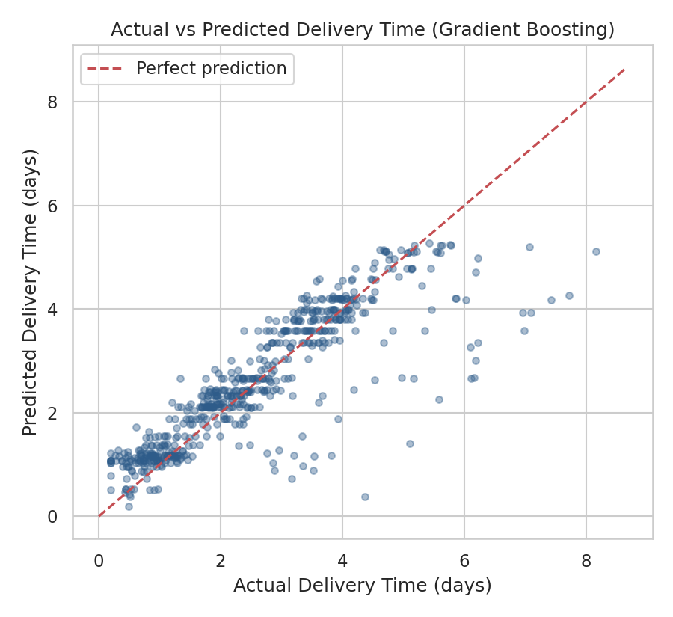
Figure 1: Actual vs predicted delivery time on the held-out test set (Gradient Boosting).
Most points sit close to the diagonal, meaning predictions track actuals well for typical deliveries. The visible cluster of points below the line in the upper-right — actual delivery time well above predicted — corresponds to the disruption-period shipments the CV results already flagged: the model knows distance and mode, but not that a specific week was disrupted, so it systematically underpredicts those cases.

4.2 Residual Distribution
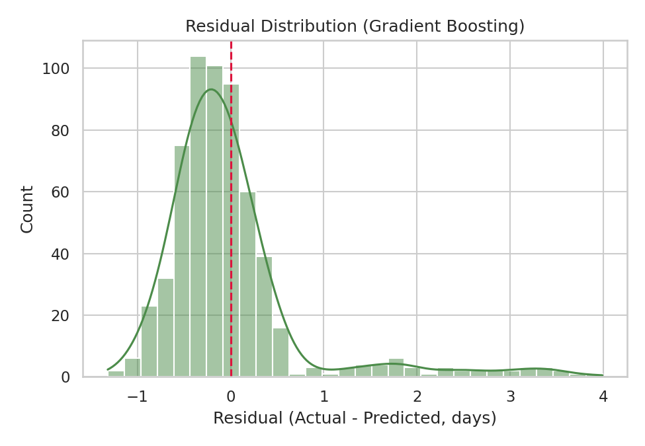
Figure 2: Residuals (actual minus predicted) for the test set.
Residuals are roughly centered on zero with a mild right tail, consistent with the model slightly underpredicting a subset of slow deliveries rather than being randomly wrong in both directions. A perfectly unbiased model would show a symmetric residual distribution; this one is close but not perfect, which is expected given the known disruption-period gap.

4.3 Feature Importance
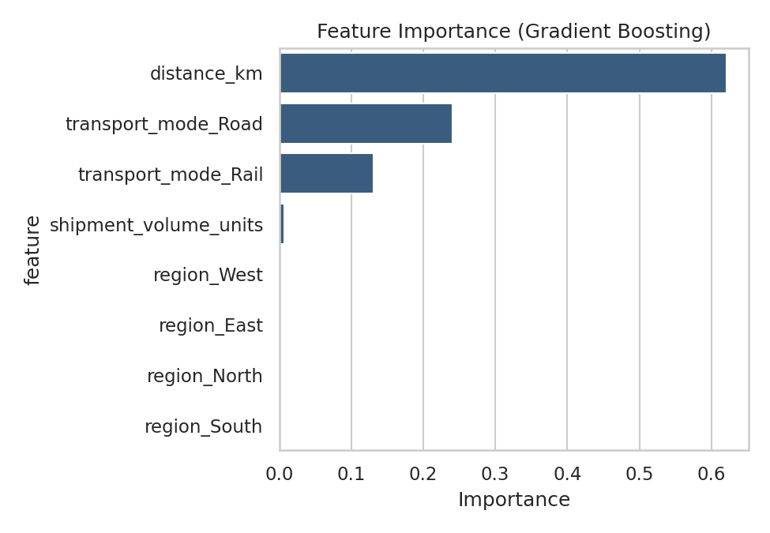
Figure 3: Gradient Boosting feature importances.
distance_km dominates (0.62), followed by transport_mode_Road and transport_mode_Rail (0.24 and 0.13 combined, i.e. the Air-vs-non-Air distinction matters most), while shipment_volume_units and all region dummies are close to zero. This doesn't mean region is operationally irrelevant — it means region's effect on delivery time is almost entirely explained through distance_km already, so the model doesn't need the region label as a separate signal once distance is known.

4.4 Model Comparison
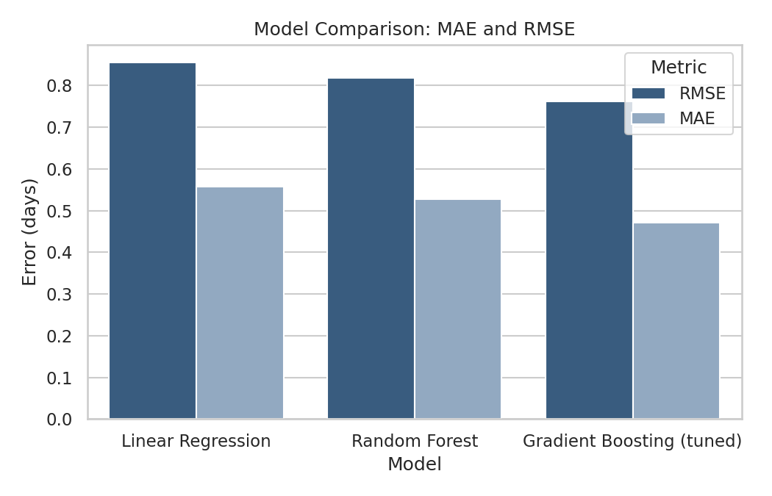
Figure 4: MAE and RMSE across all three models.
This chart makes the same point as the Section 3.1 table visually — the step down in error from Linear Regression to either ensemble model is larger than the step between Random Forest and Gradient Boosting, so most of the gain comes from allowing feature interactions at all, with the choice of ensemble method being a smaller, second-order improvement.

5. Optimization Strategies
Beyond the forecast itself, three optimization actions follow directly from what the model revealed:
- Pre-shipment risk flagging: since the model can estimate expected delivery time from distance, mode, and region before a shipment leaves the DC, orders with a predicted delivery time close to or above the 3-day SLA can be automatically flagged for mode upgrade (e.g. Road to Rail or Air) at dispatch time, rather than discovered late after the fact.
- Mode-shift cost/time tradeoff: combining this week's feature importance (transport_mode is the second-biggest driver) with Week 3's cost-per-km findings (Rail ~5x cheaper than Air), FreshCart can set a simple decision rule — use the model's predicted delivery time to identify which currently-Road shipments would only need to move to Rail (not the far more expensive Air) to comfortably clear the SLA, capturing schedule reliability without paying Air prices.
- Disruption-aware buffer, not a better base model: since CV showed the model is accurate in normal conditions but blind to disruption events, the more effective fix isn't a fancier algorithm — it's adding an operational 'disruption flag' feature (e.g. from a weather/traffic API) so the same model can widen its predictions during known-risk windows instead of confidently underpredicting them.
Together, these turn the model from a passive forecast into an active dispatch-time decision tool: flag at-risk shipments before they leave, choose the cheapest mode that still clears the SLA, and treat disruption periods as a known blind spot to be monitored rather than solved by model complexity alone.

6. Conclusion and Recommendations
The Gradient Boosting model (MAE 0.47 days, R² 0.744) is accurate enough to be operationally useful for flagging likely-late shipments before dispatch, though its accuracy is not uniform — it should be trusted less during known disruption windows until a disruption indicator is added as a feature. Combined with the cost findings from Week 3, the clearest near-term win for FreshCart is a rule-based mode-upgrade policy driven by the model's predictions: shift borderline-late Road shipments to Rail rather than defaulting to Air, which addresses both the delivery-time and cost-efficiency goals from the original Week 1 roadmap at the same time.

