Advanced Data Analysis and Visualization in Logistics
Week 3 Task — FreshCart Supplies Logistics Data Pipeline
Name: Jitta Vinith Reddy

1. Data Simulation
This week's dataset simulates 90 days of shipment-level records for FreshCart Supplies, continuing from the Week 1 scenario and the Week 2 cleaning pipeline. Since a live dataset from the DC's systems isn't available, I generated a synthetic dataset that mirrors realistic logistics behavior — regional distance effects, transport-mode cost differences, and a deliberate 'disruption event' in mid-June to simulate something like a monsoon-related road closure, so the dataset isn't just noise but has an actual pattern worth discovering.
Dataset structure — 3,000 shipment records, 9 fields:
- order_date — shipment date, spanning May 1 to July 29, 2026
- region — North / South / East / West / Central
- transport_mode — Road / Rail / Air
- distance_km — distance from DC to destination store
- shipment_volume_units — units shipped in that order
- delivery_time_days — actual delivery time
- transport_cost — total cost of the shipment ($)
- cost_per_km — transport_cost / distance_km
- on_time — whether delivery met the region's expected window

2. Exploratory Data Analysis

2.1 Central Tendency and Spread
Summary statistics for the four key continuous variables:
Metric | Delivery Time (days) | Shipment Volume (units) | Transport Cost ($)
Mean | 2.68 | 141.8 | 221.73
Median | 2.55 | 129.0 | 188.92
Std Dev | 1.53 | 68.5 | 181.85
Min | 0.30 | 14 | 15.00
Max | 8.72 | 459 | 1423.49

The mean delivery time (2.68 days) sits above the median (2.55 days), which signals a right-skewed distribution — most shipments arrive quickly, but a smaller number of slow outliers pull the average up. Transport cost shows the same pattern even more strongly (mean $221.73 vs median $188.92), largely driven by the smaller number of Air shipments, which cost several times more per km than Road or Rail.

2.2 Correlation Analysis
Distance and transport cost show a clear positive correlation (r ≈ 0.62), which is expected — longer routes cost more. More interesting is that shipment volume shows almost no correlation with either delivery time (r ≈ 0.01) or cost (r ≈ 0.03), suggesting that within this dataset, how much is shipped doesn't meaningfully affect how long it takes or what it costs — mode and distance are the real drivers, not order size. Delivery time has a mild negative correlation with cost-per-km (r ≈ -0.21), which reflects that Air shipments (highest cost/km) are used for the shorter, more time-critical routes.

3. Visualizations

3.1 Distribution of Delivery Times
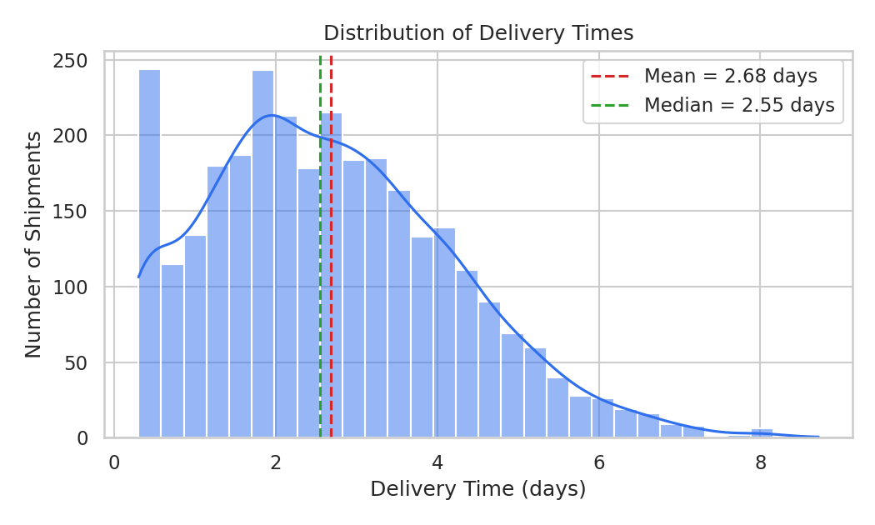
Figure 1: Histogram with KDE overlay showing the right-skewed delivery-time distribution.
A histogram with a KDE overlay was chosen here because the task is understanding the shape of a single continuous variable — is it symmetric, skewed, bimodal? The chart shows most shipments deliver in 1-4 days, but a long right tail extends out to nearly 9 days, which is what pulls the mean above the median.

3.2 Delivery Time by Region
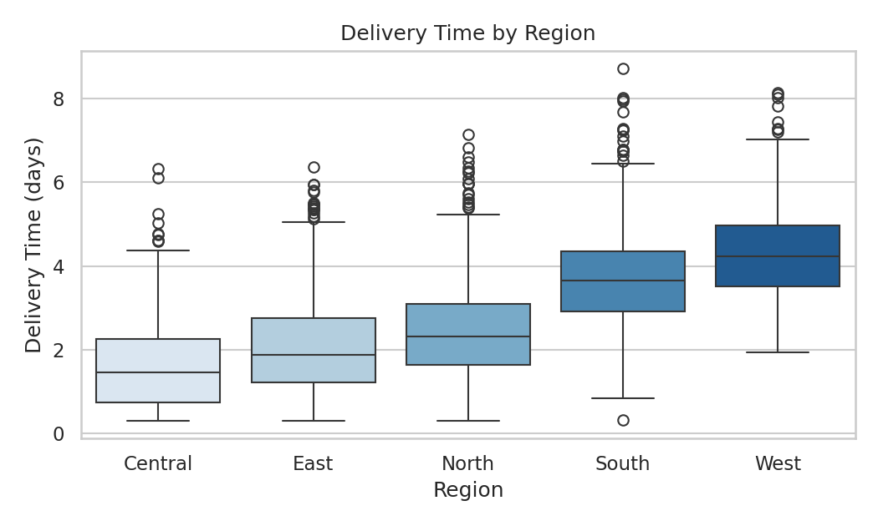
Figure 2: Boxplot comparing delivery-time distributions across the five regions.
A boxplot was chosen over a bar chart of averages because it shows the full spread and outliers per region, not just a single number — which matters for spotting bottlenecks. West and South stand out with both higher medians (~4.2 and ~3.7 days) and wider boxes, meaning deliveries there are slower and less predictable. Central and East are both faster and more consistent, most likely due to proximity to the DC.

3.3 Shipment Volume vs Transport Cost
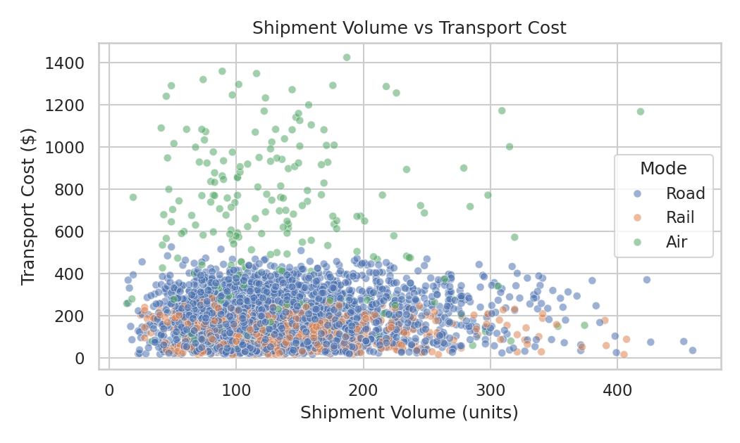
Figure 3: Scatter plot of shipment volume against transport cost, colored by transport mode.
A scatter plot is the right choice for examining the relationship between two continuous variables, and coloring by transport mode adds a third dimension without needing a separate chart. The plot confirms the correlation analysis — there's no clear diagonal trend within any single mode, but the three modes form visibly distinct cost bands, with Air sitting well above Road and Rail regardless of volume shipped.

3.4 Correlation Heatmap
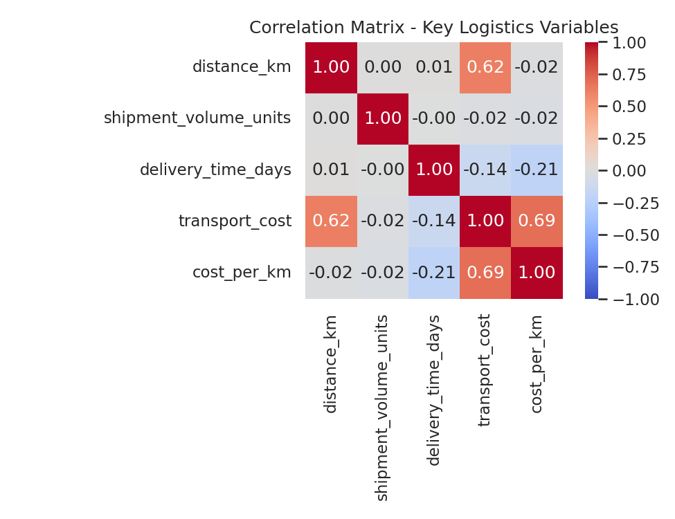
Figure 4: Correlation matrix across the five key numeric variables.
A heatmap was used to scan all pairwise correlations at once rather than reading a text table — the color gradient makes the strongest relationships (distance-cost, cost-cost/km) immediately visible without needing to compare individual numbers.

3.5 Delivery Time Trend Over Time
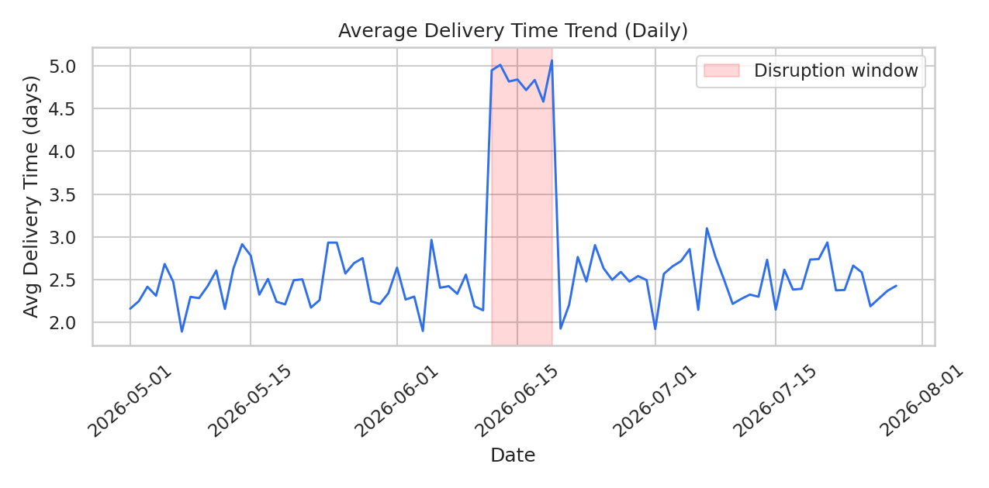
Figure 5: Daily average delivery time across the 90-day window, with the disruption period highlighted.
A line chart is the standard choice for a variable tracked over time, since it's the only chart type that makes a trend or a sudden shift visually obvious. The spike between June 12-19 (avg. delivery time roughly doubling from ~2.5 to ~5 days) stands out immediately against the otherwise stable baseline — this is exactly the kind of pattern a static summary statistic would completely hide.

3.6 Cost per Km by Transport Mode
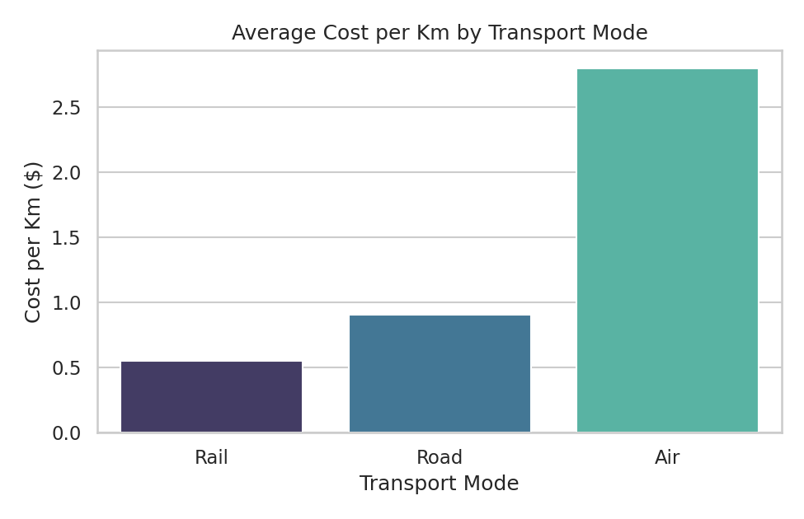
Figure 6: Average cost per km for Road, Rail, and Air shipments.
A simple bar chart works well here since it's a direct comparison across three categories. Rail is the cheapest per km (~$0.55), Road is moderate (~$0.90), and Air is nearly three times the cost of Road (~$2.80) — which quantifies the cost-of-speed tradeoff that Section 3.3 showed visually.

4. Analytical Insights

4.1 Operational Efficiency
West and South regions are the clearest operational bottleneck — both slower and more variable in delivery time than the other three regions. Since this isn't explained by shipment volume (which barely correlates with delivery time at all), the likely driver is route distance and/or reliance on slower transport modes for those regions, both of which are actionable rather than something FreshCart has to simply accept.

4.2 Cost Drivers
Distance is the dominant cost driver, not shipment size. This matters for planning — consolidating more units per shipment (as the Week 1 roadmap's clustering step proposes) won't reduce cost-per-shipment nearly as much as optimizing routes or shifting long-distance, non-urgent shipments off Air and onto Rail where feasible, given Rail's roughly 5x lower cost-per-km than Air.

4.3 Bottleneck: The June Disruption
The one-week spike in delivery time (Section 3.5) shows the value of monitoring the trend line rather than only period averages — a monthly report might show June's average delivery time only slightly elevated and miss that one specific week was in serious trouble. This is the kind of event that should trigger an operational alert in a live dashboard, not just appear after the fact in a report.

5. Recommendations
- Investigate West and South region routing specifically — these are the two regions with both the slowest and least predictable delivery times, independent of volume.
- Shift more long-distance, non-urgent shipments from Air to Rail, given the ~5x cost-per-km gap, reserving Air for genuinely time-critical orders.
- Build an automated trend alert (rather than only periodic averages) so disruption events like the mid-June spike are caught within days, not discovered retroactively in a monthly report.
- Because shipment volume shows almost no relationship with cost or delivery time, prioritize route and mode optimization over order-consolidation efforts when trying to cut logistics costs.

6. Python Code Used

6.1 Summary Statistics and Correlation
import pandas as pd

df = pd.read_csv("freshcart_shipments.csv", parse_dates=["order_date"])
summary = df[["delivery_time_days", "shipment_volume_units",
"transport_cost", "cost_per_km"]].describe()

corr = df[["distance_km", "shipment_volume_units", "delivery_time_days",
"transport_cost", "cost_per_km"]].corr()

6.2 Visualization Snippets
import seaborn as sns
import matplotlib.pyplot as plt

# Distribution
sns.histplot(df["delivery_time_days"], bins=30, kde=True)

# Regional comparison
sns.boxplot(data=df, x="region", y="delivery_time_days")

# Relationship + third dimension via color
sns.scatterplot(data=df, x="shipment_volume_units", y="transport_cost",
hue="transport_mode", alpha=0.55)

# Correlation overview
sns.heatmap(corr, annot=True, fmt=".2f", cmap="coolwarm")

# Trend over time
daily = df.groupby(df["order_date"].dt.date)["delivery_time_days"].mean()
plt.plot(daily.index, daily.values)

