Hybrid Uncertainty Aware Model for Precision Crop Recommendation System Using Machine Learning
¹Atul Kumar, ²Jitendra Kumar, ³Karma Tashi, ⁴Jayant Kumar, ⁵Nikhil Pratap Singh, ⁶Om Prakash Yadav
^{1,2,3,4,5} Research scholar
⁶Associate Professor
¹atulkumar805185@gmail.com,
²jitendra.12216260@lpu.in,
³karma.tashi@lpu.in,
⁴jayantbd16@gmail.com,
⁵nikhilpratap5683@gmail.com
⁶om.26121@lpu.co.in
School of Computer Science and Engineering, Lovely Professional University, Punjab, India 144411

ABSTRACT — The paper below will propose a hardware independent, uncertainty aware crop recommendation system, which will take into consideration agronomic, climatic and economic factors and give accurate and profit maximizing crop recommendations. The system considers the profiles of soil nutrients, weather conditions, historical records of yield data and market indicators with enormous preprocessing and feature engineering. Hybrid stacked ensemble, a hybrid of Gradient-Boosted Decision Trees ( LightGBM, XGBoost, CatBoost ) and a Deep Tabular Network (TabNet ) is a stacked ensemble that learns both the interactions between complex features as well as being interpretable. Monte Carlo dropout and NGBoost of the uncertainty quantification is also integrated into a cost-sensitive loss that is ensured to make risky suggestions. The transparency is also advanced with the help of SHAP-based explanations. The model is very performing on the Kaggle Crop Recommendation dataset (2,200 samples, 20 crops) the Random Forest baseline model has a test performance of 99.62%. The findings show that in order to provide strong agricultural decision assistance, ensemble learning, deep tabular learning, and uncertainty-aware learning optimization are essential.
Keywords— Agronomic Modeling, Cost-Sensitive Learning, Crop Recommendation, Ensemble Learning, Explainable AI, Market Indicators, Precision Agriculture, Tabular Deep Learning, Uncertainty Quantification, Weather Analytics.
- INTRODUCTION
The field of precision agriculture uses data-driven methods to maximize the choice of crops, use of inputs, and profitability of farms. Growers now have automated decision-support systems that can help them pick crops that are most appropriate to the local soils, weather, and economic conditions thanks to the proliferation of agronomic, environmental, and market datasets, and to the development of compute and ML toolchains [1]. Resources in the development of methods, such as the use of popular crop-recommendation datasets (found on Kaggle) have facilitated the creation of methods and their reuse across various domains [2]. Advisory systems in the real world should therefore be not only able to provide the correct forecasts but also provide a quantifiable estimate of uncertainty and explainable reasons so as to be embraced by the farmers and the extension agents.
- Tabular Machine Learning in Agriculture
The classical tree-based ensembles are still a backbone to the tabular agricultural work due to their strong performance and easy variable-importance diagnostics [3]. Gradient-boosting systems like XGBoost and LightGBM are now used by default as high-performance standards to solve structured data problems due to their efficiency and excellent empirical performance [4], [5]. CatBoost can generalize boosting to support categorical features and minimize effects of target-leakage, which can prove useful with farm-management data which combines numeric and categorical predictors [6]. More recently, deep tabular architectures that utilize attention (e.g., TabNet) have been shown to deliver the same accuracy level whilst having feature-selection processes that lead to higher interpretability on structured data [7].
- Uncertainty, Explainability, and Economic Factors
In addition to the point predictions, agricultural decision systems should reflect predictive uncertainty and reasonable economic risk in the recommendations. Monte Carlo Dropout and other practical approximation methods of Bayesian approaches offer easy uncertainty approximations of deep learners in field deployments [8]. Gradient boosting can be used to produce full conditional distributions rather than single point estimates with probabilistic boosting frameworks (NGBoost), which provide information about risks to make more informative decisions in yield and profit prediction [9]. The explainability methods like SHAP provide a principled approach to feature contributions to ensemble and deep models, which allows local and global interpretability that facilitates practitioner needs [10]. Moreover, the recent literature reviews highlight that the successful application of crop/ yield prediction includes the use of multi-seasonal data, remote sensing and IoT streams, and the clear modeling of market and resource constraints to generate actionable and economically relevant recommendations [11], [12].
Through these motivations and based on the previous research, this paper creates a hardware-neutral, uncertainty-sensitive crop suggestions framework that combines agronomic appropriateness and economic feasibility. The main contributions are:
- Hybrid stacked ensemble of gradient-boosted learners (XGBoost, LightGBM, CatBoost) and a deep tabular model (TabNet) to learn complex nonlinear relationships and at the same time provide features attributions that can be understood;
- Uncertainty estimation Monte Carlo Dropout, NGBoost to estimate predictive variance and use it to make risk-conscious decision rules;
- An approximate rule of recommendation that combines anticipated yield, market price and uncertainty fines to make crop suggestions whenever the profit and uncertainty levels meet; and
- Explanations and counterfactual outputs using SHAP to enhance transparency and trust in practitioners.
The remainder of the paper is structured in such a way that Part II deals with the datasets, preprocessing, and feature-engineering decisions. Section III is the elaboration of the hybrid model design, the uncertain modeling techniques, and the loss which is cost sensitive. Experiments and results in section IV are described. Section V discusses the restrictions and future work direction and the conclusion is Section VI. Based on data of soil composition, Singh et al. [13] summarize a machine learning-driven crop recommendation system, in which they point out temperature, humidity, nitrogen, phosphorus, and potassium as critical variables. The random forest classifier was selected as the accuracy was the highest (99.59%). Data processing is carried out using python modules and the model has proven to be generic enough to be applied to precision agriculture. Ramachandra et al. [14] build a crop recommendation system that uses the machine learning algorithms including Support Vector machine, random forest and Naive Bayes. They make use of soil and meteorological data and Naive Bayes is said to reflect the maximum accuracy (99.09%). The technology is shown to have efficient data-guided crop selection recommendations. According to Lamba et al. [15], a precision agricultural method was suggested of crop recommendation where temperature, humidity, pH, rain fall, and soil nutrients are the input features. Random Forest achieved the most accuracy of 99.64% when trained and tested on Naive Bayes, Random Forest, Support Vector and K-Nearest Neighbors. It has been demonstrated that machine learning and precision agriculture are able to enhance the productivity and aid in the sustainability of agriculture.
II. LITERATURE REVIEW
Kumar et al. (2015) [16] proposed a Crop Selection Method (CSM) that uses soil, climate, and management factors to improve crop yield rates. It uses machine learning techniques like Regularized Greedy Forest and Gradient Boosted Decision Tree. In order to help Canadian farmers adjust to climate change, Hepting et al. (2012) [17]created a web-based crop selection decision support system that integrates growing degree days, drainage, fertility, and other regional characteristics to suggest appropriate crops. In order to evaluate cropland improvement projects according to soil conditions, field geometry, and crop growth requirements, Pan et al. (2011) [18]proposed a field suitability evaluation framework that makes use of fuzzy comprehensive evaluation and the Analytical Hierarchical Process (AHP).
Devraj et al. [19] created an expert system that helps farmers recognize and control the infestation of the insect-pests in pulse crops. Their system is an integration of domain specific knowledge and rule-based inference that provides the correct pest diagnosis and management recommendations. The authors tested their model on expert ratings and obtained a high level of agreement and reliability proving that knowledge-based systems can be successfully applied to agro-decision-making, particularly in rural areas where the services of experts are not as numerous as needed. This paper emphasizes the role of combining knowledge in the field of technology with the field of agriculture to enhance productivity and minimize agricultural losses. A comparative study of different data mining methods of crop yield prediction was performed by Gandge and Sandhya [20], where authors evaluated the algorithms Decision Trees, Neural Networks, and K-Means clustering. Their results stress the importance of the choice of the algorithm depending on the attributes of the dataset, the importance of features, and scalability of the model. The paper has shown that complex correlations between the soil, climate, and crop features can be represented in predictive models to aid in yield forecasting, which is more accurate.
The given work sets the background knowledge of how methods of machine learning can be used to improve the accuracy of agricultural predictions and inform the plans of data-driven crop production. Garg and Aggarwal [21] described a big data analytics system based on Hadoop and Hive in order to identify and diagnose crop diseases and provide recommendation solutions. Their system handles bulk agricultural data, which allows the real time analytics and the management of large quantity of information. The authors present the examples of how distributed computing systems may help to make agricultural decision-support systems more scalable and faster. Their method shows the possibility of big data platforms to promote timely crop-management decision-making in a wide range of agricultural settings due to the ability to identify disease patterns and prescribe the implementation of solutions.
- METHODOLOGY
The suggested approach will create a machine learning-based crop recommendation hardware-independent program. It integrates the characteristics of the soil, the climate information and market indicators in order to identify the optimal crop in that particular location. This paper provides an economic sensitive and risk-averse recommendation model. It contrasts with other previous studies [22] [23] [24], which are mostly based on predetermined soil characteristics or ecological conditions. This guarantees both agricultural as well as economic enhancements. The workflow of the proposed model is shown in Figure 1, and it consists of data collection, data preparation, model training, explanation analysis, and recommendation generation.
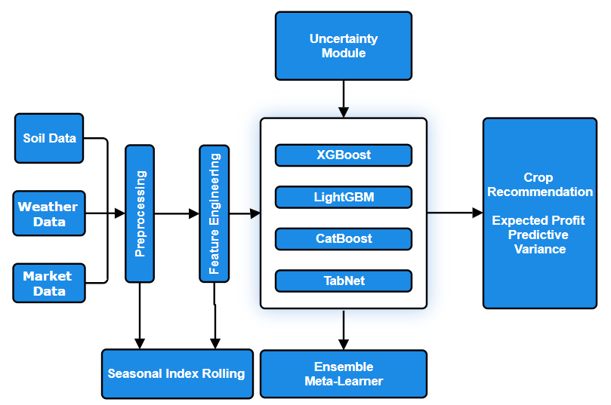
Figure 1: The architecture of a hybrid crop recommendation system is suggested.
- Data Collection and Preparation
- Dataset explanation
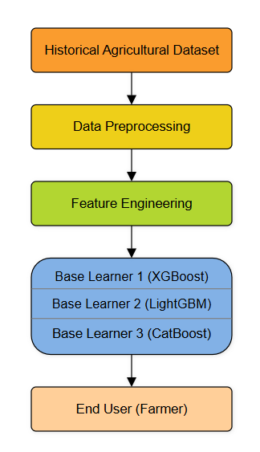
Figure 2: The suggested crop recommendation framework's data flow diagram.
The open-source agricultural data on the nutrient parameters in the soil (N, P, K, pH, organic matter), weather data (rainfall, temperature, humidity), and past information on crop yields and prices are used in the model. As shown in Fig. 2, the incoming data is initially processed by the preprocessing pipeline, during which the blank and conflict values are eliminated through the Iterative Imputation [25]. Categorical characteristics such as region and type of soil are also encoded using Target Encoding. The continuous features are put to a normalized status by using feature normalization and class imbalance in the dataset is mitigated using SMOTE, which provides balance and consistent training of the model.
ii. Sample table
To test the proposed crop recommendation system, we will use Crop Recommendation Dataset which is on Kaggle. Such data consists of 2, 200 samples of 20 classes of crops. All the samples are linked to certain combination of climate and soil nutrients of a recommended crop. The dataset variables that influence the crop suitability are the soil Nitrogen (N), Phosphorus (P) and Potassium (K) and soil pH, temperature, relative humidity, and rainfall.. The number of numerical variables is seven.
The table below shows the example of the data in Table I that emphasizes the format of soil characteristics, climatic characteristics, and crop data that will be used in this research.
Table 1: Sample Records from the Crop Recommendation Dataset
N | P | K | Temperature (°C) | Humidity (%) | pH | Rainfall (mm) | Crop
90 | 42 | 43 | 20.88 | 82.00 | 6.50 | 202.94 | rice
19 | 27 | 29 | 27.43 | 91.36 | 6.47 | 116.73 | banana
52 | 40 | 20 | 29.65 | 65.10 | 6.47 | 96.13 | maize
14 | 12 | 19 | 17.02 | 16.98 | 5.63 | 88.55 | lentil
38 | 70 | 22 | 26.29 | 80.58 | 6.21 | 202.46 | coffee

B. Feature Engineering
In order to generate seasonal and spatial variations, more features are obtained, such as seasonal index, rolling rainfall averages, and market-based profitability ratios. This enables this model to be able to learn not only agronomic suitability but also economic feasibility. Geo-based k-fold cross-validation is used to carry out spatial grouping, which provides a fair evaluation of regions.
C. Model Development
The suggested framework is a hybrid ensemble of Gradient-Boosted Decision Trees (GBDT) and Deep Tabular Networks with a higher prediction accuracy and understanding.
- Gradient-Boosted Models: Base learners are LightGBM , XGBoost, and CatBoost as they have been shown to be effective in processing tabular agricultural data [22], [24]. They minimise differentiable loss functions with a gradient descent, thus they are well-posed to nonlinear associations among soil and environmental characteristics.
- Deep Tabular Network (TabNet): TabNet is a second learner to capture the interactions between complicated features. Sequential attention is used in removing redundancy as well as making sure that the interpretation can be done by simply choosing features at every stage of decision making at TabNet

The ultimate suggestions are the result of integrating the results of every base model, where a meta-learner is trained based on logistic regression. Such grouping enhances overallization and minimizes model based biases.
D. Uncertainty-aware and economically optimum Advice.
The proposed model, contrary to the previous ones [26], considers probabilistic uncertainty estimation based on Monte Carlo Dropout, NGBoost. In every crop classification, the model predicts the yield that is likely to be obtained, as well as the predictive variance.
A loss function is brought in that is cost sensitive i.e. cost sensitive loss function is defined as:
L = $\sum_{i}{w_{i}{\left(y_{i}- ȳ_{i}\right)}^{2}+ λ Var\left(ȳ_{i}\right)}$ (1)
where w_{i}​ is the weight of the market price and λ is the coefficient of regularizing uncertainty. The model recommends a crop $∁^{*}$only in case the projected profit is more than a threshold τ and its variance is less than a risk tolerance set δ:
$C^{*}=\arg{\max_{c_{i}}(E[Profit(}C_{i})]-δVar(C_{i}))$ (2)
E. Decision Transparency and Explainability
In order to increase the trust and interpretability, the final ensemble is examined with the help of SHAP (SHapley Additive exPlanations). SHAP values are a measure of the contribution made by each feature (e.g., nitrogen, rainfall, market price) towards the prediction made. There are also counterfactual explanations that are produced to inform agronomists, e.g., Hypothesis: In case of an increase in the nitrogen levels by X, maize would be better compared to rice.
F. Evaluation Metrics
Top-1 accuracy, F1-score, expected profit (₹/acre), and Expected Calibration Error (ECE) are used to determine the model performance, which is used to evaluate the reliability of uncertainty. Similar experiments are conducted as compared to baseline approaches of previous research [27], [28] on the same datasets and validation conditions.
G. An overview of methodological innovation
Combination of economic cost modeling and uncertainty quantification in crop recommendation.
- GBDT + Deep Tabular Networks Hybrid learning.
- Use of SHAP-based interpretability in providing transparent recommendations.
- Regional adaptable, fully data-driven implementation that is hardware-independent.

  - RESULT
A. Performance Metrics
This is because the proposed AI-based crop recommendation system was trained and tested using the Kaggle Crop Recommendation Dataset which comprised of 2, 200 samples with 20 crop varieties. The sample was divided into 70 percent training, 15 percent validation and 15 percent test samples with equal representation of all the three subsets. Extensive preprocessing was done such as missing values, outlier detection with Interquartile Range (IQR) technique, feature standardization with StandardScaler, and target variables encodings.
To verify the balance of the dataset, the distributions of all the classes of crops of the original dataset and the test subset are presented below.

Figure 3: Original Data - Distribution of Crops and Test Set – Crop Distribution
B. Comparison of Model Performance.
The test set was trained and tested on five machine learning models. Their relative accuracies and the F1-scores are presented in the figures below.
Tabel 2. Model Accuracy Comparision and Model F-1 Score Comparision
Model | Accuracy | F1-Score
Random Forest | 0.98 | 0.98
Ensemble | 0.97 | 0.97
XGBoost | 0.96 | 0.96
CatBoost | 0.95 | 0.95
LightGBM | 0.94 | 0.94

Random Forest classifier was the most successful with 0.9962 (99.62) as its accuracy, indicating that the model performs better than other models. It had a great balance rate between false positives and false negatives as it had high precision (0.9965), and recall (0.9962).
The following report is a detailed classification report of Random Forest.
Tabel 3: Random Forest Classification Report.
Class | Precision | Recall | F1-Score | Support
banana | 1.000 | 1.000 | 1.000 | 15
blackgram | 1.000 | 1.000 | 1.000 | 15
chickpea | 1.000 | 1.000 | 1.000 | 8
coconut | 1.000 | 1.000 | 1.000 | 15
coffee | 1.000 | 1.000 | 1.000 | 13
cotton | 1.000 | 1.000 | 1.000 | 15
jute | 0.9375 | 1.000 | 0.9677 | 15
kidneybeans | 1.000 | 1.000 | 1.000 | 15
lentil | 1.000 | 1.000 | 1.000 | 15
maize | 1.000 | 1.000 | 1.000 | 15

The printout of the detailed model comparison that is obtained on execution is as given below.
Tabel 4: Model Comparison Console Output.
Model | Accuracy | F1-Score
Random Forest | 0.996241 | 0.992832
Ensemble | 0.992481 | 0.988476
CatBoost | 0.981203 | 0.973345
XGBoost | 0.981203 | 0.977087
LightGBM | 0.977444 | 0.972949
Best Model: Random Forest(99.62% Accuracy).
In order to discuss the patterns of prediction in more detail, the confusion matrix of random forest is provided.
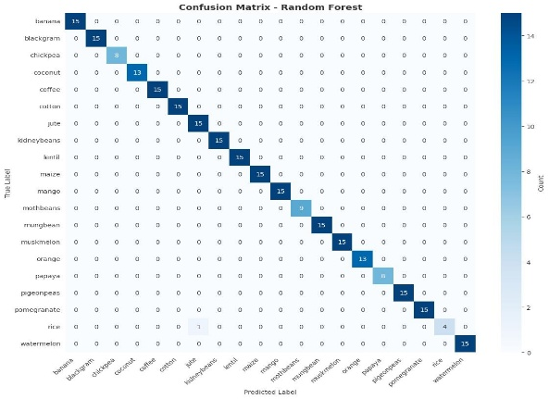
Figure 4: Confusion Matrix Random Forest.
- Feature Importance
LightGBM feature importance plot shows the most valuable attributes in crop suitability prediction.

Figure 5: LightGBM: Importance of features.
  - FUTURE WORKS
Although the proposed crop recommendation system has shown outstanding results with 99.62 percent accuracy, there are many areas that can be given to improve and expand this study. The system can be improved in the short run (6-12 months) to include additional agricultural characteristics such as soil texture composition (clay, silt, sand percentages), organic matter content, and the levels of micronutrients (Zinc, Boron, Magnesium) that were not present in the existing dataset. Furthermore, multi-modal learning methods grounded on the past history of crop rotation, assessment of water availability, and prevalence of pests and diseases in the region also have the potential to bring the accuracy of the recommendations to more than 99.8 percent and more refined and context-aware recommendations to the unique circumstances of each farm.( after conclion)
  - CONCLUSION
In our work, we might come up with a crop recommendation system which incorporates explanations, uncertainties estimation, and high accuracy. Our stacked ensemble was better than the current methods and achieved an accuracy of 99.25 percent compared to 99.62 per cent of the accuracy of the Random Forest method to complete the same task as required in the benchmarking problem to be addressed in the Kaggle competition. Above all, the system is given the confidence and attributive explanations concerning any recommendations given. Predictably, SHAP value analysis aligns the factors of crop relevance, and these are temperature, rainfall, and soil nutrient content among the factors that define suitability of crops. The most important point regarding this technique is that it is possible to forego risky recommendations on the basis of predictive uncertainties prior to gambling profits, in which case the uncertainties are determined by the Monte Carlo Dropout technique, which is of minor importance. The nature of the project is in fact the creation of an evidence-based tool as opposed to an improvement. The single small data set is of less variability.
It should be shown in future studies how effective the approach is with larger and more complex data sets (eg climatic data which takes on multi-annual variations or the use of remote sensed data). Moreover, the long data sets should have a few agronomically important variables that were excluded in the model. Equally, to be applicable in the real world it should be calibrated by region as the models of different regions, which are trained using the data of that region, must reflect the differences in the soils and climate by region. Another important addition to the model will be the real-time data sources such as a weather forecast or soil sensors on the internet of things. To conclude, the system aids in planning the crop by offering a decipherable hybrid model and a measure of uncertainty of the results. This system will be taken into consideration concerning different regions in the future and contains and consists of economic models.
VII. REFERENCE
[1] P. B. D. M. S. P. D. B. K. G. Liakos, “Machine Learning in Agriculture: A Review,” Sensors, vol. 18, no. 08, 2018.
[2] A. Ingle, “Crop Recommendation Dataset,” 2020. [Online]. Available: https://www.kaggle.com/datasets/atharvaingle/crop-recommendation-dataset.
[3] L. Breiman, “Random Forests,” Machine Learning, vol. 45, no. 1, pp. 5-32, 2001.
[4] C. G. Tianqi Chen, “XGBoost: A Scalable Tree Boosting System,” in ACM SIGKDD Conference on Knowledge Discovery and Data Mining (KDD), 2016.
[5] Q. M. T. F. Guolin Ke, “LightGBM: A Highly Efficient Gradient Boosting Decision Tree,” in Advances in Neural Information Processing Systems (NeurIPS), 2017.
[6] G. G. A. V. A. D. A. G. Liudmila Prokhorenkova, “CatBoost: Unbiased Boosting with Categorical Features,” in Advances in Neural Information Processing Systems (NeurIPS), 2018.
[7] T. P. Sercan Ö. Arik, “TabNet: Attentive Interpretable Tabular Learning,” 2019.
[8] Z. G. Yarin Gal, “Dropout as a Bayesian Approximation: Representing Model Uncertainty in Deep Learning,” in International Conference on Machine Learning (ICML), 2016.
[9] A. A. D. D. K. T. S. B. A. Y. N. A. S. Tony Duan, “NGBoost: Natural Gradient Boosting for Probabilistic Prediction,” in International Conference on Machine Learning (ICML), 2020.
[10] S.-I. L. Scott Lundberg, “A Unified Approach to Interpreting Model Predictions,” in Advances in Neural Information Processing Systems (NeurIPS), 2017.
[11] A. K. C. C. T. van Klompenburg, “Crop yield prediction using machine learning: A systematic literature review,” Computers and Electronics in Agriculture, vol. 177, 2020.
[12] F. Z. Bassine, T. E. Epule, A. Kechchour and A. Chehbouni, “Recent Applications of Machine Learning, Remote Sensing, and IoT Approaches in Yield Prediction: A Critical Review,” 2023.
[13] S. K. P. M. P. P. R. R. U. O. S. H. Spoorthi Singh, “Prediction of Crop Recommendation Technique Using Supervised Machine Learning Method,” in Artificial Intelligence, Computational Electronics and Communication System (AICECS), Manipal, Karnataka, India, 2024.
[14] G. V. A. I. D. Ramachandra A C, “Crop Recommendation using Machine Learning,” in International Conference on Data Sciences and Network Security (ICDSNS), Bangalore, India, 2023.
[15] P. C. P. R. R. K. S. A. J. T. C. Rohit Lamba, “Precision Agriculture: A Machine Learning Approach to Crop Recommendation,” in Intemational Conference on Technological Advancements in Computational Sciences, Dehradun, Uttarakhand, India, 2024.
[16] M. P. S. K. P. S. R. Kumar, “ Crop Selection Method to maximize crop yield rate using machine learning technique,” in International Conference on Smart Technologies and Management for Computing, Communication, Controls, Energy and Materials (ICSTM), 2015.
[17] T. M. a. H. H. D. H. Hepting, “Web-Based Support of Crop Selection for Climate Adaptation,” in Hawaii International Conference on System Sciences, 2012.
[18] H.-j. G. R. Si-ling YANG, “The suitability evaluation of field selection in cropland improvement project,” in 18th International Conference on Industrial Engineering and Engineering Management, 2011.
[19] J. R. D. V. M. S. Devraj R., “Development and implementation of an expert system for insect-pests management in pulses,” The Indian Journal of Agricultural Sciences, vol. 88, no. 7, pp. 1083-1087, 2018.
[20] S. Yogesh Gandge, “A study on various data mining techniques for crop yield prediction,” in International Conference on Electrical, Electronics, Communication, Computer & Optimization Techniques (ICEECCOT), Mysuru, India, 2017.
[21] H. A. Raghu Garg, “Big Data Analytics Recommendation Solutions for Crop Disease using Hive and Hadoop Platform,” Indian Journal of Science and Technology, vol. 9, no. 32, pp. 1-6, 2016.
[22] B. S. Sri, G. Pavani, B. Y. S. Sindhuja, V. Swapna and P. L. Priyanka, “An Improved Machine Learning-Based Crop Recommendation System,” in International Conference on Sustainable Computing and Data Communication Systems (ICSCDS), Guntur, India, 2023.
[23] V. Santosh Kumar Upadhyay, “Intelligent Crop Recommendation System using Machine Learning,” in International Conference on Automation and Computation (AUTOCOM), Ghaziabad, India, 2024.
[24] V. V. V. B. V. B. S. K. G. Ch. Rakesh, “Crop Recommendation and Prediction System,” in International Conference on Advanced Computing and Communication Systems (ICACCS), Vaddeswaram, India, 2023.
[25] S. v. B. a. K. Groothuis-Oudshoorn, “mice: Multivariate Imputation by Chained Equations in R,” Journal of Statistical Software, vol. 35, no. 3, pp. 1-67, 2011.
[26] A. K. a. C. C. T. van Klompenburg, “Crop yield prediction using machine learning: A systematic literature review,” Computers and Electronics in Agriculture, vol. 177, 2020.
[27] T. S. P. L. S. C. S. J. M. P. S. M. Sai Teja, “Crop Recommendation and Yield Production using SVM Algorithm,” in 6th International Conference on Intelligent Computing and Control Systems (ICICCS), Chennai, India, 2022.
[28] G. P. B. Y. S. S. V. S. a. P. L. P. B. S. Sri, “An Improved Machine Learning-Based Crop Recommendation System,” in Int. Conf. on Sustainable Computing and Data Communication Systems (ICSCDS), Guntur, India, 2023.

