Group 8 Defect Detection Project
PPT Generation Brief
Use this document as the source brief for GPT to generate a 10-minute final demo deck.

Fill before final PPT: Add all team member names in alphabetical order by last name on the title slide and report. Current placeholder: Group 8 members: [fill names].

1. One-Paragraph Project Summary
This project evaluates whether large language models and code-specific encoders can detect defective C/C++ functions from the CodeXGLUE defect detection benchmark. We compare four increasingly task-adapted approaches: zero-shot Qwen, 4-shot Qwen, LoRA fine-tuned Qwen, and a supervised GraphCodeBERT encoder baseline. The main finding is that prompt-only LLM use is not reliable for this task, LoRA fine-tuning improves stability but remains limited, and GraphCodeBERT achieves the strongest validation and test performance.

2. Rubric-Aligned Goals
- Demo: use the full 10 minutes with a planned flow, live screen share, and all group members present.
- Professionalism: show a clean GitHub repo, reproducible outputs, clear figures, and a short scripted demo path.
- Report: explain novelty/motivation, related work, evaluation measures, results quality, and presentation polish.
- Submission: one PDF report, no more than 8 pages, plus code link: https://github.com/JiufuZh/526.

3. Core Storyline for Slides
- Start with the problem: manual defect detection is costly, and code vulnerabilities are subtle.
- Frame the research question: are prompt-only LLMs enough, or do we need task adaptation/code-specific models?
- Introduce the experimental ladder: zero-shot -> 4-shot -> LoRA fine-tuning -> GraphCodeBERT.
- Show validation/test metrics and confusion matrices.
- Interpret the result: GraphCodeBERT is strongest; 4-shot collapse is a useful negative result.
- Close with limitations, future work, and reproducible repo/output locations.

4. Experimental Design
Model/Setting | Purpose | Adaptation Level | Output Status
Qwen zero-shot | Test raw LLM reasoning from prompt only | None | Validation + test complete
Qwen 4-shot | Test in-context learning with examples | Prompt examples only | Validation + test complete; collapsed to non-defective
Qwen LoRA | Task-adapt Qwen with efficient fine-tuning | Supervised LoRA adapter | Training + validation + test complete
GraphCodeBERT | Compare against code-specific encoder | Supervised encoder classifier | Training + validation + test complete

5. Evaluation Measures
Do not rely only on accuracy because defect detection is class-sensitive and the defective class is the most important target. Use Macro-F1 as the main balanced metric and Defective-F1/Recall to evaluate whether the model actually catches defective code.
- Accuracy: overall correctness, useful but can hide majority-class collapse.
- Macro Precision/Recall/F1: treats defective and non-defective classes more evenly.
- Defective Precision/Recall/F1: focuses on the positive class, which matters for security and code review.
- Confusion matrix: shows false positives and false negatives directly.

6. Final Results to Put in PPT
Experiment | Split | Accuracy | Macro-F1 | Defective-F1 | Interpretation
Qwen zero-shot | Validation | 0.5201 | 0.5086 | 0.4332 | Baseline LLM has limited signal
Qwen zero-shot | Test | 0.5264 | 0.5180 | 0.4545 | Prompt-only performance is modest
Qwen 4-shot | Validation | 0.5655 | 0.3612 | 0.0000 | Collapsed to non-defective
Qwen 4-shot | Test | 0.5406 | 0.3509 | 0.0000 | Useful negative result
Qwen LoRA | Validation | 0.5556 | 0.5509 | 0.5045 | Stable but limited improvement
Qwen LoRA | Test | 0.5523 | 0.5507 | 0.5236 | Main fine-tuned LLM result
GraphCodeBERT | Validation | 0.6618 | 0.6513 | 0.5908 | Best validation result
GraphCodeBERT | Test | 0.6589 | 0.6517 | 0.6017 | Best test result

Main conclusion: For code defect detection, a code-specific supervised encoder outperformed prompt-only Qwen and LoRA fine-tuned Qwen. The result suggests task supervision and code-pretraining matter more than simply adding few-shot examples.

7. Suggested 10-Minute Demo Deck
Slide | Title | Time | Speaker Goal
1 | Project Title + Team | 0:30 | Introduce team, task, and GitHub link.
2 | Problem & Motivation | 1:00 | Explain why defect detection matters and why this is hard.
3 | Research Question | 0:45 | Prompt-only LLM vs fine-tuned LLM vs code encoder.
4 | Dataset & Task | 1:00 | CodeXGLUE, binary labels, validation/test splits.
5 | Model Ladder | 1:15 | Zero-shot, 4-shot, LoRA, GraphCodeBERT.
6 | Evaluation Metrics | 0:45 | Macro-F1, Defective-F1, confusion matrix.
7 | Result Table | 1:30 | GraphCodeBERT wins; 4-shot collapse explained.
8 | Confusion Matrices | 1:00 | Show false positives/false negatives visually.
9 | Live Demo / Repo Walkthrough | 1:00 | Show GitHub repo, outputs, metrics files, scripts.
10 | Conclusion & Next Steps | 0:30 | State takeaway and future improvements.

8. GPT Prompt to Generate the PPT
Create a professional 10-minute PowerPoint deck for a university final project demo.
Project: Group 8 Code Defect Detection with LLMs and GraphCodeBERT.
Audience: instructor and classmates.
Tone: concise, technical, polished, demo-ready.
Team names: [fill names in alphabetical order by last name].
Code link: https://github.com/JiufuZh/526
Required slide flow:
1. Title + team + GitHub link.
2. Problem and motivation: detecting defective C/C++ functions is important for software quality and security.
3. Research question: are prompt-only LLMs enough, or do task adaptation and code-specific pretraining matter?
4. Dataset/task: CodeXGLUE defect detection; binary labels non-defective vs defective.
5. Methods: Qwen zero-shot, Qwen 4-shot, Qwen LoRA fine-tuning, GraphCodeBERT supervised encoder.
6. Evaluation: accuracy, macro precision/recall/F1, defective precision/recall/F1, confusion matrix.
7. Main results table using these numbers:
- Zero-shot test: Accuracy 0.5264, Macro-F1 0.5180, Defective-F1 0.4545.
- 4-shot test: Accuracy 0.5406, Macro-F1 0.3509, Defective-F1 0.0000.
- LoRA test: Accuracy 0.5523, Macro-F1 0.5507, Defective-F1 0.5236.
- GraphCodeBERT test: Accuracy 0.6589, Macro-F1 0.6517, Defective-F1 0.6017.
8. Confusion matrix slide: emphasize that 4-shot collapsed to non-defective, while GraphCodeBERT catches more defective samples.
9. Demo slide: show repo, scripts, metrics JSON files, figures, and reproducibility.
10. Conclusion: prompt-only LLMs are weak for this task; LoRA helps but code-specific supervised GraphCodeBERT is strongest.
Design requirements:
- Keep the deck to about 10 slides.
- Use clear charts/tables, not dense paragraphs.
- Make the result slide visually central.
- Include proper citations/URLs in small text on relevant slides.
- Avoid claiming perfect performance; emphasize limitations and future work.
- Include a backup slide with exact metrics and output file paths if useful.

9. Assets and File Paths
- GitHub repo: https://github.com/JiufuZh/526
- Main result table: results/report_ready_metrics.md and results/report_ready_metrics.csv
- Confusion matrix overview: results/figures/confusion_matrices_overview.png
- GraphCodeBERT metrics: results/graphcodebert_validation_metrics.json and results/graphcodebert_test_metrics.json
- LoRA metrics: results/lora_validation_metrics.json and results/lora_test_metrics.json
- Zero-shot and 4-shot metrics: results/zero_shot_*_metrics.json and results/four_shot_*_metrics.json
- Tillicum project path: /gpfs/projects/imt526a/group8/final

10. Figure to Use in PPT
Use this overview or the individual confusion matrix PNGs as high-resolution figures.
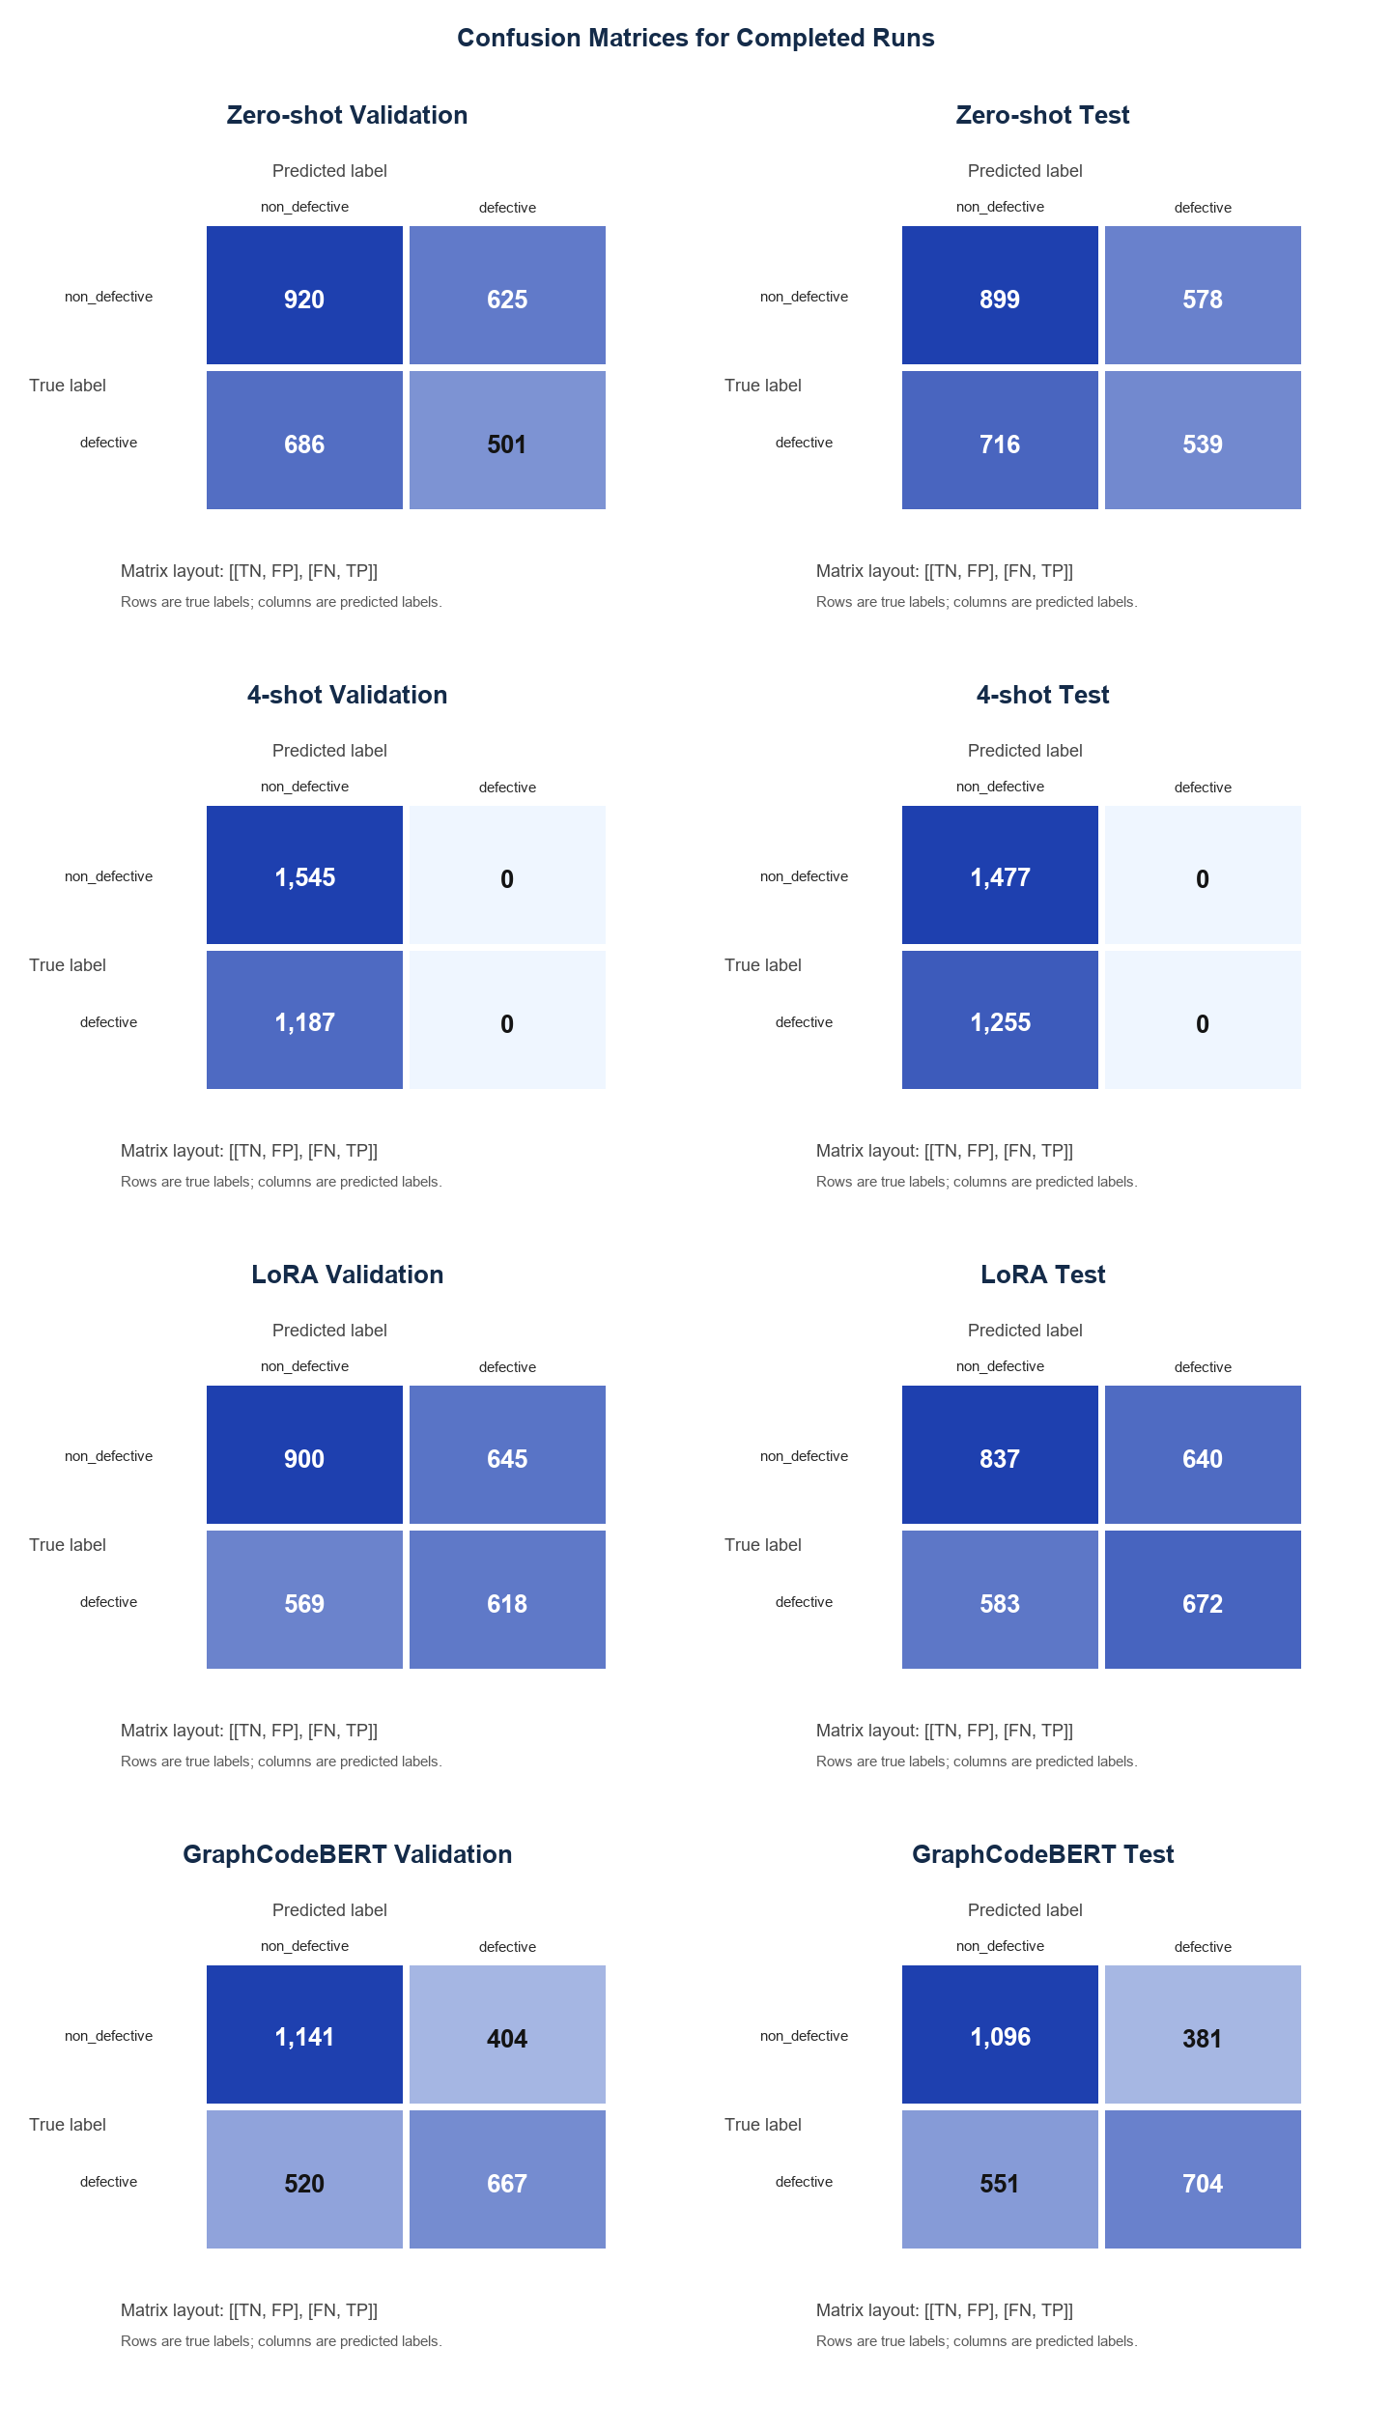

11. References to Cite
- CodeXGLUE benchmark: https://github.com/microsoft/CodeXGLUE
- GraphCodeBERT paper: https://arxiv.org/abs/2009.08366
- GraphCodeBERT model card: https://huggingface.co/microsoft/graphcodebert-base
- Qwen model family: https://huggingface.co/Qwen
- LoRA paper: https://arxiv.org/abs/2106.09685
- Project code and generated artifacts: https://github.com/JiufuZh/526

12. Report Checklist
- No more than 8 pages; submit a single PDF for grading.
- Include team member names clearly, typically alphabetical by last name.
- Include citations/URLs for datasets, models, papers, code, and generated assets.
- Use sharp figures; do not use blurry screenshots.
- Do not overstate results: GraphCodeBERT is best among current experiments, not a solved defect detector.
- Only one group submission should be made.

