Online T-Shirt Competitive Research Report
IS117 Multi-Brand Audit of Brand Archetypes, Cialdini Persuasion Cues, Modernist vs. Postmodernist Design, and E-Commerce Buying Flows
Executive Summary & Thursday In-Class Sharing Brief
Student & Course: Jivitesh Duddu | IS117 (Intro to Website Development, NJIT) | Date: November 5, 2026
Research Question: "How do competing online T-shirt retailers across novelty graphic, wholesale blank, and custom/blank hybrid models explain value, organize visual hierarchy, and reduce cost or fit uncertainty for a first-time desktop buyer?"
Competitors Audited: 1. Crazy Dog T-Shirts (crazydogtshirts.com — D2C novelty/humor graphic tees)
2. CheapesTees (cheapestees.com — everyday wholesale blank & custom basics)
3. Jiffy (jiffy.com — rapid-delivery blank tees, DTF transfers, and custom print mockup platform)
+ Adjacent UX Reference: Mobbin (On iOS 'Adding to Bag' flow for size-context retention).
Main Analytical Finding: Modernist interface organization (clean grids, upfront delivery dates, and multi-tier size/color pricing tables on Jiffy and CheapesTees) reduces buying friction far better than cluttered overlays, while Postmodernist expressive humor (Crazy Dog) and relatable lifestyle framing build stronger emotional liking. However, hidden cart additions (such as CheapesTees' pre-selected $0.49 Shipping Protection) or steep single-item custom print jumps (Jiffy's $7.53 blank tee rising to $48.33 with custom printing and Saturday rush shipping) create checkout friction.
Primary Recommendation for My T-Shirt Website: Combine a Modernist, distraction-free shopping grid and upfront ZIP-code delivery/cost transparency (adapted from Jiffy and CheapesTees) with aspect-specific customer reviews (fit, fabric weight, print durability) and relatable, humor-driven product collections (adapted from Crazy Dog).
1. Research Setup, Question, and Fair Comparison Scope (Stages 1–2)
Following the IS117 Competitive Research Guide, I inspected public desktop pages across three contrasting online T-shirt retailers on November 4–5, 2026, capturing 12 stage-by-stage screenshots (Homepage, Product/Category Listing, Product Pricing/Detail Page, and Cart/Checkout Entry) without creating accounts, subscribing to mailing lists, or submitting personal payment details.
Planning Dimension | Verified Study Scope & Fairness Parameters
Project & Target Customer | Design and positioning plan for my IS117 T-shirt e-commerce site serving everyday US shoppers and student creators seeking affordable basics or expressive graphic/custom tees.
Research Question & Design Decision | How do competing T-shirt sites balance expressive brand personality with clear pricing and checkout usability—and which layout, review, and promotional patterns should I adopt on my own site?
Market, Device & Audit Date | United States market (delivery benchmarked to Butler, NJ 07405) | Desktop Chrome browser | Audited November 4–5, 2026.
Audited Competitors & Selection Reasons | 1. Crazy Dog T-Shirts (D2C novelty graphic specialist; tests humor, Jester archetype, and sale price anchoring) — crazydogtshirts.com
Competitor 2 (Wholesale Blank Basics) | 2. CheapesTees (Everyday wholesale blank & custom retailer; tests Everyperson utility, authority cues, and sub-$3 unit pricing) — cheapestees.com
Competitor 3 (Rapid Blank + Custom Hybrid) | 3. Jiffy (High-speed blank apparel and custom DTF print platform; tests Creator archetype, ZIP delivery dates, and customizer flow) — jiffy.com
Common Shopper Scenario | First-time US desktop shopper selecting 1 short-sleeve adult crewneck T-shirt (Small or Medium), inspecting product pricing, and advancing to the shopping cart / checkout entry screen.
Documented Exceptions & Fairness Limits | • Product Type Variance: Crazy Dog sells pre-printed novelty ringspun graphic tees ($14.99 on sale from $18.99 in Heather Navy, Size S), whereas CheapesTees sells blank wholesale Gildan 3000 Light Cotton tees ($2.98 in White, Size M) and Jiffy sells blank Comfort Colors C1717 Heavyweight tees ($6.28 White / $7.53 Butter) alongside custom-printed C1717 shirts ($38.38 for 1 custom 'Store Sign' shirt).  • Cart Add-On & Shipping Variance: CheapesTees automatically includes a $0.49 Shipping Protection fee in the cart ($3.47 subtotal), while Jiffy's cart screenshot reflects a custom-printed C1717 tee ($38.38) with optional Saturday Fast Delivery (+$9.95, totaling $48.33) alongside a $0.00 Standard Delivery option.
2. Verified Evidence Log & Screenshot Register (Stages 3 & 9)
Before applying theoretical lenses, I logged what each captured screen visibly shows, separating merchant claims from independently verified observations and noting what remains unknown prior to final payment submission.
ID, Brand & Stage | Access Date & Source URL | Visible Observation | Merchant Claims, Limits & Unknowns
E01 | Crazy Dog  Homepage | Nov 5, 2026  crazydogtshirts.com | Displays hero banner 'EACH YEAR HAS AT LEAST 52 TACO TUESDAYS / DRESS ACCORDINGLY', top bar 'Sign onto our mailing lists for exclusive discounts!', 8 nav categories (Home, Men, Women, Kids, Maternity, Socks, Kitchen, Mugs, Shop, Accessories, Custom), and a bottom-left 'Spin the wheel!' widget. | Merchant Claim: 'Exclusive discounts' for mailing list sign-up.  Unknown: Exact discount percentage without submitting an email address.
E02 | Crazy Dog  Category ('Most Loved') | Nov 5, 2026  crazydogtshirts.com | 5-column grid of novelty graphic tees ('Ask Me About My Ninja Disguise Flip', 'Can't Work Today My Arm Is In A Cast', 'That Sounds Like A Horrible Idea What Time?', 'Fitness Taco In My Mouth', 'With A Body Like This Who Needs Hair'). Every item shows a green 'SALE' badge: $14.99 crossed out from $18.99 (Save $4). | Merchant Claim: 'MOST LOVED' best-seller ranking and '$4 savings' off $18.99.  Unknown: Whether $18.99 is a frequent everyday price or a permanent reference anchor.
E03 | Crazy Dog  Product Pricing (PDP) | Nov 5, 2026  Can't Work Today Tee | Selected 'Can't Work Today My Arm Is In A Cast Men's T Shirt', Heather Navy, Size S (sizes S–5XL shown), Qty 1. Price shows $18.99 crossed out, $14.99 active, 'Save $4' in green. Four left-hand thumbnails show print close-up and model photos. | Merchant Claim: 'Save $4' off $18.99.  Unknown: Fabric weight (oz/yd²), exact cotton/poly percentage, and shipping fee are not visible above the fold.
E04 | Crazy Dog  Shopping Cart | Nov 5, 2026  crazydogtshirts.com/cart | Cart lists 1 item ('Can't Work Today My Arm Is In A Cast Men's T Shirt', Size S, Heather Navy, Qty 1) at $14.99. Subtotal = $14.99. Blue 'Check out' and 'Continue shopping' buttons. | Limit / Unknown: Note states 'Shipping, taxes, and discount codes calculated at checkout'—total delivered cost is unknown in cart.
E05 | CheapesTees  Homepage | Nov 5, 2026  cheapestees.com | Hero banner reads 'FAST, FREE SHIPPING - NO SETUP FEES / Custom tees, made easy / GET AN INSTANT QUOTE'. Top green badge states 'Free Shipping at $69'. Sub-banner reads 'Cheap Blank & Custom T-Shirts at Wholesale Prices' with a bottom 'Get 10% Off' tab. | Merchant Claim: 'Wholesale Prices', 'Fast, Free Shipping - No Setup Fees' (qualified by $69 threshold in top bar).
E06 | CheapesTees  Category ('Best Sellers') | Nov 5, 2026  Gildan Collection | 6-column grid: Hanes ComfortSoft 100% Cotton ($2.34, 1,013 reviews), Tultex Fine Jersey ($4.08, 2 reviews), Gildan Light Cotton ($2.98, 38 reviews), Next Level Ladies' V-Neck ($5.68, 19 reviews), Hanes Beefy-T ($7.88, 115 reviews), Gildan DryBlend 50/50 ($3.94, 102 reviews). | Merchant Claim: 'Price Seen Elsewhere' comparison below each price and verified star ratings.
E07 | CheapesTees  Product Pricing (PDP) | Nov 5, 2026  Gildan 3000 PDP | Gildan Unisex Light Cotton T-Shirt (Style 3000), 4.8 stars (38 reviews), Color: White. Shows 'Price Seen Elsewhere: $5.80' vs. 'Our Price: $2.98 (You Save 49%)', plus 'Add Your Logo' custom link and bulk quantity boxes (XS–4XL). | Merchant Claim: 'You Save 49%' relative to $5.80 elsewhere price.  Unknown: Whether $2.98 applies to extended sizes (2XL–4XL) before typing quantities.
E08 | CheapesTees  Shopping Cart | Nov 5, 2026  cheapestees.com/cart | 1x Gildan Unisex Light Cotton T-Shirt (Style 3000, White, Size M) at $2.98 unit price. However, Order Summary Subtotal is $3.47 because a pre-checked 'Shipping Protection ($0.49)' toggle is included. Shipping estimator requires State and Zip Code; box notes 'Free shipping at $69. Free Returns.' | Contradiction / Friction: Subtotal ($3.47) exceeds item price ($2.98) due to opt-out $0.49 Shipping Protection; exact shipping cost unknown until ZIP entry.
E09 | Jiffy  Homepage | Nov 5, 2026  jiffy.com | Top utility bar: 'Bulk Discounts | Free Shipping at $59 | 1 Free Return a Year | Fast Delivery | 29K RATINGS 4.8 stars'. Shows 'Deliver to Butler 07405', 'JIFFY 1st EXTRA 10% OFF (Nov 4–5, code JIFFYFIRST10)', and 3 cards with exact dates: Blank T-Shirts (Get it by Fri, Nov 6), DTF Transfers (Tomorrow), Custom Shirts (Fri, Nov 6). | Merchant Claim: 29K ratings (4.8 avg) and guaranteed Nov 6 delivery to ZIP 07405.
E10 | Jiffy  Category ('Comfort Colors') | Nov 5, 2026  Comfort Colors Bulk | Banner highlights: 'LOW TOTAL PRICE | BULK DISCOUNT AT $99 | FREE SHIPPING AT $59 | FREE FIRST RETURN ON BLANK ITEMS WITHIN 100 DAYS | DELIVERY DATE IN CART'. Lists Comfort Colors C1717 ($7.53, 9,708 reviews), C6014 ($15.79), C9018 ($5.57), 9360 ($10.01), C1745 ($12.82). | Merchant Claim: 100-day free first return applies to blank items only (not custom printed items).
E11 | Jiffy  Product Pricing (PDP) | Nov 5, 2026  Comfort Colors C1717 | Comfort Colors C1717 Unisex Heavyweight RS T-Shirt (Color: Butter, 4.8 stars, 9,708 reviews). Includes 'Create Mockup' button, size matrix (S–XL $7.53, 2XL $11.15, 3XL $13.38, 4XL $14.37), and tier box 'SAVE UP TO 50% OFF MSRP: White $6.28, Grey $7.53, Colors from $6.33'. | Strength: Full size-by-size and color-tier pricing is transparent before adding to cart.
E12 | Jiffy  Custom Cart / Checkout Entry | Nov 5, 2026  jiffy.com/cart | Shows 'Design 1' (Front: Store Sign, 11.50" x 7.26" print) on 1x Comfort Colors C1717 (Grape, Size S) at $38.38 item price. Delivery to Butler, NJ 07405 offers Fast Delivery (22 Miles, Sat Nov 7, +$9.95 selected) or Standard Delivery (Tue Nov 10, +$0.00, Free over $35). Total = $48.33. | Important Limit: Custom printing + rush Saturday shipping increases a single C1717 tee from $7.53 (blank) to $48.33 delivered.
2.1 Illustrated Screenshot Register (Figures E01–E12)
Every screenshot below was captured directly during the November 4–5, 2026 audit and is labeled using the IS117 Page 10 caption formula.
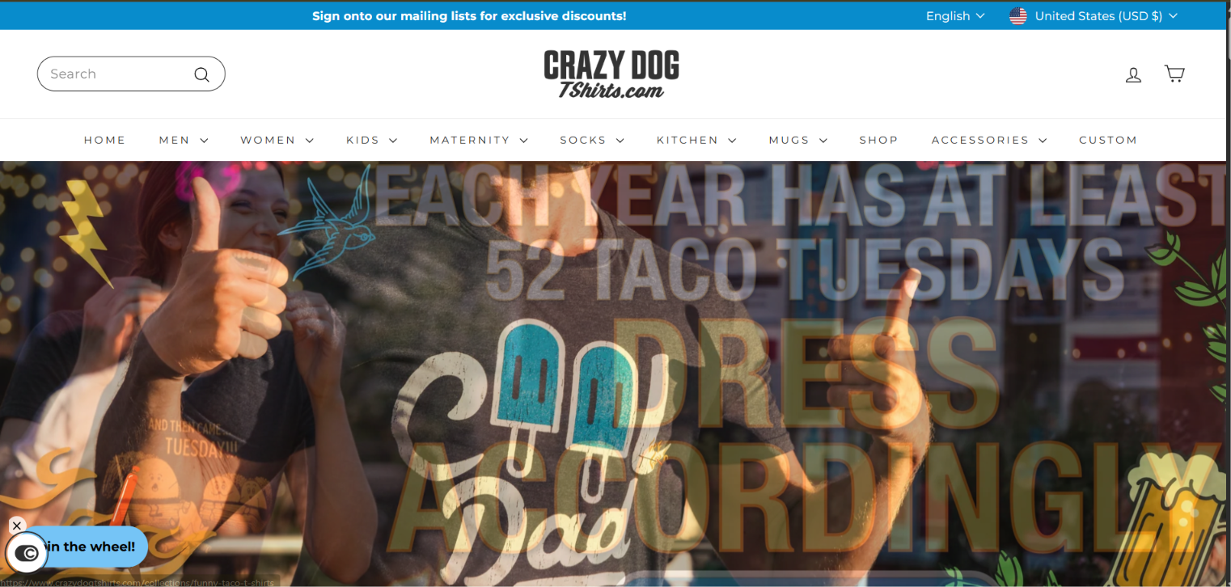  Figure E01. Crazy Dog T-Shirts, homepage, US desktop, November 5, 2026. Displays '52 Taco Tuesdays' humor banner, 11 top-level nav links, mailing-list discount bar, and 'Spin the wheel!' overlay. Discount amount requires email submission. Source: crazydogtshirts.com | 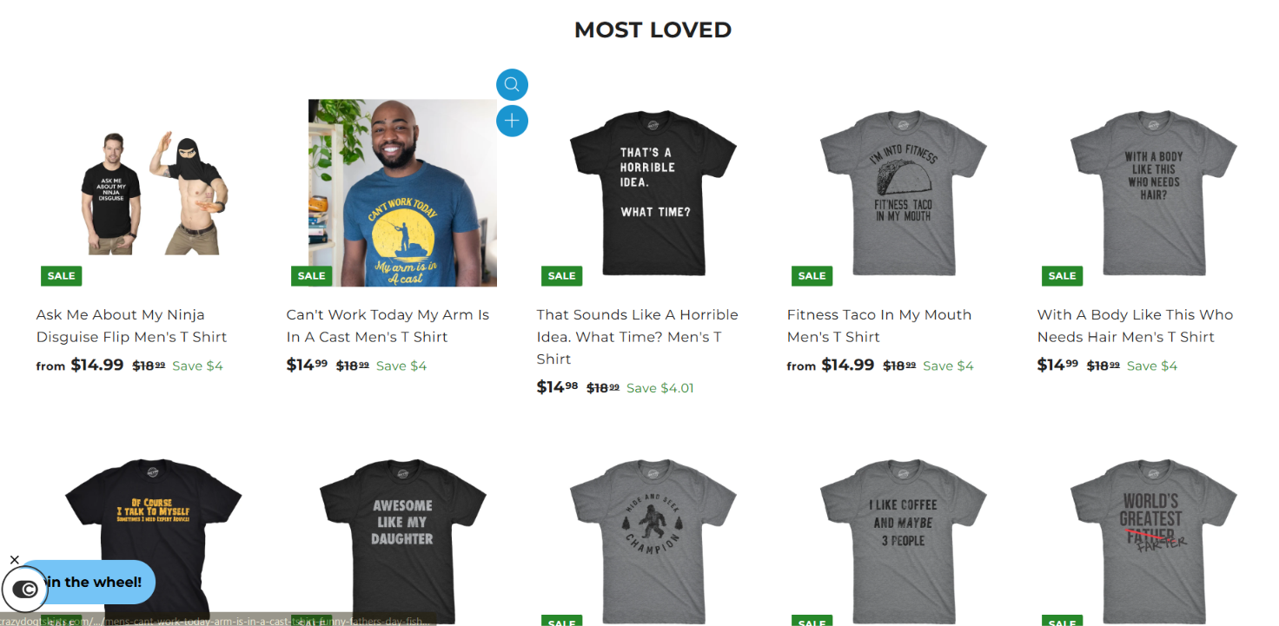  Figure E02. Crazy Dog T-Shirts, 'Most Loved' category grid, November 5, 2026. Shows 10 novelty graphic tees all marked 'SALE' at $14.99 (crossed-out $18.99, Save $4). Does not verify whether $18.99 is ever charged without a sale. Source: crazydogtshirts.com
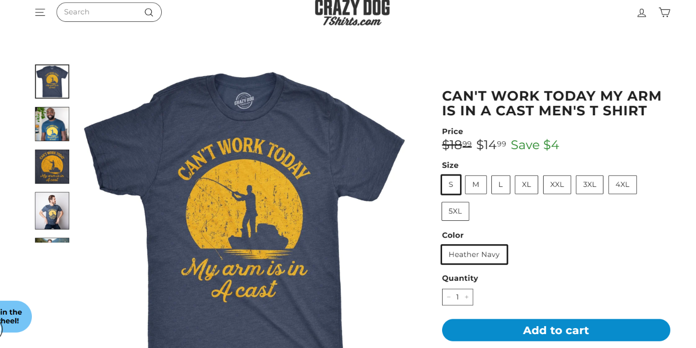  Figure E03. Crazy Dog T-Shirts, product page, 'Can't Work Today' tee in Heather Navy (Size S, Qty 1), November 5, 2026. Shows $14.99 sale price ($18.99 anchor) and sizes S–5XL. Shipping cost and fabric weight are not shown above the fold. Source: Crazy Dog PDP | 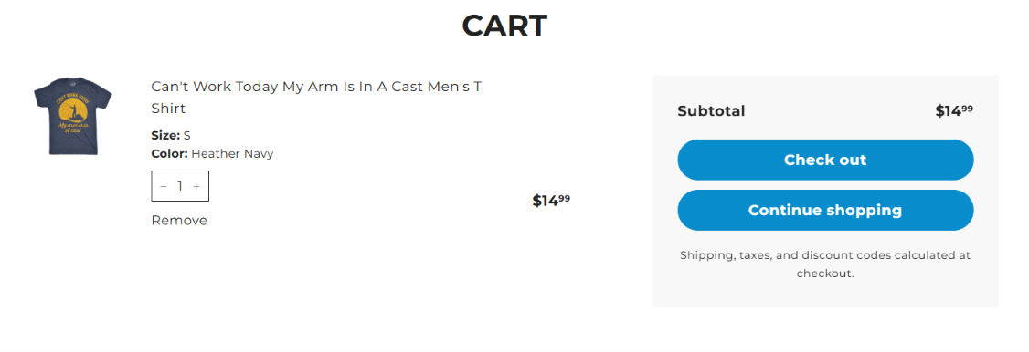  Figure E04. Crazy Dog T-Shirts, cart stage, 1 item (Heather Navy, Size S), November 5, 2026. Confirms $14.99 item subtotal with 'Check out' and 'Continue shopping' CTAs. Shipping and tax are deferred to checkout address entry. Source: crazydogtshirts.com
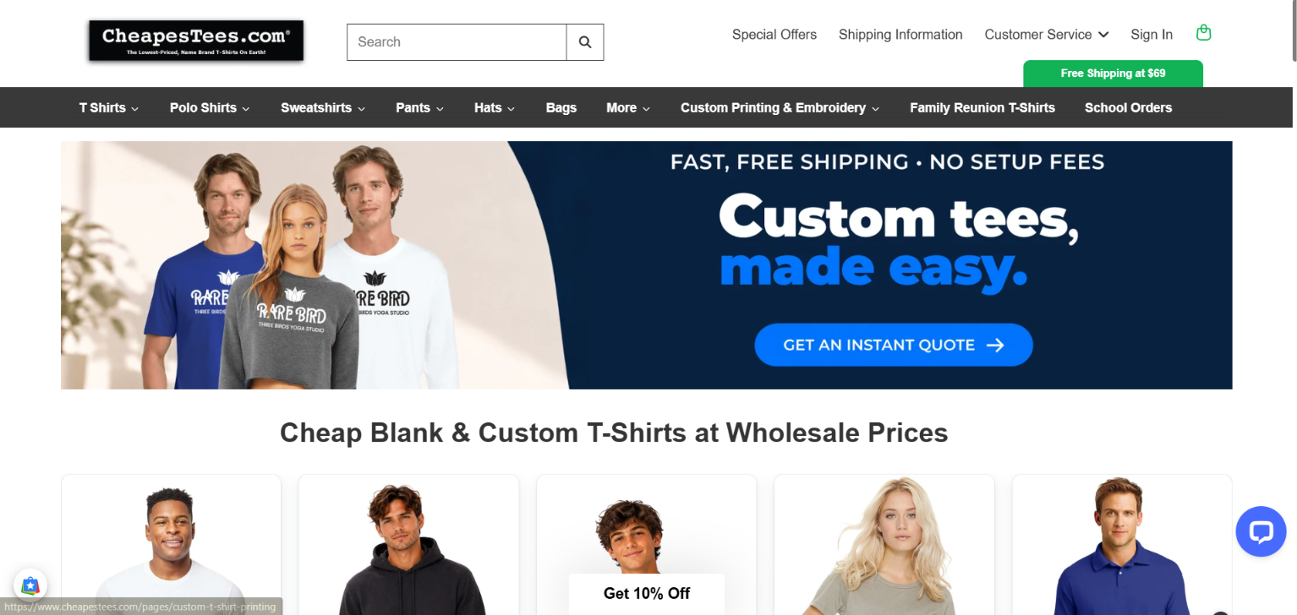  Figure E05. CheapesTees, homepage, US desktop, November 5, 2026. Highlights 'Custom tees, made easy', 'Wholesale Prices', and 'Free Shipping at $69' top badge. 'Free shipping' in hero banner requires a $69 minimum order. Source: cheapestees.com | 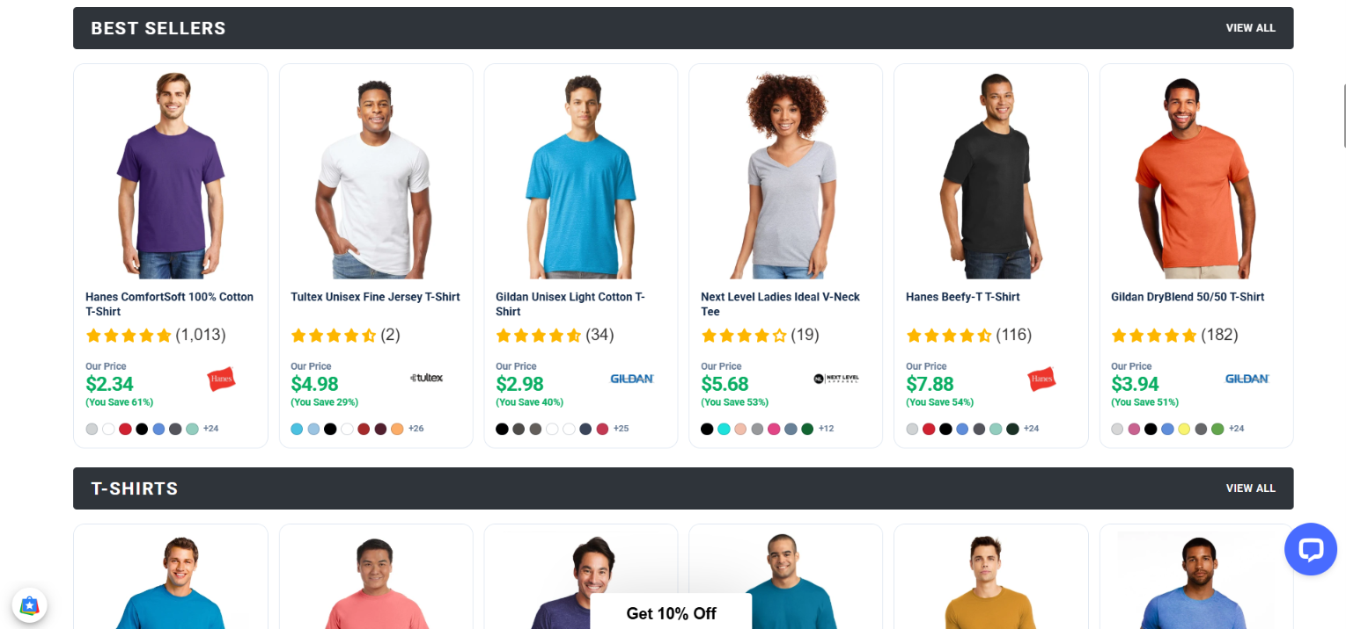  Figure E06. CheapesTees, 'Best Sellers' category grid, November 5, 2026. Displays 6 blank basics ($2.34–$7.88) with review counts (up to 1,013) and color swatches. Review authenticity is not independently audited. Source: CheapesTees Gildan
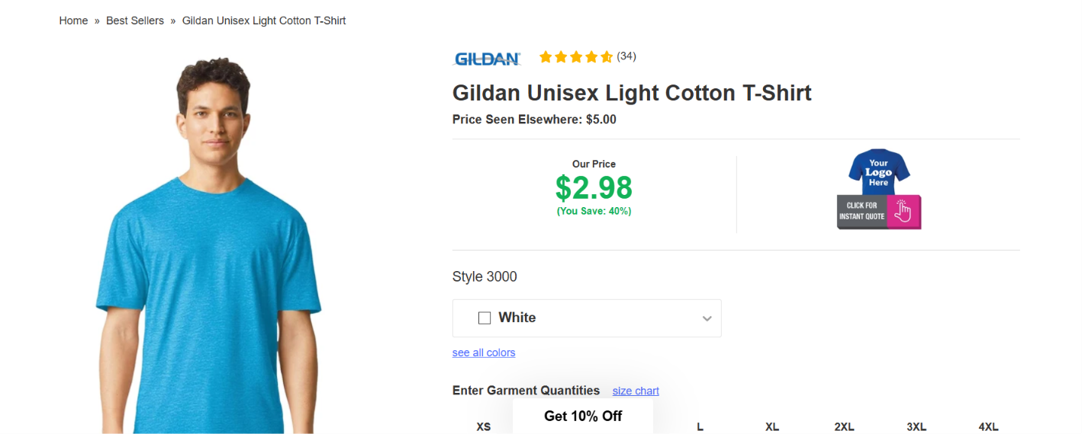  Figure E07. CheapesTees, product page, Gildan 3000 Light Cotton Tee in White, November 5, 2026. Lists $2.98 price vs. '$5.80 Price Seen Elsewhere (Save 49%)' and multi-size quantity inputs. 'Elsewhere' reference price source is not cited. Source: CheapesTees Gildan 3000 | 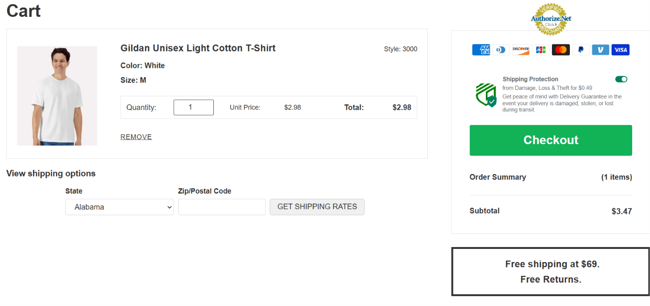  Figure E08. CheapesTees, cart stage, Gildan 3000 White (Size M, Qty 1), November 5, 2026. Shows $2.98 unit price but a $3.47 subtotal due to pre-toggled $0.49 Shipping Protection. Shipping rate requires State/ZIP lookup; not a final delivered price. Source: cheapestees.com
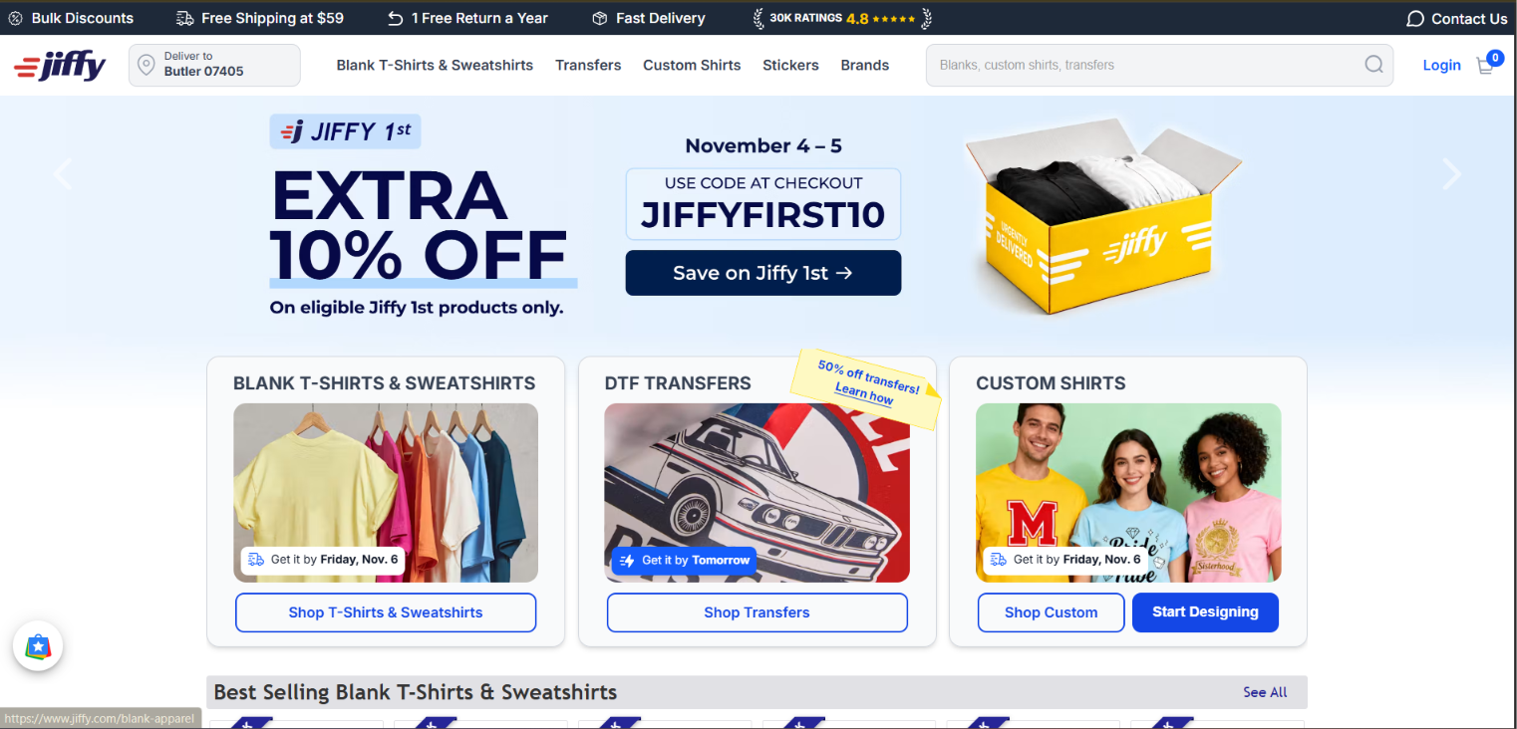  Figure E09. Jiffy, homepage localized to Butler, NJ 07405, November 5, 2026. Shows 'Free Shipping at $59', '29K Ratings (4.8)', code JIFFYFIRST10, and Nov 6 delivery dates. 10% code applies to eligible 'Jiffy 1st' items only. Source: jiffy.com | 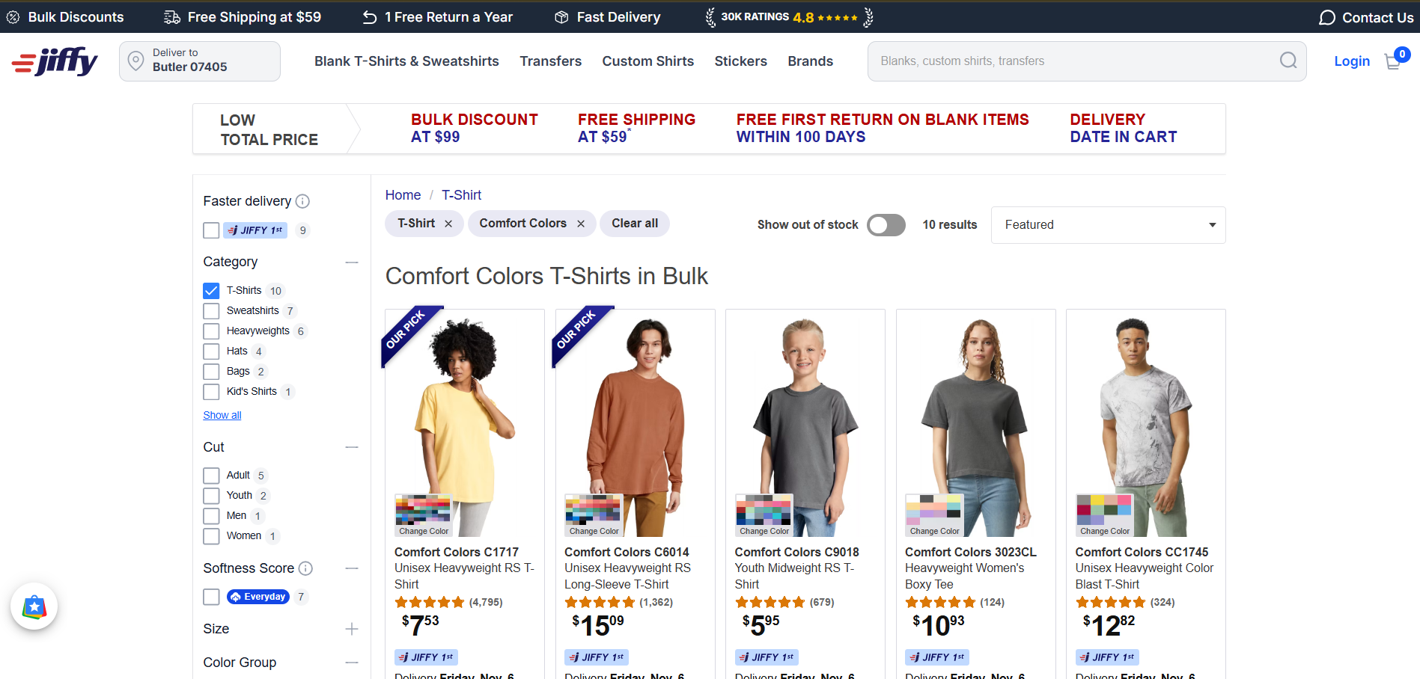  Figure E10. Jiffy, Comfort Colors bulk category page, November 5, 2026. Displays C1717 at $7.53 (9,708 reviews) and 5 policy badges including 100-day free first return on blanks. Displayed prices are starting tiers and vary by color/size. Source: Jiffy Comfort Colors
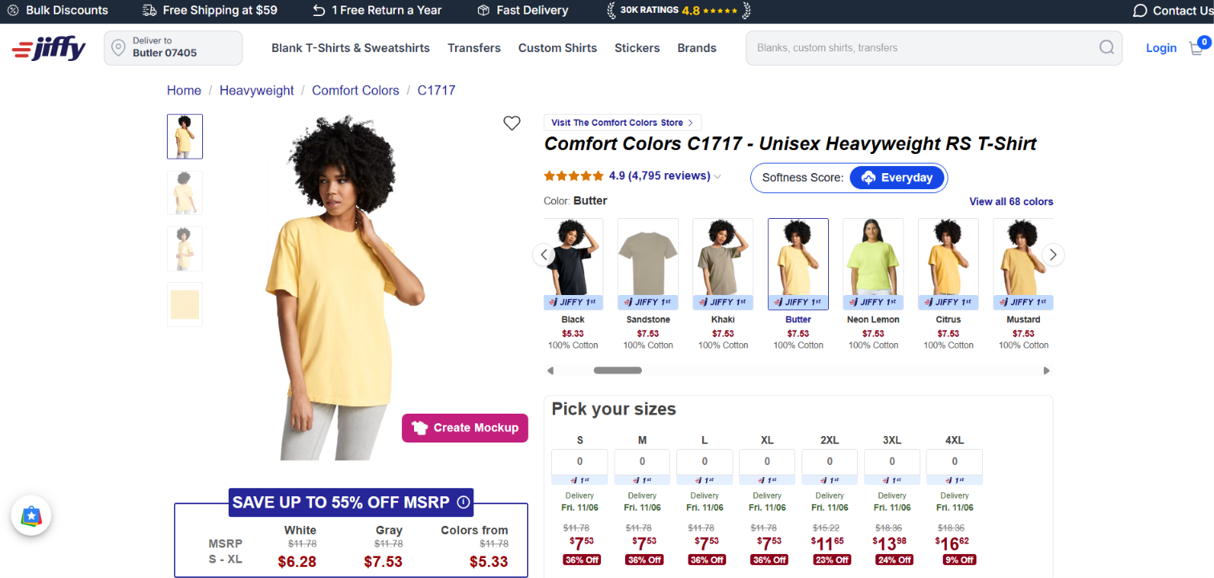  Figure E11. Jiffy, product page, Comfort Colors C1717 in Butter, November 5, 2026. Shows size matrix (S–XL $7.53, 2XL–4XL $11.15–$14.37), White $6.28 tier, and 'Create Mockup' CTA. Up to 50% off MSRP is a merchant reference claim. Source: Jiffy C1717 PDP | 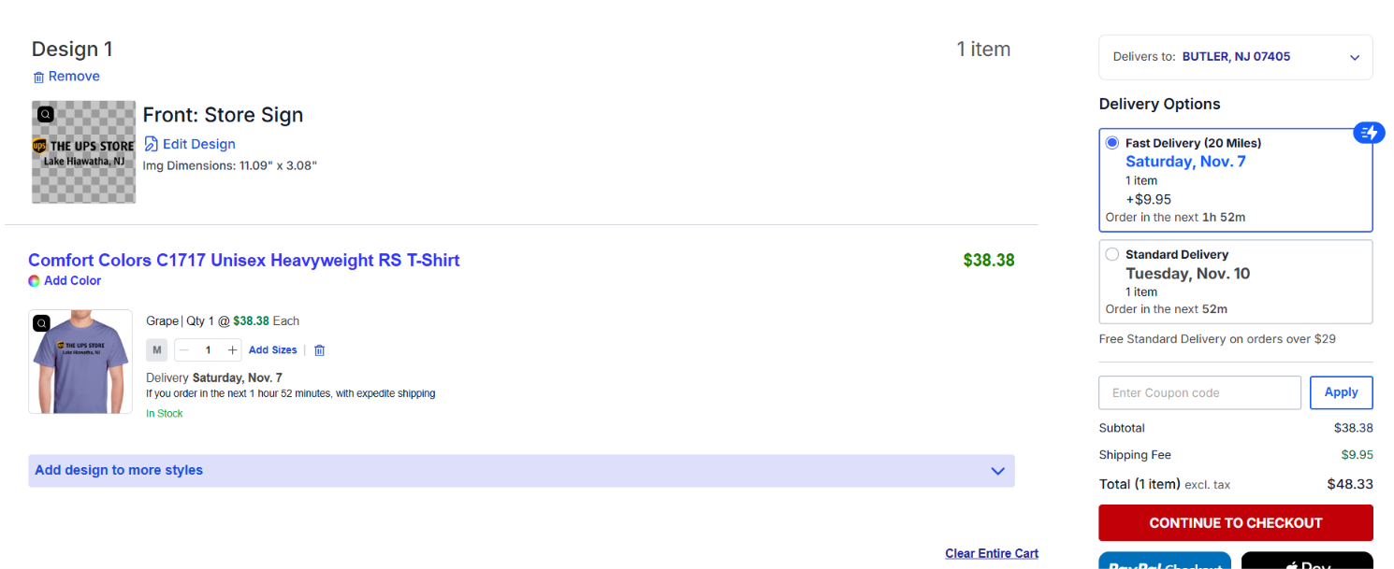  Figure E12. Jiffy, cart/checkout entry, 1 custom-printed C1717 (Grape, Size S) to 07405, November 5, 2026. Item is $38.38 with custom Front Store Sign print + $9.95 Saturday Fast Delivery ($48.33 total; Tue Standard is $0.00). Illustrates steep single-unit custom print vs. blank price gap. Source: jiffy.com
3. Brand Archetype Analysis (Stage 4 — Mark & Pearson Framework [L1])
Using Margaret Mark and Carol S. Pearson's 12-archetype framework [L1], I analyzed each brand's headline promise, product naming, and visual tone, pairing a primary archetype with a supporting lens and a plausible alternative reading.
Competitor & IDs | Primary & Supporting Archetypes | Concrete Visible Cues (Two+ per Brand) | Interpretive Statement & Plausible Alternative
Crazy Dog T-Shirts  [E01–E04] | Primary: Jester (Enjoyment, play, irreverent humor)  Supporting: Everyperson (Relatable daily-life jokes) | • Cue 1 [E01]: Hero banner 'EACH YEAR HAS AT LEAST 52 TACO TUESDAYS / DRESS ACCORDINGLY' with an expressive thumbs-up model.  • Cue 2 [E02–E03]: Sarcastic, self-deprecating product titles across adult and youth lines, including 'Can't Work Today My Arm Is In A Cast', 'Ask Me About My Ninja Disguise Flip', 'If Zombies Chase Us I'm Tripping You Youth T Shirt', and 'Stealin' Hearts And Blastin' Farts Youth T Shirt'. | I interpret Crazy Dog as the Jester because E01 and E02 invite buyers to use clothing for comedic relief and social ice-breaking. Alternative reading: A pragmatic gift buyer may view the site simply as a novelty gag catalog rather than identifying with a Jester persona.
CheapesTees  [E05–E08] | Primary: Everyperson (Belonging, practical everyday value)  Supporting: Sage (Structured specification clarity) | • Cue 1 [E05]: Direct, unpretentious headline 'Custom tees, made easy' and 'Cheap Blank & Custom T-Shirts at Wholesale Prices' aimed at schools, families, and everyday buyers.  • Cue 2 [E06–E07]: Plain-spoken comparison of familiar staple brands (Hanes, Gildan Style 3000, Fruit of the Loom) with exact fabric compositions (100% Cotton vs. 50/50 DryBlend) and size runs (XS–4XL). | I interpret CheapesTees as the Everyperson because E05 and E06 democratize wholesale apparel pricing ($2.34–$2.98) without elitist fashion jargon. Alternative reading: The utilitarian layout may reflect a standard B2B distributor template rather than deliberate brand storytelling.
Jiffy  [E09–E12] | Primary: Creator (Originality, DIY empowerment, craft)  Supporting: Caregiver / Ruler (Operational reliability & speed) | • Cue 1 [E09, E11]: Prominent 'CUSTOM SHIRTS — Start Designing' pathway, 'DTF Transfers' for home pressers, and the purple 'Create Mockup' button directly on the blank product page.  • Cue 2 [E12]: Interactive cart preview rendering the user's uploaded artwork ('Design 1 — Front: Store Sign, 11.50" x 7.26"') alongside exact delivery dates (Sat Nov 7 vs. Tue Nov 10). | I interpret Jiffy as the Creator (supported by operational reliability) because E09 and E11–E12 equip small businesses, crafters, and consumers to turn blank garments into custom products overnight. Alternative reading: High-volume buyers ordering only blank tees may experience Jiffy strictly as a fast logistics supplier.
4. Audit of Cialdini's Seven Persuasion Principles (Stage 5 [L2])
Following Robert Cialdini's seven principles of persuasion [L2], I audited all three competitors across every principle, explicitly recording 'No clear evidence in sample' where a cue was absent and separating price anchoring, risk reduction, and usability from psychological persuasion claims.
Principle / Mechanism | Crazy Dog T-Shirts [E01–E04] | CheapesTees [E05–E08] | Jiffy [E09–E12]
1. Reciprocity  (Giving something useful or valuable first) | Possible / Uncertain [E01]: 'Spin the wheel!' and mailing-list discount offer a perk, but require email capture first (conditional exchange, not pure reciprocity). | Possible / Uncertain [E05]: 'Get 10% Off' floating tab and 'Free Shipping at $69' are conditional promotional thresholds rather than unconditional upfront gifts. | Supported / Conditional [E09–E10]: Offers immediate, unrestricted ZIP-code delivery date calculation ('Butler 07405 — Get it by Fri, Nov 6') and 'EXTRA 10% OFF' code JIFFYFIRST10 printed openly on the homepage without forcing an email gate.
2. Commitment & Consistency  (Building on a small voluntary prior step) | Possible [E01]: Entering an email into 'Spin the wheel!' initiates a micro-commitment toward using the won coupon. | No clear evidence in sample [E05–E08]: Standard size/quantity selection is normal shopping usability, not psychological commitment. | Supported [E11–E12]: Clicking 'Create Mockup' and uploading/positioning custom artwork ('Front: Store Sign') creates strong ownership investment before viewing the $38.38 custom price in cart.
3. Social Proof  (Showing what peers choose or experience) | Supported [E02]: Category titled 'MOST LOVED' signals peer popularity; student draft also notes 5-star review badges on product pages (Limit: review authenticity is unverified). | Strongly Supported [E06–E07]: Displays exact star ratings and review counts under every best seller (e.g., 1,013 reviews on Hanes ComfortSoft; 4.8 stars / 38 reviews on Gildan 3000). | Strongly Supported [E09–E11]: Top bar displays '29K RATINGS (4.8 stars)', and Comfort Colors C1717 displays 4.8 stars across 9,708 customer reviews.
4. Authority  (Credible expertise, specs, or verification) | No clear evidence in sample [E01–E04]: Brand relies on peer humor rather than technical textile credentials. | Supported [E06–E08]: Detailed garment style numbers ('Style 3000', 'DryBlend 50/50'), mill brand partnerships (Gildan, Hanes, Next Level), and the Authorize.Net verified merchant seal in cart [E08] project domain credibility. | Supported [E10–E11]: Granular sizing/color matrices, exact print dimensions ('11.50" x 7.26"' in [E12]), and official Comfort Colors style documentation signal manufacturing competence.
5. Liking  (Relatability, humor, shared taste) | Strongly Supported [E01–E03]: Everyday humor ('52 Taco Tuesdays', fishing/cast excuses, nerdy/movie/science jokes) builds instant rapport and relatability with casual shoppers. | Moderate [E05–E06]: Friendly everyday casual models and family-reunion/school-order navigation links create approachable familiarity. | Supported [E09]: Cheerful custom-shirt family/group photography and colorful DTF graphics make custom printing feel approachable for beginners.
6. Scarcity  (Real limits on time or availability) | Possible / Uncertain [E02–E03]: Green 'SALE' badges ($14.99 vs. $18.99) imply a limited-time markdown, though no countdown or stock limit is shown (primarily functions as price anchoring). | No clear evidence in sample [E05–E08]: High-volume wholesale inventory emphasizes abundance rather than scarcity. | Supported [E09, E12]: Explicit date-bounded promo ('November 4–5 USE CODE JIFFYFIRST10') and countdown shipping cutoff ('Order in the next 13hr 52m' in [E12] for Saturday delivery) establish verifiable time limits.
7. Unity  (Shared group identity or belonging) | Possible [E01–E03]: Niche identity tees ('Dad', 'Awesome Like My Daughter', gamer/science tribes) appeal to family and hobbyist ingroups. | Supported in Nav [E05]: Top navigation explicitly features 'Family Reunion T-Shirts' and 'School Orders', appealing to shared community groups. | No clear evidence in sample [E09–E12]: Focuses on individual creator/small-business utility rather than shared group membership.
Non-Cialdini Commercial Mechanisms  (Price Anchoring & Risk Reduction) | Price Anchoring [E02–E03]: Strikethrough $18.99 -> $14.99 ('Save $4') on every item. | Price Anchoring [E07]: 'Price Seen Elsewhere: $5.80' vs. '$2.98 (Save 49%)'.  Risk Reduction [E08]: 'Free Returns' note and optional $0.49 Shipping Protection. | Price Anchoring [E11]: 'SAVE UP TO 50% OFF MSRP'.  Risk Reduction [E09–E10]: '1 Free Return a Year' / 'Free First Return on Blank Items Within 100 Days'.
5. Modernism and Postmodernism Design Analysis (Stage 6 [L3–L4])
Drawing on the Victoria and Albert Museum (V&A) design frameworks [L3–L4], I separated each website's underlying shopping interface from its visual brand narrative across four dimensions: Organization, Form & Ornament, References & Voice, and Meaning.
Analytical Dimension | Crazy Dog T-Shirts [E01–E04] | CheapesTees [E05–E08] | Jiffy [E09–E12]
Organization  (Grid & Hierarchy) | Hybrid: Uses a standard 5-column e-commerce grid [E02] and clean right-hand buy box [E03], but disrupts the grid with a floating 'Spin the wheel!' widget and dense multi-font hero banners [E01]. | Strongly Modernist: Strict, uniform 6-column catalog grid [E06], generous white background, predictable left-to-right PDP layout [E07], and linear cart table [E08]. | Strongly Modernist: Highly structured top utility ribbon, 3-column task router [E09], left-hand filter rail [E10], and tabular size/price matrix [E11].
Form & Ornament  (Restraint vs. Decoration) | Postmodern Tendencies: Deliberate visual loudness—neon taco graphics [E01], distressed vintage typography on shirts [E03], green sale pills, and gamified pop-up triggers. | Modernist Restraint: Minimalist typography, neutral studio model photography against solid white backdrops [E06–E07], and zero decorative flourish. | Modernist Container + Expressive Content: The UI chrome is clean, flat, and functional (blue/white badges), while the custom DTF/shirt cards showcase vibrant user graphics [E09].
References & Voice  (Systematic vs. Pastiche/Irony) | Postmodern Pastiche & Irony: Self-aware pop-culture parody, dad-joke irony ('Fitness Taco In My Mouth', 'Can't Work Today My Arm Is In A Cast'), and a playful 'digital thrift store' atmosphere. | Modernist Material/Process Voice: Objective, specification-driven labeling ('100% Cotton', 'DryBlend 50/50', 'Style 3000') focused on function and price transparency. | Hybrid / Participatory: Combines systematic logistics metrics ('22 Miles', '11.50" x 7.26"' print area) with an open canvas where buyers supply their own cultural or commercial designs [E12].
Meaning & Buying Task Tradeoff | Meaning: Shopping as entertainment and comedic self-expression.  Tradeoff: Expressive visuals attract novelty browsers, but visual clutter and deferred shipping costs increase cognitive effort during checkout. | Meaning: Utilitarian efficiency and wholesale economy.  Tradeoff: Fast scanning and low distraction, though the plain aesthetic may feel generic to fashion-conscious D2C shoppers. | Meaning: Empowered, reliable self-service production.  Tradeoff: Exceptional clarity for bulk and blank buyers, though transitioning from a $7.53 blank grid to a $38.38 single custom shirt requires careful price reading.
6. Buying Experience Journey & Mobbin UX Comparison (Stage 7)
I traced the exact same 5-step buyer task across all three websites—from initial discovery to checkout entry—and compared their interaction patterns against the course guide's Mobbin adjacent UX reference (On iOS 'Adding to Bag' flow).
Journey Stage & User Goal | Crazy Dog T-Shirts [E01–E04] | CheapesTees [E05–E08] | Jiffy [E09–E12]
1. Discovery & Brand Entry | Goal: Understand product focus.  Observed [E01]: Top nav + Taco Tuesday hero banner immediately signal funny graphic tees; 'Spin the wheel' widget competes for attention. | Goal: Verify wholesale blank/custom availability.  Observed [E05]: Hero banner + 'Free Shipping at $69' badge clearly state blank and custom wholesale model. | Goal: Choose between blanks, transfers, or custom prints.  Observed [E09]: 3 distinct cards with Butler 07405 delivery dates ('Get it by Fri, Nov 6') remove delivery guesswork immediately.
2. Category Evaluation | Goal: Compare designs and prices.  Observed [E02]: Uniform $14.99 sale price across 'Most Loved' tees simplifies price comparison, though star ratings are hidden on the grid. | Goal: Compare garment styles and unit costs.  Observed [E06]: Shows exact prices ($2.34–$7.88), star ratings, review counts, and color dots on every card. | Goal: Filter heavyweight blanks.  Observed [E10]: Left sidebar filters + top policy bar + starting prices ($5.57–$15.79) and 9,708 reviews on C1717 support rapid comparison.
3. Option Selection & Pricing (PDP) | Goal: Pick size/color and verify price.  Observed [E03]: Button pills for Size (S–5XL) and Color (Heather Navy) at $14.99; no size-upcharge matrix or fabric weight shown. | Goal: Enter quantities by size.  Observed [E07]: Displays $2.98 in White and multi-size quantity input boxes (XS–4XL) for fast single or bulk entry. | Goal: See exact cost by color and size.  Observed [E11]: Displays explicit price under every size box (S–XL $7.53; 2XL $11.15; 3XL $13.38) and 'Create Mockup' button.
4. Cart & Checkout Entry | Goal: Confirm total cost and edit items.  Observed [E04]: Shows $14.99 subtotal, quantity stepper, and 'Remove' link.  Friction: Shipping & taxes completely unknown until checkout form. | Goal: Review subtotal and estimate shipping.  Observed [E08]: Shows $2.98 tee, quantity box, and State/ZIP shipping estimator.  Friction: Pre-checked $0.49 Shipping Protection raises subtotal to $3.47. | Goal: Verify custom mockup and delivery speed.  Observed [E12]: Shows thumbnail of 'Front: Store Sign' custom tee ($38.38) and radio buttons for Sat Nov 7 Fast Delivery (+$9.95 = $48.33) vs. Tue Nov 10 Standard (+$0.00).
Transferable UX Lesson from Mobbin (On iOS 'Adding to Bag' Flow, Checked Nov 3, 2026): In the course guide's adjacent UX reference—Mobbin (On iOS App Flow)—the shopper selects a size inside a contextual bottom sheet while keeping the product imagery visible, receives an immediate 'Added to your bag' confirmation banner, and opens an inline slide-over bag displaying the free-shipping progress bar and editable quantity controls. Compared to Crazy Dog [E04] (which navigates away to a full-page cart with no shipping estimate) and CheapesTees [E08] (which silently adds a $0.49 protection fee), adopting a slide-over cart drawer with upfront shipping-threshold feedback and opt-in-only add-ons would significantly reduce checkout uncertainty on my T-shirt website.
7. Cross-Brand Synthesis, Contradictions & Recommendations (Stage 8)
The synthesis matrix below consolidates all verified evidence IDs, cost structures, analytical lenses, strengths, and friction points across the three competitors.
Competitor & IDs | Target Customer | Value Promise | Observed Item & Cart Costs | Archetype, Cialdini & Design Reading | Buying Strengths vs. Observed Friction
Crazy Dog T-Shirts  [E01–E04] | Casual shoppers & gift buyers seeking funny/sarcastic graphic tees. | Expressive humor & relatable daily jokes at a flat sale price. | Item: $14.99 (anchor $18.99)  Shipping: Unknown in cart  Total in Cart: $14.99 + shipping/tax at checkout. | Archetype: Jester (+ Everyperson)  Cialdini: Liking, Social Proof, Price Anchoring  Design: Postmodernist narrative / Hybrid grid. | Strengths: Memorable humor, simple size/color pills, flat $14.99 pricing.  Friction: No shipping estimate in cart; pop-up wheel clutter; missing fabric specs.
CheapesTees  [E05–E08] | Budget-conscious individuals, schools, and bulk/family event buyers. | Brand-name blank basics at wholesale prices ($2.34–$7.88). | Item: $2.98 (Gildan 3000 White M)  Add-On: $0.49 Shipping Protection (auto-on)  Subtotal: $3.47 + ZIP shipping (Free at $69). | Archetype: Everyperson (+ Sage)  Cialdini: Social Proof, Authority, Price Anchoring  Design: Modernist functional catalog. | Strengths: Ultra-low prices, visible review counts on grid, multi-size quantity input.  Friction: Auto-added $0.49 protection inflates cart subtotal by 16%.
Jiffy  [E09–E12] | DIY creators, small businesses, and bulk blank apparel buyers. | Fast, date-guaranteed delivery on blanks ($6.28–$7.53) & custom DTF shirts. | Blank C1717: $6.28–$7.53  Custom Printed C1717: $38.38  Shipping to 07405: $0.00 Standard (Tue) or $9.95 Fast (Sat) -> $48.33 total. | Archetype: Creator (+ Ruler/Caregiver)  Cialdini: Social Proof (29K ratings), Scarcity (cutoff timer), Commitment  Design: Modernist UI + Participatory customizer. | Strengths: Upfront ZIP delivery dates, transparent size/color pricing, live custom mockup.  Friction: Steep price jump from $7.53 blank to $38.38 single custom tee.
7.1 Contradictory Evidence & Cost Discrepancies Preserved
- 1. CheapesTees 'Free Shipping' Headline vs. $69 Threshold & Auto-Added $0.49 Fee [E05, E07, E08]: While E05 prominently advertises 'FAST, FREE SHIPPING - NO SETUP FEES' in the hero graphic, the top-right green badge and E08 cart box clarify that free shipping requires a $69 order minimum. Furthermore, adding a single $2.98 Gildan 3000 tee produces a $3.47 cart subtotal [E08] because a $0.49 Shipping Protection fee is pre-selected by default.
- 2. Jiffy $7.53 Blank PDP Price vs. $48.33 Custom Rush Cart Total [E10, E11, E12]: While E10 and E11 highlight $7.53 for the Comfort Colors C1717 tee and 'Free Shipping at $59', E12 shows a cart total of $48.33 for a single shirt. Preserving both screenshots reveals why: E12 is a custom-printed C1717 ('Front: Store Sign', $38.38 single-item custom rate) with optional Saturday Fast Delivery (+$9.95) selected instead of the $0.00 Tuesday Standard Delivery option.
7.2 How I Will Apply These Findings to My T-Shirt Website (Observation -> Validation Chains)
Strategic Direction | Observation & Lens Interpretation | Concrete Recommendation & Tradeoff | Feasible Validation Test
Direction 1: Modernist Interface Grid with Expressive Product Showcases | Observation: CheapesTees [E06] and Jiffy [E10–E11] use clean Modernist grids that make prices and sizes effortless to scan, whereas Crazy Dog [E01] obscures its layout with pop-up wheels.  Interpretation: A Modernist interface skeleton minimizes cognitive load during size/price selection, while Postmodernist expression works best inside the shirt artwork itself. | Recommendation: Build my T-shirt website primarily around a minimalist Modernist layout (clean grid, clear size/price matrix, zero spin-the-wheel pop-ups), while using expressive, unconventional storytelling strictly inside themed graphic shirt collections.  Tradeoff: May feel less gamified on initial landing. | Validation Test: Conduct a 5-student A/B task test comparing time-to-find a size M price and shipping date on our clean grid vs. a promo-heavy layout.
Direction 2: Aspect-Specific Customer Reviews (Fit, Fabric & Print Quality) | Observation: Jiffy [E10] (9,708 reviews) and CheapesTees [E06] (1,013 reviews) display aggregate star counts, while Crazy Dog [E03] omits fabric weight and fit details above the fold.  Interpretation: Aggregate stars signal popularity (Social Proof), but first-time T-shirt buyers still hesitate over shrinkage, softness, and sizing accuracy. | Recommendation: Display structured customer reviews broken down by specific shirt attributes—Fit (True to Size slider), Fabric Softness/Weight, and After-Wash Print Quality—directly below the size selector.  Tradeoff: Requires structured review prompts and more vertical space on the PDP. | Validation Test: Ask 5 test shoppers to evaluate a product page and record whether they can state how the shirt fits without opening a separate size chart.
Direction 3: Relatable Copywriting + Upfront Cost & Discount Transparency | Observation: Crazy Dog [E01–E03] builds strong Liking through relatable humor, while Jiffy [E09, E12] builds trust by showing exact ZIP delivery dates and free-shipping thresholds before checkout (unlike CheapesTees' pre-checked $0.49 fee [E08]).  Interpretation: Combining relatable category copy with transparent, opt-in-only cart pricing reduces checkout hesitation. | Recommendation: Pair relatable, community-focused product descriptions (Liking) with an upfront delivery/discount banner (e.g., open 10% student/first-order code and a visible free-shipping calculator in the cart drawer with zero pre-checked add-on fees).  Tradeoff: Foregoes passive revenue from pre-checked shipping insurance. | Validation Test: Track how many test users accurately state their final delivered cost from the cart screen without clicking into the payment form.
Defensible Conclusion Statement (IS117 Page 9 Template)
"For first-time desktop T-shirt shoppers and student creators, I recommend a Modernist, distraction-free shopping interface paired with aspect-specific wearer reviews (fit, fabric weight, print durability), relatable category storytelling, and upfront cart shipping estimates because evidence from Jiffy [E09–E12] and CheapesTees [E06–E07] shows that structured grids and localized delivery dates make product evaluation fast, while Crazy Dog [E02–E03] shows that relatable humor strengthens product appeal. The tradeoff is sacrificing aggressive email-capture pop-ups [E01] and pre-checked cart add-on revenue ($0.49 shipping protection in [E08]). I have not established whether aspect-specific reviews or upfront shipping calculators measurably increase actual purchase conversion rates. I would test this by running a 5-peer usability walkthrough measuring task completion time and perceived cost clarity from homepage to cart entry before committing to full implementation."
8. Final Self-Review, References & AI-Use Process Note (Stages 11–12)
IS117 Self-Review Criterion (Page 12) | Verification Status in This Report
1. Required scope & consistent scenario | Verified: Audited 3 contrasting T-shirt sites (Crazy Dog, CheapesTees, Jiffy) across 4 stages each (12 screenshots) using a US desktop single-shirt buyer scenario, plus Mobbin as an adjacent UX reference.
2. Dated, readable evidence & URLs | Verified: Every record E01–E12 includes its access date (Nov 4–5, 2026), embedded screenshot, and clickable source URL.
3. Facts, claims, interpretations & recs separated | Verified: Merchant claims ('Save 49%', 'Most Loved', 'Up to 50% off MSRP') are explicitly labeled and separated from lens interpretations and design proposals.
4. Archetypes have motivations & 2+ cues | Verified: Jester (Crazy Dog), Everyperson (CheapesTees), and Creator (Jiffy) each cite underlying customer motivations, 2+ evidence IDs, and an alternative reading.
5. All 7 Cialdini principles considered | Verified: Section 4 audits all 7 principles for every brand, recording 'No clear evidence in sample' where appropriate and separating price anchoring and risk reduction.
6. Design readings address concrete features | Verified: Section 5 separates interface grid organization from brand narrative and evaluates hybrid tendencies across all three competitors.
7. Checkout limits & incomplete costs labeled | Verified: Deferred shipping on Crazy Dog [E04], pre-checked $0.49 protection on CheapesTees [E08], and custom + rush fees on Jiffy [E12] are explicitly documented.
8. Recommendations include tradeoffs & tests | Verified: All three design directions include a concrete tradeoff and a 5-peer usability validation protocol.
9. Report pages checked & AI-use policy followed | Verified: All 12 figures use the Page 10 caption formula, and the AI-use disclosure below records exact human vs. AI contributions.
8.1 Primary Sources & Theoretical References (Checked November 4–5, 2026)
- [C1] Crazy Dog T-Shirts — Audited Homepage, 'Most Loved' Category, and 'Can't Work Today My Arm Is In A Cast' PDP/Cart [E01–E04]: https://www.crazydogtshirts.com/products/mens-cant-work-today-arm-is-in-a-cast-tshirt-funny-fathers-day-fishing-tee-for-guys
- [C2] CheapesTees — Audited Homepage, Best Sellers Grid, and Gildan 3000 Unisex Light Cotton Tee PDP/Cart [E05–E08]: https://www.cheapestees.com/products/gildan-unisex-light-cotton-t-shirt-3000
- [C3] Jiffy — Audited Homepage, Comfort Colors Bulk Category, and Comfort Colors C1717 Heavyweight Tee PDP/Custom Cart [E09–E12]: https://www.jiffy.com/comfortcolors-C1717.html
- [L1] Brand Archetypes Framework — Margaret Mark & Carol S. Pearson, The Hero and the Outlaw (2001) & Pearson 12-Archetype System: https://carolspearson.com/about/the-pearson-12-archetype-system-human-development-and-evolution
- [L2] Persuasion Principles Framework — Robert B. Cialdini, Influence: New and Expanded (2021) & Cialdini Institute Seven Principles: https://cialdini.com/principles
- [L3–L4] Modernism & Postmodernism Design Lenses — Victoria and Albert Museum (V&A), 'What was Modernism?' & 'What is Postmodernism?': https://www.vam.ac.uk/articles/what-was-modernism and https://www.vam.ac.uk/articles/what-is-postmodernism
AI-Use Process & Verification Note (IS117 Page 10 & Page 12 Requirement)
What I Inspected & Captured Independently: I personally selected and browsed Crazy Dog T-Shirts, CheapesTees, and Jiffy in Chrome, captured all 12 screenshots across the Homepage, Category, Product Pricing, and Cart/Checkout stages [E01–E12], identified the primary brand archetypes (Jester, Everyperson, Creator), noted key Cialdini cues and Modernist/Postmodernist traits (such as Crazy Dog's 'digital thrift store atmosphere'), and formulated the three design takeaways for my own T-shirt website.
What AI (ChatGPT & Gemini) Assisted With: AI helped organize my raw notes and 12 screenshots into the structured IS117 report format, expanded the Cialdini table so all seven principles are systematically checked across every brand, separated interface organization from narrative voice in the Modernism/Postmodernism section, and formatted the Figure E01–E12 captions and Observation -> Recommendation -> Validation chains.
What I Verified & Corrected: 1. Corrected the spelling of 'CheapesTrees' from my rough notes to the official merchant name 'CheapesTees' (cheapestees.com).
2. Flagged the exact cost discrepancies visible in my cart screenshots: CheapesTees' $2.98 Gildan tee increasing to a $3.47 subtotal due to pre-toggled $0.49 Shipping Protection [E08], and Jiffy's $7.53 blank C1717 tee rising to $38.38 (and $48.33 with +$9.95 Saturday Fast Delivery to Butler, NJ 07405) when configured with a custom 'Front: Store Sign' print [E12].
3. Reclassified strikethrough prices ($18.99 -> $14.99 on Crazy Dog; $5.80 -> $2.98 on CheapesTees) primarily as price anchoring rather than proven scarcity or conversion uplift.
What Remains Uncertain: Final shipping and tax charges on Crazy Dog T-Shirts and CheapesTees (which require submitting a street address at checkout), whether customer reviews on any of the three sites are independently audited, and whether aspect-specific review breakdowns will measurably improve conversion until peer usability testing is conducted.

