KrishiLink Prototype

1. Prototype Overview
KrishiLink is a digital platform connecting farmers, buyers, and administrators to streamline agricultural trade. It offers user-friendly dashboards, crop management, real-time updates, and secure authentication to enhance efficiency and transparency in the farming ecosystem.

2. Key Features & Benefits
- User authentication via login/register modals.
- Farmer dashboard to manage crops, view buyers, and track orders.
- Buyer dashboard to explore crops and place orders efficiently.
- Admin dashboard to oversee users, crops, and system analytics.
- Responsive design ensuring accessibility on all devices.
- Interactive UI elements including cards, modals, and flowcharts.
- MSP list helps farmers decide their crop price for fair price system in the market, benefitting the buyers.

3. Prototype Flow
The platform follows a simple flow:
1. User visits landing page.
2. User registers or logs in.
3. Based on role (Farmer / Buyer / Admin), user is redirected to the respective dashboard.
4. Farmers add/manage crops, Buyers browse crops and place orders, Admin monitors platform activity.
5. Notifications, MSP info, and other updates are displayed dynamically on dashboards.

5. Benefits
- Simplifies agricultural trade between farmers and buyers.
- Reduces middlemen and increases profit margins for farmers.
- Provides transparent pricing and updates for informed decisions.
- Enables admins to efficiently monitor and manage platform activities.
- Accessible on multiple devices due to responsive design.

4. Flow Diagram
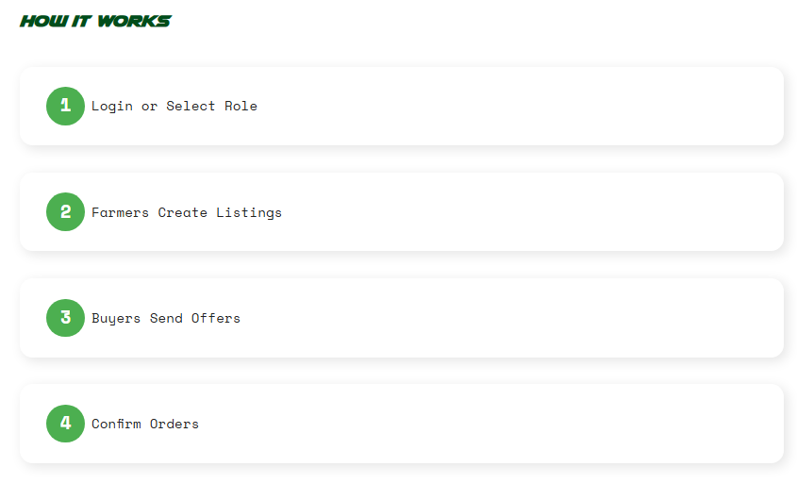
A flowchart illustrating the KrishiLink workflow is shown below.

5. Login/Register Modals

This illustration shows the Login and Register UI Modals
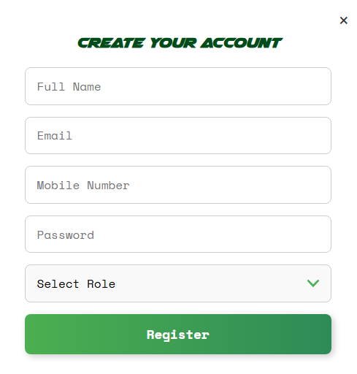
Login Modal
Register Modal

6. Dashboard Overview
The dashboard is designed to provide users (farmers and buyers) with a clear, interactive overview of all essential information. Key features include:
- Crops Overview: Displays the list of crops available, their quantities, and seasonal trends, allowing farmers to manage inventory efficiently and buyers to browse available produce.
- Buyers & Transactions: Shows active buyers, pending orders, and completed transactions, enabling better coordination and faster decision-making.
- MSP (Minimum Support Price) Tracking: Provides real-time updates on MSP for different crops, helping farmers make informed selling decisions and plan production strategies.

7. Future Improvements / Roadmap
To enhance the platform and ensure robust, scalable functionality, the following features are planned:
- Mobile Application: Develop a mobile-friendly app for both Android and iOS, making it easier for farmers and buyers to access the platform on the go.
- Database Integration (MySQL + PHP): Implement a robust backend with MySQL and PHP for secure user data management, dynamic updates, and seamless authentication.
- Weather & Alerts Integration: Incorporate local weather forecasts, crop-specific alerts, and notifications to help farmers optimize planting and harvesting schedules.
- Analytics & Insights: Future versions will include advanced analytics on crop trends, buyer preferences, and transaction histories to guide strategic decisions.

8. Conclusion
KrishiLink offers a streamlined solution bridging the gap between farmers and buyers. By combining real-time crop information, transparent pricing, and a user-friendly interface, the platform empowers farmers to maximize profits while providing buyers with reliable access to fresh produce. With planned improvements such as a mobile app, robust database management, and weather integration, KrishiLink is positioned to become an indispensable tool for modern agriculture.
Thank You

