Chengdu Neusoft University
Graduation Design Report

Title： Online course and Examination Management System

School： | Computing and Software
Major： | Software Engineering
Class： | Software Engineering19201
Name： | ISLAM MD ROKIBUL
Student ID： | 19480120002
Instructor： | Zhangchong

May 2023

Abstract

As the competition of mobile operators intensifies, new business needs are emerging, and the service quality of users is improving continuously, which requires the operation support system to adapt to the new demands and provide an effective solution for the business development. China Unicom is currently the most comprehensive telecommunications operators in the domestic telecommunications business, the construction of China Unicom Telecom Operation Support System has its own distinct characteristics of the existing support system in Henan Unicom has played a huge role in the early stage of construction, but due to the new competitive environment, more and more can not adapt to the needs of new development The purpose of this system is to build a new interface system for Henan Unicom, so as to provide a good supporting system for the rapid development of Henan Unicom.
This article is divided into the following sections on the use of Unicom specification H2 protocol, using Socket The structure and design implementation of the customer service interface for short connections.
(This part should be 150-300 words)
Key words：Supporting system，Service Interface，H2 Protocle
(This part should be 3-5 key words)

Table of Contents
Chapter 1 Introduction 1
1.1 Main research contents 1
1.1.1 Service System Introdction 1
1.1.2 Client System 1
1.2 Current situation at home and abroad 1
chapter 2 Key technology introduction 2
2.1 key development technology introduction 2
2.1.1 H2 Interface Protocol 2
2.1.2 Socket Communication 2
2.2 other related technologies 2
chapter 3 system analysis 3
3.1 framework introduction 3
3.1.1 Function Framework 3
3.1.2 Module Requirement Description 3
3.2 system development environment 3
3.3 feasibility analysis 3
3.3.1 Technology Feasibility 3
3.3.2 System Security Analysis 3
Chapter 4 System design 4
4.1 Design guiding theory and principle 4
4.1.1 Guiding Theory 4
4.2 Framework introduction 4
4.3 System function structure desgin 4
4.4 sytem controlling process 4
chapter 5 System Implementation 5
5.1 interface implementation 5
5.1.1 Controlling Management 5
5.1.2 Interface Server 5
5.2 Interface design specification 5
CHapter 6 system testing 6
6.1 testing plan and testing usecase 6
6.1.1 Sending Data 6
6.1.2 Receiving Data 6
6.2 Testing methods 6
Chapter 7 conclusion 7
Acknowledgements 8
Reference 9
Appendix 10

This part should be the same format as the example, of course you can adjust the content and structure of it.

Chapter 1 Introduction
Description: In the introduction briefly explain the design (thesis) The purpose of work, meaning, scope, research ideas, methods, the basis for selecting topics. should be concise and not identical with the abstract. In general textbooks, some knowledge, in the introduction does not appear. The review of history and the work of previous generations can be properly synthesized.
As the competition of mobile operators intensifies, new business needs are emerging, and the service quality of users is improving continuously, which requires the operation support system to adapt to the new demands and provide an effective solution for the business development. The existing support system of Henan Unicom has played a great role in the early stage of construction, but it is more and more unable to meet the need of new development because of the new competitive environment. Henan Unicom hopes to transform the original system to build a new interface system, so as to provide a good supporting system for the rapid development of Henan Unicom.

1.1 Main Research Contents
The Henan unicom Comprehensive tent four phase system customer service interface is one of Henan Unicom Comprehensive tent four phase system interface, is responsible for the customer service system and the synthesis tent system interaction. Henan Unicom Customer service system does not have the ability to update Internet user information, accounting information, but through the customer interface can be real-time to the Internet business system to provide data change applications. Customer service interface using the Unicom specification H2 protocol, with the socket Short connection, the tent system as the server, according to the request to access the database, do related processing, Returns the processing result to the client.

1.1.1 Service System Introduction
H2 interface Protocol message format: The packet is composed of Baotou and package, the contents of Baotou mainly include the common basic information of various packets, and the contents of the package mainly include the unique information of various packets.

1.1.2 Client System
In the domestic existing customer service system, most of them belong to two-tier structure, customer service system to the Integrated Accounting system service interface to send business processing data requests, customer service interface according to the request to access the database, make related processing, and then return the processing results to the client.

1.2 Current Situation at Home and Abroad
In the domestic existing customer service system, most of them belong to the two-tier structure, customer service system to the Integrated Tent system service interface to send business processing data requests, customer service interface according to the request to access the database, make related processing, and then return the processing results to the client. (slightly below)

Chapter 2 Key Technology Introduction

2.1 Key Development Technology Introduction

2.1.1 H2 Interface Protocol
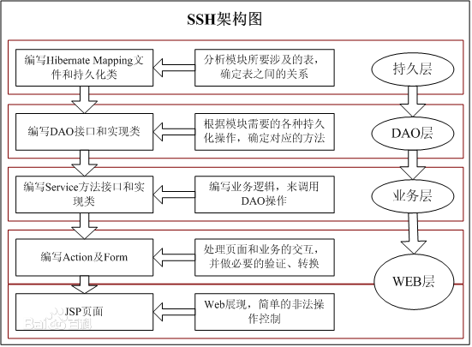
Figure 2.1 SSH Framework

2.1.2 Socket Communication

2.2 Other Related Technologies
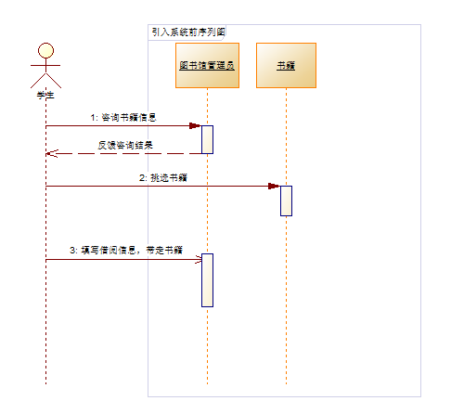
Figure 2.2 Sequence diagram before system introduction

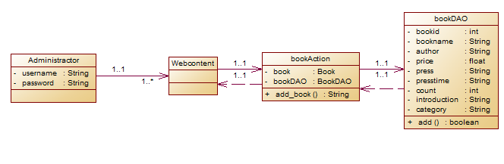

Figure2.3 New book class diagram

Chapter 3 System Analysis

3.1 Framework Introduction

3.1.1 Function Framework

3.1.2 Module Requirement Description

3.2 System Development Environment

3.3 Feasibility Analysis

3.3.1 Technology Feasibility

3.3.2 System Security Analysis

Chapter 4 System Design

4.1 Design guiding Theory and Principle

4.1.1 Guiding Theory

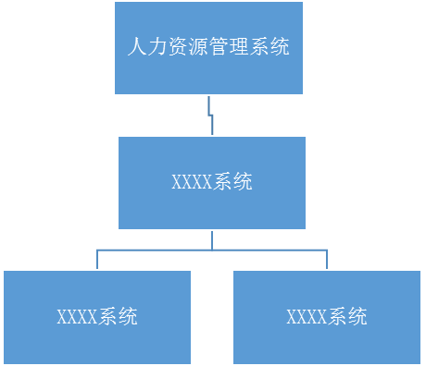
Figure 4.1 Enterprise human resource management system in big data Era
（以下略）

4.2 Framework Introduction

4.3 System Function Structure Design

4.4 System Controlling Process

Chapter 5 System Implementation

5.1 Interface Implementation

5.1.1 Controlling Management

Table 5.1 Challenges and Strategies of human resource management under big data
NO. | challenge | Strategy
1 | XXXXXXXXXX | XXXXXXXX
2
3
4

5.1.2 Interface Server

Table 5.2 userAction Class attribute
属性 | 类型 | 说明
user | User | 创建一个user对象，用来传递user的原来所有属性
userDAO | UserDAO | 创建一个UserDAO类的对象，用来调用该类中的modify()方法

5.2 Interface Design Specification

Table 5.3 UserDAO Class attribute
属性 | 类型 | 说明
id | int | 用户编号
username | String | 用户名
password | String | 密码
Email | String | 邮箱
phone | String | 电话号码

）

Chapter 6 System Testing

6.1 Testing Plan and Testing Usecase

6.1.1 Sending Data

6.1.2 Receiving Data
（

6.2Testing Methods

Chapter 7 Conclusion

Acknowledgements
Note: In the acknowledgement, the main expression of the tutor and other relevant staff of the meaning of gratitude and combined with the overall University study, the Whole graduation project (thesis) for the overall, general summary, the expression of design (thesis) ideas, learning to harvest, the future of further study ideas. In this respect, we still have to be realistic and the excessive glorification will bring about negative effects.
I got the entire graduation project at all stages XXX Teacher, XXX teacher and XXX Senior Engineer's careful guidance and patient help.

References

[1] Jiong. Unix Network Programming practical technology and instance Analysis [M]. Tsinghua University Press,2002.
[2] Xu Chuxiang. Linux C function Library Reference manual [M]. China Youth Press,2002.
[3] Zhang. oracle9i Chinese version of the basic tutorial [M]. Tsinghua University Press,2003:$.
[4] Software design mode. www.itisedu.com/ Software design pattern . htm.
[5] Xu Yucheng. Software testing and Quality management [D]. Maritime University,,.
[6]Jingxinhuayuan Mei. The driving force of the software industry [J]. China computer,,,7:32-33.
[7] Zhao, Zhaohui. UNIX Program Design tutorial [M]. Tsinghua University Press,2001.
[8] Chen Shaoying, Dai Jinlong. Software test Case Analysis [J]. Tester,,8:23-25.
[9] Wendy Boggs,Michael Boggs. UML and Rational Rose 2002 Getting started to proficient [M]. Electronic industry publishing house,2002:213-378.
[10] Sun Microsystems.Inc.JavaTM 2 SDK,Standard Edition Documentation Version 1.4.1. Sun Microsystems.Inc，2002．
All the references must follow the format as above strictly, you should list at least 15 references.

Appendix
The contents of the appendix should be separated from the body content, numbered in Arabic numerals, preceded by an appendix sequence code. For example, figure A.1, form (b.2), table C.3 , and so on.
Chengdu Neusoft University
Graduation Design (Thesis) Original Commitment
1. I promise: The submission of the Graduation Design (Thesis) is a serious study work after reading the school's "Graduation Design (thesis) Work Specification". I completed all the tasks listed in the planed task book independently under the guidance of teacher with no cheating, no copying of other’s work.
2. All the references in the Graduation Design (Thesis) citing other people's views and research results, are annotated in the paper or listed in the form of reference. All the individuals and groups who make important contributions to this work have been noted in this paper.
3., I’ll undertake the corresponding legal responsibility if there’s any infringement of intellectual property rights in the Graduation Design (Thesis).
4. I fully understand the school provisions on the preservation, use of Graduation Design (Thesis), namely: Submit both the printed and electronic version of the Graduation Design (Thesis) and related materials as the school requested; agree that the school can retain both the printed and electronic version of the Graduation Design (Thesis), which are allowed to access and borrow; the school can use photocopies, reduction printing or other means of reproduction to save the Graduation Design (Thesis), and can publish the complete or part of the paper content.
5. I fully understand the related items in the "Graduation Design (Thesis) work specification", namely: The bachelor's degree application qualification will be cancelled if the Graduation Design (Thesis) is found purchasing, ghostwritten or plagiarism; the diploma will be revoked by law even though it has been granted. The school will no longer accept the requirement of a student's degree application in three years who has received a punishment of diploma canceling.
6. I fully understand the related items in the "Student handbook", namely:" "The student who is regarded as a plagiarism person will not grant the bachelor's degree, and "Students will not grant a bachelor's degree due to disciplinary punishment in the final year, nor the bachelor's degree application qualification".
All the risks including the legal results, abnormal graduation and other unforeseen consequences will be taken by the student myself.
Student Signature:

