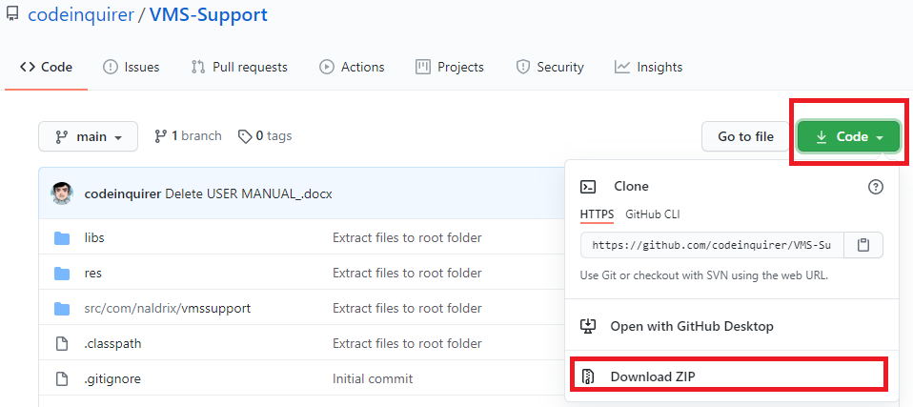**Downloading VMS Support Application from the Github and importing to Eclipse IDE**

1. Click the CODE in the upper right corner.
2. Click the DOWNLOAD ZIP.
3. Unzip the file.
4. Open the Eclipse IDE.
5. File → Import → General → Existing Projects into Workspace → Next
6. Select root directory: /path/to/project
7. Projects → Select All
8. Uncheck Copy projects into workspace and Add project to working sets
9. Finish

**VMS Support Application User Manual**

**Registration in VMS Support Application**

1. Tap the VMS app icon at your smart phone and splash screen will appear.

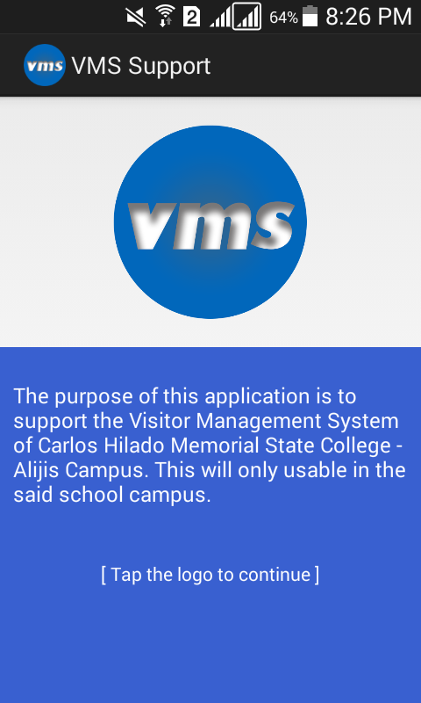

1. Fill-up the Server IP address and security code for validation of user and registration.

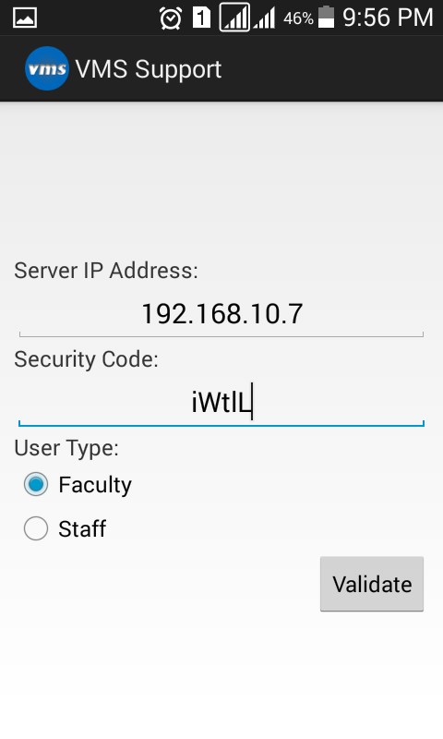

**Reading messages in VMS Support Application**

1. Click the Message icon to read messages.

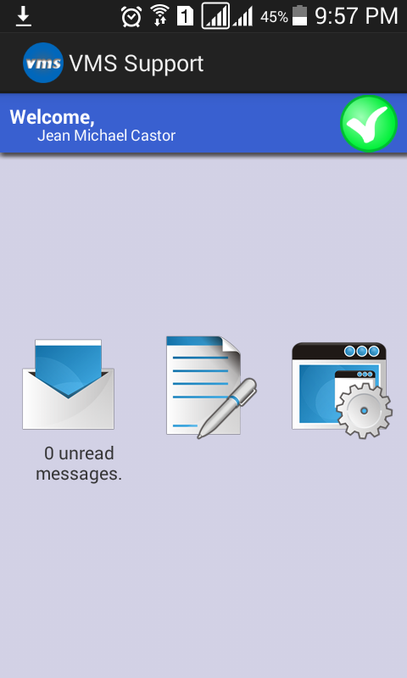

1. Click one of the messages to view the full details of the messages.

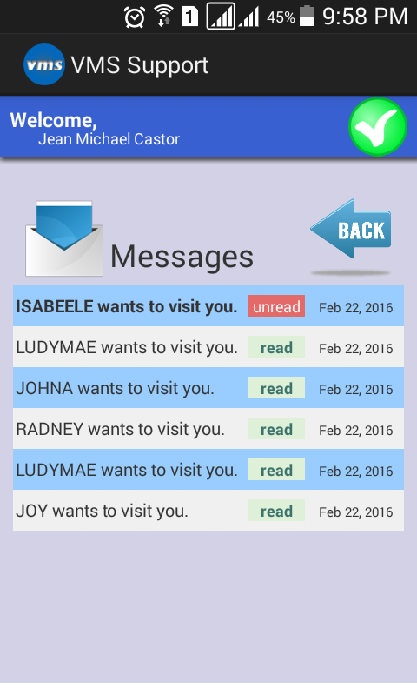

1. Scroll to bottom to accept or reject the visitor.

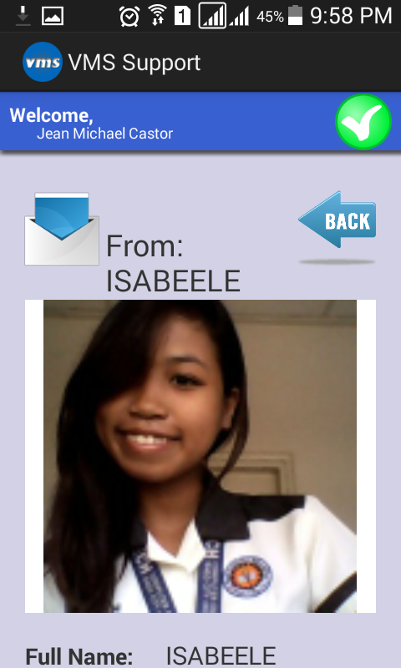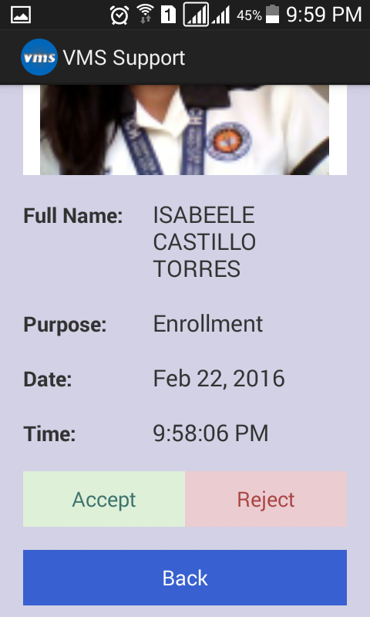

**Updating location using VMS Support Application**

1. Click the Write New Icon.
2. Select new location and write your message.

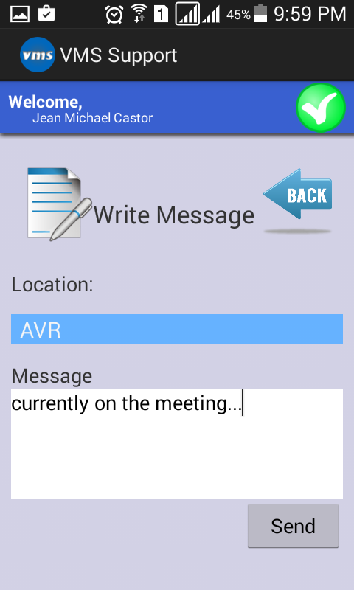

**Changing the Server (CVMS) Address in VMS Support Application**

1. Click the Settings Icon.
2. Enter the new Server IP Address.

