**PASSIVE INFRARED SENSOR**

Electronic sensor that measures infrared (IR) light radiating from objects in its field of view

They are most often used in PIR-based motion detectors.

PIR sensors are commonly used in security alarms and automatic lighting applications.

PIR sensors detect general movement, but do not give information on who or what moved.

For that purpose, an active IR sensor is required.

The term passive refers to the fact that PIR devices do not radiate energy for detection purposes.

They work entirely by detecting infrared radiation (radiant heat) emitted by or reflected from objects.

All objects with a temperature above absolute zero emit heat energy in the form of radiation.

Usually this radiation isn't visible to the human eye because it radiates at infrared wavelengths, but it can be detected by electronic devices designed for such a purpose.

At the core of a PIR sensor is a solid state sensor or set of sensors, made from pyroelectric materials—materials which generate energy when exposed to heat.

They are commonly used in burglar alarms and automatically-activated lighting systems

A PIR sensor can detect changes in the amount of infrared radiation impinging upon it, which varies depending on the temperature and surface characteristics of the objects in front of the sensor.

When an object, such as a person, passes in front of the background, such as a wall, the temperature at that point in the sensor's field of view will rise from room temperature to body temperature, and then back again.

The sensor converts the resulting change in the incoming infrared radiation into a change in the output voltage, and this triggers the detection

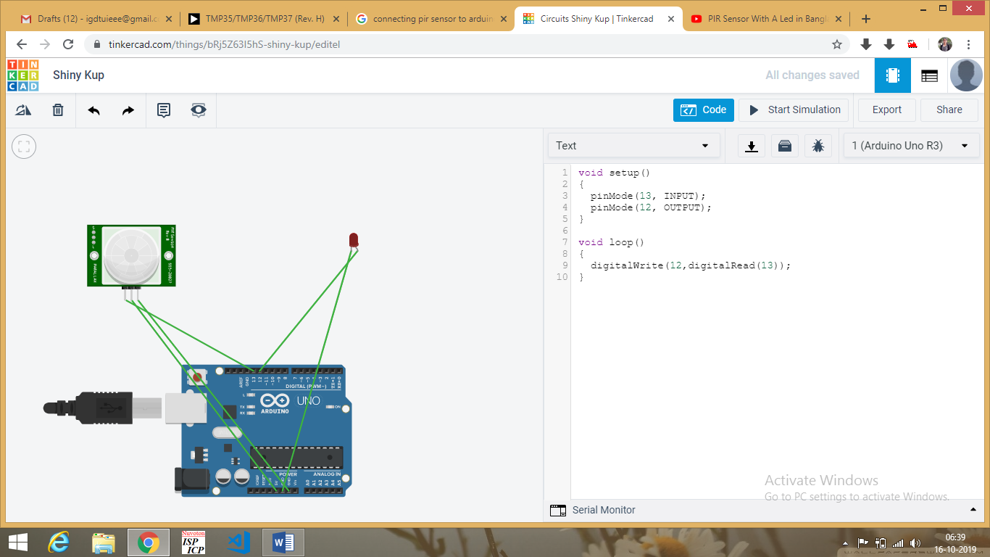

**TILT SENSOR**

it is a type of transducer.

Such [types of sensors](https://www.elprocus.com/sensors-types-applications/) produce an electrical signal which is proportional to the degree of inclination with respect to one or more axes.

This sensor helps in giving information about the horizontal and vertical inclination of the airplanes so that the pilot of the plane can easily understand the process of dealing with the obstacles during the flight.

These sensors are used to measure slope and tilt within a limited range of motion

Sometimes, the tilt sensors are referred to as inclinometers.



These sensors consist of a rolling ball with a conductive plate beneath them. When the sensor gets power, the rolling ball falls to the bottom of the sensor to form an electrical connection. When the sensor is tilted, the rolling ball doesn’t fall to the bottom so that the current cannot flow the two end terminals of the sensor.

