SDT 104 – UI Design and AI-assisted Frontend Development
Homework 10 – Introduction to JavaScript
Slipchenko Illia | Spring 2026

Repository & Links
GitHub Folder: https://github.com/jivl1/SDT104-project/tree/main/hw10
Live Site: https://jivl1.github.io/SDT104-project/hw10/
Note: Homework 10 is stored in the hw10 folder of the course repository.

Task 1 – Variables and Data Types

Code
// Task 1 – Variables and Data Types
let name = "Illia";
const age = 20;
// Log initial sentence using template literals
console.log(`Hi, my name is ${name} and I am ${age} years old.`);
// Update the name variable and log the new sentence
name = "Alex";
console.log(`Hi, my name is ${name} and I am ${age} years old.`);

Console Output
Hi, my name is Illia and I am 20 years old.
Hi, my name is Alex and I am 20 years old.

Console Screenshot
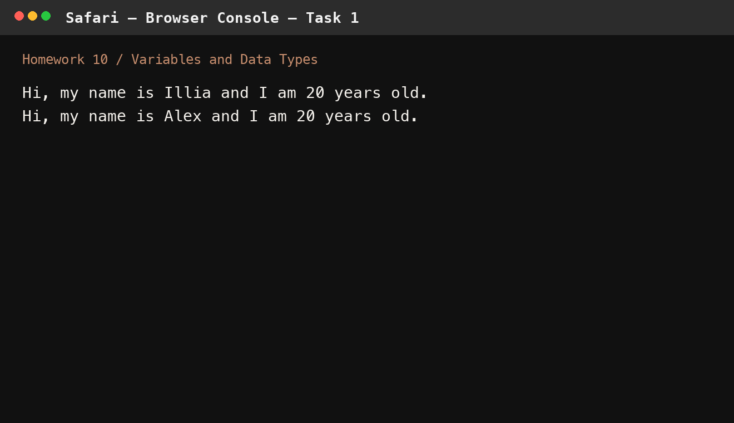

What I Learned
I practiced the difference between let and const, and used template literals to build readable strings with embedded values.

Task 2 – Arrays and Loops

Code
// Task 2 – Arrays and Loops
const students = ["Alice", "Bob", "Carol", "David", "Eva"];
// Print each name in uppercase
students.forEach(student => {
console.log(student.toUpperCase());
});
// Add a new student and log the updated array
students.push("Frank");
console.log("Updated array:", students);

Console Output
ALICE
BOB
CAROL
DAVID
EVA
Updated array: [ 'Alice', 'Bob', 'Carol', 'David', 'Eva', 'Frank' ]

Console Screenshot
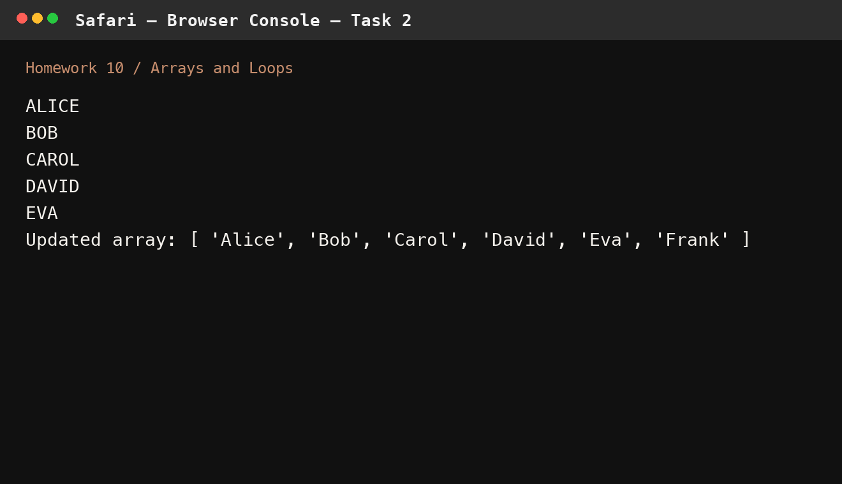

What I Learned
I worked with arrays, looped through items with forEach, transformed text with toUpperCase, and added a new value with push.

Task 3 – Object Basics

Code
// Task 3 – Object Basics
const hobby = {
name: "music production",
isIndoor: true,
weeklyHours: 10,
tools: ["DAW", "MIDI controller", "headphones"],
getHobbySummary() {
return `${this.name} – ${this.isIndoor ? "indoor" : "outdoor"}, ~${this.weeklyHours}h/week`;
}
};
// Log a descriptive sentence
const locationLabel = hobby.isIndoor ? "indoor" : "outdoor";
console.log(
`I enjoy ${hobby.name}. It's an ${locationLabel} hobby. ` +
`I spend about ${hobby.weeklyHours} hours per week using tools like: ${hobby.tools.join(", ")}.`
);
// Call the summary method
console.log(hobby.getHobbySummary());

Console Output
I enjoy music production. It's an indoor hobby. I spend about 10 hours per week using tools like: DAW, MIDI controller, headphones.
music production – indoor, ~10h/week

Console Screenshot
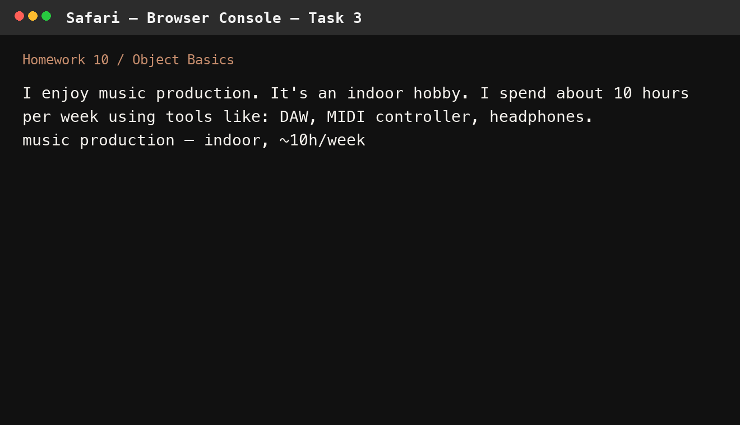

What I Learned
I created an object with mixed property types and added a method that uses this to return a short summary of the hobby.

Task 4 – Control Structures

Code
// Task 4 – Control Structures
function checkNumberType(num) {
if (num > 0) {
return "Positive";
} else if (num < 0) {
return "Negative";
} else {
return "Zero";
}
}
// Test with different values
console.log(checkNumberType(42)); // Positive
console.log(checkNumberType(-7)); // Negative
console.log(checkNumberType(0)); // Zero

Console Output
Positive
Negative
Zero

Console Screenshot
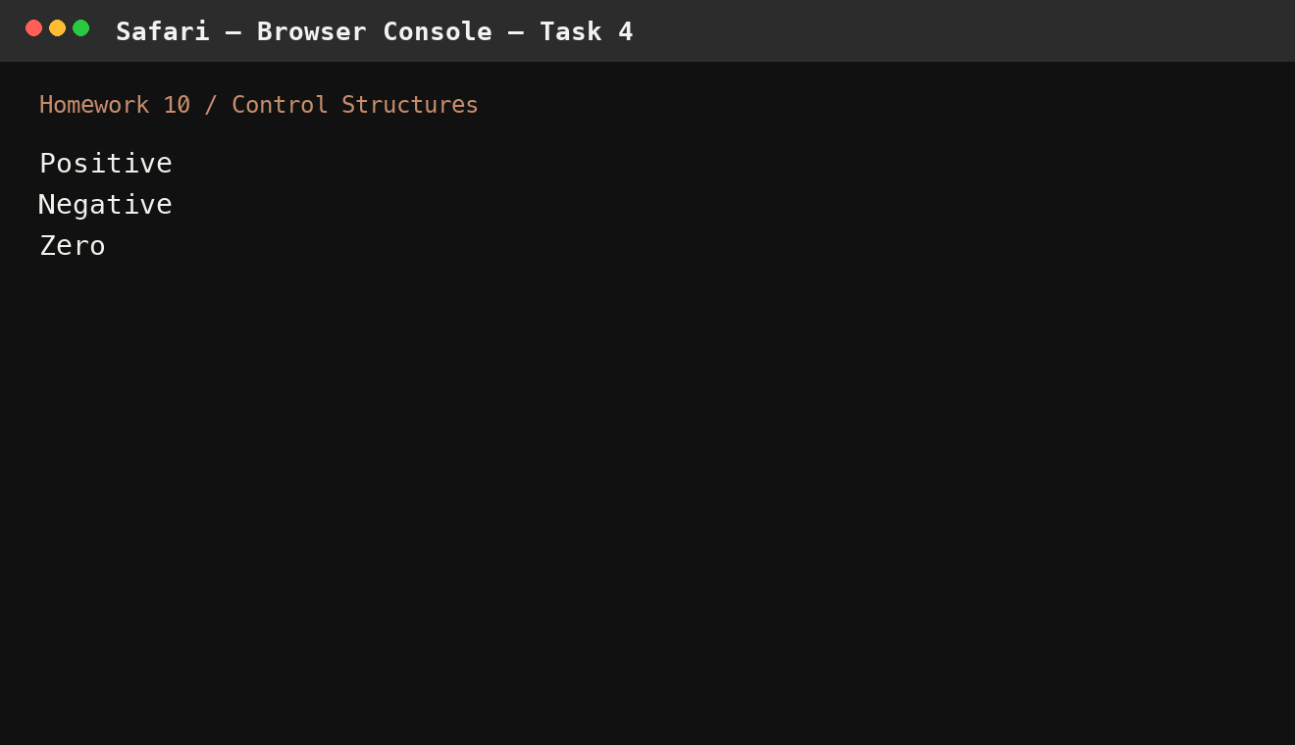

What I Learned
I used an if / else if / else chain to return different results based on the sign of the input number.

Task 5 – ES6 Class Practice

Code
// Task 5 – ES6 Class Practice
class Hobby {
constructor(name, isIndoor, weeklyHours) {
this.name = name;
this.isIndoor = isIndoor;
this.weeklyHours = weeklyHours;
}
describe() {
const type = this.isIndoor ? "indoor" : "outdoor";
console.log(
`My hobby is ${this.name}. It's an ${type} activity, and I spend ${this.weeklyHours} hours a week on it.`
);
}
}
const hobby1 = new Hobby("music production", true, 10);
const hobby2 = new Hobby("cycling", false, 6);
hobby1.describe();
hobby2.describe();

Console Output
My hobby is music production. It's an indoor activity, and I spend 10 hours a week on it.
My hobby is cycling. It's an outdoor activity, and I spend 6 hours a week on it.

Console Screenshot
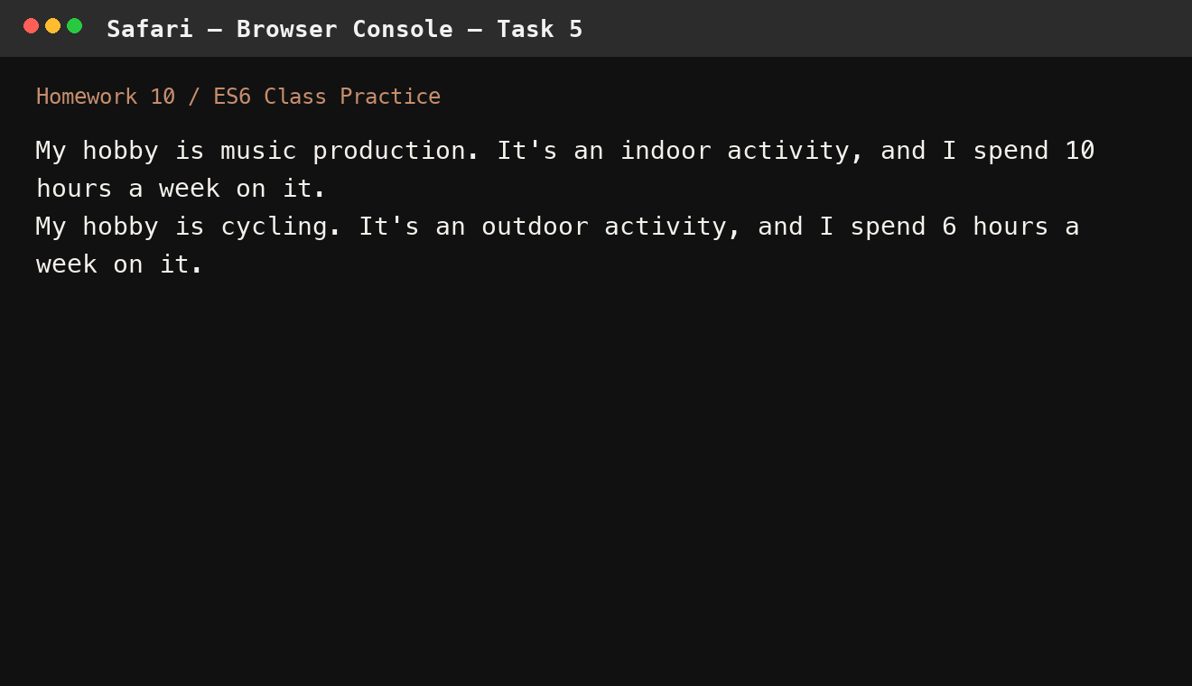

What I Learned
I defined an ES6 class with a constructor and a method, then created two instances with different data.

