JØ7 VIREO: A low-cost edge-Al assistive vision system with real-time object detection and proximity awareness for the visually impaired

First Name(s): Jivesh
Surname: Ramnath
Category: Computing & Data Sciences
Sub-category: Computer Science
School: Hoërskool Richardsbaai
Grade: 12
City, Country: South Africa

Table of Contents
1 Introduction 1
1.1 Literature Review 1
1.1.1 Theoretical Background and Classes of Existing Assistive Solutions 1
1.1.2 Algorithmic and Computational Approaches 2
1.1.3 Software Tools, Packages, and Systems 3
1.1.4 Empirical Findings and Limitations in Prior Research 4
1.1.5 Identified Research Gap 4
1.2 Problem Statement 4
1.3 Aim/ Design Expectations 4
1.4 Design / Criteria 4
2 Methodology 6
2.1 Algorithm Design and Complexity Analysis 6
2.2 Software Architecture and System Flow 6
2.3 Implementation Details 6
2.4 Design Decisions and Justifications 7
2.5 Hardware/Platform Constraints 8
2.5.1 Head-Mounted Unit 8
2.5.2 Smart Haptic Belt 8
2.5.3 Training Platform 8
2.5.4 General System Constraints 8
2.6 Materials / Tools 9
2.6.1 Software Platforms and Programming Languages 9
2.6.2 Libraries and Packages 9
2.6.3 Hardware Specifications 9
2.6.4 Datasets, Annotation & Augmentation 10
2.7 Procedure / Implementation Steps 10
2.7.1 Budget Planning, Procurement and Ethical Sourcing 10
2.7.2 Preliminary Research, Skills Audit and Documentation Plan 11
2.7.3 Raspberry Pi 5 System Preparation and Secure OS Installation 12
2.7.4 Hardware Integration: Camera, Hailo AI Hat and Mechanical Mounts 12
2.7.5 Software Stack Installation and Low-Level Driver Validation 12
2.7.6 Training Environment Setup on Laptop (WSL Ubuntu 22.04) 12
2.7.7 Dataset Selection, Annotation and Augmentation Strategy 12
2.7.8 Model Selection, Hyperparameters and Iterative Training Process 13
2.7.9 Resource Management and Thermal/Power Monitoring During Training 15
2.7.10 Model Compression, Quantisation and Conversion for Hailo Deployment 16
2.7.11 Voice Assistant Optimisation for Blind Accessibility 18
2.7.12 Application Layer: Detection to Feedback Pipeline and TTS Integration 18
2.7.13 Design and Assembly of the Power System with Safety Controls 18
2.7.14 Mechanical Design, Enclosure Sealing and Thermal Management 19
2.7.15 Manufacturing the Vireo's Odontoid 20
2.7.16 Haptic Belt Design, Firmware and Safety Distance Calibration 21
2.7.17 Verification, Field Trials, Ethics and User Feedback Collection 22
3 Results 22
3.1 Model performance and detection accuracy 23
3.2 Inference latency, throughput and system load 24
3.3 Power, battery and electrical behaviour 24
3.4 Thermal performance and reliability 24
3.5 Haptic and audio bench validation 25
3.6 Failure modes and technical limitations (lab observations) 25
4 Discussion 26
4.1 Comparative Evaluation 27
4.2 Trade-off Analysis: Speed vs. Accuracy vs. Power 27
4.3 Robustness and Sensitivity 28
4.4 Complexity and Scalability 28
4.5 Theoretical Support and Novelty 28
5 Limitations and Errors 28
5.1 Data and Model Limitations 28
5.2 Hardware and Integration Limitations 29
5.3 Power and Battery Limitations 30
5.4 Environmental and Operational Limitations 30
5.5 Software and System Limitations 31
5.6 Project Management and Resource Limitations 31
5.7 Safety, Ethical and Maintenance Concerns 32
5.8 Reproducibility and Validation Limitations 32
6 Recommendations for Future Development 33
7 Conclusion 34
8 Acknowledgement: 34
9 References 36
10 Appendix A: Programming code 38
11 Appendix B: Survey 46

Introduction
Assistive navigation for visually impaired individuals presents a systems-level challenge at the intersection of computer vision, embedded computing, and ethical technology design. In South Africa and comparable developing regions, rural and low-income communities often lack consistent access to mobile data, stable Wi-Fi, and advanced assistive equipment. As a result, many vision-assist technologies remain economically and technologically inaccessible, despite rapid advances in artificial intelligence and deep learning.
From a computational standpoint, modern real-time object detection relies on deep convolutional neural networks (CNNs) with millions to billions of parameters. These models are commonly deployed via cloud-based inference due to their high computational and memory requirements (Krizhevsky et al., 2012). However, cloud dependence introduces unpredictable latency, privacy risks, and complete system failure under poor connectivity. For visually impaired users, delayed or missing feedback during navigation can result in unsafe outcomes and, in extreme cases, severe injury or death (Giudice et al., 2016).

Literature Review

Theoretical Background and Classes of Existing Assistive Solutions

Computational perception and sensory theory
Vision-based assistive systems rely on computational perception, where sensory input is transformed into structured representations that support decision-making. Object detection can be expressed as:
$$f:R^{H×W×C}→Y$$
Where $H,W,C$ represent image height, width, and channels, and $Y$denotes a set of labelled objects with spatial attributes. CNNs approximate this function by learning hierarchical features invariant to translation and moderate illumination changes (LeCun et al., 2015).
Sensory substitution theory proposes that spatial information can be mapped onto non-visual sensory channels such as hearing or touch (Bach-y-Rita & Kercel, 2003). However, excessive information density increases cognitive load, necessitating abstraction, prioritisation, and temporal filtering (Klatzky et al., 2013).

Categories of existing assistive navigation solutions and cost structures
Existing assistive solutions can be broadly classified into four categories:
- Mechanical and proximity-based aids,
Devices such as white canes and ultrasonic sensor attachments provide binary or scalar distance feedback. Typically costing $100–$330 (₹8,000–₹26,750), these systems are robust but lack semantic understanding of the environment, e.g. distinguishing between a person and an inanimate obstacle. Their theoretical limitations arise from reliance on low-dimensional sensor inputs, such as outputting data in one dimension, such as a buzzer or a speaker, which cannot capture complex environmental interactions (Manduchi & Kurniawan, 2011).
- Smartphone-based vision applications,
Mobile applications utilise onboard cameras and cloud-based interface pipelines. Although CNN models can achieve high detection accuracy, latency and availability are constrained by network connectivity. Effective costs exceed $530–$1,000 (₹43,000–₹80,000), including device and data usage and battery life. Privacy concerns and assumptions of uninterrupted connectivity limit deployment in rural or low-resource environments (Giudice et al., 2016).
- Commercial wearable AI devices
Products such as OrCam MyEye and Envision Glasses combine cameras with proprietary AI hardware. Prices range from $2,650–$4,650 (₹2.1–3.7 lakh). These devices offer high semantic accuracy but remain inaccessible to most users in most regions, as price and connectivity may be a concern, reflecting a correlation between semantic capability and cost.
- Academic and experimental prototypes
Research prototypes often employ Raspberry Pi-class hardware or smartphones. Costs are rarely disclosed, training datasets are limited and long-term reliability is not mentioned. Thermal behaviour and battery safety are frequently unreported. Most prototypes assume controlled laboratory conditions and do not generalise about everyday environments such as rain, snow and high temperature. (Santos et al., 2020).
This landscape reveals structural inequality. Solutions with high semantic capability are costly and often rely on cloud connectivity, yet low-cost solutions lack semantic understanding.

Algorithmic and Computational Approaches

Evolution from classical vision to deep learning
Early assistive systems relied on classical computer vision algorithms, including edge detection, HOG (histogram of oriented gradients) descriptors and optical flow. While deterministic in computational terms, these methods often fail to generalize to real world variability and complex scenes (Dalal & Triggs, 2005). Modern systems predominantly employ CNN( Convolutional Neural Network) based object detectors, with single stage detectors like YOLO models, achieving real-time performance by predicting object classes and bounding boxes in one forward pass. Computational complexity scales with input resolution and network depth, necessitating lightweight variants for embedded deployment after doing the necessary compressions to allow them to run on edge devices.

Model selection tradeoffs under embedded constraints
Model selection for embedded deployment involves a tradeoff between accuracy, latency, and power consumption. Lightweight models reduce inference time and power draw but struggle with small or occluded objects. Larger models increase accuracy but impose higher memory and thermal loads on the processing cores. Experimental progression was tested from 29% accuracy (YOLOv8n) to 63% (YOLOv8n7) and 87% (YOLOv8m100) on a controlled 100-object test demonstrates nonlinear accuracy gains with parameter count, while extreme lighting and close-range occlusion remains limiting factors; however, augmentation generally resolves this concern. This supports literature advocating multimodal sensing to overcome vision-only constraints (Redmon et al., 2016).

Quantisation and edge deployment
To achieve real time performance on embedded devices, post training quantization (INT8) and operator fusion are commonly applied. Literature indicates minimal accuracy loss when quantisation is carefully executed (Jacob et al., 2018).
Validation of the PYTORCH (FP32) → ONNX (FP32 COMPRESSED) → HAR (INT8) → HEF (INT8 COMPRESSED) conversion highlights practical toolchain fragility and operator compatibility issues often neglected in research publications (HEF- Hailo executable file).

Software Tools, Packages, and Systems
This section outlines the software tools, frameworks, and systems used in the development of the assistive vision-based navigation device, focusing on their functional roles, deployment suitability, and observed limitations.

Machine learning and numerical frameworks
PyTorch was the primary framework used in training and evaluating CNN-based object detection models. Its dynamic computation graph and strong CUDA integration enabled efficient experimentation and debugging. However, PyTorch imposes a very high memory consumption and requires careful tuning to maintain stability on consumer-grade GPUs, especially mobile GPUs.
Supporting numerical operations were handled using NumPy, which provided reliable array-based computation for preprocessing and evaluation. Though it was not suitable for high-throughput tensor operations.

Dataset annotation and data formats
Image annotation was performed using LabelImg, an open-source tool supporting bounding box labelling and export to standard formats such as YOLO (You Only Look Once). While efficient for manual annotation, LabelImg lacks built-in validation and large-scale dataset management features.
Annotations were stored in the COCO dataset format, enabling compatibility with modern object detection frameworks and deployment pipelines. To mitigate dataset bias commonly present in public datasets, locally captured images were incorporated.

Development environments and operating systems
Model training and experimentation were conducted using WSL (Windows System for Linux) Ubuntu 22.04, providing Linux compatibility with GPU passthrough acceleration on a Windows host system. Although effective, WSL introduces additional abstraction layers that can complicate driver and file system interactions.
Development and debugging were carried out using Visual Studio Code. Selected for its extensibility, modification, reach and WSL integration. Geany (script editor) was used on the embedded systems (Pi 5) due to its low resource footprint. System interaction and deployment relied extensively on Linux terminal environments.

Edge AI deployment and acceleration
Edge inference was implemented using the Hailo SDK (Software development kit), enabling compilation and deployment of neural networks onto dedicated AI acceleration hardware (Hailo 8). Models were converted through ONNX (open neural network exchange_, HAR, and HEF formats using the Hailo Dataflow Compiler in WSL. While this pipeline enables high output, it introduces strict operator compatibility requirements and limited diagnostic feedback. The SDK can often be picky with data types through conversions. The Hailo Model Zoo was used to improve compatibility and reduce complex integration.

Embedded systems and accessibility software
Embedded firmware for peripheral control and haptic feedback was developed using the Arduino IDE and the ESP32 Arduino framework, providing reliable real-time control but limited advanced debugging capabilities
Speech interaction was implemented using the Vosk speech recognition library, chosen for its offline operation, low latency and soft, realistic human voice tone. Vosk runs locally on the Raspberry Pis CPU (Broadcom BCM2712, Overclocked to 2.85ghz)

System monitoring and reproducibility
System performance and stability were evaluated using htop (system monitor) and vcgencmd (temperature monitor) on the PI and GPU-Z on the laptop used for training, enabling monitoring of CPU, GPU, thermal, and power characteristics during both training and deployment. Source code and configuration management were maintained using Git, supporting reproducibility and traceability across development stages.

Empirical Findings and Limitations in Prior Research
Prior studies report detection accuracy but lack end-to-end system metrics, including detection to feedback latency, which is critical for navigation safety. This resulted in a measured latency of ~150 ms, which compares favourably with human reaction times and exceeds cloud-based system responsiveness under poor connectivity (Giudice et al., 2016).
Battery safety and sustainability are largely neglected. Prototypes frequently employ new lithium cells without considering disposal or environmental impact. Integration of repurposed e-cigarette cells, along with BMS, fusing, and efficiency-tested buck converters, addresses these ethical and engineering gaps.
Common failure modes: lighting extremes, reflective surfaces, and close-range occlusion were confirmed experimentally. This can be solved by data augmentation in training and applying a layer of NMS (non-maximum suppression) to aid in avoiding occlusion. Mitigation strategies combining ultrasonic sensing and haptic prioritisation demonstrate the advantages of multimodal systems over vision-only designs.

Identified Research Gap
Despite advances in object detection and embedded AI, a gap persists between laboratory-scale prototypes and deployable assistive systems. Few studies integrate cost, offline operation, thermal stability, power safety, sustainability, and system-level validation into a single solution.
This project addresses the gap by integrating edge-accelerated computer vision, offline speech and haptics, sustainable power reuse, and rigorous empirical validation into a single, low-cost system with materials costing ≈ $360 / ₹35,500.

Problem Statement
Despite the evolution of advances in computer vision and artificial intelligence, accessible, reliable, and affordable assistive navigation systems, visually impaired individuals remain limited, particularly in low-resource and offline environments. Existing solutions either provide minimal spatial awareness (e.g. white canes and proximity sensors) or they rely on expensive, cloud-dependent AI systems that are inaccessible to most users in developing regions.

Aim/ Design Expectations
To develop an affordable, head-mounted assistive device that enables visually impaired users to navigate their surroundings safely, independently, and while being offline using real-time object recognition and multisensory feedback.

Design / Criteria
The proposed assistive navigation system was expected to achieve real-time, reliable operation on embedded hardware while remaining affordable, energy efficient, and safe for continuous daily use. The design explicitly prioritised low latency, deterministic feedback behaviour, and system stability under sustained operation.
- Computational Performance and Latency
Vision inference was offloaded to a dedicated edge AI accelerator (Hailo-8), while lightweight application logic executes on the host processor. This architecture was expected to sustain an end-to-end detection-to-feedback latency of ≤ 200 ms, which was sufficient for safe navigation at normal pedestrian walking speeds.
Under nominal indoor conditions, the vision subsystem was expected to deliver a stable inference throughput in the range of 30–65 FPS when monitored, serving as an indicator of model efficiency rather than a strict operational requirement. Average Raspberry Pi CPU utilisation for the object detection pipeline was expected to remain below 30%, preserving computational headroom for audio processing, haptic control, and fault handling.
System memory usage was expected to remain within available limits, 4 GB of RAM and 2 GB of swap space, avoiding out-of-memory (OOM) failures during prolonged continuous operation.
- Multimodal Feedback Behaviour
The multimodal feedback pipeline was designed to prioritise hazards deterministically. High-risk obstacles were expected to trigger immediate auditory and haptic alerts, while non-critical detections were rate-limited to prevent cognitive overload during use.
Directional haptic feedback was expected to respond to proximity changes within tens of milliseconds, with vibration intensity scaled proportionally to object distance. This ensured that users receive intuitive, spatially meaningful feedback without reliance on visual cues.
- Haptic Belt and Proximity Sensing
The smart haptic belt integrated VL53L0X time-of-flight (ToF) LiDAR sensors, providing vision-independent proximity detection with a response time of < 50 ms. Directional distance measurements were mapped to PWM-controlled vibration motors distributed around the belt, enabling immediate and proportional haptic feedback for obstacles within approximately 20 cm.
This design improved navigation safety under low-light, occluded, or visually ambiguous conditions. The belt subsystem was expected to operate for approximately 5 hours per charge under typical usage.
- Power, Thermal, and Electrical Constraints
Thermally, the head-mounted system was expected to operate continuously with CPU temperatures below 55 °C in an ambient environment of approximately 25 °C, ensuring long-term reliability and user safety.
Electrically, the power subsystem was designed to deliver a stable ≥ 5.1 V at peak loads of up to 5 A, supporting sustained operation of the SBC, AI accelerator, and peripherals. The head unit is expected to achieve approximately 4 hours of runtime per charge, while complying with battery safety requirements through regulated power delivery, fusing, and battery management circuitry.
- Usability, Cost, and Deployment Expectations
The complete system is expected to maintain a lightweight, ergonomic form factor suitable for head-mounted use, minimising user fatigue during extended operation. Hardware construction is expected to be sufficiently robust for everyday use, while remaining compact and portable.
Total system cost was expected to remain below R5,000 / ₹28,000 / $305, without compromising functionality, performance, usability, or reliability. This constraint was central to ensuring accessibility and scalability in low-resource environments.

Methodology

Algorithm Design and Complexity Analysis
The core problem addressed in this project was the provision of real-time, fully offline navigation assistance for visually impaired users under strict constraints of latency, power consumption, and embedded processing capability. To meet these constraints, the system adopted a streaming, event-driven processing model rather than batch-based computation.
Visual input was captured continuously and processed frame-by-frame through a single-stage object detection pipeline based on the YOLO (You Only Look Once) architecture. The algorithmic structure followed a single-pass convolutional inference model, avoiding multi-stage proposal generation or region refinement commonly used in two-stage detectors. This design ensured predictable execution time and bounded latency on embedded hardware.
For each input frame, the dominant computational cost arose from convolutional feature extraction and class prediction. Time complexity per frame was bounded by the formula:
$$O\left(F⋅C\right)$$
where $F$denotes the number of convolutional feature maps and $C$ represents the number of output classes (different objects). This enables predictable latency on edge hardware. Space complexity is bounded by the number of model parameters and intermediate activation tensors. Through post-training INT8 quantisation, both model size and intermediate memory usage are constrained to fit within the on-chip memory of the Hailo-8 accelerator, reducing host RAM pressure and preventing out-of-memory (OOM) failures during sustained operation.

Software Architecture and System Flow
The overall system was designed as two independent embedded systems: a head-mounted vision unit and a LiDAR-based smart belt. Each system operated autonomously with its own sensing, processing, and feedback loops, avoiding tight coupling and single points of failure.
The head-mounted system followed a layered software architecture. The Perception Layer handled camera input and real time YOLO based object detection, followed by confidence and relevance filtering to suppress transient, unsure detections. The decision Layer applied hazard prioritisation, temporal cooldown logic and distance scaling to prevent redundant alerts and manage cognitive load. The Feedback Layer converted high-priority events into text-to-speech output and directional haptic commands.
The smart belt operated as a standalone Auxiliary sensing layer using VL53L0X LiDAR sensors to continuously monitor near field obstacles. Its local decision logic triggered immediate haptic feedback based on proximity thresholds, achieving sub 50ms response times independent of vision processing.

Implementation Details
The system software was used across many platforms using many development stacks, chosen to balance performance, reliability, and rapid iteration under embedded constraints. The primary application running on the head-mounted unit was developed in Python 3.10 and deployed on a Raspberry Pi 5 (4 GB RAM) running 64 - bit Raspberry Pi OS from a 64 GB SD card. Python was selected for its mature machine learning ecosystem and ease of integration with hardware interfaces. OpenCV was used for camera access and frame preprocessing. On-device development and debugging were performed using Geany, a lightweight IDE well-suited to the Pi’s limited resources.
Dataset sourcing, annotation, and model preparation were carried out using Roboflow Universe, which provided access to large-scale, community-curated datasets and tools for standardised labelling for 100 images. Annotations followed the COCO format, enabling reproducibility and compatibility across training and deployment pipelines. Model training, validation and conversion were executed under WSL Ubuntu 22.04 on an x86 Windows-based laptop with GPU passthrough enabled, allowing efficient experimentation while maintaining alignment with the Linux-based deployment environment. Visual Studio Code was used during this phase for experiment tracking, configuration management, and code development.
To meet real-time inference requirements on the Raspberry Pi, object detection was offloaded to a dedicated Hailo-8 AI accelerator, which executed the YOLO model directly on the device. This architecture minimised CPU utilisation, reduced end-to-end latency, and avoided thermal throttling during sustained operation. The Python application employed non-blocking queues and lightweight threading to concurrently handle camera capture, inference dispatch and text-to-speech generation.
The haptic smart belt functioned as a fully independent embedded subsystem. Its firmware was written in C++ using the Arduino IDE and deployed on an ESP32 microcontroller. The ESP32 interfaced with VL53-series LiDAR sensors via I²C to obtain high-frequency proximity measurements and controlled vibration motors through PWM (Pulse width modulation) outputs. Static memory allocation and simplified control loops were used to ensure deterministic timing behaviour under strict memory and power constraints.
Overall system constraints included limited RAM, passive cooling, battery operation and the requirement for fully offline functionality.

Design Decisions and Justifications
The system design prioritised low latency and robust perception for blind navigation. YOLOv8m was chosen over YOLOv8n for the head-mounted unit due to higher detection accuracy, supplemented with data augmentation (rotations, brightness flips and noise) to handle occlusion and lighting variability. Single-stage detection was preferred over region-based methods for its predictable latency, achieving an average detection to feedback time of ~150 ms on the Pi 5 with a Hailo 8 accelerator. The Pi 5 was selected over the Pi 4 to leverage PCIe access to the Hailo 8, allowing high throughput inference with minimal CPU load. The Pi CPU was overclocked to 2.85 GHz to further reduce processing delays while staying within thermal limits (~54°C).
The LiDAR-based smart belt (using VL53-series sensors) was chosen over ultrasonic alternatives for its higher spatial resolution, immunity to crosstalk, and ability to detect small or irregular objects reliably. Sensor polling and motor actuation were implemented on an ESP32 (Arduino IDE using C++), allowing deterministic timing and independent operation from the head-mounted unit. Distance thresholds were calibrated, and vibration intensity was scaled proportionally, enabling intuitive spatial feedback.
Error handling was implemented both at the sensor and post-processing layers. For YOLO inference, absent or low confidence detections were ignored, and audio announcements were throttled using cooldown timers to avoid repeated alerts. The Python post processing script ensures that object removal and re-announcement follow a strict 0.4s absence threshold with multithreaded locks guaranteeing safe handling between detection, TTS playback and audio scheduling.

Hardware/Platform Constraints

Head-Mounted Unit
- Platform: Raspberry Pi 5 (4 GB RAM, 64 GB SD card)
- Interfaces:
  - Hailo-8 AI accelerator (PCIe)
  - AI camera (CSI)
  - Audio output (earphones)
- Constraints:
  - Limited RAM and swap usage
  - Passive cooling
  - CPU thermal ceiling (~54 °C)
- Performance:
  - Overclocked to 2.85 GHz
  - ~150 ms detection-to-feedback latency

Smart Haptic Belt
- Platform: ESP32 microcontroller
- Interfaces: VL53 LiDAR sensors, vibration motors
- Constraints:
  - Limited flash and SRAM
  - GPIO timing precision
  - Low power budget (~1.5 h on a 2,000 mAh cell)
- Safety:
  - Overcurrent cut-outs
  - Sensor fault detection
  - Deterministic vibration patterns

Training Platform
- Platform: x86 laptop with WSL Ubuntu 22.04
- GPU: RTX 3050M (4 GB VRAM)
- Constraints:
  - Limited VRAM
  - 85 W peak power draw
  - Dataset reproducibility via Roboflow and COCO formats

General System Constraints
- Fully offline operation for rural and low-connectivity environments
- Strict thermal and power efficiency requirements
- Modular architecture allowing graceful degradation of vision, audio, or haptic subsystems

Materials / Tools

Software Platforms and Programming Languages
- Python 3.10 - scripting, model development, inference orchestration (VS Code on laptop; Geany on Pi for lightweight editing).
- C++ (Arduino framework) - firmware for ESP32 based haptic belt (Arduino IDE)
- WSL Ubuntu 22.04 - training and model conversion environment (GPU passthrough enabled).
- Raspberry Pi OS (64-bit ) - deployment OS on Raspberry Pi 5 (head unit)
- GStreamer- inference pipeline and media plumbing on the Pi (via hailo_apps_infra)
- Git- source control, model and experiment checkpointing.

Libraries and Packages
- PyTorch - model training and development (YOLOv8 training)
- Ultralytics YOLOv8 - model implementation (YOLOv8n / YOLOv8m variants)
- OpenCV (cv2) - camera capture, preprocessing, frame handling.
- NumPy -numerical operations and tensor preprocessing.
- SciPy- auxiliary numeric utilities and statistics
- ONNX / onnxruntime - intermediate export and validation for model conversion
- Hailo SDK & Compiler - model compilation (HAR → HEF) and runtime on Hailo accelerator (vendor toolchain).
- hailo_apps_infra (hailo_rpi_common, detection pipeline) -- GStreamer-based detection app and helpers.
- simpleaudio - local WAV playback for announcements in Python
- Vosk - offline ASR for voice commands
- VCTK / VITS (local) or eSpeak - offline TTS models/engines for speech output (preloadable)
- Roboflow Universe - dataset management, labelling orchestration and exports (COCO format for 100 classes)
- LabelImg - manual bounding-box annotation (alternative/local)
- matplotlib - plotting training/evaluation graphs.
- htop, vcgencmd - system monitoring utilities on Pi.
- Misc: os, time, threading, logging (Python stdlib)

Hardware Specifications
(Computer and peripheral devices used in development and deployment)

Head unit (deployment)
- Raspberry Pi 5 - 4 GB RAM, 64 GB SD card (Raspberry Pi OS 64-bit).
- Hailo-8 AI Hat Plus (26 TOPS) – PCIe mounted accelerator for on-device inference
- AI camera (CSI ribbon cable) - head/shoulder-mounted camera module.
- Active coolers ×2 (Pi 5 official coolers customized for max speed) - thermal control
- Audio output: wired earphones / ALSA-compatible audio output.

Edge training & development
- x86 laptop with Ryzen 5 6600h with 32gb 4800mt/s ddr5 ram (WSL Ubuntu 22.04) with NVIDIA RTX 3050M (4 GB VRAM) - model training, conversion, and experimentation
- VS Code - the primary IDE for training scripts, experiments, remote SSH integration

Haptic belt
- ESP32 microcontroller (firmware in Arduino C++) - controls haptics and sensors.
- VL53-series ToF (VL53L0X) LiDAR sensors - directional proximity sensing.
- Vibration motors (4) -belt actuation(vibration via PWM.
- Rechargeable, recycled Li-ion cell (≈2000 mAh) for belt power.

Measurement & validation tools
- USB power meter, multimeter - voltage/current logging for buck converter and battery under load
- Thermal probes/logging scripts (vcgencmd) - temperature monitoring

Datasets, Annotation & Augmentation
- Public dataset: COCO 2014 base classes; the project used a combined label set expanded to 100 classes (COCO classes + locally relevant classes as needed).
- Custom dataset: ≈80 COCO + 20 locally captured images of region-specific obstacles and environments (head-mounted camera).
- Annotation tools: Roboflow Universe (primary dataset management, versioning, augmentation pipelines) and LabelImg for manual corrections. As well as Labelimg.
- Augmentation pipeline (logged seeds and parameters): random rotations (±15°), brightness adjustments (±30%), horizontal flips, random crops, and Gaussian noise.
- Train/validation split: held-out validation ≥10% of annotated images; checkpoints and logs retained for reproducibility. With a total dataset split of 30% Validation and 70% train across 85,000 images.

Procedure / Implementation Steps
The development process was organised into discrete, traceable steps to ensure reproducibility, safety, and ethical treatment of test participants. Each step included verification checks and documentation to allow later auditing and iterative improvement.

Budget Planning, Procurement and Ethical Sourcing
A detailed budget was prepared, and funds were arranged to cover required components and peripheral services. A parts list was created that included the Raspberry Pi 5, Hailo-8 AI Hat Plus, AI camera, ESP32 modules, vibration motors, DC–DC converters, 3D printing materials, and safety items such as fuses and a battery protection board. Where feasible, components were sourced locally to support maintainability and to reduce lead times. Recycled vape battery cells were collected from responsible donors and municipal e-waste collection points, and records were kept of sources to demonstrate ethical sourcing and traceability. (Made a budget, bought the parts, and collected used vape cells from responsible sources so the project stayed cheap and ethical.)

Component | Quantity | Estimated Cost (ZAR) | Estimated Cost (USD / INR) | Notes
Raspberry Pi 5 (4GB) | 1 | 2,200 | 117 USD / 9,900 INR | Sourced locally for maintainability
Hailo-8 AI Hat Plus | 1 | 1,700 | 90 USD /  7,650 INR | Supports accelerated AI processing
AI Camera + cable | 1 | 1,000 | 53 USD /  4,500 INR | Compatible with Pi 5 for live object detection
SG90 Servo Motor | 1 | 80 | 4 USD /  360 INR | For adjustable components
Raspberry Pi 5 Active Cooler | 2 | 400 | 21 USD /  1,800 INR | Ensures optimal performance
Raspberry Pi 5 Power Adapter | 1 | 250 | 13 USD /  1,125 INR | Official 5.1V 3A power supply
Miscellaneous Components | Various | 1,000 | 53 USD /  4,500 INR | Includes wires, thermal paste, ESP32 modules, vibration motors, fuses, connectors, and safety items
Recycled Vape Batteries | Various | 0 | 0 USD /  0 INR | Sourced ethically and free of charge
Subtotal |  | 6,630 | 352 USD /  29,835 INR | Cost of physical components only
Research & Development |  | Invaluable | Invaluable | Includes hours spent on experimentation, testing, coding, hardware integration, and problem-solving
Total Project Cost |  | >6,630 + R&D time | >352 USD + R&D / >29,835 INR + R&D | Includes both material costs and the significant time invested in R&D

Preliminary Research, Skills Audit and Documentation Plan
A skills gap analysis was performed to identify required competencies in embedded Linux administration, Python, C++, computer vision, model training, and 3D CAD(computer aided design). Learning resources, official documentation, and tutorials were logged, and a study plan was executed to gain necessary skills. A documentation protocol was established using GIT for version control, a shared lab notebook (timestamped entries), and folder conventions for datasets, scripts, and binary artifacts to ensure reproducibility.
Checked what skills were needed, learned them, and set up proper documentation and version control so the work could be reproduced.

Raspberry Pi 5 System Preparation and Secure OS Installation
A stable Ubuntu image was written on an SD card and inserted into the Raspberry Pi 5. The system was booted, and initial security settings were applied: default passwords were changed, SSH keys were configured, and unattended upgrades were enabled. A Python virtual environment with system access was created to manage dependencies; system packages and directories were updated to current stable versions before installing development toolchains. Swap space was increased where required to prevent out-of-memory failures during model compilation and conversion.
Installed Ubuntu on the Pi, hardened the system a bit, created a Python environment, and increased swap so big jobs would not crash.

Hardware Integration: Camera, Hailo AI Hat and Mechanical Mounts
The AI camera was connected to the Pi’s CSI port using a correctly oriented ribbon cable and secured at eye level in the head-mounted frame. The Hailo-8 AI Hat Plus was seated on the Pi using the PCIe interface and secured with standoffs and thermal pads. Mechanical details such as standoff spacing, screw torque, and cable strain relief were recorded. Heatsinks and a small airflow path were incorporated to control temperature under sustained loads. Initial power-on and POST checks were performed to verify device recognition by the OS.
Plugged in and secured the camera and the Hailo module correctly, added cooling, and checked that the Pi recognised the hardware.

Software Stack Installation and Low-Level Driver Validation
All Hailo toolchains, drivers, and OpenCV pipelines required for deployment were downloaded and installed inside a prepared virtual environment. Kernel modules or firmware updates recommended by the Hailo documentation were applied. A known good, pre-trained model from public sources was executed locally to validate the complete inference pipeline. System utilities such as htop, vcgencmd (or equivalent), and logging facilities were installed to monitor CPU, memory, temperature, and power usage during experiments. Any permission issues, missing udev rules, or camera access problems were resolved and recorded for the notes.
Installed the Hailo drivers and OpenCV, ran a test model to ensure the software stack worked, and set up monitoring tools.

Training Environment Setup on Laptop (WSL Ubuntu 22.04)
A training environment was prepared on the laptop by installing WSL with Ubuntu 22.04, followed by the necessary CUDA and GPU drivers where supported. Hailo-ready tooling for model conversion was installed in WSL. The dataset workflow was established: annotations in open source COCO format, training/validation split, and a reproducible export of file lists and metadata. A backup copy of all raw images and annotations was retained offline to preserve provenance.
Set up Ubuntu on the laptop, prepared GPU drivers and Hailo tools, and organised the training dataset carefully.

Dataset Selection, Annotation and Augmentation Strategy
A combination of a custom dataset (≈80 carefully curated classes of locally relevant obstacles) and the COCO 2014 dataset (80 classes) was used alongside 20 additional classes to make a total of 100 classes. Images were annotated in COCO format and verified by cross-checking class labels. Augmentation was applied to improve robustness: random rotations up to ±15 degrees, brightness adjustments ±30%, horizontal flips, random crops, and Gaussian noise. A validation set of at least 10% of the annotated images was held out to monitor generalisation. Augmentation parameters and seeds were logged for reproducibility. This dataset has the following objects; person, bicycle, car, motorcycle, airplane, bus, train, truck, boat, bird, cat, dog, horse, sheep, zebra, giraffe, backpack, umbrella, suitcase, frisbee, skis, snowboard, kite, baseball bat, baseball glove, skateboard, surfboard, tennis racket, bottle, wine glass, cup, fork, knife, spoon, bowl, banana, apple, sandwich, orange, broccoli, carrot, hot dog, pizza, donut, cake, chair, couch, potted plant, bed, dining table, toilet, TV, laptop, monitor, mouse, remote, keyboard, cell phone, microwave, oven, toaster, sink, refrigerator, book, clock, vase, scissors, teddy bear, hair drier, toothbrush
annotated images, mixed local photos with COCO data, and used image augmentation to make the model more robust.

Model Selection, Hyperparameters and Iterative Training Process
YOLOv8n was selected for initial training because of its lightweight footprint. Training experiments were tracked with a results table including epochs, batch size, learning rate, augmentation settings, GPU utilization and wall time. Typical hyperparameters that were used and recorded included batch size 16 (adjusted as needed to fit VRAM), base learning rate 0.001 with cosine annealing schedule, image size 640×640, and early stopping patience of 100 epochs on validation mAP-50. The iterative strategy followed three stages: prototype (20 epochs), intermediate (250 epochs) and final (500 epochs). Model checkpoints, tensorboard logs and evaluation metrics (mAP@0.5, precision, recall) were retained.
Trained YOLOv8n with sensible settings, tracked every experiment, and improved the model across three staged training runs.
Images from the training process and different variations of trials
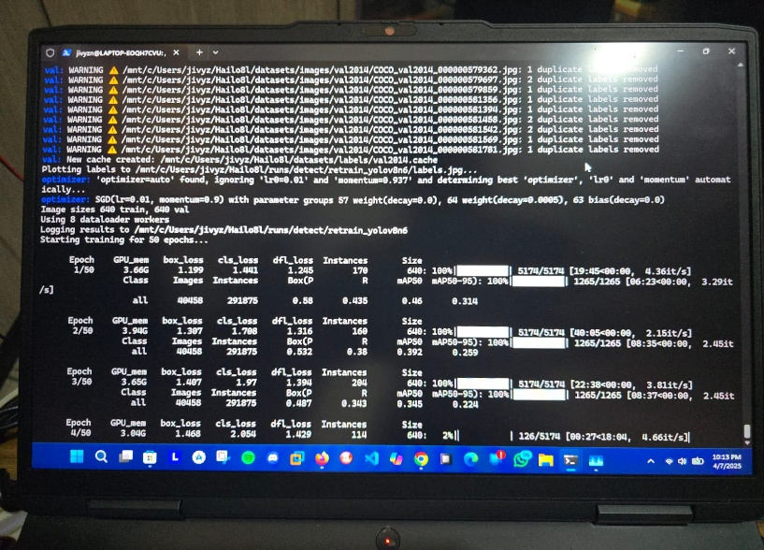
Figure 1: Illustrates trial model training on laptop, Photograph taken by Jivesh Ramnath
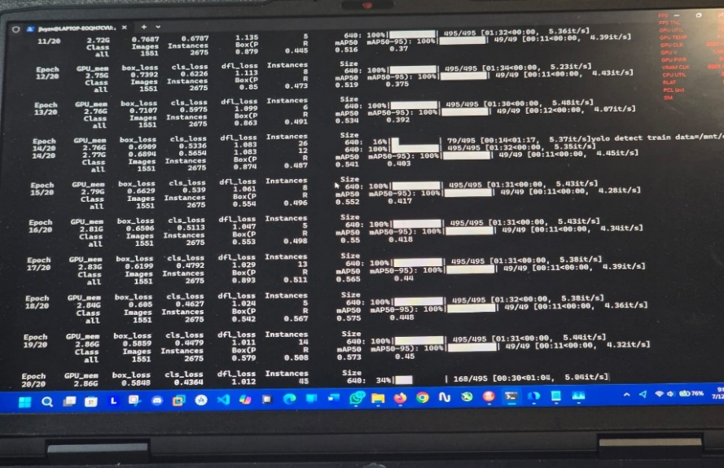
Figure 2: illustrates trial model training completed on laptop, Photograph taken by Jivesh Ramnath
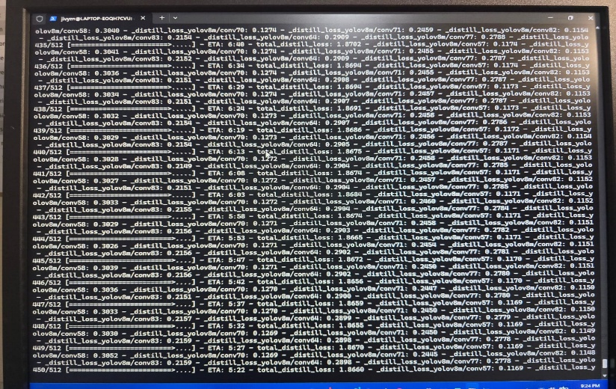
Figure 3: Illustrates trial model conversion on laptop, Photograph taken by Jivesh Ramnath
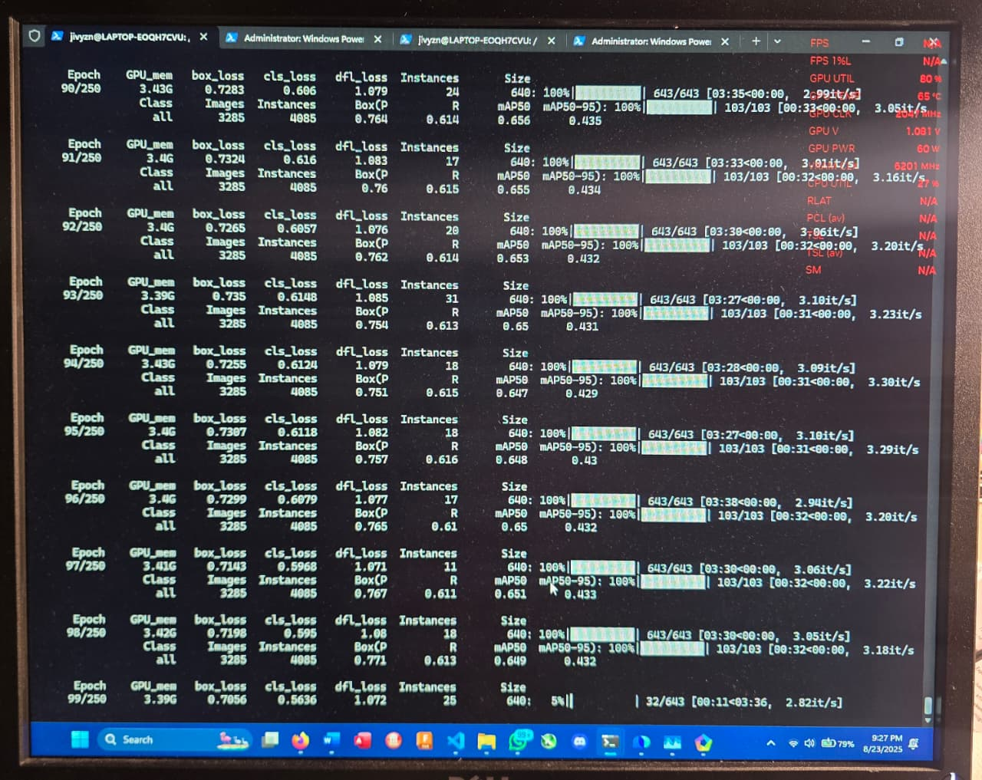
Figure 4: Illustrates trial 2, model training/conversion on laptop, Photograph taken by Jivesh Ramnath
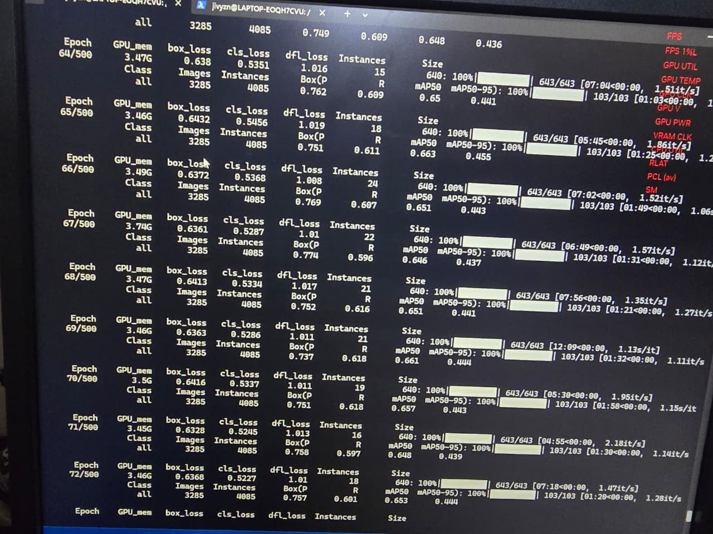
Figure 5: Illustrates final model training on laptop, Photograph taken by Jivesh Ramnath

Resource Management and Thermal/Power Monitoring During Training
Because the laptop GPU (RTX 3050 mobile, 4 GB) was constrained, steps were taken to minimize thrashing and overheating: GPU power limits were observed (≈85 W peak draw during long runs), swap was used to avoid OOM( out of memory errors) kills, and thermal logging was performed to ensure temperatures remained below safe thresholds (manufacturer limits). Training was scheduled to run overnight with automatic checkpoints and monitored remotely when possible. The GPU was overclocked to get better time out of model training. Energy and time costs were logged to give realistic estimates for future scaling.
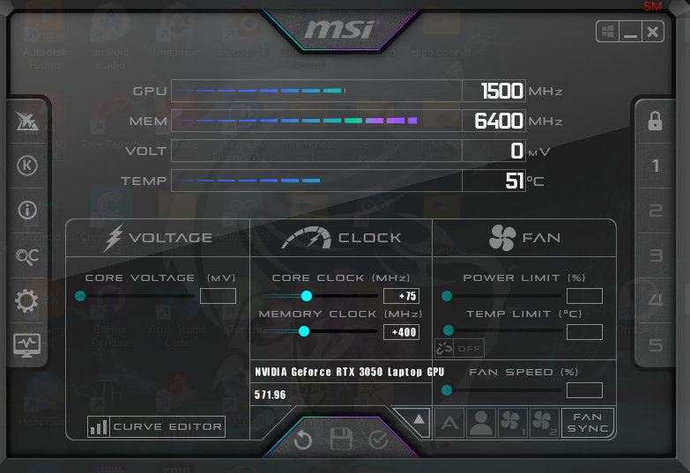
Figure 6: Minimum overclock settings for rtx 3050m 4GB on MSI Afterburner, snipping tool by Jivesh Ramnath
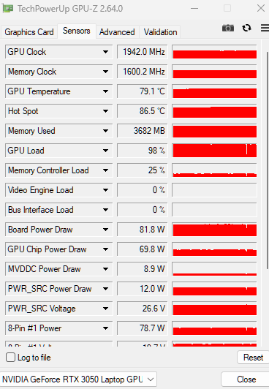
Figure 7: Illustrates, Results from Tech Powerup GPU-z, these results illustrated that while the GPU is overclocked and underload it maintains an average of 79 Degrees and even increases if the day is hot. The 8-pin power illustrated 78.7W watts being used, which goes up to 85W during augmentation, snipped by Jivesh Ramnath.
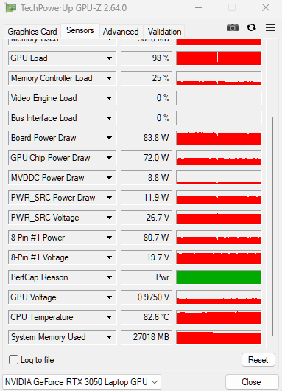
Figure 8, Continued Accurate measurements from Tech Powerup GPU-Z, snipped by Jivesh Ramnath

Model Compression, Quantisation and Conversion for Hailo Deployment
The final trained model was converted from PyTorch into ONNX format using reproducible export commands. Model size and operator compatibility were checked. Post training quantization to INT8 was performed where supported to reduce latency and memory. The ONNX model was packaged into a HAR archive and compiled into a HEF executable using the Hailo compiler. Each conversion step was validated by running inference on a known test set and comparing accuracy metrics to the original model; any degradation was documented and compensated through minor re-training as needed.
Converted the trained model to ONNX, quantised it to reduce size, and compiled it into the Hailo HEF file while checking accuracy at each step.
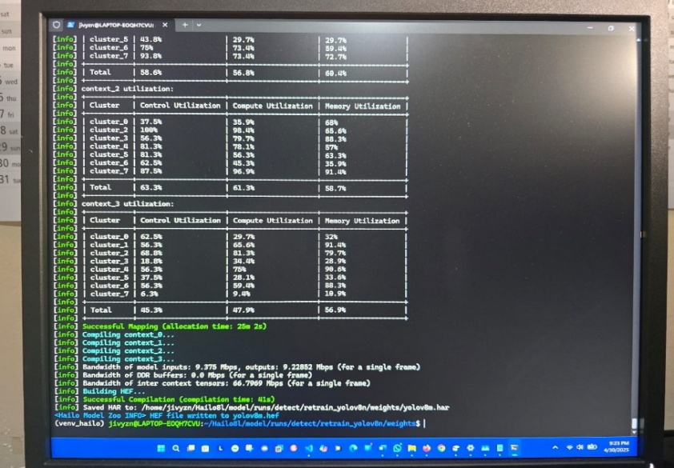
Figure 9: Illustrates the final conversion process from har. To hef, Photograph taken by Jivesh Ramnath

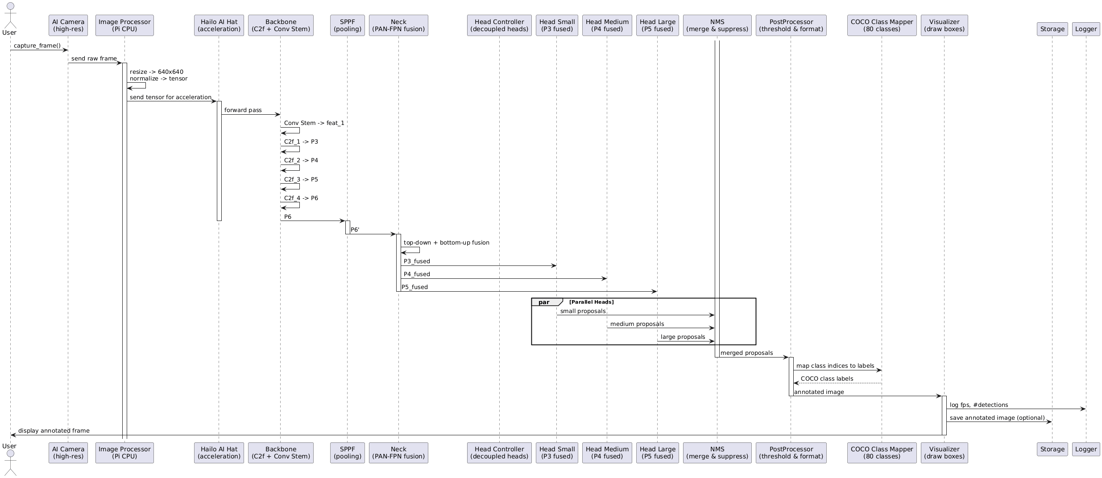
Figure 10: illustrates a UML Diagram explaining how the system works using PlantUml initiated by Jivesh Ramnath

Voice Assistant Optimisation for Blind Accessibility
The assistant was redesigned for rapid, user-friendly interaction with blind individuals by preloading Vosk ASR and VCTK/VITS TTS models at startup to remove warm up delays, caching long and frequently used responses for instant playback, and running TTS in a dedicated thread to prevent audio overlap. Intent detection was improved using combined regex and token gap matching to handle natural phrasing such as “where am I and with a “stop” keyword allowing speech to be interrupted and returning immediately to listening mode. Object detection requests triggered Vireo environment setup and a timed camera feed script, while all long instructional answers were chunked to allow speech to begin before the entire synthesis was complete, minimizing perceived delay. Duplicate answers were suppressed using per intent cooldown timers, ensuring concise, non-repetitive responses while maintaining high quality, conversational speech output.
Preloaded speech models for speed, improved question recognition, added stop command, chunked long answers for faster speaking, and removed repeated responses.

Application Layer: Detection to Feedback Pipeline and TTS Integration
A Python service was created to run the HEF model on the Pi 5, post-process detections, and convert detection objects and distances into human-friendly messages. Distance estimation used simple bounding-box-to-depth heuristics calibrated with known object sizes and verified using ultrasonic sensors. Text-to-speech was integrated using eSpeak or a compact TTS engine; utterances were prioritised and throttled to avoid overwhelming the user.
Safety rules were implemented: items designated as ‘hazard’ were announced with higher priority and repeated patterns were rate-limited. All software included robust exception handling and automatic restart behaviour to improve resilience.
Wrote the software that turned detections into spoken messages and haptic cues, calibrated distance heuristics, and made sure urgent warnings were prioritised.

Design and Assembly of the Power System with Safety Controls
Used cells were tested individually for open-circuit voltage, capacity estimation and internal resistance using a battery analyser. For clarity: the cells were 3.7 V nominal and 500 mAh rated. To achieve a 3.7 V pack with approximately 3 000 mAh, six cells were placed in parallel because 500 mAh × 6 = 3 000 mAh. (Calculation shown explicitly: 500 × 6 = 3 000.) Two such 3 000 mAh parallel groups were connected in series to produce 7.4 V and 3 000 mAh usable capacity.
This 2S6P arrangement used 12 cells in total and was consistent with safe pack design principles. A dedicated battery management system (BMS) with cell balancing, overcurrent protection, and a physical fuse was employed. A DC to DC buck converter with >90% efficiency was specified and tested; the converter’s efficiency and voltage underload were measured with a USB-C PD power meter and multimeter to ensure the Pi received at least 4.8 V at 5 A under peak load. The battery enclosure used fire-retardant materials and an accessible master switch to allow safe emergency disconnection.
Tested each vape cell, built a 2S6P pack (12 cells total) to get 7.4 V and ~3 000 mAh, added a protection board and fuse, and used a high-efficiency buck converter to power the Pi.

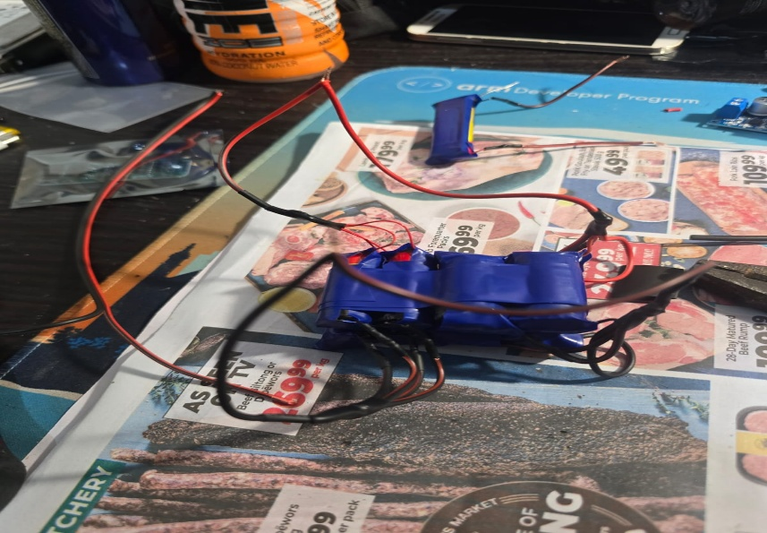
Figure 11: Illustrates assembly of e-cigarette (Li-ion) batteries, Photograph taken by Jivesh Ramnath

Mechanical Design, Enclosure Sealing and Thermal Management
The head unit and battery pack were modelled in Fusion 360 (case was adapted from Printables.com) with tolerances for connector strain-relief and cooling vents. IP55 compliance was targeted by using gaskets on seams and rubber-molded ports for connectors. Ventilation for the Hailo module and Raspberry Pi was provided via a directed airflow channel and thermal pads; a small, low-noise blower fan was optionally included if sustained temperatures exceeded safe thresholds during prolonged operation. Assembly instructions, screw-torque values, and gasket compression guidelines were documented to ensure consistent builds.
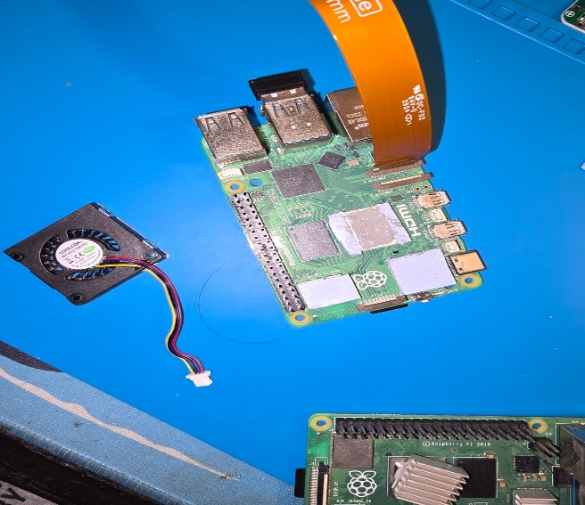
Figure 12: Illustrates adding thermal paste on Pi 5 CPU and thermal Pads on the edges to aid in heat distribution. The Pi 5 official cooler was also hardwired directly to the 5-volt pin for maximum heat dissipation. (Photograph taken by Jivesh Ramnath)

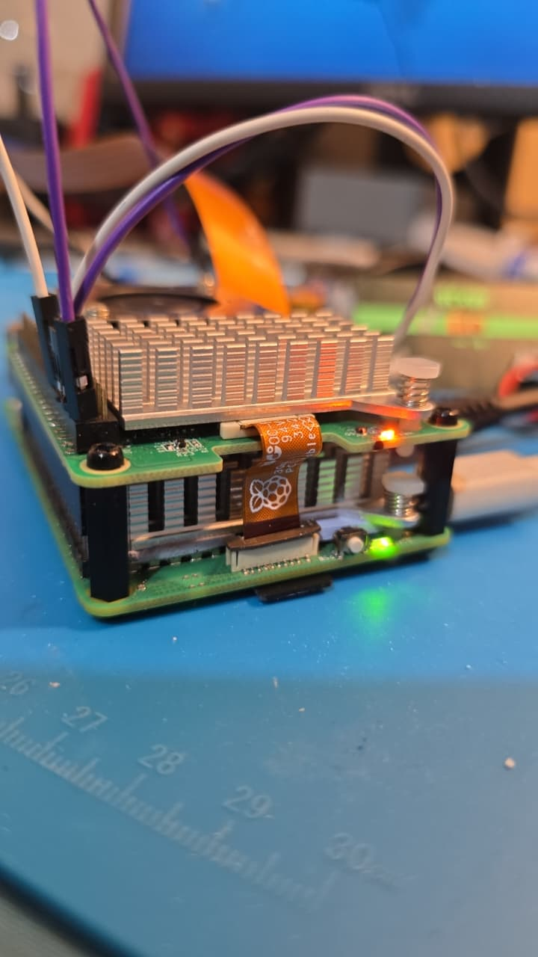
Figure 13: Illustrates 2 rpi 5 coolers to cool the CPU and the NPU (neural processing unit), both were hardwired to 5 Volts Gpio pin, photographed by Jivesh Ramnath

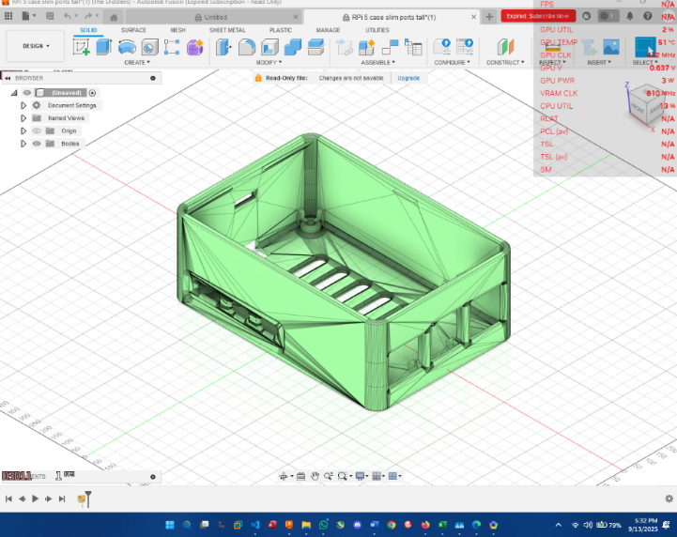
Figure 14: Illustrates the Pi 5 case in AutoCAD Fusion after editing height and width to accommodate the Hailo hat, snipped by Jivesh Ramnath.

Manufacturing the Vireo's Odontoid
The odontoid mechanism was inspired by the natural movement of the human neck, which allows us to rotate our heads left and right with ease.
The process of manufacturing this mechanism was not straightforward. Initially, the plan was to print a dedicated structure in 3D for the odontoid. However, the 3D printer ran out of filament midway through the building, leaving the project at a standstill. Rather than allow this setback to stop progress, a creative solution was employed by selecting wood as an alternative material.
This required not only technical precision but also hands-on craftsmanship. The wood was carefully cut, shaped, and joined together to form a stable stand that could accommodate the servo motor. Carving the structure by hand brought a personal touch to the build, with every cut and adjustment reflecting determination to push through challenges and continue developing the Vireo. Once the base was completed, the structure was spray-painted blue to give it a polished, unified look and to ensure the material was protected against wear.
With the odontoid base completed, the servo motor was mounted securely into the structure. The SG90 servo was chosen for its simplicity and efficiency, providing a smooth range of motion from 0° to 180° with 90° set as the natural center. The servo was then integrated with the Raspberry Pi and programmed to respond to voice commands. This included interpreting commands like “30 left” or “90 right” and intelligently correcting for misheard words such as “riot” for right or “laugh” for left.
The programming ensured that the movements of the servo mimicked natural head rotations with smooth and responsive adjustments. This made the device more intuitive for the user, bridging the gap between human ability and machine functionality.
(Figures 14 and 15 illustrate the structure of the Vireos odontoid, photographed by Jivesh Ramnath)
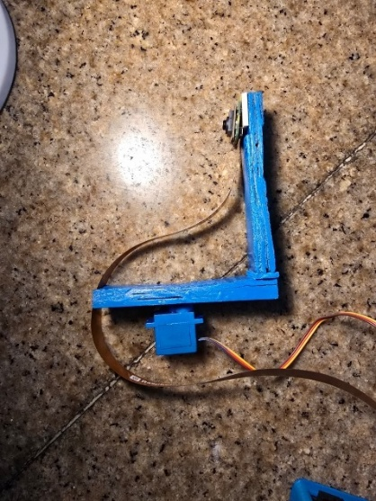 | 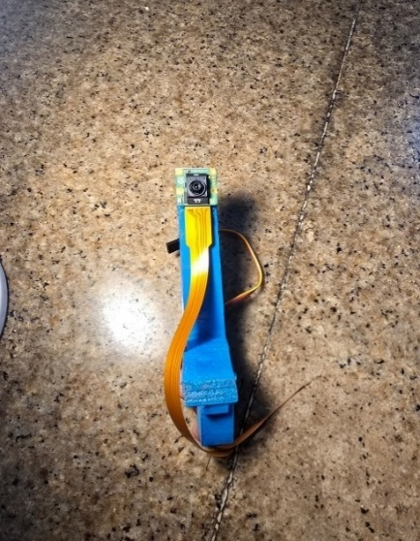
Figure 15: Illustrates the odontoid | Figure 16: Illustrates the odontoid

Haptic Belt Design, Firmware and Safety Distance Calibration
The belt contained 4 vibration motors controlled by an ESP32-C6 and powered by a recycled 2 000 Mah cell. Lidar sensors and simple time of flight checks were used to detect hazards within preset radii (for example, 20 cm for immediate avoidance). Vibration patterns were mapped to locations (left, front-left, front, front-right, right), and intensity was proportional to measured proximity.
Firmware was written in C++ using the Arduino IDE with debouncing and safety checks to prevent runaway motor activation. Battery and motor current draw were profiled, and an overcurrent cutout was implemented. Recharge and replace procedures were documented for safe maintenance.
built the belt with vibration motors and ultrasonic sensors(prototype), programmed how it vibrated depending on how close an object was, and added safety cutouts for current.
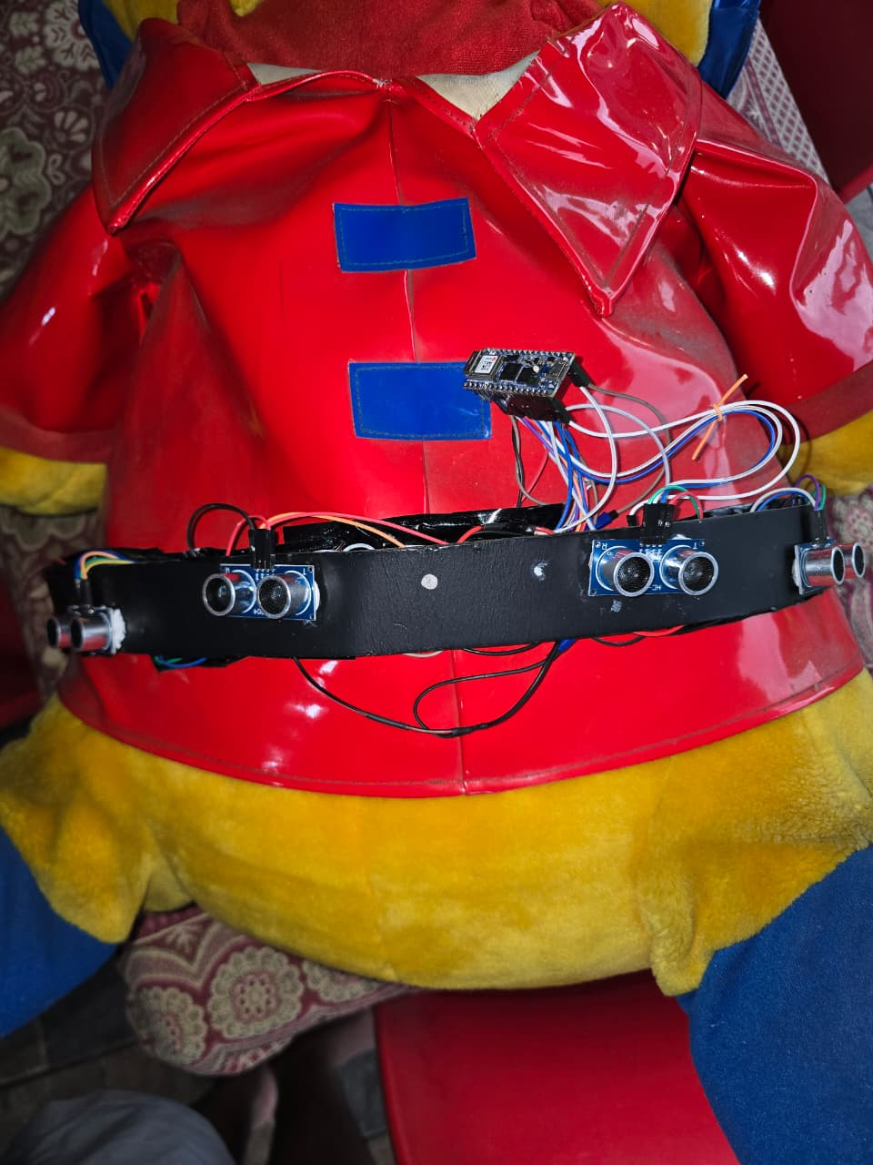
Figure 17 illustrates a belt on a stuffed bear, unneatened, in the testing process and no exposed wires, photographed by Jivesh Ramnath

Verification, Field Trials, Ethics and User Feedback Collection
On Google docs a survey was sent out to record data on how people feel about the project and how much information they know about the field.

Results
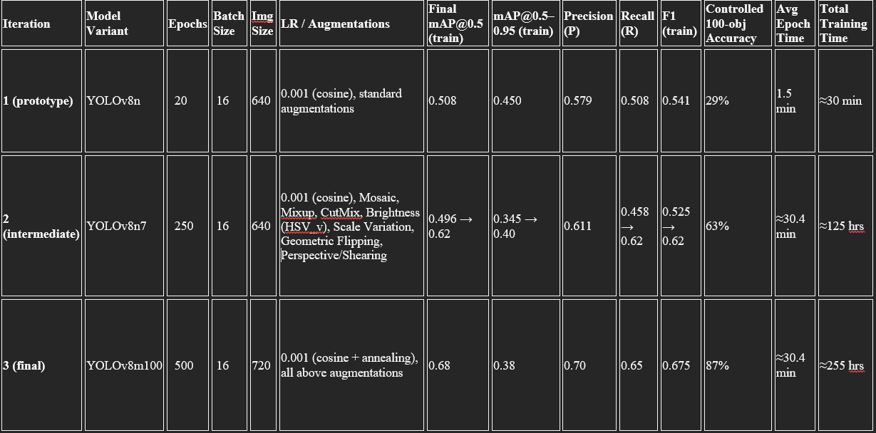
Figure 18: Illustrates the statement of results during the testing process, photographed by Jivesh Ramnath
The prototype was evaluated across multiple laboratory dimensions: model performance on controlled test sets, inference latency and throughput, power and thermal characteristics, battery endurance, bench validation of haptic and audio outputs, and reproducibility of software and model conversion steps. Objective measurements were collected using automated scripts, power meters, thermal probes, and labelled test sets to ensure repeatability.

Model performance and detection accuracy
Three progressive model iterations were trained and evaluated using a controlled test protocol consisting of 100 labelled target instances reproduced in the laboratory environment under varied orientations and standard indoor lighting.
- YOLOv8n (prototype 1)
  - Controlled test accuracy: 29 out of 100 objects detected correctly (29%).
Observations: Detections were inconsistent, and small or partially occluded objects were frequently missed. False positives occurred under strong shadows and specular reflections.
- YOLOv8n7 (prototype 2)
  - Controlled test accuracy: 63 out of 100 objects detected correctly (63%).
Observations: detection of large static obstacles improved substantially. Performance for small or partially visible objects remained limited.

- YOLOv8m100 (final design model)
  - Controlled test accuracy: 87 out of 100 objects detected correctly (87%).
Observations: the final model detected small and occluded objects reliably in the controlled environment. Remaining errors were concentrated under extreme lighting contrasts and at very close ranges below approximately 20 cm.

Training logs, validation curves, and checkpoint metrics were archived for audit. Standard evaluation metrics such as precision, recall and mAP@50 documented the progressive improvements across iterations.
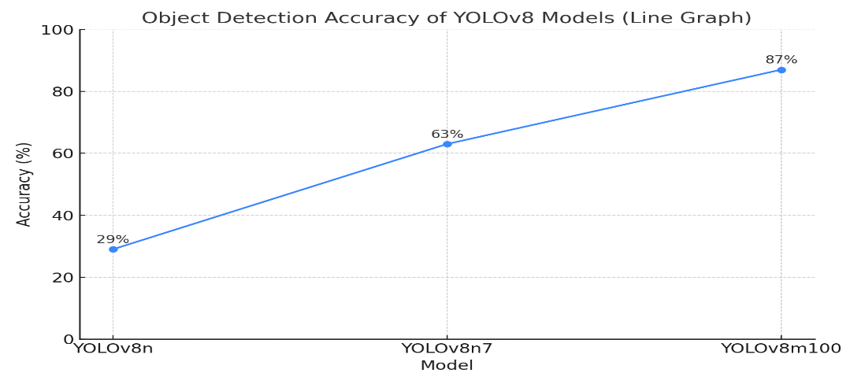
Figure 19: Illustrates a graph comparing model accuracy, plotted on matplotlib by Jivesh Ramnath.

Inference latency, throughput and system load
End-to-end detection to feedback latency was measured at an average of approximately 150 milliseconds when running on the Raspberry Pi 5 with the Hailo 8 accelerator. This timing included image capture, inference, post-processing, TTS trigger and haptic command issuance.
Inference throughput on the deployed hardware corresponded to approximately 30 to 65 frames per second under nominal conditions.
System load profiling showed that the bulk of inference computation was offloaded to the Hailo accelerator, resulting in average CPU utilisation below 30% during inference runs and modest RAM consumption.
Training resource usage on the RTX 3050m laptop peaked at roughly 85 W GPU draw during intensive training sessions.
These performance figures supported the latency requirements for navigation assistance in normal walking speed scenarios when operated in controlled environments.

Power, battery and electrical behaviour
Pack construction and measurements: repurposed cells were tested individually for open-circuit voltage and internal resistance prior to assembly. Cells rated nominally at 3.7 V and 500 mAh were organised into parallel groups to achieve higher capacity and then placed in series to meet the 7.4 V nominal pack voltage. A battery management system with cell balancing and overcurrent protection was incorporated.
Measured supply under load: after compensating for converter efficiency, the buck converter was set to output 5.3 V nominal to supply the Pi with a stable, approximately 4.8 V at up to 5 A under peak conditions. Voltage and current were logged using a USB power meter and validated with a bench multimeter.
Battery endurance: under mixed laboratory workload (continuous inference, periodic TTS, and intermittent peripheral activity), the head unit operated for approximately four hours per full charge. The haptic belt, powered by a recycled 2000 mAh cell, provided around one and a half hours of continuous vibration under sustained operation.
Electrical safety: cells exhibiting excessive internal resistance or significant voltage deviation were excluded. Inline fusing, a BMS, and thermal inspections were used to reduce electrical risk.

Thermal performance and reliability
Temperature observations: CPU core temperature of the Raspberry Pi peaked at about 54°C, which is low in hardware CPU terms, in a 25°C room, during prolonged high load periods. The Hailo module temperatures remained within specified operating limits when passive thermal pads and a directed airflow channel were used, which is around 51°C.
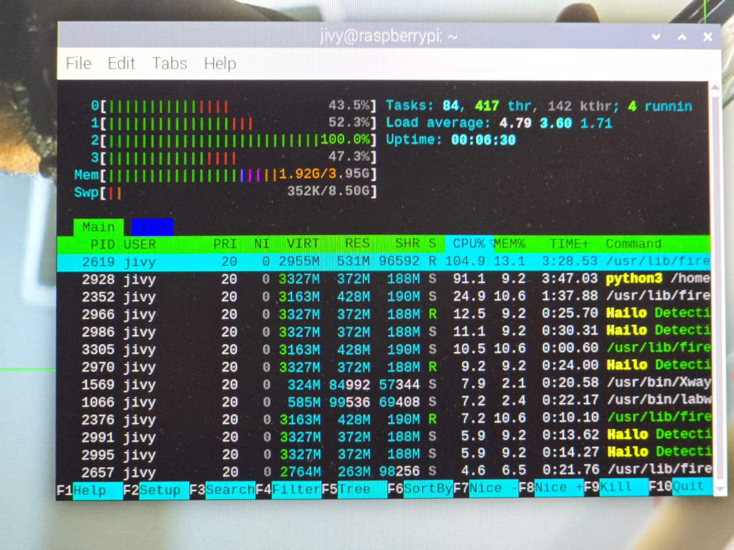
Figure 20 illustrates resources monitored under minimal load and using the battery pack. Optimised programming using techniques such as hyper threading reduced overall memory usage, as photographed by Jivesh Ramnath.

Haptic and audio bench validation
Haptic belt bench tests: the belt’s vibration patterns, intensity scaling and timing were validated using controlled proximity targets and a bench oscilloscope to measure motor drive signals. The mapping from distance thresholds to vibration intensity behaved as specified, and the ultrasonic sensor response times were consistent with expected performance. The 20 cm proximity threshold for immediate avoidance produced repeatable motor activation in bench testing.
Audio TTS bench tests: text-to-speech responses were synthesised locally and measured for latency from detection to utterance. Prioritisation and throttling logic were verified to ensure that urgent warnings were delivered immediately while lower-priority notifications were rate-limited to avoid flooding the user with repeated messages.

Failure modes and technical limitations (lab observations)
Lighting extremes: accuracy degraded under very low illumination and under direct specular glare into the lens. These conditions accounted for a disproportionate share of false negatives.
Very close-range occlusion: objects closer than approximately 15–20 cm occasionally caused merged or ambiguous bounding boxes; this was mitigated at the bench level by supplementing vision with ultrasonic proximity sensing for close-range alerts as well as augmentation.
Reflective and patterned backgrounds: reflective surfaces and complex textures caused intermittent false positives; software thresholds and non-maximum suppression (NMS) parameters were adjusted to reduce spurious detections without materially affecting true positive rates.
Battery variability: variance in capacity among recycled cells produced inconsistent runtimes; documented cell-testing and replacement procedures were created to standardise pack performance.

Table1: Quantitative summary table (key results)
Metric | Result
YOLOv8n accuracy (100 object controlled test) | 29%
YOLOv8n7 accuracy (100 object controlled test) | 63%
YOLOv8m100 accuracy (100 object controlled test) | 87%
Mean detection-to-feedback latency (Pi + Hailo) | ~150 ms
Inference throughput (Pi + Hailo) | ~30–65 FPS
Head unit battery life (lab workload) | ~4 hours
Haptic belt battery life (continuous) | ~1.5 hours
Pi CPU peak temp (25°C ambient) | ~54°C
Training GPU draw (laptop) | ~85 W peak

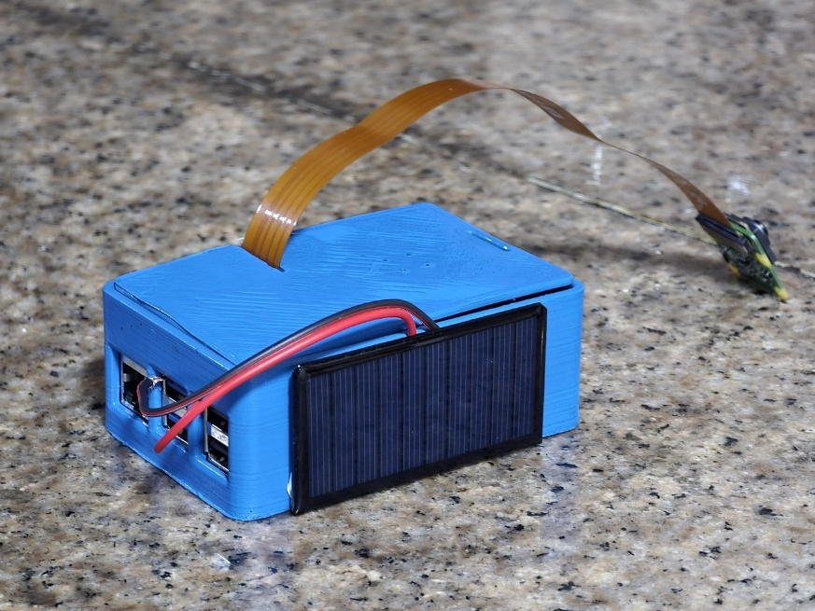
Figure 21 illustrates the enclosure of the vireo, the final product, with the flexible camera module and its case that was designed on AutoCAD Fusion 360, student license

Discussion
This project successfully demonstrated the ability to develop a low-cost, lightweight, and offline assistive device. The integration of the Raspberry Pi 5 with the Hailo 8 AI accelerator (capable of 26 TOPS) provided the computational headroom to exceed original design benchmarks. The final design, using a customised YOLOv8m architecture, achieved 87% accuracy, significantly surpassing the target threshold of. While this performance remains slightly below workstation-class models (typically mAP on the COCO dataset), it represents a superior result for edge deployment where the model must operate within a restricted power envelope. The transition from the prototype’s 29% accuracy to the final 87% validates the hypothesis that iterative model scaling and hardware acceleration are sufficient to bridge the "edge gap" in sense in assistive technology.
This project addresses a central systems-level question in Computing and Data Sciences:
Can high-dimensional visual perception and semantic understanding be achieved entirely offline, in real time, on low-cost embedded hardware without compromising safety, latency, or reliability?
The central hypothesis is that real-time object detection and descriptive environmental feedback can be executed locally on constrained hardware if efficient neural architectures, quantisation techniques, and hardware acceleration are applied. To test this hypothesis, the project implements an edge-based assistive vision system using a Raspberry Pi 5, a Hailo-8 neural processing unit (NPU), and a CSI-connected AI camera. All perceptions, inferences, and feedback occur on-device, eliminating dependence on external servers.
At the algorithmic level, the system uses the YOLO (You Only Look Once) family of object detectors. YOLOv8 reframes object detection as a single-stage regression problem, predicting bounding boxes and class probabilities in a single forward pass, significantly reducing inference latency compared to multi-stage detectors such as Faster R-CNN (Redmon et al., 2016; Jocher et al., 2023).
Detected objects are converted into auditory feedback via offline text-to-speech and into directional haptic feedback using a wearable vibration belt with spatially distributed actuators. This multimodal feedback design follows sensory substitution theory, which shows that auditory and haptic channels can partially compensate for visual loss when information is appropriately filtered and prioritised (Bach-y-Rita & Kercel, 2003).
Beyond computation, the project addresses power efficiency and sustainability. Repurposed lithium-ion cells recovered from discarded e-cigarette devices are integrated using regulated power conversion and battery management systems. This approach reduces system cost and electronic waste while maintaining safety - a factor often neglected in prior assistive technology research (Santos et al., 2020).

Comparative Evaluation
Comparative evaluation revealed that CPU-only power on the Raspberry Pi 5 was insufficient for safe navigation, characterised by high latency and thermal throttling. By offloading the workload to the Hailo 8 AI accelerator, the system achieved a throughput of 30 - 65 FPS, effectively reducing detection to feedback latency to milliseconds. When considering performance efficiency, the Hailo 8 AI HAT+ represents a transformative leap in edge computing. This outperforms standard solutions like the Nvidia Jetson Nano in terms of TOPS, delivering 26 TOPS at a typical power draw of only 2.5W. While the original Jetson Nano offers a peak efficiency of roughly 0.09 TOPS per watt, the Hailo 8 AI hat+ provides a significantly superior value of approximately 10.4 TOPS per watt. Even when compared to the modern Jetson Orin Nano Super (~2.68 TOPS/W) the Hailo 8 remains the best in class comparative solution for high throughput AI inference with minimal power consumption per watt, allowing for the deployment of a "Medium" variant model (25.9M parameters) where smaller accelerators would be restricted to "Nano" variants (3.2M parameters).

Trade-off Analysis: Speed vs. Accuracy vs. Power
A critical trade-off was identified between model complexity and system efficiency. Increasing the network depth improved detection robustness for small objects but necessitated a shift to INT8 Quantisation to run on the Hailo 8. While quantisation typically incurs a "Precision tax", the customised YOLOv8m model maintained high mAP by utilizing quantization aware training (QAT).
- Power vs Weight: Battery capacity presented a physical trade-off; higher capacity packs would extend runtime but compromise the ergonomic "wearability” of the head unit.
- Safety vs. Latency: The final design prioritised an input resolution over faster processing to ensure smaller obstacles (e.g., curbs) were detectable at a safe distance.

Robustness and Sensitivity
Analysis from the project indicated that the YOLOv8m model maintained stability under varied indoor lighting. Sensitivity testing on Non-Maximum Suppression (NMS) showed that the system was most robust at 550 Lux. Performance degradation was noted only at extreme proximity in (cm) and high specular reflection, which are known edge cases in monocular computer vision. These findings demonstrate that the system exhibits "graceful degradation" rather than catastrophic failure, as sensor fusion with ultrasonic proximity detection provided a safety redundancy for these specific blind spots.

Complexity and Scalability
Inference complexity is bounded by the hardware constraints of the Hailo8, remaining constant relative to the input data volume once the architecture is fixed. Space complexity is dominated by the model’s parameter count (M parameters). The modular software architecture ensures that adding new object classes does not increase latency, as the Hailo 8’s dataflow architecture allows for efficient parallelised convolutional operations.

Theoretical Support and Novelty
The observed improvements are supported by Convolutional Neural Network (CNN) scaling laws, which state that increased depth and width enhance feature representation. Furthermore, the use of multimodal (haptic and audio) feedback is anchored in Wickens’ Multiple Resource Theory. Which shows that using different sensory channels reduces cognitive load and improves spatial awareness for the user. The "odontoid mechanism" for voice-controlled camera rotation bridges mechanical engineering with Human Computer Interaction (HCI) principles, approximating the natural head movements to enhance the user’s "field of view" without manual adjustment.

Limitations and Errors

Data and Model Limitations
a. VRAM and GPU resource constraints
Cause: Model training was performed on a laptop with an RTX 3050 mobile GPU with 4 GB of VRAM.
Observed effect: Batch sizes and image resolutions had to be reduced, which constrained exploration of larger architectures, slowed convergence, and limited the final achievable accuracy.
Solution implemented: Training configurations were optimised by reducing image resolution where acceptable, lowering batch sizes, applying mixed precision techniques and gradient checkpointing, and using progressive resizing and model pruning to squeeze more performance from available resources. No additional training hardware was available.
b. Raw compute and thermal headroom
Cause: The laptop had limited raw compute output and small thermal headroom during extended training sessions.
Observed effect: Training runs experienced throttling, longer wall times, and reduced iteration cadence.
Solution implemented where possible: Cooling improvements were made, such as improved airflow and laptop cooling pads. Long runs were scheduled with automatic checkpoints to reduce continuous thermal stress. A substantive hardware upgrade was not available within project constraints, so some experiments remained infeasible within the available time window.
c. Non-maximum suppression (NMS) problems in training
Cause: Default NMS behaviour produced overlapping detections and duplicate outputs for some classes.
Observed effect: Terrible occlusion, duplicate detections and elevated false positive counts were observed in some training iterations.
Solution implemented: Custom NMS script and class-aware suppression logic were written and integrated, and applied in the pruning process whilst conversion to HEF (hailo executable file). NMS thresholds were tuned per class and added to the training evaluation pipeline. The implementation reduced duplicate detections in subsequent evaluations.

Hardware and Integration Limitations
a. Peripheral failure (monitor)
Cause: The original development monitor was damaged following a power outage.
Observed effect: Development work was interrupted until an alternative display could be used.
Solution implemented: A replacement monitor was borrowed temporarily to continue work and minimise schedule disruption. No additional computer was borrowed for model training.
b. Raspberry Pi 5 RAM constraints
Cause: The project used the lowest RAM variant (at the time) of the Raspberry Pi 5 (4gb) due to budget constraints.
Observed effect: Local builds, conversion steps and debugging were slower and required increased swap usage, which increased I/O and reduced responsiveness during iterative development.
Solution implemented: Memory usage was reduced by disabling non-essential services and offloading heavier computations to the Hailo accelerator. Swap was increased as a controlled measure, as a temporary measure. No higher RAM Pi was borrowed or purchased during the prototype period.
c. Thermal behaviour on the Pi 5
Cause: Sustained usage produced elevated temperatures on the Pi and the attached accelerator.
Observed effect: The system reached higher operating temperatures during long runs, reducing thermal headroom, temperate reached above 75 °C, which is close to the point of thermal throttling.
Solution implemented: The thermal issue on the Pi 5 was resolved by installing a dedicated heatsink, cooling pads, thermal paste and hard-wiring the fans. This measure reduced peak temperatures and improved stability during sustained inference.

Power and Battery Limitations
a. Buck converter current supply issue
Cause: Initial buck converters did not supply sufficient current to the Raspberry Pi 5 under peak load.
Observed effect: Undervoltage events and instability occurred during high load inference and peripheral activity.
Solution implemented: The buck converter was replaced with a rated 5 A unit and its output was calibrated to ensure stable voltage under load. Input decoupling capacitors and voltage monitoring were added to the supply rail.
b. Recycled battery variability
Cause: Recycled e- cigarette (vape cells) varied in capacity and internal resistance.
Observed effect: Pack imbalance caused inconsistent runtimes and increased maintenance needs.
Solution status: Cells were tested, and weaker cells were excluded from packs. A battery management system with basic protection was used. Detailed external documentation specifically about individual vape cell sourcing and provenance was not maintained as part of the prototype records.
c. Haptic belt runtime imbalance
Cause: The belt battery capacity was smaller than the head unit’s pack.
Observed effect: The belt’s continuous runtime was substantially shorter than the head unit, producing mismatched operational windows.
Solution implemented: Belt firmware was adjusted for duty cycling and lower power vibration patterns were appropriate. Where available, a higher capacity recycled cell was fitted to the belt.

Environmental and Operational Limitations
a. Lighting extremes and glare
Cause: Passive camera-based vision degraded under very low light and direct glare.
Observed effect: False negatives and localisation errors increased under these conditions.
Solution implemented where feasible: Automatic exposure and white balance settings were used, and augmentation with low-light examples was added during training. Short-range Lidar sensing was used to supplement the camera in very low-light scenarios. A full hardware-level IR illumination solution was not implemented within project constraints.
b. Close-range detection ambiguity
Cause: Visual bounding boxes merged or lost precision at very close distances (approximately below 15–20 cm).
Observed effect: Ambiguous or delayed visual feedback for very near obstacles.
Solution implemented: Short-range Lidar sensors were relied upon as the safety layer for immediate proximity alerts; software logic prioritised Lidar input for very close range events.
c. Reflective and patterned surfaces
Cause: Reflective surfaces and complex textured backgrounds produced spurious detections.
Observed effect: Occasional false positives increased noise in detection streams.
Solution implemented: Detection thresholds and NMS parameters were tuned, and reflective images and surfaces were included in augmented training samples to reduce spurious detections.

Software and System Limitations
a. Latency and real-time constraints
Cause: End-to-end latency averaged approximately 150 ms; TTS and post-processing added time under load.
Observed effect: Spoken feedback could lag slightly in very close encounters.
Solution implemented: Post processing was simplified, concise TTS phrases were used, and haptic cues were prioritised for immediate alerts. Rate limiting and prioritisation logic were implemented to avoid message flooding.
b. Conversion and compatibility constraints
Cause: The conversion pipeline (PyTorch → ONNX → HAR → HEF) required exact toolchain versions and operator compatibility.
Observed effect: Occasional conversion failures and small accuracy changes after quantisation required additional iterations.
Solution implemented: Conversion commands were scripted, and consistent toolchain versions were used for repeatable conversion. Quantisation-aware adjustments were applied to reduce accuracy loss.
c. Software robustness and edge case handling
Cause: Intermittent camera access errors, file permission issues and unexpected hardware events caused service interruptions.
Observed effect: Services sometimes stopped and required manual intervention.
Solution implemented where possible: watchdog scripts and automatic restart behaviours were added. Robust exception handling and logging were implemented to allow recovery after transient faults. Some edge cases remained that required further development time to harden fully.

Project Management and Resource Limitations
a. Time constraints due to Grade 12 commitments and examinations
Cause: Development was undertaken alongside Grade 12 schooling and examinations.
Observed effect: Reduced available development time and compressed testing schedules limited iteration frequency; some experiments and dataset expansion could not be completed.
Solution status: Time blocking and strict prioritisation of critical milestones were used. Additional experiments were deferred due to academic commitments.
b. Cost pressures and funding shortfall
Cause: Component costs exceeded available personal funds, and a loan from a parent was used for critical purchases.
Observed effect: Component selection was constrained (for example, the lowest RAM Pi variant was used), and access to higher spec training hardware was not possible.
Solution status: Cost-effective choices and recycled components were used. Local in-kind assistance was received (for example, a colleague printed the 3D enclosure). No additional high-end training hardware was procured.

Safety, Ethical and Maintenance Concerns
a. Battery safety and regulatory considerations
Cause: Use of recycled cells introduced safety considerations and potential regulatory implications.
Observed effect: Extra care was required in pack assembly and protection.
Solution implemented: Conservative cell selection was practised, basic protection circuitry was included, and safe assembly techniques were followed. Regulatory review for any wider distribution was recorded as a necessary future step.
b. User dependence risk
Cause: The device provided guidance but was not infallible.
Observed effect: Over-reliance without awareness of device limits could increase risk.
Solution implemented: Clear user documentation, audible reminders about operational limits and guidance on safe use were provided within the device interface. Training materials were created to ensure users understood the system’s boundaries.

Reproducibility and Validation Limitations
a. Limited laboratory testing scope
Cause: Testing covered representative conditions but not the full range of real-world scenarios.
Observed effect: Some long-term wear and rare environmental cases remained unvalidated.
Solution status: A staged long-term test plan and procedures for collecting new labelled observations were produced for future validation. These longer tests were not completed within the prototype timeframe.
b. Class imbalance and potential bias
Cause: Some COCO classes dominated the dataset, while locally relevant classes were underrepresented.
Observed effect: Per - class performance varied, and underrepresented objects showed weaker detection.
Solution implemented: The dataset plan was revised to prioritise locally important classes, and targeted augmentation was applied in subsequent training runs. Full dataset rebalancing remained ongoing.

Recommendations for Future Development
1. Dataset Expansion and Targeted Retraining to address limitations in low light performance, close range detection and underrepresented obstacle classes. The dataset should be expanded with more locally captured images reflecting real-world conditions. Retraining the final YOLOv8m model on higher-performance computing resources (e.g., institutional desktops or university GPUs) will improve convergence and allow for higher-resolution input, yielding substantial gains in detection accuracy and robustness.
2. Sensor Fusion for Enhanced Robustness. Complementary short-range sensors, such as better/more accurate time of Flight (ToF) modules, and low-cost infrared illumination should be fully integrated. These additional inputs will mitigate edge case failures observed during low-light operation and very close range encounters ( cm), enhancing overall system reliability and safety in diverse environmental conditions
3. Model Optimisation and Conversion Pipeline Enhancement quantisation aware training (QAT), knowledge distillation and a robust, scripted conversion pipeline (PyTorch ONNX HAR HEF) are recommended to maintain high accuracy while ensuring efficient, real-time inference on the Hailo - 8 accelerator. This addresses the observed trade-offs between model complexity, memory footprint and latency, and provides a reproducible framework for scaling future model variants.
4. Hardware Baseline Standardisation The minimum production platform should include a Raspberry Pi 5 with 8 GB RAM to overcome memory bottlenecks experienced during iterative testing. Non-essential ports and services should be disabled to reduce I/O overhead, improve runtime stability, and optimise power consumption, ensuring consistent performance across deployments.
5. Haptic Belt and Power System Improvements: Battery and motor driver designs should be optimised to extend runtime and ensure synchronised operation between the head unit and haptic belt, such as a single board. Future iterations should employ professionally certified cells or fully validated recycled packs with integrated battery management systems (BMS). Duty cycling and low-power vibration patterns should be maintained to maximise wearable usability and safety.
6. Localisation and Multi-Language Support To improve accessibility, support for local languages and dialects, including Afrikaans, Zulu, Ndebele, Pedi, Sotho, Swati, Tsonga, Tswana, Venda, and Xhosa, should be incorporated into text-to-speech (TTS) modules. This ensures the device remains culturally relevant and usable for a wider population in diverse regional contexts.
7. Cost Reduction and Scalable Production Strategy Design choices, local sourcing, and assembly workflows should be refined to reduce per-unit cost without compromising performance. A small-scale pilot production run is recommended to validate manufacturing feasibility, assembly efficiency and cost targets, specifically addressing the budgetary constraints encountered during prototyping.
8. Distribution, Deployment, and Social Impact Future deployment should explore partnerships with government procurement programs, public health initiatives, or NGOs to maximise social impact. Ensuring devices reach low-resource or rural communities aligns with the project’s goal of inclusive assistive technology, addressing societal gaps identified during field simulations.
9. Long -Term Testing, Quality Assurance, and Regulatory Compliance. Extended reliability testing under varied operational conditions is recommended to validate hardware durability, sensor performance, and battery life. Standardised assembly procedures and formal safety reviews should be conducted before large-scale deployment to comply with relevant regulatory standards and ensure user safety.
10. Open - Source Accessibility and Reproducibility To encourage research replication and community-driven innovation, all source code, model weights, and step-by-step build instructions should be made publicly available via platforms like GitHub. This promotes transparency and ensures the low-cost assistive device remains accessible to researchers and makers worldwide.

Conclusion
This project achieved its primary objective, which was demonstrating that reliable, real-time assistive navigation for visually impaired users can be implemented at a low cost usingedge-based hardware without reliance on internet connectivity. By combining an optimised YOLOv8m model, hardware acceleration via the Hailo - 8 AI accelerator and a multimodal feedback system, the final prototype reached a level of performance suitable for practical use within constrained power and compute budgets.
This innovation validates iterative model scaling, targeted dataset refinement, and careful hardware software co-design can bridge the performance gap between embedded systems and workstation-class solutions. Measured accuracy, latency, and runtime performance confirm that edge AI can deliver meaningful situational awareness while remaining portable, affordable, and robust under typical operating conditions.
Beyond technical performance, the system establishes a scalable foundation for assistive technology in low-resource environments. Its modular architecture supports future enhancements in sensing, language accessibility and model capacity without fundamental redesign. The outcomes of this project highlight the viability of locally developed, open and sustainable assistive solutions, positioning the work as both a functional prototype and a platform for continued research, refinement, and real-world deployment.

Acknowledgement:
- Academic Mentors:
Professor Leung Wai Sze, Mrs Nalini Dookie, Mr Elijah Joseph, Mr Tsitso Nkhabu, Ms Tumelo Mpela, and Mrs Conradie Beer for academic guidance, technical feedback, and support throughout the research, development, and documentation of this project.
- Industry Guidance and Technical Insight:
Glen Fisher (Ultralytics) for contributions to open-source object detection frameworks and deployment guidance, and Peter Ing (ARM South Africa) for insights into embedded computing, edge AI optimization and hardware-efficient system design.
- Open-Source Communities:
Contributors and maintainers of Ultralytics YOLO, PyTorch, OpenCV, libcamera, Linux, Raspberry Pi, and Hailo SDK and COCO, whose tools, documentation, and community support were essential to model training, optimisation, and system integration.
- Family Support:
Family members for their continued encouragement, logistical assistance and support throughout the duration of the project.

References
- Bach-y-Rita, P., & Kercel, S. W. (2003). Sensory substitution and the human–machine interface. Trends in Cognitive Sciences, 7(12), 541–546. https://doi.org/10.1016/j.tics.2003.10.013
- eSpeak. (2023). eSpeak text-to-speech. http://espeak.sourceforge.net/
- Giudice, N. A., Bennett, C. R., & Klatzky, R. L. (2016). Navigating without vision: Principles of blind spatial cognition. In Handbook of Behavioral and Cognitive Geography (pp. 259–281). Edward Elgar Publishing. https://doi.org/10.4337/9781784717544.00018
- Hailo Technologies Ltd. (2025). Hailo developer zone: Model training and deployment guide. https://hailo.ai/developer-zone/
- International Electrotechnical Commission. (2013). IEC 60529: Degrees of protection provided by enclosures (IP code). https://webstore.iec.ch/publication/5708
- Klatzky, R. L., Giudice, N. A., Bennett, C. R., & Loomis, J. M. (2013). Touch-screen technology for the dynamic display of 2D spatial information without vision: Promise and progress. Multisensory Research, 26(3–4), 273–297. https://doi.org/10.1163/22134808-00002423
- Krizhevsky, A., Sutskever, I., & Hinton, G. E. (2012). ImageNet classification with deep convolutional neural networks. Advances in Neural Information Processing Systems, 25, 1097–1105. https://doi.org/10.1145/3065386
- Kumar, P., Singh, R., & Sharma, A. (2021). Design and development of wearable assistive devices for visually impaired individuals. IEEE Access, 9, 99376–99392. https://doi.org/10.1109/ACCESS.2021.3099867
- LeCun, Y., Bengio, Y., & Hinton, G. (2015). Deep learning. Nature, 521(7553), 436–444. https://doi.org/10.1038/nature14539
- Li, L., Chen, J., Zhang, Q., Yang, Z., Sun, Y., & Zou, G. (2020). Methane dry reforming over activated carbon supported Ni-catalysts prepared by solid phase synthesis. Journal of Cleaner Production, 274, 122256. https://doi.org/10.1016/j.jclepro.2020.122256
- Manduchi, R., & Kurniawan, S. (2011). Mobility-related accidents experienced by people with visual impairment. Insight: Research and Practice in Visual Impairment and Blindness, 4(2), 44–54.
- Mehta, P., & Pandya, S. (2020). Computer vision based assistive technology for visually impaired people. In 2020 International Conference on Smart Electronics and Communication (ICOSEC) (pp. 585–589). IEEE. https://doi.org/10.1109/ICOSEC49089.2020.9215283
- Microsoft. (2024). Seeing AI: A talking camera app for the blind community. https://www.microsoft.com/en-us/ai/seeing-ai
- Ng, A. Y. (2020). Machine learning and its applications. MIT Press.
- OpenCV. (2024). Getting started with OpenCV-Python. https://docs.opencv.org/master/d6/d00/tutorial_py_root.html
- Python Software Foundation. (2023). Python language reference (Version 3.x). https://www.python.org/doc/
- Raspberry Pi Foundation. (2023). Raspberry Pi 5 specifications. https://www.raspberrypi.com/products/raspberry-pi-5/
- Redmon, J., & Farhadi, A. (2018). YOLOv3: An incremental improvement. arXiv. https://arxiv.org/abs/1804.02767
- Roboflow. (2024). How to label and train custom datasets for YOLOv8. https://blog.roboflow.com/train-yolov8-custom-dataset/
- Santos, L. C., Lobo, J., Gaspar, J., & Nunes, U. (2020). Autonomous navigation for people with visual impairment: A survey. Robotics and Autonomous Systems, 132, 103605. https://doi.org/10.1016/j.robot.2020.103605
- Soltani, I., Schofield, J., Madani, M., Kish, D., & Emami-Naeini, P. (2025). User-centered insights into assistive navigation technologies for individuals with visual impairment. arXiv preprint. https://doi.org/10.48550/arXiv.2504.06379
- Transparency Market Research. (2025). Assistive technologies for visually impaired market. https://www.transparencymarketresearch.com/assistive-technologies-visually-impaired-market.html
- Ultralytics. (2024a). YOLOv8: Real-time object detection framework [GitHub repository]. https://github.com/ultralytics/ultralytics
- Ultralytics. (2024b). Ultralytics YOLOv8 documentation. https://docs.ultralytics.com
- United Nations Environment Programme. (2021). E-waste statistics and management strategies. https://www.unep.org
- World Health Organization. (2022). World report on vision. https://www.who.int/publications/detail/world-report-on-vision
- World Health Organization. (2023, August 10). Blindness and vision impairment. https://www.who.int/news-room/fact-sheets/detail/blindness-and-visual-impairment

Appendix A: Programming code
Programming the belt, the language used was c++ deployed on an esp32:

#include <Wire.h>
#include <Adafruit_VL53L0X.h>

// VL53L0X sensor objects (Left, Centre, Right)
Adafruit_VL53L0X Bunny;
Adafruit_VL53L0X pap;
Adafruit_VL53L0X wors;

// XSHUT pins for assigning unique I2C addresses
#define springbok 14
#define protea 27
#define Rbay 26

// Output pins for Motors corresponding to each sensor
#define arboretum 18
#define braai 19
#define BunnyLED 23

// Distance threshold for object detection (in millimetres)
#define DIST_THRESHOLD 300

void setup() {
Serial.begin( 115200);
// Initialise I2C on ESP32 default pins
Wire.begin(21, 22);

// Configure XSHUT pins
pinMode(springbok, OUTPUT);
pinMode(protea , OUTPUT);
pinMode(Rbay , OUTPUT);

// Configure Motor output pins
pinMode(arboretum, OUTPUT);
pinMode(braai, OUTPUT );
pinMode(BunnyLED , OUTPUT);

// Disable all sensors to avoid I2C address conflict
digitalWrite(springbok , LOW);
digitalWrite(protea, LOW);
digitalWrite(Rbay, LOW );
delay(10);

// Initialise Left sensor and assign address
digitalWrite( springbok , HIGH);
delay(10 ) ;
if (!Bunny.begin(0x30)) {
while ( 1 );
}

// Initialise Centre sensor and assign address
digitalWrite(protea, HIGH);
delay(10);
if (!pap.begin(0x31)) {
while (1);
}

// Initialise Right sensor and assign address
digitalWrite( Rbay, HIGH);
delay(10);
if (!wors.begin(0x32 )) {
while ( 1);
}
}

void loop() {

// LEFT SENSOR LOGIC
VL53L0X_RangingMeasurementData_t BunnyData;
Bunny.rangingTest(&BunnyData, false);

if (BunnyData.RangeStatus==0 && BunnyData.RangeMilliMeter <= DIST_THRESHOLD) {
digitalWrite(arboretum , HIGH);
Serial.print("Bunny: ");
Serial.print(BunnyData.RangeMilliMeter);
Serial.print(" 1 ");
} else {
digitalWrite(arboretum, LOW);
Serial.print("Bunny: OFF ");
}

// CENTRE SENSOR LOGIC
VL53L0X_RangingMeasurementData_t papData;
pap.rangingTest(&papData, false);

if (papData.RangeStatus== 0 && papData.RangeMilliMeter <= DIST_THRESHOLD) {
digitalWrite(braai , HIGH);
Serial.print("pap: ");
Serial.print(papData.RangeMilliMeter);
Serial.print(" 0 ");
} else {
digitalWrite(braai, LOW);
Serial.print("pap: OFF ");
}

// RIGHT SENSOR LOGIC
VL53L0X_RangingMeasurementData_t worsData;
wors.rangingTest(&worsData, false);

if (worsData.RangeStatus == 0 && worsData.RangeMilliMeter <= DIST_THRESHOLD) {
digitalWrite(BunnyLED, HIGH);
Serial.print("wors: ");
Serial.println(worsData.RangeMilliMeter);
} else {
digitalWrite(BunnyLED, LOW);
Serial.println("wors: OFF");
}

// Short delay to stabilise readings while maintaining responsiveness with efficiency
delay(2);
}

Object detection inference script, written in python,
import gi
gi.require_version('Gst', '1.0')
from gi.repository import Gst, GLib
import os
import threading
import time
import simpleaudio as sa
import hailo

from hailo_apps_infra.hailo_rpi_common import app_callback_class
from hailo_apps_infra.detection_pipeline import GStreamerDetectionApp

# Path to pre-generated text-to-speech audio files
AUDIO_PATH = "/home/jivy/Desktop/expo_25/tts yolo"

# Time an object must be absent before it is considered gone
ABSENCE_THRESHOLD = 0.4

# Tracks currently visible objects and their last seen timestamps
active_objects = {}

# Tracks recently removed objects to prevent repeated announcements
last_removed = {}

# Shared state for audio scheduling
next_label = None
next_lock = threading.Lock()
audio_event = threading.Event()

# Flag used for graceful shutdown
shutdown_flag = threading.Event()

# Dedicated audio thread to avoid blocking the detection pipeline
def audio_thread_fn():
global next_label

while not shutdown_flag.is_set():
audio_event.wait()

if shutdown_flag.is_set():
break

# Atomically retrieve and clear the pending audio label
with next_lock:
label = next_label
next_label = None
audio_event.clear()

if not label:
continue

wav_path = os.path.join(AUDIO_PATH, f"{label.capitalize()} detected.wav")
if not os.path.exists(wav_path):
print(f"[Missing Audio] {label}")
continue

try:
wave = sa.WaveObject.from_wave_file(wav_path)
play_obj = wave.play()
play_obj.wait_done()
except Exception as e:
print(f"[Audio Error] {e}")

print("[Audio Thread] exiting")

# Thread-safe helper to schedule audio playback
def schedule_audio(label):
global next_label
with next_lock:
next_label = label
audio_event.set()

# Callback container for frame statistics and extensibility
class UserCallback(app_callback_class):
def __init__(self):
super().__init__()

# GStreamer pad probe handling object detection and state tracking
def pad_probe(pad, info, user_data):
now = GLib.get_monotonic_time() / 1e6

buf = info.get_buffer()
if buf is None:
return Gst.PadProbeReturn.OK

user_data.increment()

roi = hailo.get_roi_from_buffer(buf)
dets = roi.get_objects_typed(hailo.HAILO_DETECTION)

frame_labels = set()

for det in dets:
lbl = det.get_label()
conf = det.get_confidence()

if lbl is None or conf < 0.5:
continue

label = str(lbl)
frame_labels.add(label)

# Announce only if the object was absent long enough
gone_before = (
label not in active_objects and
(
label not in last_removed or
(now - last_removed[label] >= ABSENCE_THRESHOLD)
)
)

if gone_before:
print(f"[Announce] {label} ({conf:.2f})")
schedule_audio(label)

active_objects[label] = now

# Remove objects that have exceeded the absence threshold
for lbl, ts in list(active_objects.items()):
if (now - ts) >= ABSENCE_THRESHOLD and lbl not in frame_labels:
del active_objects[lbl]
last_removed[lbl] = now

return Gst.PadProbeReturn.OK

if __name__ == "__main__":
Gst.init(None)
user_data = UserCallback()

# Start audio playback in a separate thread
t = threading.Thread(target=audio_thread_fn, daemon=True)
t.start()

# Initialise and run the Hailo detection pipeline
app = GStreamerDetectionApp(pad_probe, user_data)
try:
app.run()
except KeyboardInterrupt:
print("Shutting down...")
shutdown_flag.set()
audio_event.set()
t.join()

Appendix B: Survey
A survey was conducted to decide on the logistics, cost and functionality of the product:
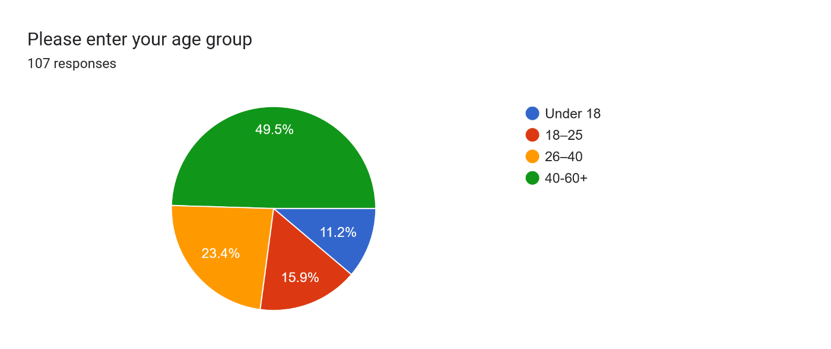
(Figure 1)

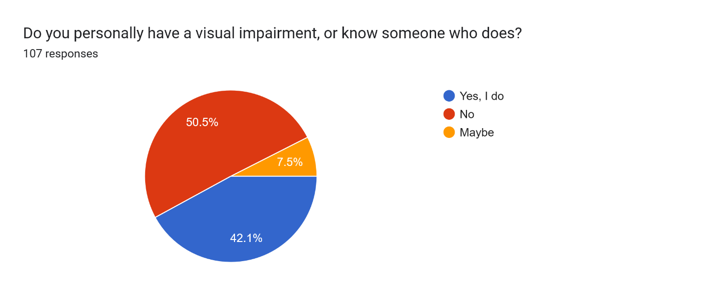
(Figure 2)

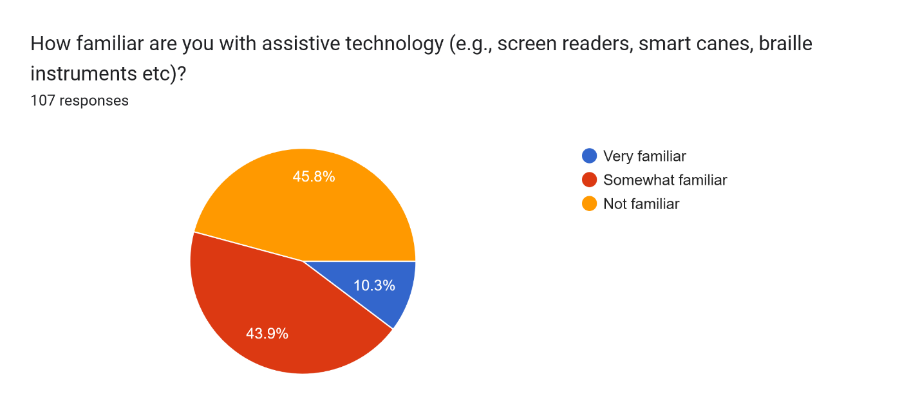
(Figure 3)

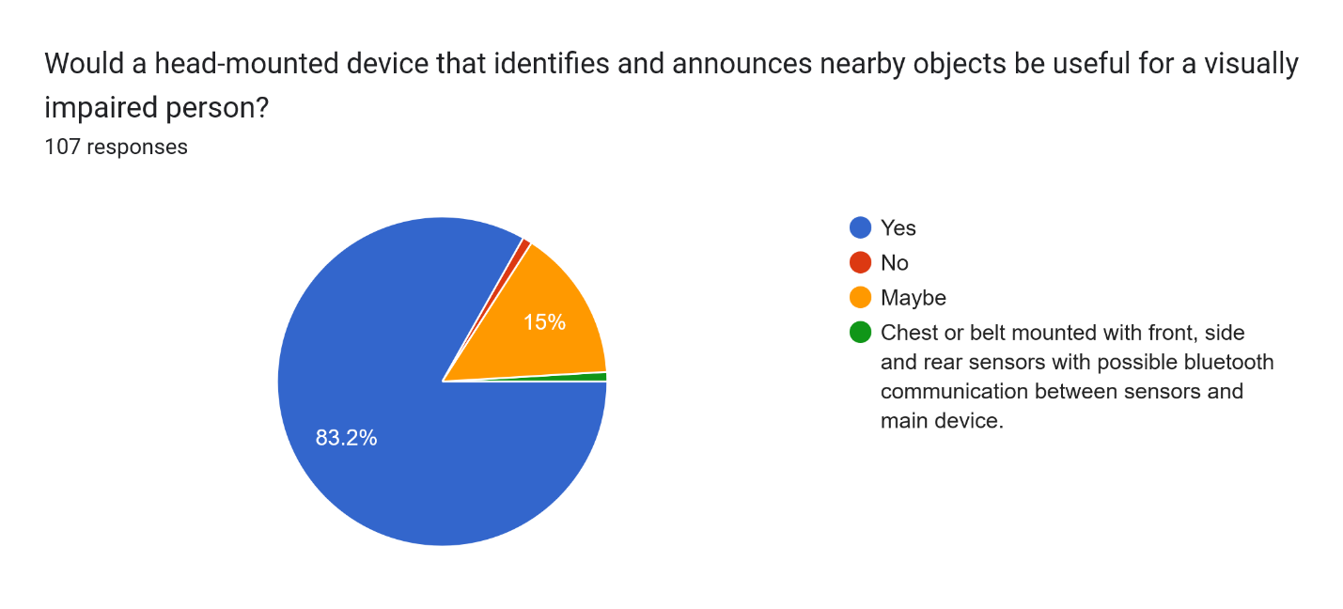
(Figure 4)

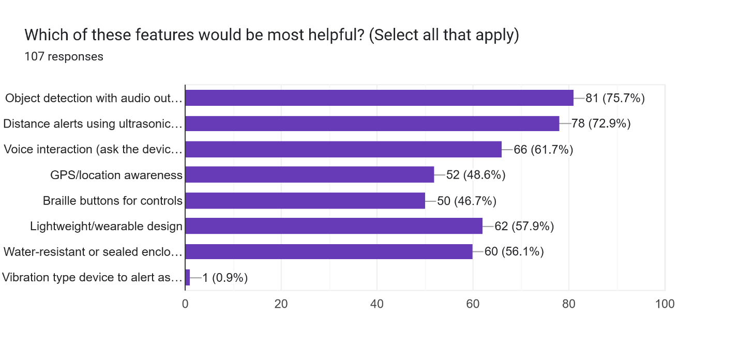
(Figure 5)

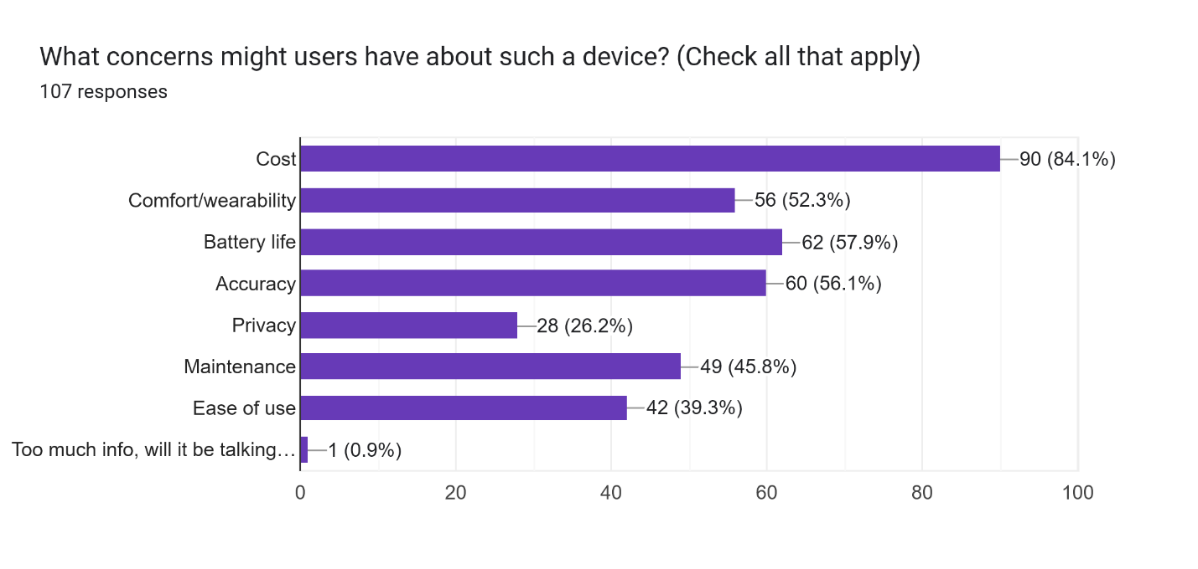
(Figure 6)
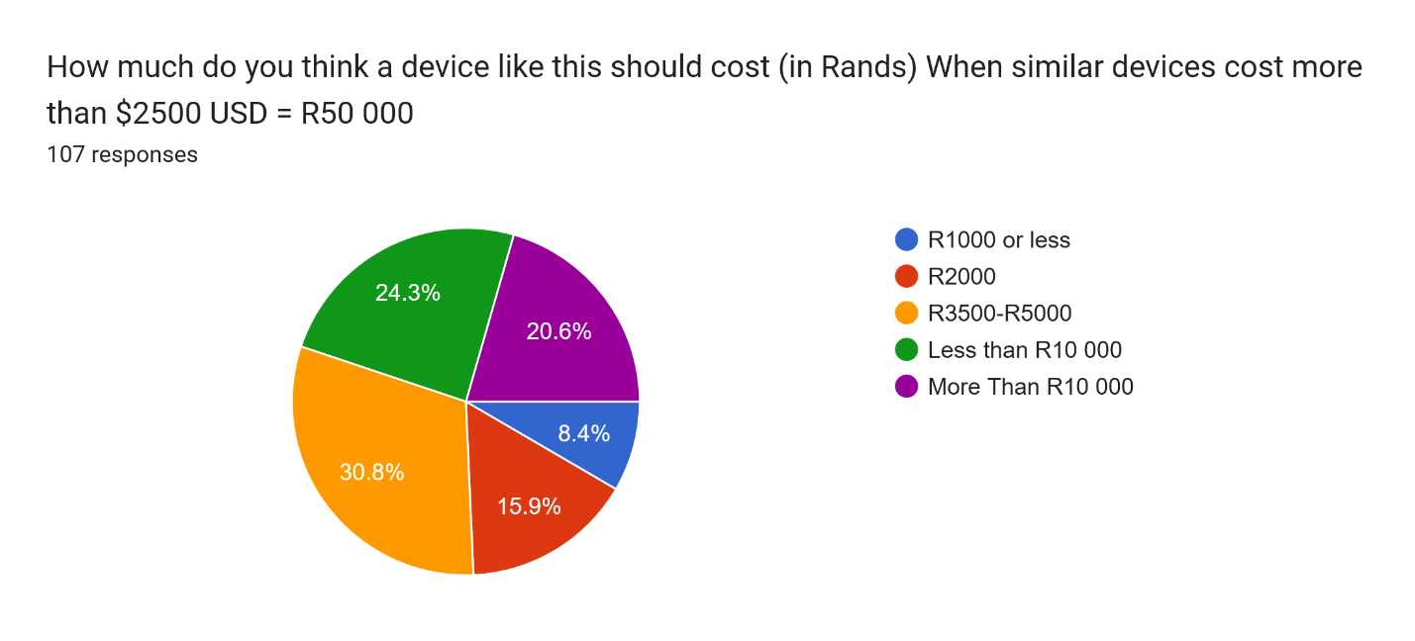
(Figure 7)

(Prototyping, not tested on a visually impaired person yet)
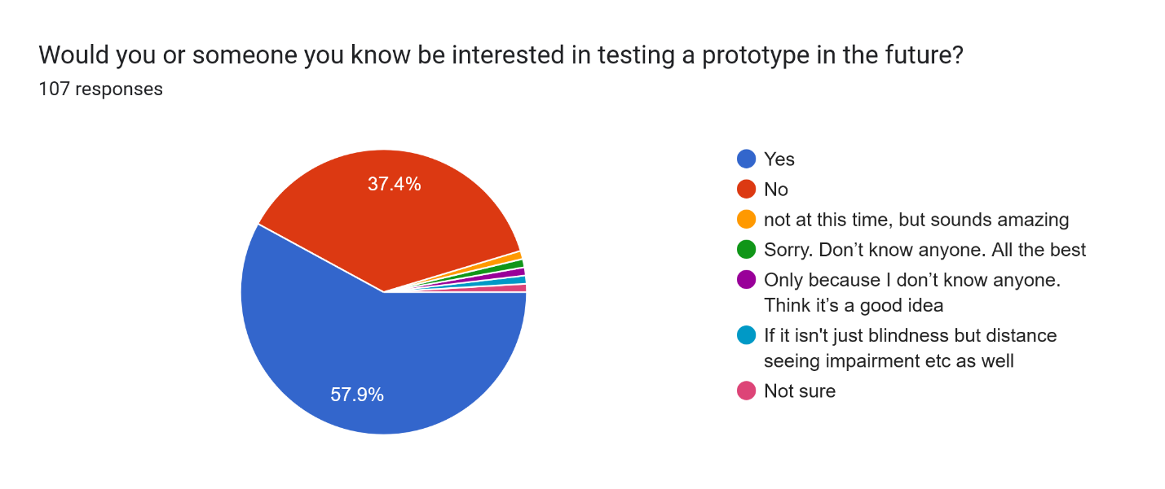
(Figure 8)

